Supplementary tables for:
Integrating Space Syntax and System Dynamics for Understanding and Managing Change in Rural Housing Morphology: A Case Study of Traditional Village Houses in Düzce, Türkiye

Supplementary Table 1: Factors affecting rural architecture (Batur and Öymen Gür, 2005)
Environmental factors | Cultural factors | Social factors | Individual factors
Climate | World view | Family size | Beneficial relations/standards established by the individual with the house
Topography | Cultural values and norms | The socio-economic status of the family and its social sphere of influence | Emotional relations of the individual with the house-identification/attachment etc.
Natural pattern and texture | Religion, language and other classification categories | Family's worldview and social attitudes | Individual's interpretation of cultural norms-education
Natural pattern and texture | Family, kinship and community relations | Family structure/roles in the family | The life intensity of individual
Man-made pattern | Lifestyle | Family lifestyle | Individual's housing experiences
Material in the environment etc. | Environment/space usage norms | Family self-image expectations and hopes | Self-image of the individual
Material in the environment etc. | Norms for residential use - the main functions and meaning of housing | Family's housing experiences and housing image | Self-image of the individual

Supplementary Table 2: Survey questions for the analysis of change
1) Year of construction of the house? | 10) Which direction was the annex made, why this direction? | 19) How often did gathering (hosting) happen at the house, how often does it happen now (pre-pandemic/post-pandemic)? (out of 10)
2) How many years have you lived in this house? | 11) Which units are changing in use in the house? | 20) What was the education level of the head of the family in the past, what is the education level of the current head of the family?
3) Which generation are you living in this house? | 12) How much time was spent in the units whose usage has changed in the past, and how much is spent now? (out of 10) | 21) What was social security in the past, what is it now?
4) What is the ownership status of the house? (Own-purchase, Own-inheritance, Family-owned-free-of-charge, Family-owned-tenant, Someone else-tenant) | 13) Is the house completely abandoned? Why is that? | 22) What was the family's livelihood (profession) in the past, what is it now?
5) Year of the first change in the house? | 14) If there were people who left the house, the reasons for leaving? | 23) How many people used to work in the family, how many people are working now?
6) In what years were the changes in the housing made? | 15) How many people lived when the house was first built? | 24) What was the average family income in the past and how is it now? (out of 10)
7) What changes were made to the house as a whole? What are the reasons? | 16) How many people currently live in the house? | 25) What were the vehicles owned by the family in the past, and what are they now?
8) Were different materials used in overhaul/change in the house, and if so, why was this material chosen? | 17) How many children used to live in the house, how many now? | 26) What are the situations in the house that are bothering you at the moment?
9) Has an additional unit been built as an overhaul/change in the house? If so, which unit? | 18) Where was the gathering place in the house in the past? Where is it now? | 27) Do you plan to live in another house in the future?  (I made an overhaul/change - I'm glad,  I'll make an overhaul/change and sit down,  I will continue to live in the original,  I will leave the house and move to a new house - this house will stay (Why?),  I will leave the house and move to a new house - this house will be demolished (Why?))

Supplementary Table 3: Photographs of the analyzed houses, pre- and post-alteration plans, justified plan graphs and mean depth (MD) values
Village-House  Status | Plans and JPGs Before Change | Plans and JPGs After Change
1- Beçi Yörükler MK House  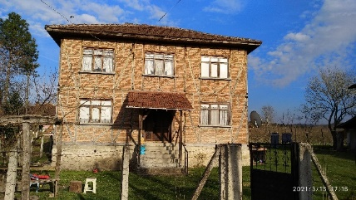 | 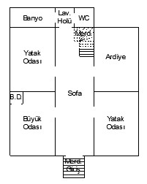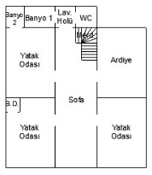  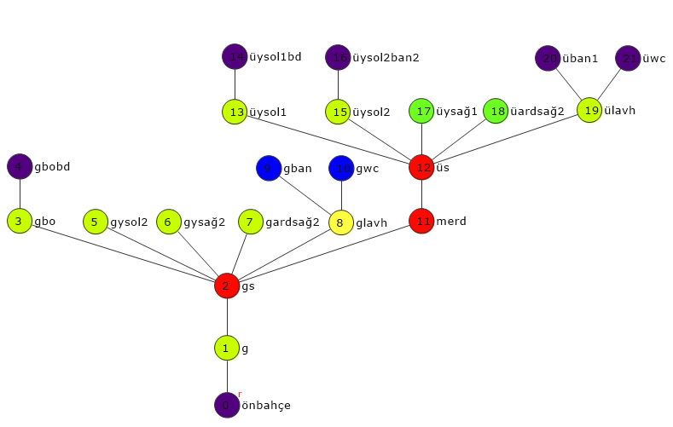  MD:3,41 | 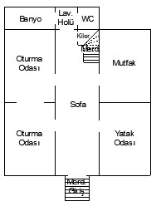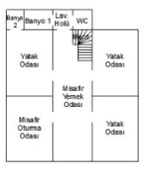  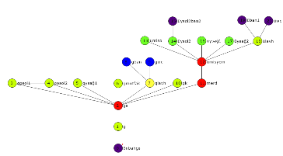  MD:3,24
2- Beçi Yörükler YÖ House  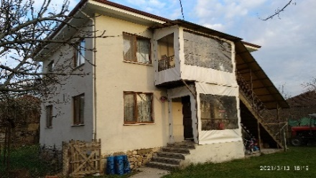 | 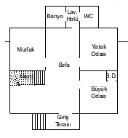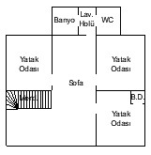  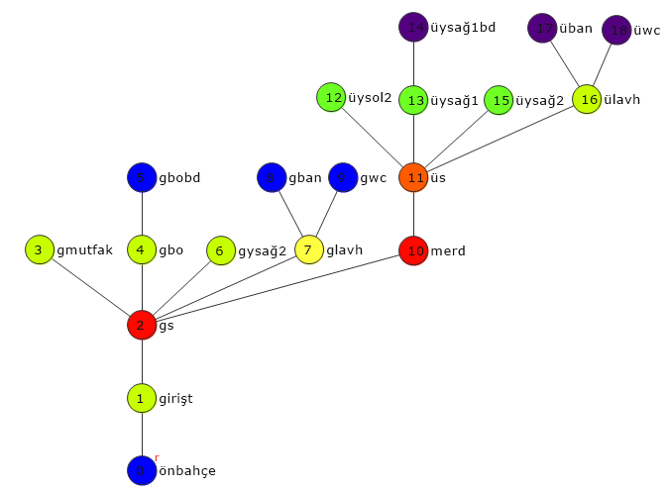  MD:3,35 | 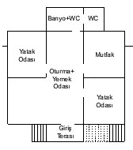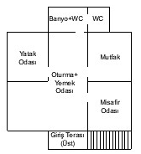  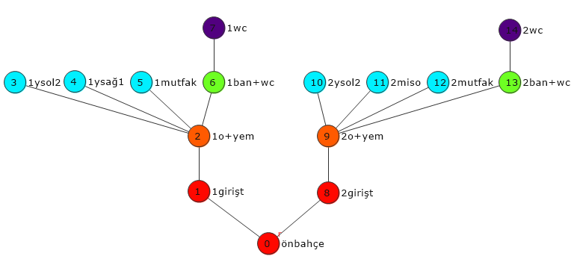  MD:3,65
3- Dadalı MB House  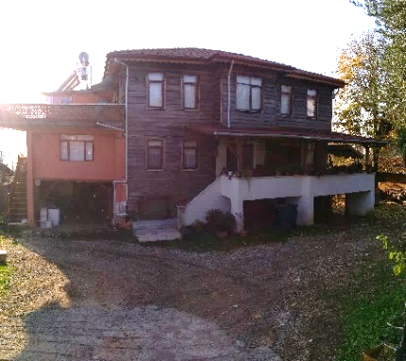 | 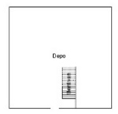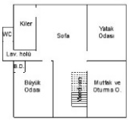  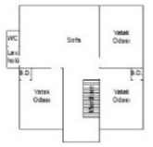  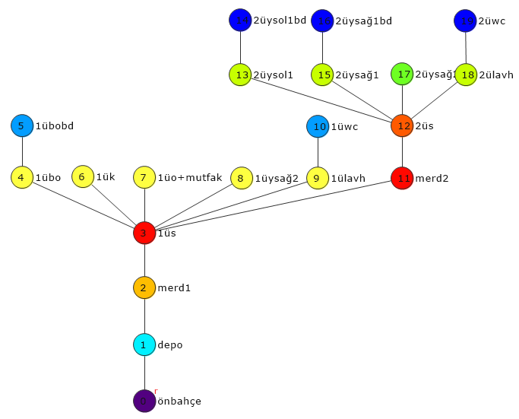  MD:3,43 | 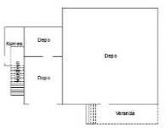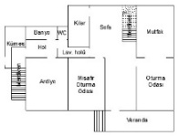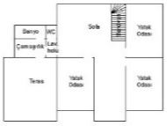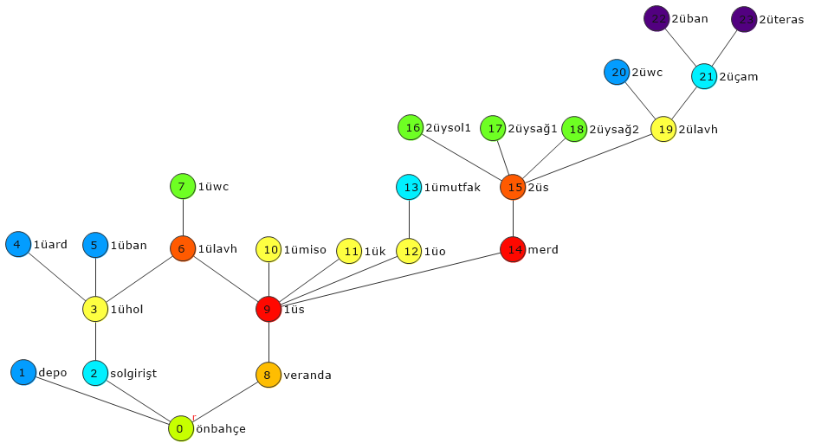  MD:3,88
4- Dadalı YB House  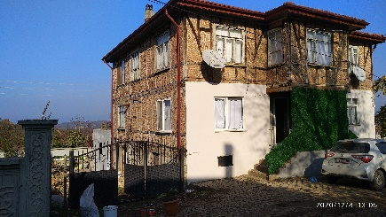 | 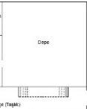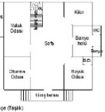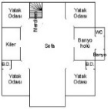  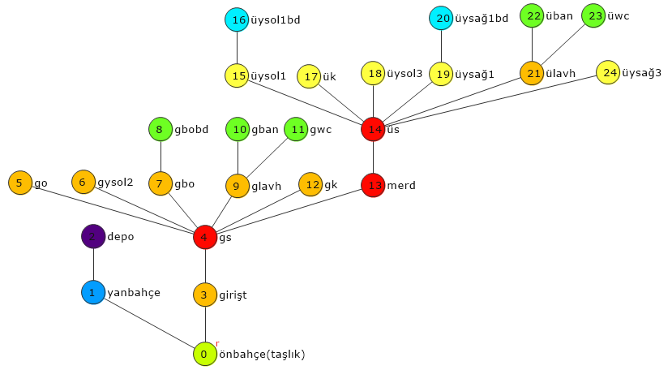 | 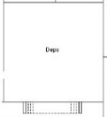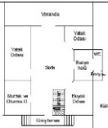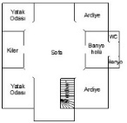  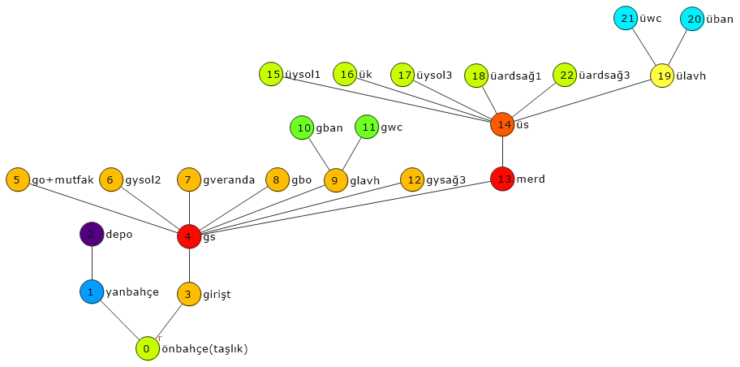  MD:3,49  MD:3,70
5- Darıyeri Mengencik NM House  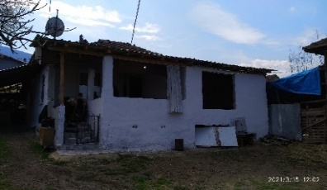 | 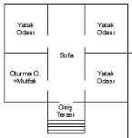  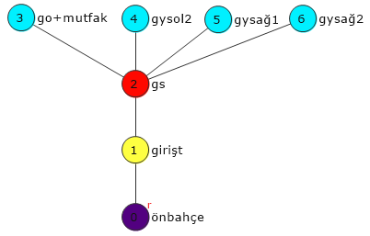 | 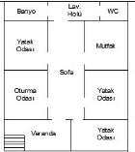  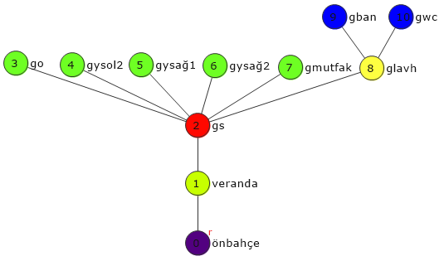  MD:2,21  MD:1,90
6- Darıyeri Mengencik ZÇ House  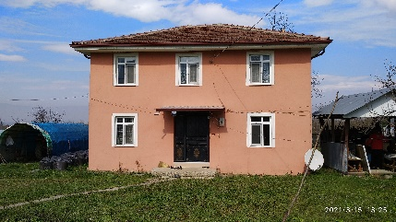 | 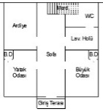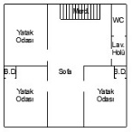  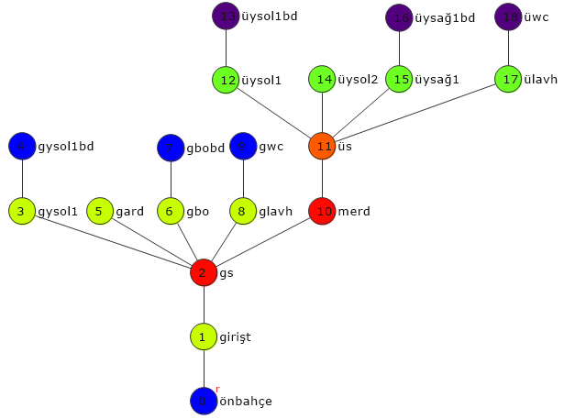  MD:3,38 | 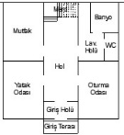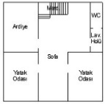  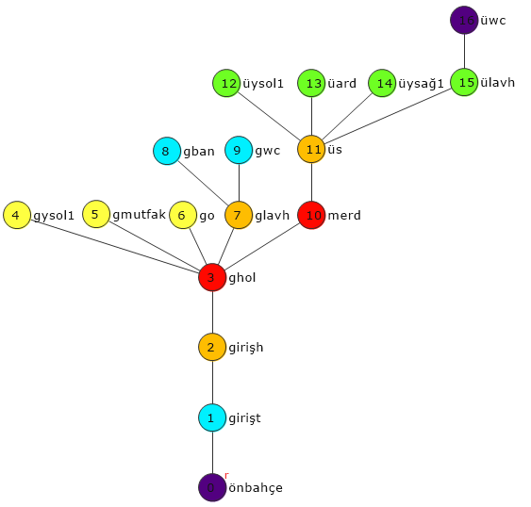  MD:3,23
7- Döngelli MA House  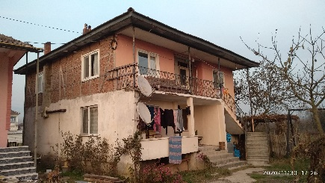 | 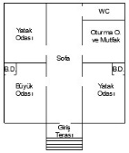  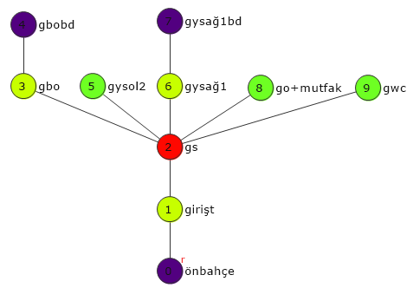  MD:2,26 | 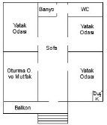  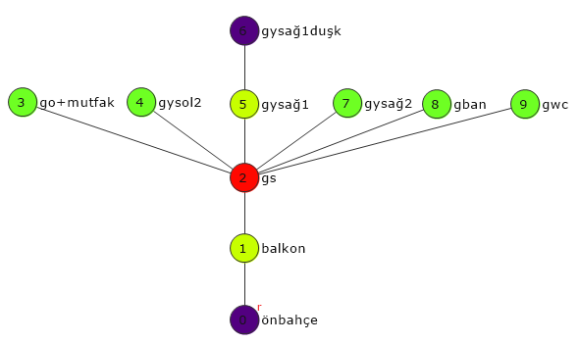  MD:2,11
8- Esentepe AY House  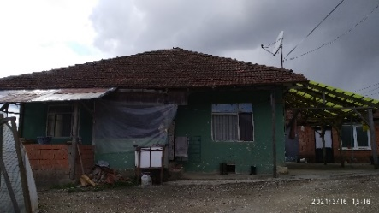 | 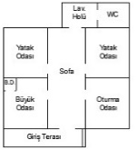  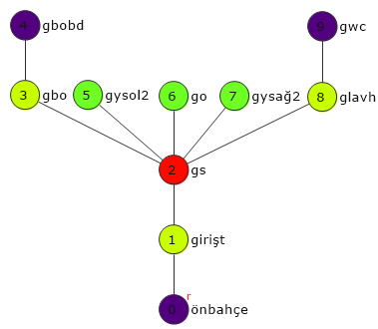  MD:2,26 | 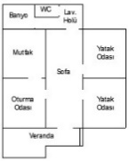  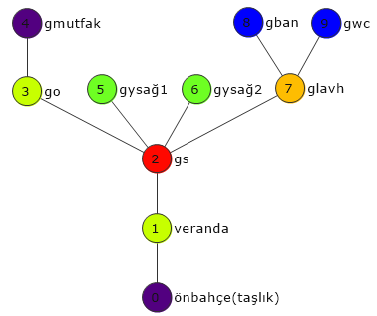  MD:2,37
9- Esentepe SY House  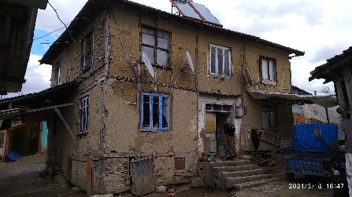 | 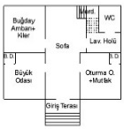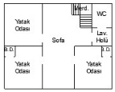  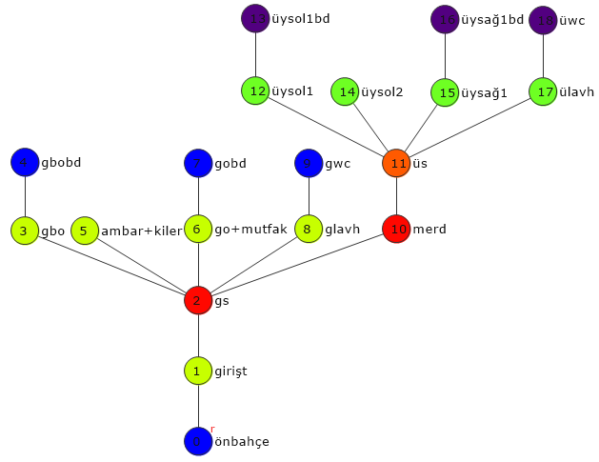  MD:3,38 | 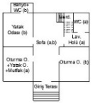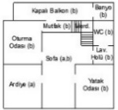  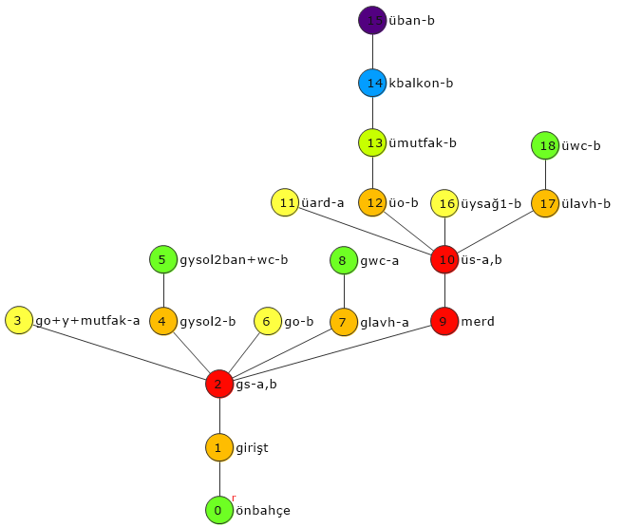  MD:3,62
10- Hacıkadirler NK House  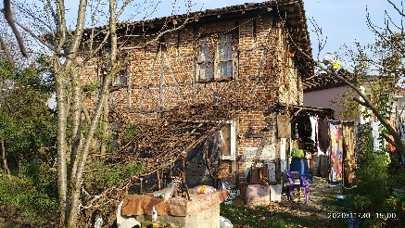 | 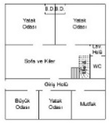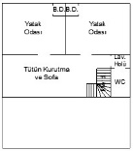  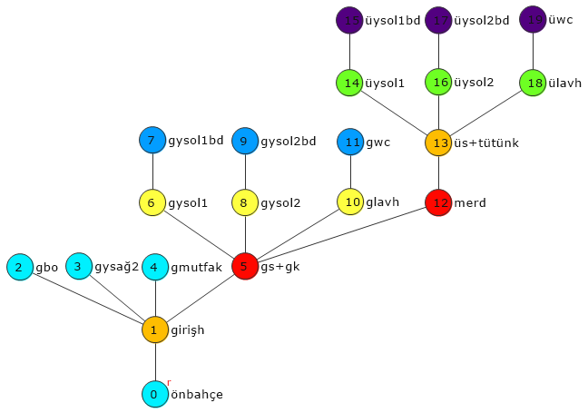  MD:3,51 | 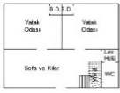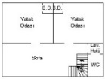  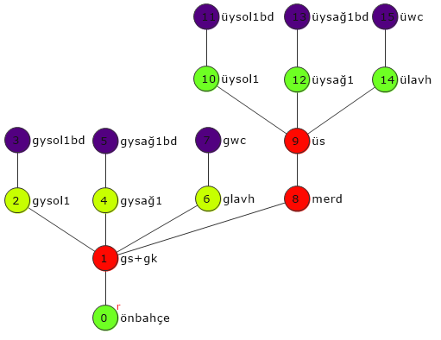  MD:3,33
11- Kemerkasım AÜ House  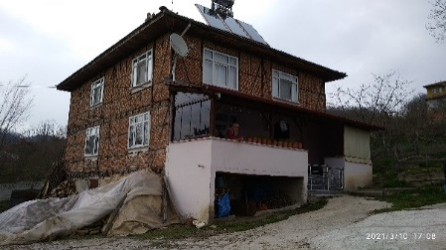 | 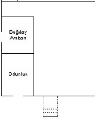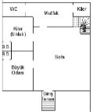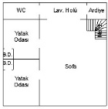  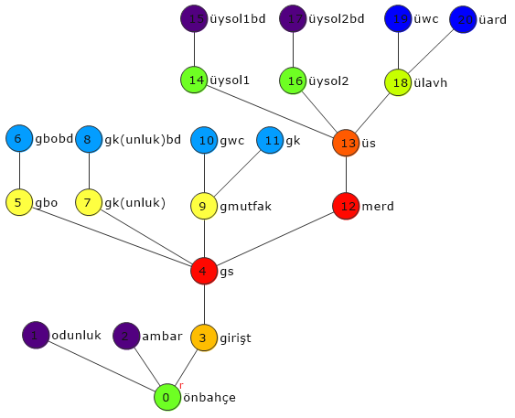  MD:3,78 | 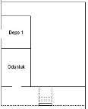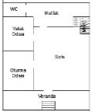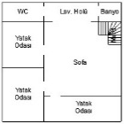  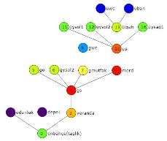  MD:3,44
12- Kemerkasım AÇ House  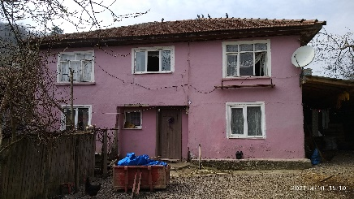 | 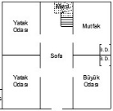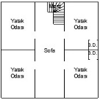  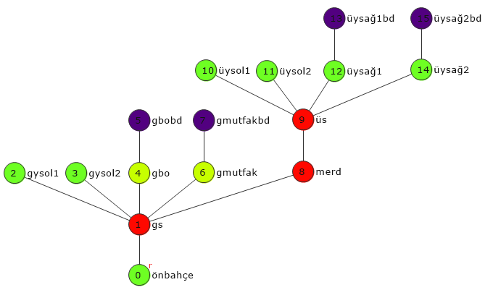  MD:3,11 | 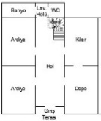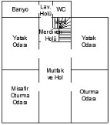  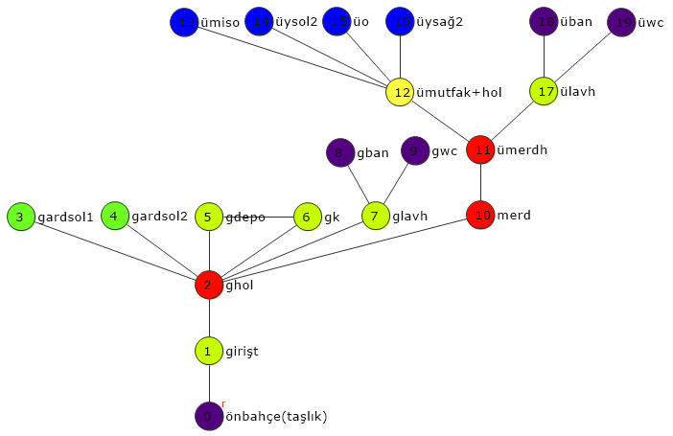  MD:3,46
13- Ketenciler BU House  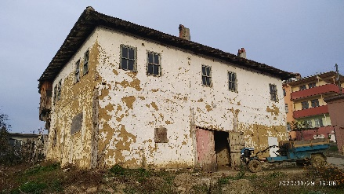 | 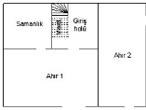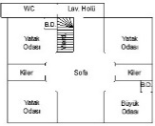  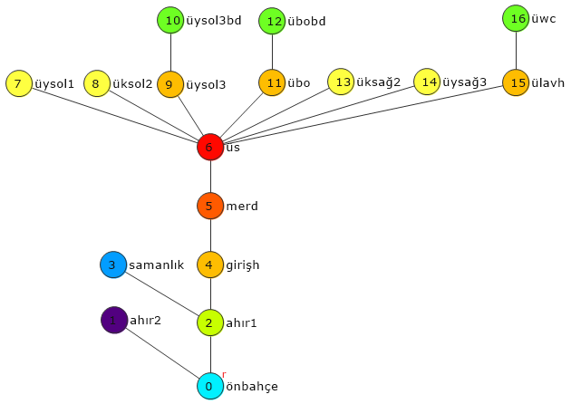 | 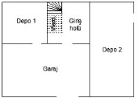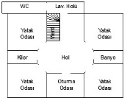  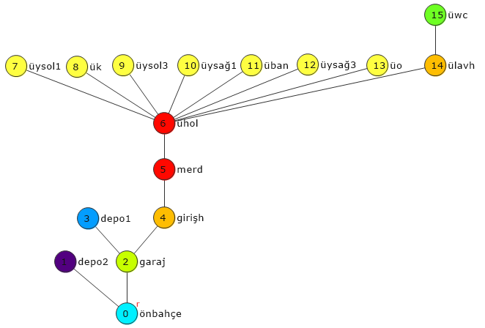  MD:3,07  MD:3,25
14- Ketenciler CS House  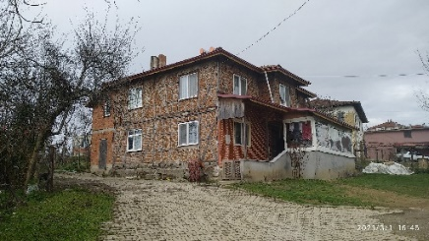 | 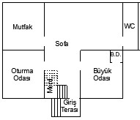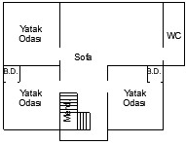  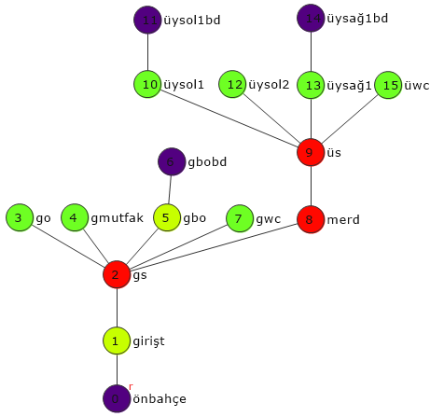  MD:3,11 | 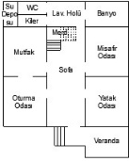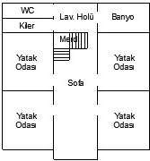  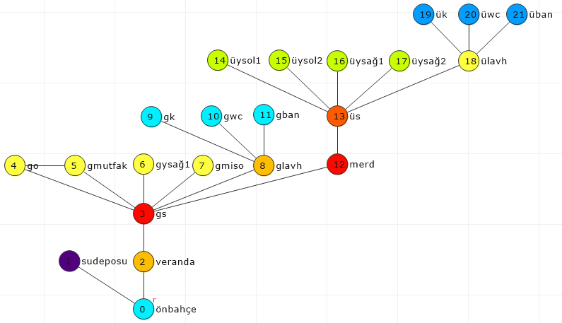  MD:3,42
15- Ketenciler OB House  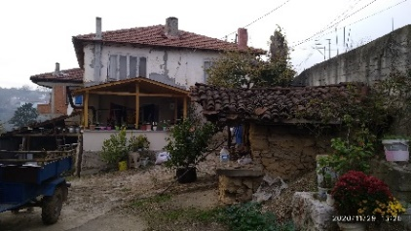 | 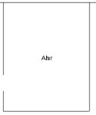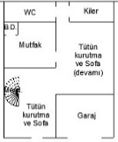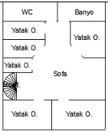  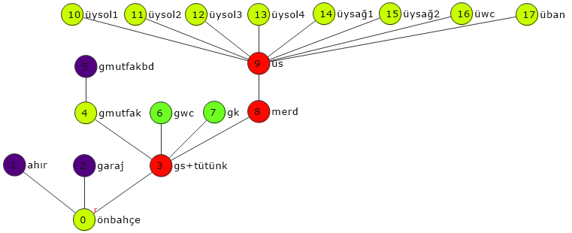  MD:3,00 | 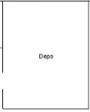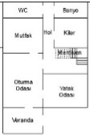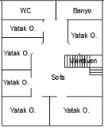  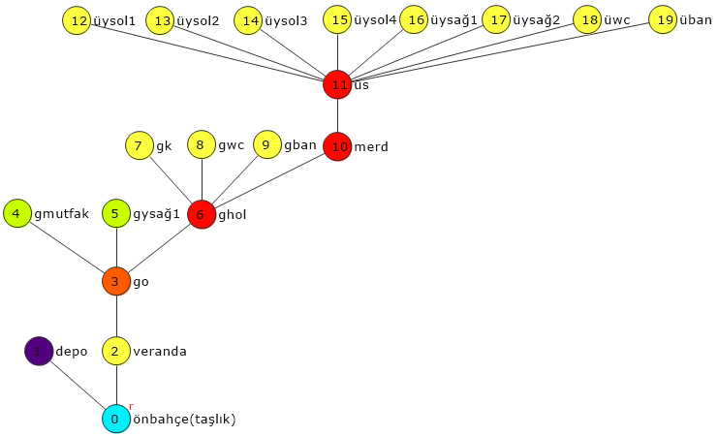  MD:3,34
16- Nasırlı HA House  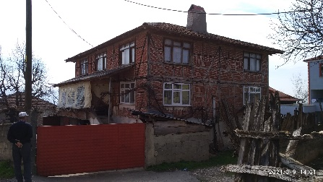 | 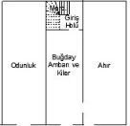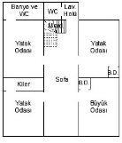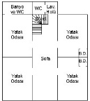  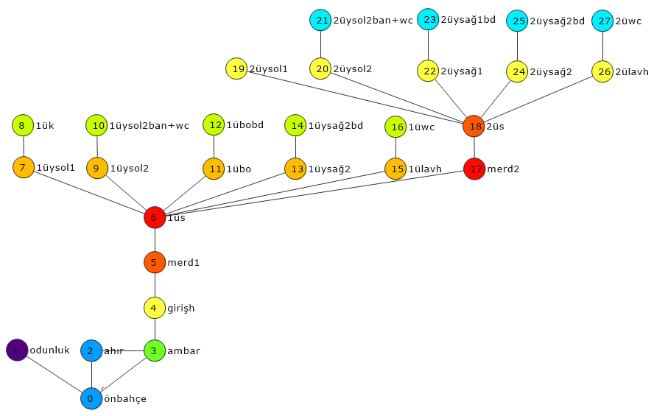  MD:4,10 | 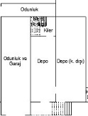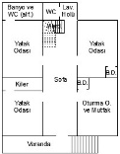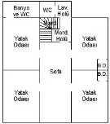  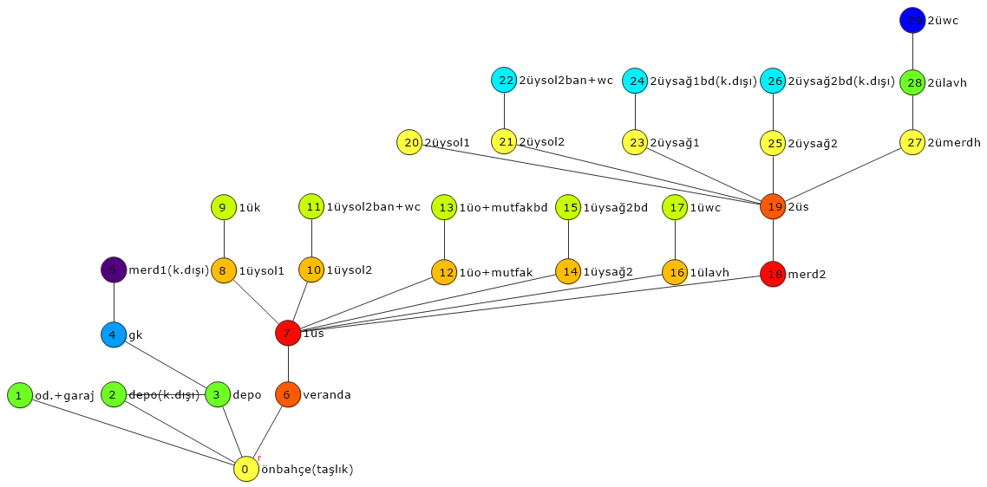  MD:4,19
17- Nasırlı HT House  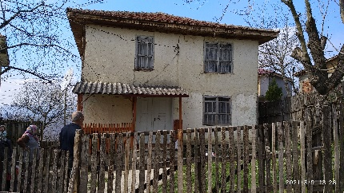 | 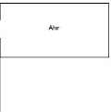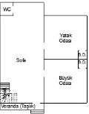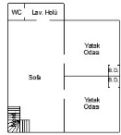  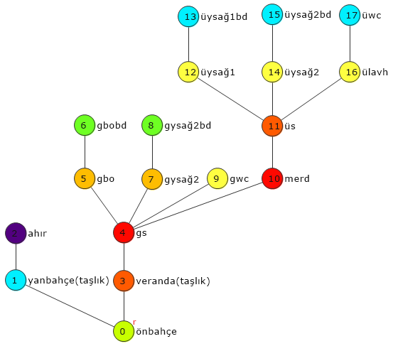  MD:3,71 | 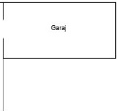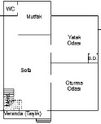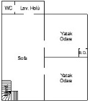  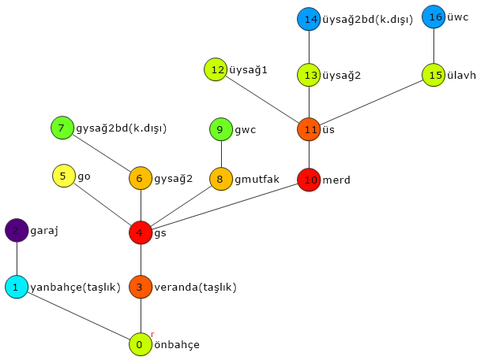  MD:3,61
18- Redifler BE House  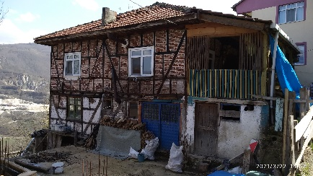 | 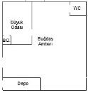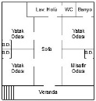  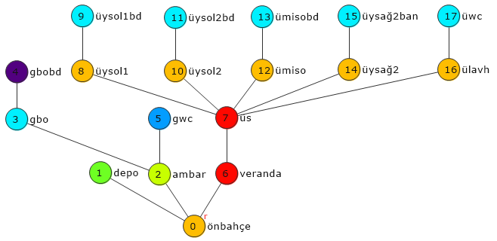  MD:3,48 | 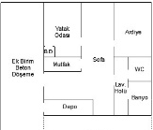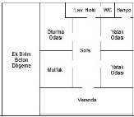  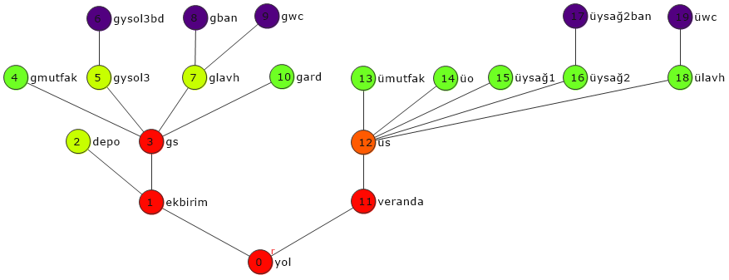  MD:3,99
19- Redifler İY House  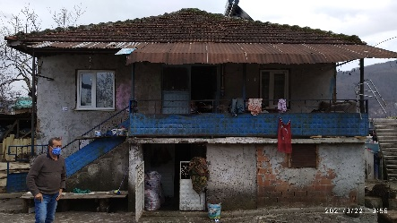 | 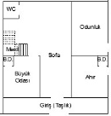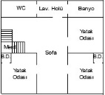  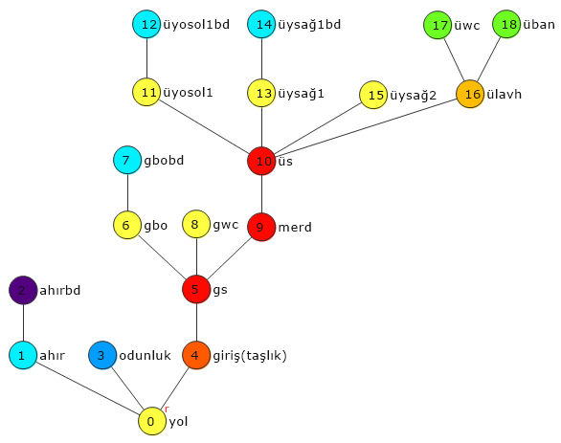  MD:3,83 | 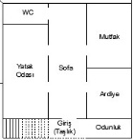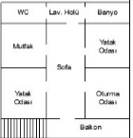  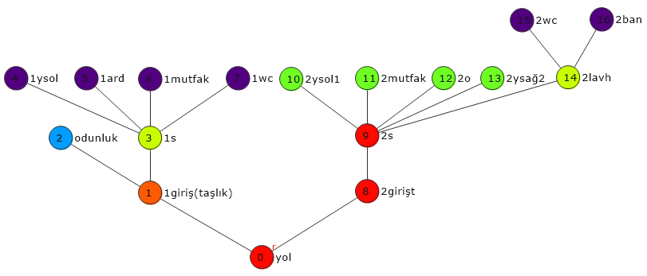  MD:3,61
20- Yukarıkaraköy SÇ House  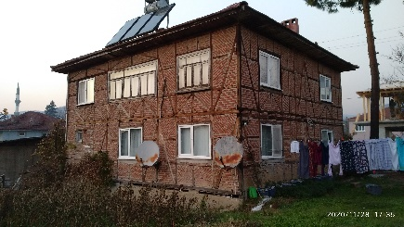 | 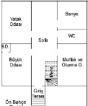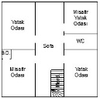  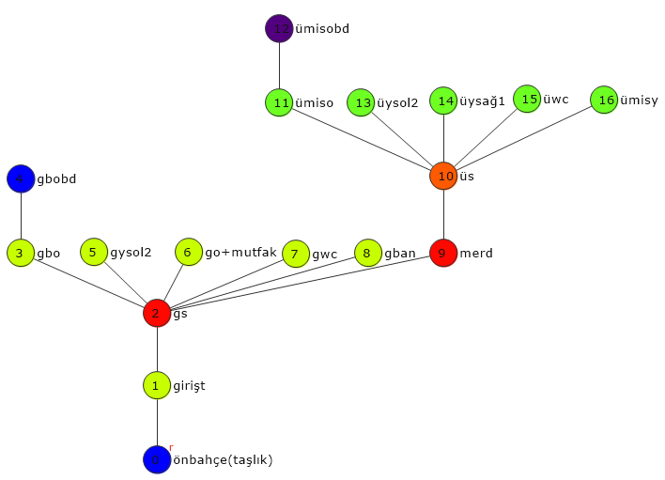 | 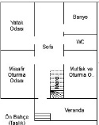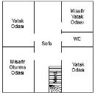  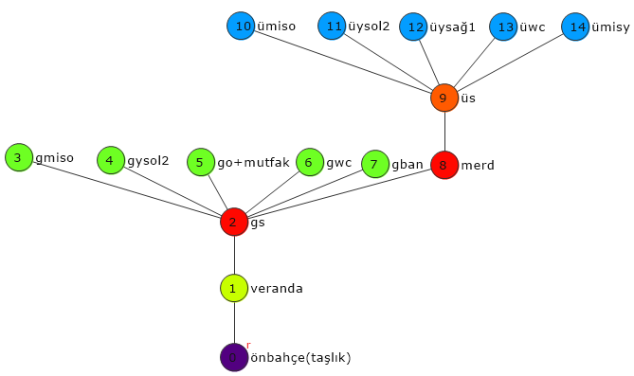  MD:3,00  MD:2,76

Supplementary Table 4: The livability level values of the houses, which are formed as a result of the simulation of all the proposed assumptions (Asm.), are given in Table IV in order to be able to be understood briefly and easily. According to Table IV, when the first assumption is applied, the livability level of all houses decreases. Compared to the year 2000, it is observed that the livability levels of 4 houses, in bold and with an asterisk, out of 18 houses (excluding 2 houses that were abandoned due to different reasons) increased with the second assumption, and in addition to this, with the third assumption, the livability levels of 3 houses increased. When viewed as a percentage, with the third assumption, it can be said that the livability of houses has increased by 39% in 2050.
Table IV: The values of the livability levels of the houses according to rate of decrease in livability level change assumptions (Comparison of 2000 and 2050)
Assumption-Year / Houses | For all assumptions  year 2000 | 1st Asm.  year 2050 | 2nd Asm.  year 2050 | 3rd Asm.  year 2050
MK House* | 47972 | 647 | 39526 | 52857*
YÖ House* | 65384 | 1443 | 60256 | 76915*
MB House | 89065 | 1108 | 64568 | 85878
YB House | 87803 | 790 | 54088 | 72957
NM House* | 43866 | 1110 | 47934* | 60886*
ZÇ House* | 37695 | 1441 | 60816* | 77601*
MA House* | 35947 | 1294 | 49859* | 62535*
AY House | 43716 | 307 | 16693 | 22447
SY House | 59190 | 187 | 17702 | 25456
NK House | 35364 | 0 (Abon.) | 0 (Abon.) | 0 (Abon.)
AÜ House* | 44248 | 27626 | 84126* | 85656*
AÇ House | 97743 | 902 | 52376 | 69625
BU House | 55839 | 0 (Abon.) | 0 (Abon.) | 0 (Abon.)
CS House | 95090 | 1465 | 65528 | 84353
OB House | 109399 | 543 | 34687 | 47752
HA House | 122770 | 306 | 49219 | 70509
HT House | 91605 | 24 | 10939 | 17136
BE House* | 57591 | 644 | 44874 | 60745*
İY House | 70969 | 782 | 40923 | 53974
SÇ House | 114352 | 1276 | 56786 | 74060

References
Batur, A. and Öymen Gür, Ş. (2005) Doğu Karadeniz’de Kırsal Mimari. İstanbul: Milli Reasürans.

For visual identification, each house has been given a resident's initials and a number respectively. The colored circles with numbers in the JPGs indicate the degrees of integration and segregation of the spaces. While the most integrated space is expressed in dark red, the most segregated space evolves from blue to purple

