Supplementary Materials

Figure S1. Example of a best-worst scaling (BWS) task asking farmers to select the most important and least important benefits potentially arising from the adoption of agroecological practices
Most important |  | Least important
 | Low costs associated with the adoption of technology
 | Reduced need for chemical fertiliser and/or pesticide/herbicide applications
 | Improved forest quality and/or coverage
 | Improved health of household members
 | Reduced need for agricultural water use
 | Improved local community ability to withstand extreme climatic shocks (droughts, floods) and pests and diseases

Figure S2. Distribution of Best-Worst (BW) scores showing that many scores are centered around zero
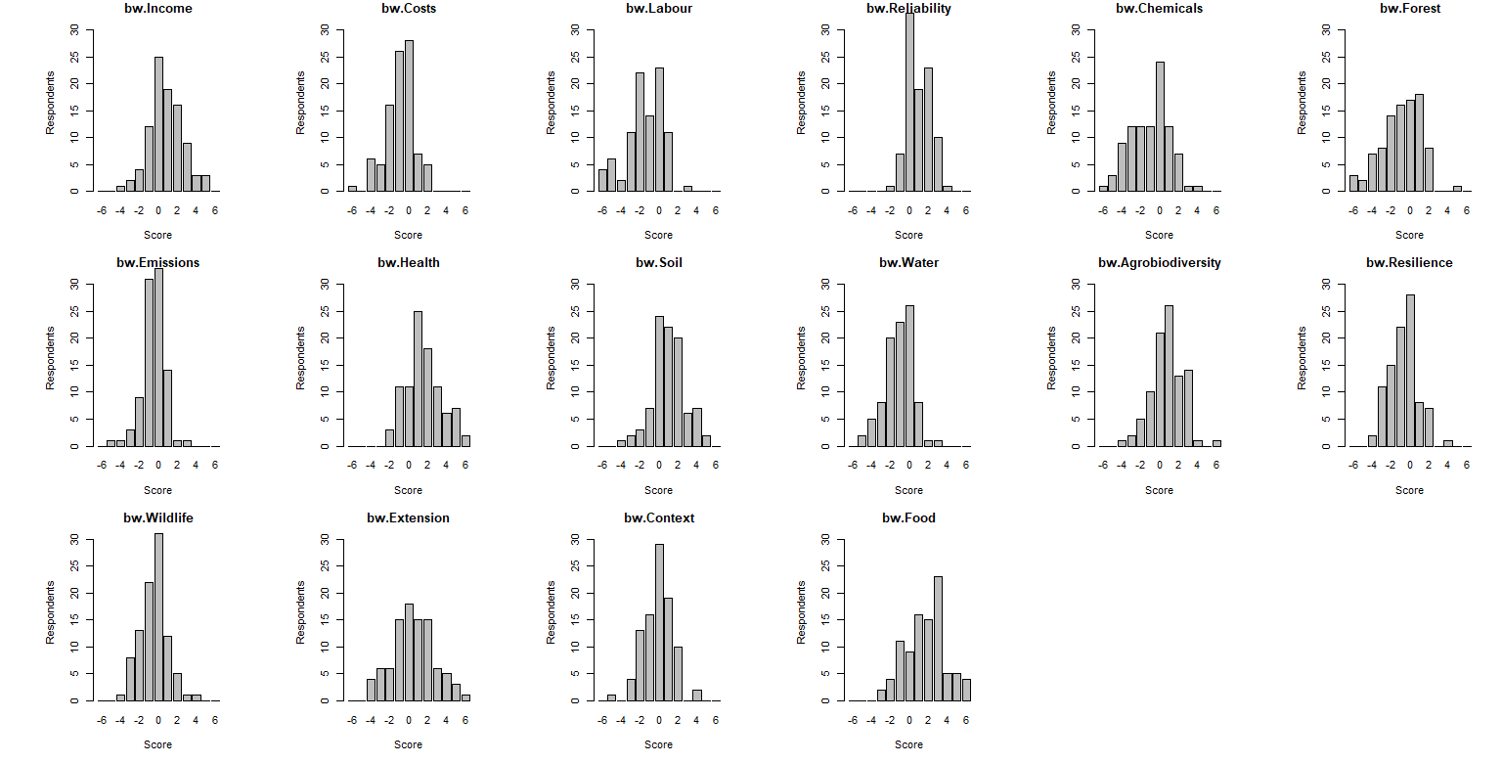

Figure S3. Differences in mean Best-Worst (BW) scores for farmers in the two research areas, Kisumu and Vihiga counties
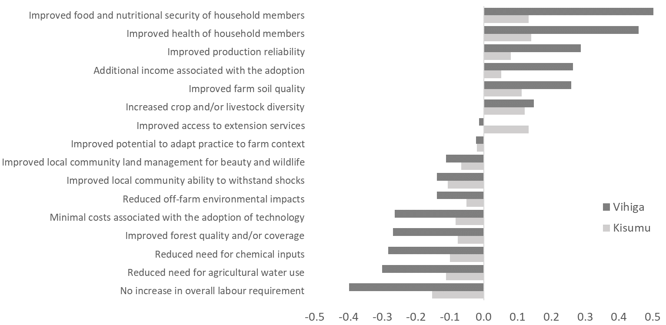

Figure S4. Differences in mean Best-Worst (BW) scores for farmers owning their own land and those not owning own land

