Managing Waste Packaging for a Sustainable Future:

a Strategic and Efficiency Analysis in the European Context

SUPPLEMENTARY MATERIAL

This supplementary material consists of twenty-eight tables and two figures.

Table A1. Numerical rating
Numerical rating | Verbal judgements of preferences
1 | Equally preferred
2 | Equally to moderately
3 | Moderately preferred
4 | Moderately to strongly
5 | Strongly preferred
6 | Strongly to very strongly
7 | Very strongly preferred
8 | Very strongly to extremely
9 | Extremely preferred

Table A2. List of experts
Number | Role | Country | Years of experience
EA1 | Professor | Spain | 16
EA2 | Professor | France | 15
EA3 | Professor | Germany | 18
EA4 | Professor | Italy | 14
EA5 | Professor | Greece | 12
EI6 | Utilities manager | Italy | 11
EI7 | Production line manager | Italy | 12
EI8 | Process manager | Italy | 16
EI9 | Process manager | Italy | 12
EI10 | Production line manager | Italy | 15

Tabella A3. Convexity and Return to Scale test results for the models.
Models | Convexity |  | Return to Scale
 | τ | p-value | τ | p-value
Sustainable Recycled | -0,932 | 0,824 | 4,143 | 0,000
Technical Recycled | -0,465 | 0,679 | -1,249 | 0,894
Sustainable Recovered | -1,849 | 0,968 | -0,296 | 0,616
Technical Recovered | -0,842 | 0,800 | -1,128 | 0,870

Table A4. Pairwise comparison - EA1
 | C1 | C2 | C3 | C4 | C5 | C6 | C7 | C8 | C9
C1 | 1 | 4 | 0.5 | 4 | 2 | 0.5 | 4 | 4 | 4
C2 | 0.25 | 1 | 0.2 | 0.5 | 0.5 | 0.2 | 2 | 0.333333 | 0.5
C3 | 2 | 5 | 1 | 5 | 2 | 0.5 | 5 | 5 | 5
C4 | 0.25 | 2 | 0.2 | 1 | 0.5 | 0.2 | 2 | 0.333333 | 2
C5 | 0.5 | 2 | 0.5 | 2 | 1 | 0.333333 | 2 | 0.333333 | 2
C6 | 2 | 5 | 2 | 5 | 3 | 1 | 5 | 5 | 5
C7 | 0.25 | 0.5 | 0.2 | 0.5 | 0.5 | 0.2 | 1 | 0.333333 | 0.5
C8 | 0.25 | 3 | 0.2 | 3 | 3 | 0.2 | 3 | 1 | 3
C9 | 0.25 | 2 | 0.2 | 0.5 | 0.5 | 0.2 | 2 | 0.333333 | 1

Table A5. Pairwise comparison – EA2
 | C1 | C2 | C3 | C4 | C5 | C6 | C7 | C8 | C9
C1 | 1 | 2 | 0.5 | 2 | 0.5 | 0.5 | 2 | 0.5 | 2
C2 | 0.5 | 1 | 0.5 | 2 | 0.5 | 0.5 | 2 | 2 | 2
C3 | 2 | 2 | 1 | 2 | 2 | 2 | 2 | 2 | 2
C4 | 0.5 | 0.5 | 0.5 | 1 | 0.5 | 0.5 | 2 | 0.5 | 0.5
C5 | 2 | 2 | 0.5 | 2 | 1 | 2 | 2 | 2 | 2
C6 | 2 | 2 | 0.5 | 2 | 0.5 | 1 | 2 | 2 | 2
C7 | 0.5 | 0.5 | 0.5 | 0.5 | 0.5 | 0.5 | 1 | 0.5 | 0.5
C8 | 2 | 0.5 | 0.5 | 2 | 0.5 | 0.5 | 2 | 1 | 2
C9 | 0.5 | 0.5 | 0.5 | 2 | 0.5 | 0.5 | 2 | 0.5 | 1

Table A6. Pairwise comparison – EA3
 | C1 | C2 | C3 | C4 | C5 | C6 | C7 | C8 | C9
C1 | 1 | 4 | 2 | 4 | 4 | 2 | 4 | 4 | 4
C2 | 0.25 | 1 | 0.25 | 0.5 | 0.333333 | 0.25 | 2 | 0.5 | 0.5
C3 | 0.5 | 4 | 1 | 4 | 4 | 0.5 | 4 | 4 | 4
C4 | 0.25 | 2 | 0.25 | 1 | 0.333333 | 0.25 | 2 | 0.5 | 2
C5 | 0.25 | 3 | 0.25 | 3 | 1 | 0.25 | 3 | 3 | 3
C6 | 0.5 | 4 | 2 | 4 | 4 | 1 | 4 | 4 | 4
C7 | 0.25 | 0.5 | 0.25 | 0.5 | 0.333333 | 0.25 | 1 | 0.5 | 0.5
C8 | 0.25 | 2 | 0.25 | 2 | 0.333333 | 0.25 | 2 | 1 | 4
C9 | 0.25 | 2 | 0.25 | 0.5 | 0.333333 | 0.25 | 2 | 0.25 | 1

Table A7. Pairwise comparison – EA4
 | C1 | C2 | C3 | C4 | C5 | C6 | C7 | C8 | C9
C1 | 1 | 2 | 0.25 | 0.25 | 0.2 | 0.25 | 2 | 2 | 2
C2 | 0.5 | 1 | 0.25 | 0.25 | 0.2 | 0.25 | 2 | 0.5 | 2
C3 | 4 | 4 | 1 | 0.5 | 0.5 | 0.5 | 4 | 4 | 4
C4 | 4 | 4 | 2 | 1 | 0.5 | 4 | 4 | 4 | 4
C5 | 5 | 5 | 2 | 2 | 1 | 5 | 5 | 5 | 5
C6 | 4 | 4 | 2 | 0.25 | 0.2 | 1 | 4 | 4 | 4
C7 | 0.5 | 0.5 | 0.25 | 0.25 | 0.2 | 0.25 | 1 | 0.5 | 0.5
C8 | 0.5 | 2 | 0.25 | 0.25 | 0.2 | 0.25 | 2 | 1 | 2
C9 | 0.5 | 0.5 | 0.25 | 0.25 | 0.2 | 0.25 | 2 | 0.5 | 1

Table A8. Pairwise comparison – EA5
 | C1 | C2 | C3 | C4 | C5 | C6 | C7 | C8 | C9
C1 | 1 | 2 | 0.5 | 2 | 0.5 | 2 | 2 | 2 | 2
C2 | 0.5 | 1 | 0.25 | 0.5 | 0.5 | 0.5 | 2 | 2 | 0.5
C3 | 2 | 4 | 1 | 2 | 4 | 2 | 4 | 4 | 4
C4 | 0.5 | 2 | 0.5 | 1 | 0.5 | 0.5 | 2 | 2 | 2
C5 | 2 | 2 | 0.25 | 2 | 1 | 0.5 | 2 | 2 | 2
C6 | 0.5 | 2 | 0.5 | 2 | 2 | 1 | 2 | 2 | 2
C7 | 0.5 | 0.5 | 0.25 | 0.5 | 0.5 | 0.5 | 1 | 0.5 | 0.5
C8 | 0.5 | 0.5 | 0.25 | 0.5 | 0.5 | 0.5 | 2 | 1 | 0.5
C9 | 0.5 | 2 | 0.25 | 0.5 | 0.5 | 0.5 | 2 | 2 | 1

Table A9. Pairwise comparison – EI6
 | C1 | C2 | C3 | C4 | C5 | C6 | C7 | C8 | C9
C1 | 1 | 3 | 2 | 2 | 3 | 2 | 3 | 3 | 3
C2 | 0.333333 | 1 | 2 | 2 | 0.5 | 0.5 | 0.5 | 2 | 0.5
C3 | 0.5 | 0.5 | 1 | 2 | 3 | 2 | 3 | 3 | 3
C4 | 0.5 | 0.5 | 0.5 | 1 | 3 | 2 | 3 | 3 | 3
C5 | 0.333333 | 2 | 0.333333 | 0.333333 | 1 | 0.5 | 0.5 | 2 | 0.5
C6 | 0.5 | 2 | 0.5 | 0.5 | 2 | 1 | 2 | 2 | 2
C7 | 0.333333 | 2 | 0.333333 | 0.333333 | 2 | 0.5 | 1 | 2 | 0.5
C8 | 0.333333 | 0.5 | 0.333333 | 0.333333 | 0.5 | 0.5 | 0.5 | 1 | 0.5
C9 | 0.333333 | 2 | 0.333333 | 0.333333 | 2 | 0.5 | 2 | 2 | 1

Table A10. Pairwise comparison – EI7
 | C1 | C2 | C3 | C4 | C5 | C6 | C7 | C8 | C9
C1 | 1 | 4 | 4 | 4 | 2 | 2 | 4 | 0.5 | 4
C2 | 0.25 | 1 | 0.5 | 0.33333 | 0.25 | 0.25 | 0.5 | 0.25 | 0.25
C3 | 0.25 | 2 | 1 | 0.5 | 0.25 | 0.25 | 0.5 | 0.25 | 0.25
C4 | 0.25 | 3 | 2 | 1 | 0.25 | 0.25 | 0.5 | 0.25 | 0.25
C5 | 0.5 | 4 | 4 | 4 | 1 | 2 | 4 | 0.5 | 4
C6 | 0.5 | 4 | 4 | 4 | 0.5 | 1 | 3 | 0.33333 | 2
C7 | 0.25 | 2 | 2 | 2 | 0.25 | 0.33333 | 1 | 0.25 | 0.5
C8 | 2 | 4 | 4 | 4 | 2 | 3 | 4 | 1 | 4
C9 | 0.25 | 4 | 4 | 4 | 0.25 | 0.5 | 2 | 0.25 | 1

Table A11. Pairwise comparison – EI8
Ind.8 | C1 | C2 | C3 | C4 | C5 | C6 | C7 | C8 | C9
C1 | 1 | 4 | 0.2 | 4 | 2 | 2 | 4 | 4 | 4
C2 | 0.25 | 1 | 0.333333 | 2 | 0.25 | 0.25 | 2 | 2 | 2
C3 | 5 | 3 | 1 | 5 | 3 | 3 | 5 | 5 | 5
C4 | 0.25 | 0.5 | 0.2 | 1 | 0.25 | 0.25 | 2 | 2 | 2
C5 | 0.5 | 4 | 0.333333 | 4 | 1 | 0.5 | 4 | 4 | 4
C6 | 0.5 | 4 | 0.333333 | 4 | 2 | 1 | 4 | 4 | 4
C7 | 0.25 | 0.5 | 0.2 | 0.5 | 0.25 | 0.25 | 1 | 0.5 | 0.5
C8 | 0.25 | 0.5 | 0.2 | 0.5 | 0.25 | 0.25 | 2 | 1 | 2
C9 | 0.25 | 0.5 | 0.2 | 0.5 | 0.25 | 0.25 | 2 | 0.5 | 1

Table A12. Pairwise comparison – EI9
 | C1 | C2 | C3 | C4 | C5 | C6 | C7 | C8 | C9
C1 | 1 | 0,5 | 0,25 | 0,25 | 0,25 | 0,25 | 0,25 | 0,25 | 0,5
C2 | 2 | 1 | 0,25 | 0,25 | 0,25 | 0,25 | 0,25 | 0,25 | 0,333333
C3 | 4 | 4 | 1 | 4 | 2 | 4 | 2 | 3 | 4
C4 | 4 | 4 | 0,25 | 1 | 0,5 | 0,5 | 0,333333 | 0,5 | 2
C5 | 4 | 4 | 0,5 | 2 | 1 | 2 | 2 | 2 | 3
C6 | 4 | 4 | 0,25 | 2 | 0,5 | 1 | 0,5 | 2 | 4
C7 | 4 | 4 | 0,5 | 3 | 0,5 | 2 | 1 | 2 | 4
C8 | 4 | 4 | 0,33 | 2 | 0,5 | 0,5 | 0,5 | 1 | 3
C9 | 2 | 3 | 0,25 | 0,5 | 0,33 | 0,25 | 0,25 | 0,33 | 1

Table A13. Pairwise comparison – EI10
 | C1 | C2 | C3 | C4 | C5 | C6 | C7 | C8 | C9
C1 | 1 | 0.25 | 0.5 | 0.25 | 0.25 | 0.5 | 0.25 | 0.25 | 0.25
C2 | 4 | 1 | 4 | 0.25 | 0.25 | 0.5 | 0.25 | 0.25 | 0.25
C3 | 2 | 0.25 | 1 | 0.25 | 0.25 | 0.5 | 0.25 | 0.25 | 0.25
C4 | 4 | 4 | 4 | 1 | 0.5 | 4 | 0.5 | 0.333333 | 0.5
C5 | 4 | 4 | 4 | 2 | 1 | 4 | 2 | 0.5 | 2
C6 | 2 | 2 | 2 | 0.25 | 0.25 | 1 | 0.25 | 0.25 | 0.25
C7 | 4 | 4 | 4 | 2 | 0.5 | 4 | 1 | 0.5 | 0.5
C8 | 4 | 4 | 4 | 3 | 2 | 4 | 2 | 1 | 0.5
C9 | 4 | 4 | 4 | 2 | 0.5 | 4 | 2 | 2 | 1

Table A14. Ranking of expert criteria
Criteria | Total experts | Criteria | Academic experts | Criteria | Industrial experts
C3 | 0.177 | C3 | 0.197 | C3 | 0.156
C5 | 0.147 | C6 | 0.177 | C5 | 0.144
C6 | 0.145 | C5 | 0.149 | C1 | 0.129
C1 | 0.136 | C1 | 0.142 | C8 | 0.126
C8 | 0.103 | C4 | 0.096 | C6 | 0.113
C4 | 0.091 | C8 | 0.079 | C9 | 0.095
C9 | 0.076 | C2 | 0.060 | C7 | 0.089
C7 | 0.065 | C9 | 0.058 | C4 | 0.086
C2 | 0.060 | C7 | 0.041 | C2 | 0.061

Table A15. Assignment of values – EA1
 | A1 | A2 | A3 | A4 | A5 | A6 | A7 | A8
C1 | 10 | 10 | 9 | 9 | 9 | 9 | 10 | 2
C2 | 10 | 10 | 9 | 9 | 9 | 8 | 9 | 2
C3 | 8 | 10 | 9 | 9 | 10 | 9 | 10 | 2
C4 | 8 | 10 | 9 | 9 | 10 | 9 | 10 | 2
C5 | 8 | 10 | 9 | 9 | 9 | 9 | 9 | 2
C6 | 10 | 10 | 9 | 9 | 10 | 9 | 9 | 2
C7 | 8 | 10 | 9 | 9 | 10 | 10 | 10 | 2
C8 | 9 | 9 | 9 | 8 | 10 | 9 | 10 | 2
C9 | 9 | 9 | 9 | 10 | 10 | 10 | 10 | 2

Table A16. Assignment of values – EA2
 | A1 | A2 | A3 | A4 | A5 | A6 | A7 | A8
C1 | 7 | 8 | 6 | 6 | 7 | 6 | 8 | 2
C2 | 6 | 8 | 6 | 6 | 7 | 5 | 8 | 2
C3 | 6 | 8 | 6 | 6 | 8 | 6 | 8 | 2
C4 | 7 | 8 | 6 | 6 | 8 | 6 | 8 | 2
C5 | 7 | 8 | 6 | 6 | 7 | 6 | 8 | 2
C6 | 7 | 8 | 7 | 6 | 7 | 5 | 8 | 2
C7 | 7 | 7 | 6 | 6 | 8 | 6 | 8 | 2
C8 | 7 | 8 | 7 | 6 | 8 | 5 | 9 | 2
C9 | 7 | 7 | 6 | 6 | 7 | 6 | 8 | 2

Table A17. Assignment of values – EA3
 | A1 | A2 | A3 | A4 | A5 | A6 | A7 | A8
C1 | 7 | 9 | 8 | 7 | 8 | 6 | 8 | 1
C2 | 7 | 9 | 8 | 7 | 8 | 6 | 8 | 1
C3 | 7 | 9 | 8 | 7 | 9 | 6 | 8 | 1
C4 | 6 | 9 | 8 | 7 | 9 | 6 | 8 | 1
C5 | 6 | 9 | 8 | 7 | 9 | 6 | 8 | 1
C6 | 7 | 9 | 8 | 7 | 9 | 6 | 8 | 1
C7 | 7 | 8 | 7 | 7 | 9 | 6 | 8 | 1
C8 | 7 | 8 | 7 | 6 | 9 | 6 | 10 | 1
C9 | 6 | 8 | 7 | 7 | 9 | 6 | 8 | 1

Table A18. Assignment of values – EA4
 | A1 | A2 | A3 | A4 | A5 | A6 | A7 | A8
C1 | 10 | 10 | 9 | 8 | 9 | 7 | 7 | 1
C2 | 8 | 8 | 8 | 6 | 8 | 8 | 8 | 1
C3 | 10 | 10 | 9 | 9 | 10 | 7 | 10 | 1
C4 | 9 | 9 | 9 | 9 | 9 | 8 | 9 | 1
C5 | 8 | 9 | 9 | 8 | 8 | 7 | 7 | 1
C6 | 10 | 10 | 10 | 8 | 8 | 6 | 8 | 1
C7 | 9 | 9 | 9 | 8 | 9 | 8 | 8 | 1
C8 | 8 | 8 | 7 | 6 | 9 | 6 | 9 | 1
C9 | 9 | 8 | 8 | 9 | 8 | 9 | 8 | 1

Table A19. Assignment of values – EA5
 | A1 | A2 | A3 | A4 | A5 | A6 | A7 | A8
C1 | 8 | 9 | 9 | 7 | 9 | 9 | 8 | 2
C2 | 9 | 9 | 9 | 7 | 9 | 7 | 8 | 2
C3 | 8 | 9 | 8 | 7 | 10 | 7 | 9 | 1
C4 | 8 | 9 | 8 | 7 | 10 | 7 | 9 | 1
C5 | 8 | 9 | 8 | 7 | 9 | 7 | 8 | 2
C6 | 8 | 10 | 9 | 7 | 9 | 7 | 8 | 2
C7 | 8 | 9 | 8 | 7 | 9 | 7 | 8 | 2
C8 | 7 | 9 | 8 | 7 | 10 | 7 | 9 | 1
C9 | 9 | 9 | 8 | 9 | 9 | 9 | 9 | 2

Table A20. Assignment of values – EI6
 | A1 | A2 | A3 | A4 | A5 | A6 | A7 | A8
C1 | 10 | 2 | 2 | 1 | 1 | 2 | 3 | 1
C2 | 7 | 10 | 7 | 2 | 8 | 5 | 6 | 10
C3 | 9 | 8 | 6 | 7 | 8 | 8 | 9 | 1
C4 | 9 | 9 | 8 | 7 | 7 | 6 | 10 | 1
C5 | 7 | 7 | 6 | 4 | 6 | 8 | 3 | 3
C6 | 9 | 9 | 7 | 7 | 3 | 5 | 5 | 5
C7 | 8 | 6 | 7 | 9 | 3 | 10 | 5 | 1
C8 | 5 | 6 | 5 | 5 | 10 | 7 | 5 | 1
C9 | 9 | 7 | 5 | 8 | 7 | 8 | 1 | 1

Table A21. Assignment of values – EI7
 | A1 | A2 | A3 | A4 | A5 | A6 | A7 | A8
C1 | 10 | 7 | 9 | 7 | 7 | 7 | 7 | 1
C2 | 10 | 8 | 9 | 7 | 7 | 7 | 7 | 1
C3 | 9 | 8 | 8 | 8 | 10 | 8 | 9 | 1
C4 | 10 | 8 | 9 | 9 | 10 | 8 | 10 | 1
C5 | 10 | 7 | 9 | 9 | 10 | 9 | 9 | 1
C6 | 10 | 7 | 9 | 7 | 8 | 8 | 7 | 1
C7 | 9 | 9 | 9 | 10 | 9 | 10 | 8 | 1
C8 | 9 | 7 | 9 | 8 | 10 | 8 | 8 | 1
C9 | 9 | 9 | 9 | 8 | 7 | 10 | 8 | 1

Table A22. Assignment of values – EI8
 | A1 | A2 | A3 | A4 | A5 | A6 | A7 | A8
C1 | 6 | 9 | 7 | 9 | 8 | 7 | 8 | 1
C2 | 6 | 10 | 7 | 8 | 9 | 7 | 6 | 1
C3 | 6 | 10 | 8 | 9 | 10 | 6 | 10 | 1
C4 | 6 | 10 | 8 | 8 | 10 | 7 | 9 | 1
C5 | 6 | 10 | 8 | 9 | 10 | 8 | 6 | 1
C6 | 6 | 10 | 8 | 8 | 10 | 6 | 6 | 1
C7 | 6 | 9 | 7 | 8 | 10 | 7 | 6 | 1
C8 | 6 | 10 | 8 | 8 | 10 | 5 | 7 | 1
C9 | 6 | 9 | 8 | 8 | 9 | 10 | 9 | 1

Table A23. Assignment of values – EI9
 | A1 | A2 | A3 | A4 | A5 | A6 | A7 | A8
C1 | 10 | 9 | 7 | 1 | 1 | 1 | 8 | 1
C2 | 1 | 9 | 8 | 6 | 1 | 1 | 1 | 1
C3 | 8 | 10 | 8 | 9 | 10 | 5 | 9 | 1
C4 | 8 | 8 | 8 | 7 | 10 | 1 | 9 | 1
C5 | 8 | 9 | 9 | 1 | 1 | 8 | 8 | 9
C6 | 8 | 9 | 9 | 1 | 1 | 1 | 7 | 9
C7 | 9 | 9 | 9 | 10 | 1 | 1 | 8 | 1
C8 | 1 | 9 | 9 | 1 | 10 | 8 | 1 | 1
C9 | 1 | 9 | 9 | 1 | 1 | 8 | 5 | 1

Table A24. Assignment of values – EI10
 | A1 | A2 | A3 | A4 | A5 | A6 | A7 | A8
C1 | 7 | 9 | 5 | 8 | 10 | 9 | 9 | 4
C2 | 8 | 9 | 9 | 6 | 10 | 9 | 9 | 4
C3 | 7 | 8 | 8 | 7 | 10 | 7 | 8 | 4
C4 | 7 | 10 | 10 | 9 | 10 | 7 | 10 | 4
C5 | 8 | 10 | 10 | 10 | 10 | 8 | 9 | 4
C6 | 8 | 10 | 10 | 6 | 10 | 6 | 8 | 4
C7 | 9 | 9 | 9 | 8 | 10 | 10 | 10 | 4
C8 | 10 | 10 | 10 | 10 | 10 | 8 | 10 | 4
C9 | 10 | 10 | 10 | 8 | 10 | 8 | 8 | 4

Table A25. Percentage distribution of values for each alternative
 | A1 | A2 | A3 | A4 | A5 | A6 | A7 | A8
1 | 3.33 | 0 | 0 | 6.67 | 7.78 | 5.56 | 3.33 | 57.78
2 | 0 | 1.11 | 1.11 | 1.11 | 0 | 1.11 | 0.00 | 26.67
3 | 0 | 0 | 0 | 0 | 2.22 | 0 | 2.22 | 1.11
4 | 0 | 0 | 0 | 1.11 | 0 | 0 | 0 | 10.00
5 | 1.11 | 0 | 3.33 | 1.11 | 0 | 7.78 | 4.44 | 1.11
6 | 15.56 | 2.22 | 10.00 | 16.67 | 1.11 | 23.33 | 5.56 | 0
7 | 21.11 | 8.89 | 14.44 | 26.67 | 11.11 | 21.11 | 7.78 | 0
8 | 23.33 | 21.11 | 28.89 | 20.00 | 15.56 | 20.00 | 38.89 | 0
9 | 18.89 | 40.00 | 35.56 | 21.11 | 25.56 | 13.33 | 22.22 | 2.22
10 | 16.67 | 26.67 | 6.67 | 5.56 | 36.67 | 7.78 | 15.56 | 1.11

Table A26. Sustainability value and its disaggregation
 | A1 | A2 | A3 | A4 | A5 | A6 | A7 | A8
C1 | 1.154 | 1.114 | 0.964 | 0.856 | 0.937 | 0.856 | 1.032 | 0.217
C2 | 0.435 | 0.544 | 0.484 | 0.387 | 0.460 | 0.381 | 0.423 | 0.151
C3 | 1.377 | 1.589 | 1.377 | 1.377 | 1.678 | 1.219 | 1.589 | 0.265
C4 | 0.709 | 0.818 | 0.754 | 0.709 | 0.845 | 0.591 | 0.836 | 0.136
C5 | 1.115 | 1.291 | 1.203 | 1.027 | 1.159 | 1.115 | 1.100 | 0.381
C6 | 1.205 | 1.335 | 1.248 | 0.958 | 1.088 | 0.856 | 1.074 | 0.406
C7 | 0.522 | 0.554 | 0.522 | 0.535 | 0.509 | 0.489 | 0.515 | 0.104
C8 | 0.709 | 0.864 | 0.812 | 0.668 | 0.987 | 0.709 | 0.802 | 0.154
C9 | 0.573 | 0.649 | 0.603 | 0.565 | 0.588 | 0.642 | 0.565 | 0.122

Table A27. Top five countries
 | Country | Sust Recy | Country | Tech Recy
1° | Sweden | 0,988 | Luxembourg | 0,989
2° | Luxembourg | 0,986 | Spain | 0,985
3° | Belgium | 0,984 | Greece | 0,984
4° | Slovenia | 0,967 | Belgium | 0,982
5° | Netherlands | 0,967 | Bulgaria | 0,98

 | Country | Sust Reco | Country | Tech Reco
1° | Austria | 0,984 | Austria | 0,998
2° | Luxembourg | 0,968 | Finland | 0,994
3° | Sweden | 0,955 | Luxembourg | 0,993
4° | Finland | 0,95 | Spain | 0,987
5° | Spain | 0,918 | Belgium | 0,987

Table A28. Eurostat data in 2021
 | Country | Recycling rate |  | Country | Recovery rate
1° | Belgium | 80.4 |  | Belgium | 99.1
2° | Netherlands | 76.8 |  | Estonia | 97.6
3° | Luxembourg | 73.7 |  | Luxembourg | 97.5
4° | Italy | 72.9 |  | Germany | 96.3
5° | Finland | 72.5 |  | Austria | 94.7
6° | Slovakia | 70.8 |  | Finland | 94.6
7° | Estonia | 70.4 |  | Netherlands | 93.4
8° | Spain | 70.1 |  | Denmark | 91.7
9° | Czechia | 69.1 |  | Ireland | 89.0
10° | Germany | 67.9 |  | Italy | 79.6
11° | Austria | 65.8 |  | Slovenia | 79.3
12° | Denmark | 64.0 |  | Czechia | 77.1
13° | Cyprus | 63.5 |  | France | 75.7
14° | Portugal | 63.1 |  | Spain | 74.5
15° | France | 61.8 |  | Slovakia | 74.1
16° | Lithuania | 61.8 |  | Portugal | 70.4
17° | Bulgaria | 61.2 |  | Lithuania | 69.8
18° | Latvia | 61.0 |  | Cyprus | 66.4
19° | Greece | 60.1 |  | Latvia | 65.2
20° | Sweden | 59.6 |  | Sweden | 61.8
21° | Ireland | 58.1 |  | Bulgaria | 61.4
22° | Poland | 55.5 |  | Greece | 60.1
23° | Slovenia | 55.1 |  | Poland | 59.9
24° | Hungary | 52.4 |  | Hungary | 55.3
25° | Croatia | 50.8 |  | Croatia | 51.4
26° | Romania | 39.9 |  | Romania | 42.5
27° | Malta | 38.4 |  | Malta | 38.5

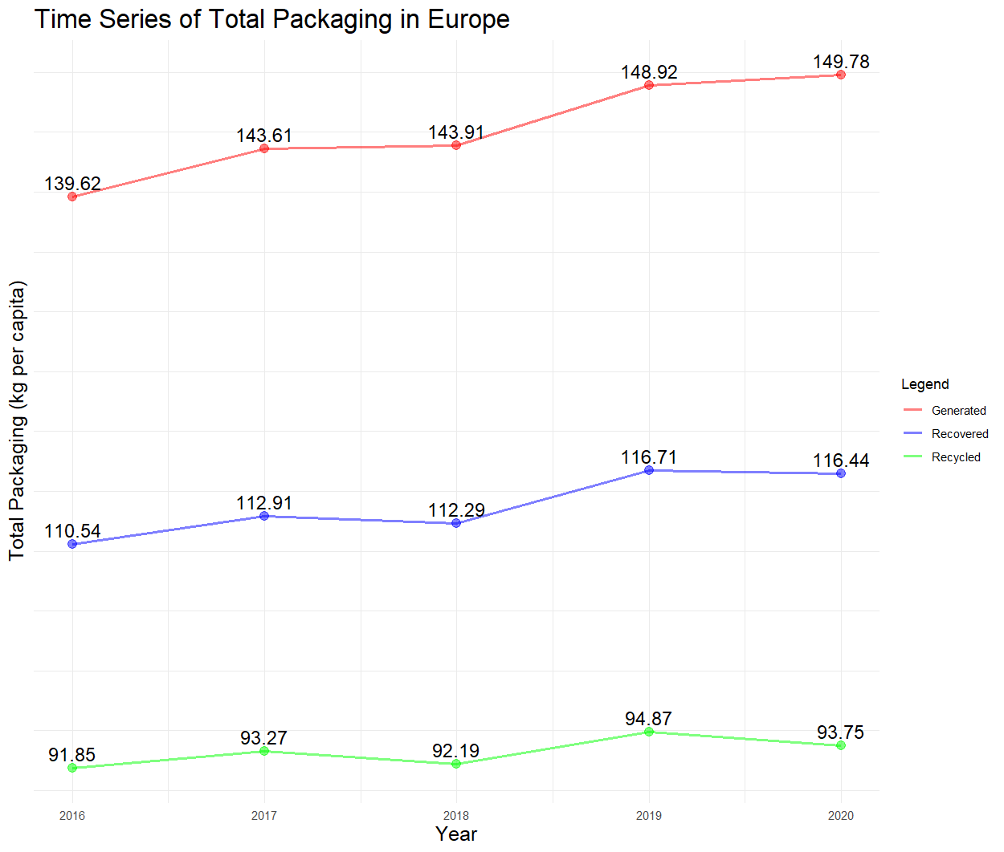
Figure A1: The Time series of total waste packaging generated, recovered and recycled in the EU

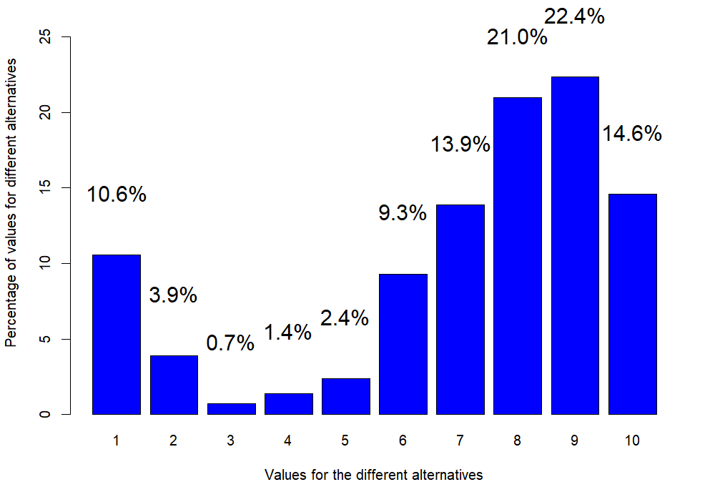
Figure A2. The percentage distribution of votes for the different alternatives

