Supplementary Material

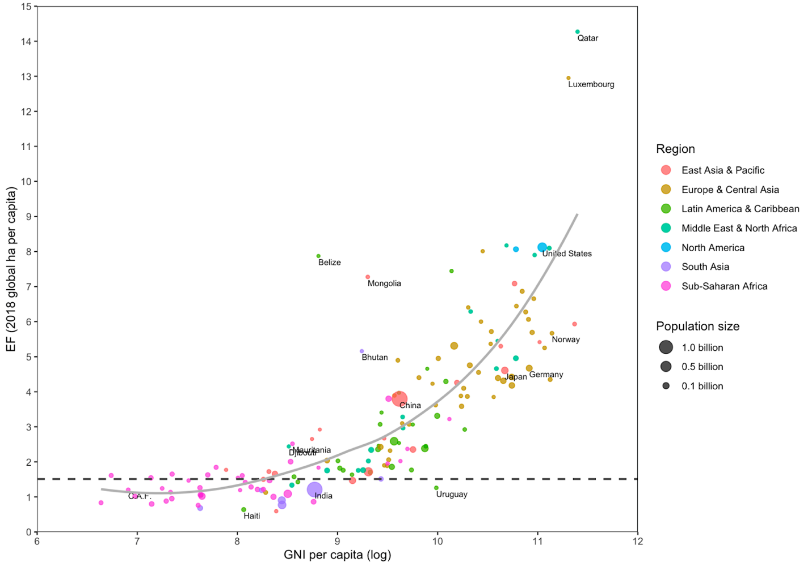
Figure 3.s. Relationship between countries’ GNI per capita (natural logged) and EF per capita in 2018. Horizontal dotted line represents Earth’s biocapacity in 2018 (1.51 g ha per person). C.A.F. = Central African Republic. Smoothed line generated using the LOESS method.

Table 1.S. Fixed-effects linear panel regressions estimating the cross-national relationship between HDI’s components and the EF from 1990 to 2018 (alternative with same n for all models)
 | ln (EF pc)
(ln) | 1 | 2 | 3 | 4 | 5 | 6 | 7 | 8
Baseline Models Panel A: Models with EYS (3-5) Panel B: Models with MYS (6-8)
HDI | 0.685***  (0.183) | - | - | - | - | - | - | -
GNI pc | - | 0.333***  (0.043) | 0.328***  (0.043) | -0.476  (0.405) | 0.214 .  (0.111) | 0.339***  (0.043) | -0.284  (0.396) | 0.274***  (0.074)
Life exp | - | -0.249  (0.127) | -0.218  (0.129) | -1.58172*  (0.67826) | -0.164  (0.138) | -0.175  (0.136) | -1.218  (0.657) | -0.115  (0.150)
EYS | - | 0.110  (0.063) | 0.125*  (0.061) | 0.159*  (0.063) | -0.221  (0.300) | - | - | -
MYS | - | 0.090  (0.062) | - | - | - | 0.109  (0.062) | 0.119  (0.065) | -0.170  (0.240)
Urban (%) | - | 0.084  (0.100) | 0.107  (0.010) | 0.140  (0.098) | 0.131  (0.097) | 0.116  (0.097) | 0.147  (0.096) | 0.153  (0.100)
Age  dep. | - | -0.343***  (0.089) | -0.362***  (0.088) | -0.366***  (0.090) | -0.363***  (0.089) | -0.334***  (0.089) | -0.333***  (0.089) | -0.323***  (0.086)
GNI pc*  Life exp | - | - | - | 0.190*  (0.094) | - | - | 0.148  (0.092) | -
GNI pc*  EYS | - | - | - | - | 0.046  (0.040) | - | -
GNI pc*  MYS | - | - | - | - | - | - | - | 0.036  (0.030)
Adj. R-squared | 0.960 | 0.968 | 0.968 | 0.968 | 0.968 | 0.968 | 0.968 | 0.968
n | 4,594 | 4,594 | 4,594 | 4,594 | 4,594 | 4,594 | 4,594 | 4,594
* p<0.05; ** p<0.01, ***p<0.001

Table 2.S. Fixed-effects linear panel regressions estimating the cross-national relationship between HDI’s components and CO₂ emissions per capita from 1990 to 2018 (alternative with same n for all models)
 | ln (CO₂pc)
(ln) | 9 | 10 | 11 | 12 | 13 | 14 | 15 | 16
Baseline Models Panel A: Models with EYS (11-13) Panel B: Models with MYS (14-16)
HDI | 2.264***  (0.565) | - | - | - | - | - | - | -
GNI pc | - | 0.481***  (0.077) | 0.463***  (0.080) | 1.960*  (0.951) | 1.096***  (0.251) | 0.513***  (0.072) | 3.102**  (.968) | 1.064***  (0.170)
Life exp | - | -0.195  (0.398) | -0.068  (0.376) | 2.589  (1.787) | -0.442  (0.472) | 0.430  (0.390) | 4.936*  (1.915) | -0.178  (0.430)
EYS | - | 0.700*  (0.338) | 0.745*  (0.352) | 0.666  (0.367) | 2.671*  (1.047) | - | - | -
MYS | - | 0.290  (0.170) | - | - | - | 0.401.  (0.232) | 0.346  (0.214) | 2.775***  (0.788)
Urban (%) | 0.979***  (0.264) | 1.083***  (0.258) | 1.600***  (0.267) | 1.095***  (0.272) | 1.020***  (0.296) | 1.289***  (0.305) | 1.146***  (0.289) | 0.964***  (0.250)
Age  dep. | -0.341  (0.185) | -0.273  (0.170) | -0.336*  (0.160) | -0.332*  (0.155) | -0.332*  (0.156) | -0.222  (0.193) | -0.233  (0.183) | -0.313  (0.164)
GNI pc*  Life exp | - | - | - | -0.354  (0.223) | - | - | -0.614**  (0.223) | -
GNI pc*  EYS | - | - | - | - | -0.255*  (0.102) | - | -
GNI pc*  MYS | - | - | - | - | - | - | - | -0.306***  (0.085)
Adj. R-squared | 0.9763 | 0.978 | 0.9774 | 0.978 | 0.978 | 0.976 | 0.977 | 0.978
n | 4,578 | 4,578 | 4,578 | 4,578 | 4,578 | 4,578 | 4,578 | 4,578
* p<0.05; ** p<0.01, ***p<0.001

Countries used in the study

Afghanistan
Albania
Algeria
Andorra
Angola
Antigua and Barbuda
Argentina
Armenia
Australia
Austria
Azerbaijan
Bahamas
Bahrain
Bangladesh
Barbados
Belarus
Belgium
Belize
Benin
Bhutan
Bolivia
Bosnia and Herzegovina
Botswana
Brazil
Brunei Darussalam
Bulgaria
Burkina Faso
Burundi
Côte d'Ivoire
Cabo Verde
Cambodia
Cameroon
Canada
Central African Republic
Chad
Chile
China
Colombia
Comoros
Congo
Congo (Democratic Republic of the)
Costa Rica
Croatia
Cuba
Cyprus
Czechia
Denmark
Djibouti
Dominica
Dominican Republic
Ecuador
Egypt
El Salvador
Equatorial Guinea
Eritrea
Estonia
Eswatini (Kingdom of)
Ethiopia
Fiji
Finland
France
Gabon
Gambia
Georgia
Germany
Ghana
Greece
Grenada
Guatemala
Guinea
Guinea-Bissau
Guyana
Haiti
Honduras
Hong Kong, China (SAR)
Hungary
Iceland
India
Indonesia
Iran (Islamic Republic of)
Iraq
Ireland
Israel
Italy
Jamaica
Japan
Jordan
Kazakhstan
Kenya
Kiribati
Korea (Democratic People's Rep. of)
Korea (Republic of)
Kuwait
Kyrgyzstan
Lao People's Democratic Republic
Latvia
Lebanon
Lesotho
Liberia
Libya
Liechtenstein
Lithuania
Luxembourg
Madagascar
Malawi
Malaysia
Maldives
Mali
Malta
Marshall Islands
Mauritania
Mauritius
Mexico
Micronesia
Moldova
Monaco
Mongolia
Montenegro
Morocco
Mozambique
Myanmar
Namibia
Nauru
Nepal
Netherlands
New Zealand
Nicaragua
Niger
Nigeria
North Macedonia
Norway
Oman
Pakistan
Palau
Palestine, State of
Panama
Papua New Guinea
Paraguay
Peru
Philippines
Poland
Portugal
Qatar
Romania
Russian Federation
Rwanda
Saint Kitts and Nevis
Saint Lucia
Saint Vincent and the Grenadines
Samoa
San Marino
Sao Tome and Principe
Saudi Arabia
Senegal
Serbia
Seychelles
Sierra Leone
Singapore
Slovakia
Slovenia
Solomon Islands
Somalia
South Africa
South Sudan
Spain
Sri Lanka
Sudan
Suriname
Sweden
Switzerland
Syrian Arab Republic
Tajikistan
Tanzania
Thailand
Timor-Leste
Togo
Tonga
Trinidad and Tobago
Tunisia
Turkey
Turkmenistan
Tuvalu
Uganda
Ukraine
United Arab Emirates
United Kingdom
United States
Uruguay
Uzbekistan
Vanuatu
Venezuela
Viet Nam
Yemen
Zambia
Zimbabwe

