Supplementary Material
Table S1: Adjusted cross-sectional associations between index of functional limitations and fertility history, showing full covariates, SHARE wave 1, men and women aged 50-79 years (complete case, weighted)
Index of functional limitations | All men  IRR (95% CI) | Fathers  IRR (95% CI) | All Women  IRR (95% CI) | Mothers  IRR (95% CI)
Fertility characteristics
Number of children (ref: 2)
0 | 1.03(0.86-1.23) |  | 1.04(0.97-1.12)
1 | 1.06(0.9-1.25) | 1.03(0.88-1.22) | 1.12(0.99-1.26) | 1.10(0.98-1.23)
3 | 1.03(0.91-1.18) | 1.03(0.91-1.17) | 1.11(1.04-1.18) | 1.10(1.04-1.18)
4+ | 1.10(0.93-1.29) | 1.07(0.91-1.26) | 1.29(1.13-1.46) | 1.27(1.11-1.44)
AFB (ref: 20-29/23-34 years)
<20/<23 years |  | 1.10(0.86-1.41) |  | 1.13(1.01-1.25)
30+/35+ |  | 1.12(1.03-1.22) |  | 1.06(0.99-1.13)
Other covariates
Age (continuous) | 1.04(1.03-1.05) | 1.04(1.03-1.05) | 1.03(1.03-1.04) | 1.04(1.03-1.04)
Age squared | 1.00 (0.99-1.00) | 1.00 (0.99-1.00) | 1.00 (0.99-1.00) | 0.99 (0.99-0.99)
Education: (ref: low ISCED 1-2)
Medium (ISCED 3-4) |  | 0.62(0.5-0.77) | 0.82(0.73-0.91) | 0.8(0.71-0.92)
High (ISCED 5-6) |  | 0.6(0.49-0.75) | 0.65(0.57-0.74) | 0.65(0.58-0.74)
Father’s occupation:  blue collar/not working | 1.07(0.94-1.22) | 1.1(0.99-1.24) | 1.07(0.99-1.17) | 1.09(1.01-1.17)
Low household wealth | 1.33(1.12-1.58) | 1.31(1.05-1.63) | 1.38(1.27-1.49) | 1.38(1.28-1.48)
Smoking: (ref: never)
Ex-smoker | 1.39(1.26-1.52) | 1.38(1.25-1.51) | 1.11(1.03-1.19) | 1.1(0.98-1.24)
Current smoker | 1.25(1.09-1.43) | 1.22(1.01-1.47) | 0.92(0.81-1.04) | 0.94(0.86-1.02)
Frequency of moderate/vigorous physical activity, ordinal (>once per week to hardly ever) | 1.49(1.43-1.56) | 1.52(1.48-1.56) | 1.34(1.28-1.4) | 1.32(1.26-1.39)
Marital status (ref: married/partnered)
Never married | 0.94(0.83-1.07) | 1.49(1.17-1.88) | 0.9(0.63-1.3) | 1.11(0.81-1.52)
Divorced | 1.45(1.1-1.93) | 1.55(1.11-2.18) | 1.13(1.01-1.27) | 1.16(0.98-1.38)
Widowed | 0.95(0.8-1.11) | 0.93(0.78-1.11) | 0.94(0.82-1.08) | 0.92(0.8-1.06)
Country (ref: Sweden)
Austria | 1.4(1.3-1.5) | 1.42(1.34-1.51) | 1.04(1-1.08) | 1.03(0.99-1.06)
Denmark | 0.88(0.8-0.96) | 0.94(0.86-1.02) | 1.02(0.98-1.06) | 1.02(0.97-1.07)
France | 0.76(0.74-0.78) | 0.75(0.74-0.76) | 0.95(0.92-0.98) | 0.98(0.95-1)
Greece | 1.07(1.02-1.11) | 1.05(1.02-1.09) | 1.25(1.2-1.31) | 1.27(1.2-1.34)
Italy | 0.86(0.81-0.91) | 0.89(0.84-0.94) | 1.01(0.97-1.06) | 1.07(1.01-1.13)
Netherlands | 0.86(0.83-0.89) | 0.88(0.86-0.9) | 0.97(0.94-0.99) | 0.96(0.93-0.99)
Spain | 1.11(1.05-1.18) | 1.17(1.1-1.24) | 1.37(1.28-1.47) | 1.44(1.33-1.55)
TOTAL N | 6123 | 5453 | 7281 | 6557
Bold indicates significant at 5% level.
Table S2: Adjusted cross-sectional associations between fertility history and health outcomes at baseline among men and women aged 50-79 years, SHARE wave 1(complete case, weighted)
ALL MEN | Grip strength  β(95% CI) | Depression  IRR (95% CI) | Cognition  β( (95% CI) | Index of health conditions  OR (95% CI)
No. children (ref:2)
0 | -0.71(-2.95-1.54) | 0.93(0.76-1.14) | 0.08(-1.13-1.29) | 1.01(0.80-1.29)
1 | -0.32(-1.55-0.91) | 1.00(0.95-1.05) | 0.15(-0.23-0.53) | 1.04(0.98-1.10)
3 | -0.86(-2.16-0.44) | 1.06(1.04-1.09) | -0.25(-0.70-0.20) | 0.97(0.89-1.06)
4+ | -0.86(-2.71-0.99) | 1.08(0.97-1.21) | -1.11(-2.21--0.01) | 1.28(1.05-1.56)
FATHERS
No. children (ref:2)
1 | 0.11(-1.09-1.30) | 0.97(0.93-1.02) | 0.39(-0.03-0.81) | 1.02(0.95-1.10)
3 | -0.94(-2.27-0.39) | 1.07(1.04-1.11) | -0.28(-0.75-0.18) | 0.96(0.88-1.04)
4+ | -0.90(-2.67-0.87) | 1.09(0.98-1.21) | -1.09(-2.36-0.18) | 1.22(1.00-1.49)
AFB (ref: 23-34 years)
<23 years | -0.13(-1.70-1.44) | 0.97(0.81-1.17) | -0.40(-1.71-0.90) | 1.04(0.62-1.74)
35+ | -2.29(-3.59--0.99) | 1.13(0.96-1.34) | -1.38(-2.04--0.71) | 1.00(0.78-1.29)
ALL WOMEN
No. children (ref:2)
0 | 0.52(-0.71-1.74) | 1.00(0.90-1.1) | -0.40(-0.97-0.17) | 1.05(0.85-1.29)
1 | -0.40(-1.09-0.28) | 1.08(1.02-1.14) | -0.68(-1.15--0.20) | 1.06(0.78-1.44)
3 | -0.17(-1.01-0.67) | 1.03(0.99-1.06) | -0.76(-1.36--0.16) | 1.05(0.86-1.29)
4+ | -0.39(-1.19-0.41) | 1.02(0.96-1.09) | -0.97(-1.82--0.13) | 1.25(0.96-1.63)
MOTHERS
No. children (ref:2)
1 | -0.59(-1.31-0.13) | 1.07(1.01-1.13) | -0.68(-1.14--0.22) | 1.06(0.76-1.47)
3 | -0.15(-1.02-0.73) | 1.03(0.99-1.07) | -0.74(-1.36--0.12) | 1.06(0.86-1.31)
4+ | -0.34(-1.22-0.54) | 1.03(0.97-1.10) | -0.87(-1.71--0.03) | 1.27(0.95-1.70)
AFB (ref: 20-29 years)
<20 years | 0.06(-0.68-0.81) | 0.99(0.94-1.04) | -0.55(-0.95--0.15) | 0.95(0.73-1.24)
30+ | 0.63(0.08-1.18) | 1.02(0.96-1.08) | -0.08(-0.41-0.24) | 1.05(0.93-1.18)
Adjusted for: age (continuous), age squared, country fixed-effects, father’s occupation, education, marital status, parity (parent’s models), smoking behaviour, physical activity, household wealth. Depression additionally adjusted for physical health (functional limitations). Coefficients in bold are statistically significant at the 5% level.
Figures S1a, S1b: Adjusted cross-sectional associations between fertility history and chronic diseases at baseline among men and women aged 50-79 years, SHARE wave 1 (complete case, weighted)

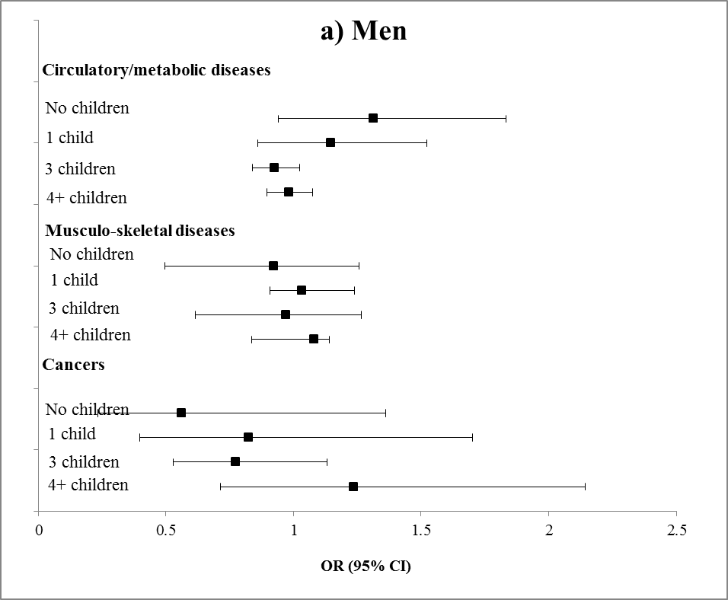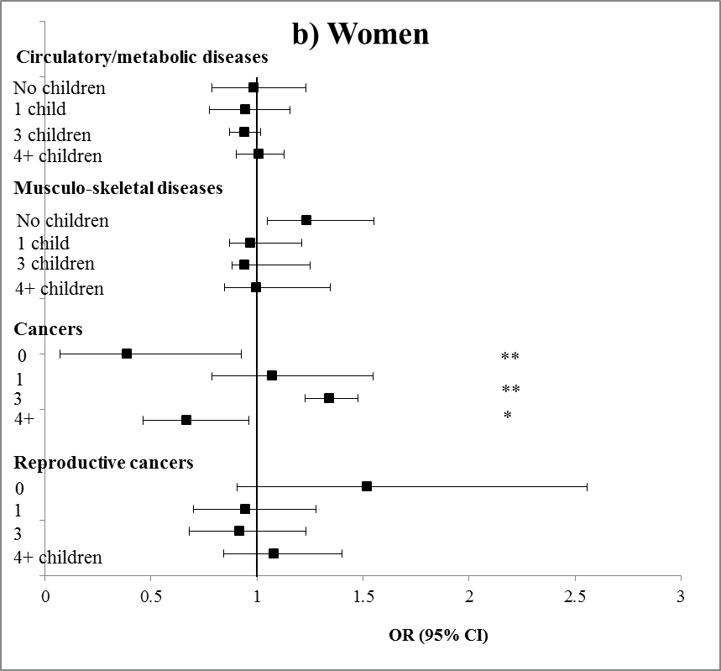

*P<0.05 **P<0.01 ***P<0.001

Figure S2a and S2b: Adjusted cross-sectional associations between fertility history and chronic diseases at baseline among parents aged 50-79 years, SHARE wave 1 (complete case, weighted)

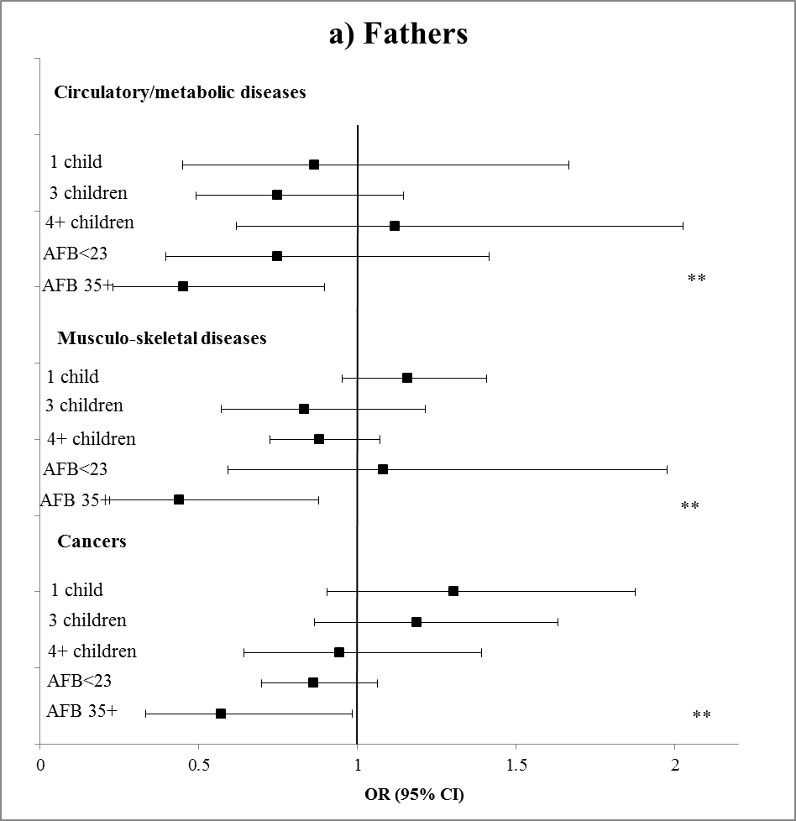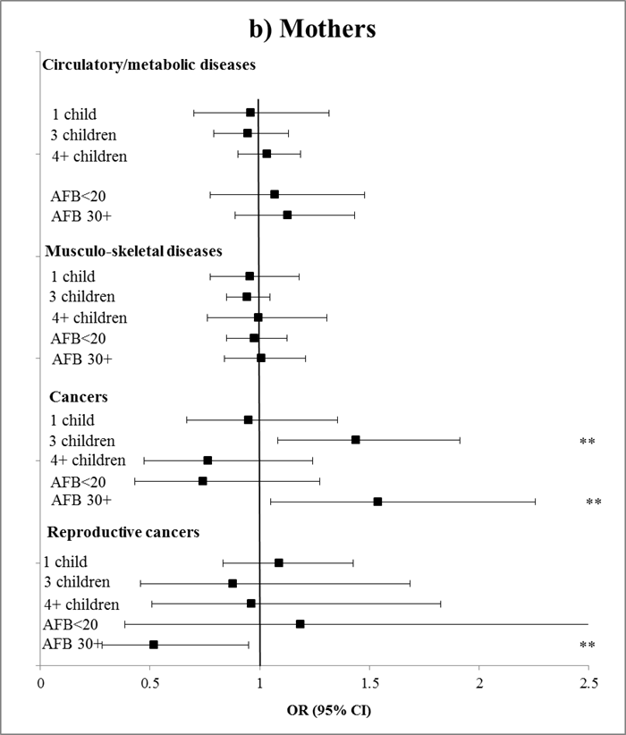
*P<0.05 **P<0.01 ***P<0.001

Table S3: Adjusted longitudinal associations between fertility history and health outcomes at follow-up (wave 2) among men aged 50-79 years, SHARE wave 1-2
ALL MEN | Grip strength  β(95% CI) | Functional limitations  IRR (95% CI) | Depression  IRR (95% CI) | Cognition  β( (95% CI) | Index of health conditions  OR (95% CI)
No. children (ref:2)
0 | -0.39(-1.61-0.83) | 1.03(0.79-1.33) | 1.29(0.99-1.68) | 0.12(-1.25-1.50) | 0.98(0.82-1.17)
1 | -0.35(-1.01-0.31) | 1.10(0.93-1.03) | 1.13(0.92-1.39) | -0.13(-1.04-0.78) | 1.33(0.95-1.86)
3 | -0.49(-1.51-0.54) | 1.06(0.96-1.18) | 1.12(0.98-1.26) | -0.35(-1.86-1.17) | 1.21(0.92-1.58)
4+ | -0.79(-1.84-0.26) | 1.02(0.87-1.18) | 1.10(1.00-1.22) | -0.32(-1.68-1.04) | 1.20(0.95-1.51)
FATHERS
No. children (ref:2)
1 | -0.34(-1.04-0.37) | 1.10(0.93-1.30) | 1.14(0.94-1.38) | -0.11(-1.05-0.83) | 1.33(0.96-1.86)
3 | -0.50(-1.58-0.57) | 1.03(0.92-1.15) | 1.10(0.98-1.23) | -0.35(-1.94-1.24) | 1.19(0.91-1.56)
4+ | -0.78(-1.97-0.41) | 0.97(0.84-1.13) | 1.09(1.00-1.19) | -0.32(-1.72-1.08) | 1.16(0.93-1.44)
AFB (ref: 23-34 yrs)
<23 years | -0.54(-1.70-0.62) | 1.27(1.05-1.55) | 1.04(0.90-1.21) | -0.88(-1.84-0.08) | 1.24(0.94-1.63)
35+ | -0.21(-0.79-0.38) | 0.90(0.74-1.09) | 0.94(0.86-1.03) | 0.08(-0.80-0.95) | 0.92(0.73-1.16)
ALL WOMEN
No. children (ref:2)
0 | 0.51(-0.01-1.04) | 1.01(0.88-1.17) | 1.04(0.99-1.10) | 0.35(-0.38-1.08) | 0.93(0.69-1.26)
1 | 0.40(-0.01-0.800) | 1.04(0.91-1.20) | 1.03(0.97-1.09) | -0.08(-0.52-0.36) | 1.02(0.88-1.18)
3 | -0.05(-0.68-0.57) | 0.96(0.86-1.08) | 1.00(0.93-1.08) | -0.59(-1.06--0.12) | 1.08(0.91-1.29)
4+ | -0.17(-0.72-0.37) | 1.06(0.94-1.19) | 1.04(0.97-1.11) | -0.85(-1.37--0.34) | 1.20(1.07-1.34)
MOTHERS
No. children (ref:2)
1 | 0.36(0.03-0.70) | 1.04(0.93-1.17) | 1.02(0.97-1.08) | -0.13(-0.65-0.40) | 1.04(0.93-1.16)
3 | -0.02(-0.74-0.69) | 0.96(0.85-1.07) | 1.00(0.93-1.08) | -0.61(-1.03--0.19) | 1.07(0.90-1.27)
4+ | -0.17(-0.67-0.33) | 1.03(0.92-1.15) | 1.03(0.96-1.10) | -0.84(-1.35--0.32) | 1.15(1.02-1.31)
AFB (ref: 20-29 yrs)
<20 years | 0.25(-0.08-0.59) | 1.15(1.08-1.23) | 1.08(0.98-1.18) | -0.36(-1.02-0.300) | 1.27(1.13-1.43)
30+ | 0.18(-0.11-0.46) | 1.01(0.91-1.14) | 1.03(0.99-1.07) | 0.07(-0.77-0.90) | 0.97(0.84-1.11)
Adjusted for: health at baseline, months between wave 1 and wave 2, age (continuous), age squared, country fixed-effects, father’s occupation, education, marital status, parity (parent’s models), smoking behaviour, physical activity, household wealth. Depression additionally adjusted for physical health (functional limitations). Bold indicates statistically significant at the 5% level.

Figure S3a and S3b: Adjusted longitudinal associations between fertility history and chronic diseases in men and women aged 50-79 years, SHARE wave 1-2(complete case, weighted)

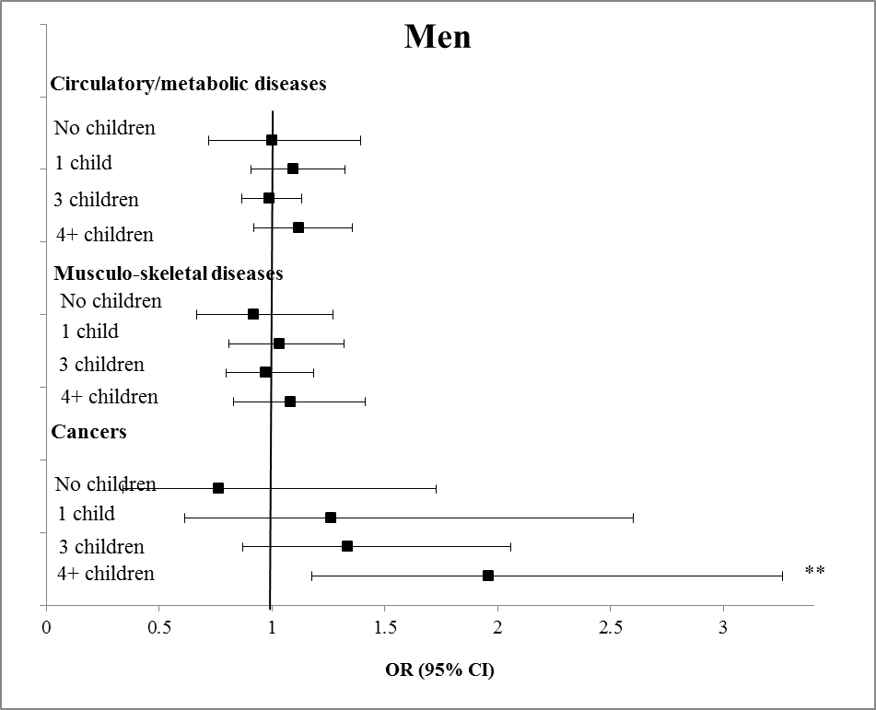 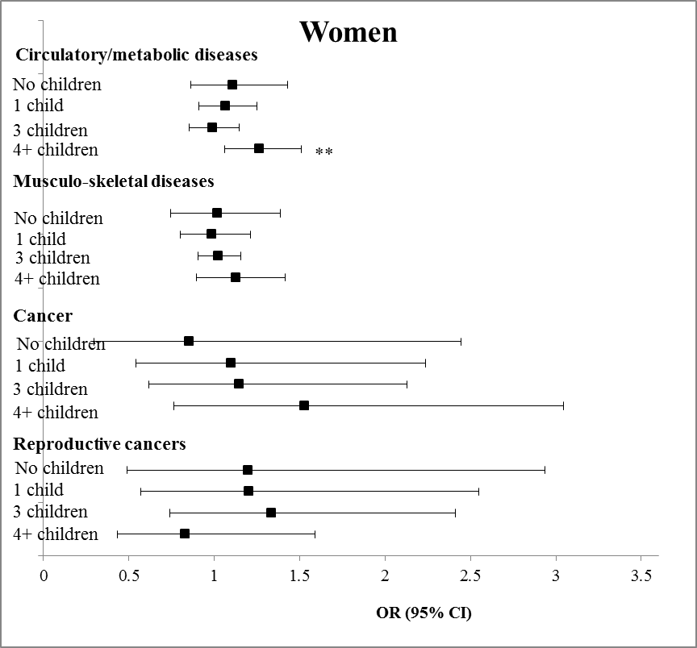*P<0.05 **P<0.01 ***P<0.001

Figure S4a and S4b: Adjusted longitudinal associations between fertility history and chronic diseases in parents aged 50-79 years, SHARE wave 1-2, (complete case, weighted)

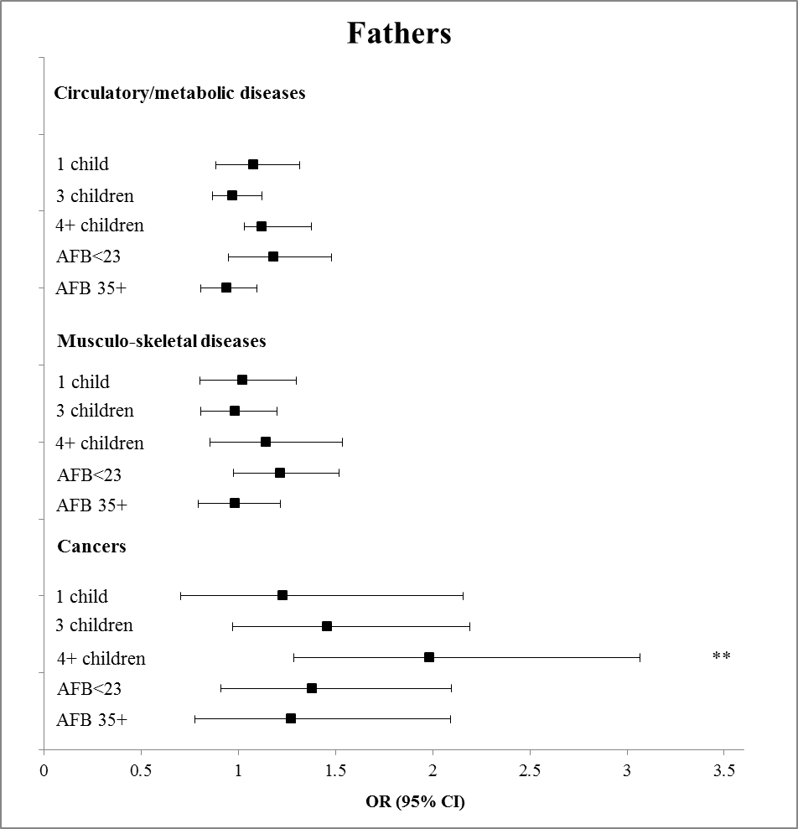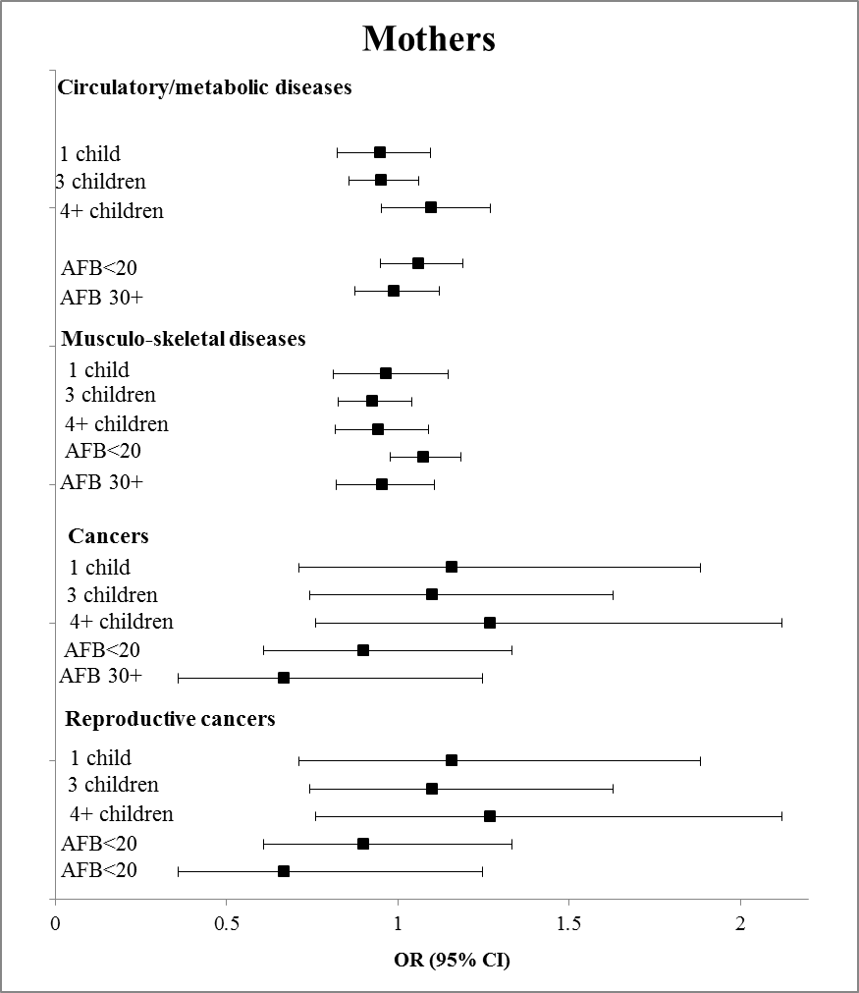.*P<0.05 **P<0.01 ***P<0.001

Figure S5a and S5b: Predicted health index score at wave 1 according to parity and societal/welfare regime in men and women aged 50-79 years, SHARE wave 1 (complete case, weighted)

Figure S6a and S6b: Predicted health index score according to parity and marital status in men aged 50-79 years, SHARE wave 1-2 (complete case, weighted)

Table S4: Sensitivity analysis adjusting for deceased children: Adjusted cross-sectional associations between fertility history and health outcomes at baseline among men and women aged 50-79 years, SHARE wave 1-3 (complete case analysis, unweighted)
ALL MEN | Grip strength  β(95% CI) | Functional limitations  IRR (95% CI) | Depression  IRR (95% CI) | Cognition  β( (95% CI) | Circulatory and metabolic diseases  OR( (95 % CI) | Musculoskeletal diseases  OR (95% CI) | Cancers  OR( (95% CI)
No. children (ref:2)
0 | -0.85(-2.23-0.52) | 1.04(0.83-1.30) | 1.05(0.95-1.16) | 0.16(-0.87-1.19) | 1.17(0.91-1.52) | 1.24(0.81-1.89) | 0.85(0.48-1.48)
1 | -0.12(-0.59-0.36) | 1.13(0.97-1.32) | 0.98(0.90-1.06) | 0.38(-0.48-1.25) | 0.98(0.82-1.17) | 1.12(0.90-1.40) | 0.85(0.53-1.38)
3 | 0.01(-0.99-1.00) | 1.07(0.95-1.20) | 1.03(0.96-1.12) | 0.08(-0.66-0.82) | 0.87(0.77-0.98) | 0.90(0.64-1.25) | 0.61(0.27-1.38)
4+ | -0.22(-1.30-0.86) | 1.19(1.05-1.34) | 1.11(1.03-1.19) | 0.02(-1.11-1.16) | 0.86(0.71-1.04) | 1.05(0.85-1.29) | 1.03(0.60-1.76)
N | 4486 | 4847 | 4794 | 4804 | 4856 | 4856 | 4623
FATHERS
No. children (ref:2)
1 | 0.07(-0.39-0.52) | 1.11(0.95-1.30) | 0.96(0.88-1.05) | 0.47(-0.38-1.33) | 1.04(0.85-1.27) | 1.20(0.97-1.50) | 0.87(0.55-1.35)
3 | -0.06(-1.06-0.95) | 1.05(0.94-1.19) | 1.03(0.95-1.12) | 0.05(-0.67-0.77) | 0.86(0.76-0.97) | 0.86(0.60-1.23) | 0.59(0.26-1.36)
4+ | -0.32(-1.34-0.7) | 1.14(1.00-1.31) | 1.10(1.01-1.20) | 0.01(-1.17-1.19) | 0.81(0.69-0.95) | 1.00(0.80-1.25) | 0.95(0.54-1.65)
AFB (ref: 23-34 yrs)
<23 years | -0.10(-1.42-1.23) | 1.15(0.97-1.36) | 1.06(0.93-1.20) | -0.18(-1.22-0.85) | 1.16(0.89-1.52) | 0.99(0.60-1.62) | 1.31(0.83-2.06)
35+ | -1.35(-2.73-0.03) | 1.10(1.01-1.20) | 1.12(1.00-1.27) | -0.79(-1.38--0.20) | 0.67(0.59-0.76) | 0.57(0.31-1.07) | 0.75(0.47-1.18)
N | 3999 | 4303 | 4259 | 4266 | 4310 | 4310 | 4310
ALL WOMEN
No. children (ref:2)
0 | -0.16(-1.08-0.76) | 1.01(0.91-1.12) | 1.04(0.96-1.12) | -0.33(-0.97-0.32) | 0.96(0.70-1.30) | 1.03(0.75-1.40) | 1.16(0.84-1.59)
1 | -0.12(-0.34-0.09) | 1.05(0.93-1.18) | 1.05(1.00-1.10) | -0.36(-1.13-0.40) | 1.02(0.84-1.24) | 0.91(0.77-1.07) | 0.85(0.54-1.32)
3 | 0.33(-0.15-0.81) | 1.05(0.99-1.11) | 1.01(0.95-1.07) | -0.23(-1.02-0.56) | 0.94(0.84-1.05) | 0.92(0.78-1.07) | 1.02(0.82-1.27)
4+ | 0.21(-0.65-1.07) | 1.26(1.09-1.45) | 1.04(0.96-1.13) | -0.30(-1.19-0.59) | 0.99(0.88-1.12) | 0.98(0.84-1.14) | 0.99(0.69-1.43)
N | 5303 | 5885 | 5837 | 5852 | 5895 | 5895 | 5895
MOTHERS
No. children (ref:2)
1 | -0.27(-0.58-0.03) | 1.07(0.95-1.20) | 1.06(1.00-1.12) | -0.40(-1.16-0.35) | 1.06(0.86-1.32) | 0.94(0.78-1.14) | 0.86(0.54-1.38)
3 | 0.38(-0.13-0.89) | 1.03(0.96-1.09) | 1.01(0.95-1.07) | -0.19(-0.96-0.59) | 0.93(0.83-1.04) | 0.90(0.78-1.03) | 1.03(0.83-1.29)
4+ | 0.38(-0.59-1.34) | 1.20(1.05-1.36) | 1.03(0.95-1.11) | -0.18(-1.11-0.75) | 0.96(0.82-1.12) | 0.93(0.77-1.12) | 1.02(0.67-1.54)
AFB (ref: 20-29 yrs)
<20 years | -0.57(-1.03--0.12) | 1.32(1.19-1.48) | 1.05(0.98-1.14) | -0.45(-1.09-0.20) | 1.29(1.04-1.60) | 1.18(0.95-1.47) | 0.73(0.52-1.01)
30+ | 0.47(-0.18-1.11) | 1.01(0.94-1.08) | 0.97(0.91-1.03) | 0.02(-0.31-0.35) | 1.00(0.84-1.20) | 0.87(0.68-1.10) | 0.83(0.61-1.14)
N | 4790 | 5299 | 5262 | 5275 | 5309 | 5309 | 5309
Bold indicates statistically significant at the 5% level.
Table S5: Sensitivity analysis adjusting for deceased children: Adjusted longitudinal associations between fertility history and health outcomes at baseline among men and women aged 50-79 years, SHARE wave 1-3 (complete case analysis, unweighted)
ALL MEN | Grip strength  β(95% CI) | Functional limitations  IRR (95% CI) | Depression  IRR (95% CI) | Cognition  β( (95% CI) | Circulatory and metabolic diseases  OR( (95 % CI) | Musculoskeletal diseases  OR (95% CI) | Cancers  OR( (95% CI)
No. children (ref:2)
0 | -0.84(-1.57--0.11) | 1.13(0.82-1.56) | 1.11(0.97-1.26) | -0.86(-2.19-0.46) | 0.8(0.58-1.10) | 0.98(0.60-1.57) | 0.81(0.37-1.77)
1 | -0.65(-1.59-0.28) | 1.09(1.00-1.18) | 1.07(0.94-1.22) | -0.15(-0.87-0.56) | 1.06(0.97-1.15) | 1.11(0.91-1.34) | 1.12(0.67-1.87)
3 | -0.61(-1.25-0.04) | 1.1(0.99-1.23) | 1.05(0.97-1.12) | -0.64(-1.36-0.09) | 0.99(0.88-1.10) | 1.00(0.80-1.25) | 0.73(0.43-1.24)
4+ | -1.06(-1.67--0.45) | 1.17(1.08-1.27) | 1.11(1.05-1.17) | -0.63(-1.53-0.27) | 1.06(0.87-1.29) | 1.14(0.96-1.36) | 1.29(0.91-1.82)
N | 4486 | 4847 | 4729 | 4738 | 4856 | 4856 | 4856
FATHERS
No. children (ref:2)
1 | -0.73(-1.65-0.18) | 1.09(0.99-1.20) | 1.07(0.94-1.22) | -0.20(-0.90-0.50) | 1.07(0.98-1.17) | 1.11(0.95-1.31) | 1.06(0.66-1.69)
3 | -0.60(-1.26-0.06) | 1.08(0.99-1.19) | 1.04(0.97-1.12) | -0.62(-1.36-0.13) | 0.98(0.88-1.10) | 0.98(0.79-1.21) | 0.73(0.44-1.21)
4+ | -1.03(-1.63--0.42) | 1.13(1.05-1.22) | 1.11(1.05-1.18) | -0.61(-1.45-0.23) | 1.04(0.85-1.26) | 1.09(0.92-1.28) | 1.26(0.87-1.83)
AFB (ref: 23-34 yrs)
<23 years | 0.14(-0.86-1.15) | 1.22(1.04-1.42) | 1.01(0.93-1.09) | -0.71(-1.52-0.10) | 1.10(0.86-1.39) | 1.42(1.09-1.85) | 1.19(0.70-2.05)
35+ | 0.64(0.11-1.16) | 0.96(0.77-1.18) | 0.93(0.88-0.99) | 0.25(-0.28-0.78) | 0.91(0.81-1.03) | 0.99(0.82-1.19) | 1.28(0.75-2.17)
N | 3999 | 4303 | 4202 | 4212 | 4310 | 4310 | 4310
ALL WOMEN
No. children (ref:2)
0 | -0.09(-0.98-0.80) | 0.93(0.82-1.06) | 0.97(0.93-1.02) | -0.08(-1.02-0.86) | 0.93(0.75-1.16) | 1.18(0.92-1.53) | 0.89(0.56-1.41)
1 | 0.33(-0.20-0.87) | 0.99(0.91-1.08) | 0.97(0.92-1.01) | -0.04(-0.69-0.62) | 1.05(0.92-1.20) | 1.04(0.85-1.27) | 0.79(0.53-1.17)
3 | 0.02(-0.48-0.52) | 0.93(0.86-1.00) | 0.95(0.89-1.01) | -0.49(-0.93--0.05) | 1.00(0.83-1.20) | 0.99(0.84-1.15) | 0.77(0.55-1.08)
4+ | 0.14(-0.32-0.60) | 0.97(0.87-1.08) | 1.03(0.97-1.08) | -0.47(-1.18-0.24) | 1.15(0.88-1.49) | 1.10(0.85-1.43) | 0.79(0.54-1.17)
N | 5303 | 5885 | 5765 | 5789 | 5895 | 5895 | 5895
MOTHERS
No. children (ref:2)
1 | 0.31(-0.15-0.77) | 0.98(0.91-1.07) | 0.96(0.93-1.00) | -0.04(-0.68-0.61) | 1.05(0.91-1.21) | 1.03(0.83-1.27) | 0.75(0.49-1.14)
3 | 0.00(-0.50-0.51) | 0.93(0.86-1.00) | 0.95(0.89-1.02) | -0.47(-0.86--0.07) | 1.00(0.81-1.23) | 0.97(0.83-1.12) | 0.77(0.55-1.07)
4+ | 0.14(-0.28-0.56) | 0.96(0.86-1.07) | 1.02(0.97-1.08) | -0.41(-1.09-0.28) | 1.14(0.85-1.52) | 1.05(0.81-1.36) | 0.75(0.44-1.29)
AFB (ref: 20-29 yrs)
<20 years | 0.22(-0.13-0.56) | 1.12(1.01-1.24) | 1.06(0.98-1.15) | -0.31(-0.90-0.28) | 1.12(0.90-1.39) | 1.08(0.88-1.32) | 1.16(0.61-2.20)
30+ | 0.19(-0.48-0.85) | 1.06(0.98-1.14) | 1.04(0.99-1.09) | 0.07(-0.49-0.62) | 1.02(0.87-1.21) | 0.94(0.81-1.09) | 1.04(0.65-1.67)
N | 4790 | 5299 | 5196 | 5218 | 5309 | 5309 | 5309
Bold indicates statistically significant at the 5% level.
Table S6: Sensitivity analysis using pattern mixture models: Adjusted longitudinal associations between fertility history and grip strength and cognition among men and women aged 50-79 years, SHARE wave 1-2
ALL MEN (N=9805) | Grip strength  β |  |  | Cognition score  β |  |  | Functional limitations  IRR |  |  | Depression score  IRR
No. children (ref:2) | MAR | -20% | -30% | MAR | -20% | -30% | MAR | -20% | -30% | MAR | -20% | -30%
0 | 0.12 | -0.45 | -0.83 | 0.11 | -0.27 | -0.51 | 1.03 | 1.04 | 1.05 | 1.06 | 1.07 | 1.08
1 | 0.41 | -0.03 | -0.32 | 0.13 | -0.27 | -0.54 | 0.99 | 0.99 | 1.00 | 1.02 | 1.03 | 1.04
3 | 0.48 | 0.45 | 0.42 | 0.05 | 0.00 | -0.03 | 0.94 | 0.94 | 0.94 | 0.93 | 0.94 | 0.94
4+ | -0.12 | 0.11 | 0.25 | -0.15 | 0.07 | 0.22 | 1 | 1 | 0.99 | 0.99 | 0.99 | 0.98
FATHERS (N=8903)
No. children (ref:2)
1 | 0.28 | -0.25 | -0.60 | 0.01 | -0.42 | -0.70 | 1.00 | 1.00 | 1.01 | 1.03 | 1.04 | 1.05
3 | 0.43 | 0.37 | 0.33 | 0.08 | 0.02 | -0.03 | 0.96 | 0.96 | 0.96 | 0.93 | 0.93 | 0.94
4+ | -0.24 | 0.06 | 0.25 | -0.24 | 0.04 | 0.22 | 0.98 | 0.97 | 0.97 | 0.98 | 0.98 | 0.98
AFB (ref: 23-34 yrs)
<23 years | -0.45 | -0.87 | -1.15* | -0.30 | -0.65 | -0.87* | 1.16 | 1.17 | 1.17 | 1.04 | 1.04 | 1.05
35+ | 0.12 | 0.36 | 0.52 | -0.21 | -0.05 | 0.06 | 0.94 | 0.94 | 0.94 | 0.94 | 0.94 | 0.94
ALL WOMEN (N=11439)
No. children (ref:2)
0 | 0.20 | -0.26 | -0.55 | 0.61 | 0.27 | 0.05 | 1.03 | 1.04 | 1.05 | 1.03 | 1.04 | 1.04
1 | 0.29 | -0.03 | -0.24 | 0.29 | -0.08 | -0.33 | 1.07 | 1.08 | 1.08 | 1.02 | 1.03 | 1.04
3 | 0.18 | 0.00 | -0.12 | 0.39 | 0.18 | 0.05 | 1.06 | 1.07 | 1.07 | 1.00 | 1.00 | 1.01
4+ | -0.07 | -0.20 | -0.28 | -0.24 | -0.29 | -0.33 | 1.09* | 1.09 | 1.09 | 1.04 | 1.04 | 1.05
MOTHERS (N=10,373)
No. children (ref:2)
1 | 0.16 | 0.16 | 0.06 | 0.30 | 0.10 | -0.04 | 1.10 | 1.12 | 1.13 | 1.03 | 1.04 | 1.05
3 | -0.02 | -0.02 | -0.07 | 0.39 | 0.28 | 0.20 | 1.06 | 1.07 | 1.08 | 0.99 | 1.00 | 1.00
4+ | -0.05 | -0.05 | -0.09 | -0.22 | -0.24 | -0.25 | 1.09 | 1.08 | 1.09 | 1.04 | 1.05 | 1.05
AFB (ref: 20-29 yrs)
<20 years | 0.02 | 0.02 | -0.05 | 0.01 | -0.09 | -0.16 | 1.12 | 1.12 | 1.13 | 1.06 | 1.06 | 1.07
30+ | -0.04 | -0.04 | -0.05 | 0.06 | 0.07 | 0.08 | 0.99 | 0.99 | 0.99 | 1.00 | 0.99 | 0.99
*P<0.05 **P<0.005. ***P<0.001 Adjusted for: health at baseline, months between wave 1 and wave 2, age (continuous), country fixed-effects, father’s occupation, education, marital status, parity (parent’s models), smoking behaviour, physical activity, household wealth. Depression additionally adjusted for physical health (functional limitations).
Table S7: Sensitivity analysis using pattern mixture models: Adjusted longitudinal associations between fertility history and chronic diseases among men and women aged 50-79 years, SHARE wave 1-2
ALL MEN (N=9805) | Circulatory and metabolic diseases  OR |  |  | Musculoskeletal diseases  OR |  |  | Cancers  OR
No. children (ref:2) | MAR | +20% | +30% | MAR | +20% | +30% | MAR | +20% | +30%
0 | 1.04 | 1.06 | 1.07 | 0.82 | 0.90 | 0.97 | 0.55 | 0.96 | 0.98
1 | 1.14 | 1.16 | 1.17 | 1.15 | 1.14 | 1.13 | 1.05 | 1.08 | 1.12
3 | 1.00 | 0.99 | 1.01 | 0.99 | 0.94 | 0.95 | 1.11 | 0.97 | 1.04
4+ | 1.24* | 1.18* | 1.18 | 1.17 | 1.04 | 1.01 | 1.51 | 1.07 | 1.06
FATHERS (N=8903)
No. children (ref:2)
1 | 1.23 | 1.27* | 1.28* | 1.15 | 1.19 | 1.25 | 1.08 | 1.23 | 1.30
3 | 1.01 | 1.04 | 1.02 | 1.01 | 1.00 | 1.00 | 1.36 | 1.12 | 1.06
4+ | 1.22 | 1.22 | 1.15 | 1.14 | 1.05 | 1.02 | 1.72 | 1.09 | 1.01
AFB (ref: 23-34 yrs)
<23 years | 1.99 | 1.03 | 1.07 | 1.15 | 1.17 | 1.18 | 1.29 | 1.31 | 1.28
35+ | 0.96 | 0.97 | 0.94 | 0.97 | 0.96 | 0.93 | 1.79 | 1.19 | 1.05
ALL WOMEN (N=11439)
No. children (ref:2)
0 | 1.01 | 1.06 | 1.06 | 0.89 | 0.97 | 0.96 | 0.90 | 1.24 | 1.19
1 | 1.03 | 1.06 | 1.05 | 0.98 | 1.02 | 1.01 | 1.87 | 1.33 | 1.28
3 | 1.02 | 1.04 | 1.02 | 0.96 | 1.01 | 1 | 1.57 | 1.18 | 1.10
4+ | 1.21* | 1.21* | 1.15* | 1.08 | 1.09 | 1.07 | 2.31** | 1.14 | 1.09
MOTHERS (N=10,373)
No. children (ref:2)
1 | 1.07 | 1.09 | 1.09 | 1.04 | 1.05 | 1.06 | 1.01 | 1.07 | 1.10
3 | 1.05 | 1.05 | 1.04 | 1.02 | 1.03 | 1.02 | 1.06 | 1.07 | 1.09
4+ | 1.26* | 1.25* | 1.25* | 1.03 | 1.02 | 1.02 | 1.39 | 1.17 | 1.21
AFB (ref: 20-29 yrs)
<20 years | 1.04 | 1.05 | 1.05 | 1.09 | 1.10 | 1.11 | 0.83 | 0.94 | 0.93
30+ | 1.05 | 1.05 | 1.05 | 0.89 | 0.90 | 0.90 | 1.02 | 0.97 | 0.99
*P<0.05 **P<0.005. ***P<0.001 Adjusted for: health at baseline, months between wave 1 and wave 2, age (continuous), country fixed-effects, father’s occupation, education, marital status, parity (parent’s models), smoking behaviour, physical activity, household wealth. Depression additionally adjusted for physical health (functional limitations)

