Online Supplementary Material
Figure S1: Average adjusted predictions of choosing separation (vs. community) of property regime by partner’s education, with 95% confidence interval

Figure S2: Average adjusted predictions of choosing separation (vs. community) of property regime by housing tenure, with 95% confidence interval

Figure S3: Average adjusted predictions of choosing separation (vs. community) of property regime by children, with 95% confidence interval

Figure S4: Average adjusted predictions of choosing separation (vs. community) of property regime by dating duration, with 95% confidence interval

Figure S5: Average adjusted predictions of choosing separation (vs. community) of property regime by duration of premarital cohabitation, with 95% confidence interval

Figure S6: Average adjusted predictions of choosing separation (vs. community) of property regime by parental education, by gender of respondent, with 95% confidence interval

Men | Women
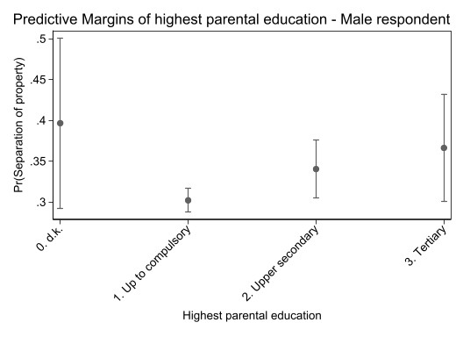 | 