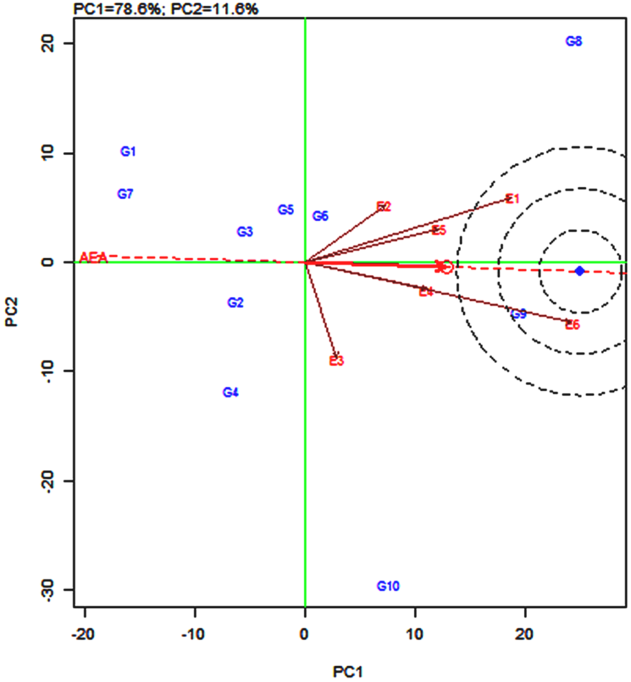
Fig S1. GGE-Environment Biplot for MT during WS
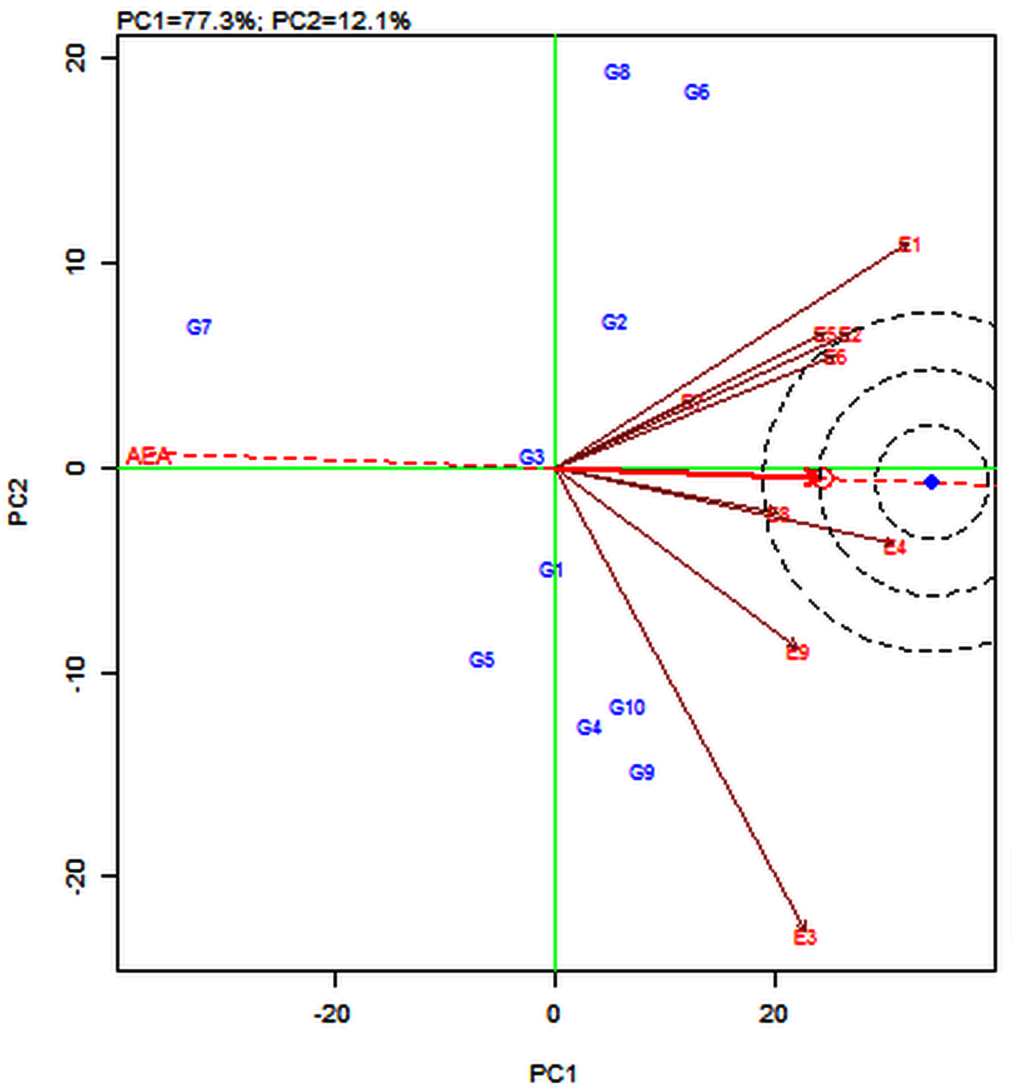
Fig S2. GGE-Environment Biplot for HT during WS
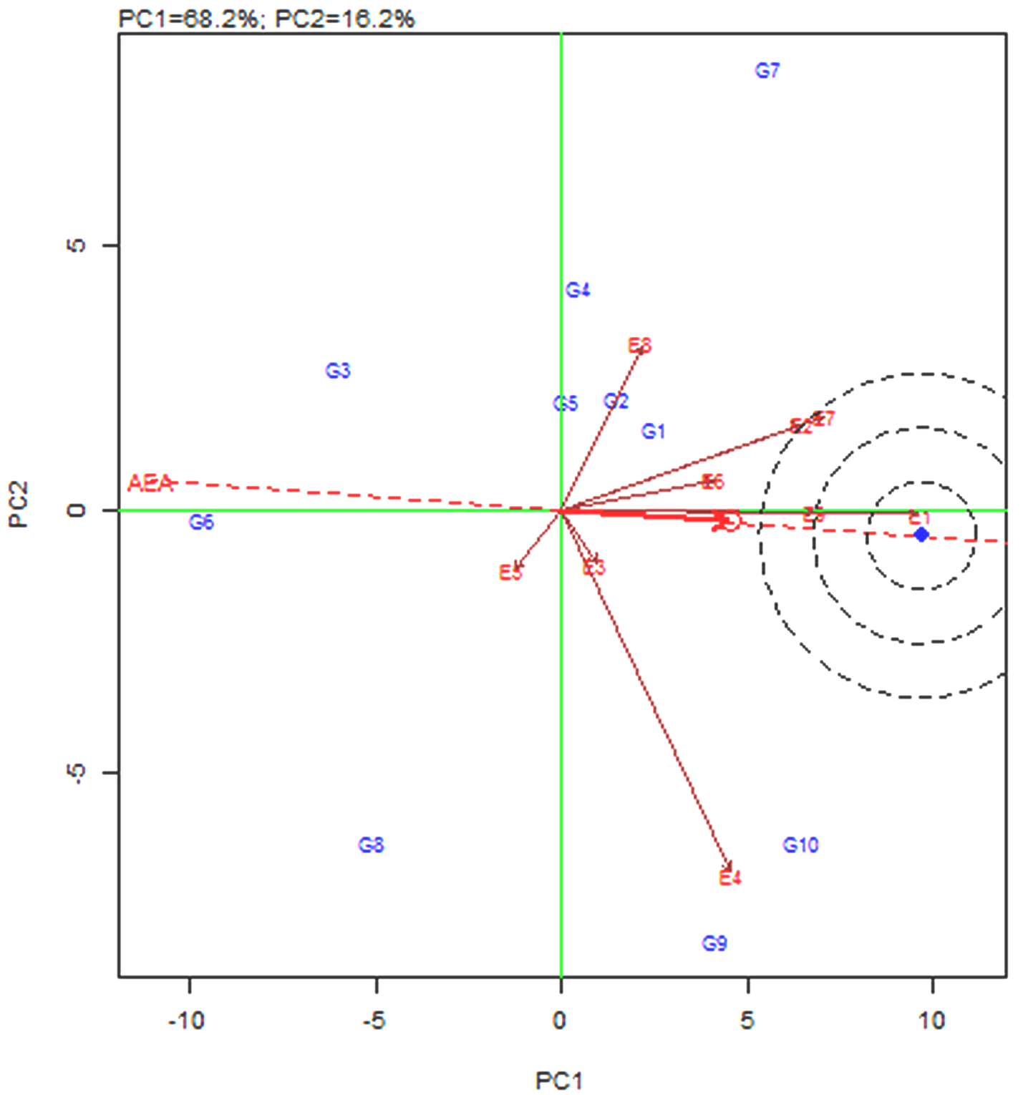
Fig S3. GGE-Environment Biplot for TN during WS
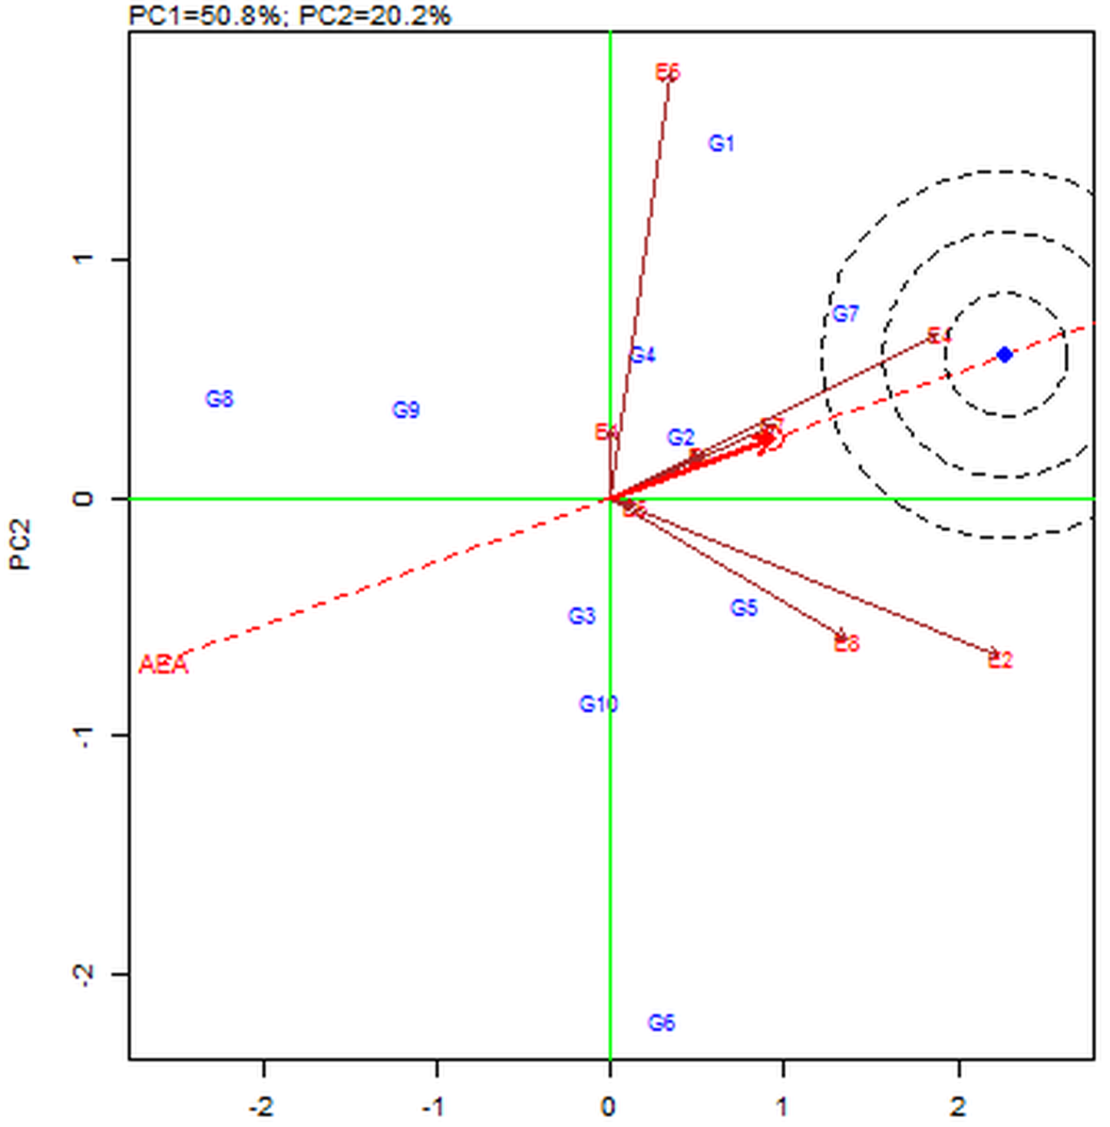
Fig S4. GGE-Environment Biplot for Fe during WS
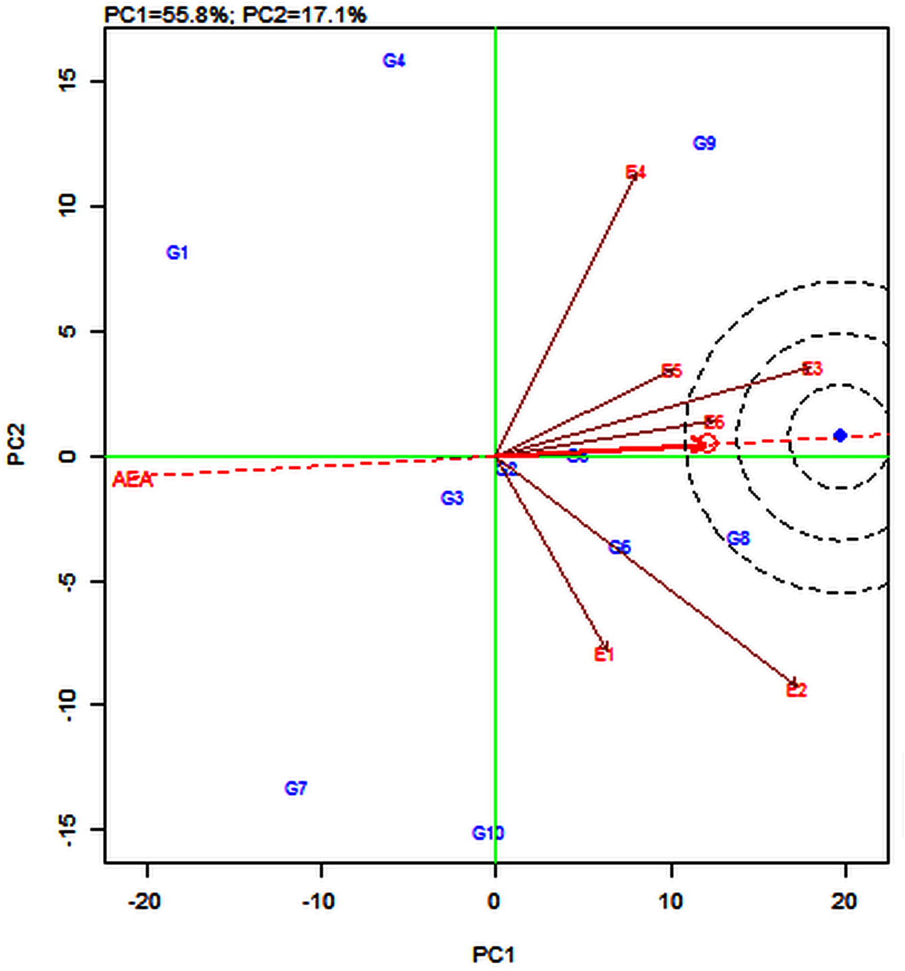
Fig S5. GGE-Environment Biplot for MT during DS

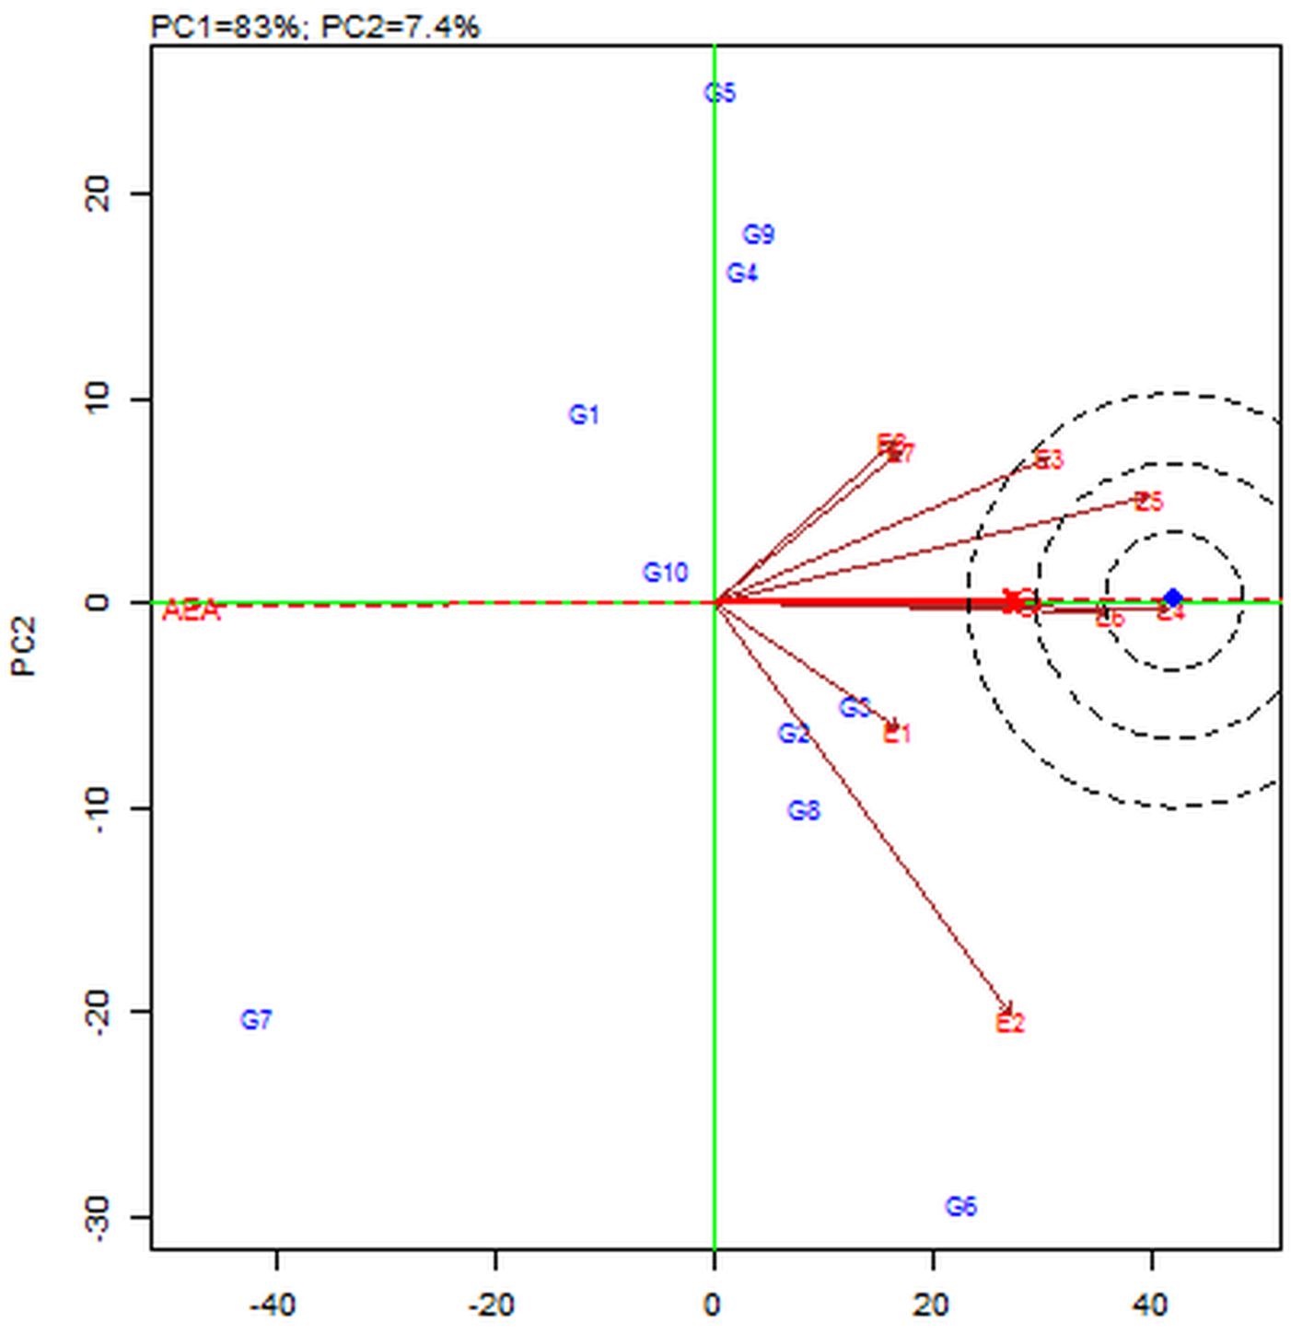
Fig S6. GGE-Environment Biplot for HT during DS

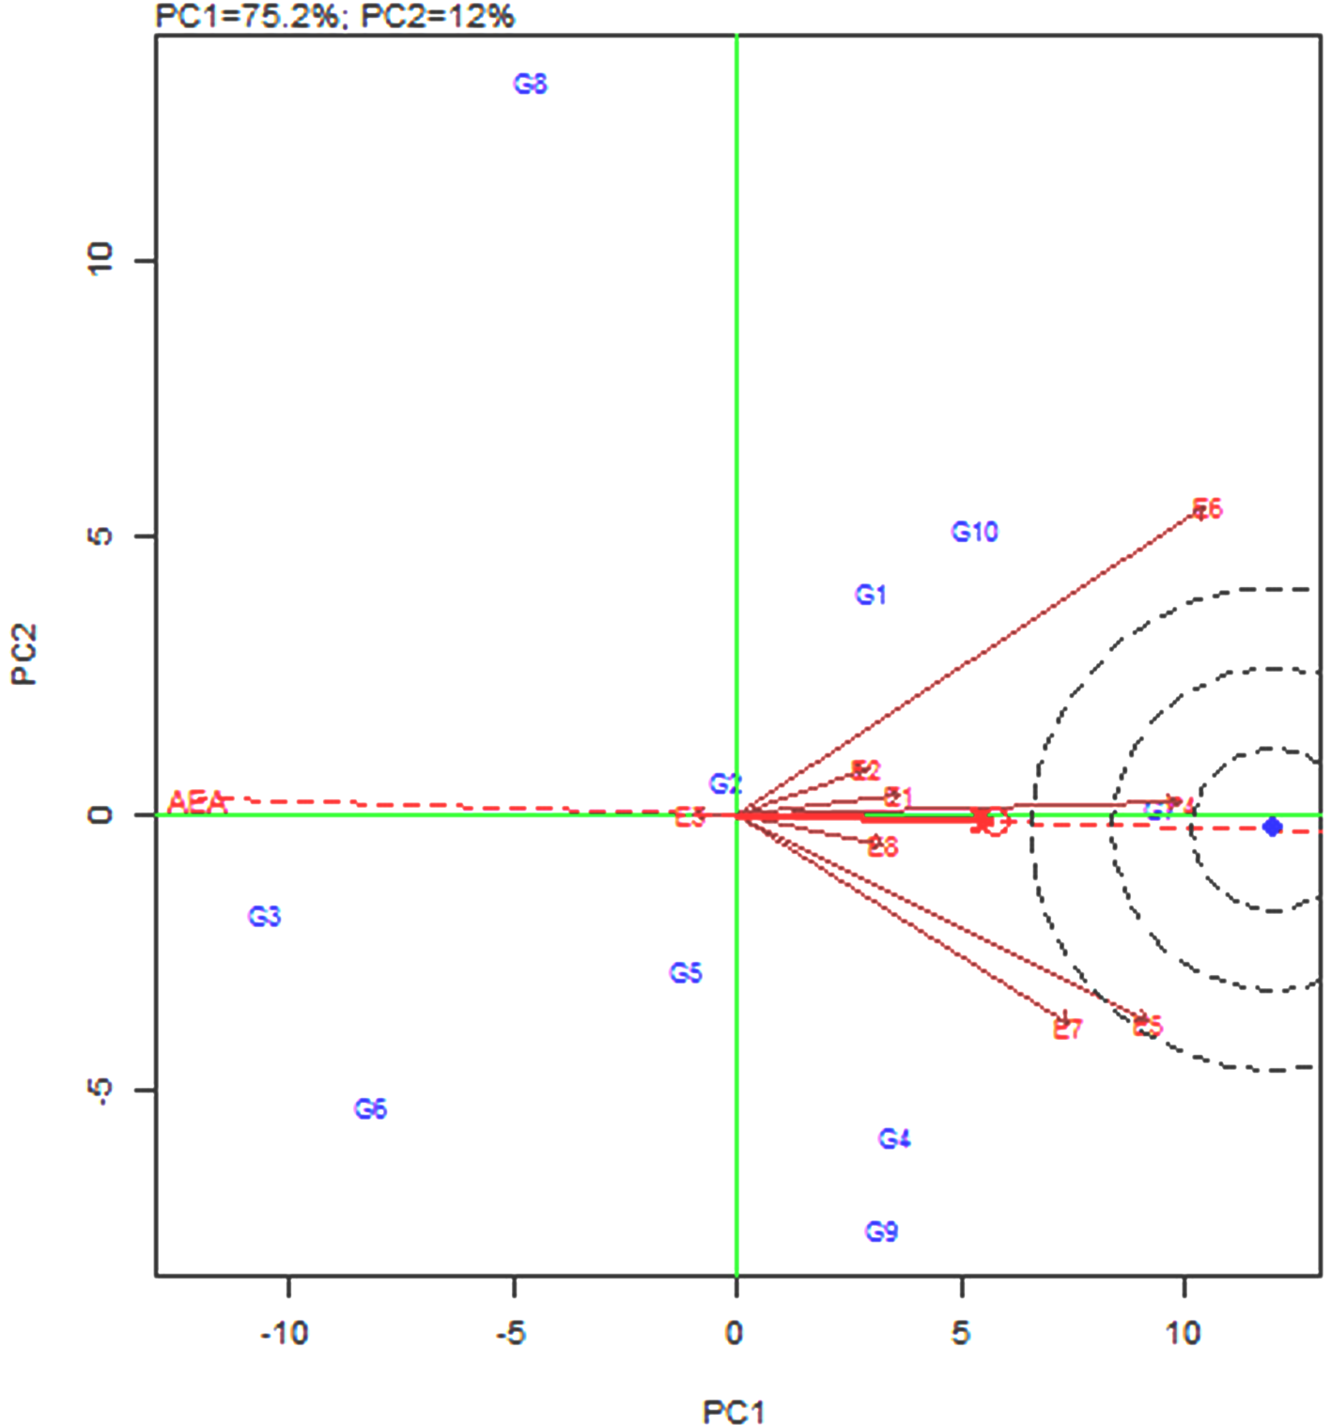
Fig S7. GGE-Environment Biplot for TN during DS
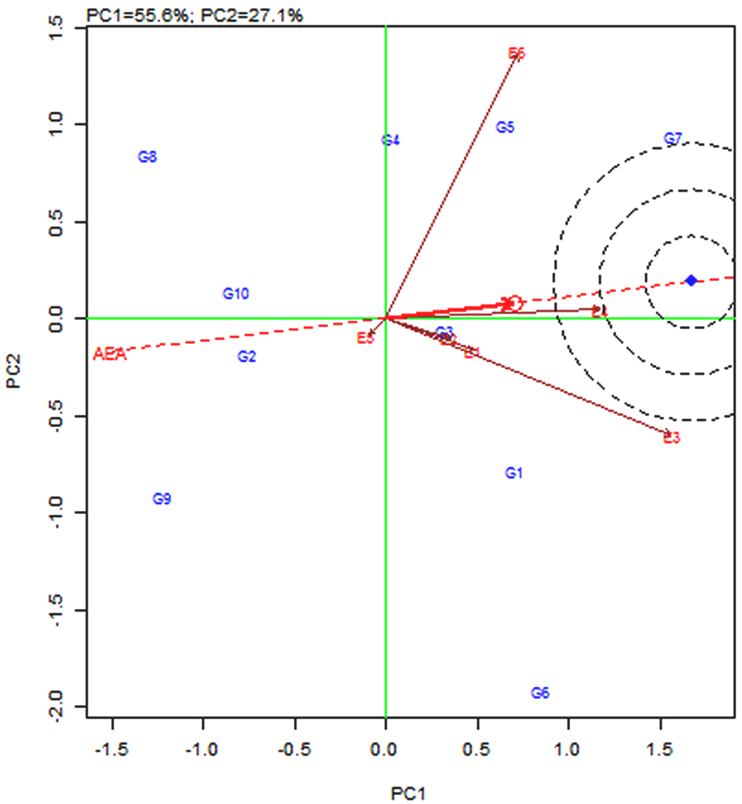
Fig S8. GGE-Environment Biplot for Fe during DS
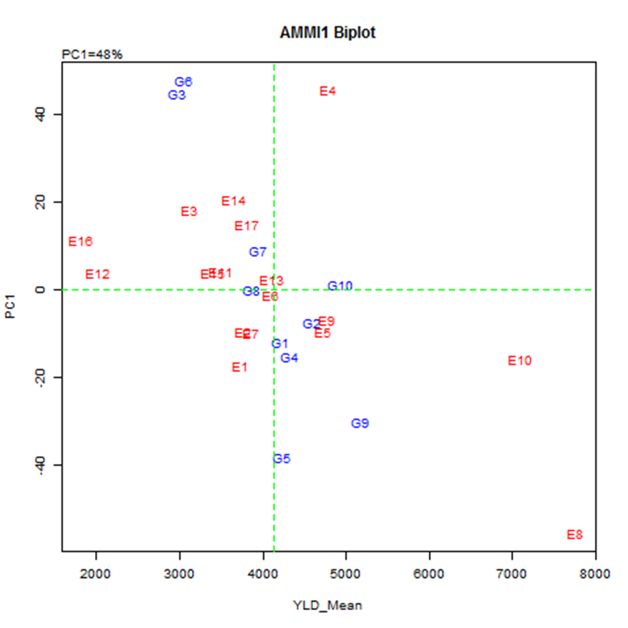
Fig S9. AMMI Biplot for YLD in combined analysis
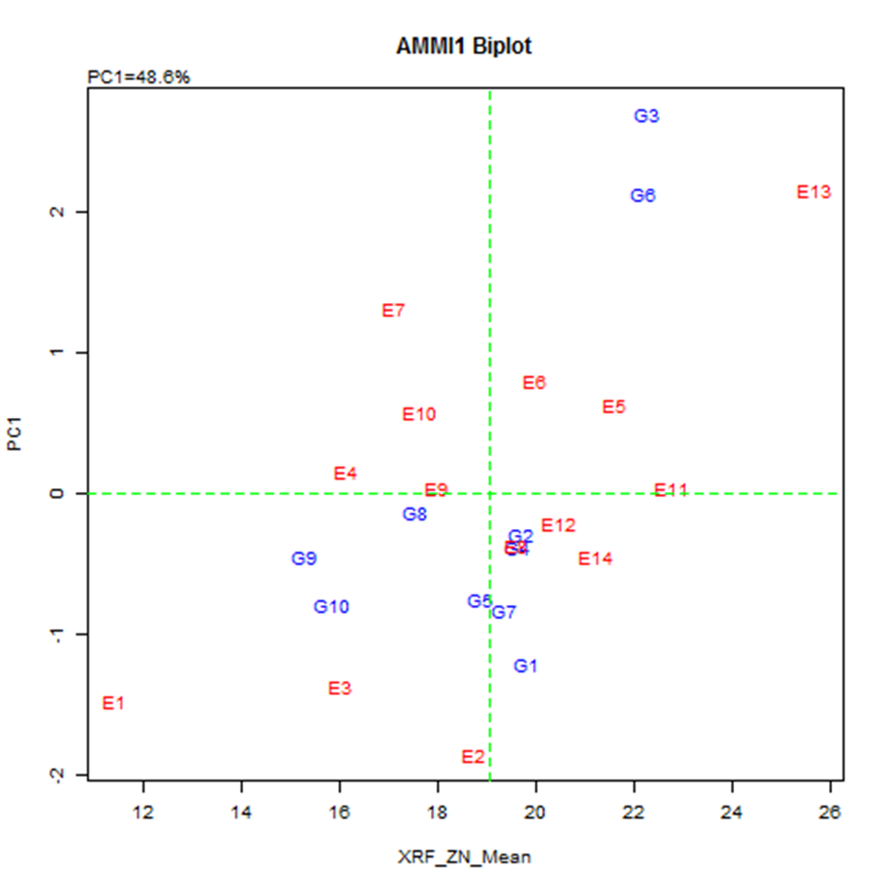
Fig S10. AMMI Biplot for Zn in combined analysis
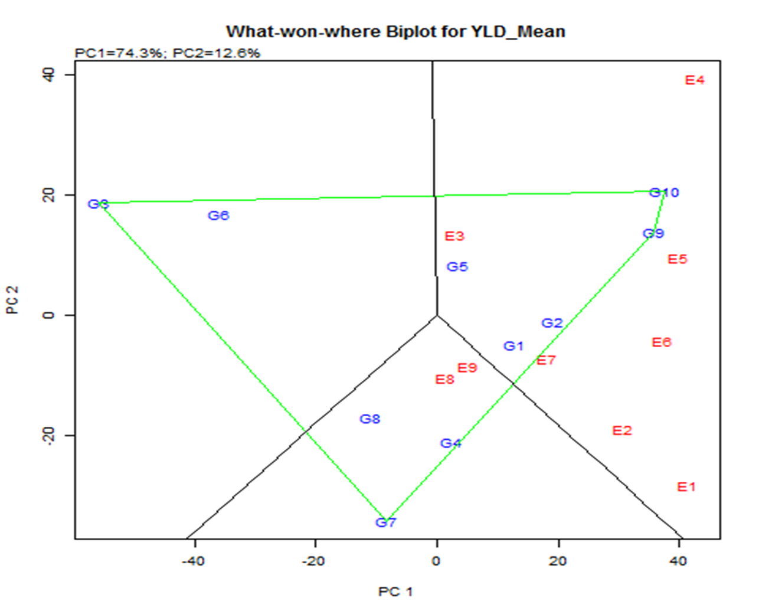
Fig S11. What-won-where plot for YLD during WS
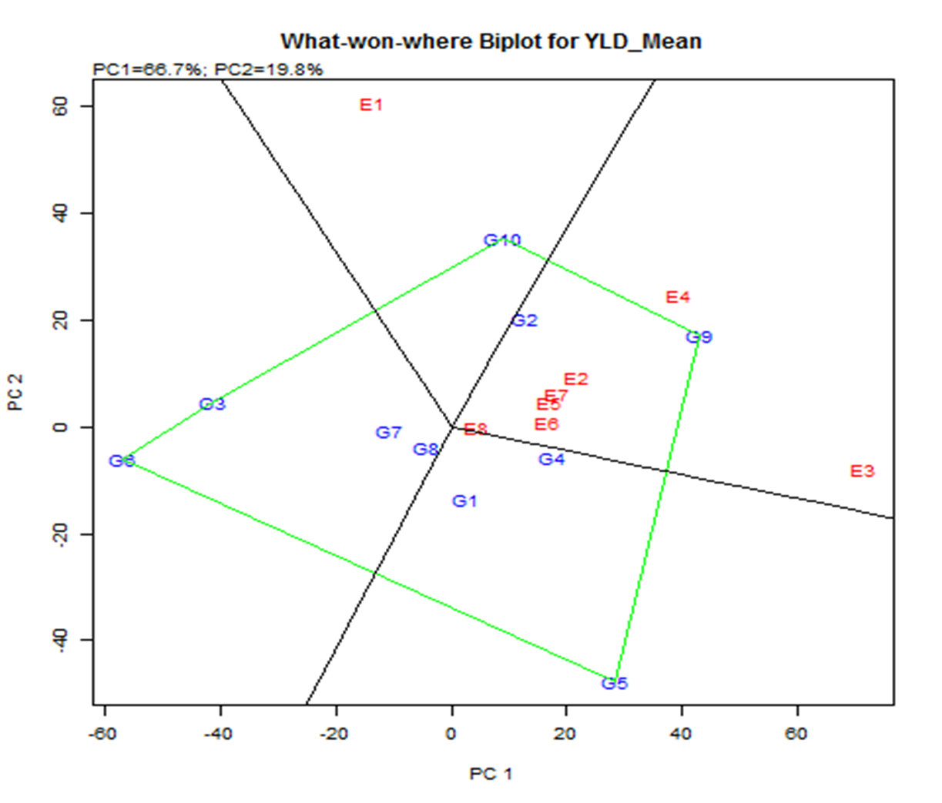
Fig S12. What-won-where plot for YLD during DS
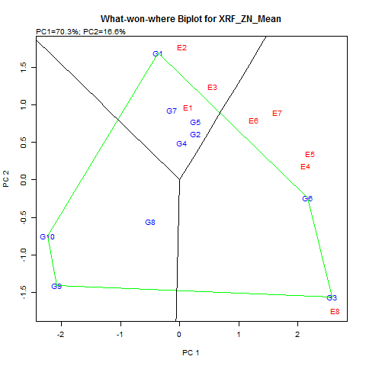
Fig S13. What-won-where plot for Zn during WS

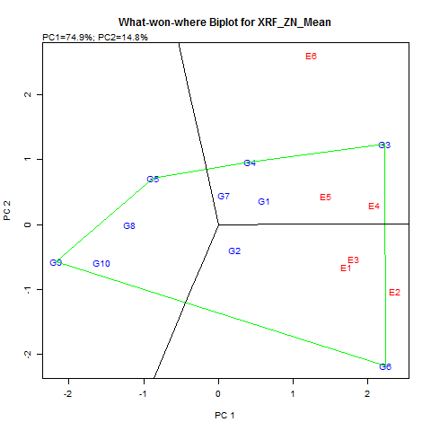
Fig S14. What-won-where plot for Zn during DS
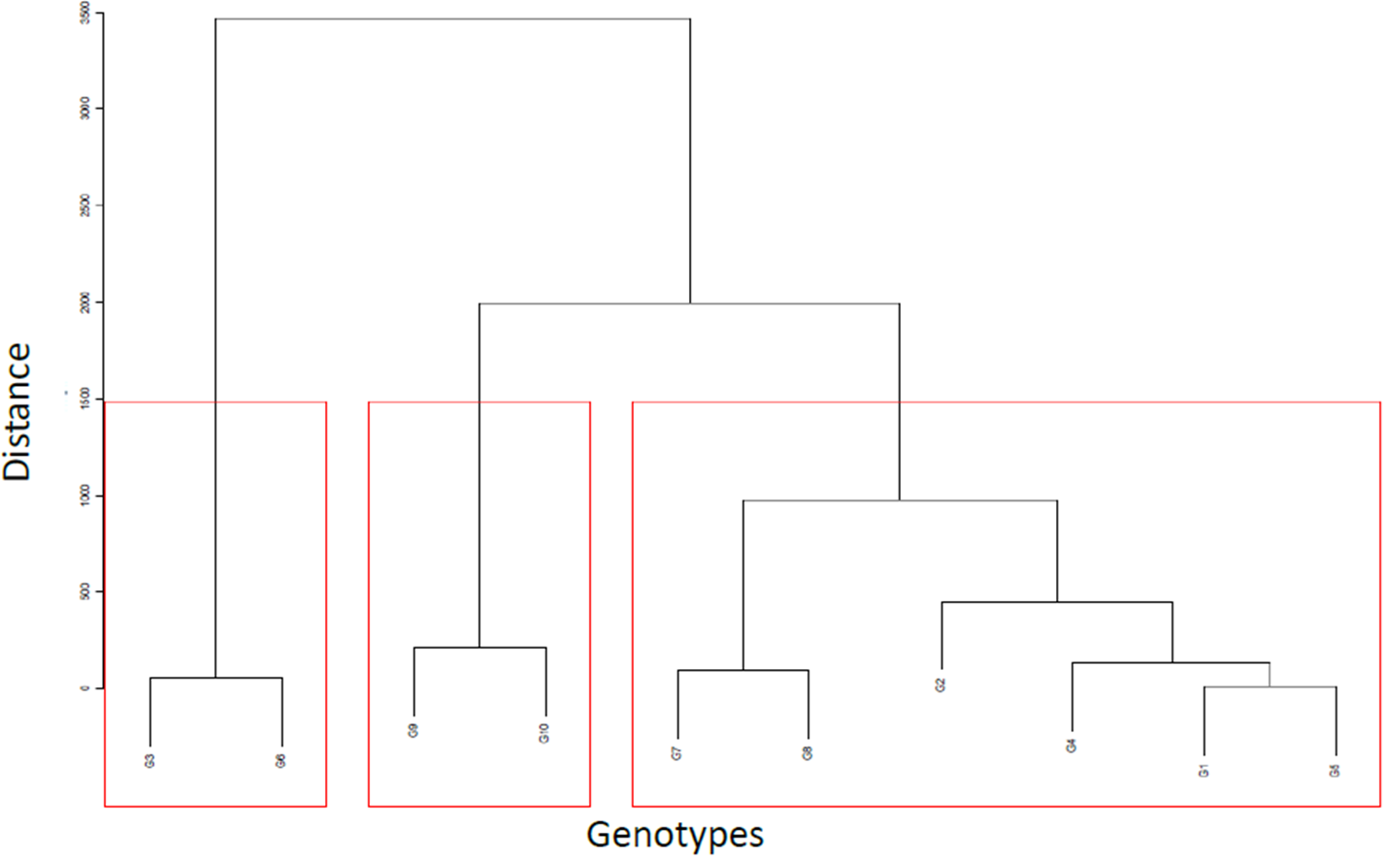
Fig S15. Diversity among the high-Zn rice genotypes

