Quality Control report for Unet 2D model (Urediomodel v 1.0) Date: 2023-08-18

Figure S1. Model training curves
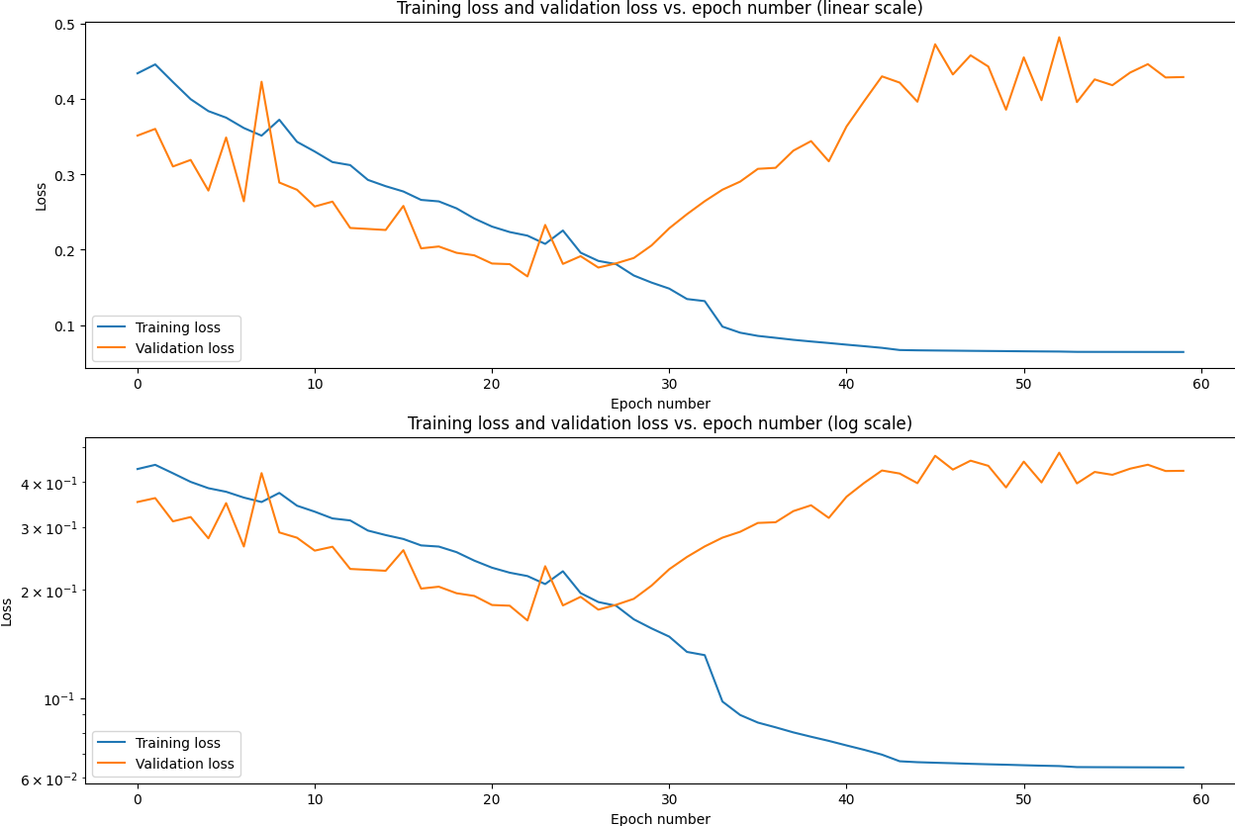

Figure S2. Model threshold optimisation.
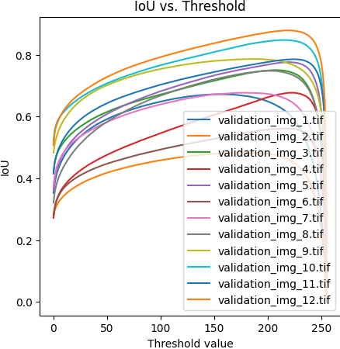

Figure S3. Example of quality control visualisation:
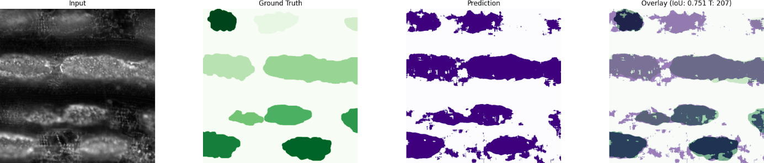

Figure S4. Model quality metrics.
