TABLE S1 | List of the spelt varieties used in the agronomic field trials, along with their country of origin and year of inscription on official lists, when applicable. “nd” stands for “not defined”, for varieties not inscribed on any official list yet.

Variety | Origin (Breeder) | Inscription year |  | Variety | Origin (Breeder) | Inscription year
Oberkulmer Rotkorn | Agroscope/DSP | 1948 |  | Dottenfelder Rotling | Dottenfelderhof, DE | 2017
Ostro | Agroscope/DSP | 1978 |  | DSA20_141 | GZPK | n.d.
Polkura | Agroscope/DSP | 2019 |  | DSP20_97 | GZPK | n.d.
Selun | Agroscope/DSP | 2019 |  | DSP20_89 | GZPK | n.d.
Dinkatou | Agroscope/DSP | 2019 |  | DSP20_17 | GZPK | n.d.
Comburger | IG Pflanzenzucht, DE | 2016 |  | DSP20_7 | GZPK | n.d.
Hohenloher | IG Pflanzenzucht, DE | 2016 |  | Bauländer Spelz | DE
Hubel | Agroscope/DSP | 1992 |  | Schwabenkorn | Hohenhein, DE
Werthensteiner Weisskorn |  | Landrace, not registered |  | Badenkrone | ZG Raiffeisen, DE
Tellenbacher Rotkorn |  | Landrace, not registered |  | Franckenkorn | IG Pflanzenzucht, DE
Rubiota | Czech Rep |  |  | Tauro | GZPK | 2004
SM Orkus | Poland |  |  | Titan | GZPK | 2004
Mv Vitalgold | Martonvasar, HU |  |  | Zürcher Oberländer | GZPK | 2012
Mv Martongold | Martonvasar, HU
Zollernfit | SWD Saatzucht, DE | 2020
Zollernspelz | Saaten-Union, DE | 2006
Zollernperle | Saaten-Union, DE
Copper | GZPK | 2018
Edelweisser | GZPK | 2018
Flauder | GZPK | 2019
Gletscher | GZPK | 2018
Raisa | GZPK | 2018
Serpentin | GZPK | 2018
DSP20_1 | GZPK | n.d.
DSP20_3 | GZPK | n.d.
DSP20_5 | GZPK | n.d.
DSP20_8 | GZPK | n.d.
DSP20_36 | GZPK | n.d.
DSA20_115 | GZPK | n.d.
DSA20_118 | GZPK | n.d.
DSA20_135 | GZPK | n.d.
DSA20_142 | GZPK | n.d.
DSA20_122 | GZPK | n.d.
DSA20_124 | GZPK | n.d.
DSA20_130 | GZPK | n.d.
DSA20_132 | GZPK | n.d.
DSA20_133 | GZPK | n.d.

TABLE S2 | Climatic data for the two growing seasons and the three sites (postcodes 1260, 1567 and 8714)
 | October 2020 - July 2021 |  |  | October 2021 - July2022
Postcode | Changins | Delley | Feldbach | Changins | Delley | Feldbach
Cumulated precipitation | 1057.5 | 1040.1 | 1463.2 | 550.2 | 554.5 | 784.6
Average temperature | 9.47 | 8.28 | 8.53 | 10.56 | 9.17 | 9.64
Maximal temperature | 30.7 | 30.3 | 31.2 | 35.8 | 35.7 | 34.3
Minimal temperature | -5.7 | -7.6 | -10.2 | -4.3 | -5.5 | -5
Cumulated hours of sunshine | 1432.3 | 1251.2 | 1251.8 | 1838.7 | 1676.25 | 1652.4

TABLE S3 | List of the spelt varieties used in the extended field trials along with their type (winter or spring) and identification number, when available.

Type | Identification number | Name
spring | NA | Wirtas
spring | NA | Flauder
spring | TS0001 | NA
spring | TS0002 | NA
spring | TS0006 | NA
spring | TS0034 | NA
spring | TS0035 | NA
spring | NA | Nendaz
spring | 01C0200984_ | _T._spelta..(Kew)
spring | 01C0200985_ | _T._spelta..(Szeged)_
spring | 01C0200986_ | _T._spelta..(Roma)
spring | 01C0204323_ | _T._spelta..(Tabor)_
spring | 01C0204865_ | _T._spelta...(VIR_St.Petersburg)_
spring | CGN08294 | Weisser_Kolbenspelz
spring | NGB15698 | Spelt_fra_Oland
spring | NGB4496 | SPELTVETE_FRAN_GOTLAND
spring | NGB4798 | Lantvete_FRAN_Oland
spring | NGB9700 | KVL8930
spring | PI_355681 | Sofia_1
spring | PI_378480 | NA
spring | PI_469028 | MG_27185
spring | PI_469051 | NA
spring | PI_469052 | MG_27216
spring | PI_469053 | NA
spring | PI_591891 | Asturien
spring | TRI_2258 | NA
spring | TRI_3419 | Schwarzer_Bartspelz
spring | TRI_3445 | Blauer_Samtiger
spring | TRI_869 | Lohnauer_Sommerspelz
spring | TRI_870 | WeiÃŸer_Grannenspelz
spring | TS1988 | T115
spring | 01C0200983_ | _T._spelta..(Ruzyne)
spring | CGN08276 | Roter_Sommerspelz
spring | CGN08278 | Spelz_aus_Tsari_Brod
spring | CGN08283 | NA
spring | NGB14119 | GOTRO
spring | PI_294576 | Spelt_Gray
spring | PI_295061 | Ungarn
spring | PI_306550 | 2943
spring | PI_306551 | 2944
spring | PI_355660 | Gelber_Badischer_Spelz
spring | PI_362062 | NA
spring | PI_362062 | NA
spring | PI_362063 | NA
spring | PI_378469 | 1744
spring | PI_469026 | MG_27183
spring | PI_469027 | MG_27184
spring | PI_471924 | NA
spring | PI_608792 | Tomarense
spring | TRI_474 | Spelz_aus_Tzaribord
spring | BP01 | NA
spring | BP02 | NA
winter | NA | MV-MARTONGOLD
winter | NA | MV-VITALGOLD
winter | NA | TSP17-20
winter | NA | TSP18-20
winter | NA | TSP20-20
winter | NA | TSP22-20
winter | NA | TSP23-20
winter | NA | TSP25-20
winter | NA | TSP26-20
winter | NA | TSP29-20
winter | NA | TSP30-20
winter | NA | TSP31-20
winter | NA | TSP32-20
winter | NA | TSP33-20
winter | NA | TSP34-20
winter | NA | TSP35-20
winter | NA | TSP36-20
winter | NA | TSP10-21
winter | NA | TSP21-21
winter | NA | TSP22-21
winter | NA | TSP23-21
winter | NA | TSP24-21
winter | NA | TSP25-21
winter | NA | D-7-010-99-02
winter | NA | D-7-019-99-02
winter | NA | TSP04-09
winter | NA | ERYT333
winter | NA | F98047G14-2INC
winter | NA | KNIISH74
winter | NA | KNIISH122
winter | NA | MV-KOLOMPOS
winter | NA | MV-MAGVAS
winter | NA | MV-TOLDI
winter | NA | Pietro
winter | NA | Benedetto
winter | NA | Giuseppe
winter | NA | Rita,
winter | NA | Maddalena
winter | NA | Rossella
winter | NA | 98.34.4.6.1
winter | NA | 2.15.8.4.4
winter | NA | Albin
winter | NA | Ardenne
winter | NA | Cosmos
winter | NA | Divepi
winter | NA | Epanis
winter | NA | Epimi
winter | NA | Franckenkorn
winter | NA | Hercule
winter | NA | Lignee 2
winter | NA | Lignee 10
winter | NA | Lignee 24
winter | NA | Lignee 73
winter | NA | Poeme
winter | NA | Redoute
winter | NA | Renval
winter | NA | Ressac
winter | NA | Rusio
winter | NA | Serenite
winter | NA | Spy
winter | NA | Stone
winter | NA | Vif
winter | NA | RL130,1
winter | NA | RL155
winter | NA | RL214,2
winter | NA | RL23
winter | NA | RL234
winter | NA | RL240
winter | NA | Castell
winter | NA | HSIOGU316
winter | NA | HSIOGU316
winter | NA | HZASO316
winter | NA | HZASO316
winter | NA | HZASO316
winter | NA | HMUHO316
winter | NA | HTIGU316
winter | NA | HTIRI316
winter | NA | HTISCH316
winter | NA | HREGU316
winter | NA | HTIFR316
winter | NA | HZAFR316
winter | NA | HZAFR316
winter | NA | HTIRO316
winter | NA | HFRAGU416
winter | NA | HFRAGU416
winter | NA | HFSO416
winter | NA | HZOGG416
winter | NA | HZONG416
winter | NA | HZONG416
winter | NA | HAAHO316
winter | NA | HZROT316
winter | NA | HZROT316
winter | NA | HFRAGU316
winter | NA | HFMUR316
winter | NA | HZLO316
winter | NA | HZLO316
winter | NA | HZLO316
winter | NA | HZONG316
winter | NA | HZAGU316
winter | NA | HZAGU316
winter | NA | HALS416
winter | NA | HAAGA316
winter | NA | HAAGA316
winter | NA | HZKR316
winter | NA | HCOLO316
winter | NA | HAZOKO316
winter | NA | HFHO316
winter | NA | HZOKR316
winter | NA | HZONG316
winter | NA | HZONG316
winter | NA | HZKEZ316
winter | NA | HZKEZ316
winter | NA | HZAGU316
winter | NA | HZAGU316
winter | NA | HZAGU316
winter | NA | ZDSZO415
winter | NA | ZDSZO415
winter | NA | ZDSZO415
winter | 361.10001 | Oberkulmer
winter | 311.10002 | Ostro
winter | 311.10118 | Polkura
winter | 311.1013 | Selun
winter | 311.10134 | Dinkatou
winter | 392.10006 | Comburger
winter | 391.10065 | Hohenloher
winter | 361.10033 | WerthensteinerW
winter | 361.10032 | TellenbacherRoK
winter | 391.10066 | Rubiota
winter | 391.10067 | SM Orkus
winter | 391.10068 | Mv Vitalgold
winter | 391.10069 | Mv Martongold
winter | 392.10012 | Zollernfit
winter | 391.10052 | Zollernspelz
winter | 391.1007 | Zollernperle
winter | 391.10053 | Copper
winter | 391.10056 | Edelweisser
winter | 391.1006 | Flauder
winter | 391.10057 | Gletscher
winter | 391.10055 | Raisa
winter | 391.10058 | Serpentin
winter | 391.10071 | DSP20_1
winter | 391.10072 | DSP20_3
winter | 391.10073 | DSP20_5
winter | 391.10074 | DSP20_8
winter | 391.10075 | DSP20_36
winter | 391.10076 | DSA20_115
winter | 391.10077 | DSA20_118
winter | 391.10078 | DSA20_135
winter | 391.10079 | DSA20_142
winter | 391.1008 | DSA20_122
winter | 391.10081 | DSA20_124
winter | 391.10082 | DSA20_130
winter | 391.10083 | DSA20_132
winter | 391.10084 | DSA20_133
winter | 391.10085 | Dottenfelder Rotling
winter | 391.10086 | DSA20_141
winter | 391.10087 | DSP20_97
winter | 391.10088 | DSP20_89
winter | 391.10089 | DSP20_17
winter | 391.1009 | DSP20_7
winter | 391.10091 | Baulander Spelz
winter | 391.10004 | Schwabenkorn
winter | 391.10061 | Badenkrone
winter | 391.10022 | Franckenkorn
winter | 391.10044 | Tauro
winter | 991.59188 | Titan
winter | 391.1005 | Zurcher Oberlander
winter | NA | Muenstertaler
winter | TS0038 | Vor 1A
winter | TS0048 | Vor 2C
winter | TS0052 | Vor 3C
winter | TS0060 | Vor 4E
winter | TS0070 | Vor 6C
winter | TS0077 | Osch 1N
winter | TS0109 | Osch 23A
winter | TS0113 | Osch 24C
winter | TS0150 | Osch 32E
winter | TS0161 | Schw 1K
winter | TS0176 | Schw 3H
winter | TS0459 | Schw 56A
winter | TS0462 | Schw 56E
winter | TS0464 | Schw 57B
winter | TS0517 | Schw 75D
winter | TS0522 | Alb 1E
winter | TS0572 | Alb 14B
winter | TS0577 | Alb 15D
winter | TS0619 | Alb 27F
winter | TS0625 | Alb 50C
winter | TS0627 | Alb 51Ia
winter | TS0712 | Alb 86F
winter | TS0873 | Alb 125D
winter | TS0882 | Alb 127A
winter | TS0957 | Gugg 2B
winter | TS0961 | Gugg 2G
winter | TS0962 | Gugg 2H
winter | TS0963 | Gugg 4A
winter | TS0964 | Gugg 4B
winter | TS0965 | Gugg 4D
winter | TS0969 | Gugg 4H
winter | TS0971 | Gugg 5C
winter | TS0976 | Gugg 6D
winter | TS0977 | Gugg 6E
winter | TS0978 | Gugg 6G
winter | TS0979 | Gugg 6H
winter | TS0982 | Gugg 7E
winter | TS0985 | Gugg 8C
winter | TS0987 | Gugg 9B
winter | TS0990 | Gugg 9E
winter | TS0992 | Gugg 9H
winter | TS0997 | Gugg 10H
winter | TS0998 | Gugg 10K
winter | TS0999 | Gugg 11A
winter | TS1004 | Gugg 11G
winter | TS1006 | Gugg 12A
winter | TS1011 | Gugg 12I
winter | TS1014 | Gugg 12O
winter | TS1016 | Napf 1B
winter | TS1017 | Napf 1C
winter | TS1018 | Napf 1D
winter | TS1019 | Napf 1F
winter | TS1020 | Napf 2A
winter | TS1021 | Napf 2B
winter | TS1022 | Napf 2E
winter | TS1026 | Napf 2L
winter | TS1029 | Napf 3A
winter | TS1031 | Napf 3C
winter | TS1034 | Napf 3K
winter | TS1036 | Napf 3N
winter | TS1037 | Napf 3O
winter | TS1038 | Napf 3P
winter | TS1042 | Napf 4D
winter | TS1044 | Napf 4H
winter | TS1047 | Napf 5D
winter | TS1051 | Napf 8A
winter | TS1052 | Napf 8B
winter | TS1060 | Mit. 1B
winter | TS1064 | Mit.2C
winter | TS1065 | Mit.2D
winter | TS1067 | Mit.2G
winter | TS1068 | Mit.2I
winter | TS1070 | Mit.3C
winter | TS1071 | Mit.3D
winter | TS1072 | Mit.3E
winter | TS1074 | Mit.3G
winter | TS1079 | Mit.4E
winter | TS1080 | Mit.4F
winter | TS1085 | Toess 1F
winter | TS1086 | Toess 2A
winter | TS1089 | Toess 2D
winter | TS1091 | Toess 2F
winter | TS1092 | Toess 2H
winter | TS1096 | Toess 2N
winter | TS1099 | Toess 3D
winter | TS1102 | Toess 3H
winter | TS1104 | Toess 4B
winter | TS1115 | Toess 6D
winter | TS1116 | Toess 6E
winter | TS1128 | Bld.2A
winter | TS1138 | Bld.5B
winter | TS1242 | Bld.37A
winter | TS1244 | Bld.38B
winter | TS1318 | Bld.61B
winter | TS1320 | Eif.6B
winter | TS1401 | Eif.50C
winter | TS1432 | Ard.10B
winter | TS1450 | Ard.15C
winter | TS1471 | Ard.21E
winter | TS1490 | Ard.27D
winter | TS1499 | Ard.28G
winter | TS1508 | Ard.31C
winter | TS1515 | Ard.32F
winter | TS1549 | Ast 6A
winter | TS1621 | Ast 17C
winter | TS1639 | Ast 20B
winter | TS1698 | Ast 29K
winter | TS1744 | Ast 35B
winter | TS1748 | Ast 35F
winter | TS1757 | Ast 37E
winter | TS1783 | Ast 40M
winter | TS1784 | Ast 41A
winter | TS1798 | Ast 42E
winter | TS1801 | Ast 42H
winter | TS1802 | Ast 43A
winter | TS1803 | Ast 43B
winter | TS1823 | Ast 45A
winter | TS1825 | Ast 45C
winter | TS1851 | Ast 48I
winter | TS1854 | Ast 49A
winter | TS1859 | Ast 49F
winter | TS1860 | Ast 49G
winter | TS1861 | Ast 49H
winter | TS1863 | Ast 50C
winter | TS2022 | Steiners Roter Tiroler
winter | TS2024 | Altgold
winter | TS2071 | V.Rechbergs Brauner Winterspelz
winter | TS2074 | Rottweiler Dinkel St.6
winter | TS2077 | Blauer Winter Kolbendinkel
winter | TS2082 | 65107
winter | TS2083 | Lueg
winter | TS2085 | Hubel
winter | TS2101 | Rouquin
winter | TS2102 | 65110
winter | TS2107 | 65171
winter | TS2108 | 65205
winter | TS2110 | 65207
winter | TS2112 | Synth Spelz
winter | TS2117 | Neuegger Weisskorn Ngg42
winter | TS2119 | Burgdorfer Weiskorn Bgd1
winter | TS2132 | Riniker Weisskorn
winter | TS2144 | Huesler Rotkorn Hn19
winter | TS2150 | Roter Schlegel Dinkel
winter | TS2165 | Rottweiler Fruehkorn 1
winter | TS2174 | LONIGO
winter | TS2175 | T.spelta No 31
winter | TS2200 | Sammetiger Winter Kolbenspelz
winter | TS2206 | Schwarzer Wintergrannen Spelz
winter | TS2207 | Schwarzer Grannenspelz
winter | TS2210 | T.Spelta No 45
winter | TS2211 | Mutant Var Allemande Oe6/1/1
winter | TS2221 | 65218
winter | TS2222 | 65219
winter | TS2225 | 65224
winter | TS2230 | GREY
winter | TS2232 | Schw 8C
winter | TS2234 | Schw 18A
winter | TS2245 | Balmegg
winter | TS2248 | 65251
winter | TS2278 | Zuzgen Zg 15A
winter | TS2317 | 65299
winter | TS2325 | 65307
winter | TS2328 | 65310
winter | TS2329 | 65311
winter | TS2332 | 65314
winter | TS2338 | 65326
winter | TS2340 | 65336
winter | TS2343 | 65342
winter | TS2344 | 65344
winter | TS2345 | 65350 Gbl63.1
winter | TS2351 | 66092 Tora
winter | TS2365 | Alkor
winter | TS2370 | 311.10132
winter | TS2371 | 311.10133
winter | TS2076 | Vogelers Dinkel weiss
winter | TS2164 | Steiners Roter Tiroler Dinkel
winter | 111.1142 | RUNAL
winter | 111.12754 | CH CLARO
winter | 111.13197 | CH NARA
winter | 111.15126 | BARETTA (Ble)
winter | 111.15145 | MONTALBANO
winter | 111.15185 | ROSATCH
winter | 211.1388 | DIAVEL
winter | 191.11795 | APWE8.11
winter | 111.1001 | ARINA
winter | 191.11364 | SPONTAN
winter | 191.11782 | EMBLEM (NEW)
winter | 142.10138 | APBH.5219-447
winter | 111.14645 | DILAGO
winter | 191.11175 | SAILOR
winter | 191.11702 | CAMPESINO
winter | 332.10004 | ostro barbu

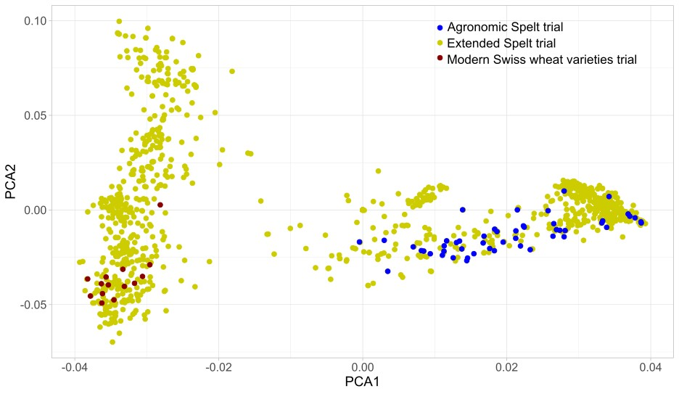
Fig. S1: Principal component analysis based on the full genomic dataset. Datapoints include the agronomic spelt trial containing the 50 spelt varieties of interest (in blue), modern Swiss wheat varieties from the national variety testing trials (in red) and other spelt and wheat varieties coming from the extended spelt trial and the study from Müller (in yellow). In this paper, we will focus on the agronomic spelt varieties (in blue).

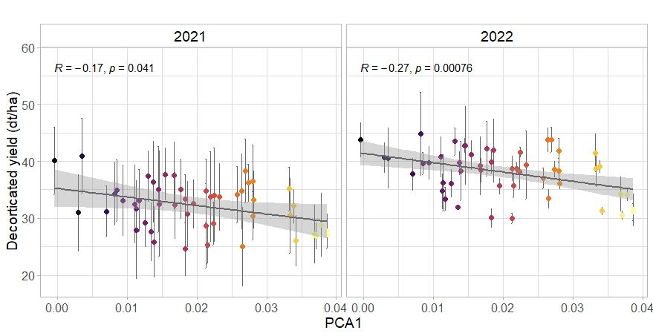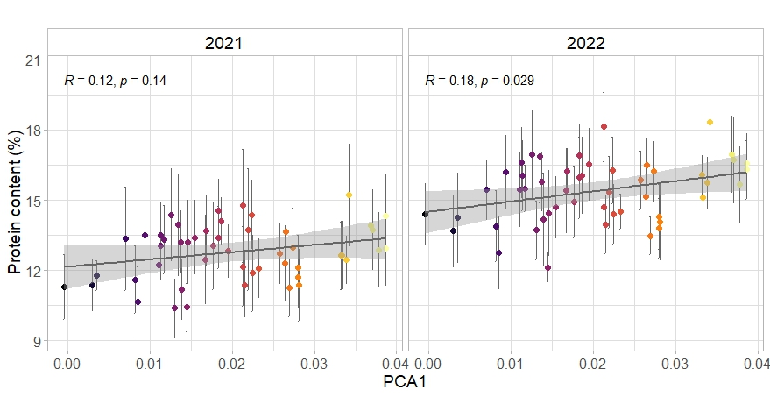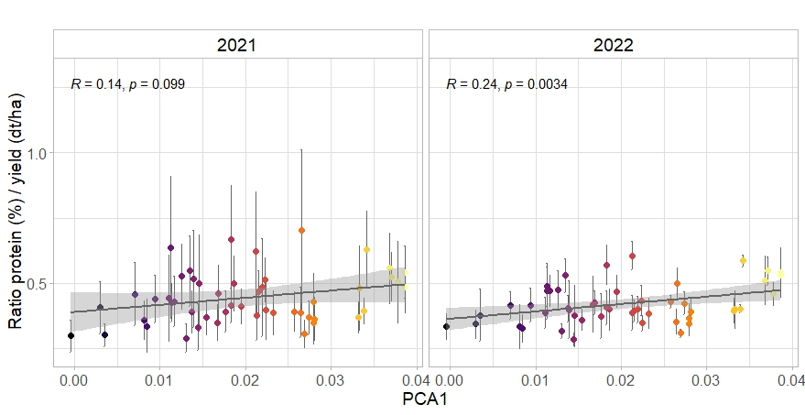
Fig. S2: Relationship between dehusked yield (dt/ha) and genetic distance to reference wheat (PCA1, i.e. proxy for spelt typicity) for 2021 and 2022. n = 450 per year. Dots represent the mean values across replicates and sites; lines represent the standard error.
The grey lines represent linear regression fittings, with the grey area representing the 0.95 confidence interval.

Fig. S3: Relationship between protein content (%) and genetic distance to reference wheat (PCA1, i.e. proxy for spelt typicity) for 2021 and 2022. n = 450 per year. Dots represent the mean values across replicates and sites; lines represent the standard error.
The grey lines represent linear regression fittings, with the grey area representing the 0.95 confidence interval.

Fig. S4: Relationship between ratio protein/yield and genetic distance to reference wheat (PCA1, i.e. proxy for spelt typicity) for 2021 and 2022. n = 450 per year. Dots represent the mean values across replicates and sites; lines represent the standard error.
The grey lines represent linear regression fittings, with the grey area representing the 0.95 confidence interval.

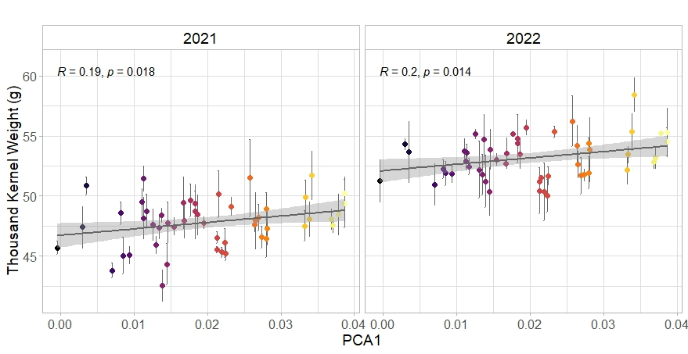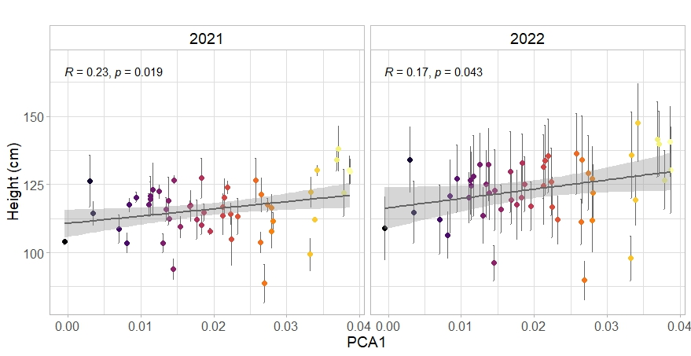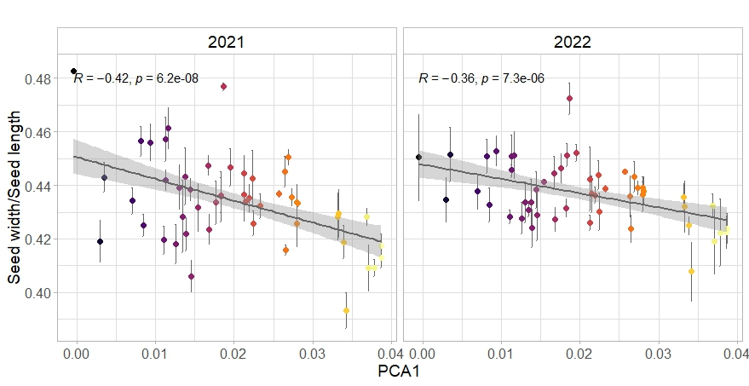
Fig. S5: Relationship between thousand kernel weight (g) and genetic distance to reference wheat (PCA1, i.e. proxy for spelt typicity) for 2021 and 2022. n = 450 per year. Dots represent the mean values across replicates and sites; lines represent the standard error.
The grey lines represent linear regression fittings, with the grey area representing the 0.95 confidence interval.

Fig. S7: Relationship between height (cm) and genetic distance to reference wheat (PCA1, i.e. proxy for spelt typicity) for 2021 and 2022. n = 450 per year. Dots represent the mean values across replicates and sites; lines represent the standard error.
The grey lines represent linear regression fittings, with the grey area representing the 0.95 confidence interval.

Fig. S6: Relationship between seed width/seed length and genetic distance to reference wheat (PCA1, i.e. proxy for spelt typicity) for 2021 and 2022. n = 450 per year. Dots represent the mean values across replicates and sites; lines represent the standard error.
The grey lines represent linear regression fittings, with the grey area representing the 0.95 confidence interval.

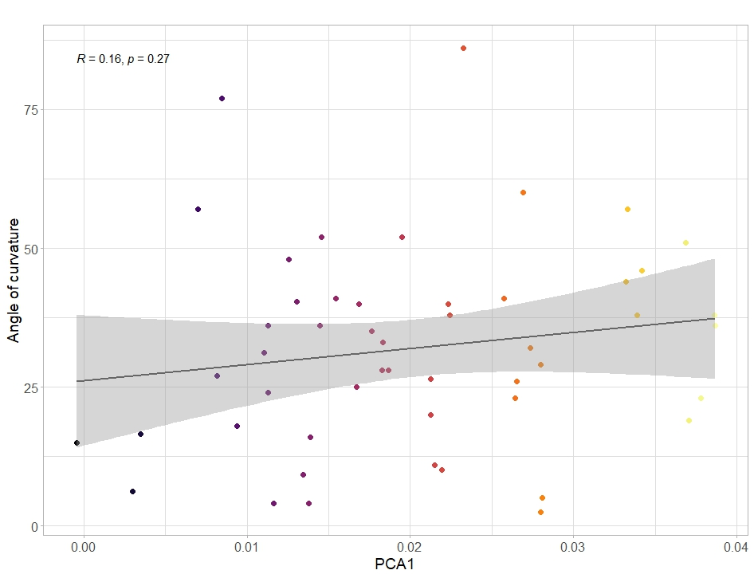
Fig. S8: Relationship between angle of curvature (°) and genetic distance to reference wheat (PCA1, i.e. proxy for spelt typicity) for 2021 in 1260. n = 50 per year.
The grey lines represent linear regression fittings, with the grey area representing the 0.95 confidence interval.

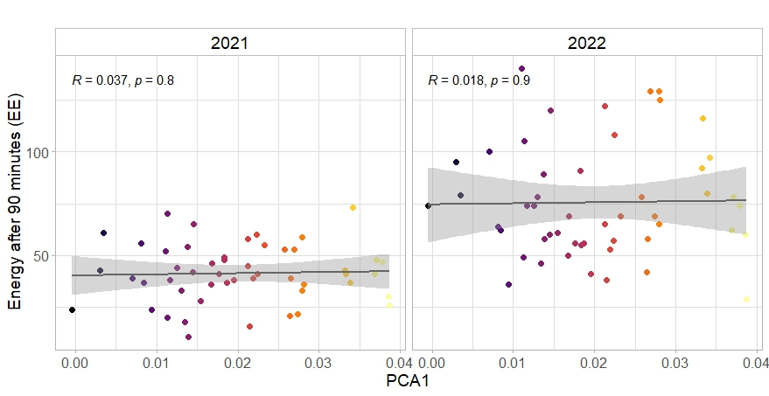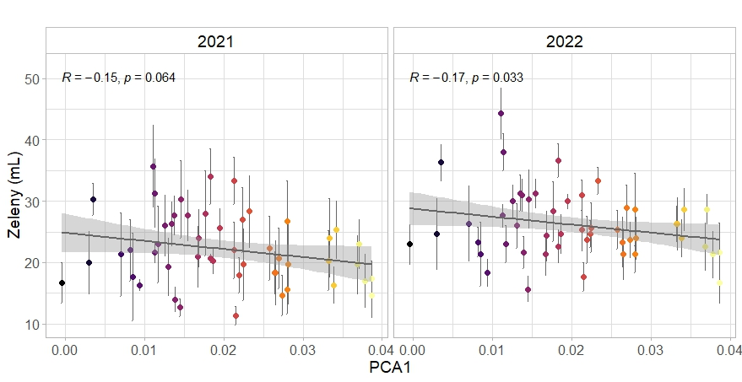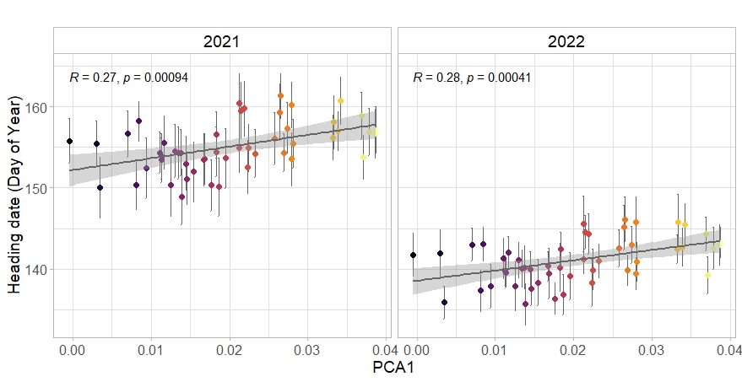
Fig. S10: Relationship between Zeleny (mL) and genetic distance to reference wheat (PCA1, i.e. proxy for spelt typicity) for 2021 and 2022. n = 150 per year. Dots represent the mean values across sites; lines represent the standard error.
The grey lines represent linear regression fittings, with the grey area representing the 0.95 confidence interval.

Fig. S11: Relationship between energy after 90 minutes (EE) and genetic distance to reference wheat (PCA1, i.e. proxy for spelt typicity) for 2021 and 2022 in 1260. n = 50 per year.
The grey lines represent linear regression fittings, with the grey area representing the 0.95 confidence interval.

Fig. S9: Relationship between heading date (day of year) and genetic distance to reference wheat (PCA1, i.e. proxy for spelt typicity) for 2021 and 2022. n = 450 per year. Dots represent the mean values across replicates and sites; lines represent the standard error.
The grey lines represent linear regression fittings, with the grey area representing the 0.95 confidence interval.

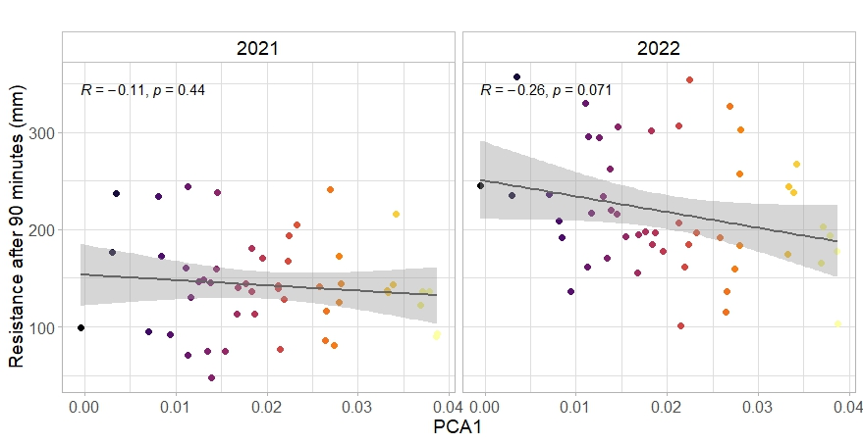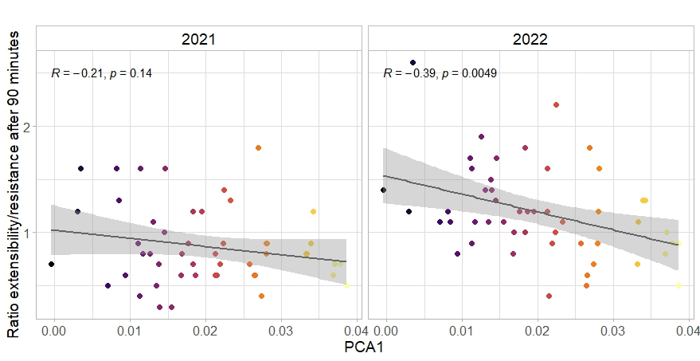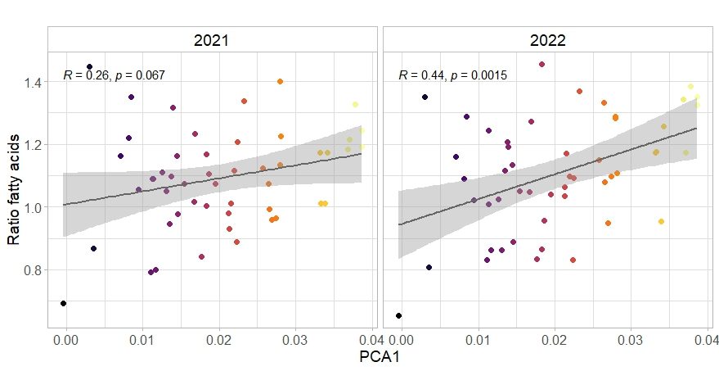
Fig. S12: Relationship between resistance after 90 min (mm) and genetic distance to reference wheat (PCA1, i.e. proxy for spelt typicity) for 2021 and 2022 in 1260. n = 50 per year.
The grey lines represent linear regression fittings, with the grey area representing the 0.95 confidence interval.

Fig. S13: Relationship between ratio extensibility/resistance and genetic distance to reference wheat (PCA1, i.e. proxy for spelt typicity) for 2021 and 2022 in 1260. n = 50 per year.
The grey lines represent linear regression fittings, with the grey area representing the 0.95 confidence interval.

Fig. S14: Relationship between oleic/palmitic acids and genetic distance to reference wheat (PCA1, i.e. proxy for spelt typicity) for 2021 and 2022 in 1260. n = 50 per year.
The grey lines represent linear regression fittings, with the grey area representing the 0.95 confidence interval.

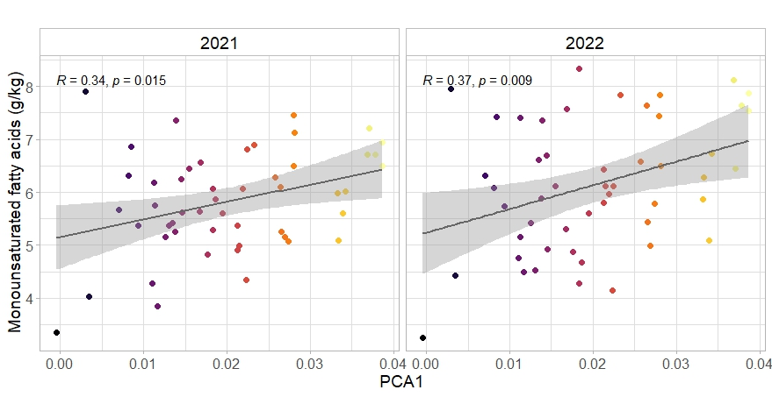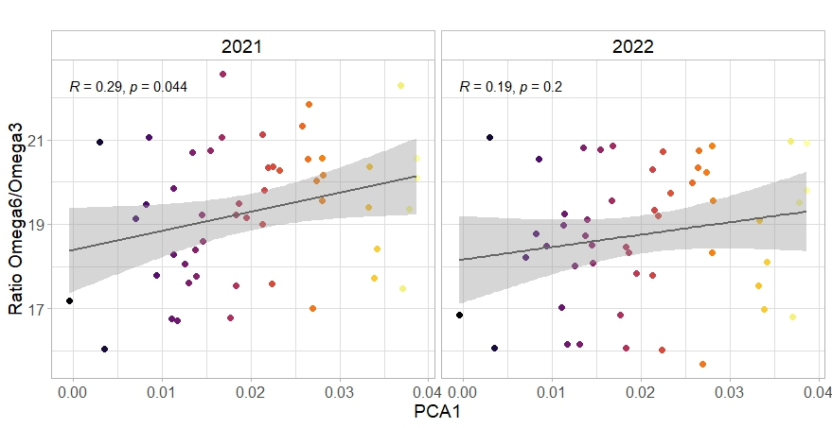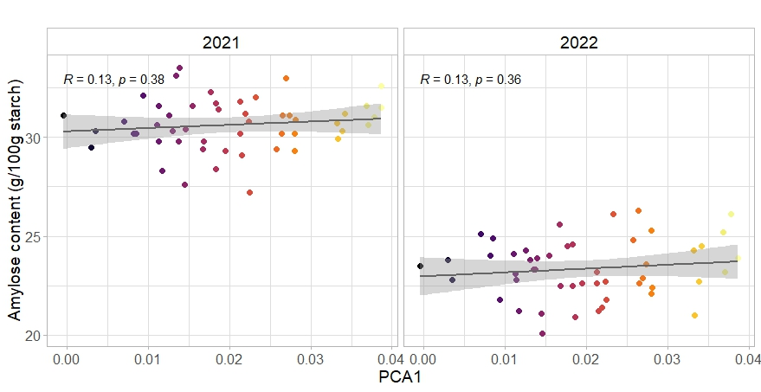
Fig. S17: Relationship between amylose content (g/100g starch) and genetic distance to reference wheat (PCA1, i.e. proxy for spelt typicity) for 2021 and 2022 in 1260. n = 50 per year.
The grey lines represent linear regression fittings, with the grey area representing the 0.95 confidence interval.

Fig. S16: Relationship between Omega6/Omega3 and genetic distance to reference wheat (PCA1, i.e. proxy for spelt typicity) for 2021 and 2022 in 1260. n = 50 per year.
The grey lines represent linear regression fittings, with the grey area representing the 0.95 confidence interval.

Fig. S15: Relationship between monounsaturated fatty acids content (g/kg) and genetic distance to reference wheat (PCA1, i.e. proxy for spelt typicity) for 2021 and 2022 in 1260. n = 50 per year.
The grey lines represent linear regression fittings, with the grey area representing the 0.95 confidence interval.

TABLE S4 | Average decorticated yield (in dt/ha) and protein content of each spelt variety. Values were averaged over replicates, sites and years.

Variety | Decorticated yield (dt/ha) | Variety | Protein content (%)
Hubel | 41.94536 | Wertensteiner Weissk | 16.81505
Zurcher Oberlander | 41.28371 | DSP20_5 | 16.45124
Zollernfit | 41.05287 | Tauro | 15.72621
Zollernperle | 40.20268 | DSP20_3 | 15.66595
Polkura | 39.95074 | Schwabenkorn | 15.44305
Gletscher | 39.93296 | DSA20_135 | 15.40913
Hohenloher | 39.16041 | DSA20_115 | 15.33193
Edelweisser | 39.01325 | Oberkulmer Rotkorn | 15.31638
Badenkrone | 38.88186 | Rubiota | 15.23363
DSP20_7 | 38.6486 | Mv Martongold | 15.09093
DSP20_17 | 38.38421 | DSP20_36 | 15.06977
Zollernspelz | 38.32274 | DSA20_133 | 15.05081
DSA20_141 | 38.04842 | DSA20_118 | 14.96669
DSP20_97 | 37.63553 | DSA20_122 | 14.86564
Comburger | 37.39665 | Ostro | 14.75798
Serpentin | 37.26066 | Selun | 14.69786
Franckenkorn | 37.07494 | Copper | 14.6884
DSP20_8 | 36.81523 | Comburger | 14.60332
DSA20_142 | 36.75825 | DSA20_130 | 14.56431
Copper | 36.64034 | DSA20_124 | 14.55143
DSA20_122 | 36.58907 | DSA20_141 | 14.50658
Dinkatou | 36.55241 | Titan | 14.4111
DSA20_124 | 36.25188 | Raisa | 14.40508
DSP20_1 | 35.84601 | Zollernspelz | 14.36019
Mv Vitalgold | 35.63366 | DSP20_89 | 14.29422
DSP20_89 | 35.58237 | Tellenbacher Rotkorn | 14.27902
Mv Martongold | 35.50313 | Mv Vitalgold | 14.10796
DSA20_118 | 35.38427 | Edelweisser | 14.0485
Baulander Spelz | 34.97155 | DSP20_7 | 13.99702
SM Orkus | 34.69333 | DSP20_17 | 13.94832
Dottenfelder Rotling | 34.55858 | Dottenfelder Rotling | 13.8782
Raisa | 34.47614 | Gletscher | 13.87357
Selun | 34.1222 | DSP20_8 | 13.84357
DSA20_130 | 33.76054 | DSP20_97 | 13.83404
DSA20_115 | 33.62769 | DSA20_142 | 13.43758
Titan | 33.46653 | Dinkatou | 13.31305
DSP20_3 | 32.67981 | Zurcher Oberlander | 13.14443
Flauder | 32.09306 | Franckenkorn | 13.14223
Tellenbacher Rotkorn | 31.46786 | Hohenloher | 13.0076
DSA20_133 | 31.35235 | Baulander Spelz | 12.96451
DSA20_132 | 30.85721 | Hubel | 12.86088
Schwabenkorn | 30.38932 | Polkura | 12.75467
DSA20_135 | 29.75589 | SM Orkus | 12.71417
Ostro | 29.64588 | Flauder | 12.68875
DSP20_5 | 29.34203 | DSA20_132 | 12.6726
DSP20_36 | 29.20363 | DSP20_1 | 12.53396
Oberkulmer Rotkorn | 29.1318 | Zollernfit | 12.37124
Wertensteiner Weissk | 28.64134 | Zollernperle | 12.19247
Rubiota | 28.5534 | Serpentin | 11.70938
Tauro | 27.3609 | Badenkrone | 11.2829

