Supplementary Information

Title: Early sex identification by leaflet distance in plantlets of Cycas revoluta
Journal name: Euphytica

Authors: Ylenia De Luca¹, Salvatore Cozzolino¹, Antonia Cristaudo², Alex Widmer³, Donata Cafasso¹

Authors’ affiliation:
¹ Department of Biology, University of Naples Federico II, Complesso Universitario MSA, 80126 Naples, Italy
² Department of Biological, Geological and Environmental Sciences, University of Catania, 58 Empedocle St., 95128 Catania, Italy
³ Department of Environmental Systems Science, ETH Zurich, 16, Universitätstrasse St., 8092 Zurich, Switzerland

Corresponding author: Salvatore Cozzolino, Department of Biology, University of Naples Federico II, Complesso Universitario MSA, 80126 Naples, Italy; E-mail: cozzolin@unina.it; Orcid-ID: 0000-0002-3176-8130

Author Contribution Statement
YDL, DC and AW conceived the project and designed experiments; YDL and SC wrote the manuscript; AC performed greenhouse plant measurements; YDL performed PCR analyses and analyzed data; DC administered the project; all the authors read and approved the manuscript contents.

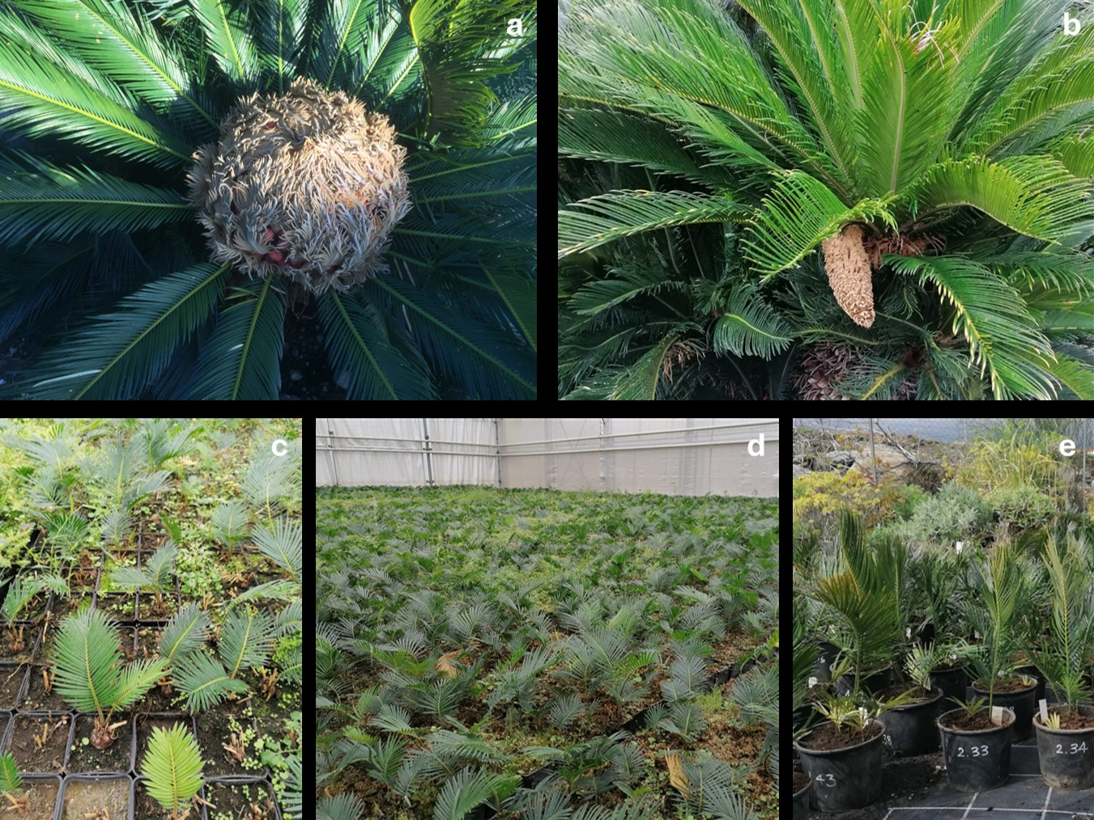

Fig. S1 Growth stages of Cycas revoluta. a) a female adult plant, b) a male adult plant; c) stage 0 corresponds to plantlets of 12 months; d) stage 1 corresponds to plantlets of 24 months and e) stage 2 corresponds to plantlets of 36 months after seed germination. These plants were all grown in a greenhouse Piante Faro in Sicily

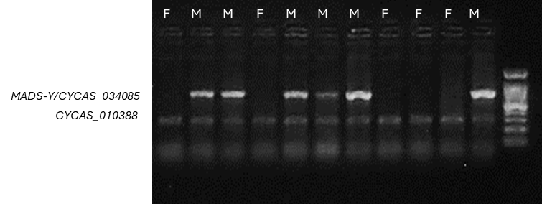
Fig. S2 PCR amplifications of the male-specific locus MADS-Y/CYCAS_034085 and locus CYCAS_010388 (control) as developed by Lui et al. (2022). The latter amplifies both in male and female plants. A 100 bp molecular ladder is in the rightmost lane.

Leaflets interval | IRD Stage 0 |  | IRD Stage1 |  | IRD Stage 2
1-2 | M(1.22-2.83) | F(2.63-5.45) | M(1.52-2.93) | F(2.91-7.66) | M(1.56-4.58) | F(1.95.4.34)
3-4 | M(1.79-4.11) | F(2.25-5.73) | M(2.21-4.11) | F(2.38-6.96) | M(1.85-3.62) | F(1.70-3.81)
5-6 | M(1.33-3.41) | F(2.66-4.47) | M(2.08-4.11) | F(2.10-6.44) | M(1.49-3.49) | F(1.88-4.01)
7-8 | M(1.17-3.76) | F(2.04-4.85) | M(1.70-4.16) | F(1.87-6.68) | M(1.30-4.51) | F(1.96-4.30)
9-10 | M(1.53-4.10) | F(2.03-3.96) | M(1.50-4.40) | F(2.14-5.41) | M(1.90-4.31) | F(1.95-5.01)
11-12 | M(1.64-3.46) | F(2.06-3.94) | M(1.53-3.40) | F(1.70-6.16) | M(1.97-4.46) | F(1.82-4.54)
13-14 | M(1.32-3.62) | F(1.71-3.09) | M(1.21-3.34) | F(2.24-5.22) | M(1.62-5.03) | F(1.85-5.24)
15-16 | M(1.53-2.95) | F(1.93-3.96) | M(1.46-3.38) | F(2.11-6.04) | M(1.41-3.62) | F(1.66-3.84)
17-18 | M(1.51-2.70) | F(2.63-3.71) | M(1.69-3.08) | F(1.89-5.56) | M(1.69-3.62) | F(1.85-3.61)
19-20 | M(1.20-2.81) | F(2.28-3.40) | M(1.60-2.56) | F(2.24-6.28) | M(1.80-4.72) | F(1.86-3.94)
21-22 |  |  | M(1.62-2.95) | F(2.85-6.04) | M(1.60-4.00) | F(1.64-4.00)
23-24 |  |  | M(1.71-2.34) | F(2.19-6.39) | M(1.51-4.71) | F(1.80-3.76)
25-26 |  |  | M(1.78-2.71) | F(2.60-6.02) | M(1.68-5.32) | F(1.86-3.66)
27-28 |  |  |  |  | M(1.93-4.31) | F(1.95-3.98)
29-30 |  |  |  |  | M(1.53-3.47) | F(1.90-3.71)
31-32 |  |  |  |  | M(2.06-4.40) | F(1.99-3.41)
33-34 |  |  |  |  | M(1.80-4.72) | F(1.67-3.90)
35-36 |  |  |  |  | M(1.94-4.08) | F(2.12-4.35)
37-38 |  |  |  |  | M(1.85-4.72) | F(1.95-4.69)
39-40 |  |  |  |  | M(1.78-6.07) | F(2.12-3.86)
41-42 |  |  |  |  | M(1.51-5.46) | F(1.80-4.73)
43-44 |  |  |  |  | M(1.37-4.88) | F(2.16-4.48)
45-46 |  |  |  |  | M(1.77-6.57) | F(2.19-4.64)
47-48 |  |  |  |  | M(1.81-6.72) | F(1.82-4.96)
49-50 |  |  |  |  | M(2.08-6.10) | F(2.30-4.76)
51-52 |  |  |  |  | M(1.80-5.48) | F(3.39-4.40)
53-54 |  |  |  |  | M(2.02-4.82) | F(2.47-4.30)
55-56 |  |  |  |  | M(2.51-3.88) | F(2.44-4.69)
57-58 |  |  |  |  | M(2.72-3.89) | F(2.47-4.54)
59-60 |  |  |  |  | M(3.25-4.28) | F(3.29-3.95)
61-62 |  |  |  |  | M(3.25-4.28) | F(3.06-3.78)
Table S1 Dimension of IRD (mm) for any single interval between leaflets in stages 0,1 and 2. The minimum and maximum values for each interval are shown. “M” male individuals and “F” female individuals. These values correspond to the raw measures without log transformation for the statistical analysis

Fig. S3 Dimension of leaf traits a) area (mm²), b) perimeter (mm), c) leaf complexity (perimeter²/area), d) number of indents in female and male plants at stage 0

Fig. S4 Dimension of leaf traits a) area (mm²), b) perimeter (mm), c) leaf complexity (perimeter²/area), d) number of indents in female and male plants at stage 1

Table S2 Results from the t-test or the Wilcoxon rank sum test for significant correlation between the sex of individuals in plants of stages 0 and 1. ‘W’ represents the sum of the rankings of values from one of the two groups in the comparison in Wilcoxon rank sum test; ‘t’ represents the ratio of the difference between the means of the two groups in t-test; ‘df’ indicates degrees of freedom of the test
Leaf Trait | Stage | df | t | p-value | W
Leaf Complexity | 0 | 26 | 0.81436 | 0.4228
Leaf Complexity | 1 |  |  | 0.0623 | 136
Perimeter | 0 | 26 | 1.2348 | 0.2280
Perimeter | 1 |  |  | 0.7352 | 103
Area | 0 | 26 | 1.0681 | 0.2953
Area | 1 |  |  | 0.1378 | 62
Number of indents | 0 | 26 | 1.2161 | 0.2349
Number of indents | 1 | 27 | 0.11196 | 0.9117

Fig. S5 Dimension of leaf IRD (as the medium of all measurements for each section with error bar, i.e. the 95% confidence interval of the mean) in female and male plants of the stage 0 collected at greenhouse La Floricola (Ispica, Sicily, Italy) in April 2024. White dots correspond to female individuals and grey dots represent male individuals. a) distal part of the leaf petiole, b) median part of the leaf petiole, and c) proximal part of the leaf petiole. *** (p-value <0.01)

Table S3 Results from the t-test for significant correlation between the sex of individuals and the IRD for plants of stage 0 collected at the greenhouse La Floricola (Ispica, Sicily, Italy) in April 2024. ‘t’ represents the ratio of the difference between the means of the two groups in t-test; ‘df’ indicates the degrees of freedom of the test
Stage | Section of the leaf | df | t | p-value
0 | Distal part of the leaf petiole | 150 | 20.802 | 2.2e⁻¹⁶
0 | Median part of the leaf petiole | 165 | 9.3166 | 2.2e⁻¹⁶
0 | Proximal part of the leaf petiole | 156 | 6.131 | 6.867e⁻¹³

