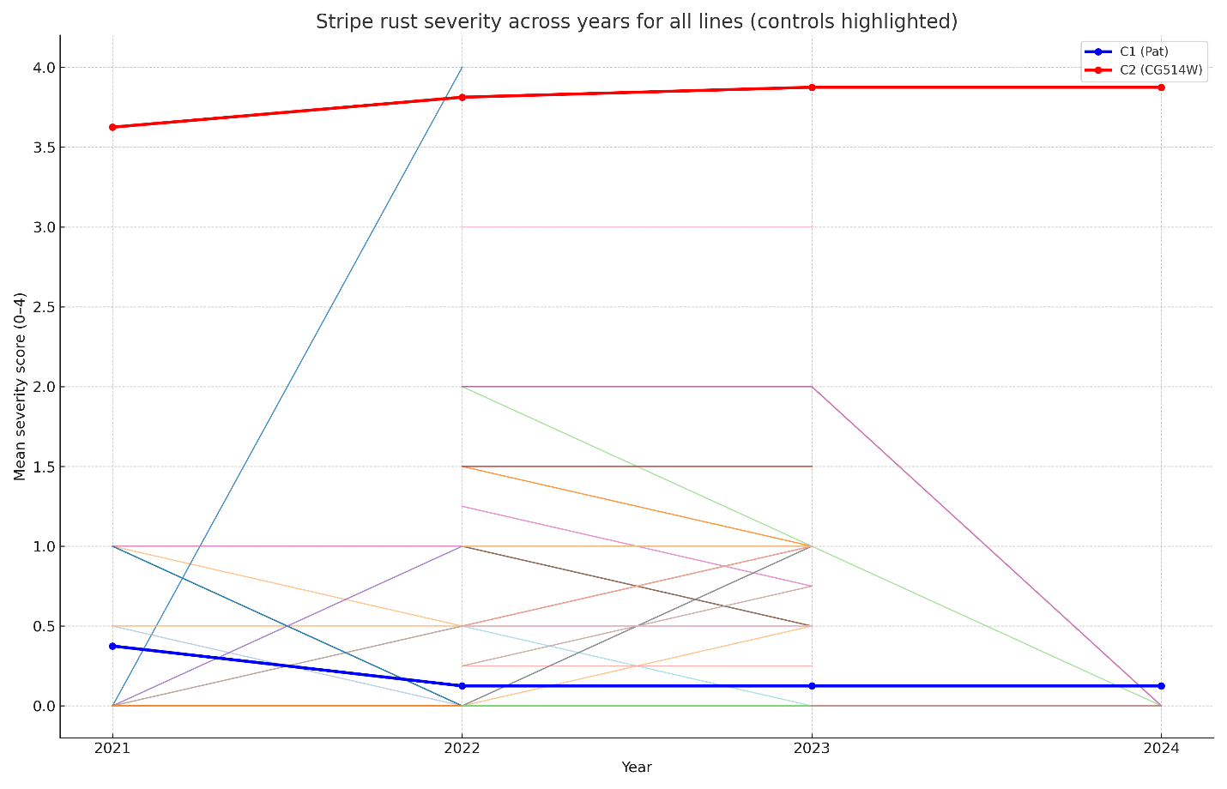

Supplementary Figure S1. Line plots showing mean stripe rust severity (0–4 scale) of SRWW lines across three seasons (2021–2024). Each colored line represents one genotype; the resistant check C1 (Pat) is shown in blue, and the susceptible check C2 (CG514W) in red. Variation in slopes reflects genotype × environment (G×E) interactions, while flat trajectories indicate stable resistance.

