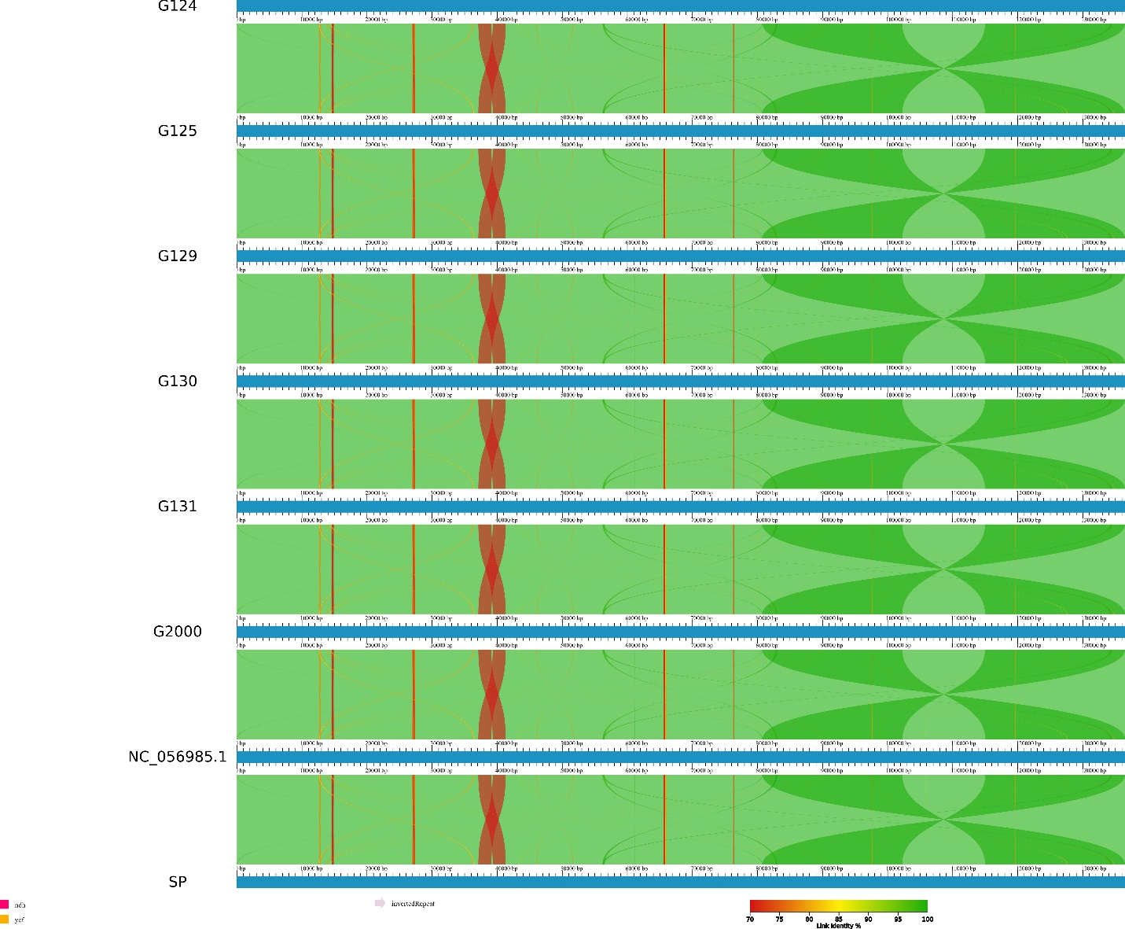
Fig S1. Comprehensive AliTV multiple sequence alignment visualization of Egyptian barley plastomes elucidating genomic synteny, structural conservation, and divergent loci among six domesticated cultivars (Hordeum vulgare subsp. vulgare Thell.) and their wild progenitor (Hordeum vulgare subsp. spontaneum K. Koch). The linear genomic alignment reveals extensive collinearity and syntenic relationships across all seven Egyptian barley plastomes, with continuous alignment blocks indicating preserved gene order and plastome architecture, while hypervariable regions and gap structures highlight indel events and cultivar-specific mutational signatures that distinguish domesticated varieties from their wild ancestor and among themselves. The chromatic encoding scheme systematically represents sequence identity and divergence patterns: blue segments denote high sequence conservation and syntenic blocks, green regions indicate moderate sequence similarity with minor variations, yellow areas represent intermediate divergence zones with notable sequence differences, orange segments highlight regions of substantial sequence variation, and red blocks signify hypervariable loci with maximum sequence divergence or structural rearrangements, while white gaps correspond to indel events or assembly discontinuities, providing fundamental insights into the evolutionary genomics of Egyptian barley diversification and the conserved yet dynamic nature of chloroplast genome evolution during domestication processes. The nadh and ycf gene families demonstrate exceptional conservation across all Egyptian barley plastomes, exhibiting minimal sequence variation between domesticated cultivars and their wild progenitor, indicating strong selective pressure maintaining the functional integrity of these essential photosynthetic and respiratory gene complexes.
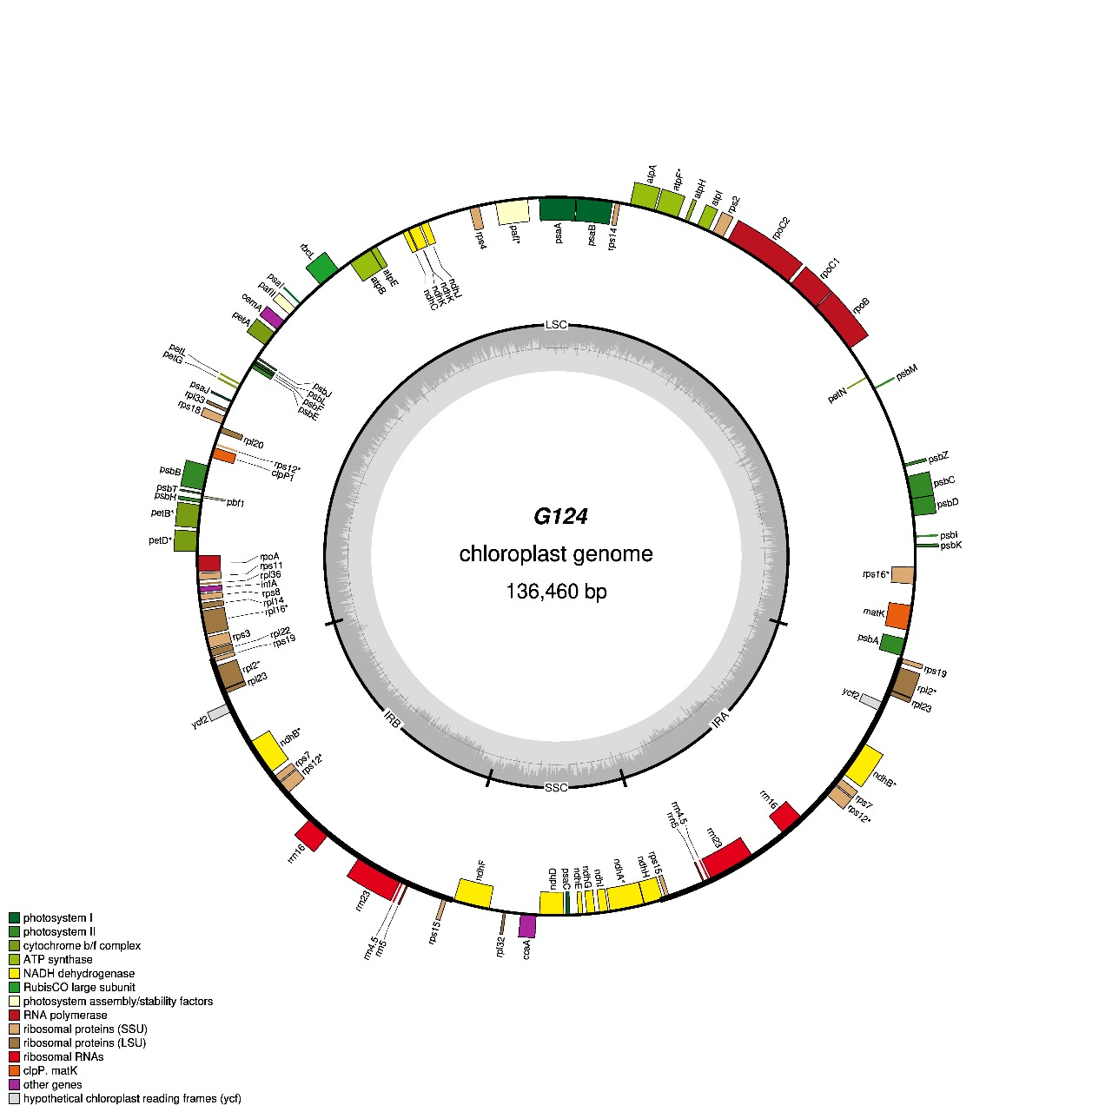
Fig S2. Comprehensive circular cartographic representation of the chloroplast genome (136,460 bp) derived from Egyptian barley cultivar G124 (Hordeum vulgare subsp. vulgare Thell.). This plastome serves as the paradigmatic exemplar for the six Egyptian cultivars subjected to analytical scrutiny, judiciously selected based on its maximal phylogenetic congruence with the canonical reference plastome (accession no. NC_056985.1). Gene annotations circumscribing the outermost circular arc delineate transcriptional directionality on clockwise (inner) and counterclockwise (outer) DNA strands, systematically color-coded according to functional taxonomies (encompassing photosynthetic apparatus, transcriptional machinery, ribosomal protein complexes, and tRNA assemblages). The cartographic visualization annotates the positional coordinates and transcriptional orientations of all genetic elements, wherein genes positioned external to the circular perimeter undergo counterclockwise transcription, while internally situated genes exhibit clockwise transcriptional directionality. Functional stratification of genetic components is distinguished through chromatic coding schemas. A concentric compositional ring depicts nucleotide constituency, with dark gray signifying guanine-cytosine content and light gray representing adenine-thymine content. The visualization further delineates three pivotal structural demarcations: the large single copy (LSC), small single copy (SSC), and inverted repeat (IR) regions, with the boundaries of the inverted repeat regions (IRa and IRb) demarcated by emphasized boundaries. Comprehensive circular depictions of plastomes for the remaining barley cultivars are systematically presented in Figs S1 through S5, respectively.
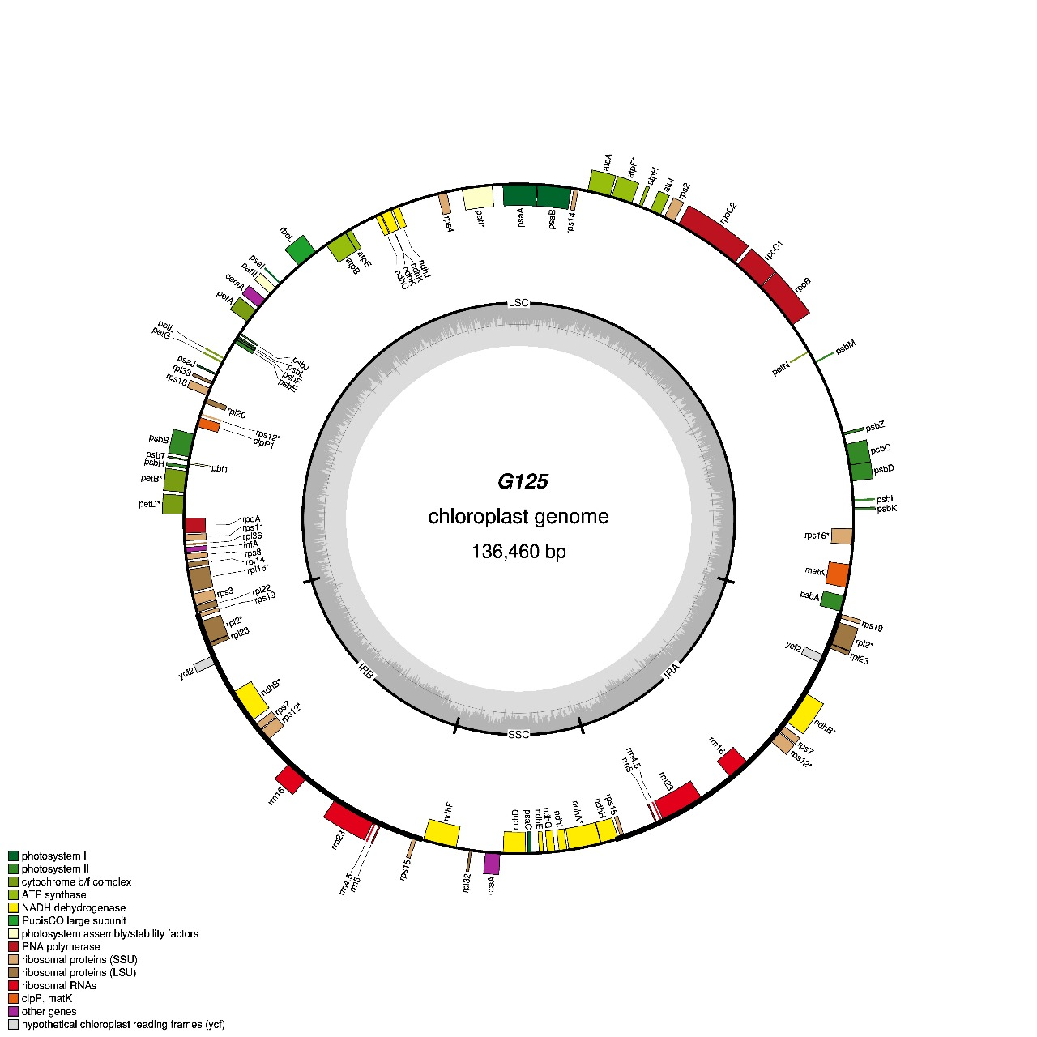

Fig S3. Comprehensive circular cartographic representation of the chloroplast genome (136,460 bp) derived from Egyptian barley cultivar G125 (Hordeum vulgare subsp. vulgare Thell.). This plastome serves as the paradigmatic exemplar for the six Egyptian cultivars subjected to analytical scrutiny, judiciously selected based on its maximal phylogenetic congruence with the canonical reference plastome (accession no. NC_056985.1). Gene annotations circumscribing the outermost circular arc delineate transcriptional directionality on clockwise (inner) and counterclockwise (outer) DNA strands, systematically color-coded according to functional taxonomies (encompassing photosynthetic apparatus, transcriptional machinery, ribosomal protein complexes, and tRNA assemblages). The cartographic visualization annotates the positional coordinates and transcriptional orientations of all genetic elements, wherein genes positioned external to the circular perimeter undergo counterclockwise transcription, while internally situated genes exhibit clockwise transcriptional directionality. Functional stratification of genetic components is distinguished through chromatic coding schemas. A concentric compositional ring depicts nucleotide constituency, with dark gray signifying guanine-cytosine content and light gray representing adenine-thymine content. The visualization further delineates three pivotal structural demarcations: the large single copy (LSC), small single copy (SSC), and inverted repeat (IR) regions, with the boundaries of the inverted repeat regions (IRa and IRb) demarcated by emphasized boundaries. Comprehensive circular depictions of plastomes for the remaining barley cultivars are systematically presented in Figs S1 through S5, respectively.
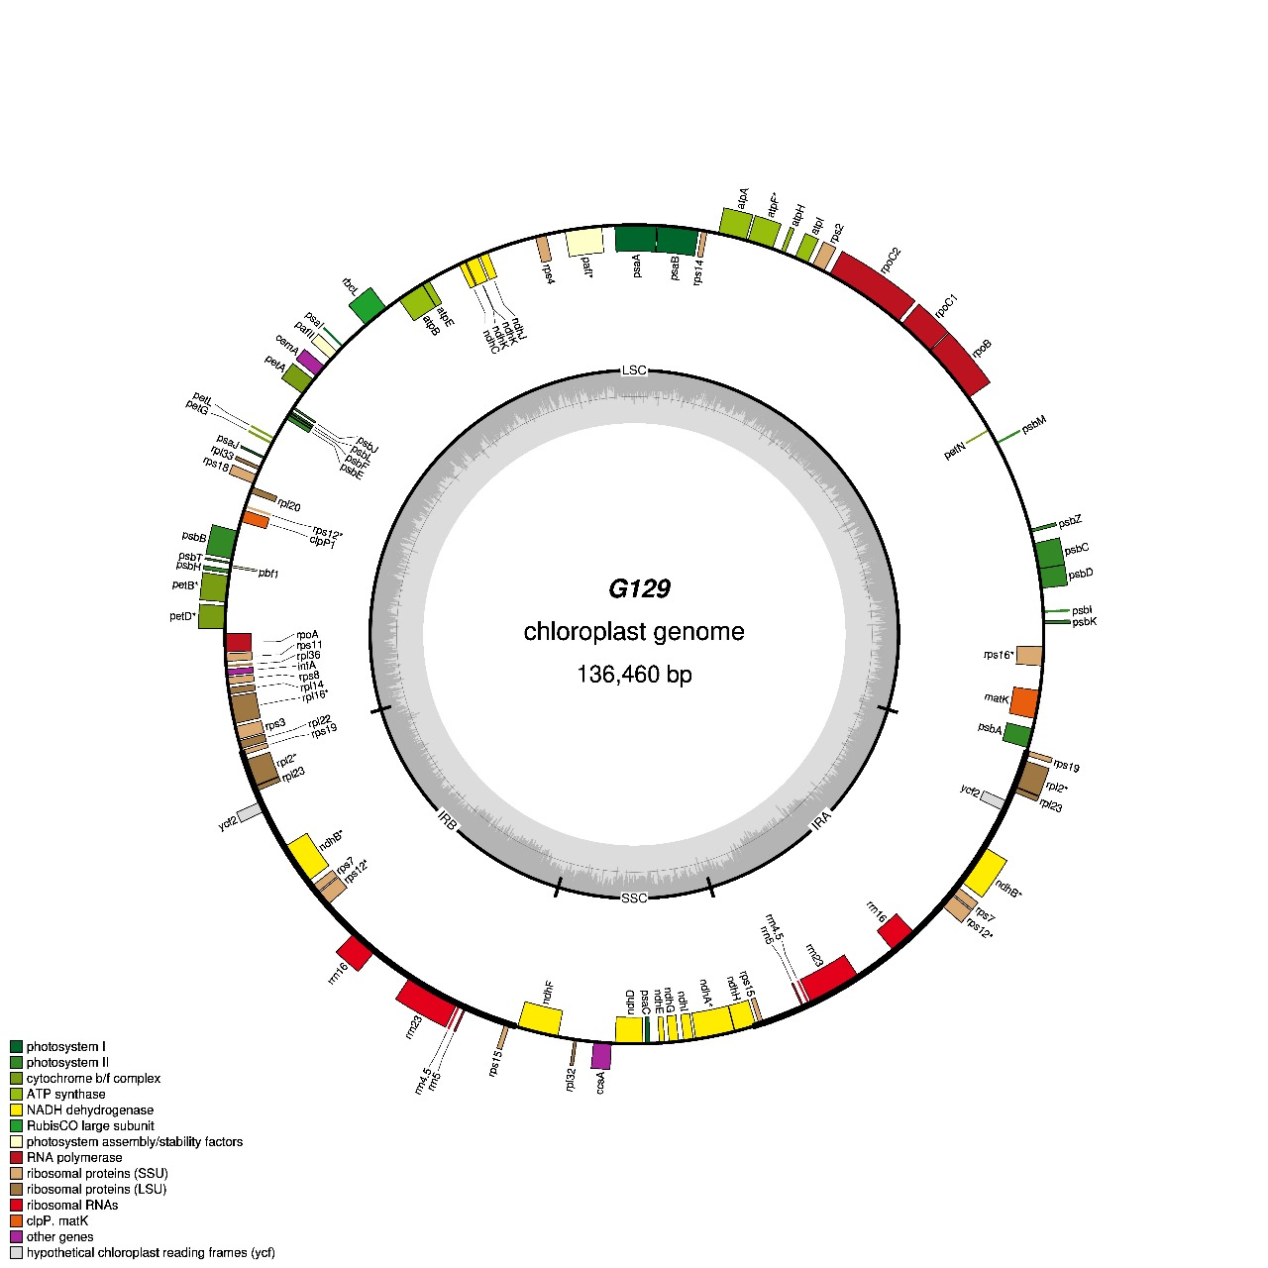
Fig S4. Comprehensive circular cartographic representation of the chloroplast genome (136,460 bp) derived from Egyptian barley cultivar G129 (Hordeum vulgare subsp. vulgare Thell.). This plastome serves as the paradigmatic exemplar for the six Egyptian cultivars subjected to analytical scrutiny, judiciously selected based on its maximal phylogenetic congruence with the canonical reference plastome (accession no. NC_056985.1). Gene annotations circumscribing the outermost circular arc delineate transcriptional directionality on clockwise (inner) and counterclockwise (outer) DNA strands, systematically color-coded according to functional taxonomies (encompassing photosynthetic apparatus, transcriptional machinery, ribosomal protein complexes, and tRNA assemblages). The cartographic visualization annotates the positional coordinates and transcriptional orientations of all genetic elements, wherein genes positioned external to the circular perimeter undergo counterclockwise transcription, while internally situated genes exhibit clockwise transcriptional directionality. Functional stratification of genetic components is distinguished through chromatic coding schemas. A concentric compositional ring depicts nucleotide constituency, with dark gray signifying guanine-cytosine content and light gray representing adenine-thymine content. The visualization further delineates three pivotal structural demarcations: the large single copy (LSC), small single copy (SSC), and inverted repeat (IR) regions, with the boundaries of the inverted repeat regions (IRa and IRb) demarcated by emphasized boundaries. Comprehensive circular depictions of plastomes for the remaining barley cultivars are systematically presented in Figs S1 through S5, respectively.
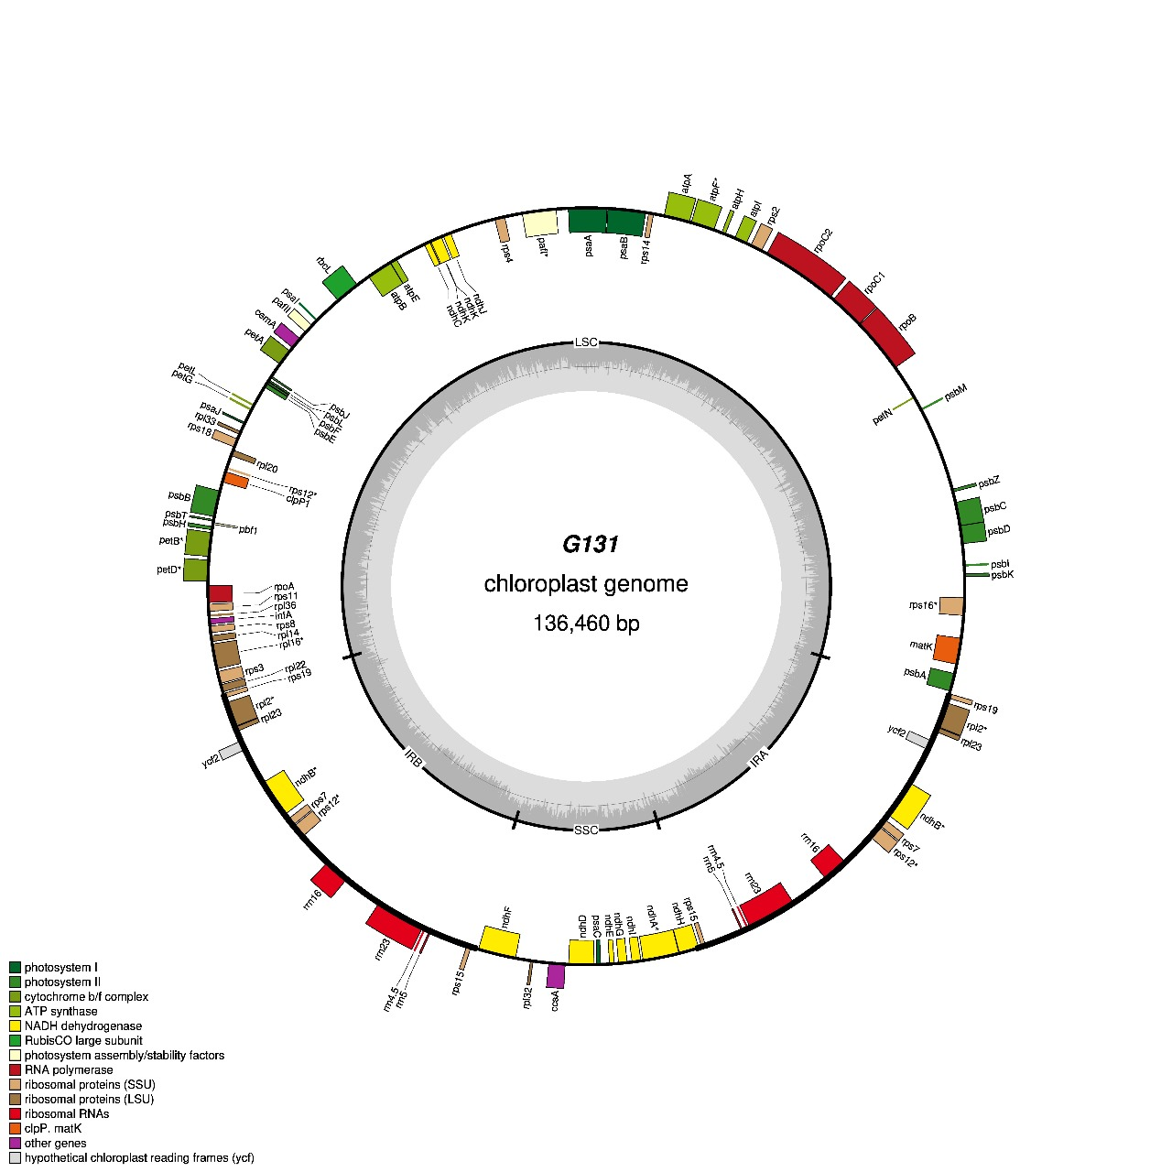
Fig S5. Comprehensive circular cartographic representation of the chloroplast genome (136,460 bp) derived from Egyptian barley cultivar G131 (Hordeum vulgare subsp. vulgare Thell.). This plastome serves as the paradigmatic exemplar for the six Egyptian cultivars subjected to analytical scrutiny, judiciously selected based on its maximal phylogenetic congruence with the canonical reference plastome (accession no. NC_056985.1). Gene annotations circumscribing the outermost circular arc delineate transcriptional directionality on clockwise (inner) and counterclockwise (outer) DNA strands, systematically color-coded according to functional taxonomies (encompassing photosynthetic apparatus, transcriptional machinery, ribosomal protein complexes, and tRNA assemblages). The cartographic visualization annotates the positional coordinates and transcriptional orientations of all genetic elements, wherein genes positioned external to the circular perimeter undergo counterclockwise transcription, while internally situated genes exhibit clockwise transcriptional directionality. Functional stratification of genetic components is distinguished through chromatic coding schemas. A concentric compositional ring depicts nucleotide constituency, with dark gray signifying guanine-cytosine content and light gray representing adenine-thymine content. The visualization further delineates three pivotal structural demarcations: the large single copy (LSC), small single copy (SSC), and inverted repeat (IR) regions, with the boundaries of the inverted repeat regions (IRa and IRb) demarcated by emphasized boundaries. Comprehensive circular depictions of plastomes for the remaining barley cultivars are systematically presented in Figs S1 through S5, respectively.
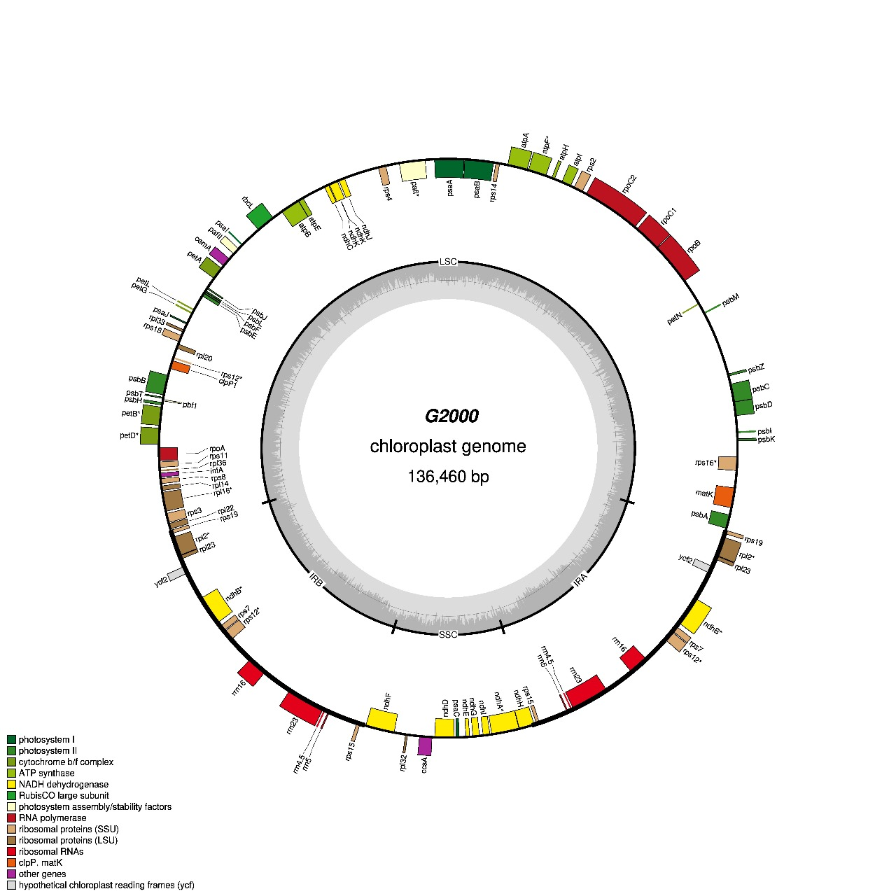
Fig S6. Comprehensive circular cartographic representation of the chloroplast genome (136,460 bp) derived from Egyptian barley cultivar G2000 (Hordeum vulgare subsp. vulgare Thell.). This plastome serves as the paradigmatic exemplar for the six Egyptian cultivars subjected to analytical scrutiny, judiciously selected based on its maximal phylogenetic congruence with the canonical reference plastome (accession no. NC_056985.1). Gene annotations circumscribing the outermost circular arc delineate transcriptional directionality on clockwise (inner) and counterclockwise (outer) DNA strands, systematically color-coded according to functional taxonomies (encompassing photosynthetic apparatus, transcriptional machinery, ribosomal protein complexes, and tRNA assemblages). The cartographic visualization annotates the positional coordinates and transcriptional orientations of all genetic elements, wherein genes positioned external to the circular perimeter undergo counterclockwise transcription, while internally situated genes exhibit clockwise transcriptional directionality. Functional stratification of genetic components is distinguished through chromatic coding schemas. A concentric compositional ring depicts nucleotide constituency, with dark gray signifying guanine-cytosine content and light gray representing adenine-thymine content. The visualization further delineates three pivotal structural demarcations: the large single copy (LSC), small single copy (SSC), and inverted repeat (IR) regions, with the boundaries of the inverted repeat regions (IRa and IRb) demarcated by emphasized boundaries. Comprehensive circular depictions of plastomes for the remaining barley cultivars are systematically presented in Figs S1 through S5, respectively.
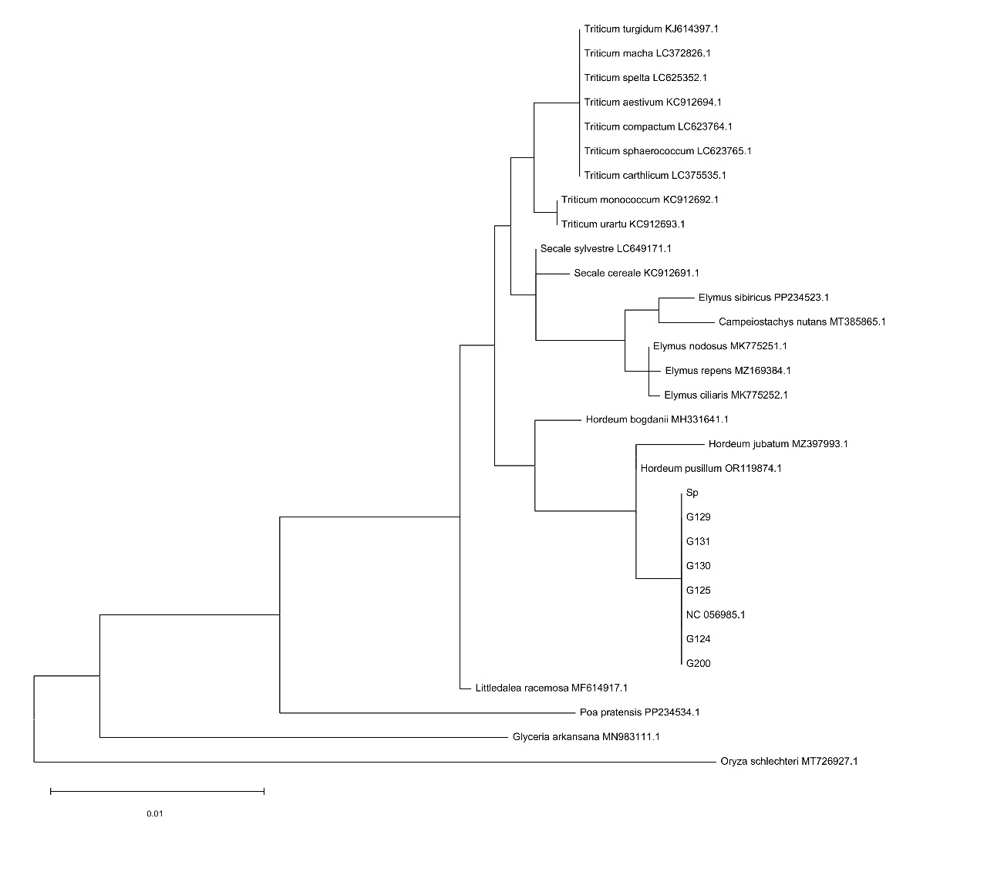Fig S7. Maximum likelihood cladistic reconstruction based on matK genetic sequences (1995 bp) elucidating comprehensive phylogenetic discontinuities among Egyptian barley cultivars, their wild ancestral progenitor, and representative Gramineae taxonomic assemblages. The phylogenetic topology systematically incorporates six Egyptian domesticated barley plastome entities (Hordeum vulgare subsp. vulgare Thell.), the wild barley progenitor (H. vulgare subsp. spontaneum K. Koch), the canonical reference plastome (NC_056985.1), and exemplar Gramineae species representing broader phylogenetic diversity within the grass family. Branch lengths quantitatively reflect magnitudes of genetic divergence accumulated through evolutionary time, while bootstrap support values systematically annotate major nodal bifurcations, providing statistical confidence assessments for inferred phylogenetic relationships. The cladistic architecture illuminates taxonomically distinct allelic assemblages and evolutionary groupings, with terminal lineages exhibiting heterogeneous degrees of plastome sequence divergence reflecting differential evolutionary trajectories and selection pressures. This molecular phylogenetic analysis provides fundamental insights into the evolutionary relationships between domesticated Egyptian barley cultivars and their wild progenitor within the broader context of Gramineae phylogenetic diversity. Comprehensive multiple sequence alignment datasets and analytical details are systematically provided in a Jalview visualization file for detailed comparative genomic analyses.
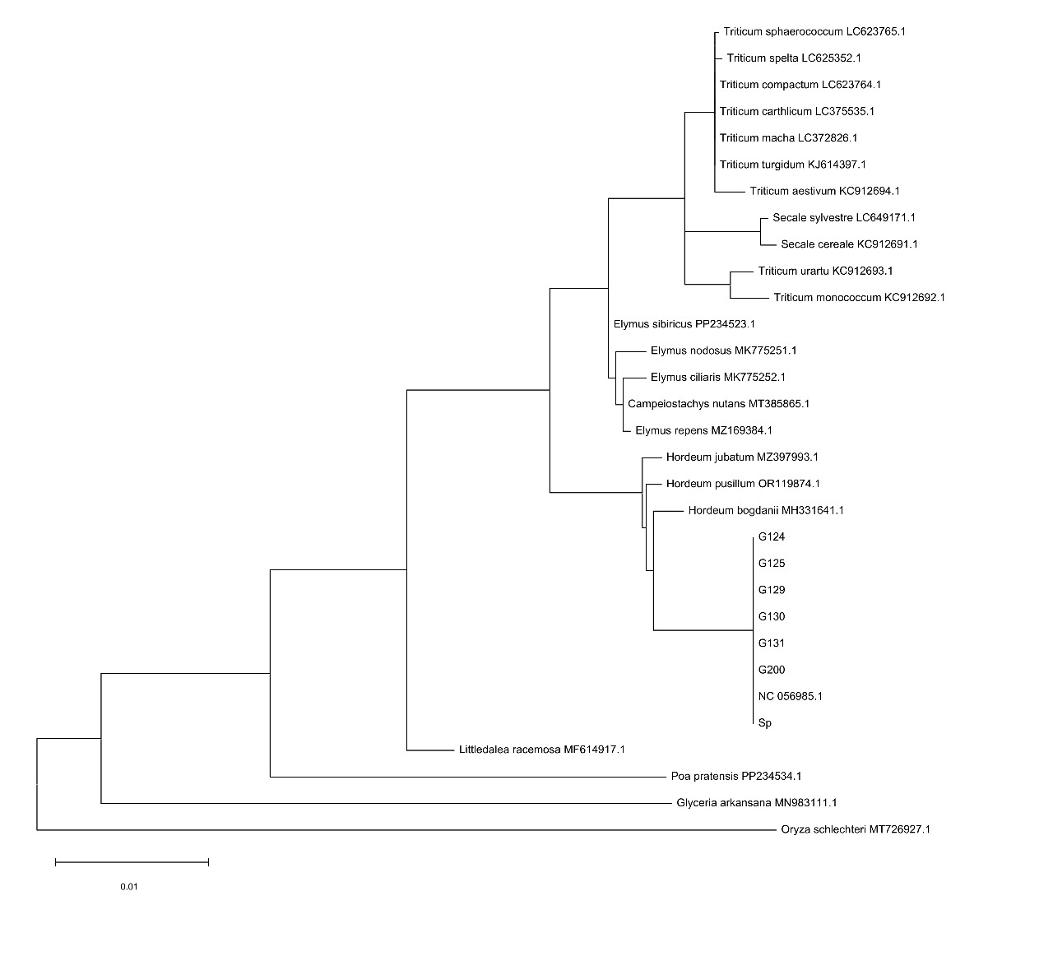Fig S8. Maximum likelihood cladistic reconstruction based on rbcL genetic sequences (1872 bp) elucidating comprehensive phylogenetic discontinuities among Egyptian barley cultivars, their wild ancestral progenitor, and representative Gramineae taxonomic assemblages. The phylogenetic topology systematically incorporates six Egyptian domesticated barley plastome entities (Hordeum vulgare subsp. vulgare Thell.), the wild barley progenitor (H. vulgare subsp. spontaneum K. Koch), the canonical reference plastome (NC_056985.1), and exemplar Gramineae species representing broader phylogenetic diversity within the grass family. Branch lengths quantitatively reflect magnitudes of genetic divergence accumulated through evolutionary time, while bootstrap support values systematically annotate major nodal bifurcations, providing statistical confidence assessments for inferred phylogenetic relationships. The cladistic architecture illuminates taxonomically distinct allelic assemblages and evolutionary groupings, with terminal lineages exhibiting heterogeneous degrees of plastome sequence divergence reflecting differential evolutionary trajectories and selection pressures. This molecular phylogenetic analysis provides fundamental insights into the evolutionary relationships between domesticated Egyptian barley cultivars and their wild progenitor within the broader context of Gramineae phylogenetic diversity. Comprehensive multiple sequence alignment datasets and analytical details are systematically provided in a Jalview visualization file for detailed comparative genomic analyses.
matK gene
>G124/1-1995
>G125/1-1995
>G129/1-1995
>G130/1-1995
>G131/1-1995
>G2000/1-1995
>Sp/1-1995
>NC_056985.1/1-1995
Fig S9. Comprehensive DNA barcode visualization of matK genetic sequences (1995 bp) across Gramineae chloroplast genomic assemblages elucidating sophisticated genetic differentiation paradigms and phylogenetic stratification patterns. The barcode representations systematically illustrate sequence-based phylogenetic relationships and molecular taxonomic affinities among six Egyptian cultivated barley (Hordeum vulgare subsp. vulgare Thell.) genotypic entities and the Egyptian wild barley (Hordeum vulgare subsp. spontaneum K. Koch) plastome, providing visual delineation of nucleotide-level variations and evolutionary signatures. Each horizontal barcode constitutes a molecular fingerprint reflecting the unique mutational landscape and evolutionary trajectory characteristic of individual genotypic lineages within the broader phylogenetic framework. The chromatic patterns within each barcode segment correspond to nucleotide variations relative to consensus sequences, thereby facilitating rapid identification of conserved regions, hypervariable domains, and lineage-specific mutational signatures that distinguish domesticated cultivars from their wild progenitor and among cultivated varieties. This molecular barcoding approach enables high-resolution phylogenetic discrimination and taxonomic identification at the subspecific level, providing unprecedented insights into the genetic architecture underlying Egyptian barley diversity. Exhaustive multiple sequence alignment datasets encompassing the seven Egyptian barley plastomes, the canonical reference barley plastome (accession NC_056985.1), and representative Gramineae species are systematically provided in the accompanying Jalview visualization file, facilitating comprehensive comparative genomic analyses and detailed phylogenetic investigations across multiple taxonomic hierarchies.

rbcL Gene
>G124/1-1872
>G125/1-1872
>G129/1-1872
>G130/1-1872
>G131/1-1872
>G2000/1-1872
>Sp/1-1872
>NC_056985.1/1-1872
Fig S10. Comprehensive DNA barcode visualization of rbcL genetic sequences (1872 bp) across Gramineae chloroplast genomic assemblages elucidating sophisticated genetic differentiation paradigms and phylogenetic stratification patterns. The barcode representations systematically illustrate sequence-based phylogenetic relationships and molecular taxonomic affinities among six Egyptian cultivated barley (Hordeum vulgare subsp. vulgare Thell.) genotypic entities and the Egyptian wild barley (Hordeum vulgare subsp. spontaneum K. Koch) plastome, providing visual delineation of nucleotide-level variations and evolutionary signatures. Each horizontal barcode constitutes a molecular fingerprint reflecting the unique mutational landscape and evolutionary trajectory characteristic of individual genotypic lineages within the broader phylogenetic framework. The chromatic patterns within each barcode segment correspond to nucleotide variations relative to consensus sequences, thereby facilitating rapid identification of conserved regions, hypervariable domains, and lineage-specific mutational signatures that distinguish domesticated cultivars from their wild progenitor and among cultivated varieties. This molecular barcoding approach enables high-resolution phylogenetic discrimination and taxonomic identification at the subspecific level, providing unprecedented insights into the genetic architecture underlying Egyptian barley diversity. Exhaustive multiple sequence alignment datasets encompassing the seven Egyptian barley plastomes, the canonical reference barley plastome (accession NC_056985.1), and representative Gramineae species are systematically provided in the accompanying Jalview visualization file, facilitating comprehensive comparative genomic analyses and detailed phylogenetic investigations across multiple taxonomic hierarchies.

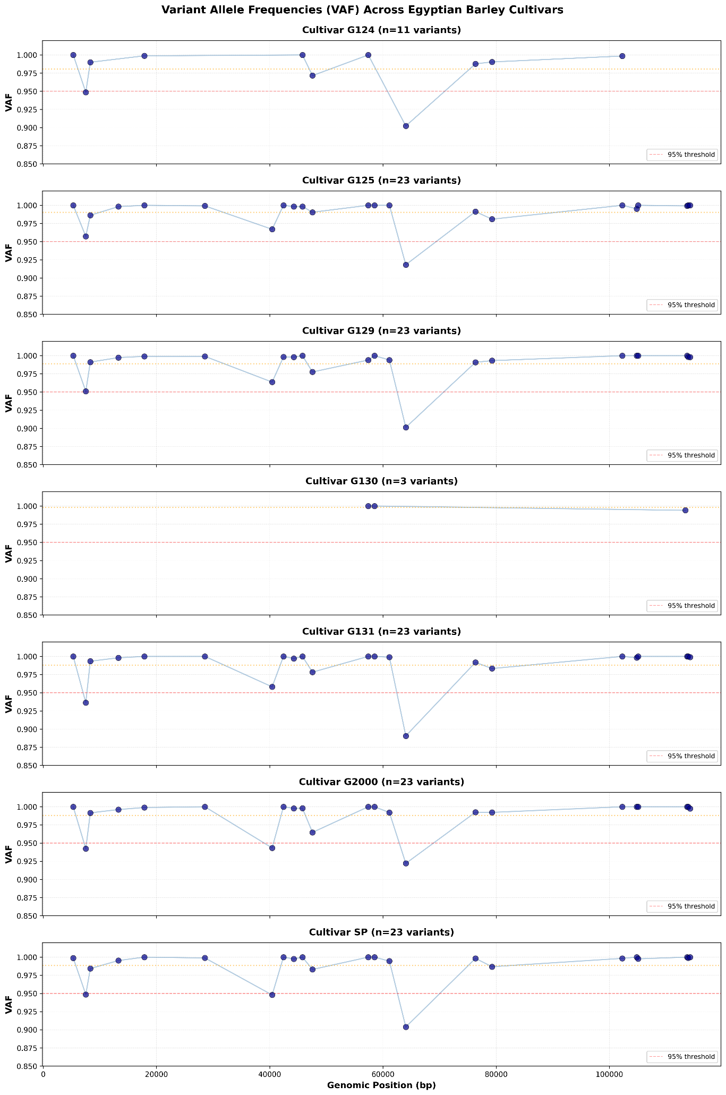
Figure S11. Multi-panel variant allele frequency (VAF) distribution across plastome positions in Egyptian barley cultivars, and their wild ancestral progenitor. VAF profiles at 23 polymorphic chloroplast loci distributed across six Egyptian domesticated barley cultivars (Hordeum vulgare subsp. vulgare Thell.; G125, G129, G131, G124, G2000) and their wild ancestor (H. vulgare subsp. spontaneum K. Koch; SP). Each panel presents one cultivar, with genomic positions displayed on the x-axis and VAF values (0.85–1.0) on the y-axis. Data points represent individual variant positions, connected by lines for visual continuity. Horizontal reference lines indicate the 95% VAF threshold (red dashed line) and cultivar-specific mean VAF (orange dotted line). Most cultivars (G125, G129, G131, G2000, SP) exhibit extensive heteroplasmy with mean VAF values ranging from 0.9880 to 0.9904 across 23 polymorphic sites, reflecting substantial allelic diversity within their plastomes. In contrast, cultivar G130 demonstrates exceptionally high and uniform VAF (mean 0.9980) across only three variable loci, indicating near-complete sequence homogeneity and marked plastome uniformity. Two hypervariable loci at genomic positions 40435 and 64044 display notably lower VAF frequencies relative to other polymorphic sites, identifying them as evolutionary hotspots with elevated mutational potential. This analysis underscores pronounced genetic heterogeneity among Egyptian barley germplasm, with distinct heteroplasmy patterns reflecting different evolutionary trajectories and selection pressures within the cultivated collection.

