Supplementary information

Table S1. Number of individuals used for thermal tolerance experiments
Species | Habitat | Stage | Treatments | N values
Bicyclus dorothea | Forest | Larva | CTmin | 102
Bicyclus dorothea | Forest | Larva | CTmax | 100
Bicyclus dorothea | Forest | Adult | CTmin | 90
Bicyclus dorothea | Forest | Adult | CTmax | 89
Bicyclus dorothea | Ecotone | Larva | CTmin | 288
Bicyclus dorothea | Ecotone | Larva | CTmax | 411
Bicyclus dorothea | Ecotone | Adult | CTmin | 158
Bicyclus dorothea | Ecotone | Adult | CTmax | 143
Bicyclus vulgaris | Forest | Larva | CTmin | 232
Bicyclus vulgaris | Forest | Larva | CTmax | 229
Bicyclus vulgaris | Forest | Adult | CTmin | 178
Bicyclus vulgaris | Forest | Adult | CTmax | 154
Bicyclus vulgaris | Ecotone | Larva | CTmin | 404
Bicyclus vulgaris | Ecotone | Larva | CTmax | 401
Bicyclus vulgaris | Ecotone | Adult | CTmin | 138
Bicyclus vulgaris | Ecotone | Adult | CTmax | 132
Bicyclus sandace | Forest | Larva | CTmin | 72
Bicyclus sandace | Forest | Larva | CTmax | 67
Bicyclus sandace | Forest | Adult | CTmin | 96
Bicyclus sandace | Forest | Adult | CTmax | 96
Bicyclus sandace | Ecotone | Larva | CTmin | 79
Bicyclus sandace | Ecotone | Larva | CTmax | 78
Bicyclus sandace | Ecotone | Adult | CTmin | 84
Bicyclus sandace | Ecotone | Adult | CTmax | 77
Bicyclus sanaos | Ecotone | Lava | CTmin | 174
Bicyclus sanaos | Ecotone | Lava | CTmax | 174
Bicyclus sanaos | Ecotone | Adult | CTmin | 112
Bicyclus sanaos | Ecotone | Adult | CTmax | 100
Table S2. Summary of statistical results of the generalized linear model (with negative binomial distribution) for the relationship between the abundance and environmental predictors for adult individuals in four Bicyclus species.
Species | Model parameters | Estimates | Lower CI | Upper CI | z-value | P-value
B. dorothea | Intercept | 2.242 | 1.750 | 2.805 | 8.388 | <0.001
B. dorothea | Habitat | 0.466 | -0.369 | 1.353 | 1.073 | 0.283
B. dorothea | Microhabitat | 0.504 | -0.234 | 1.242 | 1.350 | 0.177
B. dorothea | Season | 2.198 | 1.351 | 3.123 | 4.931 | <0.001
B. dorothea | Habitat*Microhabitat | -2.593 | -3.909 | -1.293 | -3.906 | <0.001
B. dorothea | Habitat*Season | -0.980 | -2.287 | 0.291 | -1.502 | 0.133
B. dorothea | Microhabitat*Season | -3.201 | -4.457 | -1.962 | -5.068 | <0.001
B. dorothea | Habitat*Microhabitat*Season | 0.805 | -1.355 | 2.905 | 0.745 | 0.457
B. sandace | Intercept | 0.322 | -0.350 | 0.995 | 0.943 | 0.346
B. sandace | Habitat | -0.770 | -2.080 | 0.550 | -1.145 | 0.252
B. sandace | Microhabitat | 1.131 | 0.260 | 2.005 | 2.542 | 0.011
B. sandace | Season | 2.680 | 1.813 | 3.550 | 6.054 | <0.001
B. sandace | Habitat*Microhabitat | -1.430 | -3.342 | 0.478 | -1.470 | 0.142
B. sandace | Habitat*Season | -0.620 | -2.176 | 0.941 | -0.777 | 0.437
B. sandace | Microhabitat*Season | -2.055 | -3.276 | -0835 | -3.300 | 0.001
B. sandace | Habitat*Microhabitat*Season | 1.480 | -0.821 | 3.790 | 1.262 | 0.207
B. sandace | Zero-inflated model
B. sandace | Intercept | -2.010 | -3.420 | -0.603 | -2.800 | 0.005
B. vulgaris | Intercept | 1.642 | 1.174 | 2.147 | 6.650 | <0.001
B. vulgaris | Habitat | 0.304 | -0.466 | 1.104 | 0.763 | 0.445
B. vulgaris | Microhabitat | 1.225 | 0.571 | 1.881 | 3.683 | <0.001
B. vulgaris | Season | 2.438 | 1.690 | 3.240 | 6.222 | <0.001
B. vulgaris | Habitat*Microhabitat | -2.283 | -3.442 | -1.136 | -3.895 | <0.001
B. vulgaris | Habitat*Season | -0.441 | -1.585 | 0.680 | -0.767 | 0.443
B. vulgaris | Microhabitat*Season | -3.587 | -4.683 | -2.505 | -6.489 | <0.001
B. vulgaris | Habitat*Microhabitat*Season | 1.396 | -0.323 | -2.505 | 1.595 | 0.111
B. sanaos | Intercept | -1.390 | -2.600 | -0.176 | -2.245 | 0.025
B. sanaos | Habitat | 0.133 | -1.790 | 2.060 | 0.136 | 0.891
B. sanaos | Microhabitat | 3.164 | 1.860 | 4.470 | 4.752 | <0.001
B. sanaos | Season | 2.890 | 1.485 | 4.300 | 4.031 | <0.001
B. sanaos | Habitat*Microhabitat | -2.065 | -4.280 | 0.150 | -1.830 | 0.067
B. sanaos | Habitat*Season | -1.386 | -3.612 | 0.840 | -1.221 | 0.222
B. sanaos | Microhabitat*Season | -1.432 | -3.030 | 0.165 | -1.758 | 0.078
B. sanaos | Habitat*Microhabitat*Season | 0.970 | -1.681 | 3.620 | 0.717 | 0.049
 | Zero-inflated model
 | Intercept | -14.540 | -780.166 | 751.083 | -0.037 | 0.97

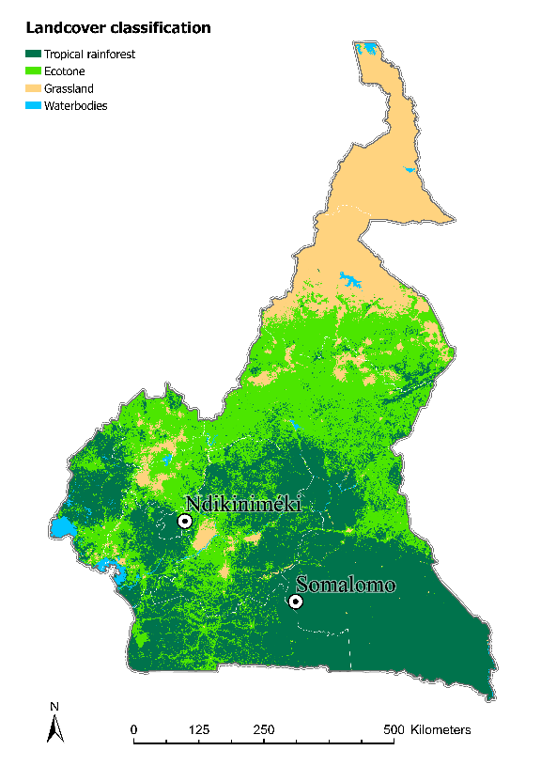
Wild butterflies
Adults
Fifth instar
larvae

20°C
30°C

First generation
Adults
Fifth instar
larvae

CT_{min} and CT_{max}
(a)
(b)

Fig S1. (a); Flow chart of rearing programme and thermal tolerance assessment plus depiction of sites and microhabitats. This experimental design was applied to all butterfly species (B. dorothea, B. sanaos, B. sandace, and B. vulgaris) from ecotone and forest habitats; (b) map showing the sampling localities;

Figure S2. Daily seasonal temperature variation in microhabitats (open vs understory) in both forest and ecotone habitats. These temperatures were obtained by summarising hourly values of each temperature logger set in each microhabitat for 20 continuous days during the wet and the dry seasons.

