Appendix
This appendix provides additional figures on the numerical domain used and extra validated simulation results for S1 Fluid, S2 Heat and S3 Buoyancy. These appendixes intend to give a better picture of the numerical setup and provide extra confidence in the model’s capability to predict each physics present in these.

Turbulence model
The WALE model computes the SGS eddy viscosity, $ν_{sgs}$ as follows:
 | $$ν_{sgs}=\left(C_{w}Δ^{2}\right)\frac{{\left(S_{ij}^{d}S_{ij}^{d}\right)}^{\frac{3}{2}}}{{\left({\tilde{S}}_{ij}{\tilde{S}}_{ij}\right)}^{\frac{5}{2}}+{\left(S_{ij}^{d}S_{ij}^{d}\right)}^{\frac{5}{4}}}$$ | (9)
Where C_{w} is the model constant with a coefficient of C_{w}=0.55 based on [52]. $Δ$ is the LES filter size, $S_{ij}^{d}$ is the special tensor defined by Nicoud [51], and ${\tilde{S}}_{ij}$ is the resolved scale strain rate tensor. The SGS turbulent kinetic energy, $k_{sgs}$ and the rate of dissipation of SGS turbulent kinetic energy in WALE is expressed, as shown below:
 | $$k_{sgs}={\left(\frac{ν_{sgs}}{C_{k}Δ}\right)}^{2}$$ | (10)
 | $$ε_{sgs}=C_{E}\frac{k_{sgs}^{\frac{3}{2}}}{Δ}$$ | (11)
Where C_{k} and C_{E} are the model constants, where values are based on [52] (C_{k}= 0.29 and C_{E}=1.048).
However, to ensure the WALE model implemented is suitable for cavity flow, both Smagorinsky and k-equation eddy viscosity models are used in S1 Flow and S2 Heat to compare the differences between the models.
In the Smagorinsky model, $ν_{sgs}$ is modelled as follows:
 | $$ν_{sgs}={\left(C_{s}Δ\right)}^{2}\left|\tilde{S}\right|$$ | (12)
Where C_{s} is the model constant with a range of 0.1 to 0.25 [63]. In the present study, the coefficient used is C_{s}=0.1 based on [53].$\left|\tilde{S}\right|=\sqrt{{\tilde{S}}_{ij}{\tilde{S}}_{ij}}$ is the strain rate tensor. To obtain $k_{sgs}$, the Smagorinsky model solves the balance equation shown in (8), with the value of $ε_{sgs}$ obtained through (5)
 | $$\tilde{S}:B+\frac{C_{E}k_{sgs}^{\frac{3}{2}}}{Δ}=0$$ | (13)
Where “:” is the double inner product operator, $B=\frac{2}{3}k_{sgs}I-2C_{k}\sqrt{k_{sgs}}Δ{\tilde{S}}_{D}$ is the SGS stress tensor with ${\tilde{S}}_{D}$ a the deviatoric component of the strain rate tensor. The model constants C_{k} and C_{E} have a coefficient of 0.05 and 1.048, respectively.
For the k-equation model, the $ν_{sgs}$ is calculated as:
 | $$ν_{sgs}=C_{k}Δ\sqrt{k_{sgs}}$$ | (14)
Where C_{k} is 0.05. To obtain the $k_{sgs}$, a transport equation is solved as shown:
 | $$\frac{∂\left(\overline{ρ}k_{sgs}\right)}{∂t}+\frac{∂\left( \overline{ρ}\tilde{u_{i}}k_{sgs}\right)}{∂x_{i}}-\frac{∂}{∂x_{i}}\left(\overline{ρ}\left(ν+ν_{sgs}\right)\frac{∂k_{sgs}}{∂x_{i}}\right) =-\frac{2}{3}\left(\overline{ρ}k_{sgs}+\overline{ρ}ν_{sgs}\frac{∂{\tilde{u}}_{k}}{∂x_{k}}\right)\frac{∂{\tilde{u}}_{i}}{∂x_{i}}+2\overline{ρ}ν_{sgs}\frac{∂{\tilde{u}}_{i}}{∂x_{j}}\frac{∂{\tilde{u}}_{j}}{∂x_{i}}-\overline{ρ}ε_{sgs}$$ | (15)
The closure expression for $ε_{sgs}$ uses the same expression in (5) with C_{E} =1.048.

Computational Domain
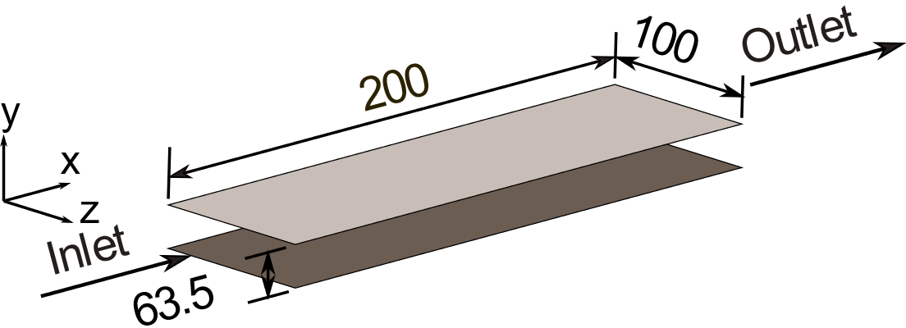 | 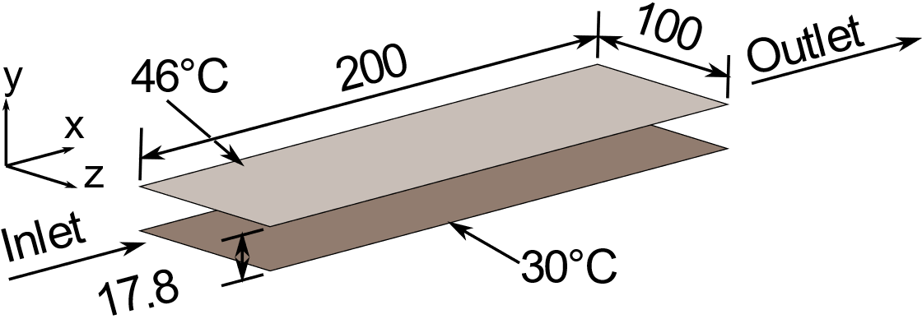
Appendix 1 Numerical domain of S1 Flow. All dimensions are in millimetres (mm). | Appendix 2 Numerical domain of S2 Heat. Dimensions are in milimetres (mm).
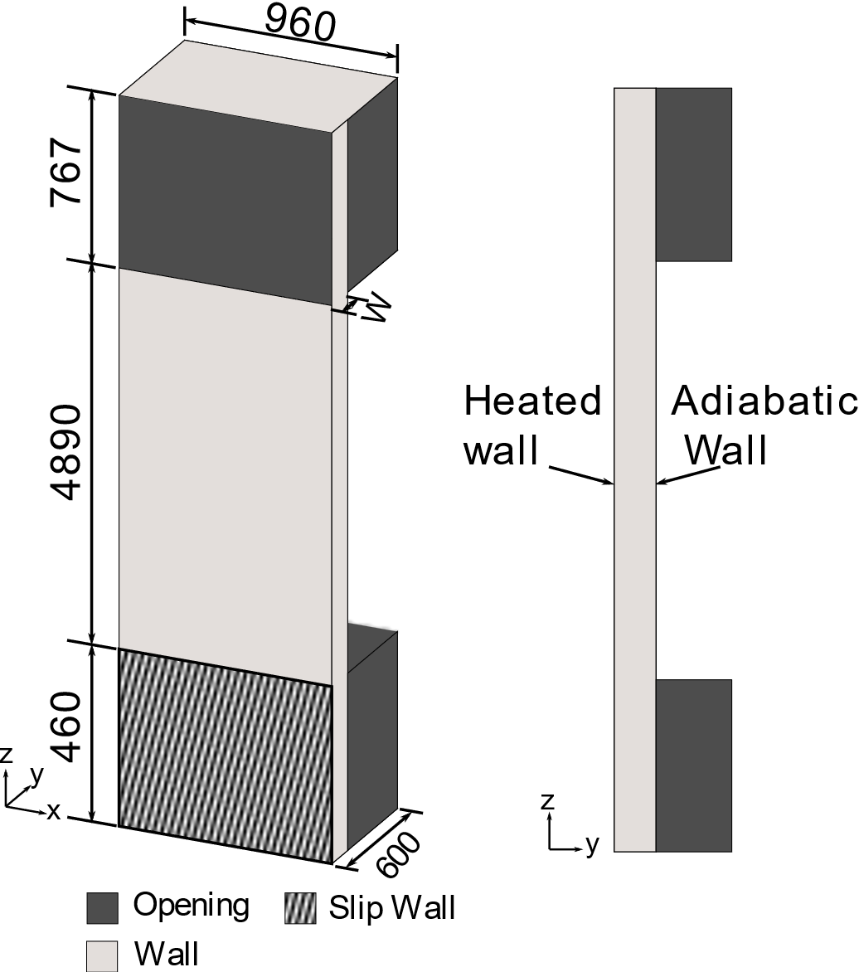
Appendix 3 Numerical Domain of S3 Buoyancy. Due to symmetry, only one cavity channel was simulated. Dimensions are in millimetres (mm)

Results
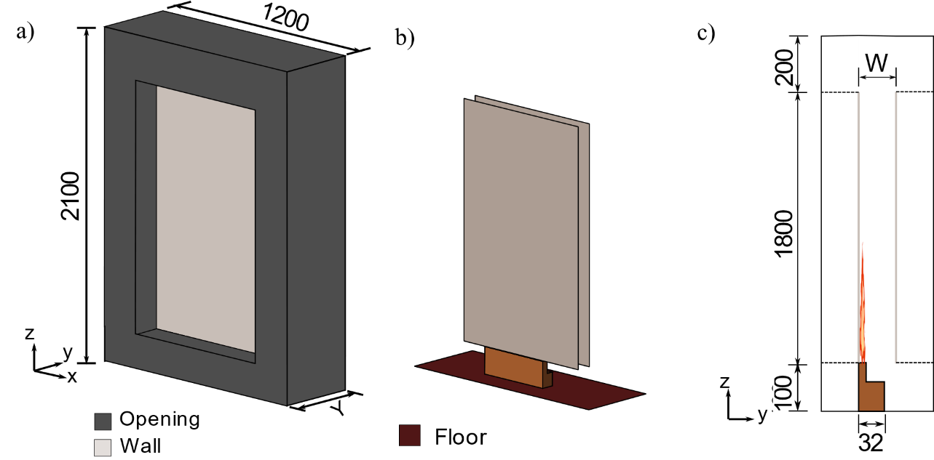
Appendix 4 a)Numerical Domain of S4 Combustion with domain with all boundaries shown. b) Opening was hidden to show both the burner and facade cavity. c) Cross-section of the numerical domain. All dimensions are in millimetres (mm)
Appendix 5 Scenario 2 Heat simulation result compared to experimental for a) variation of temperature with velocity and b) Wall normal variation of SGS kinetic energy. Good agreement with the experimental result was found for all turbulence submodel, although WALE model better at predicting the vanishing SGS kinetic energy at near the wall.
Appendix 6 Comparison of experimental and predicted Velocity profile for cavity widths of W = 50 mm, 100 mm, and 200 mm at the height of 820 mm, 2655 mm and 3865 mm for q_{w} = 208 W

Error analysis
The error analysis between the model and the experiment is obtained by comparing the global features, first-order statistical moments and, if experimental data is available, the second-order statistical moments. These comparisons are made by evaluating the mean relative error and bounded relative error between the experimental data and simulation prediction, as shown in (16) and (17)
 | $$RE^{m}=\frac{1}{N}\sum_{i=1}^{i=N}{\left(\frac{M_{i}-E_{i}}{E_{i}}\right)}×100$$ | (16)
 | $$RE^{b}=\sum_{i=1}^{i=N}{\tanh\left(\frac{M_{i}-E_{i}}{E_{i}}\right)}×100$$ | (17)
Where $RE^{m}$ is the mean relative error, $RE^{b}$ is the bounded relative error, M is the predicted value, and E is the experimental value. Uncertainty of the error is also calculated for experiments that provide information on experimental uncertainty.
$RE^{b}$ was also used to avoid the large relative error when the measured value is close to zero.

Appendix 7 Mean Relative error and bounded relative error for Scenario 1 over the various measurements. Smagorinksy and K-equation model performs slightly better due to the Van Driest wall function.
 | Mean velocity,$\overline{U}$ |  | Log law velocity, $\frac{U^{+}}{U_{τ}}$ |  | Velocity intensity, $\frac{\sqrt{\overline{u^{'2}}}}{\overline{U}}$
 | $$RE^{M}$$ | $$RE^{b}$$ | $$RE^{M}$$ | $$RE^{b}$$ | $$RE^{M}$$ | $$RE^{b}$$
WALE | 6.4% | 6.3% | 12.4% | 12.3% | 24.8% | 23.2%
Smagorinsky | 5.9% | 5.9% | 7.9% | 7.8% | 19.7% | 18.2%
K-equation | 5.8% | 5.6% | 7.6% | 7.6% | 21.4% | 19.7%

Appendix 8 Mean Relative error and bounded relative error for Scenario 2 over the various measurements. WALE model performs better likely due to better prediction of ν_{sgs} near walls
 | Mean velocity,$\overline{U}$ |  | Temperature, $T$ |  | Dimensionless Mean Temperature, $\frac{{\overline{T}}^{+}}{Pr}$ |  | Dimensionless Temperature Fluctuation, $\frac{θ^{'+}}{Pr}$
 | $$RE^{M}$$ | $$RE^{b}$$ | $$RE^{M}$$ | $$RE^{b}$$ | $$RE^{M}$$ | $$RE^{b}$$ | $$RE^{M}$$ | $$RE^{b}$$
WALE | 4.6% | 4.6% | 0.6% | 0.6% | 14.7% | 14.5% | 8.8% | 6.7%
Smagorinsky | 11.9% | 11.7% | 1.3% | 1.3% | 16.1% | 15.8% | 12.4% | 9.6%
K-equation | 8.8% | 8.8% | 0.9% | 0.9% | 15.7% | 15.5% | 14.5% | 11.2%

Appendix 9 Mean Relative error and bounded relative error for Scenario 3 over the various measurements. After the addition of buoyancy, the relative error increased drastically.
Cavity width, mm | Mean velocity,$\overline{U}$ (208 W) |  | Temperature, $T$ (104 W) |  | Velocity fluctuation, (104W) |  | Temperature Fluctuation, $\frac{\sqrt{{\overline{T}}^{2}}}{T}$ (104 W)
Cavity width, mm | $$RE^{M}$$ | $$RE^{b}$$ | $$RE^{M}$$ | $$RE^{b}$$ | $$RE^{M}$$ | $$RE^{b}$$ | $$RE^{M}$$ | $$RE^{b}$$
50 | 24.6 ± 8% | 23.9 ± 8% | 17.1 ± 10% | 16.9 ± 10% | N/A | N/A | N/A | N/A
100 | 28.4 ± 8% | 27.3 ± 8% | 16.8 ± 10% | 16.6 ± 10% | 40.3% | 34.6% | 23.4% | 22.4%
200 | 49.0 ± 8% | 39.7 ± 8% | 14.0 ± 10% | 13.9 ± 10% | 24.2% | 22.3% | N/A | N/A

