Supplementary file

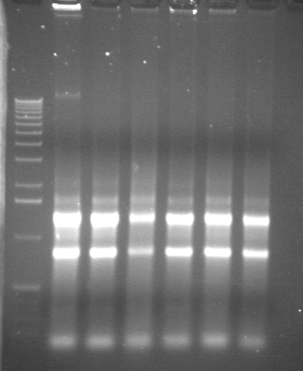

Fig. A supplementary: 1% agarose gel electrophoresis of randomly selected RNA extraction samples to check their integrity. 1.5 µg of RNA was loaded in each lane. The left lane contains molecular weight markers. The two upper bands correspond to 28S and 18S ribosomal RNA.

