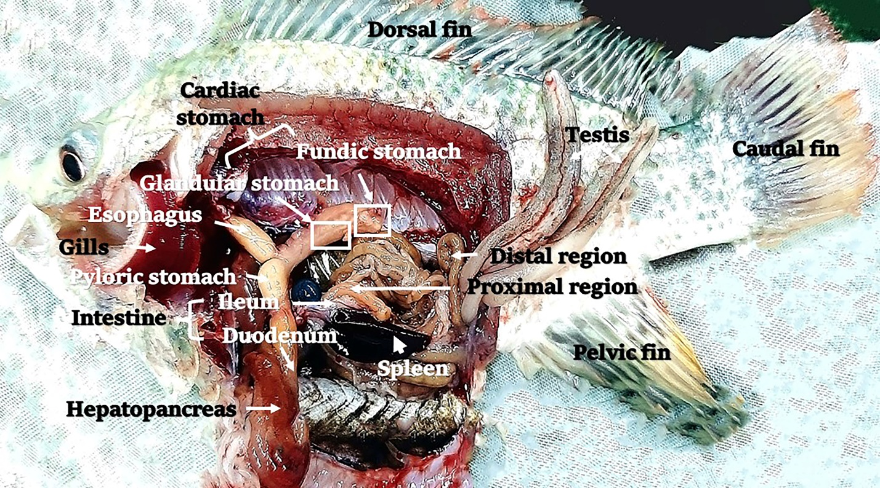

Fig S1: Macroscopical organization of the digestive tract in Nile tilapia (Oreochromis niloticus).

