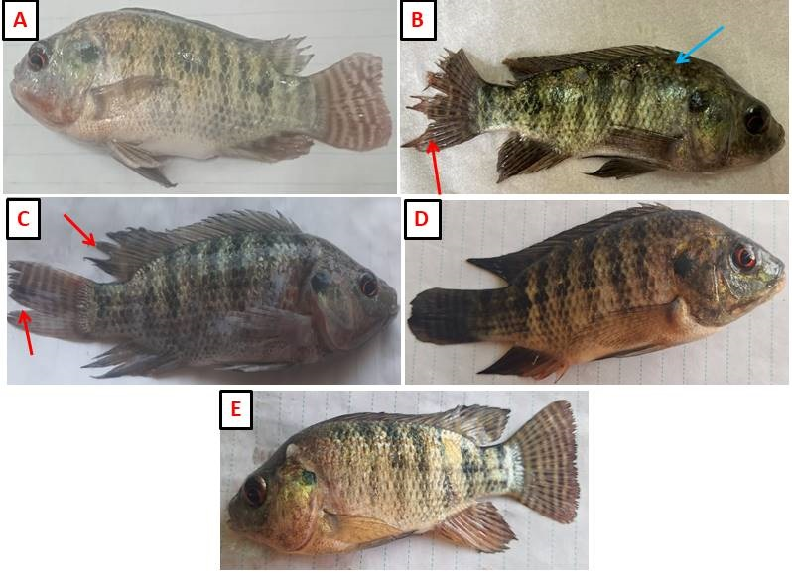

Clinical signs of Nile tilapia exposed to nickel-intoxication and fed on tea tree (TTO) and basil essential oils (BEO) -fortified for 45 days. A representative photo to control, TTO, and BEO groups exhibit a normal appearance. B−C Fish that were exposed to 3.6 mg/L nickel, exhibit skin darkness (blue arrows) and fin rot . D−E Fish exposed to nickel and fed on TTO and BEO diets, respectively exhibit apparently normal appearance.

