1. Initial literature search
Supplementary Material 2: Additional analysis for the meta-analysis.
List of relevant reference & books
Studies = 39
Web of science
Studies = 203
Google Scholar
Studies = 154
Mendelely
Studies = 107

Total literature searched & found
Studies = 503

2. Screening of literature found

Criteria
- Is a maize monoculture?
- Is field located within African smallholder landscape?
- Is a randomized trial & mineral fertilizer applied as treatment?

Selection of potential relevant publication (studies) for the meta-analysis

Excluded
- No control reported,
Studies = 22
- No soil information,
Studies = 126
- Aggregated data from multiple trials, Studies = 234
- Intercrop of maize with other crops, Studies = 49
- Combined with inorganic fertilizer, Studies = 45

Relevant Information
- Control & fertilizer treatment
- Management factors
- Environmental factors

Final inclusion in the database
Studies = 71
(n = 457, total;
Kenya = 202, rest of SSA =255)
3. Database development

Fig.S1. Meta-analysis flow chart for selection of studies and database development, n represents the total number of observations. Control were considered as plots where no fertilizer (organic or inorganic) had been applied. Rest of SSA include other countries in SSA besides Kenya.
Fig. S2. Flowchart showing the different steps that were done to estimate the missing values for some of the soil properties in the database. The R² is the Pearson correlation coefficient obtained from correlation analysis. Soil property that were highly correlated (R²>0.8), the property with the highest number of missing values was removed from the analysis.
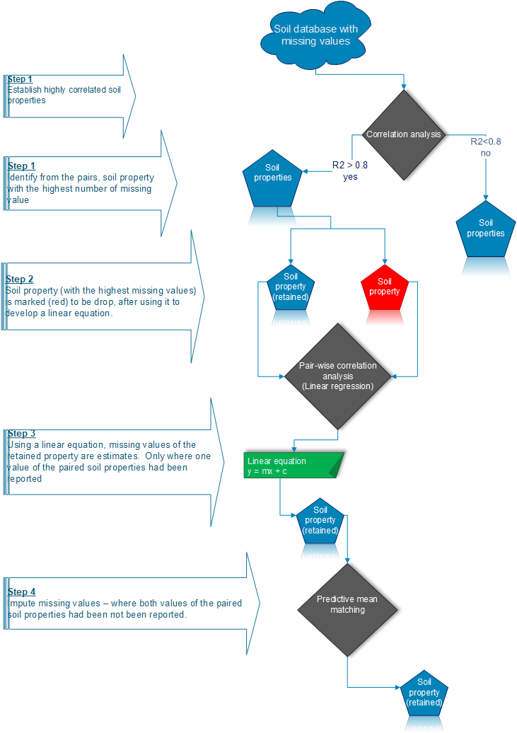

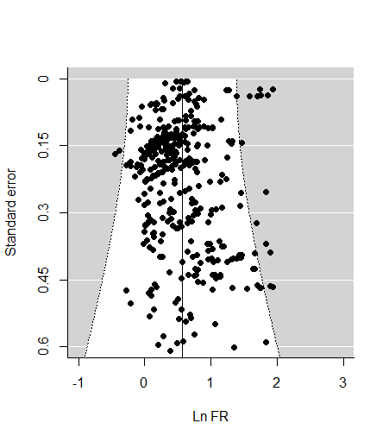
Fig. S3. Funnel plot showing the distribution of the natural log fertilizer response (ln FR) in the funnel plot adjusted with the heterogeneity of the random effect model. The vertical line is the regression line, which divides the funnel into equal portions to illustrate the asymmetry. Black dots are individual ln FR observations (n = 457); the grey area illustrates area outside the funnel

