Electronic Supplementary Material

Deep N fertilizer placement mitigated N₂O emissions in a Swedish field trial with cereals
Vide Rychelª, Katharina H.E. Meurer*ª, Gunnar Börjessonª, Monika Strömgrenª, Gizachew Tarekegn Getahunª, Holger Kirchmannª, Thomas Kätterer^{b}

ª Department of Soil and Environment, Swedish University of Agricultural Sciences, Box 7014, SE-750 07 Uppsala, Sweden
^{b} Department of Ecology, Swedish University of Agricultural Sciences, Box 7044, SE-750 07 Uppsala, Sweden
*Correspondence: Katharina Meurer, Department of Soil and Environment, Swedish University of Agricultural Sciences, Box 7014, SE-75007 Uppsala, Sweden. E-mail: katharina.meurer@slu.se

Table S1 Average daily fluxes of N₂O-N [µg m⁻² h⁻¹] and CH₄-C [µg m⁻² h⁻¹. The data is presented as mean values ± SE. Different letters denote statistical difference on the respective day of measurement as determined by repeated measures ANOVA with the repetitions as random factor. DAF = Number of days after fertilization, NF = no fertilizer, SP = shallow fertilizer placement (0.07 m), MP = mixed placement of fertilizer (half at 0.07 m, half at 0.20 m), and DP = deep fertilizer placement (0.20 m).
 |  | N₂O-N [µg m⁻² h⁻¹] |  |  |  | CH₄-C [µg m⁻² h⁻¹]
Date | DAF | NF | SP | MP | DP | NF | SP | MP | DP
5/18/2016 | 1 | 19 ± 5 ab | 35 ± 6 a | 9 ± 11 ab | 7 ± 6 b | -42 ± 10 b | -16 ± 3 ab | -26 ± 6 ab | -5 ± 10 a
5/23/2016 | 6 | 24 ± 2 b | 48 ± 3 ab | 50 ± 10 ab | 40 ± 10 ab | -9 ± 3 a | -11 ± 6 a | -6 ± 7 a | 4 ± 7 a
5/30/2016 | 13 | 10 ± 11 a | 27 ± 10 a | 35 ± 9 a | 10 ± 6 a | -11 ± 3 a | -6 ± 2 a | -6 ± 3 a | -12 ± 3 a
6/8/2016 | 22 | 35 ± 2 a | 41 ± 7 a | 17 ± 11 a | 20 ± 9 a | -19 ± 8 a | -14 ± 2 a | -7 ± 3 a | -16 ± 6 a
6/20/2016 | 34 | 22 ± 15 a | 46 ± 9 a | 43 ± 6 a | 42 ± 10 a | -18 ± 5 a | -18 ± 7 a | -15 ± 2 a | -10 ± 6 a
7/4/2016 | 48 | 20 ± 8 a | 34 ± 15 a | 40 ± 12 a | 43 ± 7 a | -10 ± 3 a | -15 ± 1 a | -4 ± 6 a | -12 ± 2 a
7/14/2016 | 58 | 28 ± 6 a | 29 ± 16 a | 51 ± 4 a | 45 ± 12 a | 2 ± 9 a | -11 ± 4 ab | -14 ± 5 ab | -21 ± 5 b
7/27/2016 | 71 | 34 ± 15 a | 56 ± 19 a | 28 ± 10 a | 21 ± 12 a | -3 ± 11 a | -30 ± 17 a | -29 ± 4 a | -16 ± 10 a
5/17/2017 | 1 | 19 ± 5 a | 25 ± 6 a | 25 ± 6 a | 31 ± 9 a | -49 ± 12 b | -18 ± 4 ab | -27 ± 6 ab | -4 ± 11 a
5/18/2017 | 2 | 10 ± 6 a | 22 ± 7 a | 22 ± 7 a | 19 ± 1 a | 2 ± 4 a | -9 ± 10 a | -1 ± 11 a | -1 ± 6 a
5/19/2017 | 3 | 35 ± 3 ab | 47 ± 10 a | 47 ± 10 a | 25 ± 5 b | -5 ± 5 a | 1 ± 5 a | 5 ± 2 a | -2 ± 5 a
5/22/2017 | 6 | 40 ± 4 a | 48 ± 11 a | 48 ± 11 a | 40 ± 7 a | -16 ± 11 a | -5 ± 6 a | -31 ± 18 a | -1 ± 4 a
5/23/2017 | 7 | 19 ± 10 a | 47 ± 8 a | 47 ± 8 a | 22 ± 7 a | 10 ± 6 a | 2 ± 3 a | -1 ± 4 a | -5 ± 7 a
5/24/2017 | 8 | 12 ± 2 b | 24 ± 5 a | 24 ± 5 a | 32 ± 5 a | -1 ± 6 ab | 20 ± 8 a | -11 ± 4 b | -11 ± 5 b
5/25/2017 | 9 | 51 ± 8 a | 64 ± 17 a | 64 ± 17 a | 59 ± 16 a | -3 ± 4 a | -14 ± 5 a | -9 ± 5 a | -15 ± 7 a
5/26/2017 | 10 | 49 ± 12 a | 42 ± 13 a | 42 ± 13 a | 17 ± 8 a | -1 ± 5 a | -7 ± 6 a | 6 ± 7 a | -5 ± 6 a
5/29/2017 | 13 | 27 ± 9 b | 54 ± 8 a | 54 ± 8 a | 11 ± 4 b | -4 ± 14 a | 13 ± 2 a | 16 ± 10 a | -4 ± 4 a
5/30/2017 | 14 | 27 ± 8 b | 73 ± 7 a | 73 ± 7 a | 36 ± 6 b | -17 ± 2 a | -12 ± 5 a | -19 ± 6 a | -14 ± 4 a
6/2/2017 | 17 | 21 ± 6 ab | 31 ± 7 a | 31 ± 7 a | 9 ± 2 b | 4 ± 4 a | 1 ± 7 a | 7 ± 5 a | 1 ± 3 a
6/7/2017 | 22 | 21 ± 8 a | 28 ± 5 a | 28 ± 5 a | 14 ± 3 a | 14 ± 8 a | -4 ± 10 a | 7 ± 2 a | 1 ± 4 a
6/9/2017 | 24 | 59 ± 7 bc | 107 ± 4 a | 107 ± 4 a | 34 ± 8 c | 2 ± 4 a | -6 ± 2 a | -4 ± 6 a | -7 ± 3 a
6/16/2017 | 31 | 49 ± 5 bc | 119 ± 15 a | 119 ± 15 a | 41 ± 7 c | -11 ± 5 a | -6 ± 6 a | -6 ± 7 a | -8 ± 5 a
6/27/2017 | 42 | 28 ± 11 b | 76 ± 11 a | 76 ± 11 a | 33 ± 10 b | -3 ± 4 a | 3 ± 9 a | -3 ± 6 a | -13 ± 5 a
7/5/2017 | 50 | 47 ± 16 b | 109 ± 4 a | 109 ± 4 a | 53 ± 9 b | -20 ± 6 b | -10 ± 3 ab | 4 ± 6 a | -14 ± 3 b
7/20/2017 | 65 | 38 ± 6 a | 45 ± 9 a | 45 ± 9 a | 36 ± 10 a | -13 ± 5 b | 9 ± 12 ab | 16 ± 5 a | 6 ± 7 ab
7/27/2017 | 72 | 61 ± 3 a | 78 ± 11 a | 78 ± 11 a | 79 ± 18 a | -4 ± 9 a | -7 ± 5 a | -8 ± 8 a | 8 ± 3 a
8/1/2017 | 77 | 164 ± 17 a | 191 ± 35 a | 191 ± 35 a | 160 ± 7 a | 1 ± 12 a | -16 ± 3 a | 8 ± 16 a | 7 ± 9 a
8/11/2017 | 87 | 61 ± 10 a | 82 ± 11 a | 82 ± 11 a | 55 ± 14 a | -4 ± 7 a | 10 ± 8 a | 1 ± 9 a | -2 ± 7 a
8/22/2017 | 98 | 50 ± 17 b | 138 ± 25 a | 138 ± 25 a | 90 ± 22 ab | -3 ± 6 a | 9 ± 6 a | -2 ± 7 a | 4 ± 3 a
9/15/2017 | 122 | 79 ± 24 a | 90 ± 13 a | 90 ± 13 a | 92 ± 6 a | -1 ± 6 ab | 8 ± 4 ab | 11 ± 3 a | -6 ± 1 b
4/13/2018 | 332 | 517 ± 118 a | 270 ± 70 a | 270 ± 70 a | 561 ± 180 a | -5 ± 2 a | -2 ± 2 a | -5 ± 2 a | -4 ± 1 a
4/17/2018 | 336 | 399 ± 21 a | 448 ± 48 a | 448 ± 48 a | 288 ± 101 a | -5 ± 1 a | -4 ± 5 a | -2 ± 2 a | 5 ± 8 a
4/24/2018 | 343 | 319 ± 90 a | 260 ± 90 a | 260 ± 90 a | 109 ± 25 a | -11 ± 3 a | -8 ± 3 a | -17 ± 4 a | -6 ± 1 a

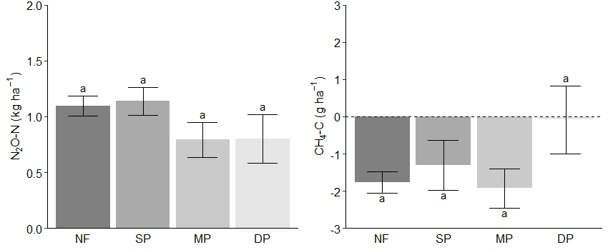
Fig. S1 Cumulative fluxes of N₂O (kg N₂O-N ha⁻¹) and CH₄ (g CH₄-C ha⁻¹) between 13 and 24 April 2018. Nitrous oxide (kg N₂O-N ha⁻¹), methane (g CH₄-C ha⁻¹). Vertical error bars represent standard error (SE) of the mean. NF = no fertilizer, SP = shallow fertilizer placement (0.07 m), MP = mixed placement of fertilizer (half at 0.07 m, half at 0.20 m), and DP = deep fertilizer placement (0.20 m).
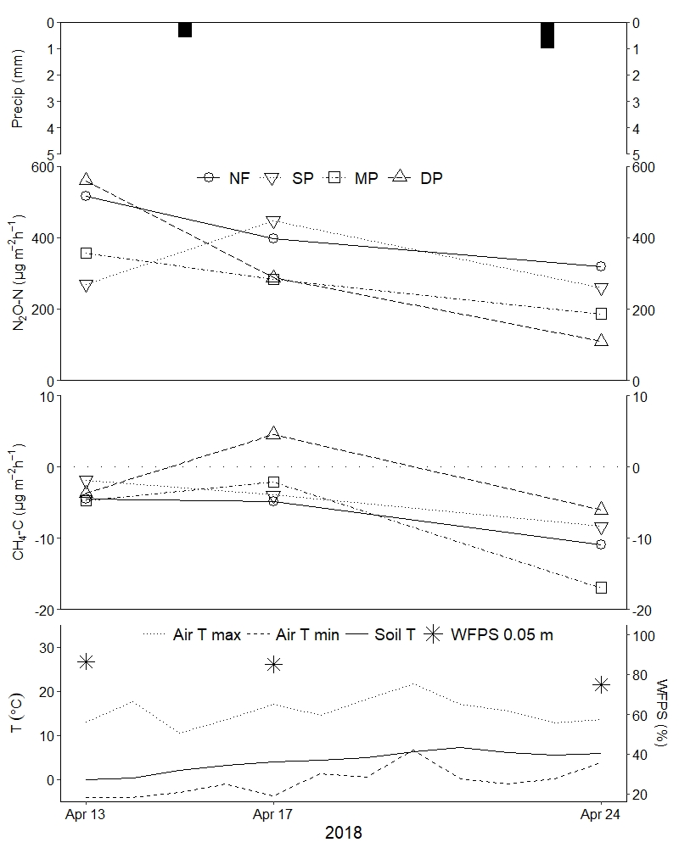
Fig. S2 Spring 2018 thawing period daily precipitation (mm), mean treatment nitrous oxide fluxes (µg N₂O-N m⁻² h⁻¹), methane fluxes (µg CH₄-C m⁻² h⁻¹), maximum and minimum air temperature*, soil temperature at 0.10 m soil depth*, and soil water content (% WFPS) at 0 – 0.05 m soil depth. For clarity, error bars have been excluded from gas concentration values but can be found in supplementary material Table S1. NF = no fertilizer, SP = shallow fertilizer placement (0.07 m), MP = mixed placement of fertilizer (half at 0.07 m, half at 0.20 m), and DP = deep fertilizer placement (0.20 m).
* Accessed on 13-Feb-2019 from Uppsala Funbo-Lövsta Lantmet climate station (http://www.ffe.slu.se/lm/LMHome.cfm?LMSUB=1).

N₂O and CH₄ fluxes measured during spring thaw
The N₂O fluxes measured during three occasions in spring 2018 were, on average, 5 to 10 times higher than any previously measured flux recorded during the growing seasons. Half of the fluxes measured during this period were greater than the highest measured flux (400 µg N₂O-N m⁻² h⁻¹) from the preceding 2017 cropping season. Average fluxes ± SD for NF, SP, MP and DP were 412 ± 191, 326 ± 167, 276 ± 160, and 319 ± 303 µg N₂O-N m⁻² h⁻¹, respectively. The lowest and highest emissions of this period were measured in DP, 64.4 and 1696 µg N₂O-N m⁻² h⁻¹. Cumulative N₂O emissions were highest in the NF plots and lowest in MP (Figure S1). These emissions comprised between 40 to 70 % of cumulative N₂O during the cropping season, with the highest percentage in the unfertilized plots. A comparable study on Finnish boreal mineral soils reported a similar range of annual N₂O emissions, of which around 60 % generally occurred outside of the growing season (Syväsalo et al., 2004). Interpretation of the treatment effect on N₂O emissions during this period is speculative because mineral N and labile C, as well as the size and composition of the microbial community during that time are unknown. Generally, it is assumed that much of the flush of N and C supplied to denitrifiers after thaw comes from microbial necromass (Schimel et al. 2007) and soil disaggregation, as well as from remaining crop residue. Cropland freeze-thaw cycles are known to be a major source of N₂O emissions in this part of the hemisphere, but since the frequency of these cycles, which is proposed to be positively correlated with higher emissions (Chen et al. 1995), is expected to increase with climate change (Henry 2008), measurements during early spring may be even more important to monitor in future studies than those ocurring during the cropping season (e.g. Wagner-Riddle & Thurtell 1998).
Average CH₄ fluxes (± SD) for NF, SP, MP and DP were -6.8 ± 5.7, -4.7 ± 7.8, -7.9 ± 8.5, and -1.7 ± 10.1 µg CH₄-C m⁻² h⁻¹, respectively. The greatest uptake during this period was in MP (-35.4 µg CH₄-C m⁻² h⁻¹) and the highest emission was in DP (31.1 µg CH₄-C m⁻² h⁻¹). Low uptake rates from an arable field after spring thaw have also been observed by Dörsch et al. (2004) in Southern Germany. However, uptake rates were generally independent of freeze-thaw cycles. The authors suggest that this is mainly caused by the down-regulation of CH₄ oxidation in cold temperatures.

References
Chen Y, Tessier S, MacKenzie AF, Laverdière MR (1995) Nitrous oxide emission from an agricultural soil subjected to different freeze-thaw cycles. Agric Ecosyst Environ 55:123-128. https://doi.org/10.1016/0167-8809(95)00611-U
Dörsch P, Palojärvi A, Mommertz S (2004) Overwinter greenhouse gas fluxes in two contrasting agricultural habitats. Nutr Cycl Agroecosyst 70:117-133
Henry, HAL (2008) Climate change and soil freezing dynamics: historical trends and projected changes. Clim Change 87:421-434. https://doi.org/10.1007/s10584-007-9322-8
Schimel J, Balser TC, Wallenstein M (2007) Microbial stress-response physiology and its implications for ecosystem function. Ecol 88:1386-1394. https://doi.org/10.1890/06-0219
Syväsalo E, Regina K, Pihlatie M, Esala M (2004) Emissions of nitrous oxide from boreal agricultural clay and loamy sand soils. Nutr Cycl Agroecosyst 69:155-165. https://doi.org/10.1023/B:FRES.0000029675.24465.fc
Wagner-Riddle C, Thurtell GW (1998) Nitrous oxide emissions from agricultural fields during winter and spring thaw as affected by management practices. Nutr Cycl Agroecisyst 52:151-163.

