Supplementary Material
For: Three-dimensional distribution and transformations of nitrogen from band-applied urea and enhanced efficiency fertilizers in a Vertosol
Chelsea K Janke^{a,*}, Philip Moody^{b}, Michael J Bell^{a,c}
ªSchool of Agriculture and Food Sciences, University of Queensland, Australia
^{b}Landscape Sciences, Department of Environment and Science, Queensland Government, Australia
^{c} Centre for Plant Science, Queensland Alliance for Agriculture and Food Innovation, University of Queensland, Australia
*Corresponding author: chelsea.stroppiana@uq.net.au

*
This aim of this Supplementary Material is to aid interpretation of data presented and discussed in the manuscript by presenting the sampling grid, demonstrating the statistical analysis approach, displaying data not included in the manuscript and exhibiting the process for generating the heat maps used to display variable concentrations and distribution within a soil profile. Full datasets and statistical output are available on request.
*

The efficacy of the various enhanced efficiency fertilizer (EEF) technologies is discussed in terms of their impact on the major soil processed outlined in Fig. S1.

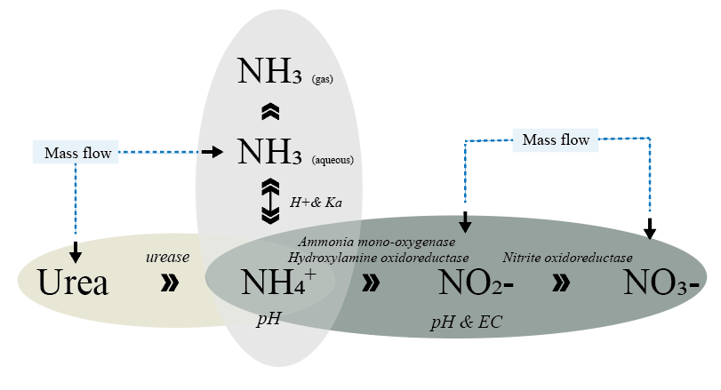
Figure S1 Schematic of the key soil biological and chemical properties influencing N transformation in response to urea addition and the N species subject to mass flow effects

A 350 × 200 × 70 mm (l × b × d) soil monolith was extracted in the field. This was subsequently sectioned into 50 × 50 mm sections at specific locations, which were analysed separately.
25 < 0 > 25 | 25 – 75 | 75 – 125 | From surface (mm) | From centre band (mm)
1 |  |  | 0 – 50 | +75 – 125
3 | 2 |  | 50 – 100 | +25 – 75
Band  6 | 5 | 4 | 100 – 150 | 0 ± 25
8 | 7 |  | 150 – 200 | -25 – 75
9 |  |  | 200 – 250 | -75 – 125

Figure S2 The zones of the sample grid on the extracted soil profile. The band is located in the centre of zone 6 (‘fertosphere’), which extends 25 mm in all directions

Multiple ANOVAs were conducted to test for statistical variation over time, position (i.e., zones 6 & 8 in sample grid, Fig. 1), N-fertilizer treatment, and the interactions thereof. As NH₄-N was generally used to direct interpretations of trends and processes within the manuscript, only the output for this variable is shown here. Statistical output for other measurements (urea-N, NO₃-N, NO₂-N, aqueous NH₃, pH, and EC), post-hoc analysis and mean + standard error tables are available on request.

Analysis of Variance
Variate: Log₁₀(NH₄-N + 0.5) [antilog(NH₄-N - 0.5)]
Source | DF | SS |  | MS |  | F-Value | P-Value
Block | 3 | 1.4417 | [-0.0261] | 0.4806 | [0.0087] | 1.02
Block*Subject
Treatment | 5 | 104.8185 | [-2.0184] | 20.9637 | [-0.4036] | 44.43 | <.001
Treatment*Position | 6 | 3.4693 | [-0.4727] | 0.5782 | [-0.0787] | 1.23 | 0.318
Residual | 33 | 15.5693 | [-1.1781] | 0.4718 | [-0.0357] | 1.78
Block*Subject*Time
(DF correction factor 0.7626)
Time | 4 | 18.0012 | [-1.2431] | 4.5003 | [-0.3108] | 17.01 | <.001
Time*Treatment | 20 | 23.8616 | [-1.3685] | 1.1931 | [-0.0684] | 4.51 | <.001
Time*Treatment*Position | 24 | 6.1393 | [-0.7512] | 0.2558 | [-0.0313] | 0.97 | 0.503
Residual | 144 | 38.0878 | [-1.5750] | 0.2645 | [-0.0109]
Total | 239 | 211.3888 | [-2.3241]
Table S1 The variation in NH₄-N values between all N-fertilizer treatments applied at the high in-band concentration (26 g N m⁻¹) at positions 6 & 8, over time. This analysis was conducted on transformed data (log₁₀ (x+0.5)) and is a combined analysis using time as a repeated measure to test the effects of different N-fertilizer treatments (including control), with sampling position nested within treatments

Table S2 The variation in NH₄-N values between urea and DMPP-urea treatments applied at the varying in-band concentration (9 – 27 g N m⁻¹) at positions 6 & 8, over time. This analysis was conducted on transformed data (log₁₀ (x+0.5)) and is a combined analysis using time as a repeated measure to test the effects of different N-fertilizer products and rates (excluding control), with sampling position nested within treatments (N-fertilizer product × rate)
Analysis of Variance
Variate: Log₁₀(NH₄-N + 0.5) [antilog(NH₄-N - 0.5)]
Source | DF | SS |  | MS |  | F-Value | P-Value
Block | 3 | 0.9682 | [-0.3296] | 0.3227 | [-0.1099] | 0.75
Block*Subject
Treatment | 1 | 13.5257 | [-1.1148] | 13.5257 | [-1.1148] | 31.24 | <.001
Rate | 2 | 36.9963 | [-1.5622] | 18.4982 | [-0.7811] | 42.73 | <.001
Treatment*Rate | 2 | 3.3573 | [-0.4560] | 1.6787 | [-0.2280] | 3.88 | 0.031
Rate*Position | 3 | 3.9677 | [-0.5400] | 1.3226 | [-0.1800] | 3.05 | 0.042
Treatment*Rate*Position | 3 | 0.7064 | [-0.6853] | 0.2355 | [-0.2284] | 0.54 | 0.656
Residual | 33 | 14.287 | [-1.1395] | 0.4329 | [-0.0345] | 1.28
Block*Subject*Time
(DF correction factor 0.6612)
Time | 4 | 31.271 | [-1.4881] | 7.8177 | [-0.3720] | 23.04 | <.001
Time*Treatment | 4 | 4.2463 | [-0.5736] | 1.0616 | [-0.1434] | 3.13 | 0.035
Time*Rate | 8 | 1.0661 | [-0.2471] | 0.1333 | [0.0309] | 0.39 | 0.862
Time*Treatment*Rate | 8 | 6.5471 | [-0.7815] | 0.8184 | [-0.0980] | 2.41 | 0.039
Time*Rate*Position | 12 | 2.2459 | [-0.2420] | 0.1872 | [-0.0202] | 0.55 | 0.813
Time*Product*Rate*Position | 12 | 2.2059 | [-0.2320] | 0.1838 | [-0.0193] | 0.54 | 0.821
Residual | 144 | 48.8576 | [-1.6845] | 0.3393 | [-0.0117]
Total | 239 | 170.2487 | [-2.22981]

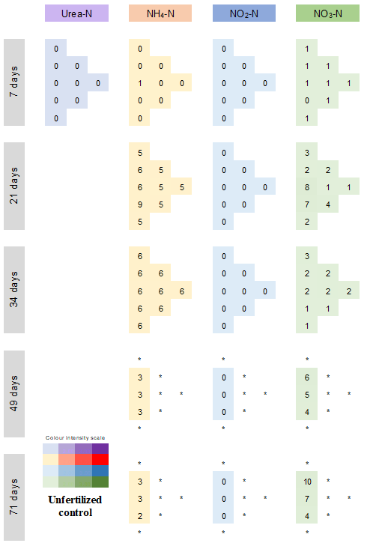
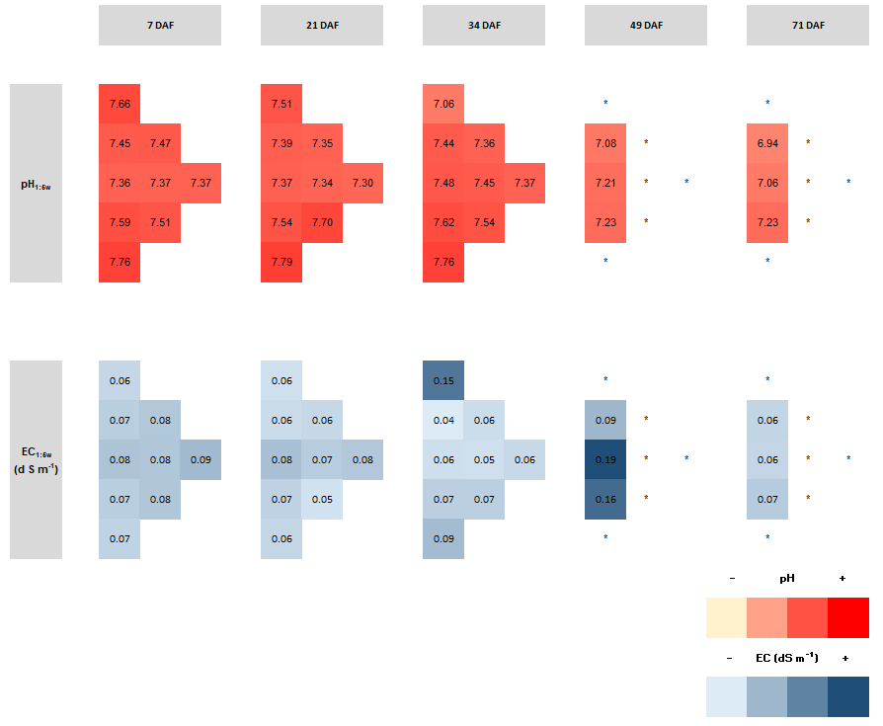
Figure S3 Distribution of N species (mg N kg soil⁻¹) on X-axis over time (Y-axis) in unfertilized soil, characterising the background conditions. The colour intensity for each N species indicates the concentration relative to that of all treatments over 71 days for that N species. (*) indicates zones (Fig. S2) which were not sampled
Figure S4 The distribution of pH_{1:5w} and EC_{1:5} over time in untreated soil profiles
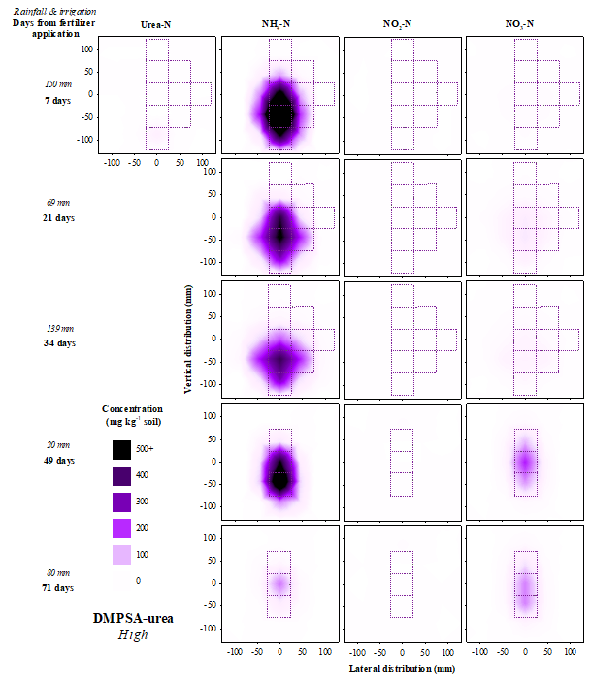
Figure S5 Distribution of N species (mg N kg⁻¹ soil) over time in soil treated with the high in-band concentration (27 g N m⁻¹) of banded DMPSA-urea. No measurement of urea-N was taken after 7 days

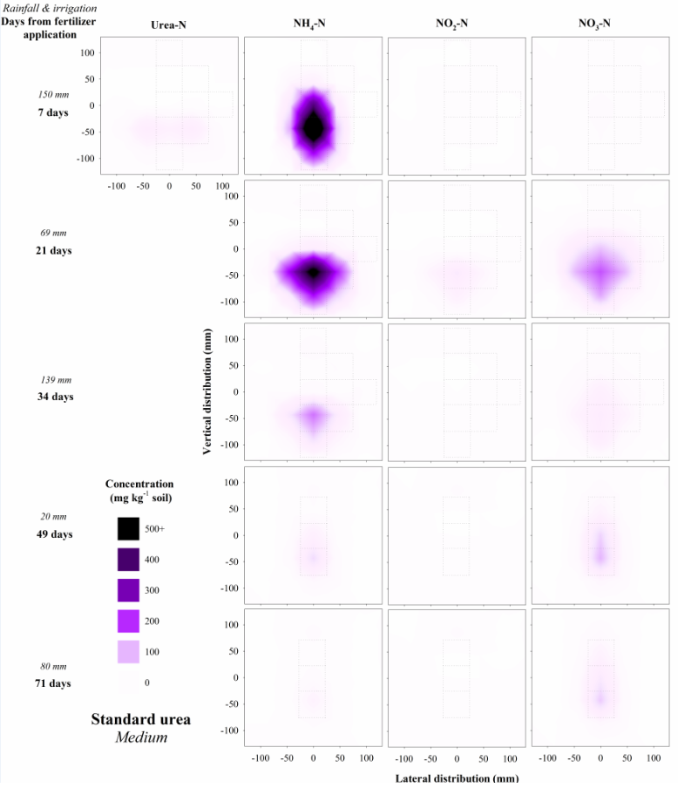
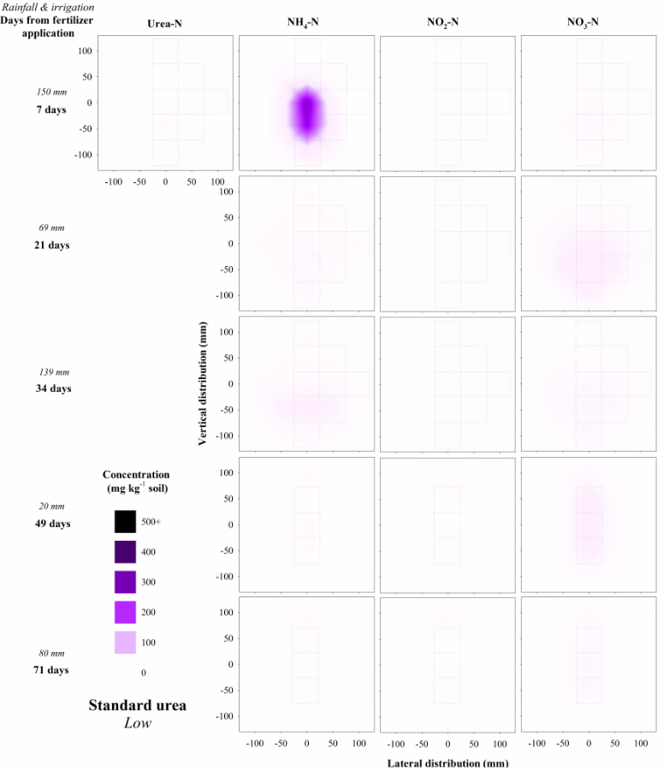
Figure S6 Distribution of N species (mg N kg⁻¹ soil) over time in soil treated with the (A) low and (B) medium in-band concentrations (9 and 18 g N m⁻¹, respectively) of banded urea. No measurement of urea-N was taken after 7 days. The grid indicates the zones (Fig. S2) that were sampled at each time point
B
A

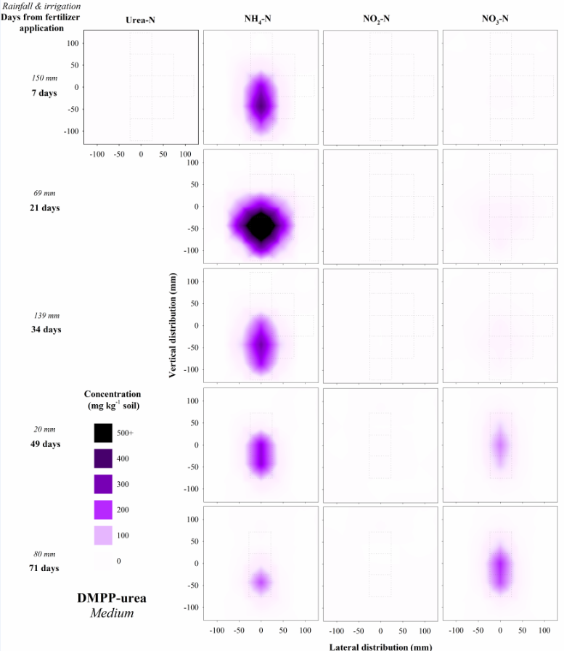
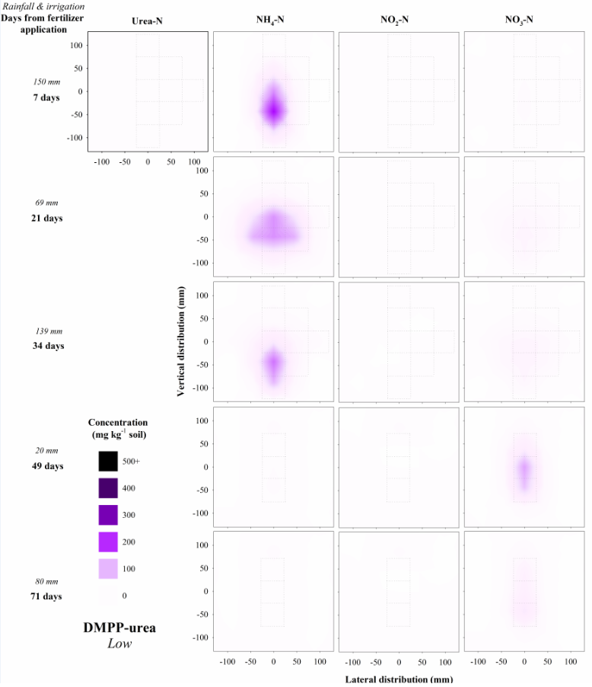
Figure S7 Distribution of N species (mg N kg⁻¹ soil) over time in soil treated with the (A) low and (B) medium in-band concentrations (9 and 18 g N m⁻¹, respectively) of banded DMPP-urea. No measurement of urea-N was taken after 7 days. The grid indicates the zones (Fig. S2) that were sampled at each time point
B
A

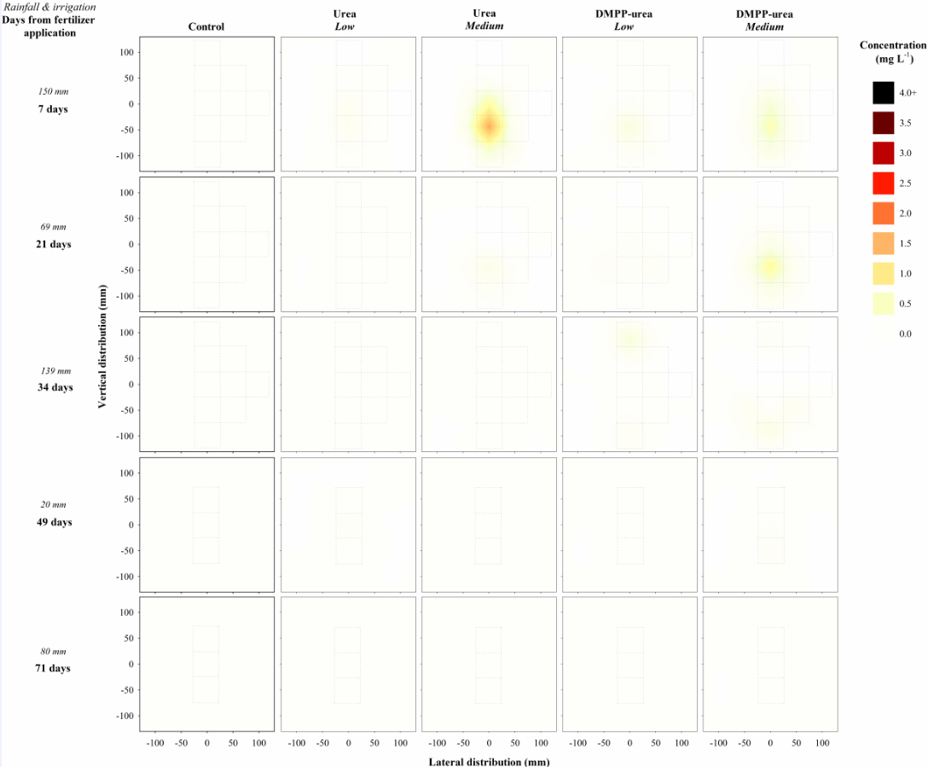
Figure S8 The distribution and change in calculated aqueous NH₃ concentration (mg L⁻¹) over time in response to banded urea and DMPP-urea treatments at in-band concentrations of 9 and 18 g N m⁻¹

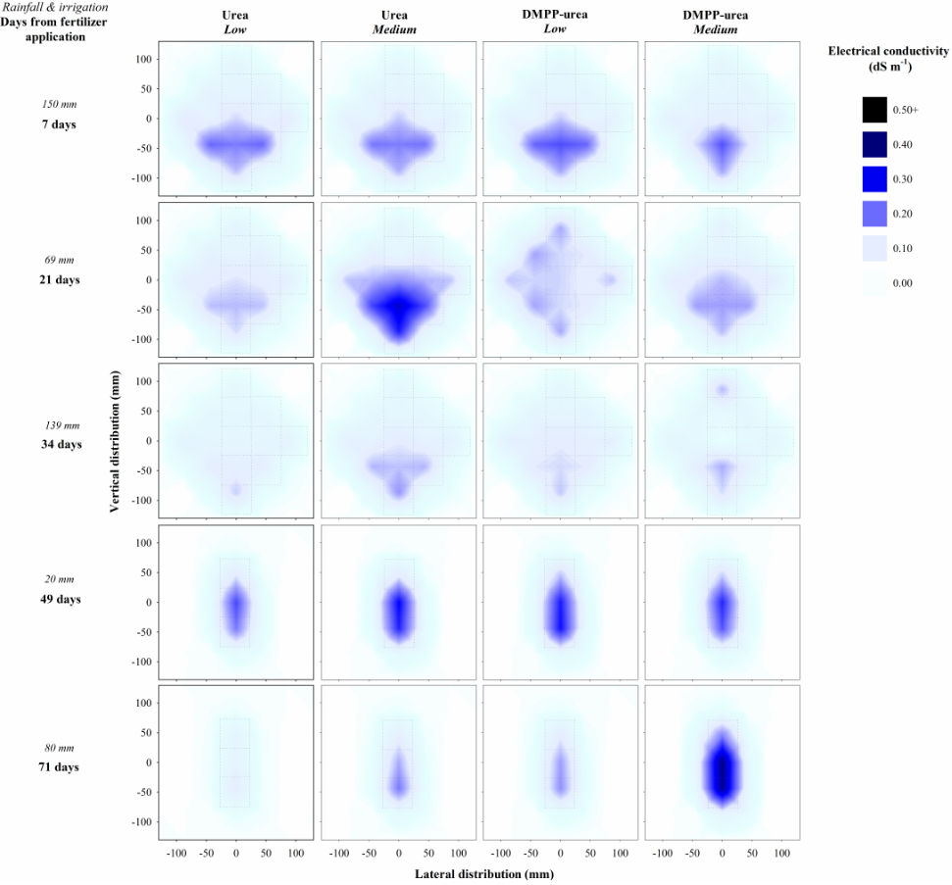
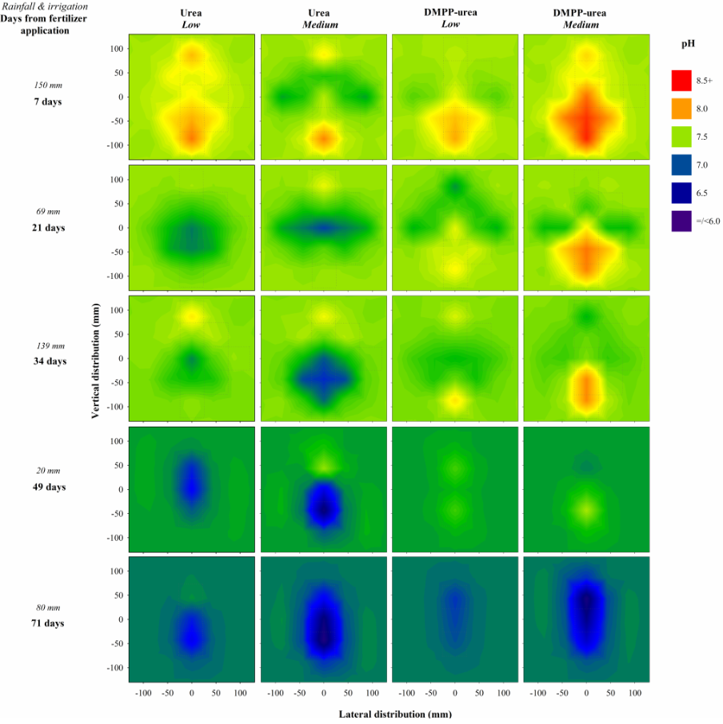
Figure S9 Heat maps of (A) pH fluxes and (B) electrical conductivity (dS m⁻¹) over time in response to banded urea and DMPP-urea treatments at the low and medium in-band concentrations of 9 and 18 g N ha⁻¹, respectively. The pH indicated outside the sample zone (marked with grid) is representative of the average pH throughout the profile in control soil at that time.
B
A

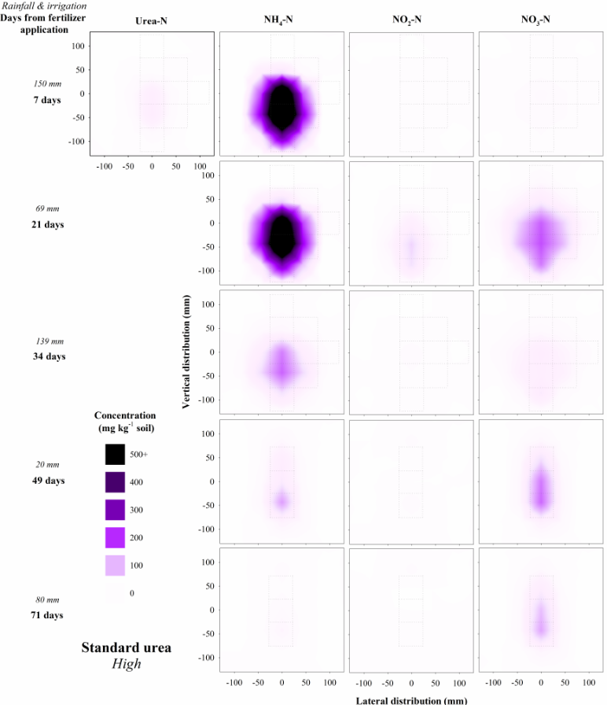
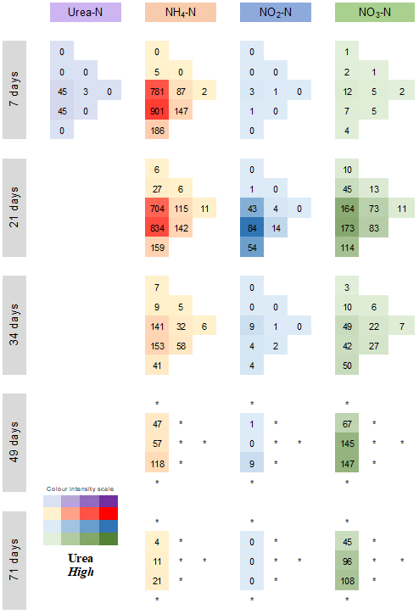
Figure S10 Illustration of how the mean of measured values of N species for each treatment × time × position (A) were converted to heat maps (B). For heat maps, the ‘left’ lateral values were the duplicate of measured values to the ‘right’ of the fertosphere (see Fig. 1), under the assumption of uniform lateral distribution from fertilizer bands. In the following graphs, the colour intensity for each N species value indicates the concentration and / or value relative to that of all treatments over 71 days for that N species. (*) indicates zones (see Fig. S2) which were not sampled
A
B

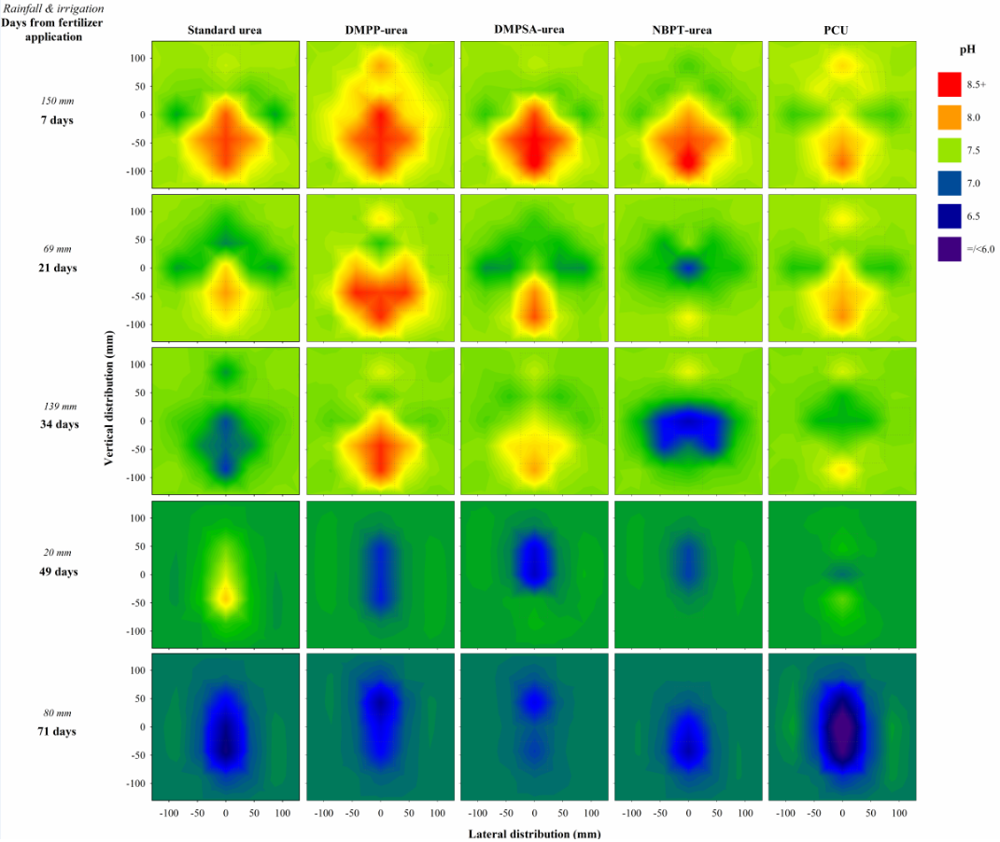
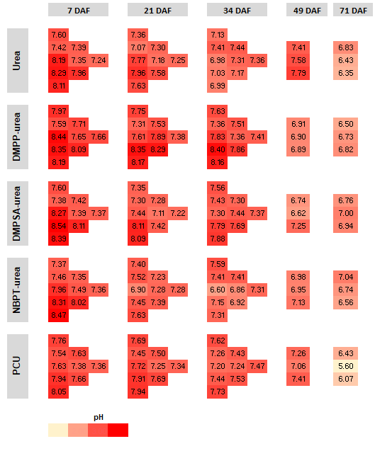
Figure S11 Illustration of how pH values for each treatment × time × position (A) were converted to heat maps (B). For heat maps, the ‘left’ lateral values were the duplicate of measured values to the ‘right’ of the fertosphere (see Fig. S2), under the assumption of uniform lateral distribution from fertilizer bands. In the following graphs, the colour intensity for each N species value indicates the concentration and / or value relative to that of all treatments over 71 days for that N species. Additionally, background values (i.e., outside the sample zone which is marked with grid) in the heat map is representative of the average pH throughout the profile in control soil at that time
B
A

