Early nitrogen supply as an alternative management for a cover crop-maize sequence under no-till system
Letusa Momesso, Carlos A. C. Crusciol, Rogério P. Soratto, Carlos A. C. Nascimento, Ciro A. Rosolem, Luiz G. Moretti, Eiko E. Kuramae, Heitor Cantarella

L. Momesso*, C. A. C. Crusciol*, R. P. Soratto, C. A. Rosolem, L. G. Moretti
São Paulo State University (UNESP), College of Agricultural Sciences, Department of Crop Science, Av. Universitaria, 33789, Lageado Experimental Farm, 18610-034, Botucatu, São Paulo, Brazil

L. Momesso*, E. E. Kuramae*
Netherlands Institute of Ecology, Department of Microbial Ecology, Droevendaalsesteeg 10, 6708 PB, Wageningen, The Netherlands
Ecology and biodiversity, Institute of Environmental Biology, Utrecht University, Padualaan 8, 3584 CH, Utrecht, The Netherlands

C. A. C. Nascimento
University of Sao Paulo (USP-ESALQ), Av. Pádua Dias, 235, 13418-900, Piracicaba, São Paulo, Brazil.

H. Cantarella
Agronomic Institute of Campinas (IAC), Av. Barao de Itapura, 1481, Botafogo, 1307-630, Campinas, São Paulo, Brazil

*Correspondence:
Corresponding Authors
l.momesso@nioo.knaw.nl (L. Momesso)
carlos.crusciol@unesp.br (C.A.C. Crusciol)
e.kuramae@nioo.knaw.nl (E.E. Kuramae)

Supplementary Material

Supplementary Table 1

Chemical properties of field experiment soil (0-0.20 m depth) in the experimental.
Growing season | pH  (CaCl₂) | SOM †  (g dm⁻³) | P_{(resin)}  (mg dm⁻³) | H+Al | K⁺ | Ca²⁺ | Mg²⁺ | CEC ‡ | BS §
 |  |  |  | (mmol_{c} dm⁻³) |  |  |  |  | (%)
2015/16 | 4,8 | 32 | 19 | 44 | 4,9 | 34 | 18 | 101 | 56
2016/17 | 4,6 | 24 | 18 | 39 | 3,8 | 37 | 16 | 96 | 59
2017/18 | 4,5 | 27 | 20 | 42 | 3,3 | 31 | 21 | 98 | 57
SOM - Soil organic matter.
CEC - Cation exchange capacity.
BS - Base saturation.

Supplementary Table 2

Historical crop rotation before study period for three field areas in the 2014-2015 and 2015-2016 growing seasons.
Field area | Season | Crops (spring-summer/fall-winter)
Area I  (2015-2016) | 2006-2007 | soybean / white oat
Area I  (2015-2016) | 2007-2008 | maize / white oat
Area I  (2015-2016) | 2008-2009 | soybean / white oat
Area I  (2015-2016) | 2009-2010 | maize / forage grass (Urochloa ruziziensis)
Area I  (2015-2016) | 2010-2011 | maize / forage grass (Urochloa ruziziensis)
Area I  (2015-2016) | 2011-2012 | common bean / forage grass
Area I  (2015-2016) | 2012-2013 | peanut / forage grasses (U. brizantha and U. ruziziensis)
Area I  (2015-2016) | 2013-2014 | forage grasses (U. brizantha and U. ruziziensis)
Area I  (2015-2016) | 2014-2015 | forage grasses (U. brizantha and U. ruziziensis)
Area II  (2016-2017) | 2006-2007 | soybean / white oat
Area II  (2016-2017) | 2007-2008 | maize / white oat
Area II  (2016-2017) | 2008-2009 | soybean / white oat
Area II  (2016-2017) | 2009-2010 | maize / forage grass (Urochloa ruziziensis)
Area II  (2016-2017) | 2010-2011 | maize / forage grass (Urochloa ruziziensis)
Area II  (2016-2017) | 2011-2012 | common bean / forage grass
Area II  (2016-2017) | 2012-2013 | peanut / forage grasses (U. brizantha and U. ruziziensis)
Area II  (2016-2017) | 2013-2014 | forage grasses (U. brizantha and U. ruziziensis)
Area II  (2016-2017) | 2014-2015 | forage grasses (U. brizantha and U. ruziziensis)
Area II  (2016-2017) | 2015-2016 | maize / forage grasses
Area III (2017-2018) | 2006-2007 | soybean / white oat
Area III (2017-2018) | 2007-2008 | maize / white oat
Area III (2017-2018) | 2008-2009 | soybean / white oat
Area III (2017-2018) | 2009-2010 | maize / forage grass (Urochloa ruziziensis)
Area III (2017-2018) | 2010-2011 | maize / forage grass (Urochloa ruziziensis)
Area III (2017-2018) | 2011-2012 | common bean / forage grass
Area III (2017-2018) | 2012-2013 | peanut / forage grasses (U. brizantha and U. ruziziensis)
Area III (2017-2018) | 2013-2014 | forage grasses (U. brizantha and U. ruziziensis)
Area III (2017-2018) | 2014-2015 | forage grasses (U. brizantha and U. ruziziensis)
Area III (2017-2018) | 2015-2016 | maize / forage grasses
Area III (2017-2018) | 2016-2017 | maize / forage grasses

Supplementary Table 3

Dry matter yields and N accumulated in straw residues of palisade grass and ruzigrass under different N application timing in three growing seasons and sampling time (0, 30, 60, 90 and 120 days after desiccation).
Treatment | Dry matter | N
Treatment | Mg ha⁻¹ | kg ha⁻¹
Growing season
2015-2016 | 10.5a | 122a
2016-2017 | 7.7b | 86b
2017-2018 | 7.3b | 84b
F value
N application timing (N) | 111.9* | 51.1*
Sampling time (T) | 392.3* | 408.4*
Growing season (G) | 401.1* | 111.5*
N × T | 6.9* | 7.9*
N × G | 5.9^{ns} | 3.5^{ns}
T × G | 37.2^{ns} | 11.3^{ns}
N × T × G | 3.3^{ns} | 1.6^{ns}
† 120 kg N ha⁻¹ broadcast over grass cover crop 35 days before maize seeding plus 40 kg N ha⁻¹ in the maize seeding furrow.
‡ 120 kg N ha⁻¹ broadcast over terminated cover crop 1 day before maize seeding plus 40 kg N ha⁻¹ in the maize seeding furrow.
§ Conventional N application method: 40 kg N ha⁻¹ in the maize seeding furrow plus 120 kg N ha⁻¹ sidedressed in V₄ maize growth stage.
†† Means followed by different letters in the column differ statistically (P ≤ 0.05) according to LDS test.
* p < 0.05; ^{ns} Non-significant.

Supplementary Table 4

Total N, ammonium (N-NH₄⁺) and nitrate (N-NO₃⁻) concentration in the soil (0.0-0.20 m) at 0, 30, 60 and 90 days after cover crop termination (DAT) as affected by cover crops (CC), N application timing (NM) and growing season (GS).
Treatment | N-NH₄ |  |  |  | N-NO₃⁻ |  |  |  | Total-N
 | 0 DAT | 30 DAT | 60 DAT | 90 DAT | 0 DAT | 30 DAT | 60 DAT | 90 DAT | 0 DAT | 30 DAT | 60 DAT | 90 DAT
 | ____________ mg kg^{-1 ____________} |  |  |  | ____________ mg kg^{-1 ____________} |  |  |  | ____________ g kg^{-1 ____________}
Growing season (GS)
2015-2016 | 13.7b† | 13.4b | 8.1a | 5.5a | 18.0ab | 15.3c | 8.4a | 6.9a | 1.44c | 1.58b | 1.67a | 1.41a
2016-2017 | 26.7a | 17.2ab | 9.0a | 6.6a | 20.0a | 18.3b | 7.8a | 4.6b | 1.57b | 1.59a | 1.72a | 1.52a
2017-2018 | 24.0a | 24.9a | 9.1a | 7.6a | 13.8b | 20.9a | 7.9a | 6.7a | 1.70a | 1.75a | 1.59a | 1.57a
Source of variation
CC | 0.432 | 0.388 | 0.789 | 0.235 | <0.001 | 0.872 | 0.098 | 0.153 | 0.067 | 0.379 | 0.401 | 0.232
NM | <0.001 | <0.001 | <0.001 | 0.312 | 0.032 | <0.001 | 0.454 | 0.094 | <0.001 | 0.062 | 0.178 | 0.298
GS | <0.001 | 0.012 | 0.986 | 0.064 | <0.001 | <0.001 | 0.222 | <0.001 | <0.001 | 0.101 | 0.098 | 0.202
CC × NM | 0.823 | 0.042 | 0.063 | 0.401 | 0.028 | 0.900 | 0.356 | 0.231 | 0.543 | 0.092 | 0.086 | 0.198
CC × GS | 0.781 | 0.901 | 0.946 | 0.582 | 0.110 | 0.623 | 0.933 | 0.742 | 0.239 | 0.813 | 0.132 | 0.099
NM × GS | 0.099 | 0.302 | 0.834 | 0.387 | 0.512 | 0.119 | 0.891 | 0.488 | 0.867 | 0.121 | 0.398 | 0.521
CC × NM × GS | 0.157 | 0.693 | 0.899 | 0.867 | 0.633 | 0.757 | 0.856 | 0.321 | 0.281 | 0.144 | 0.425 | 0.673
† Means followed by different letters in the column differ statistically (P ≤ 0.05) according to LDS test.

Supplementary Table 5

Shoot dry matter flowering, plant population, number of ears per plant, number of grains per ear, 100-grain weight, grain yield, and nitrogen agronomic efficiency of maize crop as affected by cover crop, N application timing, and growing season, and analyses of variance.
Treatment | N | Shoot  dry matter | Plant  population | Ears  per plant | Grains  per ear | 100-grain  weight | Grain  yield | N agronomic  efficiency
Treatment | g kg⁻¹ | Mg ha⁻¹ | thousand  plants ha⁻¹ | no. plant⁻¹ | no. ear⁻¹ | g | Mg ha⁻¹ | kg grain  kg⁻¹ N
Growing season (GS)
2015-2016 | 24b | 11.9b | 62.2b | 1.07a | 566a | 27a | 10.3b | 46b
2016-2017 | 25b | 12.6ab | 62.6ab | 1.05a | 567a | 27a | 10.4b | 49a
2017-2018 | 31a | 13.1a | 62.8a | 1.03a | 575a | 27a | 10.8a | 49a
Source of variation | _____________________________________________ P > F _____________________________________________
CC | <0.001 | <0.001 | <0.001 | 0.052 | <0.001 | <0.001 | <0.001 | <0.001
NT | <0.001 | <0.001 | <0.001 | 0.061 | <0.001 | <0.001 | <0.001 | <0.001
GS | <0.001 | 0.020 | 0.030 | 0.081 | 0.213 | 0.052 | 0.018 | 0.006
CC × NT | 0.002 | 0.472 | 0.352 | 0.092 | <0.001 | <0.001 | <0.001 | 0.001
CC × GS | 0.064 | 0.838 | 0.607 | 0.552 | 0.181 | 0.077 | 0.536 | 0.891
NT × GS | 0.095 | 0.817 | 0.812 | 0.102 | 0.095 | 0.083 | 0.105 | 0.231
CC × NT × GS | 0.140 | 0.070 | 0.340 | 0.245 | 0.068 | 0.099 | 0.657 | 0.112
ª N application timing treatments: 35 DBS = 120 kg N ha⁻¹ broadcast over grass cover crop 35 days before maize seeding plus 40 kg N ha⁻¹ in the maize seeding furrow; 1 DBS = 120 kg N ha⁻¹ broadcast over terminated cover crop 1 day before maize seeding plus 40 kg N ha⁻¹ in the maize seeding furrow; Conventional = conventional N application method of 40 kg N ha⁻¹ in the maize seeding furrow plus 120 kg N ha⁻¹ sidedressed in V₄ growth stage. ^{b} Means ± SE (standard error) followed by different letters in the column differ statistically (P ≤ 0.05) according to LSD test.

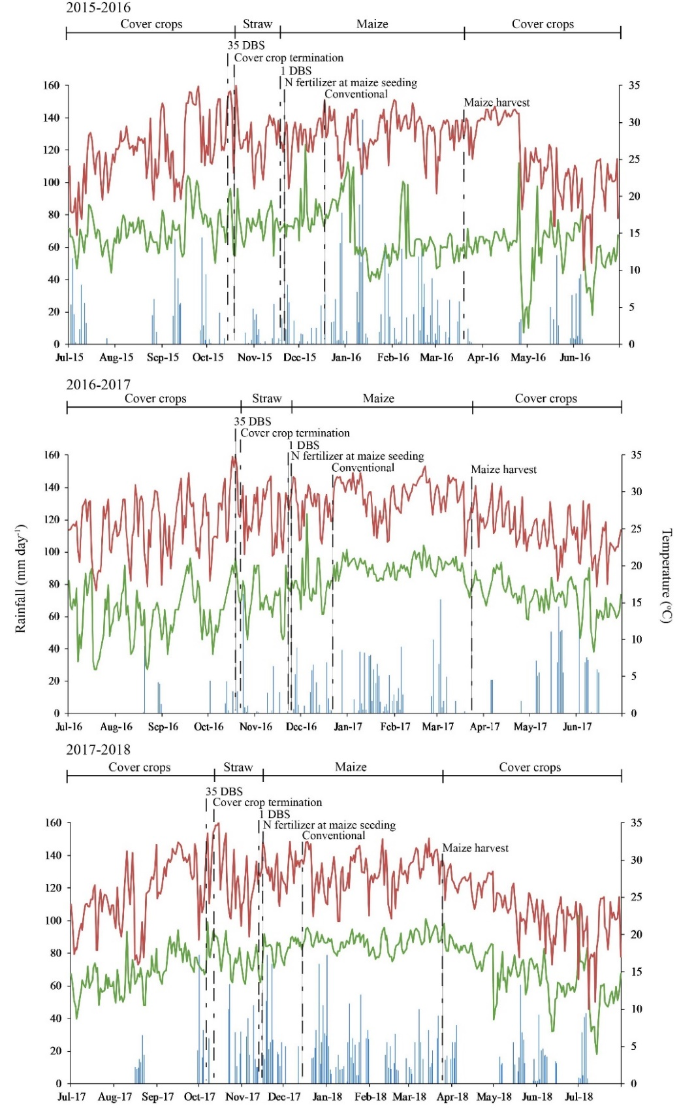

Supplementary Fig. 1. Daily rainfall (— blue bars), maximum (— red lines) and minimum (— green lines) temperatures observed in a meteorological station located near the field site during periods in 2015-2016, 2016-2017, and 2017-2018 growing seasons, and N application timing and main events in the experiment. Nitrogen application timing treatments are as follows: 35 DBS: 120 kg N ha⁻¹ broadcast over cover crop 35 days before maize seeding (5 days before cover crop termination); 1 DBS: 120 kg N ha⁻¹ broadcast over crop 1 day before maize seeding; Conventional method: 120 kg N ha⁻¹ sidedressed at V₄ growth stage of maize. At maize seeding, application of 40 kg N ha⁻¹ at maize seeding to all N treatments.

