Supplement

S1. Methods

S1a. Calculation of relative response
The calculation of CNE is based on the relation between uptake and yield as well as recovery fractions for the different nutrients as follows:

CNE = Σ( R_{i} *A_{i} *Ph_{i} /Ph_{N} ) / R_{N}

Where R_{i}, A_{i} and Ph_{i} are the recovery fractions, application rates and median use efficiencies (kg grain/ kg nutrient taken-up) for the different nutrients (i=N, P, K). Values of R were set to 0.5, 0.1 and 0.5 for N, P and K, respectively. Values of Ph for the three macro nutrients were 43, 360, 60 for maize, 55,380, 75 for sorghum and 18, 148 and 54 for the different legumes. Taking such general and per crop averages represents an obvious simplification that is necessary to represent the total amount of fertilizer by a single number.

S1b. Estimating field-specific response and its variability
To estimate the extent of non-responsiveness to fertilizers, it is imperative to estimate field-level response and its variability, ideally accounting for plot-level residual variation as outlined above.
For absolute response, we applied a relatively crude method to adjust estimates of variability for plot-level residual variation by using a fixed estimated for this variation, derived from existing studies that included some form of field-level replication, into a linear mixed model as follows:
response = mu + field + error
where mu is the overall mean response, field is a random field specific intercept and error is the plot-level residual error term. Two options were considered in this paper for the error: (i) based on average values in the literature, the plot level residual error was set to 697 kg ha⁻¹ for cereals ( Njoroge et al. 2017; ten Berge et al. 2019; De Laune et al. under review; Kamanga et al. 2014) and 250 kg ha⁻¹ for legumes (Ronner et al. 2016; van Heerwaarden et al. 2018); (ii) the error was fixed at 0, which represents the simple empirical distribution of response where all variations are absorbed by the random field term.
For the relative response as a function of fertilizer application intensity (kg grain/ kg CNE), a more sophisticated approach is possible in which the plot-level residual variation is estimated from the data. When the same nutrient is applied repeatedly or at different rates on the same field, an independent approximate estimate of plot-level residual variation can be obtained even for an experiment without on-site replicates. For example, in an nonreplicated on-farm NPK nutrient omission trial containing three omission treatment plots, a full NPK application plot and a control plot without fertilizer, there are a total of 5 plots to estimate 4 parameters (mean yield, and responses to the removal of the three macro nutrients). That means that by making a simplifying assumption of no field-specific nutrient interactions, there is an additional degree of freedom for each field that can be used to estimate residual variation due to random differences between plots within a field. This approach was used by van ten Berge et al. 2019 to obtain predictions of field-level responses to inoculation in soybean whose variation was corrected for plot-level residual variation. In a similar manner, if more than two fertilizer application intensities are applied to experimental fields, the simplifying assumption of a linear response between input intensity and yield allows for response to be measured as the slope in a linear regression, where deviations from the regression line are taken as residuals and can be used to obtain estimates of plot-level residual variation, which is the approach used here.

More specifically, we use the following linear mixed model:

output = study+intensity + study:intensity + intensity|field+error

Where output corresponds to the observed yield and intensity refers to CNE. Random effects are underlined, with “:” indicating interaction, and model the variation in control yield (intercept) and response (slope) at the level of location and trial (or field), as indicated by the vertical bar symbol. By incorporating field specific response as a random effect, the resulting predicted values are Best Linear Unbiased Predictors (BLUP) of local responses, whose variation is appropriately corrected (i.e. shrunk) with respect to the residual plot-level (i.e. error) variation, since variance in field-level deviations from the random regression lines are taken as residual variance.
Significance of fixed effects was determined by a type III ANOVA with Satterthwaite approximation for degrees of freedom while uncertainty in random and fixed effects was quantified by parametric bootstrapping using the bootmer function in the lme4 package in R (R Core Team 2018).

Table S1. Selected characteristics of studies included in the quantification of response to fertilizers
Country | Region/State/District/ County | Crop | Year | Fertilizer | Source  IDª and reference
Kenya | Vihiga, Meru | Maize | 2004 | Urea, TSP, SSP, MoP | C10: SFG, 2006
Zimbabwe | Murewa | Soybean, Groundnut | 2004 | SSP | C9: Zingore et al. 2008
Nigeria | Kaduna | Maize | 2015 | Urea, TSP, MoP | C7: Shehu et al. 2019
Nigeria | Benue, Kano, Kaduna, Niger | Soybean | 2012-2015 | SSP | C1: Notore, 2016
Nigeria  Kenya  DRC  Tanzania | Kaduna  Siaya  Walungu  Tabora | Maize  Maize  Maize  Maize | 2014, 2015  2013  2014  2012, 2013 | Urea, TSP, MoP  Urea, TSP, MoP  Urea, TSP, MoP  Urea, TSP, MoP | C4: Roobroeck et al. 2021
Nigeria  Kenya  Tanzania  Malawi  Mali | Kaduna  Siaya  Mbinga, Handeni  Kasungu, Mulanje, Nkhata Bay  Kontela, Koloko | Maize  Maize  Maize  Maize  Maize  Sorghum | 2010  2010  2010  2009 - 2011  2009 - 2011  2009 | Urea, TSP, MoP  Urea, TSP, MoP  Urea, TSP, MoP  Urea, TSP, MoP  Urea, TSP, MoP  Urea, TSP, MoP | C3: Kihara et al. 2016
Rwanda | Bugesera, Kibungo | Bush bean  Soybean | 2008, 2009  2009 | DAP  DAP | C2 : CIALCA, 2009
DRC  Ethiopia  Ghana  Kenya  Mozambique  Nigeria  Rwanda  Tanzania  Uganda | Walungu, Kabale  Various districts  Northern, Upper west  Western, Nyanza  Tete, Zambezi  Kaduna, Kano, Borno  Eastern, Southern  Various districts  North | Soybean  Soybean  Cowpea, Soybean  Soybean  Soybean  Groundnut, Soybean  Soybean, Climbing bean  Soybean  Soybean | 2012  2014, 2015  2012, 2011-2015  2010, 2011  2012  2010, 2011-2014  2010, 2012  2015  2015 | DAP, TSP  DAP  TSP, SSP  DAP, TSP, MRP  SSP  SSP  DAP, TSP  TSP  TSP | C 8 : van Heerwaarden et al. 2018 ; Adjei-Nsiah et al. 2018
ªthe source ID is an identifier of the origin of the data and is used in tables across the paper.
Table S2. Spatial layers used in the evaluation of geospatial patterns of response to fertilizers in a dataset from 41 studies conducted across sub-Saharan Africa.

layer name | definition | source
af_BLD_T__M_sd1_250m | Bulk density (kg / cubic-m) of the fine earth, at 2.5 cm depth | https://data.isric.org : Africa SoilGrids
af_CEC_T__M_sd1_250m | Cation exchange capacity (cmolc / kg) of the fine earth, at 2.5 cm depth | https://data.isric.org : Africa SoilGrids
af_CLYPPT_T__M_sd1_250m | Clay content (w%) of the fine earth, at 2.5 cm depth | https://data.isric.org : Africa SoilGrids
af_ORCDRC_T__M_sd1_250m | Organic carbon content (g / kg) of the fine earth, at 2.5 cm depth | https://data.isric.org : Africa SoilGrids
af_PHIHOX_T__M_sd1_250m | pH (x 10) of soil-water solution, at 2.5 cm depth | https://data.isric.org : Africa SoilGrids
af_SLTPPT_T__M_sd1_250m | Silt content (w%) of the fine earth, at 2.5 cm depth | https://data.isric.org : Africa SoilGrids
af_SNDPPT_T__M_sd1_250m | Sand content (w%) of the fine earth, at 2.5 cm depth | https://data.isric.org : Africa SoilGrids
af250m_nutrient_b_m_agg30cm | Extractable B in 100 ppm, 0-30 cm | https://data.isric.org : Africa SoilGrids
af250m_nutrient_cu_m_agg30cm | Extractable Cu in 100 ppm, 0-30 cm | https://data.isric.org : Africa SoilGrids
af250m_nutrient_k_m_agg30cm | Extractable K in ppm, 0-30 cm | https://data.isric.org : Africa SoilGrids
af250m_nutrient_mg_m_agg30cm | Extractable Mg in ppm, 0-30 cm | https://data.isric.org : Africa SoilGrids
af250m_nutrient_mn_m_agg30cm | Extractable Mn in ppm, 0-30 cm | https://data.isric.org : Africa SoilGrids
af250m_nutrient_n_m_agg30cm | Organic N in ppm, 0-30 cm | https://data.isric.org : Africa SoilGrids
af250m_nutrient_p_m_agg30cm | Extractable P in 100 ppm, 0-30 cm | https://data.isric.org : Africa SoilGrids
af250m_nutrient_zn_m_agg30cm | Extractable Zn in 100 ppm, 0-30 cm | https://data.isric.org : Africa SoilGrids
afsis_250percentslope | Slope | https://data.isric.org : Africa SoilGrids
wc2.1_30s_bio_1 | Annual Mean Temperature | https://www.worldclim.org/data/worldclim21.html
wc2.1_30s_bio_2 | Mean Diurnal Range (Mean of monthly (max temp - min temp)) | https://www.worldclim.org/data/worldclim21.html
wc2.1_30s_bio_3 | Isothermality (BIO2/BIO7) (×100) | https://www.worldclim.org/data/worldclim21.html
wc2.1_30s_bio_4 | Temperature Seasonality (standard deviation ×100) | https://www.worldclim.org/data/worldclim21.html
wc2.1_30s_bio_5 | Max Temperature of Warmest Month | https://www.worldclim.org/data/worldclim21.html
wc2.1_30s_bio_6 | Min Temperature of Coldest Month | https://www.worldclim.org/data/worldclim21.html
wc2.1_30s_bio_7 | Temperature Annual Range (BIO5-BIO6) | https://www.worldclim.org/data/worldclim21.html
wc2.1_30s_bio_8 | Mean Temperature of Wettest Quarter | https://www.worldclim.org/data/worldclim21.html
wc2.1_30s_bio_9 | Mean Temperature of Driest Quarter | https://www.worldclim.org/data/worldclim21.html
wc2.1_30s_bio_10 | Mean Temperature of Warmest Quarter | https://www.worldclim.org/data/worldclim21.html
wc2.1_30s_bio_11 | Mean Temperature of Coldest Quarter | https://www.worldclim.org/data/worldclim21.html
wc2.1_30s_bio_12 | Annual Precipitation | https://www.worldclim.org/data/worldclim21.html
wc2.1_30s_bio_13 | Precipitation of Wettest Month | https://www.worldclim.org/data/worldclim21.html
wc2.1_30s_bio_14 | Precipitation of Driest Month | https://www.worldclim.org/data/worldclim21.html
wc2.1_30s_bio_15 | Precipitation Seasonality (Coefficient of Variation) | https://www.worldclim.org/data/worldclim21.html
wc2.1_30s_bio_16 | Precipitation of Wettest Quarter | https://www.worldclim.org/data/worldclim21.html
wc2.1_30s_bio_17 | Precipitation of Driest Quarter | https://www.worldclim.org/data/worldclim21.html
wc2.1_30s_bio_18 | Precipitation of Warmest Quarter | https://www.worldclim.org/data/worldclim21.html
wc2.1_30s_bio_19 | Precipitation of Coldest Quarter | https://www.worldclim.org/data/worldclim21.html
Table S3a: Proportions of non-responsive fields based on Absolute response without consideration of residual error in studies to evaluate non-response to fertilizer for cereals. qmin: lower confidence limit, qmid: mean, qmax: higher confidence limit
 |  |  |  |  |  | Proportion non-responsive (%) |  |  |  | Response (kg ha⁻¹)
Source ID | Country | year | Crop | No fields |  | qmin | qmid | qmax |  | mean response | median response
C4 | DRC | 2014 | Maize | 21 |  | 0.0 | 0.0 | 19.0 |  | 791 | 738
C10 | Kenya | 2004 | Maize | 103 |  | 13.6 | 15.5 | 26.2 |  | 1293 | 960
C3 | Kenya | 2010 | Maize | 26 |  | 0.0 | 3.8 | 11.5 |  | 1751 | 1649
C4 | Kenya | 2013 | Maize | 55 |  | 0.0 | 0.0 | 10.9 |  | 1876 | 1810
C3 | Malawi | 2009 | Maize | 29 |  | 8.5 | 17.2 | 37.9 |  | 640 | 357
C3 | Malawi | 2010 | Maize | 49 |  | 4.1 | 8.2 | 18.4 |  | 1450 | 1272
C3 | Malawi | 2011 | Maize | 22 |  | 0.0 | 4.5 | 11.5 |  | 2279 | 2228
C3 | Nigeria | 2010 | Maize | 28 |  | 0.0 | 0.0 | 7.1 |  | 1702 | 1822
C4 | Nigeria | 2014 | Maize | 36 |  | 0.0 | 0.0 | 19.4 |  | 758 | 646
C7 | Nigeria | 2015 | Maize | 16 |  | 0.0 | 0.0 | 6.3 |  | 1936 | 2194
C3 | Tanzania | 2010 | Maize | 46 |  | 4.3 | 17.4 | 21.7 |  | 1334 | 1358
C4 | Tanzania | 2012 | Maize | 24 |  | 0.0 | 0.0 | 10.5 |  | 968 | 982
C4 | Tanzania | 2013 | Maize | 17 |  | 0.0 | 0.0 | 17.6 |  | 1735 | 1274
C3 | Mali | 2009 | Sorghum | 43 |  | 0.0 | 2.3 | 14.0 |  | 599 | 540

Table S3b: Proportions of non-responsive fields based on Absolute response with consideration of residual error in studies to evaluate non-response to fertilizer for cereals. qmin: lower confidence limit, qmid: mean, qmax: higher confidence limit

 |  |  |  |  |  | Proportion non-responsive (%) |  |  |  | Response (kg ha⁻¹)
Source ID | Country | year | Crop | No fields |  | qmin | qmid | qmax |  | mean response | median response
C4 | DRC | 2014 | Maize | 21 |  | 0.0 | 0.0 | 2.5 |  | 791 | 791
C10 | Kenya | 2004 | Maize | 103 |  | 6.8 | 8.7 | 22.3 |  | 1293 | 1031
C3 | Kenya | 2010 | Maize | 26 |  | 0.0 | 0.0 | 3.8 |  | 1751 | 1695
C4 | Kenya | 2013 | Maize | 55 |  | 0.0 | 0.0 | 1.8 |  | 1876 | 1837
C3 | Malawi | 2009 | Maize | 29 |  | 0.0 | 0.0 | 20.9 |  | 640 | 546
C3 | Malawi | 2010 | Maize | 49 |  | 0.0 | 0.0 | 11.3 |  | 1450 | 1334
C3 | Malawi | 2011 | Maize | 22 |  | 0.0 | 0.0 | 6.9 |  | 2279 | 2244
C3 | Nigeria | 2010 | Maize | 28 |  | 0.0 | 0.0 | 0.0 |  | 1702 | 1734
C4 | Nigeria | 2014 | Maize | 36 |  | 0.0 | 0.0 | 0.0 |  | 758 | 758
C7 | Nigeria | 2015 | Maize | 16 |  | 0.0 | 0.0 | 0.0 |  | 1936 | 1957
C3 | Tanzania | 2010 | Maize | 46 |  | 0.0 | 4.3 | 14.2 |  | 1334 | 1350
C4 | Tanzania | 2012 | Maize | 24 |  | 0.0 | 0.0 | 0.0 |  | 968 | 968
C4 | Tanzania | 2013 | Maize | 17 |  | 0.0 | 0.0 | 5.9 |  | 1735 | 1493
C3 | Mali | 2009 | Sorghum | 43 |  | 0.0 | 0.0 | 2.3 |  | 599 | 599

Table S4a: Proportions of non-responsive fields based on Absolute response without consideration of residual error in studies to evaluate non-response to fertilizer for legumes. BS: bush bean; CL: climbing bean. qmin: lower confidence limit, qmid: mean, qmax: higher confidence limit
 |  |  |  |  |  | Proportion non-responsive (%) |  |  |  | Response (kg ha⁻¹)
Source ID | Country | Year | Crop | No Fields |  | qmin | qmid | qmax |  | mean response | median response
C2 | Rwanda | 2008 | BS | 18 |  | 0.0 | 0.0 | 22.2 |  | 247 | 208
C2 | Rwanda | 2009 | BS | 46 |  | 10.9 | 19.6 | 34.9 |  | 303 | 271
C8 | Rwanda | 2012 | CL | 109 |  | 12.8 | 5.5 | 25.7 |  | 671 | 556
C8 | Ghana | 2012 | Cowpea | 92 |  | 4.9 | 5.4 | 19.0 |  | 386 | 313
C8 | Nigeria | 2010 | Groundnut | 24 |  | 16.7 | 50.0 | 50.0 |  | 99 | 27
C9 | Zimbabwe | 2004 | Groundnut | 24 |  | 35.3 | 41.7 | 70.8 |  | -27 | 39
C8 | DRC | 2012 | Soybean | 73 |  | 31.4 | 49.3 | 54.9 |  | 29 | 0
C8 | Ethiopia | 2014 | Soybean | 27 |  | 22.2 | 25.9 | 59.3 |  | 117 | 143
C8 | Ethiopia | 2015 | Soybean | 19 |  | 10.5 | 21.1 | 47.4 |  | 265 | 165
C8 | Ghana | 2011 | Soybean | 114 |  | 29.3 | 35.1 | 46.1 |  | 105 | 80
C8 | Ghana | 2012 | Soybean | 97 |  | 23.2 | 23.7 | 40.2 |  | 181 | 175
C8 | Ghana | 2015 | Soybean | 29 |  | 3.4 | 6.9 | 27.6 |  | 292 | 273
C8 | Kenya | 2010 | Soybean | 24 |  | 0.0 | 8.3 | 27.2 |  | 388 | 425
C8 | Kenya | 2011 | Soybean | 21 |  | 2.3 | 19.0 | 28.6 |  | 359 | 346
C8 | Mozambique | 2012 | Soybean | 48 |  | 4.2 | 4.2 | 17.8 |  | 219 | 213
C8 | Nigeria | 2011 | Soybean | 51 |  | 3.9 | 9.8 | 23.5 |  | 384 | 320
C8 | Nigeria | 2012 | Soybean | 19 |  | 0.0 | 5.3 | 31.6 |  | 161 | 133
C1 | Nigeria | 2012 | Soybean | 61 |  | 3.3 | 4.9 | 17.3 |  | 314 | 320
C1 | Nigeria | 2013 | Soybean | 261 |  | 3.4 | 1.1 | 8.4 |  | 387 | 360
C8 | Nigeria | 2014 | Soybean | 73 |  | 13.7 | 13.7 | 28.8 |  | 369 | 389
C1 | Nigeria | 2014 | Soybean | 1009 |  | 11.2 | 2.9 | 15.2 |  | 408 | 320
C1 | Nigeria | 2015 | Soybean | 1569 |  | 6.6 | 2.9 | 8.8 |  | 361 | 388
C2 | Rwanda | 2009 | Soybean | 24 |  | 0.0 | 4.2 | 20.8 |  | 298 | 214
C8 | Rwanda | 2010 | Soybean | 19 |  | 26.3 | 42.1 | 63.2 |  | 13 | 28
C8 | Tanzania | 2015 | Soybean | 20 |  | 15.0 | 25.0 | 55.0 |  | 79 | 60
C8 | Uganda | 2015 | Soybean | 30 |  | 13.3 | 16.7 | 40.0 |  | 210 | 247
C9 | Zimbabwe | 2004 | Soybean | 29 |  | 6.9 | 13.8 | 39.7 |  | 171 | 132

Table S4b: Proportions of non-responsive fields based on Absolute response with consideration of residual error in studies to evaluate non-response to fertilizer for legumes. BS: bush bean; CL: climbing bean. qmin: lower confidence limit, qmid: mean, qmax: higher confidence limit
 |  |  |  |  |  | Proportion non-responsive (%) |  |  |  | Response (kg ha⁻¹)
Source ID | Country | Year | Crop | No Fields |  | qmin | qmid | qmax |  | mean response | median response
C2 | Rwanda | 2008 | BS | 18 |  | 0.0 | 0.0 | 2.9 |  | 247 | 247
C2 | Rwanda | 2009 | BS | 46 |  | 0.0 | 6.5 | 28.3 |  | 303 | 285
C8 | Rwanda | 2012 | CL | 109 |  | 8.7 | 5.5 | 24.8 |  | 671 | 568
C8 | Ghana | 2012 | Cowpea | 92 |  | 0.0 | 0.0 | 6.0 |  | 386 | 351
C8 | Nigeria | 2010 | Groundnut | 24 |  | 0.0 | 0.0 | 41.7 |  | 99 | 99
C9 | Zimbabwe | 2004 | Groundnut | 24 |  | 22.8 | 50.0 | 98.0 |  | -27 | 13
C8 | DRC | 2012 | Soybean | 73 |  | 0.0 | 0.0 | 100.0 |  | 29 | 29
C8 | Ethiopia | 2014 | Soybean | 27 |  | 5.5 | 22.2 | 59.3 |  | 117 | 134
C8 | Ethiopia | 2015 | Soybean | 19 |  | 0.0 | 10.5 | 39.6 |  | 265 | 198
C8 | Ghana | 2011 | Soybean | 114 |  | 12.3 | 22.8 | 41.7 |  | 105 | 92
C8 | Ghana | 2012 | Soybean | 97 |  | 6.7 | 14.4 | 30.9 |  | 181 | 178
C8 | Ghana | 2015 | Soybean | 29 |  | 0.0 | 0.0 | 0.0 |  | 292 | 290
C8 | Kenya | 2010 | Soybean | 24 |  | 0.0 | 4.2 | 12.5 |  | 388 | 407
C8 | Kenya | 2011 | Soybean | 21 |  | 0.0 | 0.0 | 14.3 |  | 359 | 355
C8 | Mozambique | 2012 | Soybean | 48 |  | 0.0 | 0.0 | 0.0 |  | 219 | 219
C8 | Nigeria | 2011 | Soybean | 51 |  | 0.0 | 0.0 | 7.8 |  | 384 | 353
C8 | Nigeria | 2012 | Soybean | 19 |  | 0.0 | 0.0 | 13.3 |  | 161 | 161
C1 | Nigeria | 2012 | Soybean | 61 |  | 0.0 | 0.0 | 0.0 |  | 314 | 314
C1 | Nigeria | 2013 | Soybean | 261 |  | 0.0 | 0.0 | 0.0 |  | 387 | 387
C8 | Nigeria | 2014 | Soybean | 73 |  | 2.7 | 11.0 | 21.9 |  | 369 | 382
C1 | Nigeria | 2014 | Soybean | 1009 |  | 0.6 | 0.3 | 3.4 |  | 408 | 362
C1 | Nigeria | 2015 | Soybean | 1569 |  | 0.0 | 0.0 | 0.0 |  | 361 | 361
C2 | Rwanda | 2009 | Soybean | 24 |  | 0.0 | 0.0 | 0.0 |  | 298 | 298
C8 | Rwanda | 2010 | Soybean | 19 |  | 5.3 | 42.1 | 81.7 |  | 13 | 22
C8 | Tanzania | 2015 | Soybean | 20 |  | 0.0 | 0.0 | 100.0 |  | 79 | 79
C8 | Uganda | 2015 | Soybean | 30 |  | 0.0 | 10.0 | 33.3 |  | 210 | 228
C9 | Zimbabwe | 2004 | Soybean | 29 |  | 0.0 | 0.0 | 6.9 |  | 171 | 171

Table S5: Proportions of non-responsive fields based on Relative response using crop nutrient equivalent (CNE) in studies to evaluate non-response to fertilizers for cereals. qmin: lower confidence limit, qmid: mean, qmax: higher confidence limit

 |  |  |  |  |  | Proportion non-responsive (%) |  |  |  | Response (kg grain kg⁻¹ CNE)
Source ID | Country | Year | Crop | No fields |  | qmin | qmid | qmax |  | mean response | median response
C4 | DRC | 2014 | Maize | 21 |  | 0.0 | 0.0 | 31.1 |  | 3.38 | 3.40
C10 | Kenya | 2004 | Maize | 103 |  | 0.0 | 0.0 | 2.9 |  | 4.83 | 4.50
C3 | Kenya | 2010 | Maize | 26 |  | 0.0 | 0.0 | 0.0 |  | 7.79 | 7.28
C4 | Kenya | 2013 | Maize | 55 |  | 0.0 | 0.0 | 0.0 |  | 8.02 | 8.16
C3 | Malawi | 2009 | Maize | 29 |  | 0.0 | 0.0 | 29.4 |  | 2.77 | 2.93
C3 | Malawi | 2010 | Maize | 49 |  | 0.0 | 0.0 | 0.0 |  | 6.42 | 6.15
C3 | Malawi | 2011 | Maize | 22 |  | 0.0 | 0.0 | 0.0 |  | 9.83 | 9.61
C3 | Nigeria | 2010 | Maize | 28 |  | 0.0 | 0.0 | 0.0 |  | 7.71 | 8.13
C4 | Nigeria | 2014 | Maize | 36 |  | 0.0 | 0.0 | 11.1 |  | 3.24 | 2.97
C7 | Nigeria | 2015 | Maize | 16 |  | 0.0 | 0.0 | 0.0 |  | 6.93 | 7.08
C3 | Tanzania | 2010 | Maize | 46 |  | 0.0 | 0.0 | 2.2 |  | 5.63 | 5.41
C4 | Tanzania | 2012 | Maize | 24 |  | 0.0 | 0.0 | 8.3 |  | 4.14 | 4.12
C4 | Tanzania | 2013 | Maize | 17 |  | 0.0 | 0.0 | 0.0 |  | 7.42 | 6.97
C3 | Mali | 2009 | Sorghum | 43 |  | 0.0 | 0.0 | 25.6 |  | 2.78 | 2.73

Table S6: Proportions of non-responsive fields based on Relative response using crop nutrient equivalent (CNE) in studies to evaluate non-response to fertilizers for Legumes. BB: bush bean; CL: climbing bean. qmin: lower confidence limit, qmid: mean, qmax: higher confidence limit

 |  |  |  |  |  | Proportion non-responsive (%) |  |  |  | Response (kg grain kg⁻¹ CNE)
Source ID | Country | Year | Crop | No fields |  | qmin | qmid | qmax |  | mean response | median response
C2 | Rwanda | 2008 | BS | 18 |  | 5.6 | 0.0 | 50.0 |  | 2.38 | 2.08
C2 | Rwanda | 2009 | BS | 46 |  | 6.5 | 17.4 | 30.4 |  | 2.92 | 2.83
C8 | Rwanda | 2012 | CL | 109 |  | 0.0 | 0.0 | 1.8 |  | 8.65 | 7.24
C8 | Ghana | 2012 | Cowpea | 92 |  | 11.9 | 35.9 | 45.1 |  | 1.64 | 0.72
C8 | Nigeria | 2010 | Groundnut | 24 |  | 27.0 | 58.3 | 87.5 |  | -0.67 | -0.87
C9 | Zimbabwe | 2004 | Groundnut | 24 |  | 20.8 | 66.7 | 87.5 |  | -0.54 | -0.79
C8 | DRC | 2012 | Soybean | 73 |  | 35.6 | 39.7 | 58.3 |  | 0.11 | 0.11
C8 | Ethiopia | 2014 | Soybean | 27 |  | 5.5 | 44.4 | 55.6 |  | 1.51 | 1.43
C8 | Ethiopia | 2015 | Soybean | 19 |  | 0.0 | 26.3 | 39.6 |  | 3.42 | 2.67
C8 | Ghana | 2011 | Soybean | 114 |  | 12.7 | 29.8 | 40.4 |  | 2.07 | 1.60
C8 | Ghana | 2012 | Soybean | 97 |  | 2.1 | 20.6 | 20.7 |  | 3.58 | 3.30
C8 | Ghana | 2015 | Soybean | 29 |  | 0.0 | 0.0 | 13.8 |  | 5.77 | 5.30
C8 | Kenya | 2010 | Soybean | 24 |  | 14.5 | 12.5 | 50.0 |  | 1.79 | 1.49
C8 | Kenya | 2011 | Soybean | 21 |  | 14.3 | 4.8 | 52.4 |  | 1.41 | 1.36
C8 | Mozambique | 2012 | Soybean | 48 |  | 0.0 | 0.0 | 7.3 |  | 7.22 | 7.38
C8 | Nigeria | 2011 | Soybean | 51 |  | 0.0 | 0.0 | 0.0 |  | 12.65 | 12.37
C8 | Nigeria | 2012 | Soybean | 19 |  | 0.0 | 0.0 | 39.6 |  | 5.32 | 4.89
C1 | Nigeria | 2012 | Soybean | 61 |  | 0.0 | 0.0 | 0.0 |  | 10.35 | 10.13
C1 | Nigeria | 2013 | Soybean | 261 |  | 0.0 | 0.0 | 0.0 |  | 12.77 | 12.67
C8 | Nigeria | 2014 | Soybean | 73 |  | 0.0 | 0.0 | 0.0 |  | 12.15 | 11.69
C1 | Nigeria | 2014 | Soybean | 1009 |  | 0.0 | 0.0 | 0.0 |  | 13.45 | 12.29
C1 | Nigeria | 2015 | Soybean | 1569 |  | 0.0 | 0.0 | 0.0 |  | 11.91 | 11.35
C2 | Rwanda | 2009 | Soybean | 24 |  | 0.0 | 12.5 | 35.5 |  | 2.87 | 2.53
C8 | Rwanda | 2010 | Soybean | 19 |  | 20.8 | 57.9 | 73.7 |  | -0.28 | -0.02
C8 | Tanzania | 2015 | Soybean | 20 |  | 5.0 | 0.0 | 75.2 |  | 1.57 | 1.37
C8 | Uganda | 2015 | Soybean | 30 |  | 0.0 | 3.3 | 28.4 |  | 4.16 | 3.85
C9 | Zimbabwe | 2004 | Soybean | 29 |  | 0.0 | 0.0 | 41.4 |  | 3.39 | 2.55

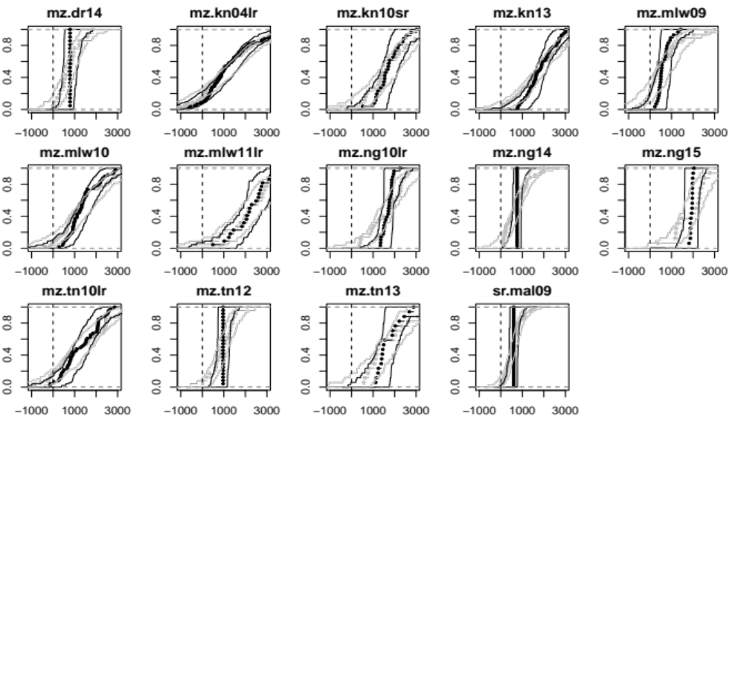
Figure S1. Cumulative distributions, with 95% confidence intervals, of predicted absolute fertilizer response for cereals in different studies. Gray dots represent the “empirical” distribution assuming zero residual error. Black represents the distribution under the assumption of a residual standard deviation of 697 kg/ha. Each study is presented by the first letter representing the crop, then 2 letters for the country, followed by the year and season. mz: maize, sr: sorghum. dr: Democratic republic of Congo, kn:Kenya, mlw: Malawi, ng: Nigeria, tn:Tanzania, ml: mali. sr: short rainy season, lr: long rainy season.

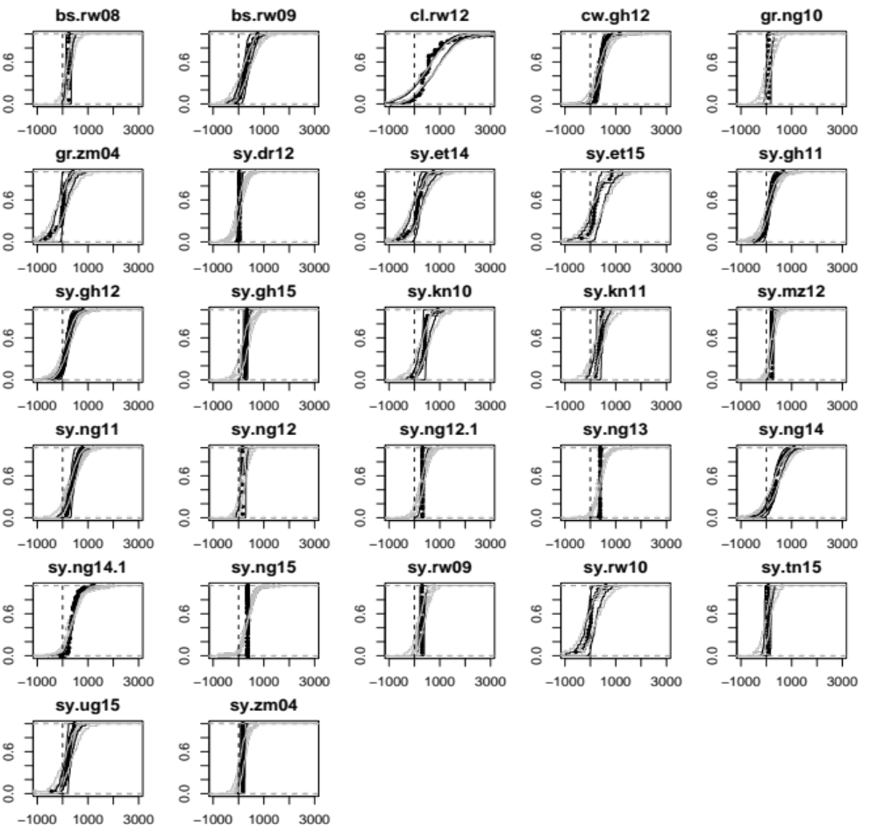
Figure S2. Cumulative distributions, with 95% confidence intervals, of predicted absolute fertilizer response for legumes in different studies. Gray dots represent the “empirical” distribution assuming zero residual error. Black represents the distribution under the assumption of a residual standard deviation of 250 kg/ha. Each study is presented by the first letter representing the crop, then 2 letters for the country, followed by the year. bs: bush bean, cl: climbing bean, cw: cowpea, gr: groundnut, sy: soybean. rw: Rwanda, gh: Ghana, ng: Nigeria, zm; Zimbabwe, dr: Democratic republic of Congo, et: Ethiopia, kn:Kenya, mz: Mozambique, tn:Tanzania, ug: Uganda

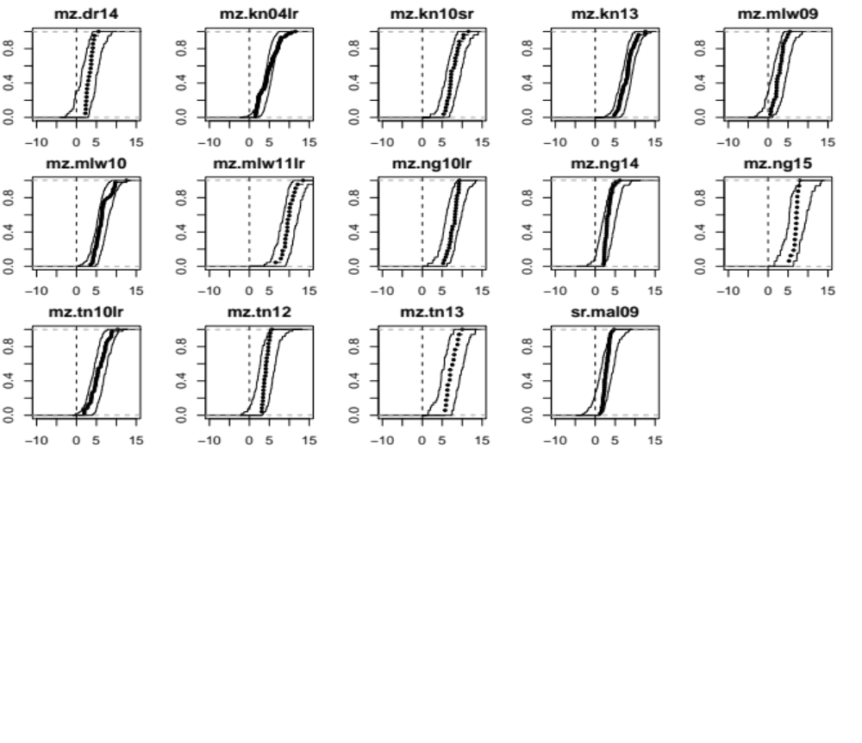
Figure S3. Cumulative distribution of relative fertilizer response, and 95% confidence interval, for cereals across the different studies. Relative response is defined as the predicted slope of yield as a function of fertilizer application intensity (CNE). Each study is presented by the first letter representing the crop, then 2 letters for the country, followed by the year and season. mz: maize, sr: sorghum. dr: Democratic republic of Congo, kn:Kenya, mlw: Malawi, ng: Nigeria, tn:Tanzania, ml: Mali. sr: short rainy season, lr: long rainy season.

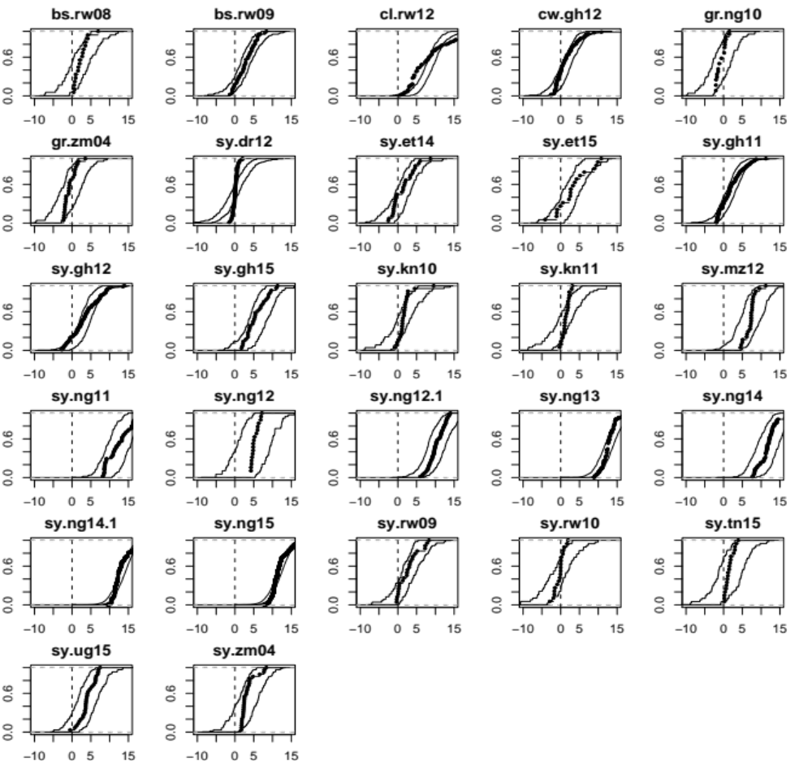

Figure S4. Cumulative distribution of relative fertilizer response, and 95% confidence interval, for legumes across the different studies. Relative response is defined as the predicted slope of yield as a function of fertilizer intensity (CNE). Each study is presented by the first letter representing the crop, then 2 letters for the country, followed by the year. bs: bush bean, cl: climbing bean, cw: cowpea, gr: groundnut, sy: soybean. rw: Rwanda, gh: Ghana, ng: Nigeria, zm: Zimbabwe, dr: Democratic republic of Congo, et: Ethiopia, kn:Kenya, mz: Mozambique, tn:Tanzania, ug: Uganda.

