Supplementary Information
Title: Similar distribution of ¹⁵N labeled cattle slurry and mineral fertilizer in soil after one year
Authors:
Frick, Hanna^{1,2,(*)}, Oberson, Astrid², Cormann Michael^{1,3}, Wettstein, Hans-Rudolf⁴, Frossard, Emmanuel², Bünemann, Else Katrin¹

^{(*)} Corresponding author: hanna-frick@web.de, ORCID 0000-0003-0097-203X
¹⁾ Department of Soil Science, Research Institute of Organic Agriculture (FiBL), Frick, Switzerland
²⁾ Group of Plant Nutrition, Institute of Agricultural Sciences, ETH Zurich, Lindau, Switzerland
³⁾ Department of Micrometeorology, Faculty for Biology, Chemistry and Earth Sciences, University of Bayreuth, Bayreuth, Germany
⁴⁾ AgroVet Strickhof, ETH Zurich, Lindau, Switzerland

SUPPLEMENTARY INFORMATION
SI. 1 Climatic conditions at the field site 2
SI. 2 Experimental design and sampling scheme 3
SI. 3 Production and characterization of ¹⁵N labeled cattle slurry 5
SI. 4 Methodological approach and data evaluation of ammonia volatilization from microplots 11
SI. 5 Biological nitrogen fixation 16
SI. 6 Gravimetric soil moisture and correlation with Nmic and Nmin 19

Climatic conditions at the field site

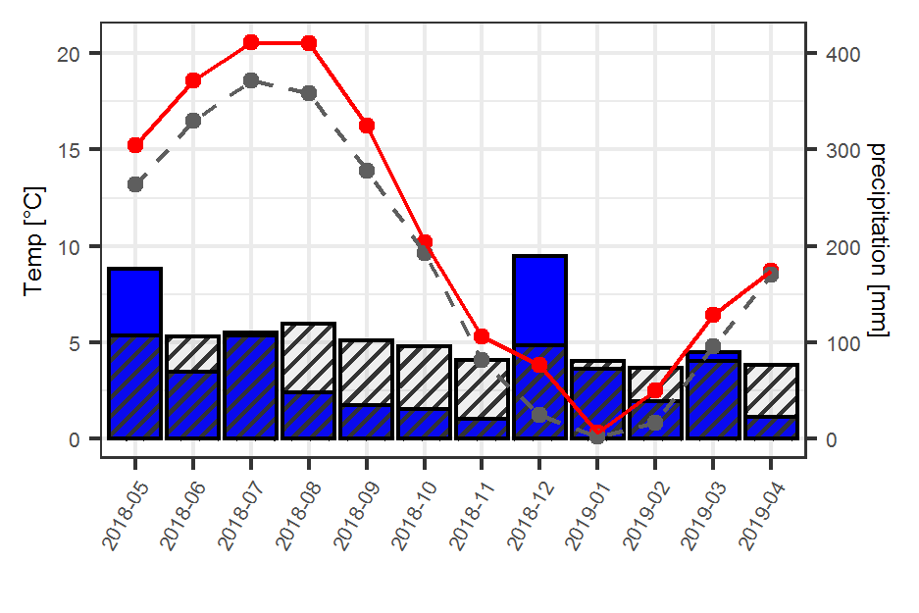
SI Fig. 1: Climatic conditions at Wynau (closest meteorological station, 422m a.s.l., 47.255025 / 7.787475) during the whole time course of the field experiment. Mean monthly temperature (red) and sum of monthly precipitation (blue bars) are shown. Grey dotted line and shaded bars show long-term average values (1981-2010).

Experimental design and sampling scheme

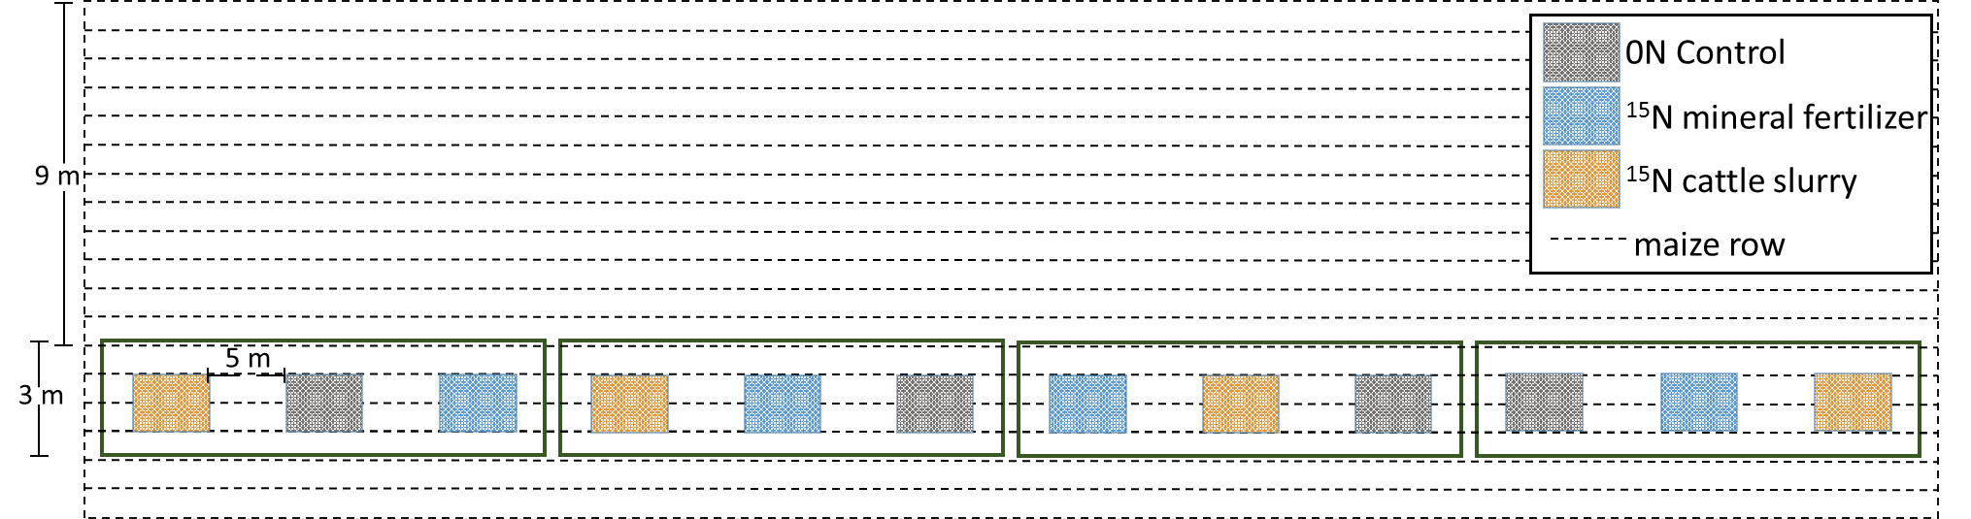
SI Fig. 2: Arrangement of microplots in complete randomized block design

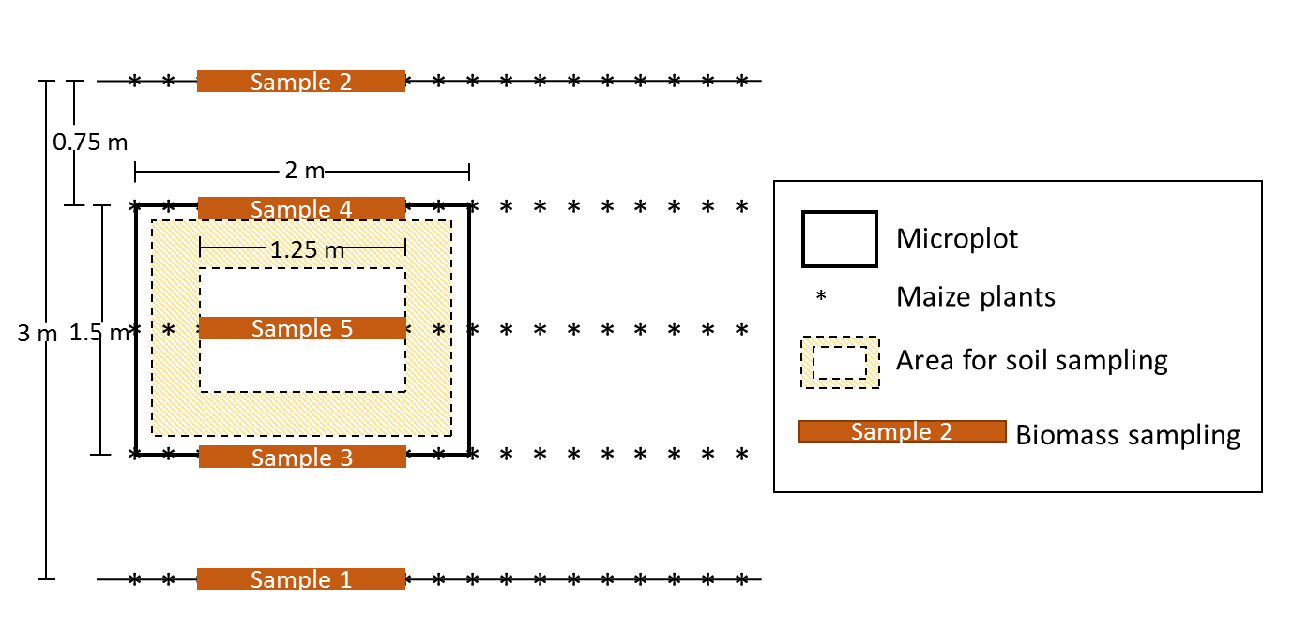SI Fig. 3: Layout of microplots Field A (maize) including area for soil sampling and locations for biomass samples
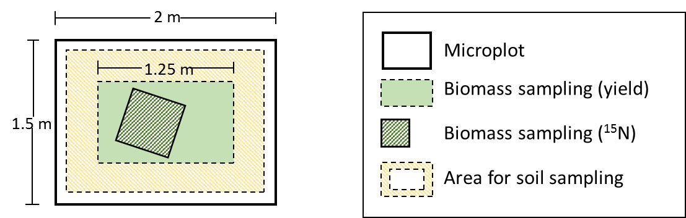
SI Fig. 4: Layout of microplots Field B (grass-clover) including area for soil sampling and area for biomass sampling

Production and characterization of ¹⁵N labeled cattle slurry
¹⁵N labeled cattle slurry was produced by feeding a female heifer (240 kg live weight) with ¹⁵N labeled ryegrass (Lolium multiflorum var. Westerwoldicum) hay, partly produced under greenhouse and partly under field conditions. In the greenhouse, ryegrass was grown in container boxes filled with a sand-perlite mix and fertilized with ¹⁵NH₄¹⁵NO₃ (19.4 atom% abundance). After 32, 53, 74, and 99 days, aboveground biomass was harvested with scissors and dried at 40°C. In the field, a pure ryegrass stand was fertilized twice with ¹⁵NH₄¹⁵NO₃ (35 atom% abundance) at a total rate of 40 kg N ha⁻¹ in September 2017, cut once in October 2017, and dried at 30-40 °C. Hay from the greenhouse and field were mixed for the final feed with an average ¹⁵N abundance of 12.6 atom%. The hay contained 167 g kg⁻¹ DM crude protein, 231 g kg⁻¹ DM crude fiber, and 114 g kg⁻¹ DM crude ash.
The heifer was fed with the ¹⁵N labeled ryegrass hay for 8 days after an adaptation phase of 7 days. Urine and faeces were collected quantitatively and separately and stored frozen until analysis of their ¹⁵N content.
In faeces N, a maximum of 9.48 atom% ¹⁵N was achieved while urine N reached up to 7.64 atom% ¹⁵N (SI Fig. 5). During these days, the animal had an average daily N intake of 142 ± 4.6 g, of which about 23% were excreted as faeces and 37% as urine. Based on ¹⁵N calculations, about 16% of N intake were recovered in faeces and 21% in urine.
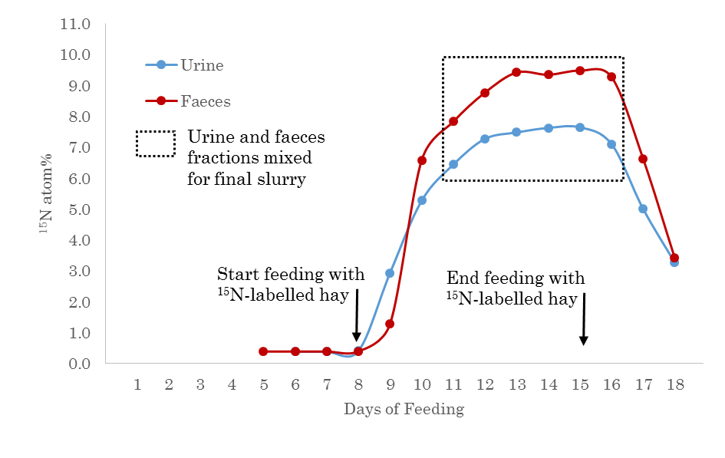
SI Fig. 5: ¹⁵N label in urine and faeces portions over feeding period (n=3 for faeces, n=1 for urine). The heifer was fed with non-labeled ryegrass hay for the first seven days and for the last three days, while from Day 8 to Day 15 feed consisted of ¹⁵N labeled ryegrass hay
Based on absolute amounts of N intake and N excretion, the animal excreted about two thirds of its N intake, which was lower than values reported by some authors who found that on average about 80% of N intake were excreted (Pagliari et al., 2020, Haynes and Williams, 1993). Also, ¹⁵N from feed recovered in urine and faeces, summing up to 40% in our experiment, was lower than the 51 to 64% found by others (Powell and Wu, 1999). The deviations from previous studies possibly occurred because the heifer was only about six months old, having a higher N retention than an adult animal used in other studies. The pronounced differences in N excretion estimates based on total N or ¹⁵N indicate that within the digestive system of the heifer, labeled feed N was assimilated while non-labeled body N was excreted.
The temporal development and overall ¹⁵N enrichment of faeces and urine (SI Fig. 5) followed an already well-documented pattern for feeding with ¹⁵N labeled feed over several days, with the ¹⁵N label first appearing in the urine, rapidly being exceeded by the ¹⁵N label in the faeces (e.g. Barros et al., 2017, Powell et al., 2004, Bosshard et al., 2011).
In order to test for the homogeneity of the ¹⁵N labeling of in slurry fractions with different degrees of recalcitrance, a fractionation protocol, usually used for faeces only, was used. The fractionation followed the method by Mason (1969) and simplified by Kreuzer and Kirchgessner (1985). According to their definition, total faeces N (Ntot) can be divided into i) water soluble N (WSN), ii) undigested dietary N (UDN), consisting mainly of (hemi-)cellulose and some denatured proteins from plant cell walls of the animal`s feed, and iii) bacterial and endogenous debris N (BEDN), which includes N compounds derived from microbial cells of the rumen and hindgut or from abrasions from the digestive tract tissue. Thereby, BEDN and UDN together make up the water insoluble N fraction (WIN). While concentrations of N and ¹⁵N in UDN and WIN were determined directly, corresponding values in BEDN were calculated as the difference between WIN and UDN.
We applied this procedure to the faeces (mixed from Day 11 until Day 16 of the feeding period) and to the whole slurry used in the field experiment. The WSN and the WIN fractions of the slurry or faeces mix were separated by centrifugation of a 30 mL subsample at 2650 g at 4°C for 30 min, followed by a washing step with milliQ water. The pellet (WIN) was lyophilized, pulverized and analyzed for N and ¹⁵N. We determined N and ¹⁵N in WSN on the filtered supernatant by TOC/TNb-analysis and direct analysis in the liquid mode of the mass spectrometer. However, the latter was only done for the slurry, but not for the faeces as the N concentration of the WSN fraction of the faeces was too low for direct ¹⁵N measurement. Thus, ¹⁵N WSN of faeces had to be calculated based on a mass balance (Bosshard et al., 2011, Langmeier et al., 2002).
UDN was determined for the slurry by boiling a dried and milled subsample with a neutral detergent fiber solution (Van Soest et al., 1991) in an automatic Fibretherm FT12 system (Gerhardt Analytical Systems, Germany). Thus, UDN was defined as the amount of N in the neutral detergent fiber (NDF) fraction of the slurry. After boiling, the samples were dried at 130°C and analyzed for their total N content. Ash content was determined by ashing a separate subsample at 600°C. For faeces, UDN was not measured, but calculated with a mass balance approach assuming that all UDN in slurry would originate from faeces.
The fractionation revealed that about 75% of total slurry N was WSN, compared to about 25% for faeces N (SI Table 1). UDN in slurry was about 4.6% of total slurry N. UDN of the faeces mix was not determined, but since about 39% of slurry N originate from faeces and presuming that UDN was only derived from faeces, about 12.1% of faecal N was UDN.
Overall, the enrichment in the different slurry fractions ranged from 7.39 to 8.78 atom% ¹⁵N and followed the order of WSN < total slurry N < UDN < BEDN (SI Table 1). Total slurry N had an enrichment of 7.89 atom% ¹⁵N. Thus, the enrichment of the individual fractions deviated from that of total slurry N by -6%, +3% and +11% for WSN, UDN and BEDN.
SI Table 1: Fractionation of slurry (urine + faeces from Day 11 until Day 16 of the feeding period) and faeces (faeces mixed from Day 11 until Day 16 of the feeding period); Ntot = total N, N_{sum} = total N as sum of WSN and WIN, WSN = water-soluble N, WIN = water-insoluble N, UDN = undigested dietary N (=NDF-N), BEDN = bacterial and endogenous debris N; nd = not determined
 | Slurry |  | Faeces
 | g N kg⁻¹ DM  (Share of Ntot (%)) | ¹⁵N atom% | g N kg⁻¹ DM  (Share of Ntot (%)) | ¹⁵N atom%
Ntot _{(measured)} | 67.8 (100) | 7.89 | 37.9 (100) | 8.99
N_{sum (calculated)} | 70.0 (103.2) | 8.01 | 35.3 (93.1) | [-]
WIN ¹ | 19.3 (28.5) | 8.67 | 26.0 (68.6) | 8.86
UDN | 3.2 (4.7) | 8.12 | nd | nd
BEDN² | 16.1 (23.7) | 8.78 | nd | nd
WSN ¹ | 50.7 (74.9) | 7.39 | 9.3 (24.5) | 9.36³
¹fractionation of slurry into WIN and WSN was done on n=6 samples: five samples originated from the five slurry applications in the field, and one sample from the storage
²BEDN was calculated based on difference between WIN (n=6) and UDN (n=2); ¹⁵N BEDN was calculated based on mass balance between ¹⁵N WIN and ¹⁵N UDN
³calculated based on mass balance for ¹⁵N WIN and ¹⁵N Ntot
In previous publications, fractionation into different N fractions was usually done for faeces only (Bosshard et al., 2011, Langmeier et al., 2002). In our study, we were interested in the N distribution and corresponding ¹⁵N labeling in the whole slurry and, therefore, additionally applied the fractionation procedure to the whole slurry. Haynes and Williams (1993) found that on average 20-25% of faecal N of dairy cows was water-soluble, 15-25% was in the UDN fraction, while the remainder was considered as BEDN. Compared to that, faeces in our slurry ranged at the higher end for WSN and were even twice as high as WSN reported for cow faeces (Langmeier et al., 2002) or sheep faeces (Bosshard et al., 2011). This might partially be explained by a leaking urine pipe during day 12 and day 14 of the feeding period, adding WSN to faeces. At the same time, UDN content was at the lower end of values reported, but similar to results by Langmeier et al. (2002) and Hoekstra et al. (2011).
We assumed that within the time scale of one year considered in this experiment, only BEDN and WSN will become plant available due to the stable nature of UDN (Kreuzer and Kirchgessner, 1985, Sørensen et al., 1994, Bosshard et al., 2011). Thus, for the slurry label used for calculating plant uptake, only the enrichment of BEDN and WSN might be relevant. With their relative share, their combination results in a label of 7.72 atom% ¹⁵N, which is only slightly lower than the 7.89 atom% ¹⁵N label of total slurry N (SI Table 1).

Methodological approach and data evaluation of ammonia volatilization from microplots

Choice of methodology
The volatilization of NH₃ from organic and mineral fertilizers is highly dependent on fertilizer properties, environmental conditions, application technique and timing (Sommer and Hutchings, 2001, Asman et al., 1998, Meisinger and Jokela, 2000). After volatilization, NH₃ is moved away from the source area by turbulent atmospheric transport (Meisinger and Jokela, 2000, Sommer and Hutchings, 2001). For measuring the volatilization of NH₃ from the microplots of the field experiment, the Standard Comparison Method (SCM) (Vandré and Kaupenjohann, 1998) was chosen. The SCM is designed to be applied on small plots and follows a micrometeorological approach – unlike enclosure approaches widely used to investigate trace gas fluxes from microplots. This ensures the NH₃ air-surface equilibrium, which is determined by meteorological parameters, to remain undisturbed N (Sommer and Hutchings, 2001, Sommer and Olesen, 1991, Loubet et al., 2018). NH₃ is sampled passively by exposing sulfuric acid to the ambient air close to the plot surface. Thereby, NH₃ is transported into the passive samplers by turbulent transport and dissolves in the solution according to Henry’s law, where it is stabilized as NH₄⁺ due to the low pH of the solution (acid trap). The conversion of sample NH₃ concentrations into NH₃ fluxes is based on the assumption of transport conditions being similar between microplots and adjacent reference flux plots. In principle, the method therefore does not require complex sensor equipment and in-depth micrometeorological knowledge.
Nevertheless, wind speed, temperature and relative humidity were logged in order to check spatial inhomogeneities in conditions of turbulent transport along the experimental field. Additionally, the option of predicting and temporarily replacing reference flux plot data by standard meteorological measurements and a sufficiently calibrated model was assessed.

Field and lab work
Strips of microplots both on Field A and Field B were oriented from west-southwest to east-northeast, which corresponds to the most prevailing wind directions.
Two replicate reference plots were installed in parallel alignment to the strip of microplots at a distance of 10 m. Reference plots consisted of a perforated tube system releasing NH₃ gas from gas cylinders in similar quantities as expected to volatilize from applied fertilizer.
Directly (only a few seconds) after fertilizer application, passive samplers filled with 20 ml of 0.05 M sulphuric acid were installed above microplots as well as above reference plots and in the four edges of the measurement area (for tracking background NH₃ concentrations) in a height of 0.1 m above the soil surface (Field A) or the grass-clover canopy (Field B) under 0.2 x 0.2 m rain and sun protection roofs. Evaporation or dilution were tracked by adding a 10 ppm PO₄³⁻ spike to the acid. In total, NH₃ emissions were monitored 60 hours after fertilizer application by a sequence of six to seven sampling intervals of increasing duration (3 – 24 hours). At the end of each measuring interval, acid solution was extracted from the passive samplers and a clean passive sampler was installed, starting a new sampling interval. Samples were stored cool in the field and frozen once in the lab until colorimetric analysis for NH₄⁺ and PO₄³⁻ concentrations on a Skalar Aqua Pro Segmented Flow Analyzer (Skalar Analytical, 2005).
Data analysis and calculations
Measured concentrations of NH₄⁺ (mg l⁻¹) were corrected for dilution or evaporation during the time of exposure based on the observed deviation in PO₄³⁻ concentrations. Further, NH₄⁺ concentrations were normalized by the time of exposure and corrected by the mean of the observed background concentrations in order to only contain plot effects.
According to the SCM method, transfer factors (mg l⁻²) were calculated for each sampling interval by dividing normalized NH₄⁺ concentrations (mg l⁻¹ min⁻¹) on reference plots by the known reference NH₃ gas flux (l min⁻¹). Normalized NH₄⁺ concentrations (mg l⁻¹ min⁻¹) observed on experimental plots were then converted into fluxes of volatilized NH₃ (l min⁻¹) by dividing them by the transfer factor of the respective sampling interval (mg l⁻²).
For both the first fertilizer application at Field A and at Field B, data from reference plots was only partially available due to failures of the NH₃ release system. In these cases, a model could be calibrated and optimized based on meteorological data (wind speed, temperature, relative humidity) and using the available reference plot data of each fertilizer application. This allowed for reconstructing probable transfer factors and the complete calculation of NH₃ volatilization from applied fertilizers.
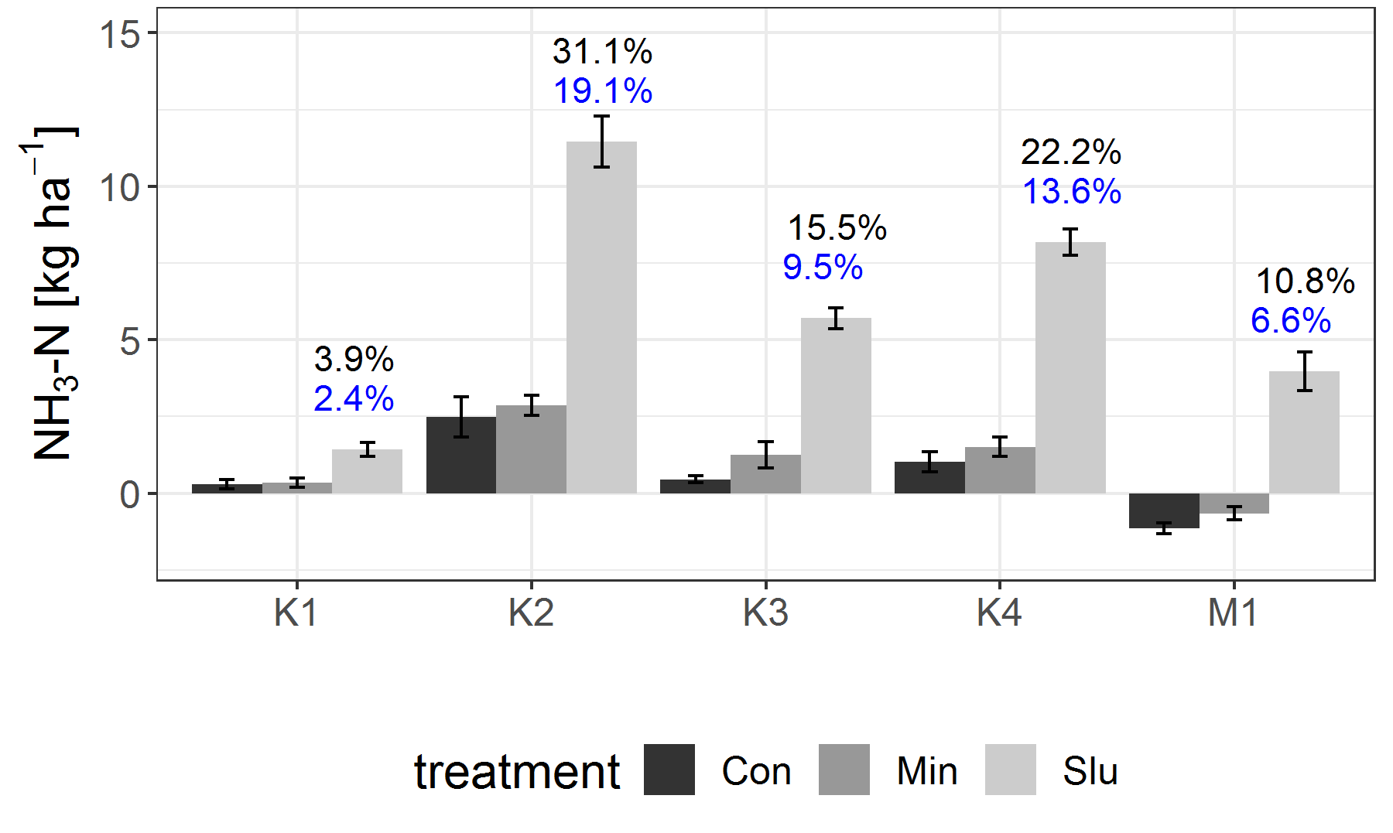
SI Fig. 6: Total amounts of NH₃ volatilized from Slu, Min and Con plots, according to the optimized meteorological model. Additionally, the share of total slurry N (blue) or NH₄-N in slurry (black) lost via NH₃ emissions is displayed for the Slu plots.
M = sampling in silage maize (Field A), K = sampling in grass-clover (Field B)
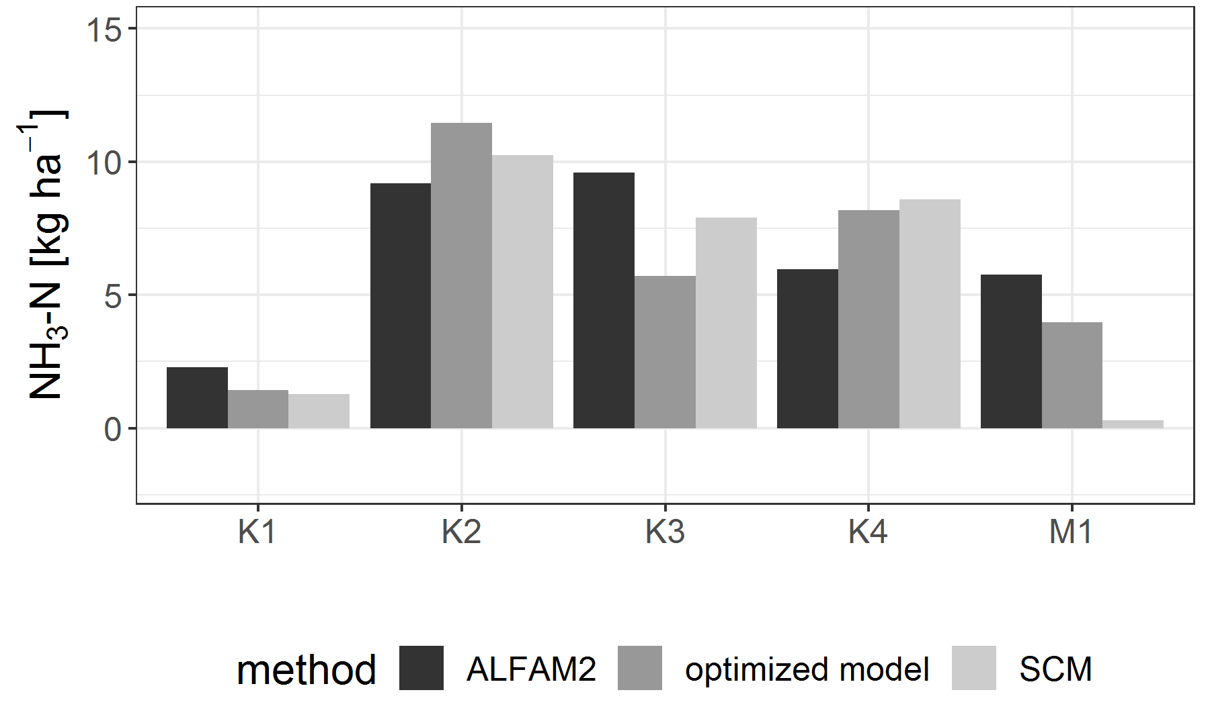
SI Fig. 7: Total amounts of NH₃ volatilized from Slu plots according to the standard comparison method (SCM) as well as the optimized meteorological model, compared with predictions by the ALFAM2 model (Hafner et al., 2019)
M = sampling in silage maize (Field A), K = sampling in grass-clover (Field B)

Results and interpretation
NH₃-emissions showed a large variability over the different fertilizer applications, ranging between 2.4 to 19.1% of total slurry N (SI Fig. 6). The high data variability can partly be explained by weather conditions during or shortly after fertilizer application. For instance, after the first slurry application at Field B, there was considerable rainfall, possibly explaining low emission values (main text Fig. 2). However, also some methodological issues cannot be excluded due to the failure of the reference system failed during several periods during the first fertilizer application both at Field A and Field B. Thus, for validation of the measured and modelled data, NH₃-emissions were also estimated using the ALFAM2 model (Hafner et al., 2019). Values obtained from this model confirmed the pattern of measured NH₃-emissions, overall yielding slightly higher emissions (SI Fig. 7). Overall, the NH₃ emissions were rather low compared to other studies (e.g. Hoekstra et al., 2011, Sommer and Hutchings, 2001, Misselbrook et al., 2005). On the one hand, this might be surprising as slurry had a rather high share of NH₄-N (main text Table 2). On the other hand, the application with watering cans and subsequent rinsing of cans with water reduced NH₃-losses and prevented fertilizers from remaining on plant and soil surfaces. Also, our experimental slurry did not contain any bedding material such as straw which would have impaired infiltration.

Biological nitrogen fixation
Since Field B was cropped with a grass-clover mixture, also biological nitrogen fixation (BNF) added to the N inputs. Thereby, BNF can be calculated by different means (Unkovich and Pate, 2000). The simplest approach is to assume BNF to be the difference between N uptake of leguminous plants and non-leguminous reference plants. However, due to the low yield of the legumes in this experiment, this approach resulted in negative values. Alternatively, BNF can be calculated by isotopic approaches, which are independent from the yield.
For the fertilized treatments (Min and Slu), N derived from atmosphere (Ndfa) was calculated according to McAuliffe et al. (1958) using the enriched dilution (ED) method:
$$Ndfa_{ED} \left[\%\right]=(1- \frac{atom\% 15N{excess}_{legume} }{atom\% 15N{excess}_{grass}})×100$$ | (1)
As the control treatment did not receive any ¹⁵N labeled fertilizers, BNF was calculated using the natural abundance (NA) method (Shearer and Kohl, 1986).
$$Ndfa_{NA} \left[\%\right]=\frac{δ^{15}N_{grass}- δ^{15}N_{legume} }{δ^{15}N_{grass}-B}×100$$ | (2)
where δ¹⁵N [‰] is the deviation (excess or depletion) over the ¹⁵N abundance of N in air (0.36637 atom% ¹⁵N).
According to Carlsson et al. (2009) the lowest measured δ¹⁵N value for legumes in the field was used as B value, for this experiment B=-1.0. This value is also well in accordance with values considered by others under similar field conditions (Oberson et al., 2013).
For both, the ED and the NA method, grass grown in the same microplot as the legume was used as the corresponding non-N fixing reference plant. We acknowledge that this approach comprises methodological constrains by differing root morphology and probably temporal and spatial distinct N uptake patterns for legumes and grasses. Furthermore, N transfer between legumes and grasses must be expected, especially since Field B had been cropped with grass-clover already for four years when starting the experiment, leading to an underestimation in Nfix. Still, if N transfer is suspected, more reliable results can be expected with reference plants grown in mixture with legumes and not in adjacent pure stands (Carlsson and Huss-Danell, 2014) .
Our results, ranging between 14 to 40 kg Nfix ha⁻¹ during one year, are lower than results reported elsewhere, where usually Nfix reached values between 60 and 160 kg N ha⁻¹ at a legume share between 29 and 53% of total biomass (Oberson et al., 2013). Besides underestimation due to N transfer between legumes and grasses, also the overall very low legume share, even further decreasing over the duration of our experiment, might explain the low values (SI Fig. 8). Again, the low legume share might result from the rather old grass-clover stand, receiving substantial amounts of animal manure for several years.
Overall, we expected that the non-fertilized control would have higher Nfix values, than the fertilized treatments, as biological nitrogen fixation usually is hindered by large amounts of available N (McAuliffe et al., 1958). However, we could not statistically prove this, but identified one replicate within the control treatment as an outlier in which no legumes were growing at the specific location of this microplot. Exclusion of this value would have made the Nfix of the control treatment significantly higher than for the fertilized treatments. We did not exclude it from the analysis presented within this study, though, as it also was part of the heterogeneity of the field. Nfix did not differ between Min and Slu and overall strongly decreased over the time course of the experiment, possibly due to increased amounts of available N with repeated fertilization.

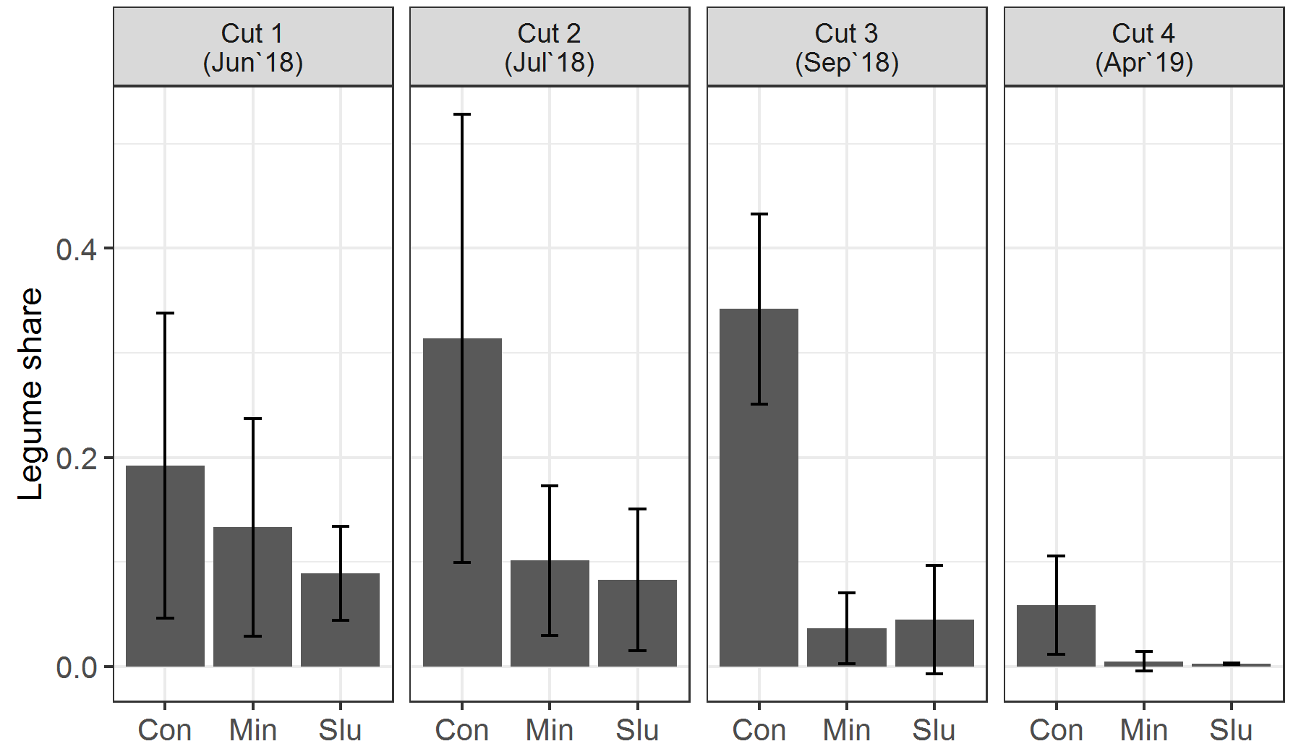
SI Fig. 8: Relative share of legumes in total biomass at Field B at the 4 cuts between April 2018 and April 2019 (mean ± standard deviation, n = 4)

Gravimetric soil moisture and correlation with Nmic and Nmin

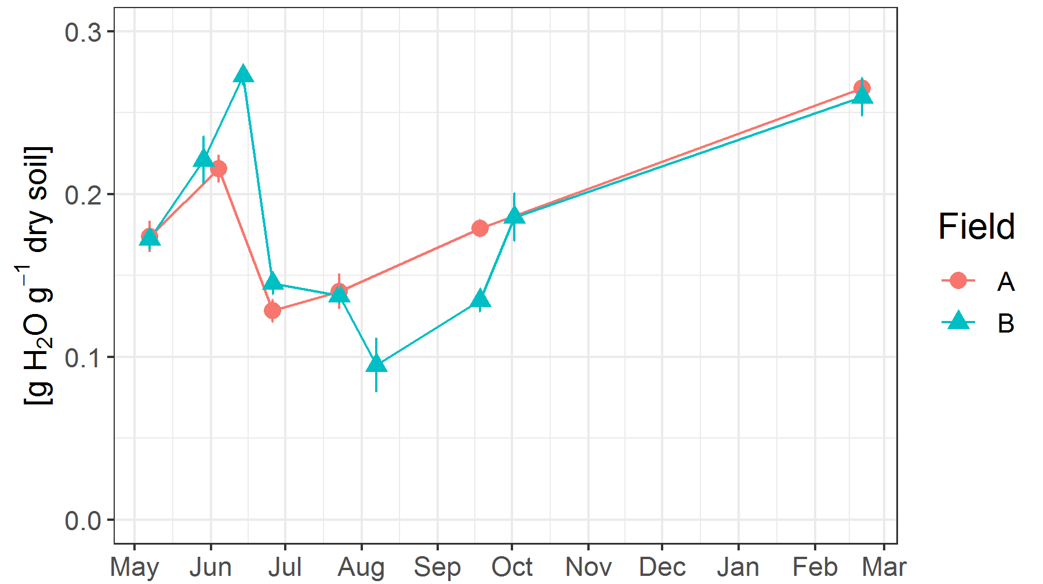
SI Fig. 9: Gravimetric soil moisture content (0-0.15 m) between May 2018 and March 2019 at the two field sites

SI Table 2: Spearman`s rank correlation coefficient over both fields and all sampling points
 | Gravimetric moisture | Nmic | Cmic | NO₃ | NH₄ | NH₄:NO₃ ratio
 |  | [kg ha⁻¹] | [kg ha⁻¹] | [kg ha⁻¹] | [kg ha⁻¹] | [-]
Gravimetric moisture |  | 0.24*** | 0.13 | -0.37*** | -0.40*** | 0.11
Nmic [kg ha⁻¹] |  |  | 0.74*** | 0.00 | -0.03 | 0.03
Cmic [kg ha⁻¹] |  |  |  | 0.17* | 0.05 | -0.13
NO₃ [kg ha⁻¹] |  |  |  |  | 0.32*** | -0.78***
NH₄ [kg ha⁻¹] |  |  |  |  |  | 0.29***
NH₄:NO₃ ratio
*, **, *** significant at p<0.05, 0.01 and 0.001 probability level

References

ASMAN, W. A., SUTTON, M. A. & SCHJØRRING, J. K. 1998. Ammonia: emission, atmospheric transport and deposition. New Phytologist, 139, 27-48.
BARROS, T., POWELL, J., DANES, M., AGUERRE, M. & WATTIAUX, M. 2017. Relative partitioning of N from alfalfa silage, corn silage, corn grain and soybean meal into milk, urine, and feces, using stable 15N isotope. Animal Feed Science and Technology, 229, 91-96.
BOSSHARD, C., OBERSON, A., LEINWEBER, P., JANDL, G., KNICKER, H., WETTSTEIN, H. R., KREUZER, M. & FROSSARD, E. 2011. Characterization of fecal nitrogen forms produced by a sheep fed with N-15 labeled ryegrass. Nutrient Cycling in Agroecosystems, 90, 355-368.
CARLSSON, G. & HUSS-DANELL, K. 2014. Does nitrogen transfer between plants confound 15N-based quantifications of N2 fixation? Plant and Soil, 374, 345-358.
CARLSSON, G., PALMBORG, C., JUMPPONEN, A., SCHERER-LORENZEN, M., HÖGBERG, P. & HUSS-DANELL, K. 2009. N2 fixation in three perennial Trifolium species in experimental grasslands of varied plant species richness and composition. Plant Ecology, 205, 87-104.
HAFNER, S. D., PACHOLSKI, A., BITTMAN, S., CAROZZI, M., CHANTIGNY, M., GÉNERMONT, S., HÄNI, C., HANSEN, M. N., HUIJSMANS, J. & KUPPER, T. 2019. A flexible semi-empirical model for estimating ammonia volatilization from field-applied slurry. Atmospheric Environment, 199, 474-484.
HAYNES, R. J. & WILLIAMS, P. H. 1993. Nutrient Cycling and Soil Fertility in the Grazed Pasture Ecosystem. In: SPARKS, D. L. (ed.) Advances in Agronomy. Academic Press.
HOEKSTRA, N. J., LALOR, S. T. J., RICHARDS, K. G., O’HEA, N., DUNGAIT, J. A. J., SCHULTE, R. P. O. & SCHMIDT, O. 2011. The fate of slurry-N fractions in herbage and soil during two growing seasons following application. Plant and Soil, 342, 83-96.
KREUZER, M. & KIRCHGESSNER, M. 1985. Zum Einfluss von Stärkeart und-menge in der Ration auf scheinbare und wahre Verdaulichkeit des Stickstoffs und auf die N-Bilanz beim Schaf. Archiv für Tierernährung, 35, 723-731.
LANGMEIER, M., FROSSARD, E., KREUZER, M., MÄDER, P., DUBOIS, D. & OBERSON, A. 2002. Nitrogen fertilizer value of cattle manure applied on soils originating from organic and conventional farming systems. Agronomie, 22, 789-800.
LOUBET, B., CAROZZI, M., VOYLOKOV, P., COHAN, J.-P., TROCHARD, R. & GÉNERMONT, S. 2018. Evaluation of a new inference method for estimating ammonia volatilisation from multiple agronomic plots. Biogeosciences, 15, 3439-3460.
MASON, V. C. 1969. Some observations on the distribution and origin of nitrogen in sheep faeces. The Journal of Agricultural Science, 73, 99-111.
MCAULIFFE, C., CHAMBLEE, D., URIBE‐ARANGO, H. & WOODHOUSE JR, W. 1958. Influence of Inorganic Nitrogen on Nitrogen Fixation by Legumes as Revealed by N15 1. Agronomy Journal, 50, 334-337.
MEISINGER, J. & JOKELA, W. 2000. Ammonia volatilization from dairy and poultry manure. Managing nutrients and pathogens from animal agriculture. NRAES-130. Natural Resource, Agriculture, and Engineering Service, Ithaca, NY, 334-354.
MISSELBROOK, T., NICHOLSON, F., CHAMBERS, B. & JOHNSON, R. 2005. Measuring ammonia emissions from land applied manure: an intercomparison of commonly used samplers and techniques. Environmental Pollution, 135, 389-397.
OBERSON, A., FROSSARD, E., BÜHLMANN, C., MAYER, J., MÄDER, P. & LÜSCHER, A. 2013. Nitrogen fixation and transfer in grass-clover leys under organic and conventional cropping systems. Plant and Soil, 371, 237-255.
PAGLIARI, P. H., WILSON, M., WALDRIP, H. M. & HE, Z. 2020. Nitrogen and phosphorus characteristics of beef and dairy manure. Animal Manure: Production, Characteristics, Environmental Concerns, and Management, 67, 45-62.
POWELL, J. M. & WU, Z. 1999. Nitrogen-15 labeling of dairy feces and urine for nutrient cycling studies. Agronomy Journal, 91, 814-818.
POWELL, J. M., WU, Z., KELLING, K., CUSICK, P. & MUÑOZ, G. 2004. Differential nitrogen-15 labeling of dairy manure components for nitrogen cycling studies. Agronomy Journal, 96, 433-441.
SHEARER, G. & KOHL, D. H. 1986. N2-fixation in field settings: estimations based on natural 15N abundance. Functional Plant Biology, 13, 699-756.
SOMMER, S. & OLESEN, J. 1991. Effects of dry matter content and temperature on ammonia loss from surface‐applied cattle slurry. Wiley Online Library.
SOMMER, S. G. & HUTCHINGS, N. 2001. Ammonia emission from field applied manure and its reduction. European Journal of Agronomy, 15, 1-15.
SØRENSEN, P., JENSEN, E. S. & NIELSEN, N. 1994. Labelling of animal manure nitrogen with 15 N. Plant and Soil, 162, 31-37.
UNKOVICH, M. J. & PATE, J. S. 2000. An appraisal of recent field measurements of symbiotic N2 fixation by annual legumes. Field Crops Research, 65, 211-228.
VAN SOEST, P. V., ROBERTSON, J. & LEWIS, B. 1991. Methods for dietary fiber, neutral detergent fiber, and nonstarch polysaccharides in relation to animal nutrition. Journal of Dairy Science, 74, 3583-3597.
VANDRÉ, R. & KAUPENJOHANN, M. 1998. In situ measurement of ammonia emissions from organic fertilizers in plot experiments. Soil Science Society of America Journal, 62, 467-473.

