Supplementary Material

Drivers of soil respiration across a management intensity gradient in temperate grasslands under drought

Antonios Apostolakis*, Ingo Schöning, Beate Michalzik, Valentin H. Klaus, Runa S. Boeddinghaus, Ellen Kandeler, Sven Marhan, Ralph Bolliger, Markus Fischer, Daniel Prati, Falk Hänsel, Thomas Nauss, Norbert Hölzel, Till Kleinebecker, Marion Schrumpf

*Corresponding author: Antonios Apostolakis
Affiliation: Max-Planck-Institute for Biogeochemistry, Hans-Knöll-Str. 10, 07745 Jena, Germany
E-mail: apostolakis@bgc-jena.mpg.de
ORCID: 0000-0001-6418-189X
Postal address: Max-Planck-Institute for Biogeochemistry, Hans-Knöll-Str. 10, 07745 Jena, Germany

Table S1 Geographical, geological and climatic characteristics of the three study regions in the Biodiversity Exploratories project: Schwäbische-Alb =ALB; Hainich-Dün =HAI; Schorfheide-Chorin =SCH (*Fischer et al., 2010). Abbreviations: a.s.l.: above sea level. Soil types are given according to the **IUSS Working group WRB (2014)
Parameter | Study region
 | ALB | HAI | SCH
Location in Germany | Southwest | Central | Northeast
Geology | Calcareous  bedrock with loam  layer and karstic  phenomenon | Calcareous  bedrock with  loess layer | Post glacial  landscape with  sandy ridges and  fens
Elevation (m a.s.l.) | 460-860 | 285-550 | 3-140
Dominant soil types | Leptosols  and Cambisols | Cambisols,  Stagnosols  and Vertisols | Histosols,  Gleysols,  Cambisols,  Luvisols  and Albeluvisols
Annual mean temperature (°C) | 6.0-7.0 | 6.5-8.0 | 8.0-8.5
Annual precipitation (mm) | 700-1,000 | 500-800 | 500-600
*Fischer, M., ..., Weisser, W.W., 2010. Implementing large-scale and long-term functional biodiversity research: The Biodiversity Exploratories. Basic Appl. Ecol. 11, 473–485. https://doi.org/10.1016/j.baae.2010.07.009
**IUSS Working Group WRB, 2014. World Reference Base for Soil Resources 2014, Update 2015. International Soil Classification System for Naming Soils and Creating Legends for soil Maps. World Soil Resources Reports No. 106, Rome: FAO.

Table S2 Minimum, average and maximum values of soda-lime sample mass increase (%, per dry weight) for the 2018 and 2019 campaigns in the three study regions; Schwäbische-Alb =ALB, Hainich-Dün =HAI and Schorfheide-Chorin =SCH. Mass gain did not exceed the limit of 9.0% proposed by *Janssen et al. (2000), and the highest values were observed in SCH in 2019. Control samples had mass gains consistently lower than 1.0% (data not shown)
Region | Year | Mean | Min | Max
ALB | 2018 | 2.3 | 0.2 | 3.8
 | 2019 | 1.6 | 0.6 | 2.7
HAI | 2018 | 1.9 | 0.2 | 3.4
 | 2019 | 2.2 | 1.3 | 4.3
SCH | 2018 | 2.2 | 0.2 | 5.3
 | 2019 | 1.6 | 0.5 | 3.7
*Janssens, I., …, Ceulemans, R. (2000). Assessing forest soil CO2 efflux: an in situ comparison of four techniques. Tree Physiology, 20(5), 23–32. https://doi.org/10.1093/treephys/20.1.23

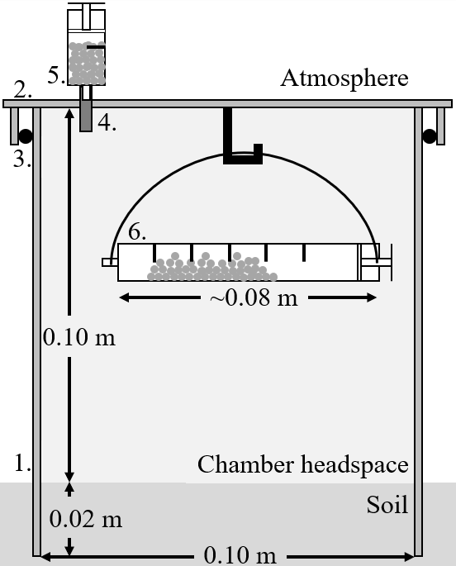
Fig. S1 Sketch of the soda-lime method with an open and static chamber. A PVC ring (1.) of 0.12 m is inserted to the soil down to 0.02 m. A PVC lid (2.) is placed over the PVC ring and a plastic O-ring (3.) ensures the airtightness of the chamber. The color of the PVC ring and lid was orange-brown. A plastic tube (4.), which is glued on the PVC lid with CO₂-impermeable silicon, passes through the PVC lid. This tube provides a flow-channel between the headspace of the chamber and ambient atmosphere and, thus, pressure equilibrium between the two. In line with the plastic tube, a syringe (5.) with 4 holes of a diameter of 1 mm is placed out of the chamber. This syringe contains soda-lime granules to prevent atmospheric CO₂ from entering the headspace of the chamber. Inside the chamber, a syringe (6.) with 64 holes (1 mm diameter) is held from a hook and contains soda-lime granules for the determination of soil CO₂ efflux

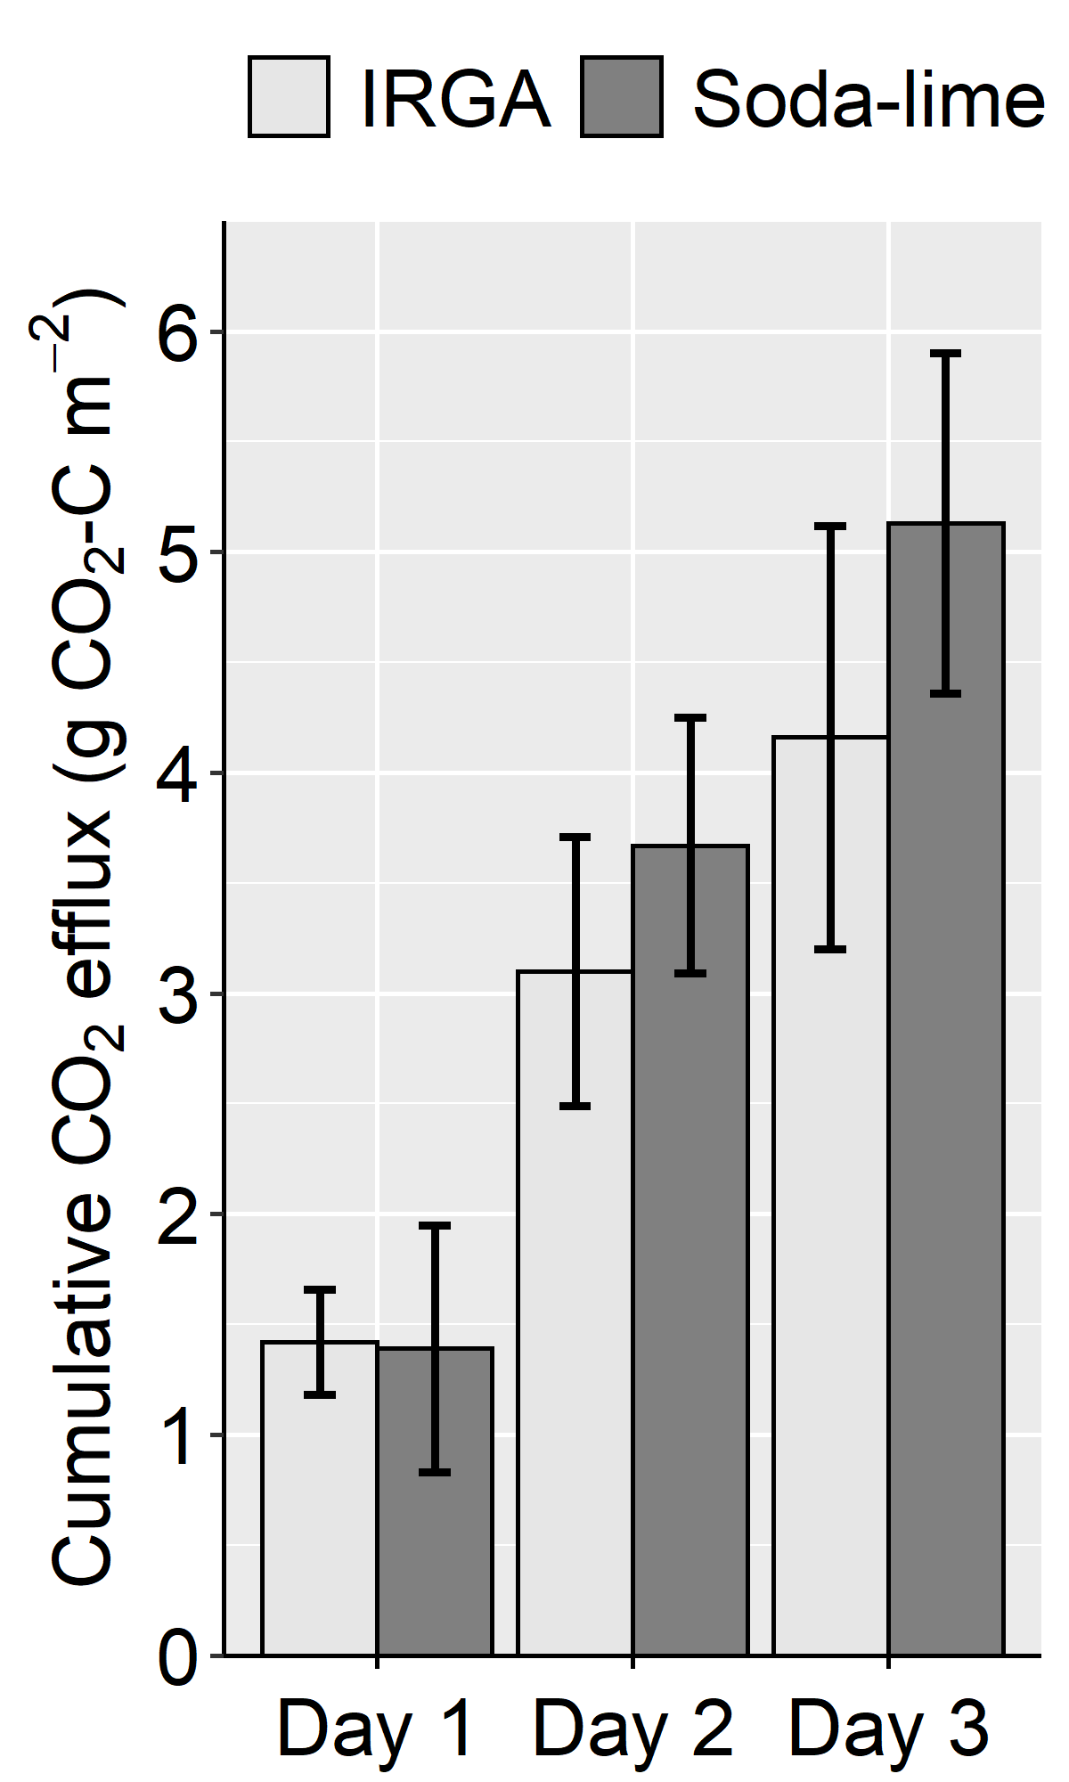
Fig. S2 Comparison of cumulative soil CO₂ efflux with the soda-lime method and an infra-red gas analyser (IRGA) (Li8100A, LI-COR Biosciences) in a grassland soil (pH =7.5) over a period of three days. No significant differences were observed between the two methods based on one-way ANOVA (significance level at p-value <0.05)

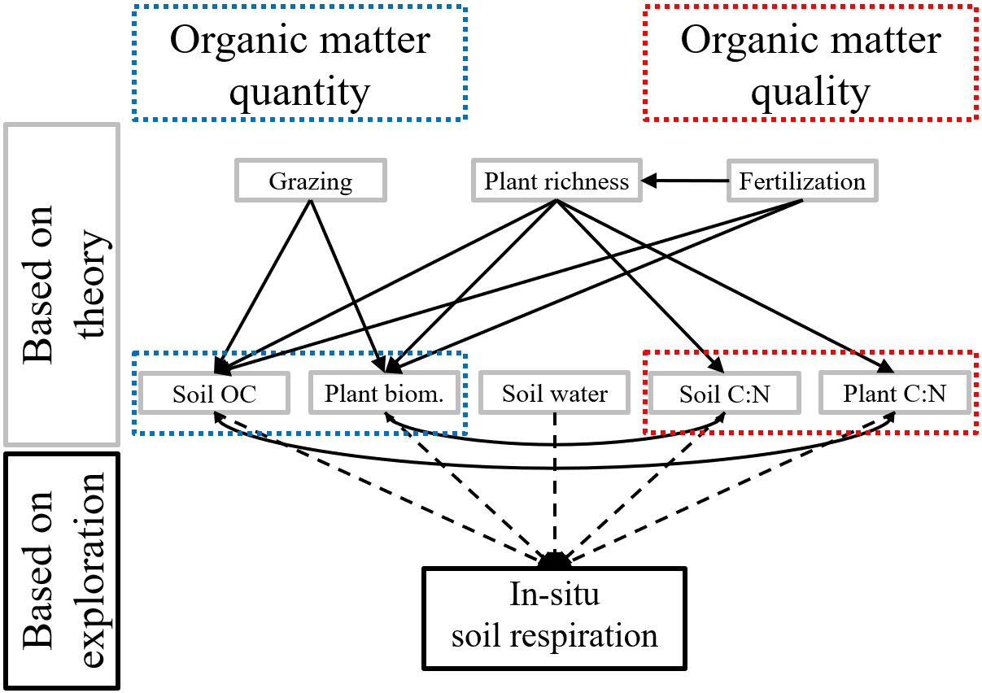
Fig. S3 Hypothetical structure to test whether management intensification influences in-situ soil respiration via changes in organic matter quantity and/or quality. Our structure was based on the following prior hypotheses, as shown in the figure: i) fertilization, grazing and plant diversity are indirectly linked to in-situ soil respiration via organic matter quantity and quality, ii) fertilization intensity is directly linked with organic matter quantity and indirectly linked with organic matter quality via plant diversity, iii) grazing intensity is linked with organic matter quantity and not linked with plant diversity or organic matter quality and iv) plant diversity is linked both with organic matter quantity and quality (*Apostolakis et al., 2022; **Dias et al., 2010; ***Dietrich et al., 2017; ⁺Klaus et al., 2018; §Lange et al., 2015). In our study, organic matter quantity was expressed as soil organic carbon concentration and plant biomass. Organic matter quality was expresses as soil C:N ratio and plant biomass C:N ratios. Finally, plant diversity was expressed as plant species richness. We tested all possible paths. Grazing was indeed related to organic matter quantity, but only of plants. Plant biomass and plant C:N ratio were never linked to in-situ soil respiration and, thus, not included in the final Structural Equation Models. We tested all possible covariances between soil and plant properties and soil volumetric water content. Soil organic carbon concentration covaried with plant C:N ratio and plant biomass covaried with soil C:N ratio. Soil volumetric water content was linked only with soil respiration

*Apostolakis et al., 2022. Direct and plant community mediated effects of management intensity on annual nutrient leaching risk in temperate grasslands. Nutr. Cycl. Agroecosystems. https://doi.org/10.1007/s10705-022-10209-1
**Dias et al., 2010. Plant species richness regulates soil respiration through changes in productivity. Oecologia 163, 805–813. https://doi.org/10.1007/s00442-010-1569-5
***Dietrich et al., 2017. Fertilization, soil and plant community characteristics determine soil microbial activity in managed temperate grasslands. Plant Soil 419, 189–199. https://doi.org/10.1007/s11104-017-3328-4
⁺Klaus et al., 2018. Land use intensity, rather than plant species richness, affects the leaching risk of multiple nutrients from permanent grasslands. Glob. Chang. Biol. 24, 2828–2840. https://doi.org/10.1111/gcb.14123
§Lange et al., 2015. Plant diversity increases soil microbial activity and soil carbon storage. Nat. Commun. 6. https://doi.org/10.1038/ncomms7707
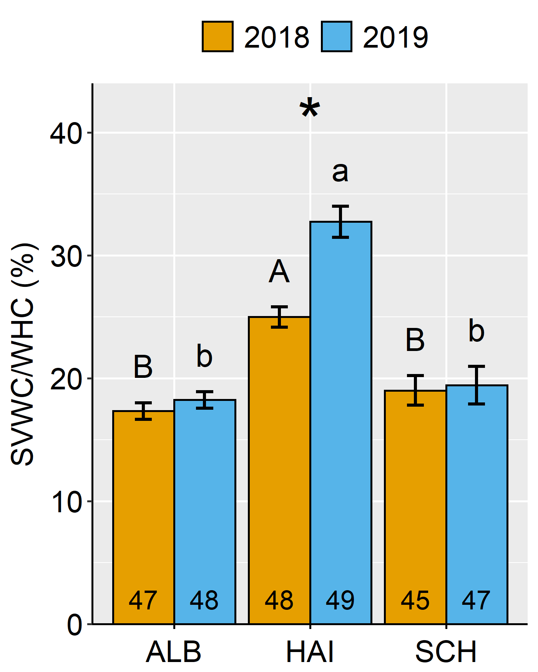
Fig. S4 Soil Volumetric Water Content (SVWC) over Water Holding Capacity (WHC) for the three study regions; Schwäbische-Alb =ALB, Hainich-Dün =HAI and Schorfheide-Chorin =SCH and the two years; 2018 and 2019. Asterisks indicate differences between the two years for a given study region. Lower- and upper-case letters indicate differences among study regions in 2018 and 2019, respectively

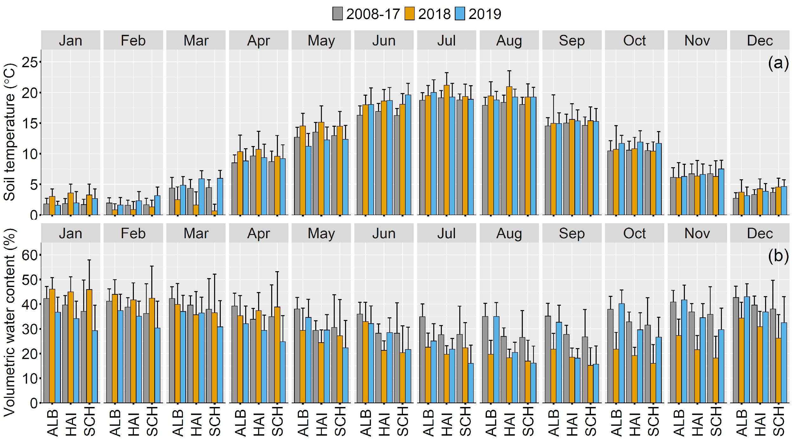
Fig. S5 Mean (a) soil temperature (°C) and (b) soil volumetric water content (%) per month for the 10-year-mean (2008-17) and the sampling years 2018 and 2019 for the three study regions; Schwäbische-Alb =ALB, Hainich-Dün =HAI and Schorfheide-Chorin =SCH. Error bars represent standard deviations around the mean

