Supplementary online material
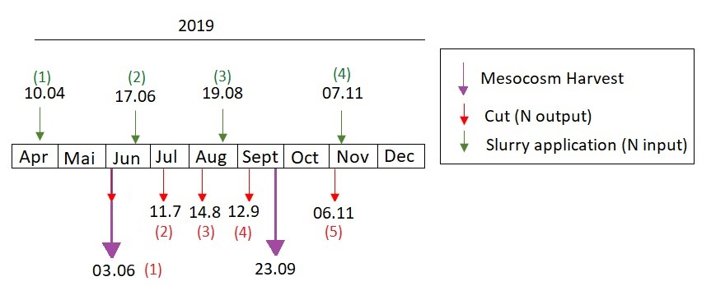

Figure S1: Scheme of management and mesocosm harvests in the study year 2019.

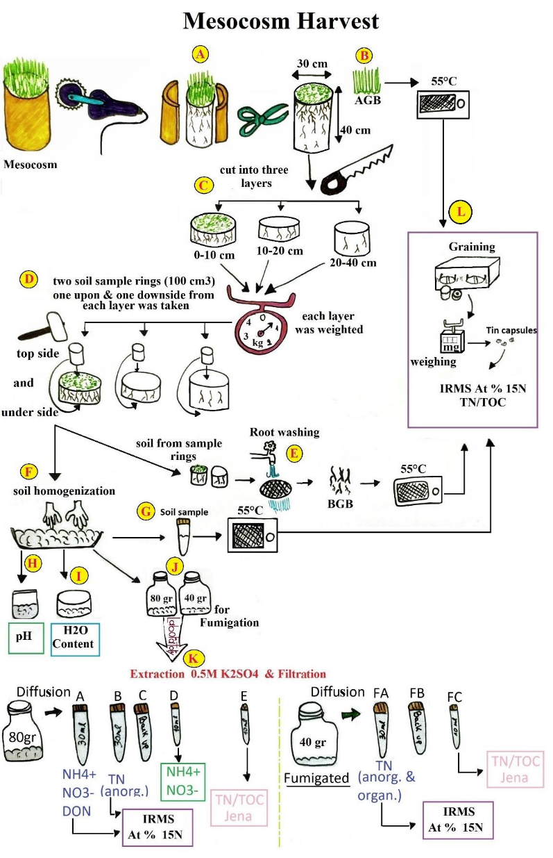
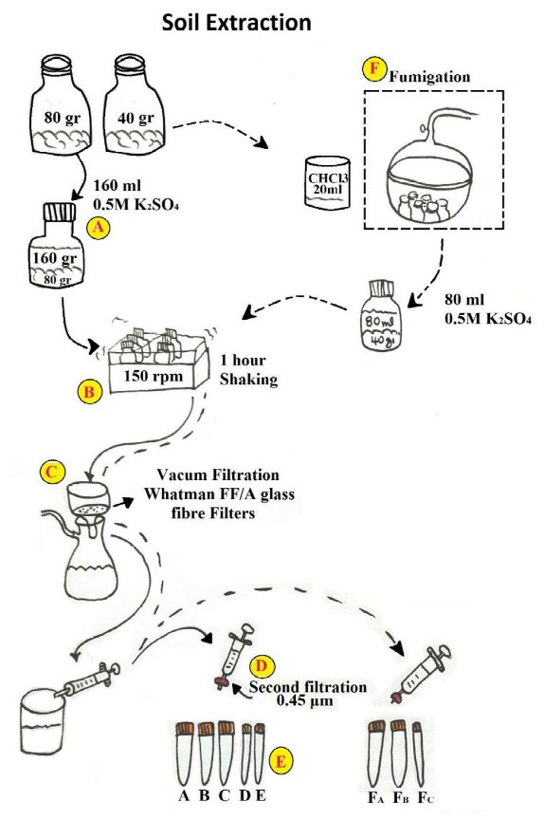
Figure

Figure S2: Flowchart for the mesocosm harvest (left) and the soil extraction (right) (drawn by E. Bazaios).
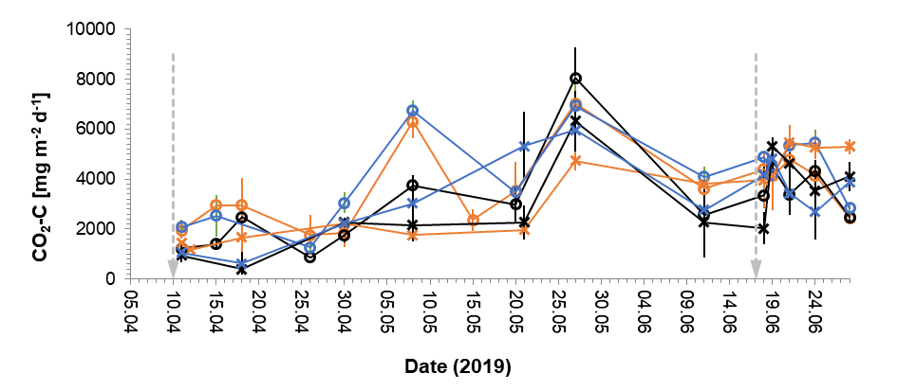
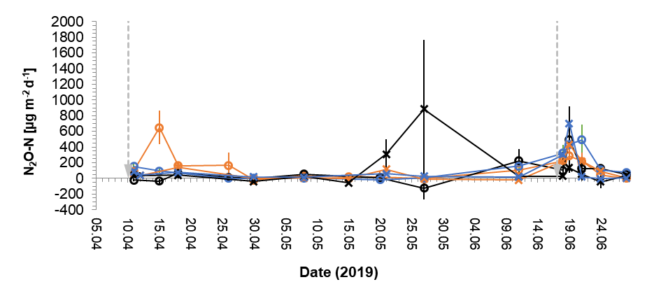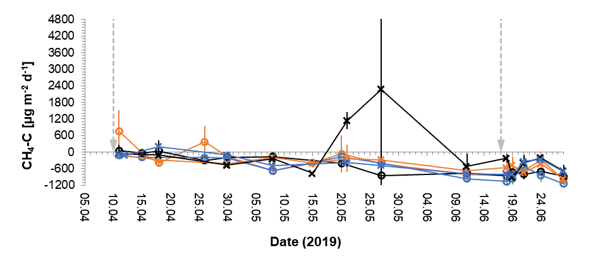
Figure S3: Daily CO₂, N₂O and CH₄ fluxes ± SE for acidified, injected and broadcast slurry (control) treatment from 11.4. – 24.6. 2019 for Graswang (ambient climate) and the climate change site Fendt. Fertilization was on April 4 and June 17, 2019. SE are indicated by error bars on the measurement days.
Table S1: Overview of averaged N pool sizes (kg N ha⁻¹) ± standard deviation for both (June and September) harvest events on the climate treatments Graswang and Fendt with the different management treatments “control”, “injected” and “acidified”. P statistic for both harvest events together, shows no significant effects of management treatments. Statistically significant differences between climate treatments are indicated by capital letters.
Pool sizes [kg N ha⁻¹]
 | 1st Harvest (June 3, 2019) |  |  |  | 2nd Harvest (Sept. 23, 2019)
Graswang | NO₃⁻ | NH₄⁺ | DON | N MB | NO₃⁻ | NH₄⁺ | DON | N MB
Acidified | 2.8 ± 0.1 A | 7.9 ± 0.2 | 38.2 ± 0.8 | 188.3± 18.1 | 5.1 ± 0.3 A | 4.1 ± 0.1 | 21.1 ± 0.4 | 628.3 ± 30.3
Injected | 2.8 ± 0.1 A | 7.2 ± 0.2 | 30.3 ± 0.2 | 200.3± 24.3 | 2.7 ± 0.1 A | 21.4 ± 0.7 | 27.8 ± 0.8 | 392.4 ± 10.5
Control | 2.5 ± 0.1 A | 8.3 ± 0.3 | 32.8 ± 1.0 | 175.5± 10 | 4.5 ± 0.3 A | 8.2 ± 1.3 | 20.9±0.8 | 465.5 ± 19.1
Fendt | NO₃⁻ | NH₄⁺ | DON | N MB | NO₃⁻ | NH₄⁺ | DON | N MB
Acidified | 2.5 ± 0.1 B | 6.6 ± 0.3 | 35.1 ± 1.1 | 210 ± 11.8 | 1.8 ± 0.1 B | 16.5 ± 1.4 | 29 ± 1.2 | 445.1 ± 19.3
Injected | 2.6 ± 0.1 B | 9.3± 1.4 | 26.9 ± 2.2 | 237.7± 4 | 2.7± 0.2 B | 5.5 ± 0.1 | 23.9 ± 0.7 | 503.8 ± 19.3
Control | 2.6 ± 0.1 B | 6.1 ± 0.2 | 30.5 ± 0.4 | 202.6 ± 8.7 | 3 ± 0.2 B | 6.2 ± 0.2 | 23.9 ± 0.7 | 614.3 ± 8.3
p (climate) | 0.037 | 0.151 | 0.674 | 0.233
p (manage-ment) | 0.558 | 0.269 | 0.604 | 0.395
p (climate*  management) | 0.236 | 0.019 | 0.262 | 0.089
p (harvest) | 0.011 | 0.029 | 0.126 | 0.028

