Nutrient Cycling in Agroecosystem

Supplementary Information

Phosphorus Removal and Use in Organic Crop Farming in The EU

S. Magaya*
Department of Environmental Geography, Institute for Environmental Studies, VU University Amsterdam, De Boelelaan 1085, 1081 HV Amsterdam, The Netherlands
J. Magid
Department of Plant and Environmental Sciences, University of Copenhagen, Thorvaldsensvej 40, 1871 Frederiksberg C, 71 Højhus 71, Building: 71-3-T324, Denmark
L. Herman,
Proman Consulting GmbH, Austria.
C.J.E. Schulp
Department of Environmental Geography, Institute for Environmental Studies, VU University Amsterdam, De Boelelaan 1085, 1081 HV Amsterdam, The Netherlands
*Corresponding author: s.magaya@vu.nl

Table 1: P removed by different crop groups across the EU in tonnes
Crop Group | P removed (tonnes)
Cereals | 21 605
Fruits & vegetables | 19734
Fodder | 11863
Permanent crops | 4996
Oil crops | 2386
Root crops | 703
Other arable crops | 7
Total | 61 296

Table 2: P removed through harvesting of each crop type across the EU
Crop groups | FADN Crop | FADN code of crop production | P removed per crop  (tonnes)
Cereals
 | Barley | CBRL_PRQ | 4670.9
 | Rice | CRICE_PRQ | 243.6
 | Durum wheat | CWHTD_PRQ | 2562.4
 | Sweet corn | CCRNSWT_PRQ | 52.9
 | Common wheat and spelt | CWHTC_PRQ | 6479.7
 | Rye | CRYE_PRQ | 1850.5
 | Oats and spring cereal mixtures | COAT_PRQ | 4733.2
 | Grain maize | CMZ_PRQ
Root crops |  |  | 1254.9
 | Sugar beet | CSUGBT_PRQ
 | Potatoes | CPOT_PRQ | 288.4
 | Other root crops | CFODRTBR_PRQ | 525.1
Oil crops
 | Soya | CSOYA_PRQ
 | Sunflower | CSNFL_PRQ | 696.2
 | Rape and turnip rape | CRAPE_PRQ | 828.7
 | Fibre flax | CFLAX_PRQ | 926.1
 | Other oil seed crops | CCRPOILOTH_PRQ | 9.0
Fodder
 | Pasture and meadow | CGRSXRG_PRQ
 | Rough grazings | CRG_PRQ | 5937.1
 | Temporary grasses and grazings | CGRSTMP_PRQ | 1149.3
 | Green maize | CFODMZ_PRQ | 1149.3
Fruit & Vegetables
 | Vegetables, flowers | CTOTHORT_PRQ
 | Fruit (incl. citrus) | CTOTFRUT_PRQ | 16202.9
 | Cultivated mushrooms | CMUSH_PRQ | 1060.8
 | Tomatoes | CTOMAT_PRQ | 23.8
 | Legumes
 | Field peas, beans and sweet lupins | CPEA_PRQ | 486.9
 | Lentils, chickpeas and vetches | CLNTL_PRQ | 1931.5
Permanent crops
 | Olives for oil production | COLVFR_PRQ | 135.4
 | Table olives | COLV_PRQ
 | Table grapes | CGRPTAB_PRQ
 | Wine grapes | CGRPWINOTH_PRQ | 453.5
 | Grapes for wine with protected geographical indication | CGRPWINPGI_PRQ | 4.1
 | Grapes for wine with protected designation of origin | CGRPWINPDO_PRQ | 68.6

Table 3: Total P removed (kg ha⁻¹) per country, for all crops
Country Code | Conventional | Organic | Organic farming % on conventional farming
BE | 14.2 | 5.7 | 40.4
BG | 13.7 | 10.9 | 79.9
CY | 9.0 | 13.0 | 145.5
CZ | 20.3 | 8.0 | 39.5
DK | 19.8 | 6.5 | 32.8
DE | 20.3 | 4.4 | 21.4
EL | 7.6 | 4.1 | 54
EE | 9.9 | 3.1 | 31.4
FR | 12.5 | 2.3 | 18.3
HR | 13.4 | 5.3 | 39.5
HU | 14.2 | 9.3 | 65.3
IE | 2.5 | 0.8 | 33.9
IT | 32.9 | 17.6 | 53.5
LT | 11.3 | 2.7 | 23.7
LU | 4.6 | 1.5 | 32.0
LV | 11.1 | 4.5 | 40.8
NE | 20.5 | 7.2 | 35.1
AT | 10.7 | 2.1 | 19.8
PL | 13.3 | 3.9 | 29.5
PT | 7.8 | 0.1 | 1.5
SK | 13.7 | 6.3 | 45.7
Sl | 11.0 | 5.4 | 49.3
UK | 8.1 | 1.7 | 20.5
Average | 13.1 | 5.5

Table 4: Comparison in kgP ha⁻¹ removal between organic and conventional farms, considering crops that have the highest P removal in organic farming
Conv= Conventional farming
Org= Organic farming
 | Cereals |  |  | Fruits & Vegetables |  |  | Fodder
Country | Conv | Org | %Org in Conv | Conv | Org | %Org in Conv | Conv | Org | %Org in Conv
AT | 18.4 | 10.8 | 58.6 | 7.5 | 0.4 | 5.9 | 0.0 | 0.0 | 0.0
BE | 27.5 | 18.9 | 68.7 | 32.5 | 28.3 | 87.1 | 0.0 | 0.0 | 0.0
BG | 16.5 | 13.4 | 80.9 | 10.4 | 8.4 | 80.4 | 4.5 | 1.1 | 25.6
CY | 5.8 | NA | NA | 13.8 | 0.4 | 3.0 | 0.1 | NA | 0.0
CZ | 17.7 | 10.7 | 60.6 | 12.9 | 1.4 | 10.7 | 27.8 | 7.9 | 28.5
DE | 22.4 | 12.0 | 53.7 | 20.1 | 3.9 | 19.3 | 17.4 | 1.0 | 5.7
DK | 22.7 | 13.3 | 58.5 | 10.9 | 0.0 | 0.0 | 7.2 | 0.9 | 11.8
EE | 15.1 | 7.7 | 51.2 | 7.2 | 0.2 | 2.2 | 3.2 | 1.6 | 51.2
EL | 11.2 | 9.9 | 88.6 | 9.9 | 2.4 | 23.8 | 2.0 | 0.0 | 0.0
FR | 21.6 | 13.0 | 60.0 | 17.9 | 5.1 | 28.3 | 0.0 | 0.0 | 0.0
HR | 15.8 | 15.3 | 96.8 | 17.2 | 0.5 | 2.7 | 7.5 | 3.7 | 49.6
HU | 16.1 | 13.2 | 82.0 | 16.6 | 4.3 | 25.8 | 5.5 | 0.7 | 12.7
IE | 29.5 | 10.8 | 36.8 | 26.0 | 0.0 | 0.0 | 0.0 | 0.0 | 0.0
IT | 16.1 | 11.4 | 70.8 | 119.6 | 55.9 | 46.8 | 12.7 | 5.5 | 43.2
LT | 16.5 | 8.3 | 50.5 | 14.3 | 0.2 | 1.7 | 1.7 | 0.0 | 0.0
LU | 17.7 | 10.5 | 59.4 | 0.6 | 0.2 | 31.8 | 0.0 | 0.0 | 0.0
LV | 13.9 | 7.2 | 51.9 | 13.8 | 1.1 | 8.3 | 4.1 | 4.0 | 97.6
NL | 27.0 | 17.8 | 65.9 | 31.5 | 32.5 | 103.0 | 16.3 | 2.4 | 14.9
PL | 16.5 | 8.1 | 49.4 | 8.9 | 1.9 | 21.4 | 4.8 | 1.0 | 21.0
PT | 10.4 | 4.6 | 44.4 | 16.7 | 0.9 | 5.3 | 5.1 | 0.1 | 1.1
SI | 19.1 | 10.4 | 54.4 | 13.3 | 1.2 | 9.0 | 7.4 | 5.3 | 72.0
SK | 14.0 | 9.4 | 66.8 | 17.1 | 37.9 | 222.0 | 12.0 | 4.9 | 40.7
UK | 24.5 | 12.2 | 49.5 | 13.8 | 10.1 | 73.3 | 1.2 | 0.0 | 3.5

Table 5: Count of farm types in Organic Farming
Organic Farming Count of farms
Country | Mixed | Livestock | Crops Only
AT | 845.8 | 16265.7 | 3602.0
BE | 294.0 | 1303.4 | 366.8
BG | 1175.7 | 272.2 | 1379.6
CY | 0.0 | 0.0 | 16.6
CZ | 499.0 | 3249.9 | 1045.8
DE | 1623.0 | 12246.0 | 3716.9
DK | 546.3 | 1942.4 | 1791.9
EE | 235.1 | 906.5 | 506.0
EL | 268.9 | 2490.7 | 5528.6
ES | 1331.8 | 7610.9 | 32038.6
FI | 108.1 | 2072.7 | 2355.4
FR | 2461.5 | 10340.3 | 10245.8
HR | 835.8 | 2169.0 | 1860.1
HU | 354.1 | 455.8 | 631.0
IE | 126.0 | 2200.8 | 106.2
IT | 4240.4 | 24755.0 | 73987.9
LT | 1511.7 | 2509.1 | 1075.0
LU | 10.8 | 55.4 | 0.0
LV | 2231.9 | 4228.5 | 869.5
NL | 0 | 2057.5 | 509.4
PL | 8377.2 | 12646.2 | 12571.9
PT | 535.4 | 1157.7 | 714.4
SE | 215.8 | 3212.9 | 428.2
SI | 1491.6 | 5533.1 | 2283.1

Table 6: Count of farm types in Conventional farming
Conventional Farming Count of farms
Country | Mixed | Livestock | Crops Only
AT | 3573.2 | 31552.8 | 14972.7
BE | 2790.1 | 15433.0 | 8400.0
BG | 6842.9 | 23621.9 | 28072.3
CY | 994.2 | 3617.8 | 6245.4
CZ | 2762.3 | 2899.8 | 7588.2
DE | 18495.0 | 87137.0 | 56972.1
DK | 1786.4 | 8688.9 | 11292.1
EE | 556.1 | 2426.3 | 2995.0
EL | 21937.4 | 68594.0 | 232852.1
FR | 25402.3 | 109612.0 | 137497.2
HR | 20509.2 | 23231.6 | 21991.7
HU | 20944.8 | 20753.2 | 68383.8
IE | 2842.6 | 84472.7 | 3673.8
IT | 15474.0 | 117577.1 | 323297.6
LT | 13040.3 | 24922.1 | 19260.9
LU | 102.6 | 1147.2 | 222.0
LV | 3120.1 | 7415.5 | 7056.5
NL | 934.0 | 27689.6 | 15471.0
PL | 170930.6 | 183052.0 | 349709.6
PT | 12299.0 | 43078.3 | 47505.5
SI | 7544.4 | 19594.2 | 8208.9
SK | 467.1 | 1032.0 | 2271.7
UK | 6239.6 | 59972.5 | 28120.5
AT | 3573.2 | 31552.8 | 14972.7

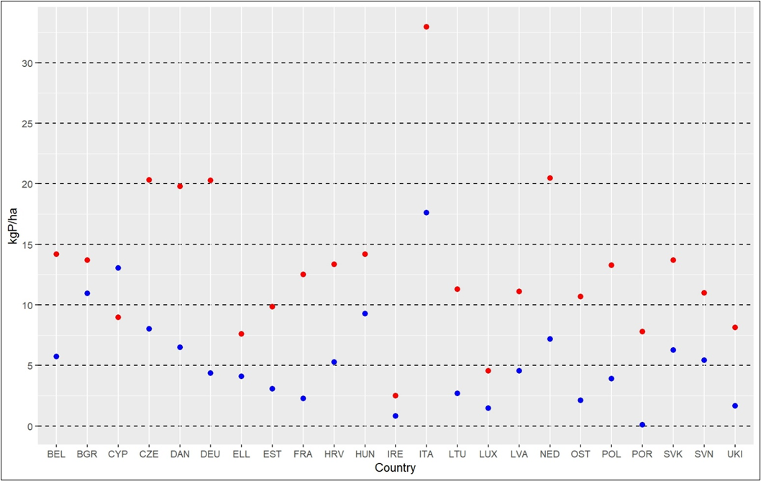
Figure 1: P removed from organic (blue) and conventional (red) farming in each EU country in kg ha⁻¹

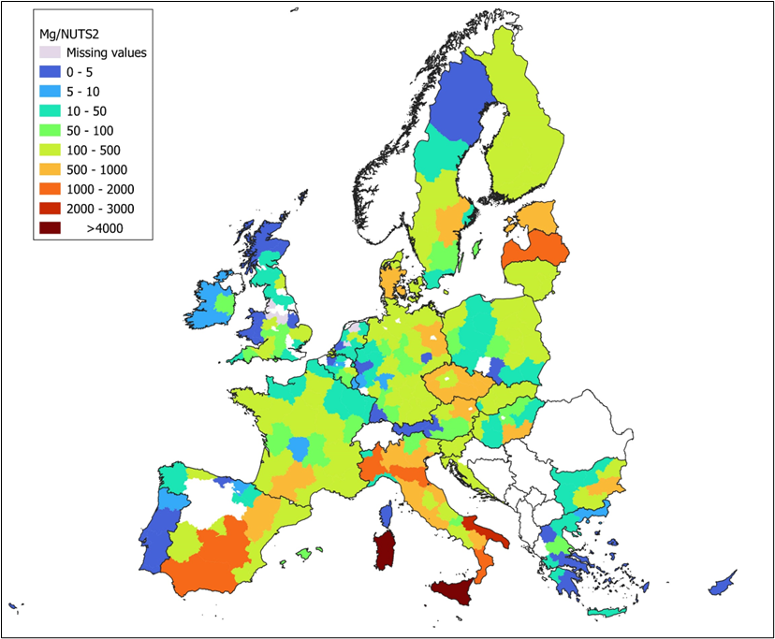Figure 2: Total P removed per NUTS2 region

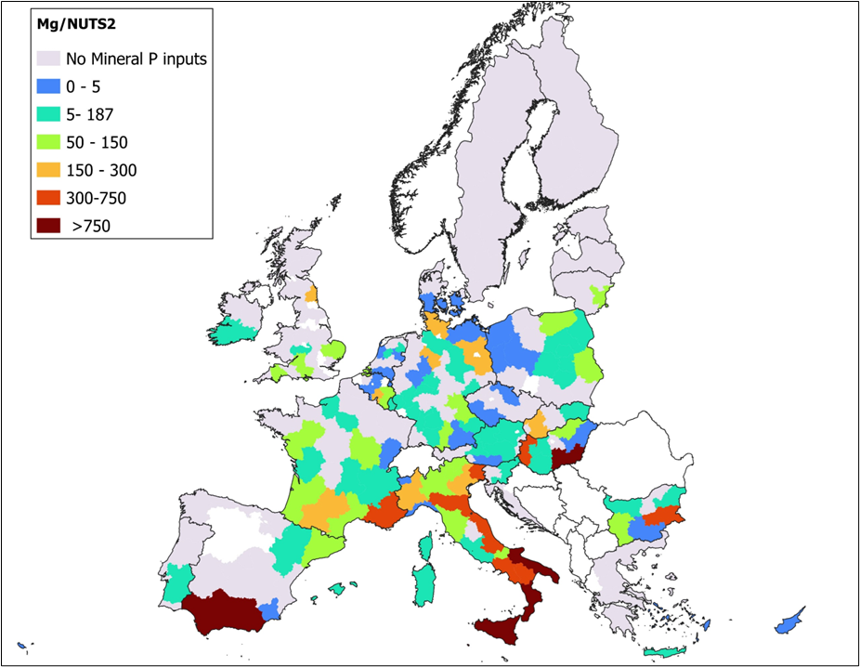
Figure 3: Total mineral fertiliser P used per NUTS2 region

