Supplementary materials

Informing APSIM using ¹⁵N recovery data to establish fertiliser N budgets in grain systems
Naoya Takeda*ª, Johannes Friedl*^{a,b}, Stephen Leo^{c}, Graeme Schwenke^{d}, David Rowlingsª, Ashley Wallace^{e}, Roger Armstrong^{e,f}, Michael Bell^{g}, Peter Graceª
ª Centre for Agriculture and the Bioeconomy, Queensland University of Technology, Brisbane, Queensland, Australia
^{b} University of Natural Resources and Life Sciences Vienna, Department of Forest and Soil Sciences, Institute of Soil Research, Vienna, Austria
^{c} Department of Environment and Science, Queensland Government, Brisbane, Queensland, Australia
^{d} New South Wales Department of Primary Industries, Tamworth Agricultural Institute, Calala, New South Wales, Australia
^{e} Agriculture Victoria, Grains Innovation Park, Horsham Victoria, Australia
^{f} Department of Animal, Plant and Soil Sciences, La Trobe University, Bundoora, VIC 3083, Australia
^{g} School of Agriculture and Food Sciences, University of Queensland, Gatton, Queensland, Australia.

*Corresponding Authors
E-mail: n3.takeda@qut.edu.au, johannes.friedl@boku.ac.at

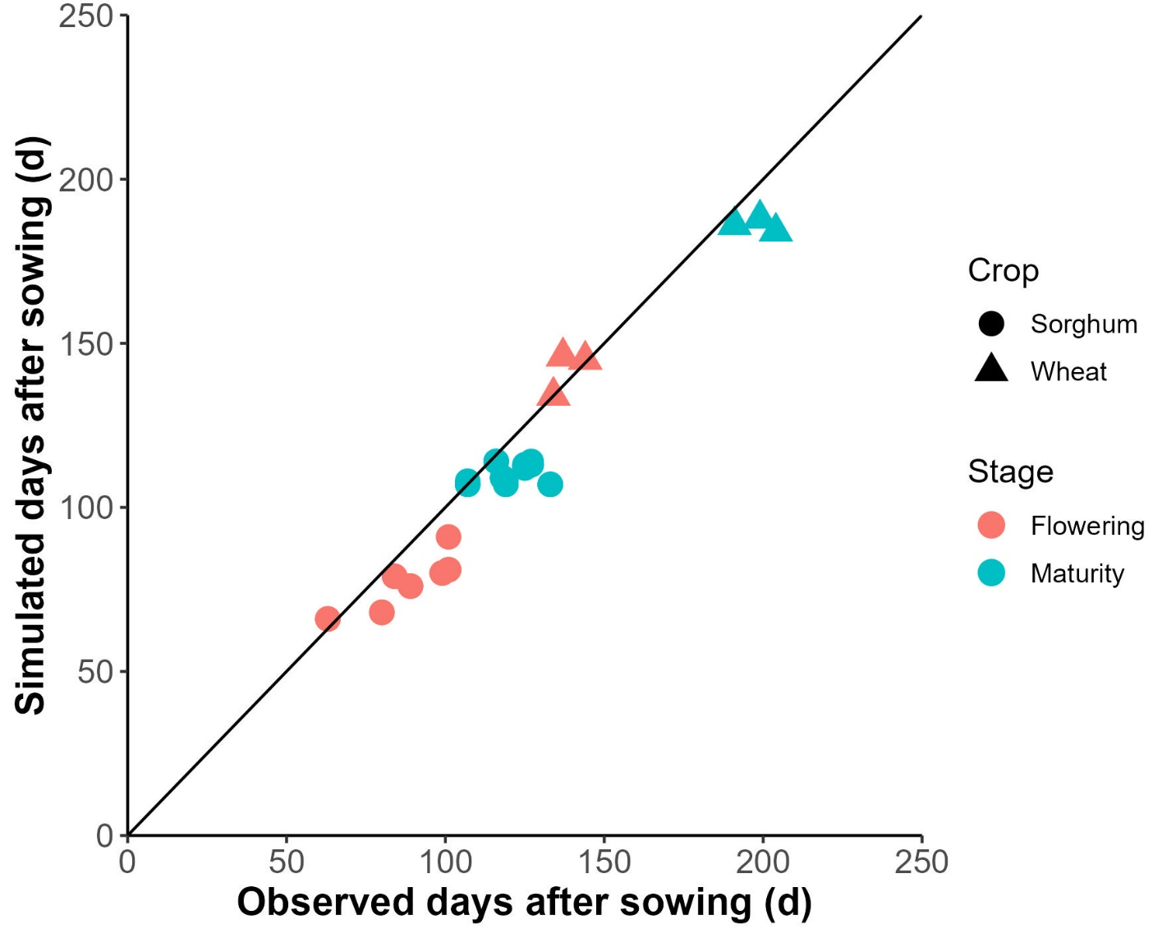
Figure S1 APSIM simulated versus observed days after sowing for flowering (red) and maturity (blue) across different sorghum (circle) and wheat (triangle) sites and N rates in eastern Australia after conventional setup. The solid line represents the 1:1 relationship.

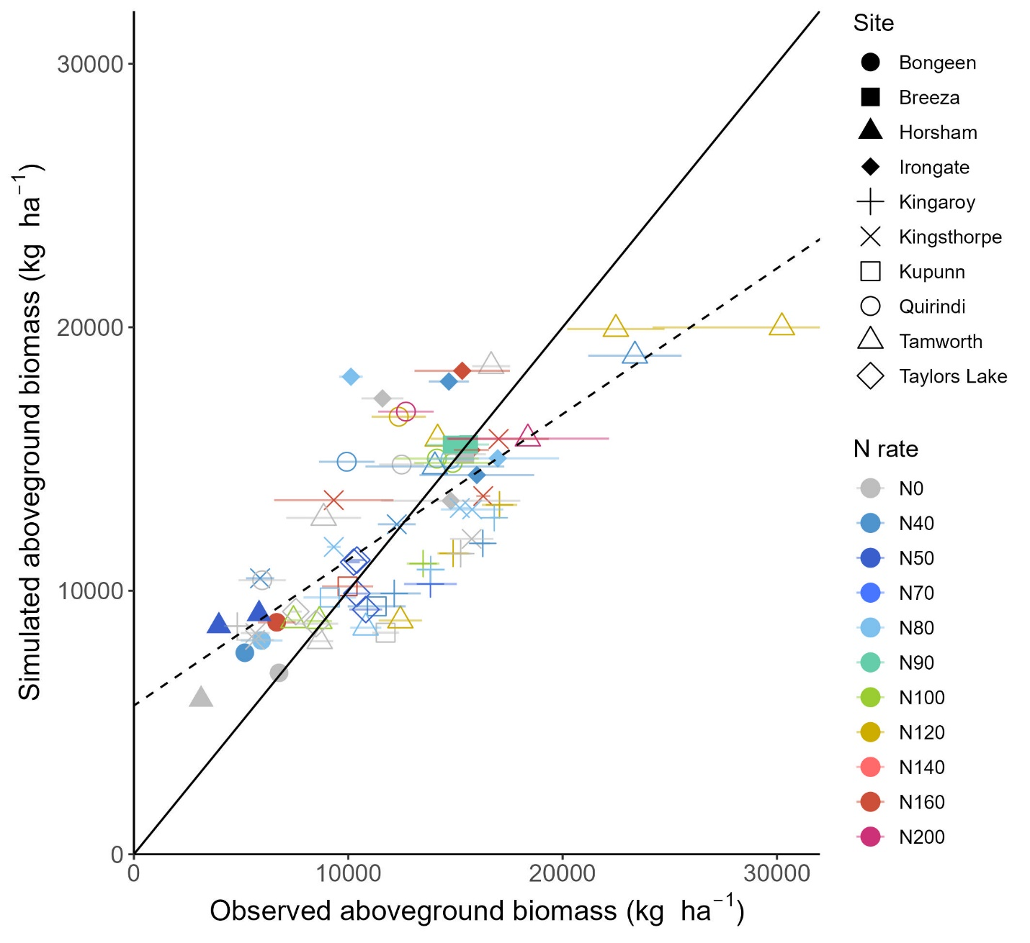
Figure S2 APSIM simulated versus observed aboveground biomass at harvest across different sorghum and wheat sites and N rates in eastern Australia after conventional setup. The solid line represents the 1:1 relationship, while the dashed line represents the least squares regression fitted to the complete data set. Horizontal error bars indicate standard errors in the observed values
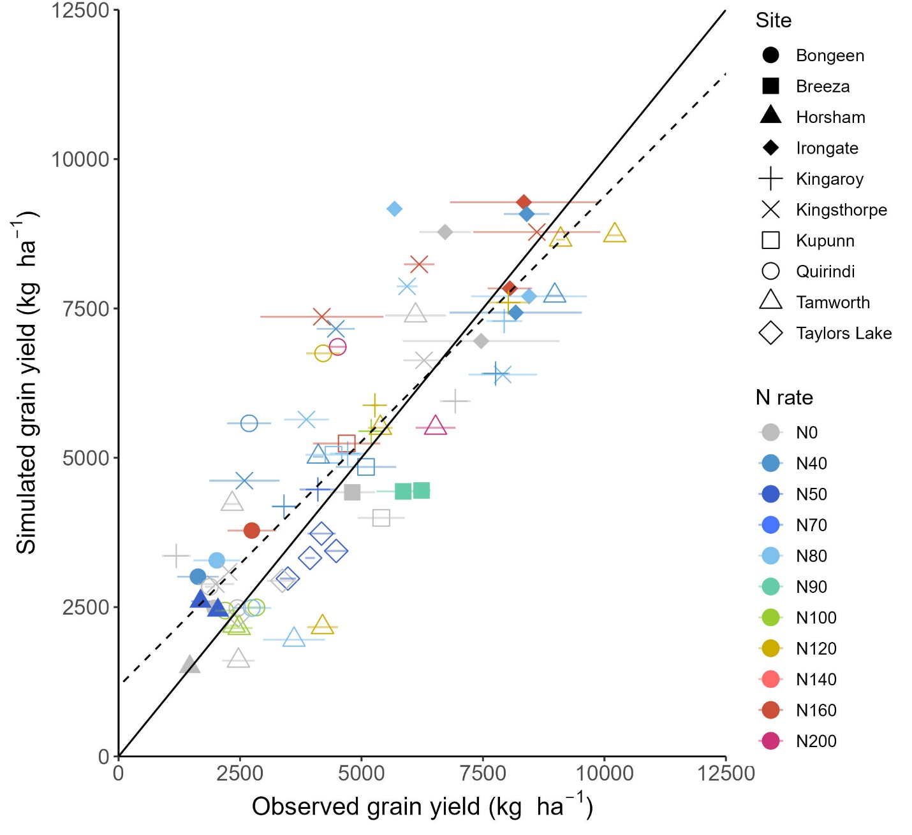
Figure S3 APSIM simulated versus observed grain yield at harvest across different sorghum and wheat sites and N rates in eastern Australia after conventional setup. The solid line represents the 1:1 relationship, while the dashed line represents the least squares regression fitted to the complete data set. Horizontal error bars indicate standard errors in the observed values

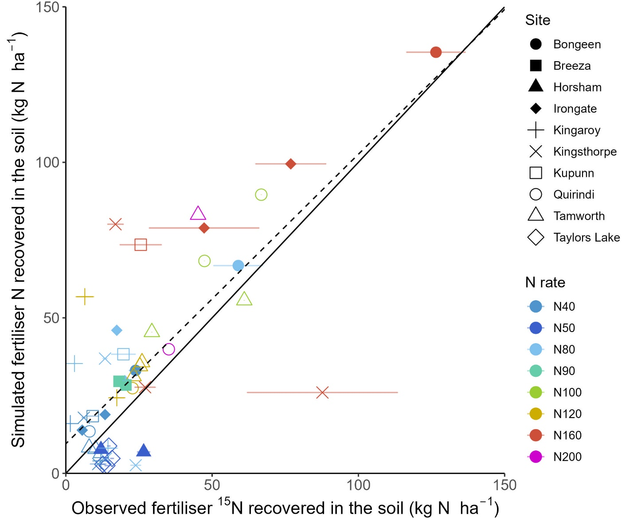
Figure S4 APSIM simulated versus observed residual fertiliser N in the soil at harvest across different sorghum and wheat sites and N rates in eastern Australia after conventional calibration. The solid line represents the 1:1 relationship, while the dashed line represents the least squares regression fitted to the complete data set. Horizontal error bars indicate standard errors in the observed values
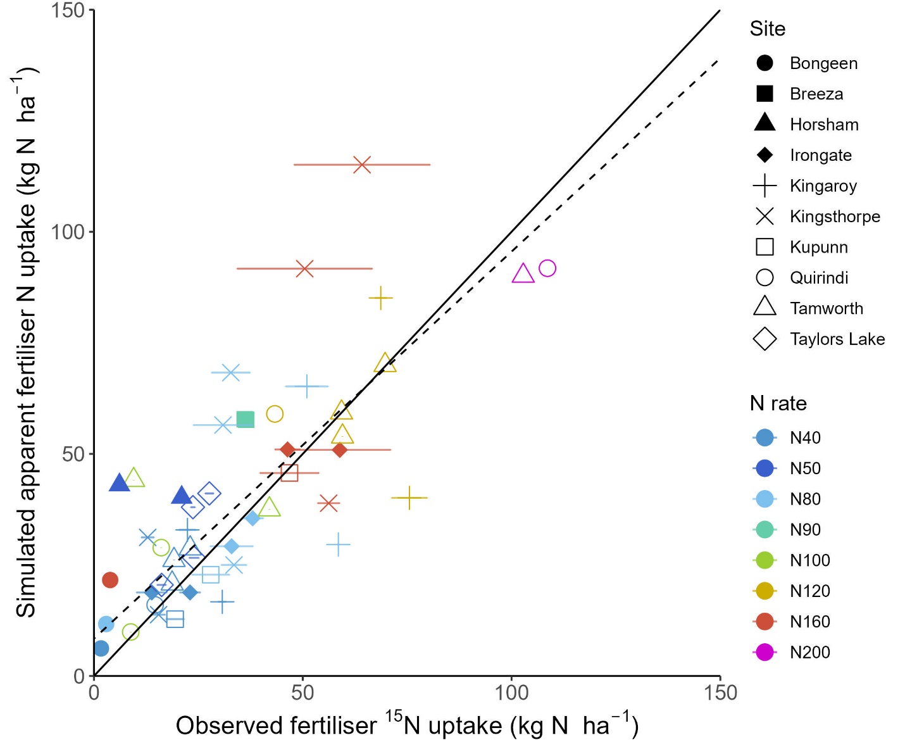
Figure S5 APSIM simulated versus observed fertiliser N uptake at harvest across different sorghum and wheat sites and N rates in eastern Australia after conventional calibration. The solid line represents the 1:1 relationship, while the dashed line represents the least squares regression fitted to the complete data set. Horizontal error bars indicate standard errors in the observed values

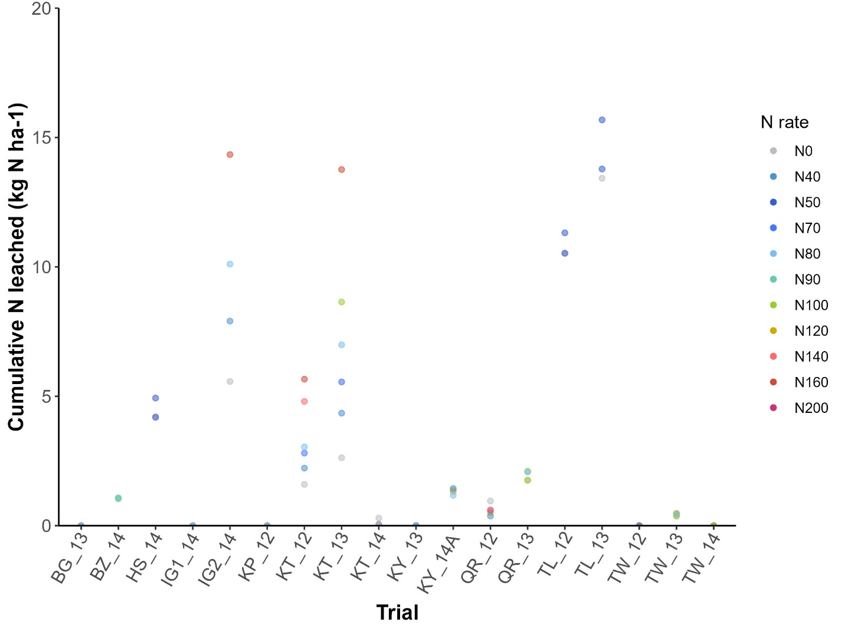
Figure S6 APSIM simulated cumulative N leached at harvest across different sorghum and wheat sites and N rates in eastern Australia after the conventional setup
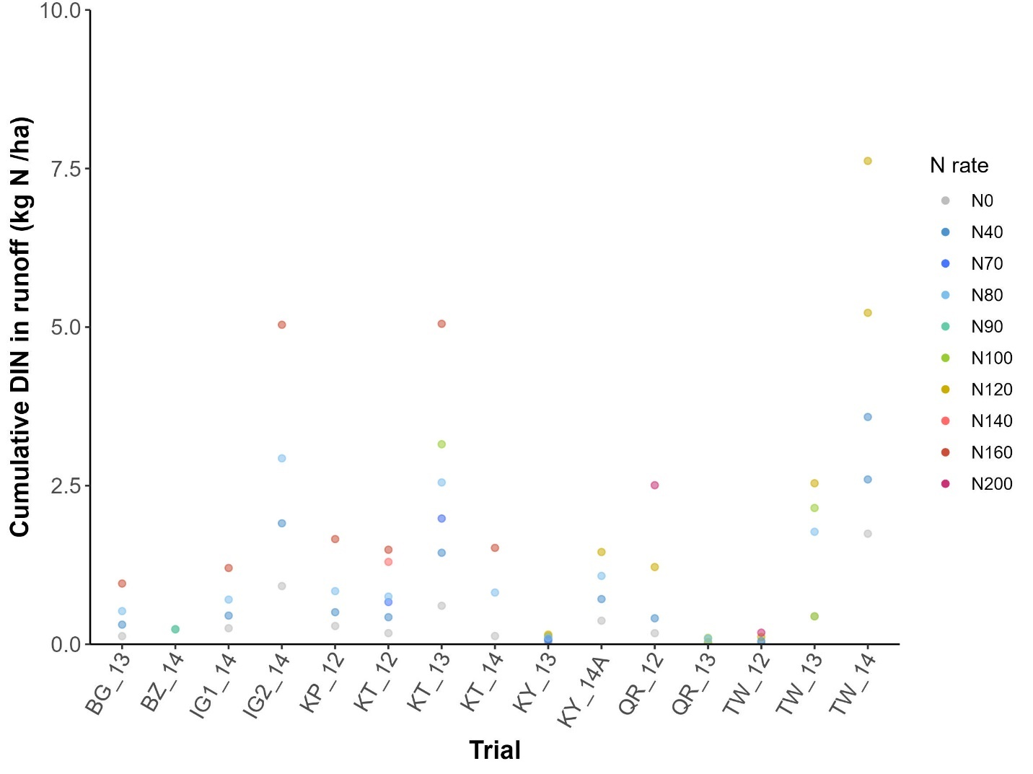
Figure S7 APSIM simulated cumulative N leached at harvest across different sorghum and wheat sites and N rates in eastern Australia after the conventional setup

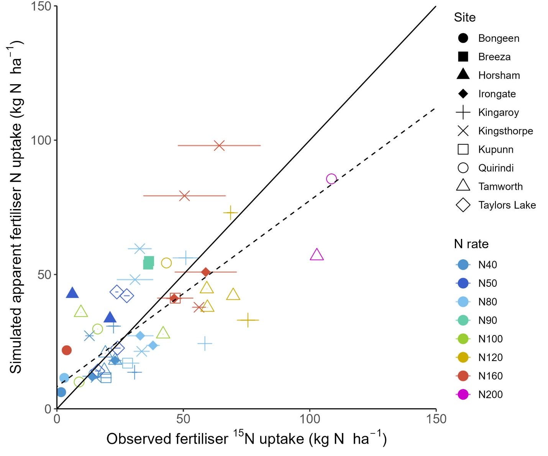
Figure S8 APSIM simulated versus observed fertiliser N uptake at harvest across different sorghum and wheat sites and N rates in eastern Australia after improved calibration. The solid line represents the 1:1 relationship, while the dashed line represents the least squares regression fitted to the complete data set. Horizontal error bars indicate standard errors in the observed values

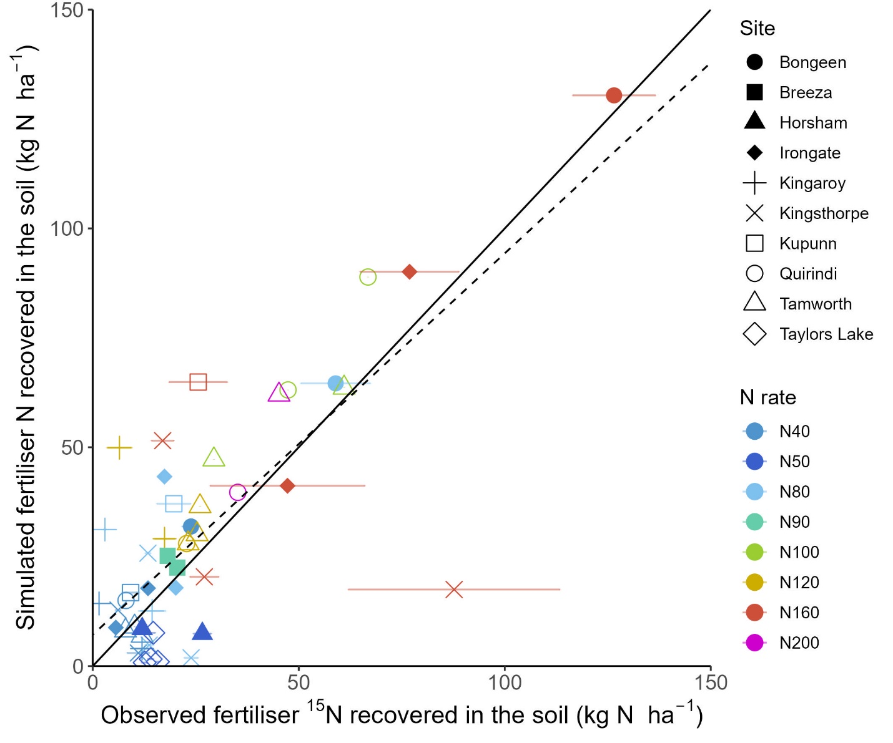
Figure S9 APSIM simulated versus observed residual fertiliser N in the soil at harvest across different sorghum and wheat sites and N rates in eastern Australia after improved calibration. The solid line represents the 1:1 relationship, while the dashed line represents the least squares regression fitted to the complete data set. Horizontal error bars indicate standard errors in the observed values

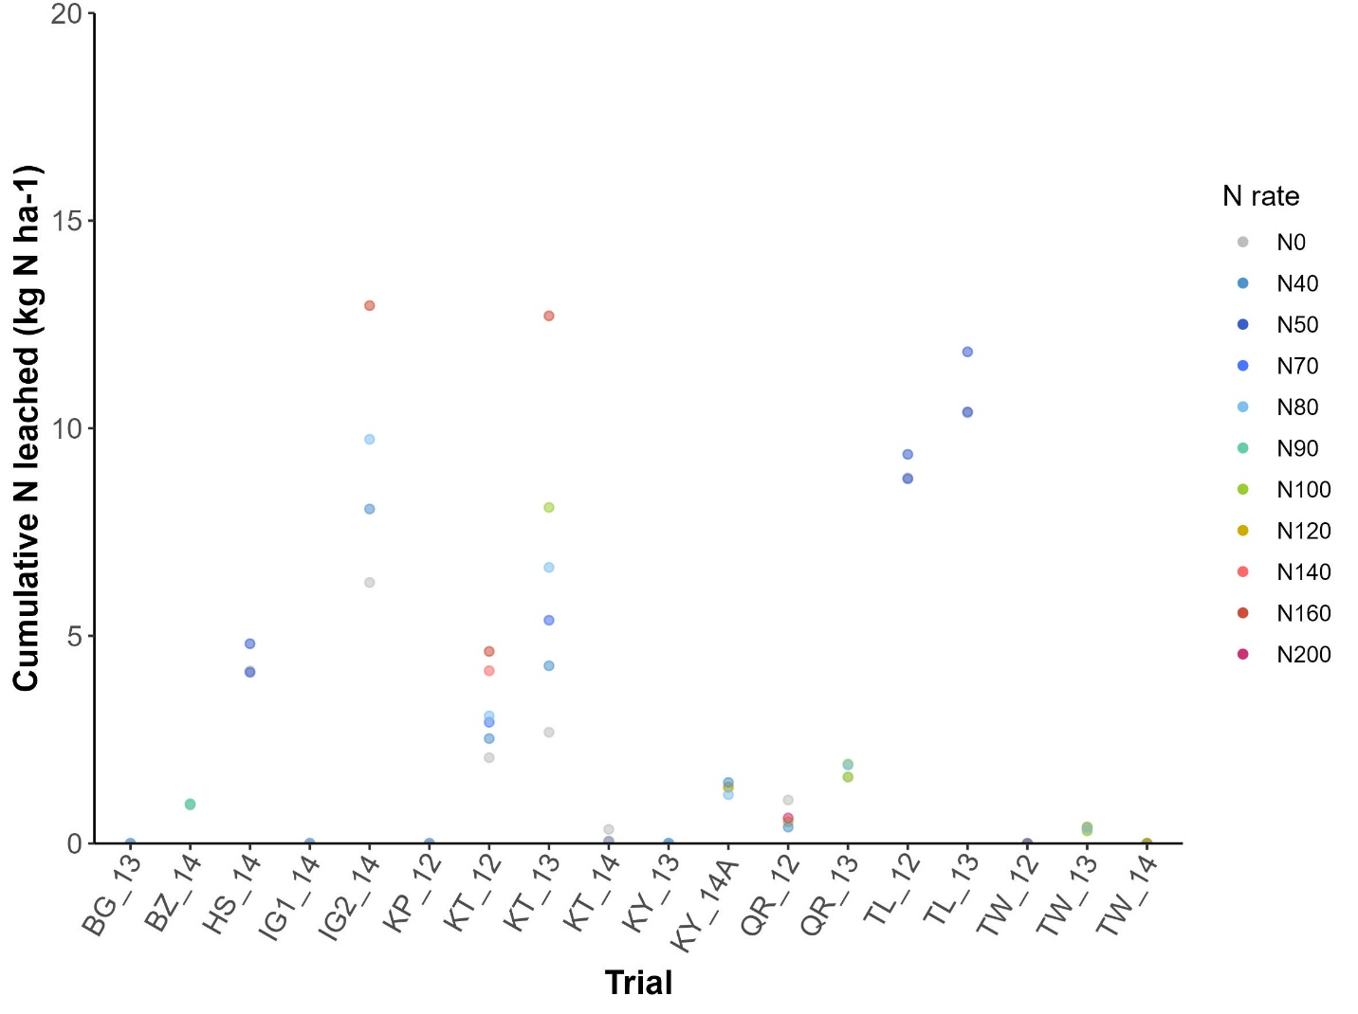
Figure S10 APSIM simulated cumulative N leached at harvest across different sorghum and wheat sites and N rates in eastern Australia after the improved calibration
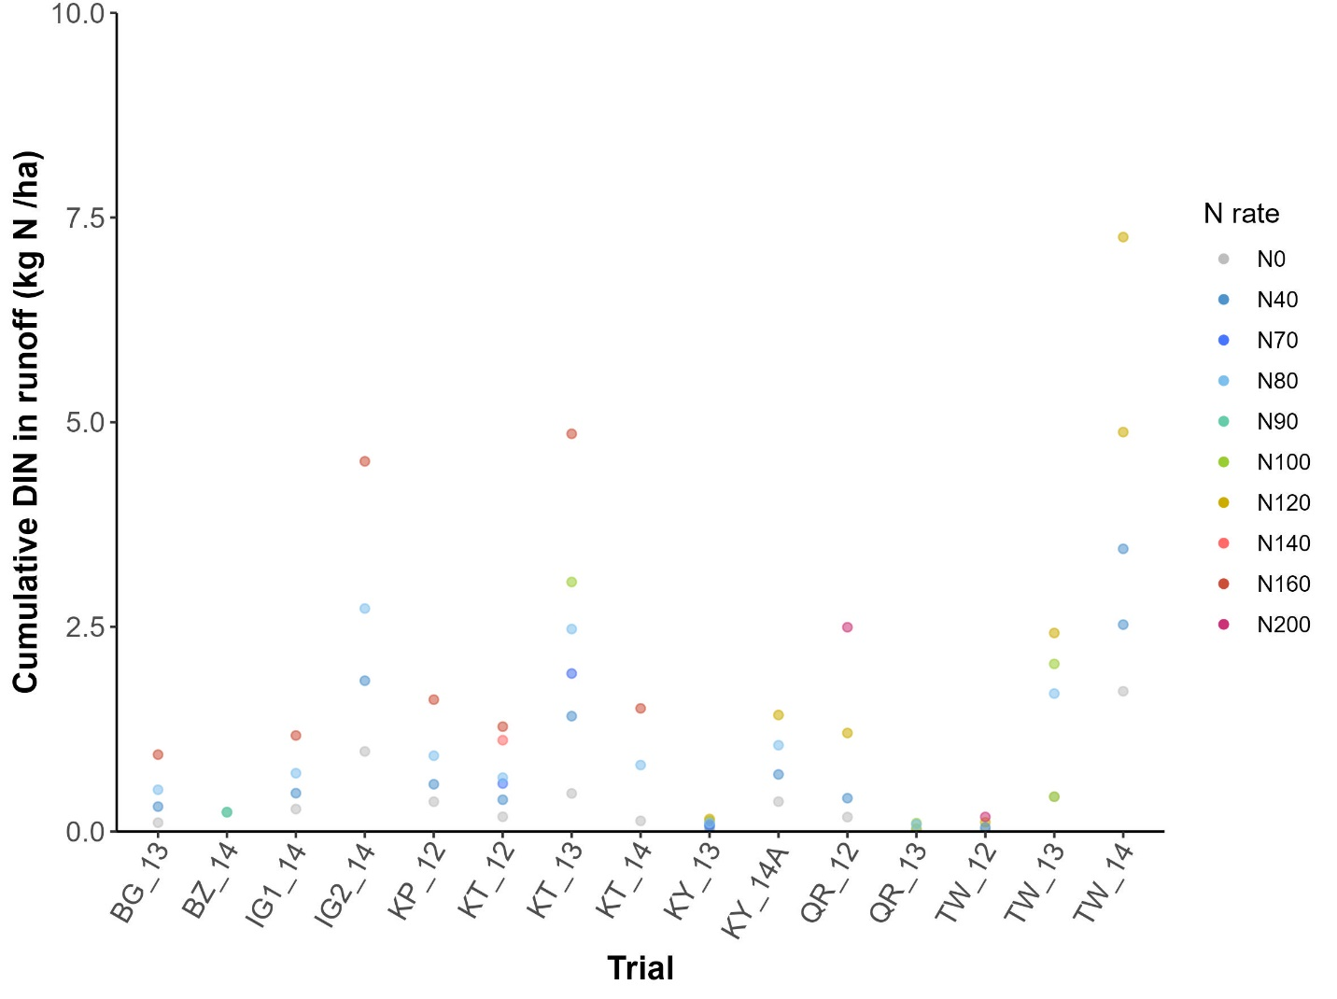
Figure S11 APSIM simulated cumulative N loss via runoff at harvest across different sorghum and wheat sites and N rates in eastern Australia after the improved calibration

Table S1 APSIM inputs for the topsoil layer after the conventional calibration at each of the sorghum and wheat trials in eastern Australia
Trial | SAT | DUL | LL15 | SWCON | CN ratio | FBiom | FInert
BG_13 | 0.65 | 0.54 | 0.23 | 0.3 | 17.6 | 0.034 | 0.40
IG1_14 | 0.65 | 0.54 | 0.23 | 0.3 | 12.9 | 0.039 | 0.60
IG2_14 | 0.65 | 0.54 | 0.23 | 0.3 | 13.8 | 0.037 | 0.30
KY_13 | 0.45 | 0.35 | 0.20 | 0.5 | 11.6 | 0.049 | 0.50
KY_14A | 0.45 | 0.35 | 0.20 | 0.5 | 13.4 | 0.041 | 0.40
KT_12 | 0.64 | 0.48 | 0.28 | 0.3 | 12.0 | 0.062 | 0.30
KT_13 | 0.64 | 0.48 | 0.28 | 0.3 | 13.8 | 0.052 | 0.40
KT_14 | 0.64 | 0.48 | 0.28 | 0.3 | 14.2 | 0.048 | 0.40
KP_12 | 0.55 | 0.39 | 0.21 | 0.3 | 12.0 | 0.032 | 0.40
QR_12 | 0.59 | 0.54 | 0.30 | 0.3 | 12.0 | 0.058 | 0.60
QR_13 | 0.59 | 0.54 | 0.30 | 0.3 | 12.0 | 0.050 | 0.40
TW_12 | 0.53 | 0.37 | 0.20 | 0.3 | 11.2 | 0.065 | 0.50
TW_13 | 0.53 | 0.37 | 0.20 | 0.3 | 11.2 | 0.065 | 0.60
TW_14 | 0.53 | 0.37 | 0.20 | 0.3 | 11.2 | 0.062 | 0.30
BZ_14 | 0.57 | 0.48 | 0.27 | 0.3 | 12.0 | 0.051 | 0.30
TL_12 | 0.57 | 0.52 | 0.21 | 0.3 | 11.4 | 0.065 | 0.40
TL_13 | 0.57 | 0.52 | 0.21 | 0.3 | 10.8 | 0.075 | 0.40
HS_14 | 0.55 | 0.47 | 0.20 | 0.3 | 11.8 | 0.078 | 0.40

Table S2 Model evaluation metrics (RMSE and nRMSE) at each of sorghum and wheat trials in eastern Australia for daily soil temperature, water content, NH₄⁺ content and NO₃– content dynamics in the topsoil simulated in APSIM with conventional calibration. Blank cell indicates that model evaluation metrics could not be calculated due to the lack of observed data.
 | Soil temperature (°C) |  | Soil water content (%) |  | Soil NH₄⁺ (kg N ha⁻¹) |  | Soil NO₃– (kg N ha⁻¹)
Trial | RMSE | nRMSE (%) | RMSE | nRMSE (%) | RMSE | nRMSE (%) | RMSE | nRMSE (%)
BG_13 | 3.4 | 12.8 | 7.4 | 25.7 | 102.0 | 161.4 | 37.3 | 56.6
IG1_14
IG2_14 |  |  | 13.6 | 31.2 | 275.1 | 156.3 | 26.7 | 69.7
KY_13 | 4.7 | 22.2 | 4.2 | 12.7
KY_14A | 2.5 | 9.5 | 11.0 | 47.7 | 52.8 | 195.6 | 25.8 | 102.9
KT_12 | 3.8 | 16.9 | 9.1 | 21.6 | 12.0 | 149.9 | 8.7 | 323.7
KT_13 | 4.9 | 20.0 | 9.6 | 20.6 | 45.4 | 138.9 | 42.5 | 134.2
KT_14
KP_12 |  |  | 4.4 | 13.9 | 10.1 | 120.3 | 16.8 | 129.5
QR_12 | 6.0 | 27.0 | 5.9 | 16.2 | 20.9 | 113.8 | 9.0 | 71.7
QR_13 | 4.7 | 18.1 | 5.9 | 11.6 | 22.4 | 108.9 | 26.0 | 74.6
TW_12 |  |  | 6.3 | 15.6 | 26.8 | 201.8 | 14.8 | 153.4
TW_13 | 3.2 | 13.3 | 2.6 | 9.5 | 30.2 | 189.5 | 18.4 | 88.4
TW_14 | 3.7 | 14.3 | 9.1 | 30.2 | 5.9 | 130.0 | 14.7 | 164.3
BZ_14 | 5.3 | 20.1 | 8.9 | 20.1 | 14.8 | 134.6 | 8.3 | 52.2
TL_12 | 4.9 | 37.4 | 6.0 | 17.5 | 19.6 | 356.1 | 10.8 | 126.2
TL_13 | 3.8 | 28.1 | 8.3 | 21.5 | 7.5 | 116.7 | 5.7 | 104.1
HS_14 | 5.1 | 48.2 | 8.9 | 24.3 | 12.5 | 352.0 | 9.9 | 335.0

Table S3 Model evaluation metrics (RMSE and nRMSE) at each of sorghum and wheat trials in eastern Australia for daily soil temperature, water content, NH₄⁺ content and NO₃– content dynamics in the topsoil simulated in APSIM after the improved calibration. Blank cell indicates that model evaluation metrics could not be calculated due to the lack of observed data.
 | Soil temperature (°C) |  | Soil water content (%) |  | Soil NH₄⁺ (kg N ha⁻¹) |  | Soil NO₃– (kg N ha⁻¹)
Trial | RMSE | nRMSE (%) | RMSE | nRMSE (%) | RMSE | nRMSE (%) | RMSE | nRMSE (%)
BG_13 | 3.4 | 12.8 | 7.4 | 25.8 | 101.9 | 161.3 | 37.3 | 56.6
IG1_14
IG2_14 |  |  | 13.6 | 31.2 | 275.0 | 156.3 | 26.8 | 70.0
KY_13 | 4.7 | 22.2 | 4.3 | 13.1
KY_14A | 2.5 | 9.5 | 11.0 | 47.7 | 52.7 | 195.2 | 25.5 | 102.0
KT_12 | 3.8 | 16.9 | 9.2 | 21.7 | 11.9 | 149.2 | 8.9 | 331.7
KT_13 | 4.9 | 20.0 | 9.6 | 20.6 | 45.3 | 138.8 | 42.6 | 134.4
KT_14
KP_12 |  |  | 4.4 | 13.7 | 10.0 | 119.4 | 16.5 | 126.8
QR_12 | 6.0 | 27.0 | 6.3 | 16.7 | 20.8 | 113.4 | 9.0 | 71.4
QR_13 | 4.7 | 18.2 | 5.6 | 10.9 | 22.3 | 108.7 | 25.6 | 73.5
TW_12 |  |  | 6.5 | 16.0 | 26.7 | 201.3 | 12.9 | 134.2
TW_13 | 3.2 | 13.3 | 2.6 | 9.4 | 30.1 | 189.1 | 18.9 | 90.7
TW_14 | 3.7 | 14.3 | 9.1 | 29.9 | 5.8 | 128.3 | 13.9 | 154.9
BZ_14 | 5.3 | 20.1 | 8.8 | 20.0 | 14.5 | 132.6 | 8.1 | 51.4
TL_12 | 5.0 | 38.2 | 6.4 | 18.6 | 19.5 | 354.5 | 10.5 | 122.4
TL_13 | 3.8 | 28.2 | 8.9 | 22.9 | 7.4 | 115.9 | 5.4 | 99.2
HS_14 | 5.1 | 48.2 | 8.7 | 24.0 | 12.5 | 352.4 | 9.5 | 320.4

