SUPPLEMENTARY MATERIALS
Table S 1 Nitrogen recovery efficiency and agronomic efficiency from the wheat site
 | NREt¶ (soft dough) | NREt (harvest) | NREu§  (soft dough) | NREu  (harvest)
Treatment | 0.790 | 0.844 | 0.738 | 0.206
Rate | 0.853 | 0.009 * | 0.846 | 0.294
Treatment:rate | 0.943 | 0.501 | 0.935 | 0.142
¶NRE_{t}, Nitrogen recovery efficiency of total N inputs.
§NRE_{u}, Nitrogen recovery efficiency of urea.
*effect only in trt=no compost, due to the combination 168+112 having higher kgN/ha. 0+0 and 168+112 have similar %N, this is due to 168+112 having higher straw yield.

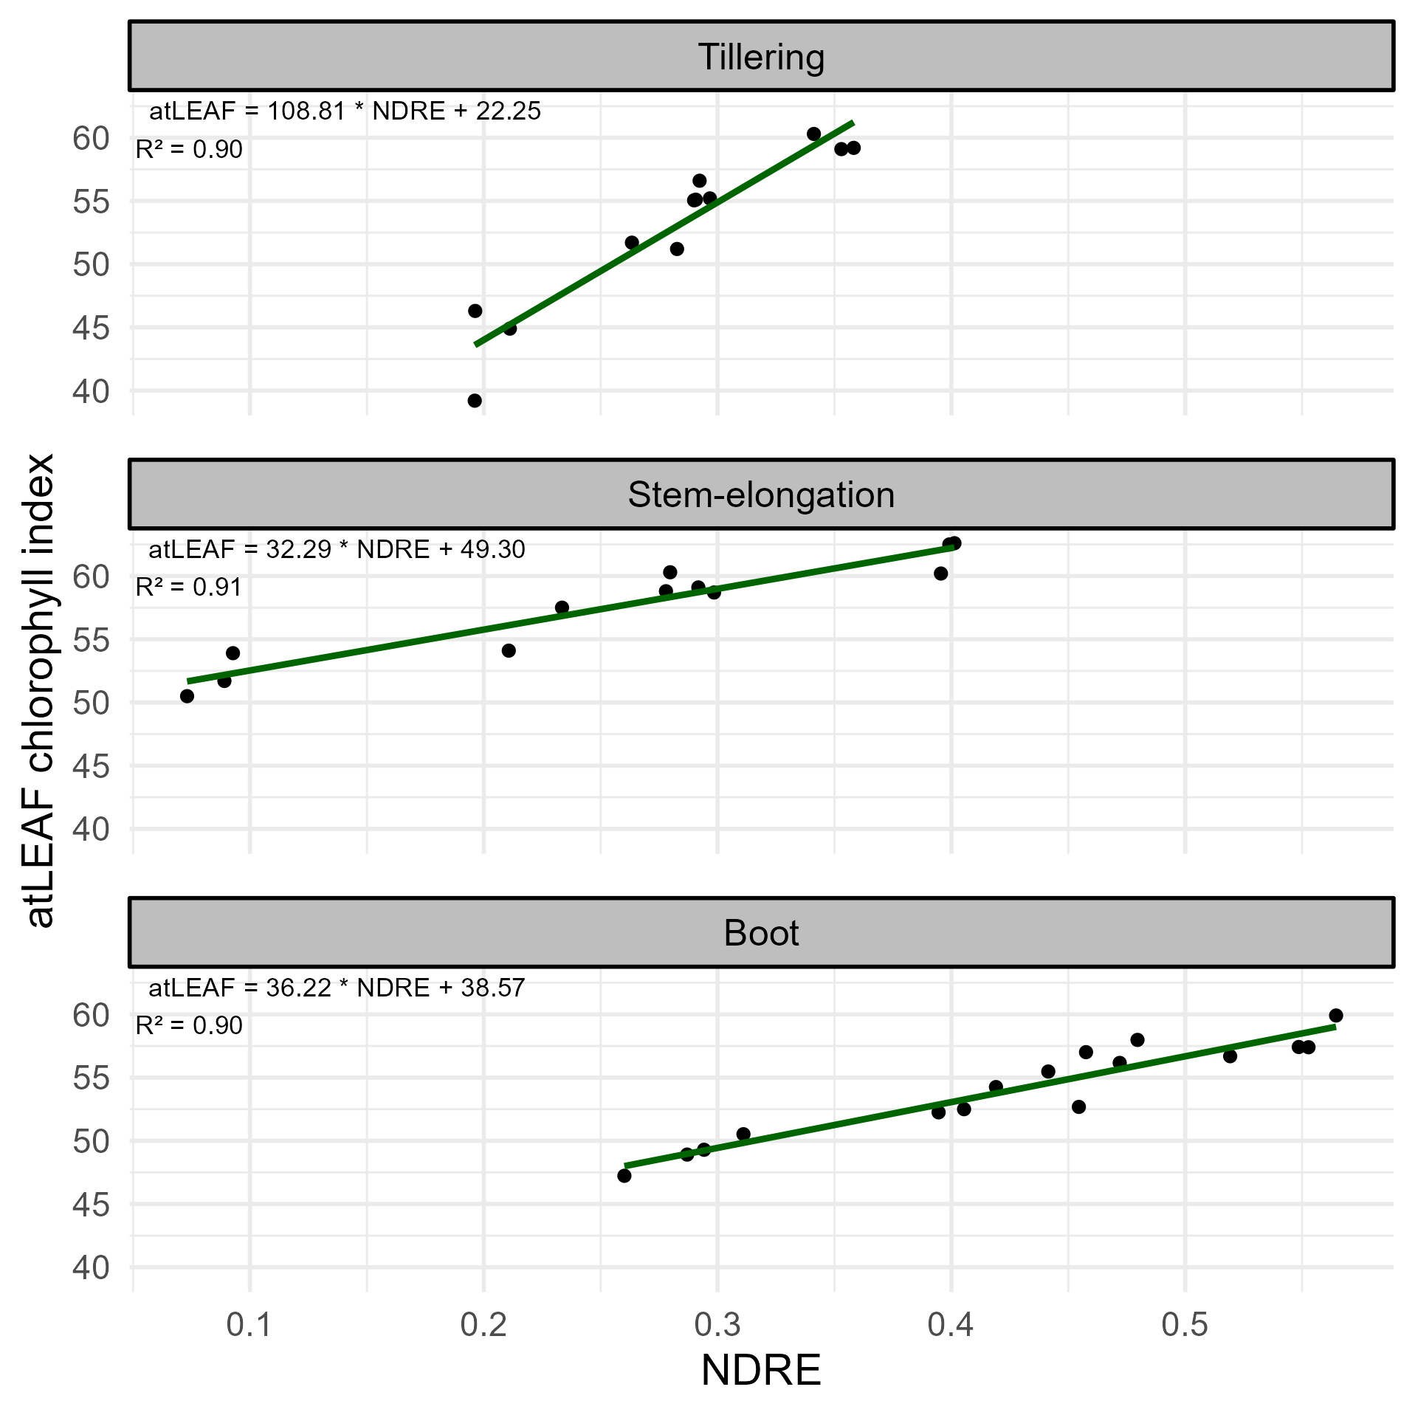Figure S 1. Relationship between Normalized Difference Red Edge Index (NDRE) and atLEAF chlorophyll index at three dates at the triticale site, as described by linear regression models.
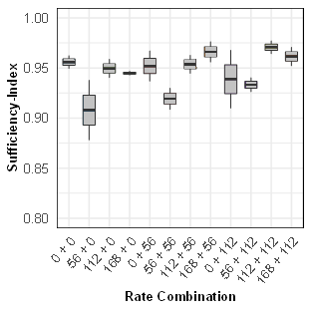
a b
Figure S 2. The effect of organic amendment at different nitrogen rates on Sufficiency-Index measured at stem elongation (a) at the triticale site (b) at the wheat site.
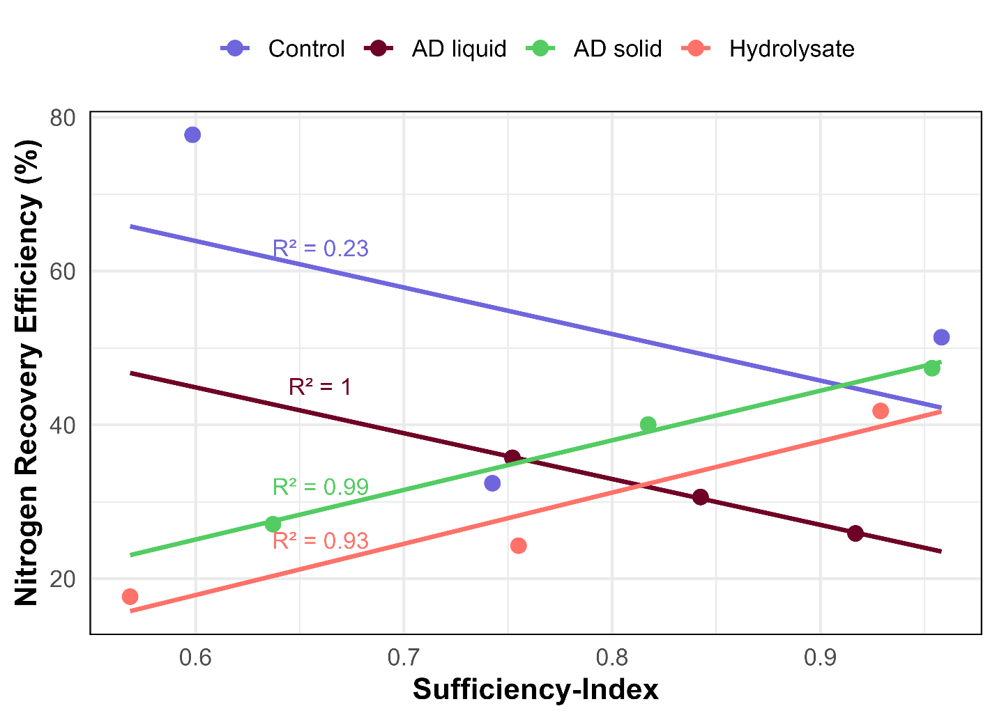
Figure S 3. Relationship between Nitrogen recovery efficiency of total nitrogen (NREt) of total above ground biomass at grain harvest and Sufficiency-Index at the triticale site, as described by linear regression models.

