Supplementary Information

Soil carbon and nitrogen emissions under farmer managed conservation agriculture in Zimbabwe

Johannes Meyer zu Drewer^{1,2}, Christian Thierfelder³ and Andreas Buerkert^{4*}

1. Tropical Plant Production and Agricultural System Modelling (TROPAGS), University of Göttingen, Grisebachstraße 6, D-37077 Göttingen, Germany
2. Ithaka Institute for Carbon Strategies, Arbaz, Switzerland (Email: mzd@ithaka-institut.org)
3. International Maize and Wheat Improvement Centre (CIMMYT), P.O. Box MP 163, Harare, Zimbabwe (Email: c.thierfelder@cgiar.org)
4. Organic Plant Production and Agroecosystems Research in the Tropics and Subtropics (OPATS), University of Kassel, Steinstr. 19, D-37213 Witzenhausen, Germany (Email: buerkert@uni-kassel.de)

Content
SI.1 Location, soil typology, and climate of the study site 3
SI.2 Agronomic management in demonstration plots 11
SI.3 INNOVA multi-gas meter programming, regression example, and quality control procedure 12
SI.4 Soil cabron and nitrogen ratios and distributions 14
SI.5 Soil particulate organic matter and mineral associated organic matter framework 16
SI.6 Corelation analysis of soil fractions, soil emissions, and micro climatic data 17
SI.7 Python script for raw emission data curation and aggregation 20

SI.1 Location, soil typology, and climate of the study site

Table S1: Location and soil properties of the four selected on-farm trials on high fertility Luvisols in Zimbabwe
# Plot | #1 |  | #2 |  | #3 |  | #4
Established | 2013 |  | 2005 |  | 2008 |  | 2005
GPS coordinates | 17°11'24.9"S  31°29'38.8"E |  | 17°11′25.08″S 31°29′33.48″E |  | 17°11′23.23″S 31°29′29.71″E |  | 17°11'38.4"S 31°29'27.2"E
Management | CONV | CA | CONV | CA | CONV | CA | CONV | CA
Bulk density  0-10 cm horizon  (g cm⁻³) | n.a. | n.a. | 1.01 | 1.20 | 1.15 | 1.01 | n.a. | n.a.
Bulk density  10-20 cm horizon  (g cm⁻³) | n.a. | n.a. | 1.19 | 1.19 | 1.01 | 1.01 | n.a. | n.a.
Clay fraction  0-10 cm horizon | n.a.. | n.a. | 32 | 40 | 24 | 41 | n.a.. | n.a.
Silt fraction  0-10 cm horizon | n.a. | n.a. | 17 | 16 | 16 | 20 | n.a. | n.a.
Sand fraction  0-10 cm horizon | n.a. | n.a. | 51 | 44 | 60 | 39 | n.a. | n.a.
Soil pH  0-10 cm horizon | n.a.. | n.a. | 6.12 | 6.02 | 6.84 | 6.01 | n.a.. | n.a.
CONV = conventionally managed plots, CA = plots managed according to conservation agriculture principles.

Table S2: Locations and soil properties of the four selected on-farm trials on low fertility Arenosols in Zimbabwe
Plot | #1 |  | #2 |  | #3 |  | #4
Established | 2005 |  | 2005 |  | 2018 |  | 2005
GPS coordinates | 16°58′30.33″S 31°25′12.51″E |  | 16°58′43.39″S 31°25′16.17″E |  | 16°59′06.92″S 31°25′02.03″E |  | 16°59′27.1″S 31°24′54.56″E
Management | CONV | CA | CONV | CA | CONV | CA | CONV | CA
Bulk density  0-10 cm horizon  (g cm⁻³) | 1.38 | 1.27 | 1.28 | 1.18 | n.a. | n.a. | 1.31 | 1.30
Bulk density  10-20 cm horizon  (g cm⁻³) | 1.31 | 1.43 | 1.40 | 1.30 | n.a. | n.a. | 1.24 | 1.28
Clay fraction  0-10 cm horizon | 4 | 4 | 6 | 3 | n.a.. | n.a. | 3 | 4
Silt fraction  0-10 cm horizon | 7 | 7 | 0 | 9 | n.a. | n.a. | 4 | 18
Sand fraction  0-10 cm horizon | 89 | 89 | 94 | 88 | n.a. | n.a. | 93 | 78
Soil pH  0-10 cm horizon | 5.17 | 5.37 | 5.29 | 5.45 | n.a.. | n.a. | 4.83 | 4.98
CONV = conventionally managed plots, CA = plots managed according to conservation agriculture principles.

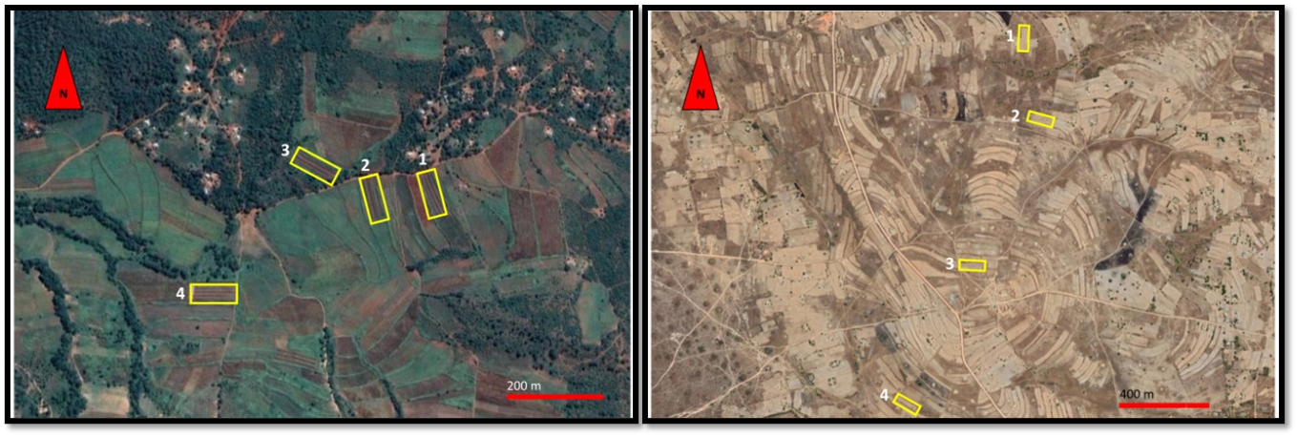
Figure S1: Left panel: Aerial photograph of the Luvisol-region (high fertility) in Zimbabwe with selected on-farm trials indicated in yellow. Right panel: Aerial photograph of the Arenosol region (low fertility) in Zimbabwe with selected on-farm trials indicated in yellow. Material modified form Google Earth (2021). Note that the pictures were taken at different seasons and from different altitudes.

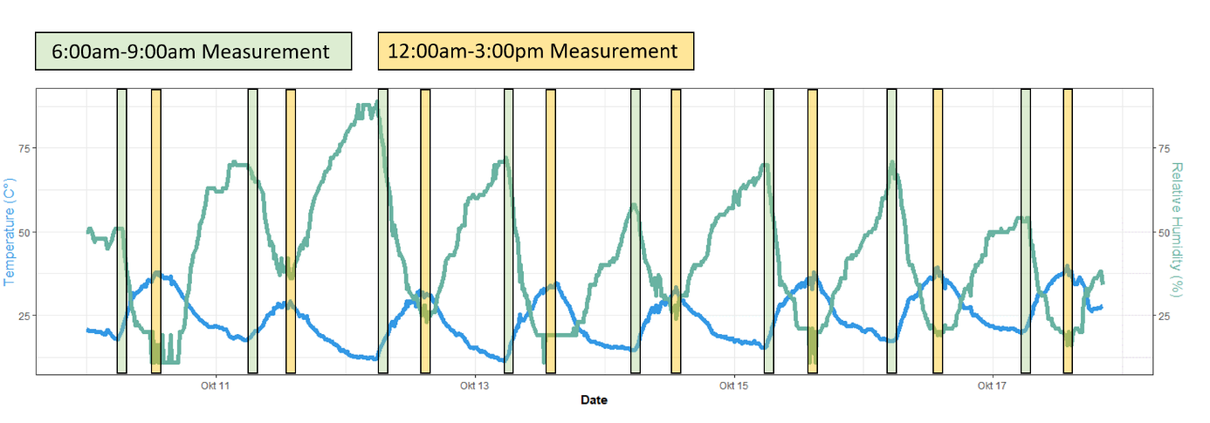
Figure S2: Daily measurement windows to capture diurnal temperature differences. Green= 6:00 am- 9:00 am (cold/ morning hours); Yellow= 12:00 am- 03:00 pm (warm/ afternoon hours) Exemplarily plotted into climate data records of the Madziwa dry-season measurement series. Blue line= Daily temperature fluctuations in °C. Green line= Daily fluctuations in relative air humidity in %. Climate data was recorded continuously in 10 min intervals.

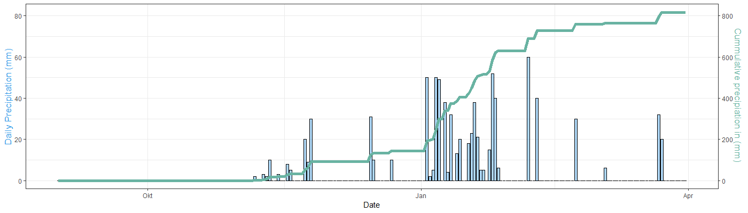
Figure S3: Shamva (Luvisol region) in Zimbabwe: Daily and cumulative rainfall September 2021 – March 2022. Blue bar= daily precipitation in mm. green line= cumulative seasonal precipitation in mm. Records were taken daily with onsite rain gauges. Cumulative seasonal rainfall: 817 mm.

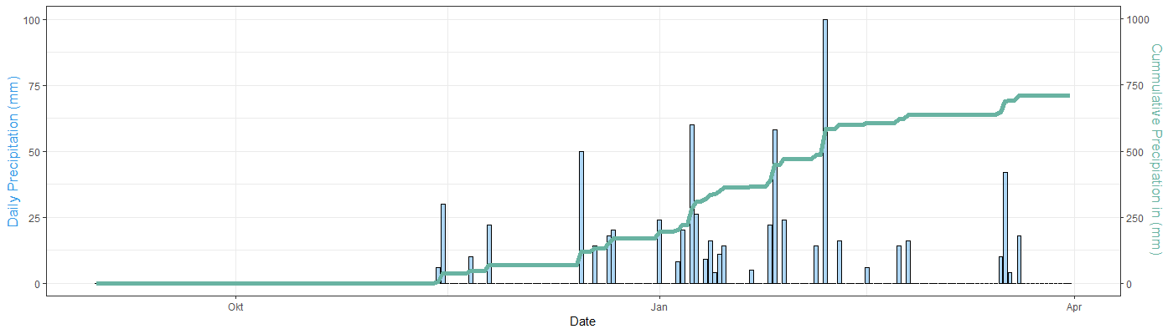
Figure S4: Madziwa (Arenosol region) in Zimbabwe: Daily and cumulative rainfall September 2021 – March 2022. Blue bar= daily precipitation in mm. green line= cumulative seasonal precipitation in mm. Records were taken daily with onsite rain gauges. Cumulative seasonal rainfall: 711 mm.

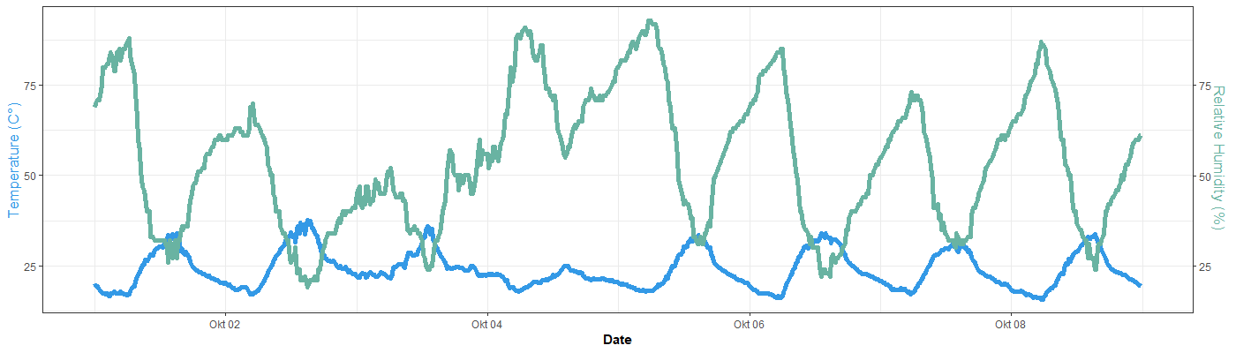
Figure S5: Climate-data-logger records: Blue line= Daily temperature fluctuations in °C. Green line= Daily fluctuations in relative air humidity in %. Climate data was recorded continuously in 10 min intervals during the dry season emission measurements in the Luvisol region of Zimbabwe. Mean temperature: 23.9 °C and mean relative humidity: 54.3 %.

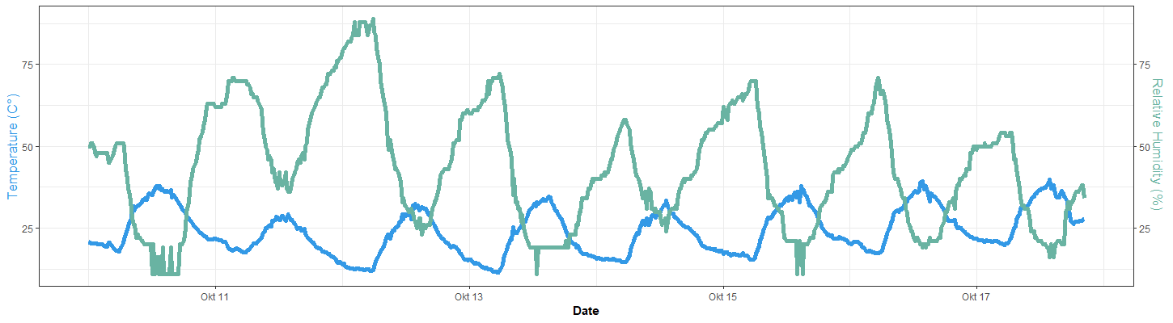
Figure S6: Climate-data-logger records: Blue line= Daily temperature fluctuations in °C. Green line= Daily fluctuations in relative air humidity in %. Climate data was recorded continuously in 10 min intervals during the dry season emission measurements in the Arenosol region of Zimbabwe. Mean temperature: 24.1 °C and mean relative humidity: 43.4 %.

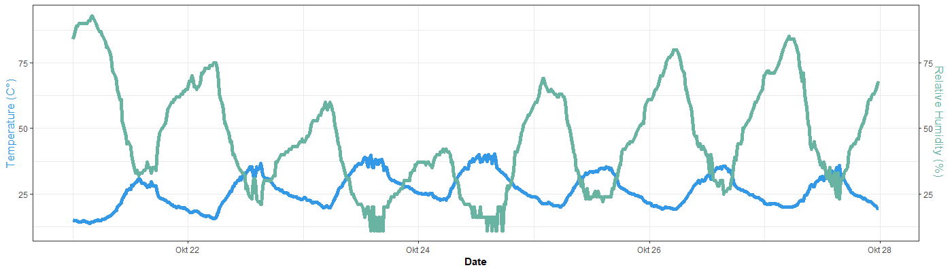
Figure S7: Climate-data-logger records: Blue line= Daily temperature fluctuations in °C. Green line= Daily fluctuations in relative air humidity in %. Climate data was recorded continuously in 10 min intervals during the wet season emission measurements in the Luvisol region of Zimbabwe. Mean temperature: 26.2 °C and mean relative humidity: 46.5 %.

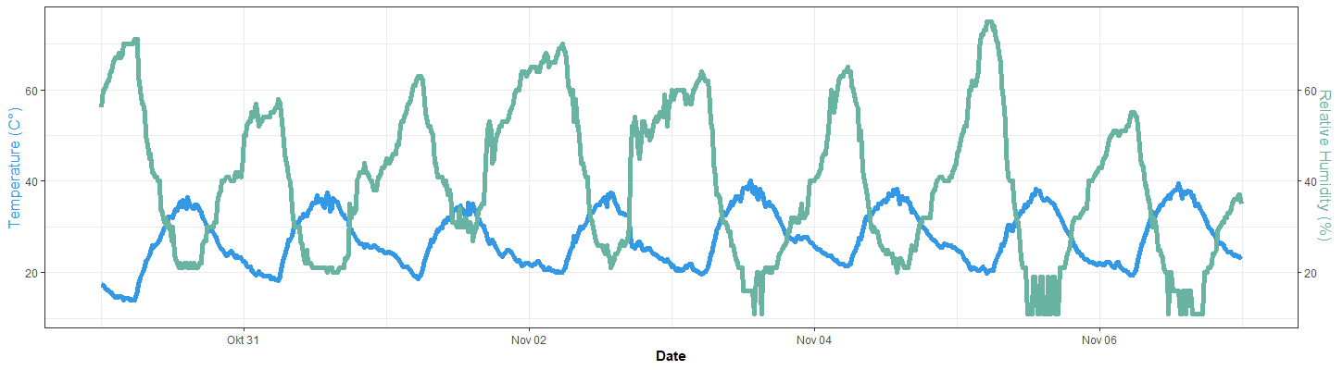
Figure S8: Climate-data-logger records: Blue line= Daily temperature fluctuations in °C. Green line= Daily fluctuations in relative air humidity in %. Climate data was recorded continuously in 10 min intervals during the wet season emission measurements in the Arenosol region of Zimbabwe. Mean temperature: 27.5 °C and mean relative humidity:40.1 %.

SI.2 Agronomic management in the on-farm trials

Table S3: Agronomic management in the on-farm trials of Zimbabwe
Management aspect | Location
 | Luvisol region | Arenosol region
Maize planting density | 90 cm between rows, 50 cm between planting stations within a row. Each station with three seeds, thinned out to two seedlings after emergence. In DS treatment no stations are deployed but continues line planting. Plant population: 44.000 ha⁻¹. | 90 cm between rows, 50 cm between planting stations within a row. Each station with three seeds, thinned out to two seedlings after emergence. In DS treatment no stations are deployed but continues line planting. Plant population: 44.000 ha⁻¹
Legume planting density | Soybean, variety Safari, 45 cm between rows, 5cm between plants. Planting density: 444.444 ha⁻¹.  A crop rotation with legumes was included in both CONV and CA treatments. | Cowpea (bushy type), variety CBC2, planted at 45 cm row distance and 50 cm between planting stations within a row. Each station with three seeds, thinned out to two seedlings after emergence. Plant population: 32.000 ha⁻¹. A crop rotation with legumes was included in both CONV and CA treatments.
Basal fertilization | 165 kg ha⁻¹ Compound D at seeding for Maize  165 kg ha⁻¹ Soy blend at seeding for Soy | 165 kg ha⁻¹ Compound D at seeding.
Top-dressing fertilization | 200 kg ha⁻¹ Ammonium nitrate as split application in week 4 and 7 after planting, for Maize. | 200 kg ha⁻¹ Ammonium nitrate as split application in week 4 and 7 after planting, for Maize.
Weed control | Manually in CONV treatment, chemically for Maize plots in CA treatments using 2.5 L ha⁻¹ Glyphosate and 3.6 L ha⁻¹ Atrazine. | Manually in all treatments.

SI.3 INNOVA multi-gas meter programming, regression example and quality control procedure
Tabel S4: Programming and settings of the INNOVA multi-gas meter used for field monitoring
Sampling Index |  | Monitoring Task
Flushing Mode | Auto | Sample Continuously | Yes
Length of Tube | 120 cm | Pre-set Period | No
Actual Air pressure (Luvisol region) | 885 mBar | Compensate for Water vapour | Yes
Actual Air pressure (Arenosol region)) | 888 mBar | Compensate for Cross Interference | Yes
Normalized Temperature | 25 °C | Ammonia | Yes
 |  | Carbon dioxide | Yes
 |  | Nitrous oxide | Yes
 |  | Methane | No
 |  | Water vapour | Yes
Sampling Index and Monitoring Task refer to the two classes of settings to be specified before operation of the INNOVA multi-gas meter. The sensor for methane was not functioning correctly and was thus deactivated.

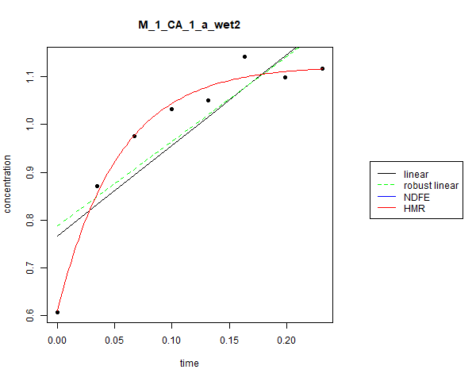
Figure S9: Exemplary regression analysis of gas measurement, as produced by R package gasflux. Sample ID: M_1_CA_1_a_wet2 = Madziva (Arenosol region of Zimbabwe), on farm-trial (replicate) 1, conservation agriculture, measurement chamber 1/5, in the afternoon (warm hours), 2nd measurement under wet-season conditions.

Additional Text S3

Quality control of regression analysis and associated gas flux rate
The automatically generated regressions and associated gas fluxes were subject to quality control. Considered were regressions via robust-linear method and a saturation curve via HMR-method only. All regressions with a p-value >/= 0.1 were rejected automatically. Of the remaining, the most appropriate type of regression was selected according to the smaller p-value associated with the regression curve. Further rejected were CO₂ measurements with negative flux rates. Such values were deemed unrealistic, due to the higher CO₂ concentration in the soil as compared to the atmosphere, thus CO₂ effluxes are the baseline condition in relevant land use classes (Upadhyay et al., 2021). Negative fluxes in N₂O and NH₃ measurements were not rejected, as soils can also act as a sink towards this N-derived gases (Chapuis-lardy et al., 2007; Domeignoz-Horta et al., 2016).
After deployment of the above decision criteria, the share of “valid” measurements was assessed in percent (%). If for one gas, in either dry or wet season environmental conditions, the share of valid measurements fell below 75 % the complete treatment was excluded from further analysis. This was the case for the dry-season measurements of N₂O.
If the share of valid measurements was above 75 %, a two-step averaging process was executed. Firstly, the available spatial pseudo-replicates (5 chambers in each plot) were averaged. Secondly, the temporal pseudo-replicates (two repeated measurements in each plot) were averaged. Thus, every true replicate (CA or CONV plot under given environmental condition e.g., dry season in could hours) was calculated as a robust mean of n=10 single measurements.
References
Chapuis-lardy, L., Wrage, N., Metay, A., Chotte, J. L., & Bernoux, M. (2007). Soils, a sink for N2O? A review. Global Change Biology, 13(1), 1–17. https://doi.org/10.1111/J.1365-2486.2006.01280.X
Domeignoz-Horta, L. A., Putz, M., Spor, A., Bru, D., Breuil, M. C., Hallin, S., & Philippot, L. (2016). Non-denitrifying nitrous oxide-reducing bacteria - An effective N2O sink in soil. Soil Biology and Biochemistry, 103, 376–379. https://doi.org/10.1016/J.SOILBIO.2016.09.010
Upadhyay, S., Singh, R., Verma, P., & Raghubanshi, A. S. (2021). Spatio-temporal variability in soil CO2 efflux and regulatory physicochemical parameters from the tropical urban natural and anthropogenic land use classes. Journal of Environmental Management, 295, 113141. https://doi.org/10.1016/J.JENVMAN.2021.113141

SI.4 Soil carbon and nitrogen ratios and distributions

Table S5: Soil fractions C:N ratios
Soil horizon | Bulk soil  C:N ratio | POM  C:N ratio | MAOM  C:N ratio
Madziwa CA 0-10 cm | 8.9 | 21.4 | 9.8
Madziwa CA 10-20 cm | 8.5 | 20.0 | 10.0
Madziwa CONV 0-10 cm | 8.3 | 23.0 | 10.1
Madziwa CONV 10-20 cm | 8.6 | 23.9 | 10.2
Location Mean: | 8.6 | 22.1 | 10.0
Shamva CA 0-10 cm | 11.9 | 17.7 | 11.1
Shamva CA 10-20 cm | 12.0 | 20.1 | 11.3
Shamva CONV 0-10 cm | 12.0 | 18.6 | 11.0
Shamva CONV 10-20 cm | 11.8 | 19.5 | 11.1
Location Mean: | 11.9 | 19.0 | 11.1
Mean bulk soil C:N ratio, POM C:N ratio and MAOM C:N ratio by location (Madziwa = Arenosol region, Shamva= Luvisol region of Zimbabwe), sampling depth (0-10 cm / 10-20 cm) and soil management (CA= Conservation agriculture; CONV= Conventionally managed control). Each mean is based on n=4 composite samples analysed. Additionally, in bold, the locations mean over all 4 soil categories based on n=16 composite samples. POM= particulate organic matter, MAOM= mineral associated organic matter.

Figure S10: Relative distribution of total soil organic carbon between particulate organic matetr (POM) and mineral associated organic matter (MAOM) carbon pool (Y-axis); seperated by locations, sampling depth and soil management. CA= Conservation agriculture; CONV= Conventionally managed control. Calculation based on mean shares of POM-Carbon and MAOM-Carbon as fraction of Bulk-Ccarbon. Recoveryrate induced deviations were proportionally normalized to 100 % total using Microsoft Excel. Madziva = Arenosol region, Shamva = Luvison region of Zimbabwe.

Figure S11:
Relative distribution of total soil nitrogen between particulate organic matter (POM) and mineral associated organic matter (MAOM) nitrogen pool (Y-axis); seperated by locations, sampling depth and soil management. CA= Conservation agriculture; CONV= Conventionally managed control. Calculation based on mean shares of POM-nitrogen and MAOM-nitrogen as fraction of bulk-nitrogen. Recoveryrate induced deviations were proportionally normalized to 100 % total using Microsoft Excel. Madziva = Arenosol region, Shamva = Luvison region of Zimbabwe.

SI.5 Soil particulate organic matter and mineral associated organic matter framework

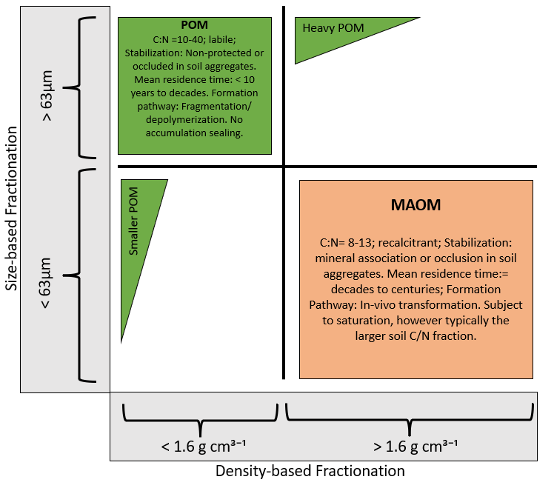
Figure S12: The particulate organic matter (POM) versus mineral associated organic matter (MAOM) fractionation framework. An analysis approch to evaluate quantity and quality of soil-C sequestration. Figure adopted from Lavallee et al. (2020). Fractionation thresholds are given on the X-axis for density-based approaches and at the Y-axis for size-based apporaches. The size of the boxes referes to the relative pool-size relation. Main charateristis of the organic matter fractions are listed in the respective box.

SI.6 Corelation analysis of soil fractions, soil emissions, and micro climatic data

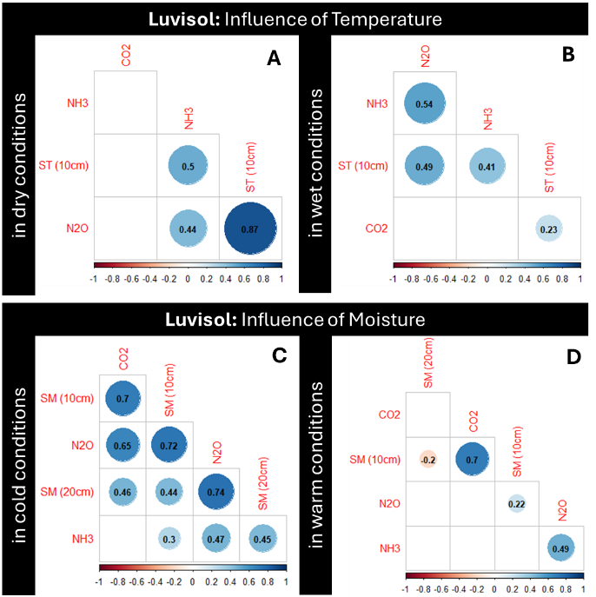
Figure S13: Correlation analysis of environmental factors and soilborne greenhouse gas (GHG) emissions in the Luvisol region of Zimbabwe according to the R corrplot package. Top: influence of soil temperature on soilborne GHG emissions. Bottom: influence of moisture on soilborne GHG emissions. Blue= positive correlation, red= negative correlation, black numbers indicate strength of correlation between -1 (max. negative) and 1 (max positive). ST= Soil temperature; SM= Soil moisture.

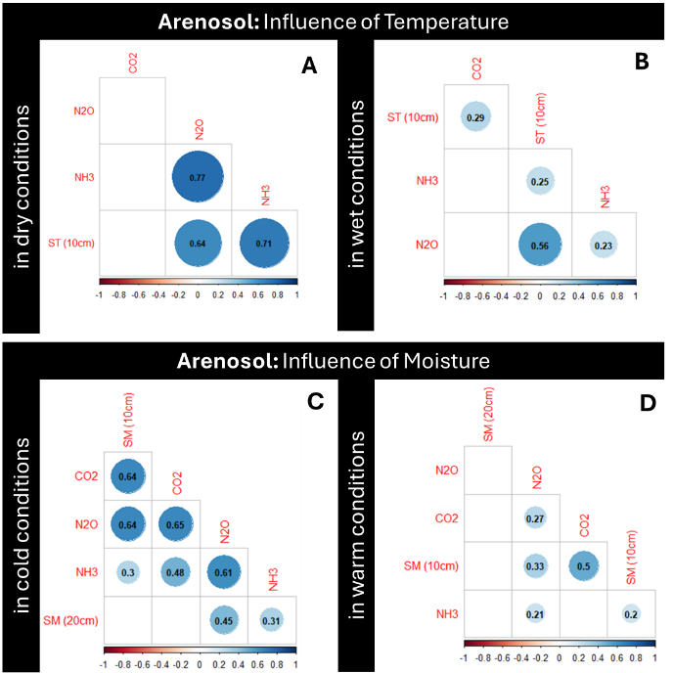
Figure S14: Correlation analysis of environmental factors and soilborne greenhouse gas (GHG) emissions in the Arenosol region of Zimbabwe according to the R corrplot package. Top: influence of soil temperature on soilborne GHG emissions. Bottom: influence of moisture on soilborne GHG emissions. Blue= positive correlation, red= negative correlation, black numbers indicate strength of correlation between -1 (max. negative) and 1 (max positive). ST= Soil temperature; SM= Soil moisture.

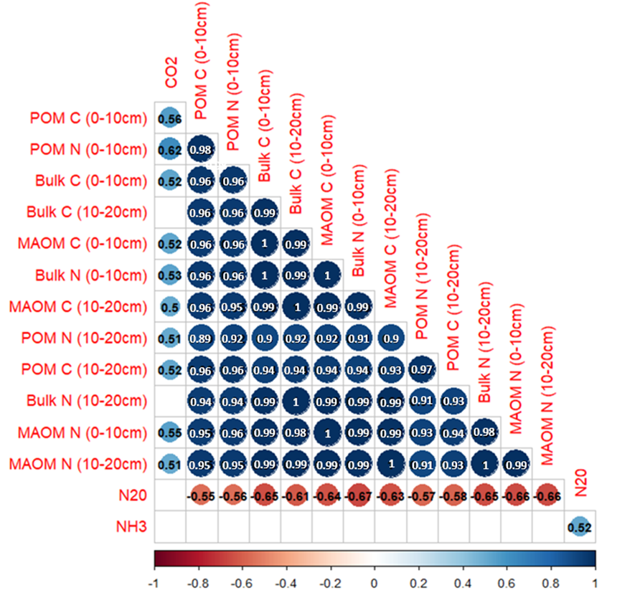
Figure S15: Correlation analysis of soil carbon and nitrogen fractions with soilborne greenhouse gas (GHG) emissions over all study sites in Zimbabwe according to the R corrplot package. Blue= positive correlation, red= negative correlation, numbers indicate strength of correlation between -1 (max. negative) and 1 (max positive). MAOM= mineral associated organic matter, POM= particulate organic matter; C= carbon, N= nitrogen, bulk= bulk soil sample (0-10 cm or 10-20 cm).

SI.7 Python script for raw emission data curation and aggregation
Additional text S7
# -*- coding: utf-8 -*-
import csv
import pandas as pd
from datetime import datetime
import glob
from datetime import timedelta
'''
#hobodata preparation, executed once
filenames = ['Madziwa_w1_2_311021.csv', 'Madziwa_w1_3_011121.csv', 'Madziwa_w1_4_021121.csv' ]
hobo_time = 'Datum Zeit, GMT+02:00'
for name in filenames:
file = pd.read_csv('HOBO/wrong_timezone/'+name, encoding='UTF-8', header=1)
title = pd.read_csv('HOBO/wrong_timezone/'+name, encoding='UTF-8', index_col=0, nrows=0).columns.tolist()
file[hobo_time] = pd.to_datetime(
file['Datum Zeit, GMT+02:00'], format='%m.%d.%y %I:%M:%S %p'
) + pd.DateOffset(hours=1)
title = pd.DataFrame(title)
title.to_csv('HOBO/ALL/fixed_'+name, encoding='utf-8',
index=False)
file.to_csv('HOBO/ALL/fixed_'+name, encoding='utf-8',
date_format='%m.%d.%y %I:%M:%S %p',
index=False, mode='a')
'''
# FIELDNOTES
fieldnotesname = 'Datasheet Zimbabwe.xlsx'
fieldnotes = pd.read_excel(fieldnotesname, sheet_name=1)
fieldnotes['START'] = pd.to_datetime(
fieldnotes['Date'].astype(str) +' '+ fieldnotes['START'].astype(str),
format='%Y-%m-%d %H:%M:%S')
fieldnotes['END'] = pd.to_datetime(
fieldnotes['Date'].astype(str) +' '+ fieldnotes['END'].astype(str),
format='%Y-%m-%d %H:%M:%S')
fieldnotes['measurement'] = fieldnotes.index+1
# INNOVA
innovafolder = 'INNOVA/ALL'
innovafiles = glob.glob(innovafolder + "/*.txt")
li = []
for filename in innovafiles:
df = pd.read_table(filename, index_col=None, header=0, encoding='ansi')
li.append(df)
nnovadata = pd.concat(li, axis=0, ignore_index=True)
innovadata['Time'] = pd.to_datetime(innovadata['Time'])
# HOBO
hobofolder = 'HOBO/ALL'
hobofiles = glob.glob(hobofolder + "/*.csv")
li = []
for filename in hobofiles:
df = pd.read_csv(filename, encoding='UTF-8', header=1)
li.append(df)
hobodata = pd.concat(li, axis=0, ignore_index=True)
hobo_time = 'Datum Zeit, GMT+02:00'
hobodata = hobodata.loc[:, [hobo_time, 'Temp., °C (LGR S/N: 745161, SEN S/N: 745161, LBL: Air temperature)']]
hobodata[hobo_time] = pd.to_datetime(hobodata['Datum Zeit, GMT+02:00'], format='%m.%d.%y %I:%M:%S %p')
hobodata = hobodata.sort_values(by=[hobo_time], ignore_index=True)
#merge innova and hobo
for index, row in innovadata.iterrows():
hobodata['delta'] = abs(hobodata.loc[:,hobo_time] - row['Time'])
hobo_delta = hobodata.sort_values(by=['delta'], ignore_index=True)
if(hobo_delta.loc[0, 'delta'] > timedelta(minutes=3)):
print('############################## if this happens, check if you missed some data')
print(hobo_delta.loc[0,['delta', hobo_time]])
print('index: ', index, ' row: ', row)
print('################################')
innovadata.loc[index, 'hobotime'] = hobo_delta.loc[0, hobo_time]
innovadata = pd.merge(innovadata,
hobodata,
left_on = 'hobotime',
right_on = hobo_time,
how="left")
#merge all
for index, row in fieldnotes.iterrows():
innovadata.loc[(row['START'] <= innovadata['Time']) & (innovadata['Time'] <= row['END']), 'ID'] = row['ID']
#TODO: nur relevante columns
all_data = pd.merge(innovadata, fieldnotes, on = 'ID')
all_data = all_data.sort_values(by=['Time_x'], ignore_index=True)
all_data = all_data.reindex(['measurement', 'ID', 'Region', 'Farm',
'Treatment', 'Ring', 'Time_y', 'Season',
'Height(m)', 'START',
'END', 'Date',
'Time_x', 'A: Ammonia [mg/m³]', 'B: Carbon dioxide [mg/m³]',
'C: Dinitrogen oxide [mg/m³]', 'W: Water Vapour [Tdew °C]',
'Temp., °C (LGR S/N: 745161, SEN S/N: 745161, LBL: Air temperature)',
hobo_time
], axis="columns")
all_data.to_csv('results.csv', sep='\t', encoding='utf-8')

