Article types
Technical Notes

Title
Assessing Historical Landslide Risk Management Based on Trigger Magnitude and Consequences: A Case Study from the Rokko Mountains, Kobe, Japan

Authors
Tadamichi Satoª* and Yasuhiro Shuin^{b}

Author Affiliations
ª Graduate School of Bioresource and Bioenvironmental Sciences, Kyushu University, Fukuoka, Japan; ^{b} Faculty of Agriculture, Kyushu University, Fukuoka, Japan

* Corresponding author
Tadamichi Sato, Graduate School of Bioresource and Bioenvironmental Sciences, Kyushu University, 744 Motooka, Nishi-ku, Fukuoka, 819-0395, Japan
Telephone (mobile): +81-80-7073-7778
Fax: 092-802-4645
E-mail: sato.tadamichi.343@s.kyushu-u.ac.jp

ORCID
Tadamichi Sato 0000-0003-0066-7094
Yasuhiro Shuin 0000-0002-1602-0941

Table S1 Sources of dataset
Datasets | Organization or Author (s) | Period for which data are analyzed in this study | Documents | Website
Hourly rainfall | Japan Meteorological Agency | 1900–1944, 1946–2020 |  | https://www.data.jma.go.jp/gmd/risk/obsdl/index.php
Landslide and inundation area | Ministry of Land, Infrastructure, Transport and Tourism | 1938, 1967 |  | https://nlftp.mlit.go.jp/kokjo/inspect/landclassification/land/land_history_2011/pdf_landform_03.html
Sediment discharge by watersheds | Hyogo Association of Land Conservation and Forest Roads | 1938, 1967 | History of disasters in Rokko Mountains | https://rokkosan-saigaiten.jp/disasters/
Fatalities | Kobe City | 1938, 1967 | Kobe City disaster preparedness plan | https://www.city.kobe.lg.jp/a46152/shise/kekaku/kikikanrishitsu/plan/index.html
Completely collapsed houses | Kobe City | 1938, 1967 | Kobe City disaster preparedness plan | https://www.city.kobe.lg.jp/a46152/shise/kekaku/kikikanrishitsu/plan/index.html
Households | Statistics Bureau of Japan | 1935, 1940, 1947, 1950, 1960, 1965, 1970 | Population Census | https://www.stat.go.jp/english/index.html
Population | Statistics Bureau of Japan  Kobe City | 1940  1960, 1965, 1970 | Population Census | https://www.stat.go.jp/english/index.html  https://www.city.kobe.lg.jp/a47946/shise/toke/toukei/kokutyou/tyoubetsujinkou.html
Area of Kobe City | Kobe City | 1928–1972 |  | https://www.city.kobe.lg.jp/a47946/shise/toke/toukei/toukeisho/kobetoukeisho.html
Administrative boundary | Center for Open Data in the Humanities | 1920, 1935, 1965 |  | https://geoshape.ex.nii.ac.jp/city/

Table S2 Sediment discharge volume for each watershed in 1938 and 1967
 |  | Landslide event in 1938 | Landslide event in 1967
Volume of sediment discharge (10³×m³) | Myohoji River | 69.0 | 112.2
Volume of sediment discharge (10³×m³) | Shin-Minato River | 572.0 | 616.2
Volume of sediment discharge (10³×m³) | Uji River | 299.0 | 199.7
Volume of sediment discharge (10³×m³) | Shin-Ikuta River | 710.0 | 484.0
Volume of sediment discharge (10³×m³) | Saigo River | 116.0 | 50.4
Volume of sediment discharge (10³×m³) | Toga River | 810.0 | 226.1
Volume of sediment discharge (10³×m³) | Ishiya River | 266.0 | 36.8
Volume of sediment discharge (10³×m³) | Sumiyoshi River | 1729.0 | 417.7
Volume of sediment discharge (10³×m³) | Tenjo River | 29.0 | 32.0

Text S1 Methodology for calculating the population and households in Kobe City between 1928 and 1967.

Kobe City has gradually expanded by merging with surrounding municipalities (Fig. S1). In this study, we investigated the population, households, and their densities based on the area of Kobe City in 1967. We first identified the merger year of each municipality from the Kobe City website (Kobe City 2024) (Fig. S2). Next, we obtained data for the population and households from the population censuses and Kobe City records. Lastly, we summed the population and households of each municipality included within the boundary of Kobe City in 1967 and calculated their densities. The population census recorded the population for each municipality in most periods, while household data for each municipality were available only in limited periods.

References
Kobe City (2024) History of Kobe City. https://www.city.kobe.lg.jp/a89138/shise/about/energy/rekishi.html. Accessed 30 Jul. 2024

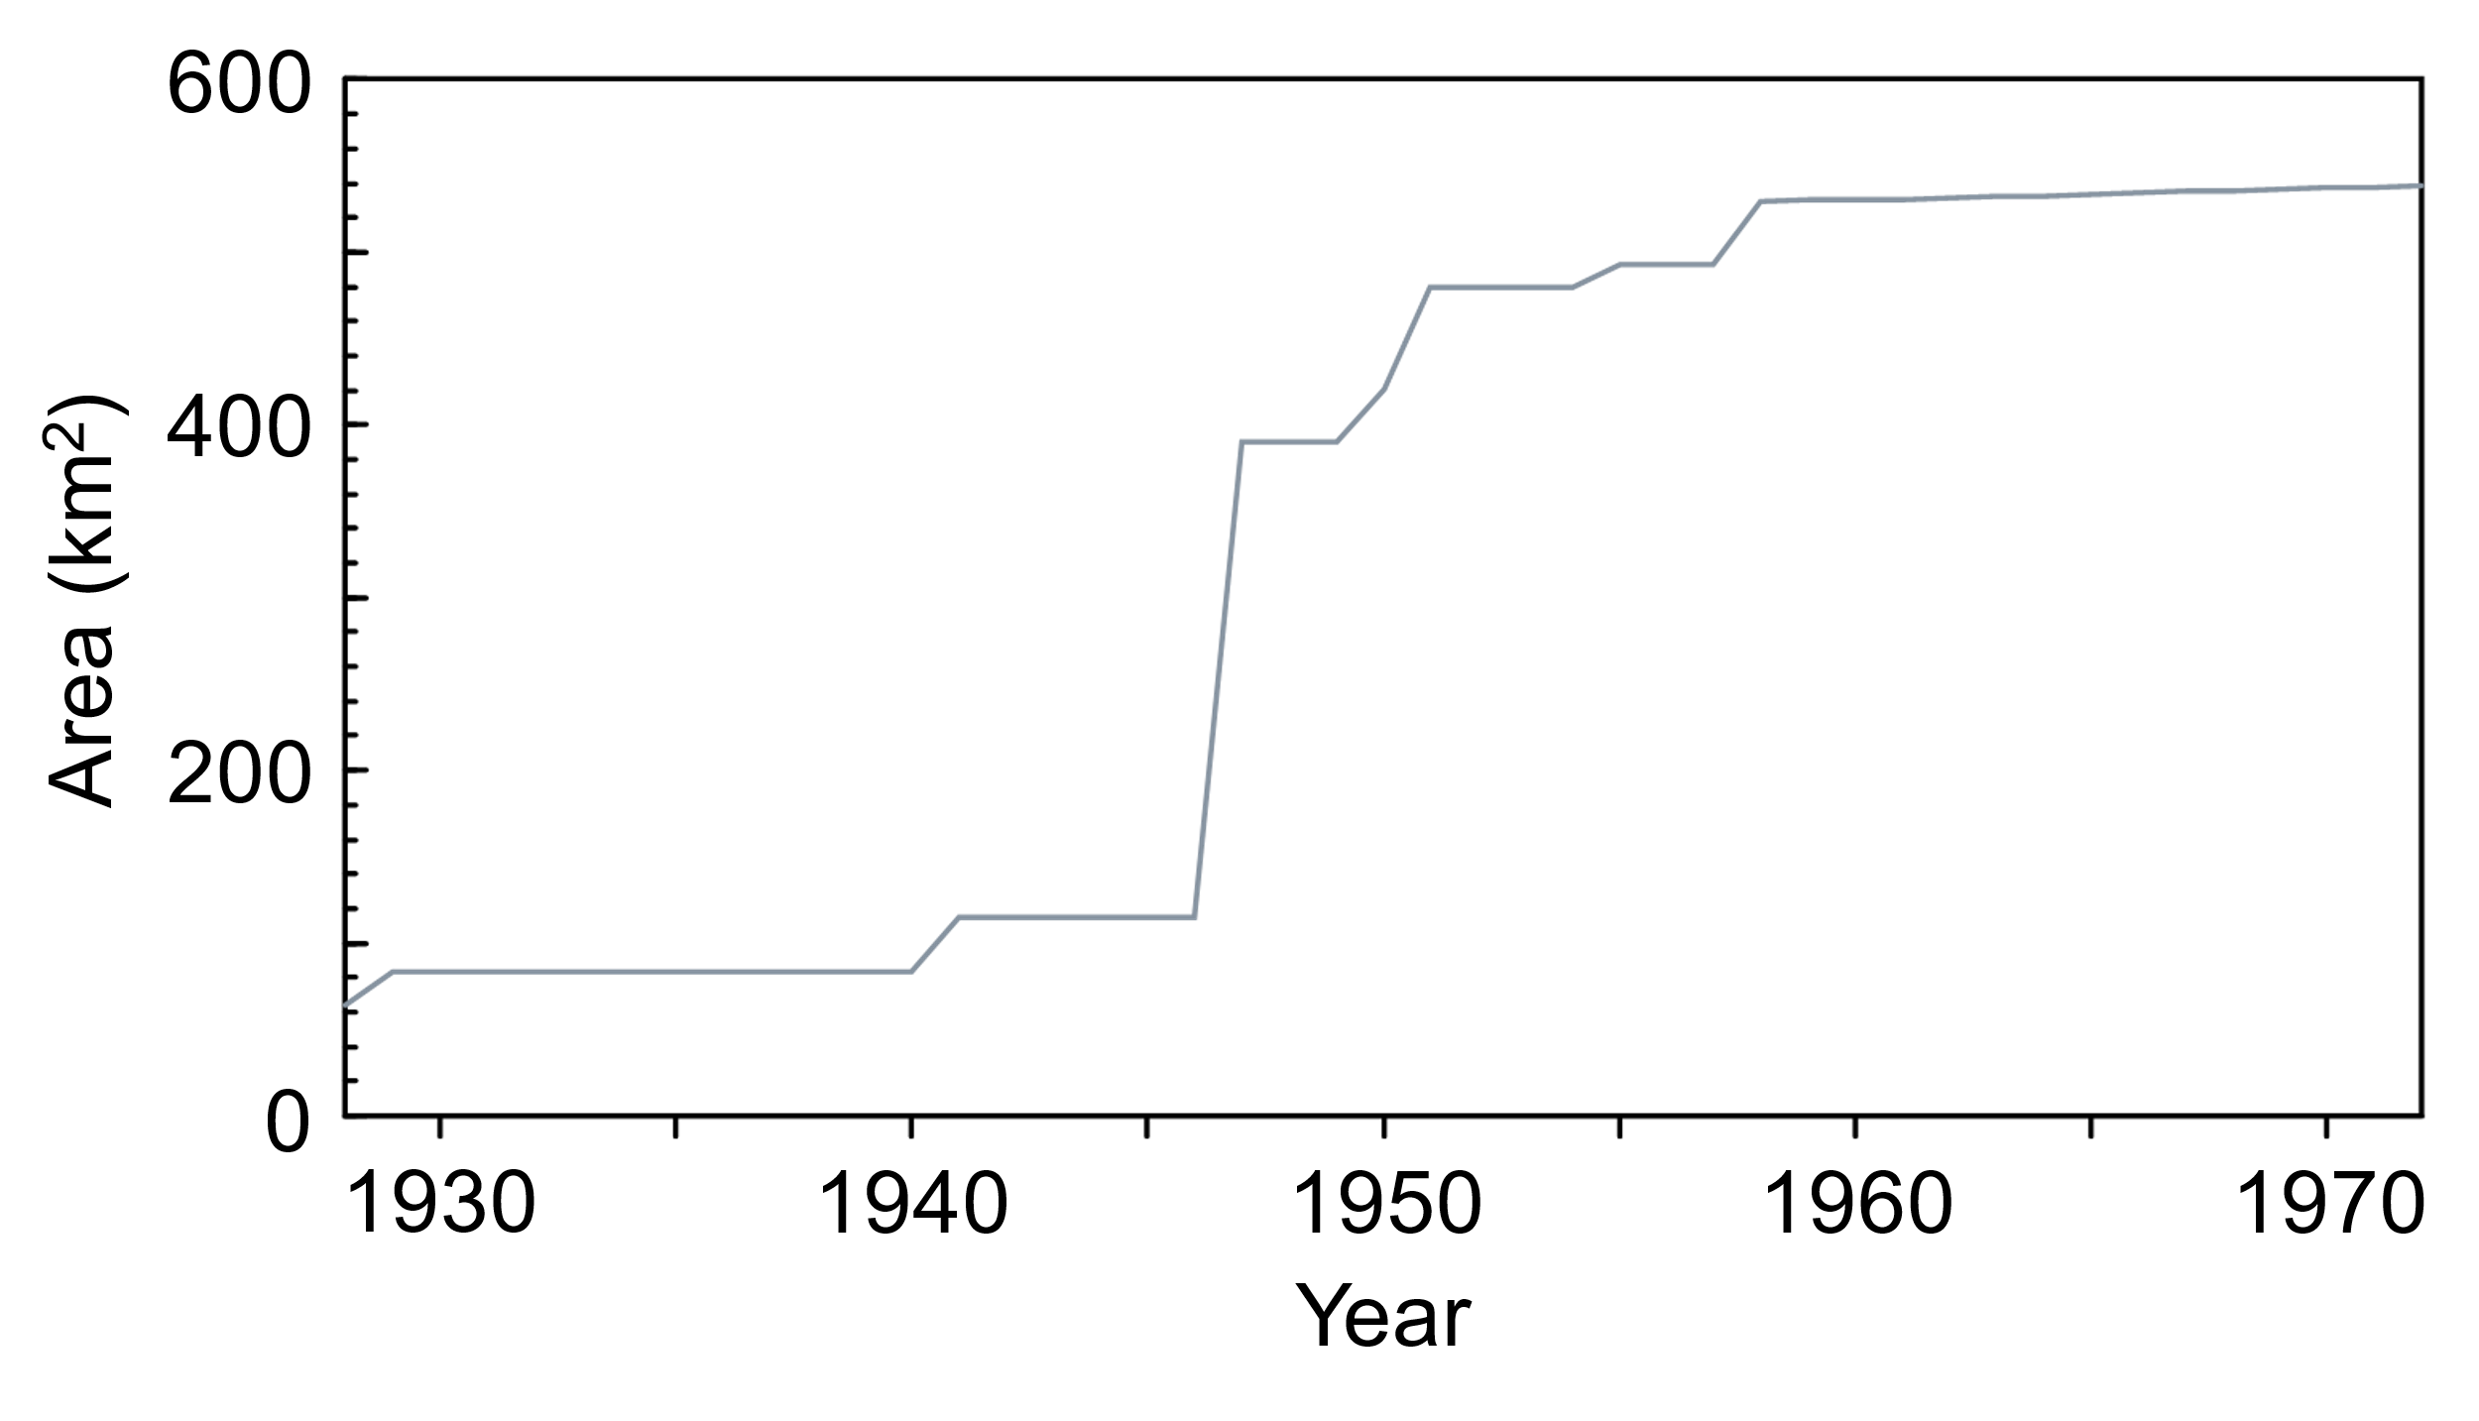
Fig. S1 Temporal change in area of Kobe City. Data source is detailed in Table S1.

Fig. S2 Map of temporal change in area of Kobe City. This figure was draw using administrative boundary in 1920.

