Supplementary Material

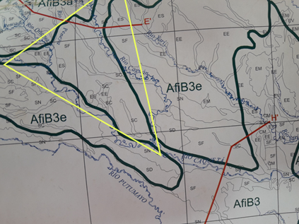
Fig. S1. Section of the national amazon classification of climatic zones where the AfiB3 area belongs to the region of the Amazon expedition.

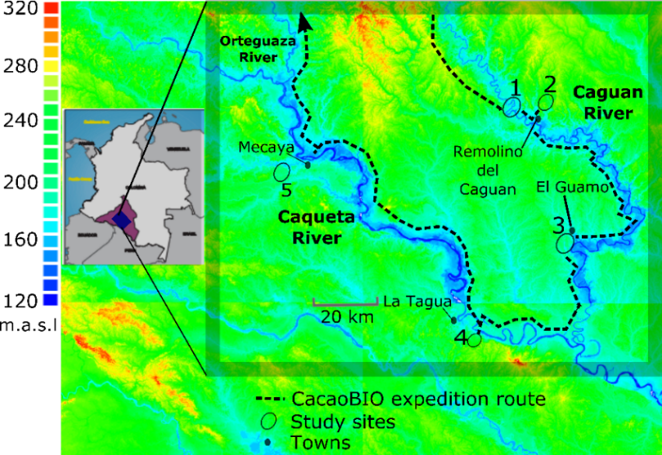

Fig. S2. Geographic distribution of the five Amazon collections sites in relation to the hydrology of river networks. Hydrography map at 1 km² spatial resolution from the expedition to the Caguán and Caquetá Rivers, Colombia.

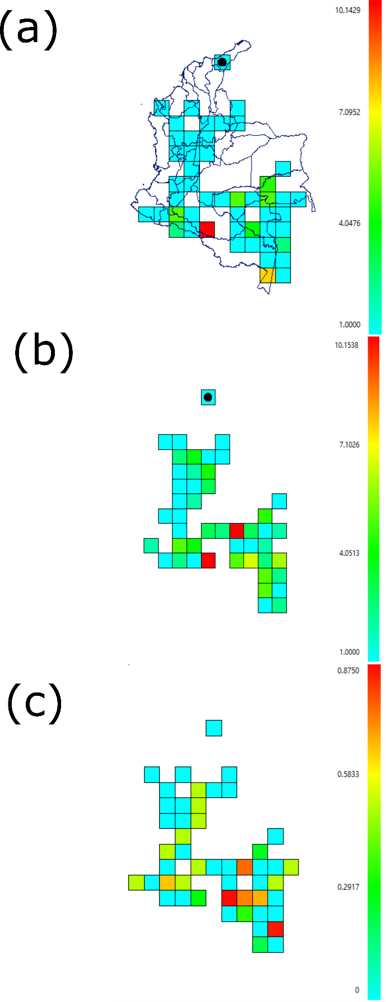

Fig S3. Maps of Chao1 species richness indicators for Theobroma a, Herrania b and redundancy collection map. The numbers are from 0-1 and represent the percentage of predicted species richness.

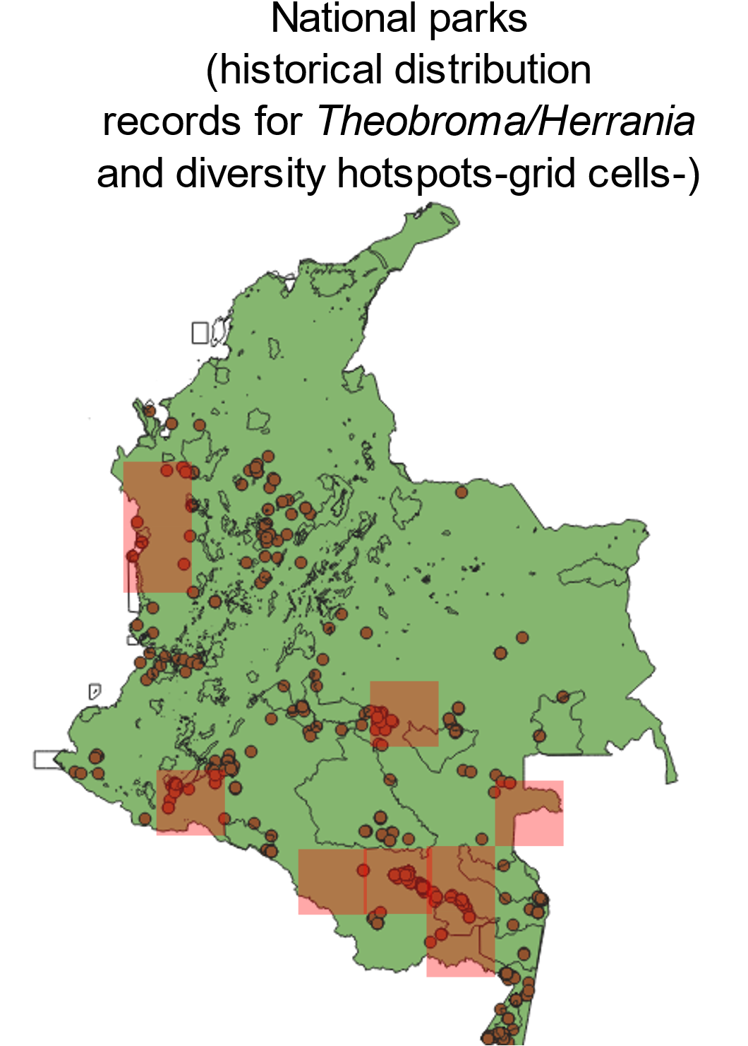

Fig. S4. Polygons of protected areas, distribution records of species and hotspots of species diversity from historical collections of cacao CWR in Colombia.
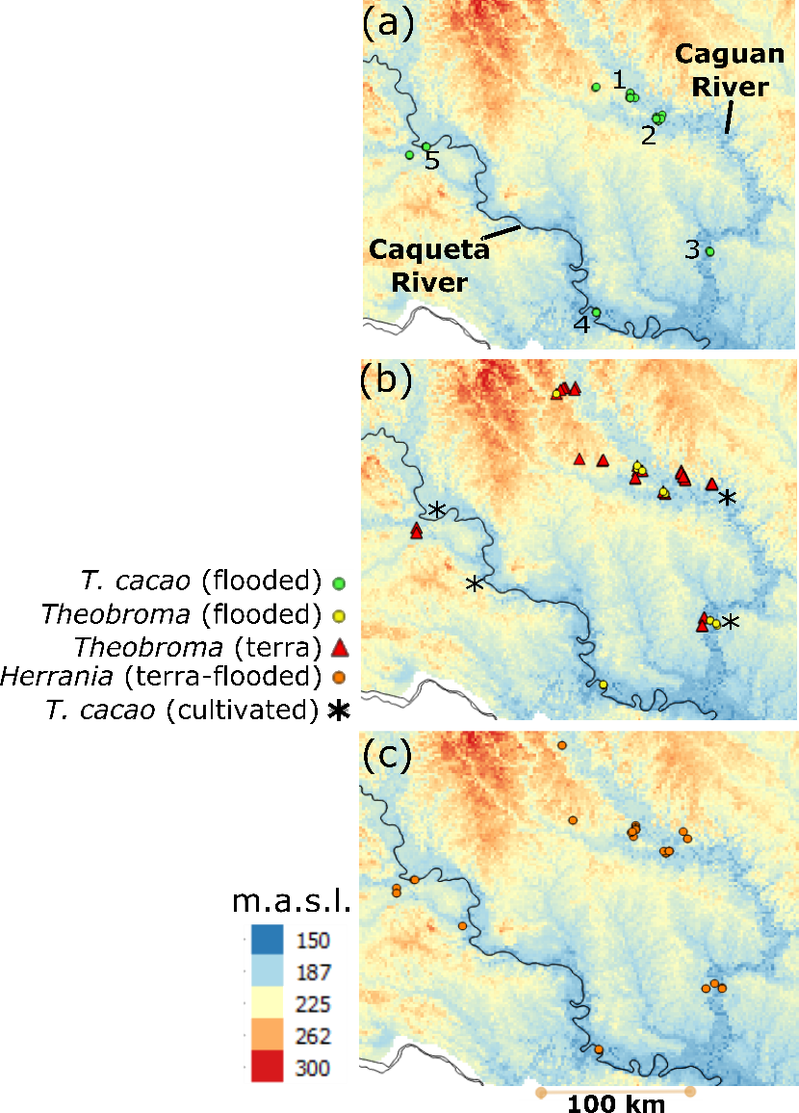

Fig. S5. a Expeditions collection sites numbered 1 to 5 and, b-c location of species distributions of T. cacao, Theobroma and Herrania in different landscapes along the Caguan and Caquetá rivers in the Colombian Amazon.

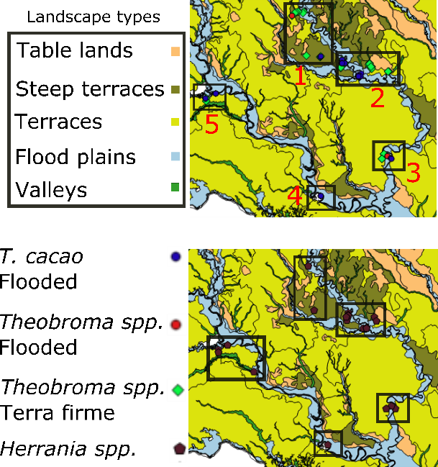
Fig. S6. Map of land form units of the study site with the species distribution of cacao based on flooded and terra firme landscapes.

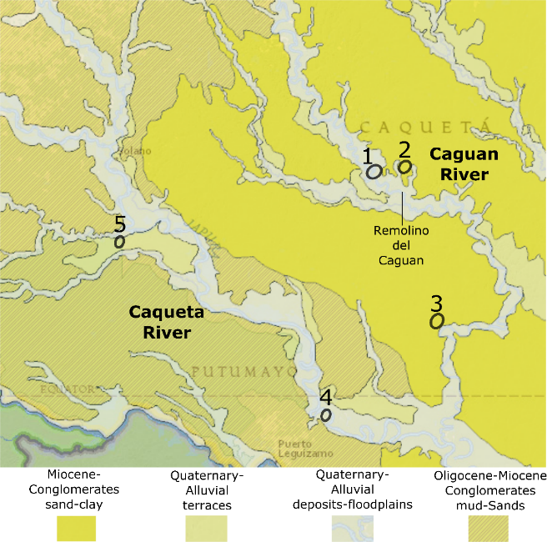
Fig. S7. Map of geological units of the Caguan and Caquetá region (1.500.000). Source: SGC, 2015.

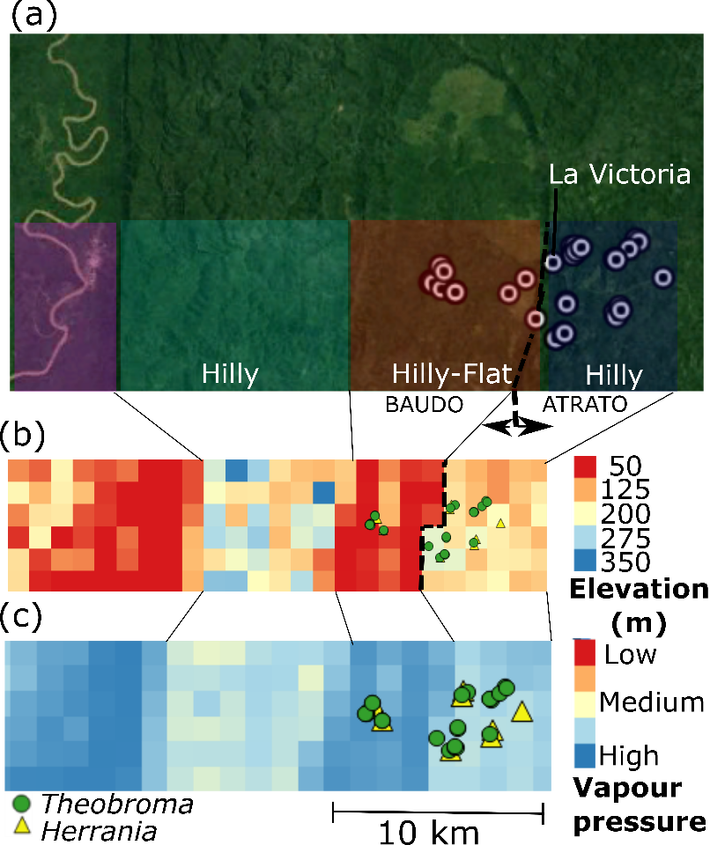

Fig. S8. Geographic distribution and environmental drivers of cacao in Chocó. Satellite image showing the differences in forest landscapes across the Baudó and Atrato catchments a, a digital elevation model at 1 km spatial resolution for the section where collections took place b, and map of vapour pressure showing landscape humidity levels across the study region c.

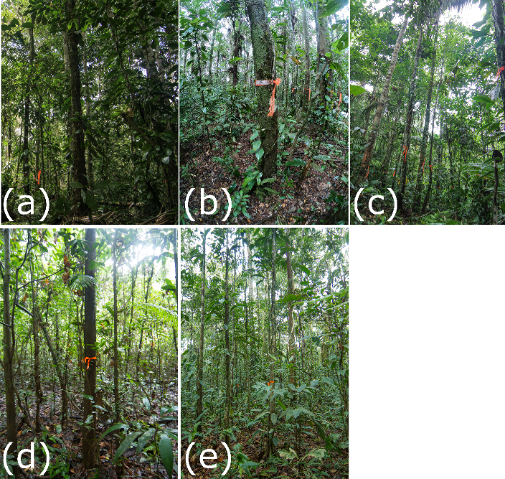

Fig S9. Pictures of some forest types found in different collection sites in the Amazon. Flooding landscapes in a and d, and terra firme landscapes in b, c and e.

Expeditions/taxon | Theobroma | Herrania | T. cacao
Amazon | 80 | 22 | 57
Chocó | 31 | 15 | 10
 | 111 | 37 | 67

Table S1 Summary of the total number of taxa included in our collections for the expeditions.
Taxon # | Our expeditions (2018-2019)  (Sp., species name, and voucher #) | Cuatrecasas  (1960)  (taxonomic section) | Anglo-Colombian  expedition  (1953)
 | Genus Theobroma
1 | Sp1, bicolor | Not registred | bicolor
2 | Sp2, aff. bernoulli (ASG-496)* | bernoulli (Oreantes) | capilliferum (bernoullii)
3 | Sp3, aff. chocoense (ASG-604)* | chocoense (Glossopetalum) | chocoense
4 | Sp4, aff. glaucum (ASG-219)** | glaucum (Oreantes) | calodesmis (glaucum)
5 | Sp5, aff. cirmolinae (ASG)* | cirmolinae (Glossopetalum) | cirmolinae
6 | Sp6, aff. gileri (ASG)* | gileri (Telmatocarpus) | gileri
7 | Sp7, aff. hylaeum (ASG-632)* | hylaeum (Glossopetalum) | Not sampled
8 | Not sampled | grandiflorum | grandiflorum
9 | Not sampled | microcarpum (Telmatocarpus) | microcarpum
10 | Sp8, aff. nemorale (ASG)* | nemorale (Glossopetalum) | nemorale
11 | Sp9, aff. obovatum (ASG-271)** | obovatum (Glossopetalum) | obovatum
12 | Sp10, aff. simiarum (ASG)** | simiarum (Glossopetalum) | simiarum
13 | Sp11, aff. speciosum (ASG)** | Not registred | Not sampled
14 | Sp12, aff. stipulatum (ASG)* | stipulatum (Glossopetalum) | stipulatum
15 | Sp13, aff. subincanum (ASG-138)** | subincanum (Glossopetalum) | subincanum
 | Genus Herrania
 |  | R.E. Schultes monography (1968)
1 | Sp1, aff. nitida (ASG-102)** | NA | NA
2 | Sp2, aff. nycterodendron (ASG-136)** | NA | NA
3 | Sp3, aff. marie (ASG)** | NA | NA
4 | Sp4, aff. pulcherrima (ASG)* | NA | NA
5 | Sp5, aff. purpurea (ASG)* | NA | NA
6 | Sp6, (ASG)* | NA | NA

Table S2 List of taxa collected in our expeditions compared to species reported in Jose Cuatrecasas (1964) taxonomic review, and the species listed by the Anglo-Colombian Cacao expedition. Bolded suggests domesticated species and italic a new range record for Colombia. ASG= collection number for Angela Sanchez Galan from the Universidad de los Andes herbarium; NA=Not applicable. *=Collected in Choco;**=collected in the Amazon. There are 4 taxa of Theobroma cacao that could be hybrids. They are part of the collection numbers but not reported in this table S2.

