Genetic Resources and Crop Evolution
Phylogeography and conservation gaps of Musa balbisiana genetic diversity revealed by microsatellite markers
Arne Mertens^{1,2*}, Yves Bawin^{2,3}, Samuel Vanden Abeele², Simon Kallow^{1,4}, Rony Swennen^{1,5}, Dang Toan Vu⁶, Tuong Dang Vu⁶, Ho Thi Minh⁶, Bart Panis⁷, Filip Vandelook², Steven B. Janssens^{2,3}
¹Department of Biosystems, Laboratory of Tropical Crop Improvement, KU Leuven, Leuven, Belgium
²Meise Botanic Garden, Meise, Belgium
³Department of Biology, KU Leuven, Leuven, Belgium
⁴Royal Botanic Gardens Kew, Millennium Seed Bank, Ardingly, United Kingdom
⁵International Institute of Tropical Agriculture, Kampala, Uganda
⁶Research Planning and International Department, Plant Resources Center, VAAS, Hanoi, Vietnam
⁷Bioversity International, Leuven, Belgium
*Corresponding author
E-mail: arne.mertens70@gmail.com

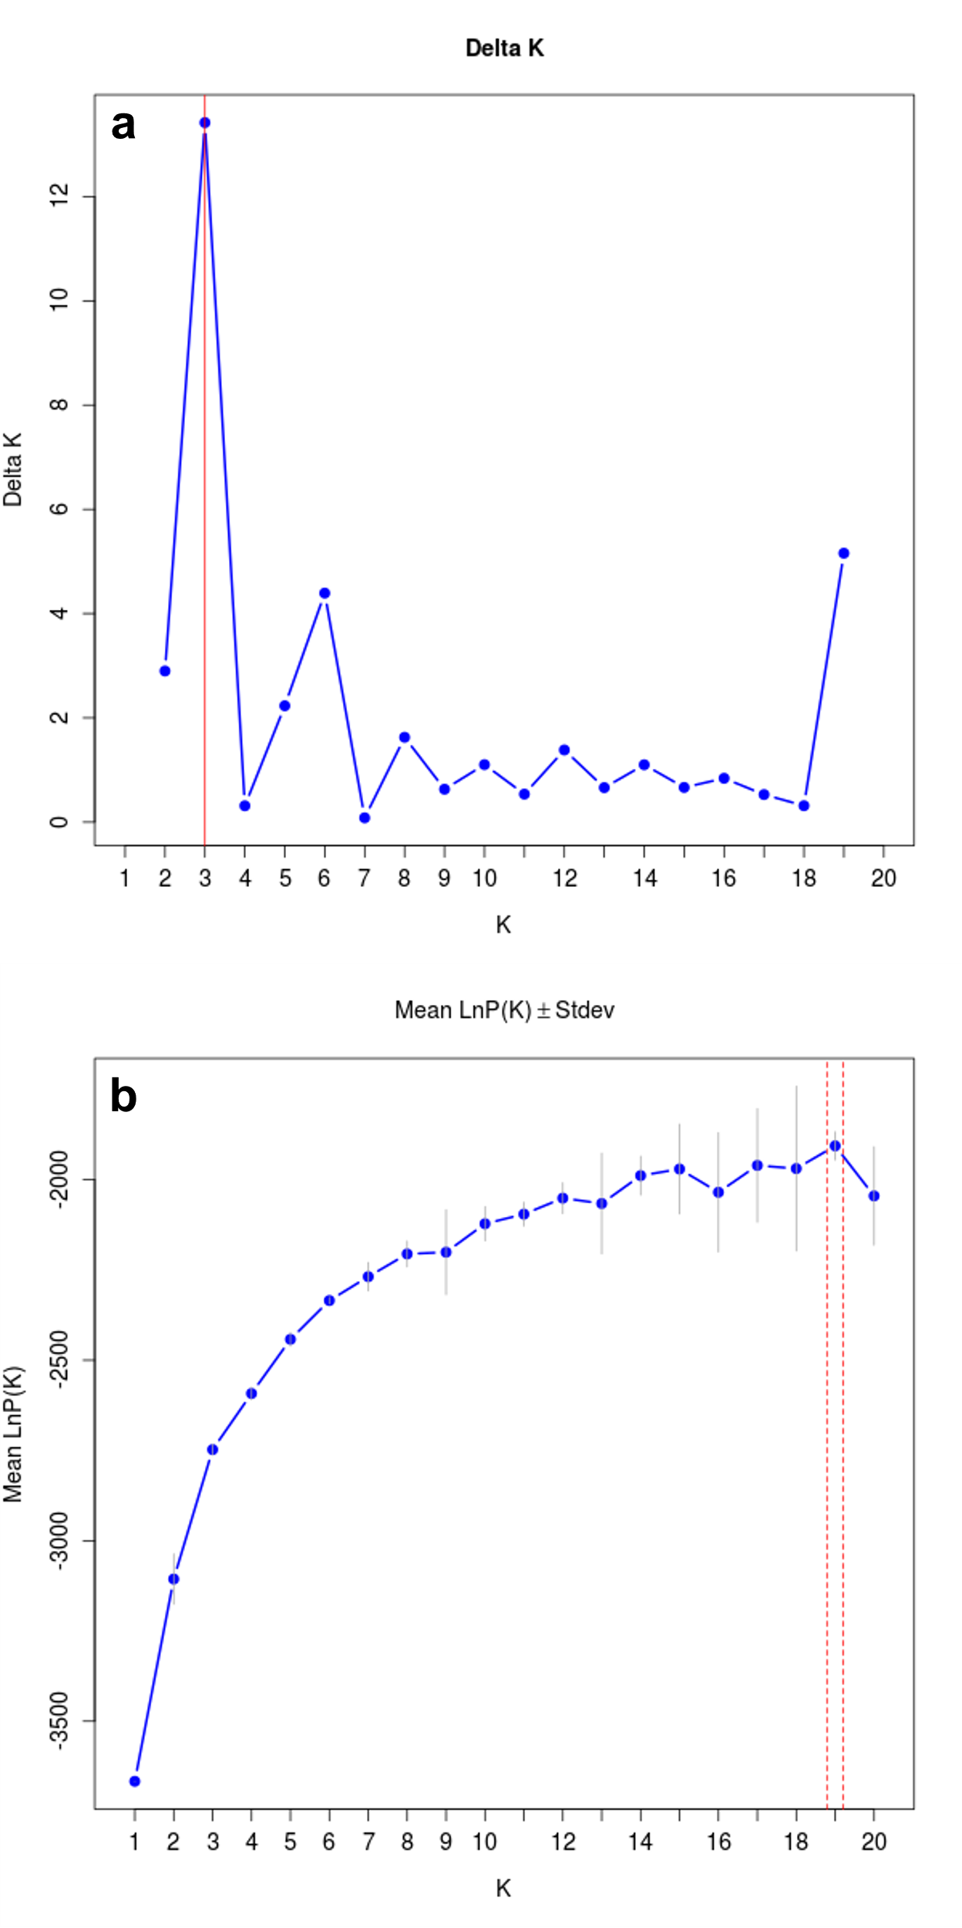
Supplementary Figure 1. Determination of the optimal number of clusters (K) in the complete Musa balbisiana microsatellite dataset. a Evanno method ΔK/K. b Mean LnP(K) / Mean LnP(K). The optimal K is marked with a red line in both figures (Evanno et al., 2005)

References
Evanno, G., Regnaut, S., Goudet, J., 2005. Detecting the number of clusters of individuals using the software STRUCTURE: A simulation study. Mol. Ecol. 14, 2611–2620. https://doi.org/10.1111/j.1365-294X.2005.02553.x

