Table S1: Main genetic parameters of the loci obtained with the (GATA)₄ analysis of the 64 genotypes.
Locus | Na | GD | I
L1 | 2 | 0.3047 | 0.4826
L2 | 2 | 0.4995 | 0.6927
L3 | 2 | 0.375 | 0.5623
L4 | 2 | 0.2188 | 0.3768
L5 | 2 | 0.1172 | 0.2338
L6 | 2 | 0.2417 | 0.4061
L7 | 2 | 0.3047 | 0.4826
L8 | 2 | 0.4175 | 0.6082
L9 | 2 | 0.144 | 0.2742
L10 | 2 | 0.3589 | 0.5445
L11 | 2 | 0.4956 | 0.6887
L12 | 2 | 0.4175 | 0.6082
L13 | 2 | 0.4512 | 0.6435
L14 | 2 | 0.3901 | 0.5789
L15 | 2 | 0.144 | 0.2742
L16 | 1 | 0 | 0
L17 | 2 | 0.0605 | 0.1391
L18 | 2 | 0.3047 | 0.4826
L19 | 2 | 0.3901 | 0.5789
L20 | 2 | 0.4688 | 0.6616
L21 | 2 | 0.4512 | 0.6435
L22 | 2 | 0.4922 | 0.6853
L23 | 2 | 0.2637 | 0.4334
L24 | 2 | 0.4761 | 0.669
L25 | 2 | 0.1948 | 0.3452
L26 | 2 | 0.4956 | 0.6887
L27 | 2 | 0.4604 | 0.6531
L28 | 2 | 0.0605 | 0.1391
L29 | 1 | 0 | 0
Bands (L) are numbered according to the decreasing molecular weight. Na: number of alternative states of the band (2: present or absent; 1: always present); GD: Gene Diversity according to Nei (1973); I: Shannon Index of Diversity.

Table S2: Genetic distance and differentiation between landrace’s populations. The table reports the pairwise Provesti distance (below diagonal) and the Fst value (above diagonal).

 | PB | PBD | SMMU | SMMO | SGRI | STRL | TD | TI | TL | VD | CI | GD | CE | TM | CB | SMC
PB |  | 1.000 | 1.000 | 1.000 | 1.000 | 1.000 | 1.000 | 1.000 | 1.000 | 1.000 | 0.794 | 0.866 | 1.000 | 0.911 | 0.634 | 0.688
PBD | 0.016 |  | 1.000 | 1.000 | 1.000 | 1.000 | 1.000 | 1.000 | 1.000 | 1.000 | 0.804 | 0.896 | 1.000 | 0.906 | 0.702 | 0.716
SMMU | 0.040 | 0.034 |  | 1.000 | 1.000 | 1.000 | 1.000 | 1.000 | 1.000 | 1.000 | 0.821 | 0.906 | 1.000 | 0.911 | 0.715 | 0.554
SMMO | 0.037 | 0.025 | 0.012 |  | 1.000 | 1.000 | 1.000 | 1.000 | 1.000 | 1.000 | 0.835 | 0.919 | 1.000 | 0.901 | 0.739 | 0.653
SGRI | 0.037 | 0.044 | 0.040 | 0.043 |  | 1.000 | 1.000 | 1.000 | 1.000 | 1.000 | 0.794 | 0.906 | 1.000 | 0.928 | 0.654 | 0.740
STRL | 0.041 | 0.041 | 0.061 | 0.056 | 0.044 |  | 1.000 | 1.000 | 1.000 | 1.000 | 0.663 | 0.856 | 1.000 | 0.866 | 0.688 | 0.760
TD | 0.030 | 0.030 | 0.040 | 0.037 | 0.044 | 0.044 |  | 1.000 | 1.000 | 1.000 | 0.821 | 0.906 | 1.000 | 0.896 | 0.758 | 0.760
TI | 0.034 | 0.027 | 0.034 | 0.025 | 0.047 | 0.054 | 0.040 |  | 1.000 | 1.000 | 0.804 | 0.896 | 1.000 | 0.906 | 0.688 | 0.716
TL | 0.041 | 0.049 | 0.061 | 0.056 | 0.052 | 0.025 | 0.052 | 0.047 |  | 1.000 | 0.633 | 0.688 | 1.000 | 0.915 | 0.612 | 0.740
VD | 0.041 | 0.049 | 0.047 | 0.049 | 0.052 | 0.049 | 0.052 | 0.047 | 0.033 |  | 0.522 | 0.813 | 0.692 | 0.475 | 0.524 | 0.740
CI | 0.054 | 0.058 | 0.052 | 0.052 | 0.051 | 0.042 | 0.059 | 0.044 | 0.038 | 0.038 |  | 0.856 | 0.832 | 0.490 | 0.647 | 0.249
GD | 0.042 | 0.050 | 0.046 | 0.051 | 0.052 | 0.046 | 0.052 | 0.046 | 0.025 | 0.037 | 0.040 |  | 0.201 | 0.375 | 0.155 | 0.315
CE | 0.020 | 0.027 | 0.020 | 0.025 | 0.034 | 0.047 | 0.034 | 0.027 | 0.040 | 0.040 | 0.048 | 0.036 |  | 0.925 | 0.488 | 0.609
TM | 0.043 | 0.041 | 0.039 | 0.035 | 0.052 | 0.041 | 0.036 | 0.039 | 0.058 | 0.045 | 0.050 | 0.058 | 0.048 |  | 0.675 | 0.699
CB | 0.036 | 0.043 | 0.038 | 0.038 | 0.035 | 0.051 | 0.048 | 0.035 | 0.044 | 0.044 | 0.039 | 0.040 | 0.021 | 0.049 |  | 0.438
SMC | 0.040 | 0.044 | 0.024 | 0.029 | 0.044 | 0.061 | 0.047 | 0.037 | 0.057 | 0.047 | 0.043 | 0.050 | 0.027 | 0.049 | 0.033

Table S3: Membership coefficients (Q-matrix) of the genotypes based on the STRUCTURE and CLUMPP analyses for K=9.
Genotype | C1 | C2 | C3 | C4 | C5 | C6 | C7 | C8 | C9
PB1 | 0.004 | 0.005 | 0.004 | 0.005 | 0.004 | 0.003 | 0.010 | 0.959 | 0.006
PB2 | 0.004 | 0.005 | 0.004 | 0.005 | 0.004 | 0.003 | 0.010 | 0.960 | 0.006
PB3 | 0.004 | 0.005 | 0.003 | 0.005 | 0.004 | 0.003 | 0.010 | 0.960 | 0.006
PB4 | 0.004 | 0.005 | 0.004 | 0.005 | 0.004 | 0.003 | 0.010 | 0.960 | 0.006
PBD1 | 0.005 | 0.003 | 0.008 | 0.003 | 0.009 | 0.002 | 0.004 | 0.960 | 0.006
PBD2 | 0.005 | 0.003 | 0.008 | 0.003 | 0.009 | 0.002 | 0.004 | 0.960 | 0.006
PBD3 | 0.005 | 0.003 | 0.008 | 0.003 | 0.009 | 0.002 | 0.004 | 0.960 | 0.006
PBD4 | 0.004 | 0.003 | 0.008 | 0.003 | 0.009 | 0.002 | 0.004 | 0.961 | 0.006
SMMU1 | 0.003 | 0.003 | 0.975 | 0.003 | 0.003 | 0.003 | 0.004 | 0.003 | 0.003
SMMU2 | 0.003 | 0.003 | 0.974 | 0.003 | 0.003 | 0.003 | 0.005 | 0.003 | 0.003
SMMU3 | 0.003 | 0.003 | 0.975 | 0.003 | 0.003 | 0.003 | 0.004 | 0.003 | 0.003
SMMU4 | 0.003 | 0.003 | 0.975 | 0.003 | 0.003 | 0.003 | 0.004 | 0.003 | 0.003
SMMO1 | 0.004 | 0.003 | 0.961 | 0.003 | 0.009 | 0.003 | 0.004 | 0.008 | 0.004
SMMO2 | 0.004 | 0.003 | 0.961 | 0.003 | 0.009 | 0.003 | 0.004 | 0.009 | 0.004
SMMO3 | 0.004 | 0.003 | 0.961 | 0.003 | 0.009 | 0.003 | 0.004 | 0.009 | 0.004
SMMO4 | 0.004 | 0.003 | 0.961 | 0.003 | 0.009 | 0.003 | 0.004 | 0.009 | 0.004
SMC1 | 0.003 | 0.005 | 0.916 | 0.005 | 0.005 | 0.027 | 0.010 | 0.027 | 0.002
SMC2 | 0.003 | 0.005 | 0.916 | 0.005 | 0.005 | 0.027 | 0.010 | 0.027 | 0.002
SMC3 | 0.002 | 0.003 | 0.003 | 0.002 | 0.002 | 0.981 | 0.003 | 0.002 | 0.002
SMC4 | 0.002 | 0.003 | 0.003 | 0.002 | 0.002 | 0.981 | 0.003 | 0.002 | 0.002
SGRI1 | 0.003 | 0.003 | 0.002 | 0.980 | 0.002 | 0.002 | 0.003 | 0.003 | 0.002
SGRI2 | 0.003 | 0.003 | 0.002 | 0.980 | 0.002 | 0.002 | 0.003 | 0.003 | 0.002
SGRI3 | 0.003 | 0.003 | 0.003 | 0.980 | 0.002 | 0.002 | 0.003 | 0.003 | 0.002
SGRI4 | 0.003 | 0.003 | 0.002 | 0.980 | 0.002 | 0.002 | 0.003 | 0.003 | 0.002
TD1 | 0.003 | 0.003 | 0.003 | 0.002 | 0.003 | 0.002 | 0.003 | 0.004 | 0.977
TD2 | 0.003 | 0.003 | 0.003 | 0.002 | 0.003 | 0.002 | 0.003 | 0.004 | 0.977
TD3 | 0.003 | 0.003 | 0.003 | 0.002 | 0.003 | 0.002 | 0.003 | 0.004 | 0.977
TD4 | 0.003 | 0.003 | 0.003 | 0.002 | 0.003 | 0.002 | 0.003 | 0.004 | 0.978
TI1 | 0.003 | 0.003 | 0.003 | 0.002 | 0.977 | 0.002 | 0.003 | 0.004 | 0.003
TI2 | 0.003 | 0.003 | 0.003 | 0.002 | 0.977 | 0.002 | 0.003 | 0.004 | 0.003
TI3 | 0.003 | 0.003 | 0.003 | 0.002 | 0.977 | 0.002 | 0.003 | 0.004 | 0.003
TI4 | 0.003 | 0.003 | 0.003 | 0.002 | 0.977 | 0.002 | 0.003 | 0.004 | 0.003
TL1 | 0.007 | 0.957 | 0.003 | 0.004 | 0.006 | 0.004 | 0.008 | 0.007 | 0.005
TL2 | 0.007 | 0.957 | 0.003 | 0.004 | 0.006 | 0.004 | 0.008 | 0.007 | 0.005
TL3 | 0.007 | 0.957 | 0.003 | 0.004 | 0.006 | 0.004 | 0.007 | 0.007 | 0.005
TL4 | 0.007 | 0.957 | 0.003 | 0.004 | 0.006 | 0.004 | 0.008 | 0.007 | 0.005
VD1 | 0.006 | 0.971 | 0.004 | 0.002 | 0.003 | 0.004 | 0.004 | 0.004 | 0.003
VD2 | 0.005 | 0.971 | 0.004 | 0.002 | 0.003 | 0.004 | 0.004 | 0.004 | 0.003
VD3 | 0.006 | 0.970 | 0.004 | 0.002 | 0.003 | 0.004 | 0.004 | 0.004 | 0.003
VD4 | 0.006 | 0.970 | 0.004 | 0.002 | 0.003 | 0.004 | 0.004 | 0.004 | 0.003
CI1 | 0.032 | 0.921 | 0.005 | 0.010 | 0.004 | 0.011 | 0.003 | 0.007 | 0.006
CI2 | 0.033 | 0.921 | 0.005 | 0.010 | 0.004 | 0.012 | 0.003 | 0.007 | 0.006
CI3 | 0.099 | 0.348 | 0.020 | 0.003 | 0.328 | 0.046 | 0.149 | 0.004 | 0.003
CI4 | 0.032 | 0.921 | 0.005 | 0.010 | 0.004 | 0.012 | 0.003 | 0.007 | 0.006
GD1 | 0.006 | 0.953 | 0.005 | 0.004 | 0.007 | 0.003 | 0.009 | 0.008 | 0.006
GD2 | 0.015 | 0.523 | 0.103 | 0.008 | 0.012 | 0.006 | 0.305 | 0.017 | 0.010
GD3 | 0.006 | 0.953 | 0.004 | 0.004 | 0.007 | 0.003 | 0.009 | 0.008 | 0.005
GD4 | 0.006 | 0.953 | 0.005 | 0.004 | 0.007 | 0.003 | 0.009 | 0.008 | 0.005
CB1 | 0.106 | 0.831 | 0.003 | 0.011 | 0.022 | 0.014 | 0.006 | 0.004 | 0.003
STRL1 | 0.720 | 0.226 | 0.003 | 0.014 | 0.004 | 0.004 | 0.006 | 0.015 | 0.010
STRL2 | 0.721 | 0.225 | 0.003 | 0.014 | 0.004 | 0.004 | 0.006 | 0.014 | 0.009
STRL3 | 0.719 | 0.226 | 0.003 | 0.014 | 0.004 | 0.004 | 0.006 | 0.015 | 0.009
STRL4 | 0.719 | 0.227 | 0.003 | 0.014 | 0.004 | 0.003 | 0.006 | 0.014 | 0.009
TM1 | 0.968 | 0.004 | 0.006 | 0.002 | 0.005 | 0.003 | 0.003 | 0.004 | 0.005
TM2 | 0.871 | 0.009 | 0.013 | 0.006 | 0.025 | 0.003 | 0.005 | 0.012 | 0.056
TM3 | 0.968 | 0.004 | 0.007 | 0.002 | 0.005 | 0.003 | 0.003 | 0.004 | 0.005
TM4 | 0.967 | 0.004 | 0.006 | 0.002 | 0.005 | 0.003 | 0.003 | 0.004 | 0.005
CB2 | 0.003 | 0.003 | 0.004 | 0.007 | 0.004 | 0.003 | 0.969 | 0.004 | 0.003
CB3 | 0.003 | 0.004 | 0.003 | 0.004 | 0.003 | 0.005 | 0.973 | 0.003 | 0.002
CB4 | 0.003 | 0.004 | 0.003 | 0.004 | 0.003 | 0.005 | 0.973 | 0.003 | 0.002
CE1 | 0.004 | 0.005 | 0.009 | 0.004 | 0.005 | 0.004 | 0.951 | 0.014 | 0.005
CE2 | 0.004 | 0.004 | 0.009 | 0.004 | 0.005 | 0.004 | 0.951 | 0.014 | 0.005
CE3 | 0.003 | 0.005 | 0.009 | 0.004 | 0.005 | 0.004 | 0.951 | 0.014 | 0.005
CE4 | 0.003 | 0.005 | 0.009 | 0.004 | 0.005 | 0.004 | 0.951 | 0.014 | 0.005

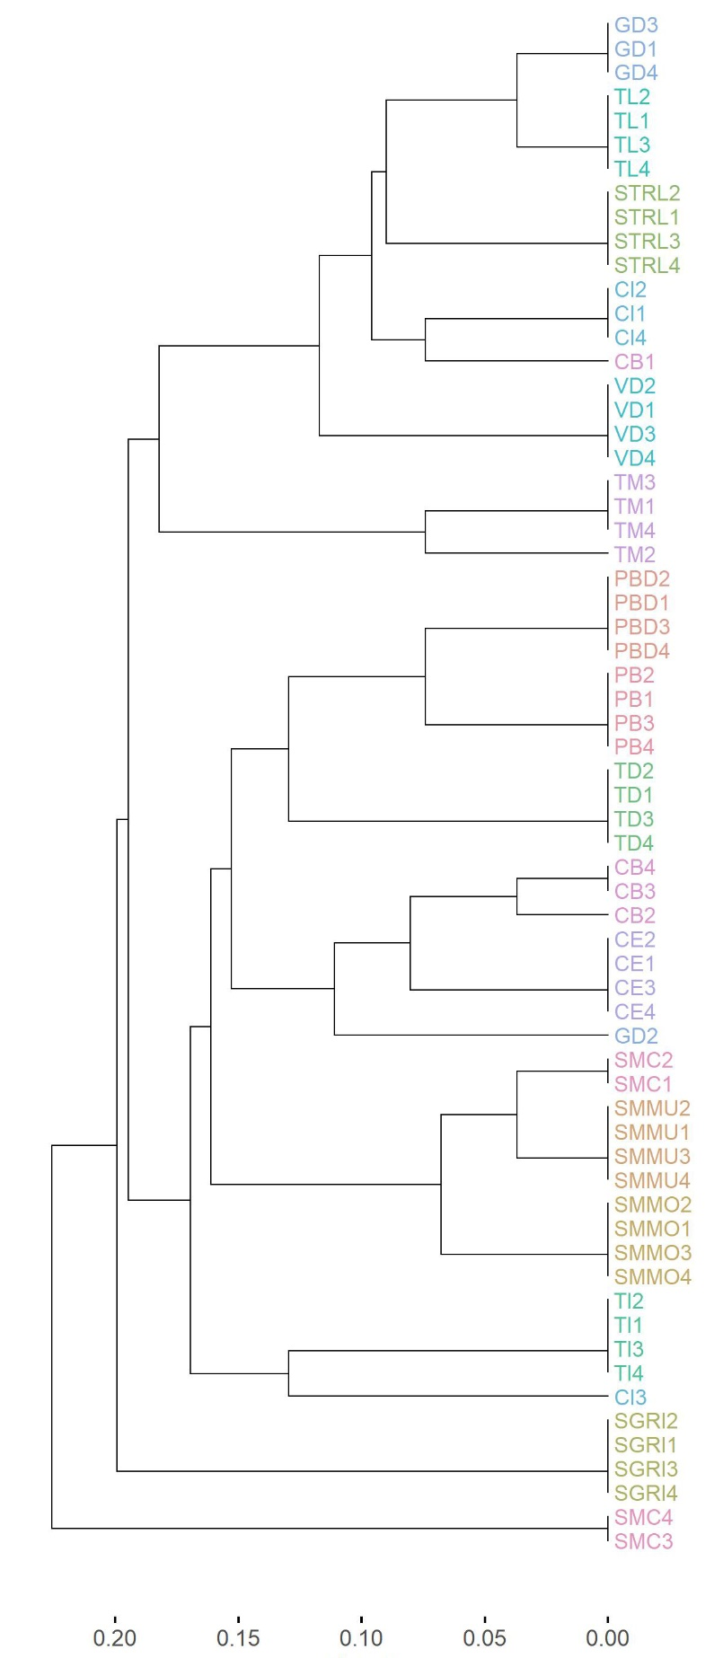

Figure S1: Hierarchical classification of the germplasm under investigation. To ease the comparison, each landrace is identified by a different color.

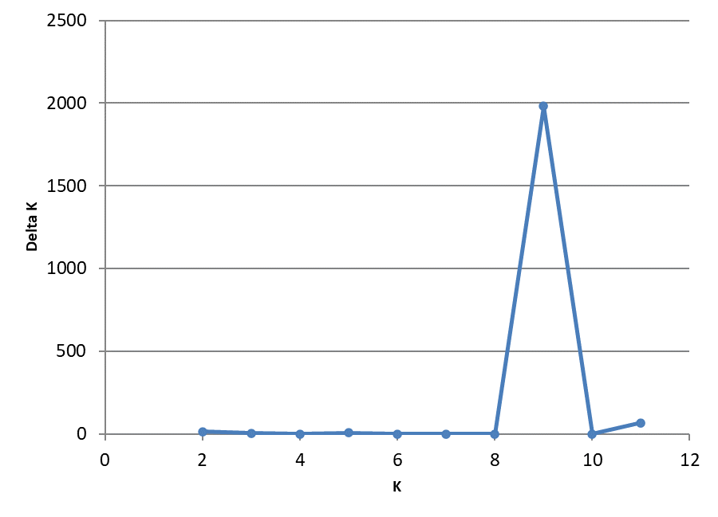
Figure S2. Estimation of the optimum number of clusters for the tomato landraces according to the Evanno's method. The graph displays the Delta K for each K value.

