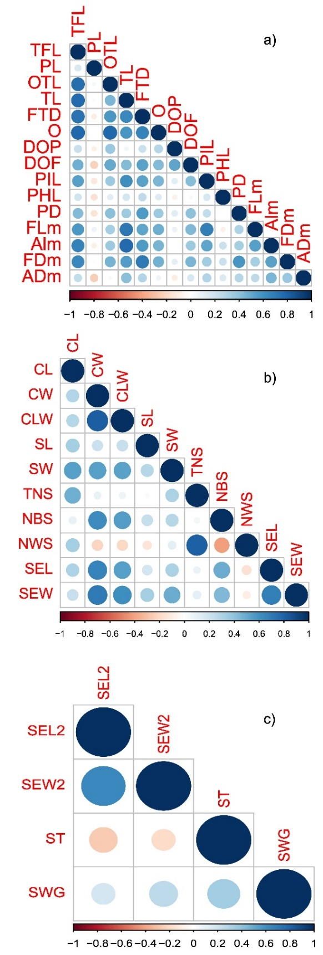
Figure S1. Spearman’s correlations between traits of a) flowers, b) fruits, and c) seeds. Circle size and color intensity reflect the correlation strength. Blue indicates positive correlations; red, negative correlations. Trait abbreviations according to Table 2.
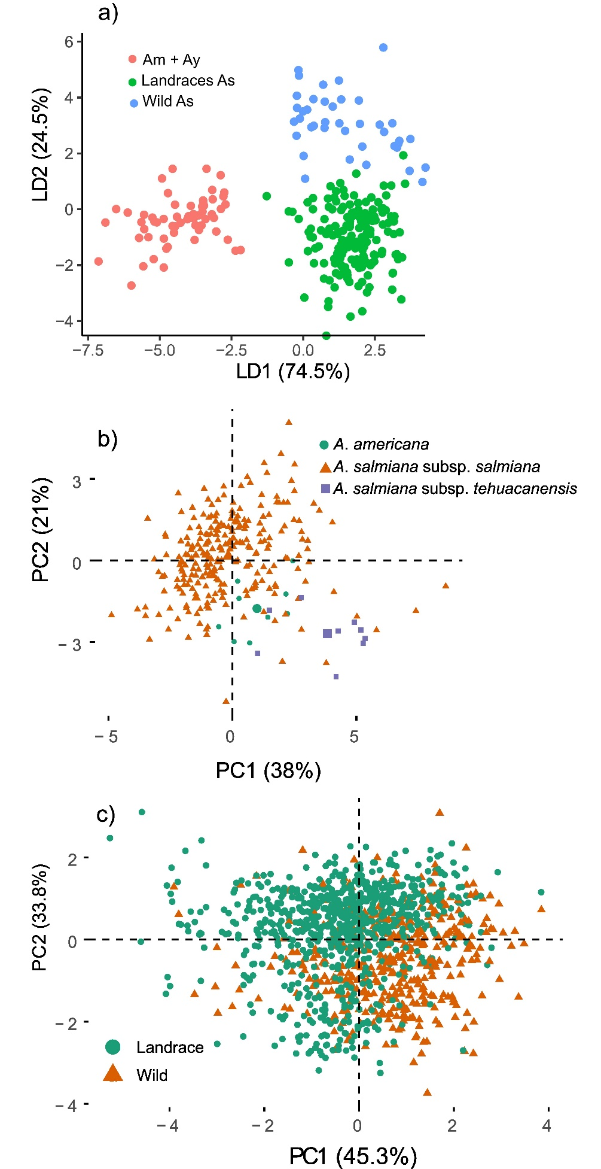
Figure S2. Flowers, fruits, and seeds. a) LDA for flower traits (Flower dataset). Am+Ay are plants of Agave mapisaga and A. salmiana subsp. salmiana 'Ayoteco'. Landrace As contains mainly cultivated plants of Agave salmiana subsp. salmiana. Wild As are mainly wild plants of Agave salmiana. b) PCA for fruit traits. From left to right, landraces of subspecies salmiana, followed by A. americana; in purple, fruits of wild plants of the subspecies tehuacanensis c) PCA for seed traits. Seeds of wild and cultivated plants overlap, but there is a tendency for them to separate along PC1.
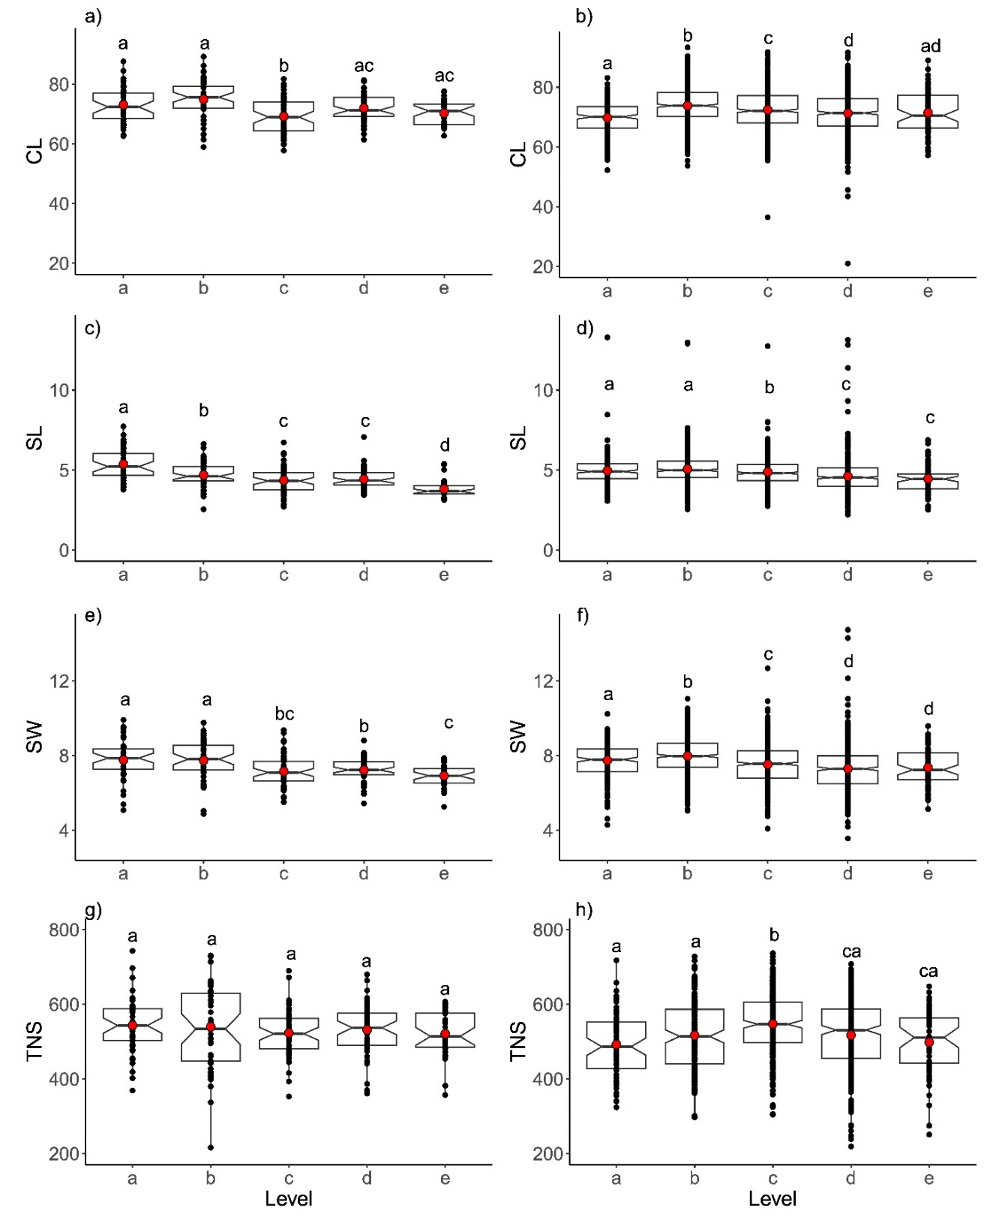
Figure S3. Boxplots representing capsule length (CL), stipe length (SL), stipe width (SW), and total number of seeds values (TNS) for the five levels along the infructescence. Red dots represent mean values. Letters represent homogeneous groups from post hoc tests. Images a, c, e, and g correspond to Fruit dataset 2; images b, d, f, and h, to Fruit dataset 3.
Table S1. Environmental descriptors of the study sites.

Municipality | Altitude | Precipitation | Max–Min temperature | Climate
Atlangatepec | 2621 m a.s.l. | 600–700 mm | 26.3 °C–0.7 °C | Temperate subhumid with summer rains.
Tlaxco | 2562 m a.s.l. | 500–900 mm | 25 °C–1.5 °C | Temperate subhumid and subhumid semi-cold with summer rains and cold
Nanacamilpa | 2803 m a.s.l. | 700–800 mm | 23 °C–3 °C | Temperate subhumid and subhumid semi-cold with summer rains.
El Carmen Tequexquitla | 2426 m a.s.l. | 300–500 mm | 24.1 °C–0.9 °C | Temperate semi-dry.
Tlaxcala | 2228 m a.s.l. | 600–900 mm | 25 °C–1.5 °C | Temperate subhumid with summer rains.
Santa Cruz Tlaxcala | 2416 m a.s.l. | 800–1000 mm | 25 °C–5 °C | Temperate subhumid with summer rains.
Chiautempan | 2496 m a.s.l. | 800–1000 mm | 25 °C–9 °C | Temperate subhumid and subhumid semi-cold with summer rains.

Table S2. Average seed set values by subspecies, landrace, and crop system.
Species | Landrace/Var | Crop system | Seed set
Agave americana var. marginata |  | ornamental | 0.15 ± 0.08
Agave salmiana subsp. salmiana |  | metepantle/monoculture | 0.09 ± 0.08
Agave salmiana subsp. salmiana | 'Ayoteco' | metepantle | 0.11 ± 0.08
Agave salmiana subsp. salmiana | 'Colorado' | metepantle | 0.11 ± 0.04
Agave salmiana subsp. salmiana | 'Manso' | metepantle | 0.09 ± 0.08
Agave salmiana subsp. salmiana | 'Manso' | monoculture | 0.04 ± 0.01
Agave salmiana subsp. salmiana | 'Prieto' | metepantle | 0.18 ± 0.11
Agave salmiana subsp. salmiana | 'Púa Larga' |  | 0.04 ± 0.01
Agave salmiana subsp. tehuacanensis | De Cerro | wild | 0.45 ± 0.21

Table S3. Seed set values in Fruit data sets 1 to 3.
Collection No. | Species | Variety | Wild/  Cultivated | Metepantle/  Monoculture | Municipality | Locality | Seed set
 |  |  |  |  |  |  | Fruit set 1 | Fruit set 2 | Fruit set 3
1182 | Agave americana var. marginata |  | cultivated | Metepantle | Santa Cruz Tlaxcala | San Miguel Contla | 0.15 ± 0.08
1187 | Agave salmiana subsp. salmiana | 'Ayoteco' | cultivated | Metepantle | Nanacamilpa | Rancho La Soledad | 0.11 ± 0.08
1185 | Agave salmiana subsp. salmiana | 'Colorado' | cultivated | Metepantle | Nanacamilpa | Rancho La Soledad | 0.11 ± 0.04
1178 | Agave salmiana subsp. salmiana | 'Manso' | cultivated | Metepantle | Atlangatepec | Rancho El Toronjil | 0.11 ± 0.06
1176 | Agave salmiana subsp. salmiana | 'Manso' | cultivated | Metepantle | Atlangatepec | Zumpango el Alto | 0.05 ± 0.02
1183 | Agave salmiana subsp. salmiana | 'Manso' | cultivated | Metepantle | Atlangatepec | Zumpango el Alto | 0.24 ± 0.13
1530 | Agave salmiana subsp. salmiana | 'Manso' | cultivated | Metepantle | Atlangatepec | Zumpango el Alto | 0.05 ± 0.06
720 | Agave salmiana subsp. salmiana | 'Manso' | cultivated | Monoculture | Nanacamilpa | PULMEX | 0.05 ± 0.02 |  | 0.04 ± 0.01
729 | Agave salmiana subsp. salmiana | 'Manso' | cultivated | Monoculture | Nanacamilpa | PULMEX | 0.02 ± 0.004
731 | Agave salmiana subsp. salmiana | 'Manso' | cultivated | Monoculture | Nanacamilpa | PULMEX | 0.05 ± 0.01
734 | Agave salmiana subsp. salmiana | 'Manso' | cultivated | Monoculture | Nanacamilpa | PULMEX | 0.03 ± 0.007
742 | Agave salmiana subsp. salmiana | 'Manso' | cultivated | Monoculture | Nanacamilpa | PULMEX | 0.06 ± 0.03
871 | Agave salmiana subsp. salmiana | 'Manso' | cultivated | Monoculture | Nanacamilpa | PULMEX | 0.04 ± 0.01 | 0.04 ± 0.01
1706 | Agave salmiana subsp. salmiana | 'Manso' | cultivated | Monoculture | Nanacamilpa | PULMEX | 0.06 ± 0.05
705 | Agave salmiana subsp. salmiana | 'Manso' | cultivated | Metepantle | Nanacamilpa | Rancho La Soledad | 0.1 ± 0.06
706 | Agave salmiana subsp. salmiana | 'Manso' | cultivated | Metepantle | Nanacamilpa | Rancho La Soledad | 0.04 ± 0.01
708 | Agave salmiana subsp. salmiana | 'Manso' | cultivated | Metepantle | Nanacamilpa | Rancho La Soledad | 0.04 ± 0.01
709 | Agave salmiana subsp. salmiana | 'Manso' | cultivated | Metepantle | Nanacamilpa | Rancho La Soledad | 0.12 ± 0.07 | 0.07 ± 0.04
1292 | Agave salmiana subsp. salmiana | 'Manso' | cultivated | Metepantle | Nanacamilpa | Rancho La Soledad | 0.09 ± 0.06 | 0.08 ± 0.05
1295 | Agave salmiana subsp. salmiana | 'Manso' | cultivated | Metepantle | Nanacamilpa | Rancho La Soledad | 0.07 ± 0.05
1296 | Agave salmiana subsp. salmiana | 'Manso' | cultivated | Metepantle | Nanacamilpa | Rancho La Soledad | 0.11 ± 0.3
1308 | Agave salmiana subsp. salmiana | 'Manso' | cultivated | Metepantle | Nanacamilpa | Rancho La Soledad | 0.06 ± 0.05
1585 | Agave salmiana subsp. salmiana | 'Manso' | cultivated | Metepantle | Nanacamilpa | Rancho La Soledad | 0.07 ± 0.03
1184 | Agave salmiana subsp. salmiana | 'Manso' | cultivated | Metepantle | Nanacamilpa | Rancho La Soledad | 0.16 ± 0.03
680 | Agave salmiana subsp. salmiana | 'Prieto' | cultivated | Metepantle | Chiautempan | San Pedro Tlacuapan | 0.12 ± 0.09
1008 | Agave salmiana subsp. salmiana | 'Prieto' | cultivated | Metepantle | Santa Cruz Tlaxcala | San Miguel Contla | 0.27 ± 0.03
1010 | Agave salmiana subsp. salmiana | 'Prieto' | cultivated | Metepantle | Santa Cruz Tlaxcala | San Miguel Contla | 0.26 ± 0.07
1557 | Agave salmiana subsp. salmiana | 'Prieto' | cultivated | Metepantle | Santa Cruz Tlaxcala | San Miguel Contla | 0.07 ± 0.09
1305 | Agave salmiana subsp. salmiana | 'Púa Larga' | cultivated | Metepantle | Nanacamilpa | Rancho La Soledad | 0.03 ± 0.01
1562 | Agave salmiana subsp. salmiana | 'Púa Larga' | cultivated | Metepantle | Tlaxco | Tlaxco | 0.05 ± 0.02
2020 | Agave salmiana subsp. tehuacanensis | De Cerro | wild |  | El Carmen Tequexquitla | Barrio de Guadalupe | 0.45 ± 0.21

Seed set = number of black seeds/total number of seeds; Fruit dataset 1 = nine fruits per plant; Fruit dataset 2 = three fruits per branch; Fruit dataset 3 = total number of fruits.

Table S4. Percent viability and non-viability of seeds per plant of the Seed dataset. In addition, the classification of non-viable seeds is shown. The percentage shown in the classification is based on the percentage of non-viable seeds. Numbers correspond to those in Table 1.

 |  | % viability | % non-viability | % empty seeds | % seeds with no embryo | % seeds with no endosperm | % seeds with neither embryo nor endosperm
Agave salmiana subsp. salmiana | 'Ayoteco'  (1187) | 79.3 | 20.7 | 12.1 | 0.0 | 8.9 | 79.0
 | 'Prieto'  (680) | 88.0 | 12 | 4.2 | 0.0 | 23.6 | 72.2
 | 'Manso' 1 | 57.7 | 42.3 | 54.3 | 4.3 | 16.9 | 24.4
 | 'Manso' 2 | 57.8 | 42.2 | 45.1 | 1.2 | 33.5 | 20.2
Agave salmiana | Amarillo  (1556) | 55.8 | 44.2 | 6.4 | 0.0 | 23.0 | 70.6
Agave salmiana subsp. tehuacanensis | De Cerro  (2020) | 94.5 | 5.5 | 15.2 | 9.1 | 3.0 | 72.7

Table S5. Spearman’s correlations for traits of branches, fruits, and viability in the Fruit data sets for the three plants. Significant correlations are marked in bold (p < 0.05). Abbreviations according to Table 2.
 | TNF | NBS | BSW | BL | TNB | VpB
TNF | 1
NBS | 0.898 | 1
BSW | 0.89 | 0.993 | 1
BL | 0.362 | 0.296 | 0.327 | 1
TNB | 0.378 | 0.17 | 0.196 | 0.80 | 1
VpB | 0.211 | 0.219 | 0.253 | 0.627 | 0.492 | 1

Table S6. Morphological traits recorded in the three individuals from Fruit dataset 3. All plants are A. salmiana subsp. salmiana
 | Plant Number
Traits | 720 | 729 | 731
Rosette height (m) | 2.74 | 2.88 | 2.79
Average rosette diameter (m) | 4.41 | 4.285 | 4.445
Inflorescence height (m) | 11.06 | 11.24 | 11.35
Number of umbels | 31 | 29 | 31
Number of capsules | 854 | 601 | 539
Total number of seeds | 446,900 | - | -
Number of black seeds (%) | 17,483 | 6,931 | 7,375
Number of white seeds (%) | 429,418 | - | -
Reproductive Capacity Index | 0.04 | - | -
Average number of seeds per fruit | 523.302 | - | -
Average number of black seeds per fruit | 20.471 | 11.532 | 13.682
Average number of white seeds per fruit | 502.831 | - | -
Weight of all seeds (g) | 469.41 | 255.52 | 253.43
Weight of black seeds (g) | 130.06 | 49.95 | 48.17
Weight of white seeds (g) | 339.33 | 205.56 | 205.26
Total number of floral buds | 5667 | 6475 | 6647
Average capsule length (mm) | 68.431 | 72.181 | 74.426
Average capsule diameter (mm) | 17.410 | 16.903 | 16.772

Table S7. Spearman’s correlations between fruit traits (Table 2) in Fruit dataset 1. Significant correlations are marked in bold (p < 0.05). These correlations are shown in Figure 8 (main text).
 | CL | CW | CLW | SL | SW | NBS
CL | 1
CW | 0.297 | 1
CLW | 0.287 | 0.822 | 1
SL | 0.334 | 0.211 | 0.229 | 1
SW | 0.543 | 0.546 | 0.535 | 0.289 | 1
NBS | 0.098 | 0.621 | 0.557 | 0.23 | 0.289 | 1

Table S8. Spearman’s correlations between fruit traits (Table 2) in plants of the 'Manso' landrace included in Fruit dataset 1. Significant correlations are marked in bold (p < 0.05).
 | CL | CW | CLW | SL | SW | NBS
CL | 1
CW | 0.585 | 1
CLW | 0.447 | 0.773 | 1
SL | 0.492 | 0.297 | 0.162 | 1
SW | 0.699 | 0.589 | 0.515 | 0.373 | 1
NBS | 0.373 | 0.657 | 0.58 | 0.124 | 0.432 | 1

Table S9. Spearman’s correlations from data for plants in Fruit dataset 3. Significant correlations are marked in bold (p < 0.05).
 | CL | CW | CLW | SL | SW | NBS
CL | 1
CW | 0.399 | 1
CLW | 0.291 | 0.817 | 1
SL | 0.456 | 0.295 | 0.247 | 1
SW | 0.471 | 0.541 | 0.428 | 0.408 | 1
NBS | 0.361 | 0.752 | 0.7 | 0.321 | 0.586 | 1

Table S10. Spearman’s correlations between fruit traits (Table 2) in Fruit dataset 2, 'Manso' landrace. Significant correlations are marked in bold (p < 0.05).
 | CL | CW | CLW | SL | SW | NBS
CL | 1
CW | 0.294 | 1
CLW | 0.389 | 0.604 | 1
SL | 0.540 | 0.183 | 0.335 | 1
SW | 0.598 | 0.392 | 0.471 | 0.556 | 1
NBS | 0.407 | 0.683 | 0.409 | 0.246 | 0.361 | 1

Table S11. Fruit dataset and seed set values reported for Agave species from different sources (wild, landrace, or cultivated).
Species | Origin | Fruit set | Seed Set | Reference
A. americana | Cultivated |  | 0.1 | Escobar-Guzmán et al. 2008
A. angustifolia | Wild |  | 0.4-0.5 | Gonçalves de Lima 1986
A. angustifolia | Wild | 0.24 | 0.2 | Molina-Freaner et al. 2003
A. celsii albicans | Wild | 0.44 | 0.3 | Rocha et al. 2005
A. cupreata | Wild/Landrace |  | 0.5 | Avendaño-Arrazate et al. 2015
A. cupreata | Landrace |  | 0.4 | Figueredo-Urbina et al. 2017
A. difformis | Wild | 0.47 | 0.4 | Rocha et al. 2005
A. fourcroydes | Cultivated |  | 0.1 | Colunga-GarcíaMarín et al. 2006
A. hookeri | Landrace |  | 0.3 | Figueredo-Urbina et al. 2017
A.inaequidens | Wild |  | 0.6 | Figueredo-Urbina et al. 2017
A. macroacantha | Wild |  | 0.6 | Arizaga et al. 2000
A. salmiana | Wild? |  | 0.1-0.3 | Huerta-Lovera et al. 2018
A. salmiana | Wild? | 0.19 |  | Estrella 2005
A. salmiana subsp salmiana | Cultivated |  | 0.04 | This work
A. salmiana subsp crassispina | Wild |  | 0.3-0.6 | Medrano et al. 2000
Agave sp. | Wild | 0.59 | 0.5 | Rocha et al. 2005
A. striata | Wild | 0.51 | 0.3 | Rocha et al. 2005
A. subsimplex | Wild | 0.32 | 0.3 | Molina-Freaner et al. 2003
A. tequilana | Cultivated |  | 0.1 | Escobar-Guzmán et al. 2008
A. xylonacantha | Wild | 0.63 | 0.5 | Rocha et al. 2005

