SUPPLEMENTAL MATERIAL
Table S1. List of accessions used in this study. PI Number: US National Plant Germoplasm System "plant introduction number".
Accession PI Number | Donor or collecting number | Species
631192 | VIR 9786 | Solanum acaule Bitter
631193 | VIR 17901 | Solanum acaule Bitter
631195 | VIR 18004 | Solanum acaule Bitter
631218 | VIR 4114 | Solanum acaule Bitter
653786 | VIR 04250 | Solanum acaule Bitter
653787 | VIR 04253 | Solanum acaule Bitter
653788 | VIR 04263 | Solanum acaule Bitter
653812 | VIR 09784 | Solanum acaule Bitter
653825 | VIR 18010 | Solanum acaule Bitter
653826 | VIR 18014 | Solanum acaule Bitter
653827 | VIR 18021 | Solanum acaule Bitter
658586 | VIR 18522 | Solanum acaule Bitter
631198 | VIR 9814 | Solanum albicans Ochoa
631199 | VIR 9813 | Solanum albicans Ochoa
653801 | VIR 07635 | Solanum berthaultii Hawkes
653802 | VIR 07642 | Solanum berthaultii Hawkes
653829 | VIR 23047 | Solanum berthaultii Hawkes
473378 | HHCH 4498 | Solanum brevicaule Bitter
631209 | VIR 7370 | Solanum brevicaule Bitter
631210 | VIR 7381 | Solanum brevicaule Bitter
653800 | VIR 05764 | Solanum brevicaule Bitter
653817 | VIR 09798 | Solanum brevicaule Bitter
653818 | VIR 09808 | Solanum brevicaule Bitter
631200 | VIR 2733 | Solanum chacoense Bitter
631202 | VIR 7610 | Solanum chacoense Bitter
631203 | VIR 7613 | Solanum chacoense Bitter
631207 | VIR 3701 | Solanum chacoense Bitter
653782 | VIR 03678 | Solanum chacoense Bitter
653783 | VIR 03702 | Solanum chacoense Bitter
653785 | VIR 04236 | Solanum chacoense Bitter
653792 | VIR 05257 | Solanum chacoense Bitter
653822 | VIR 15994 | Solanum chacoense Bitter
160220 | COR 14199 | Solanum demissum Lindl.
160221 | COR 14200 | Solanum demissum Lindl.
160227 | COR 14215 | Solanum demissum Lindl.
160230 | COR 14220 | Solanum demissum Lindl.
161149 | COR 14203 | Solanum demissum Lindl.
161151 | COR 14209B | Solanum demissum Lindl.
161164 | COR 14237 | Solanum demissum Lindl.
161165 | COR 14238 | Solanum demissum Lindl.
161166 | COR 14239 | Solanum demissum Lindl.
161167 | COR 14240 | Solanum demissum Lindl.
161168 | COR 14243 | Solanum demissum Lindl.
161169 | COR 14244 | Solanum demissum Lindl.
161175 | COR 14259 | Solanum demissum Lindl.
161176 | COR 14260 | Solanum demissum Lindl.
161179 | COR 14265 | Solanum demissum Lindl.
161180 | COR 14266 | Solanum demissum Lindl.
161181 | COR 14267 | Solanum demissum Lindl.
161365 | COR 14274 | Solanum demissum Lindl.
161366 | COR 14283 | Solanum demissum Lindl.
161367 | COR 14286 | Solanum demissum Lindl.
161686 | COR 14435 | Solanum demissum Lindl.
161693 | COR 14319 | Solanum demissum Lindl.
161715 | COR 14379 | Solanum demissum Lindl.
161719 | COR 14413 | Solanum demissum Lindl.
161729 | COR 14378 | Solanum demissum Lindl.
161731 | COR 14411 | Solanum demissum Lindl.
175403 | EBS 17/1 | Solanum demissum Lindl.
175404 | EBS 17/28 | Solanum demissum Lindl.
175408 | EBS 46/33 | Solanum demissum Lindl.
175409 | EBS 46/34 | Solanum demissum Lindl.
175411 | EBS 14/144 | Solanum demissum Lindl.
175423 | EBS 48B/36 | Solanum demissum Lindl.
186551 | HAW 1077 | Solanum demissum Lindl.
186552 | HAW 1079 | Solanum demissum Lindl.
186561 | HAW 1117 | Solanum demissum Lindl.
186562 | HAW 1118 | Solanum demissum Lindl.
195165 | CPC 43.2 | Solanum demissum Lindl.
201853 | BEL DEM 52 | Solanum demissum Lindl.
201854 | BEL DEM 55 | Solanum demissum Lindl.
205515 | CPC 14.2 | Solanum demissum Lindl.
205516 | CPC 14.3 | Solanum demissum Lindl.
205518 | CPC 1363.1 | Solanum demissum Lindl.
205519 | CPC 1364.3 | Solanum demissum Lindl.
205625 | CPC 2127 | Solanum demissum Lindl.
218047 | BB s.n. | Solanum demissum Lindl.
225652 | CCC 606 | Solanum demissum Lindl.
225653 | CCC 620A | Solanum demissum Lindl.
230558 | EBS 18 | Solanum demissum Lindl.
230559 | EBS 44 | Solanum demissum Lindl.
230578 | SPB s.n. | Solanum demissum Lindl.
230579 | SPB s.n. | Solanum demissum Lindl.
230589 | RDD 178 | Solanum demissum Lindl.
230591 | RDD 696 | Solanum demissum Lindl.
230592 | RDD 886 | Solanum demissum Lindl.
275206 | HAW 1295 | Solanum demissum Lindl.
275208 | HAW 1601 | Solanum demissum Lindl.
275209 | HAW 1657 | Solanum demissum Lindl.
275210 | HAW 1608 | Solanum demissum Lindl.
275211 | HAW 1782 | Solanum demissum Lindl.
310961 | UGN 1514 | Solanum demissum Lindl.
310962 | UGN 2448 | Solanum demissum Lindl.
338618 | ROW 1 | Solanum demissum Lindl.
338619 | ROW 2 | Solanum demissum Lindl.
347760 | TRN 64 | Solanum demissum Lindl.
347761 | TRN 88 | Solanum demissum Lindl.
347762 | TRN 142C | Solanum demissum Lindl.
365381 | TRN 7A | Solanum demissum Lindl.
365387 | TRN 15D | Solanum demissum Lindl.
473520 | EBS 2624 | Solanum demissum Lindl.
498012 | TRHRG 123 | Solanum demissum Lindl.
498013 | TRHRG 150 | Solanum demissum Lindl.
498014 | TRHRG 167 | Solanum demissum Lindl.
498015 | TRHRG 186 | Solanum demissum Lindl.
498016 | TRHRG 192 | Solanum demissum Lindl.
498017 | TRHRG 194 | Solanum demissum Lindl.
498018 | TRHRG 196 | Solanum demissum Lindl.
498229 | OCH 14154 | Solanum demissum Lindl.
498230 | OCH 14155 | Solanum demissum Lindl.
498231 | OCH 14156 | Solanum demissum Lindl.
498233 | OCH 14217 | Solanum demissum Lindl.
498299 | HAW 1134 | Solanum demissum Lindl.
545754 | TRHRG 198 | Solanum demissum Lindl.
545756 | TRHRG 203 | Solanum demissum Lindl.
545758 | TRHRG 204C | Solanum demissum Lindl.
545765 | TRHRG 294 | Solanum demissum Lindl.
545767 | TRHRG 304 | Solanum demissum Lindl.
558051 | HJT 7259 | Solanum demissum Lindl.
558389 | SHGRF 4261 | Solanum demissum Lindl.
558390 | SHGRF 4045 | Solanum demissum Lindl.
558391 | SHGRF 4062 | Solanum demissum Lindl.
558392 | SHGRF 4064 | Solanum demissum Lindl.
558464 | SHGRF 4048 | Solanum demissum Lindl.
558482 | SHGRF 4019 | Solanum demissum Lindl.
607841 | RSSV 920 | Solanum demissum Lindl.
607849 | RSSV 940 | Solanum demissum Lindl.
607869 | RSSV 975 | Solanum demissum Lindl.
607873 | RSSV 984 | Solanum demissum Lindl.
653762 | VIR 02353 | Solanum demissum Lindl.
653770 | VIR 03287 | Solanum demissum Lindl.
653772 | VIR 03341 | Solanum demissum Lindl.
653773 | VIR 03342 | Solanum demissum Lindl.
653774 | VIR 03355 | Solanum demissum Lindl.
653776 | VIR 03362 | Solanum demissum Lindl.
653779 | VIR 03540 | Solanum demissum Lindl.
653789 | VIR 04445 | Solanum demissum Lindl.
653803 | VIR 08446 | Solanum demissum Lindl.
653804 | VIR 08462 | Solanum demissum Lindl.
653805 | VIR 08466 | Solanum demissum Lindl.
653828 | VIR 18407 | Solanum guerreroense Correll
631201 | VIR 9742 | Solanum juzepczukii Bukasov
653799 | VIR 05763 | Solanum michoacanum (Bitter) Rydb.
631212 | VIR 5684 | Solanum microdontum Bitter
230489 | ROC S-44 | Solanum pinnatisectum Dunal
275230 | HAW 1424 | Solanum pinnatisectum Dunal
275234 | HAW 1456 | Solanum pinnatisectum Dunal
631206 | VIR 8505 | Solanum stoloniferum Schltdl.
631213 | VIR 8416 | Solanum stoloniferum Schltdl.
631214 | VIR 8475 | Solanum stoloniferum Schltdl.
631215 | VIR 2492 | Solanum stoloniferum Schltdl.
631216 | VIR 4226 | Solanum stoloniferum Schltdl.
653763 | VIR 02534 | Solanum stoloniferum Schltdl.
653764 | VIR 02536 | Solanum stoloniferum Schltdl.
653771 | VIR 03326 | Solanum stoloniferum Schltdl.
653777 | VIR 03527 | Solanum stoloniferum Schltdl.
653778 | VIR 03533 | Solanum stoloniferum Schltdl.
653780 | VIR 03554 | Solanum stoloniferum Schltdl.
653793 | VIR 05347 | Solanum stoloniferum Schltdl.
653794 | VIR 05431 | Solanum stoloniferum Schltdl.
653823 | VIR 16888 | Solanum stoloniferum Schltdl.
'Alpha' | commercial cultivar | Solanum tuberosum L.

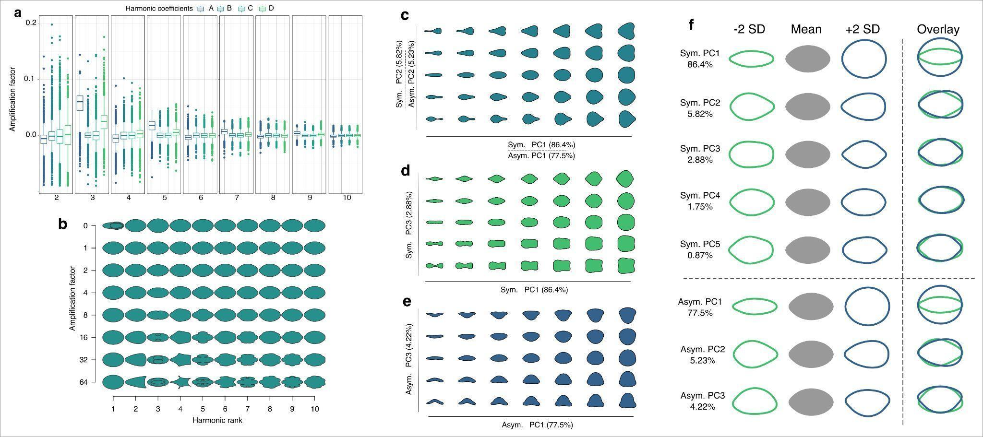
Fig. S1 Elliptical Fourier Descriptors for complete data. (a) Variation of harmonic coefficients. (b) Harmonic contributions to shape resulting from EFD analysis. Principal components (c) PC1 and PC2, (d, e) PC1 and PC3. (f) PCs explaining variance in leaflet shape

