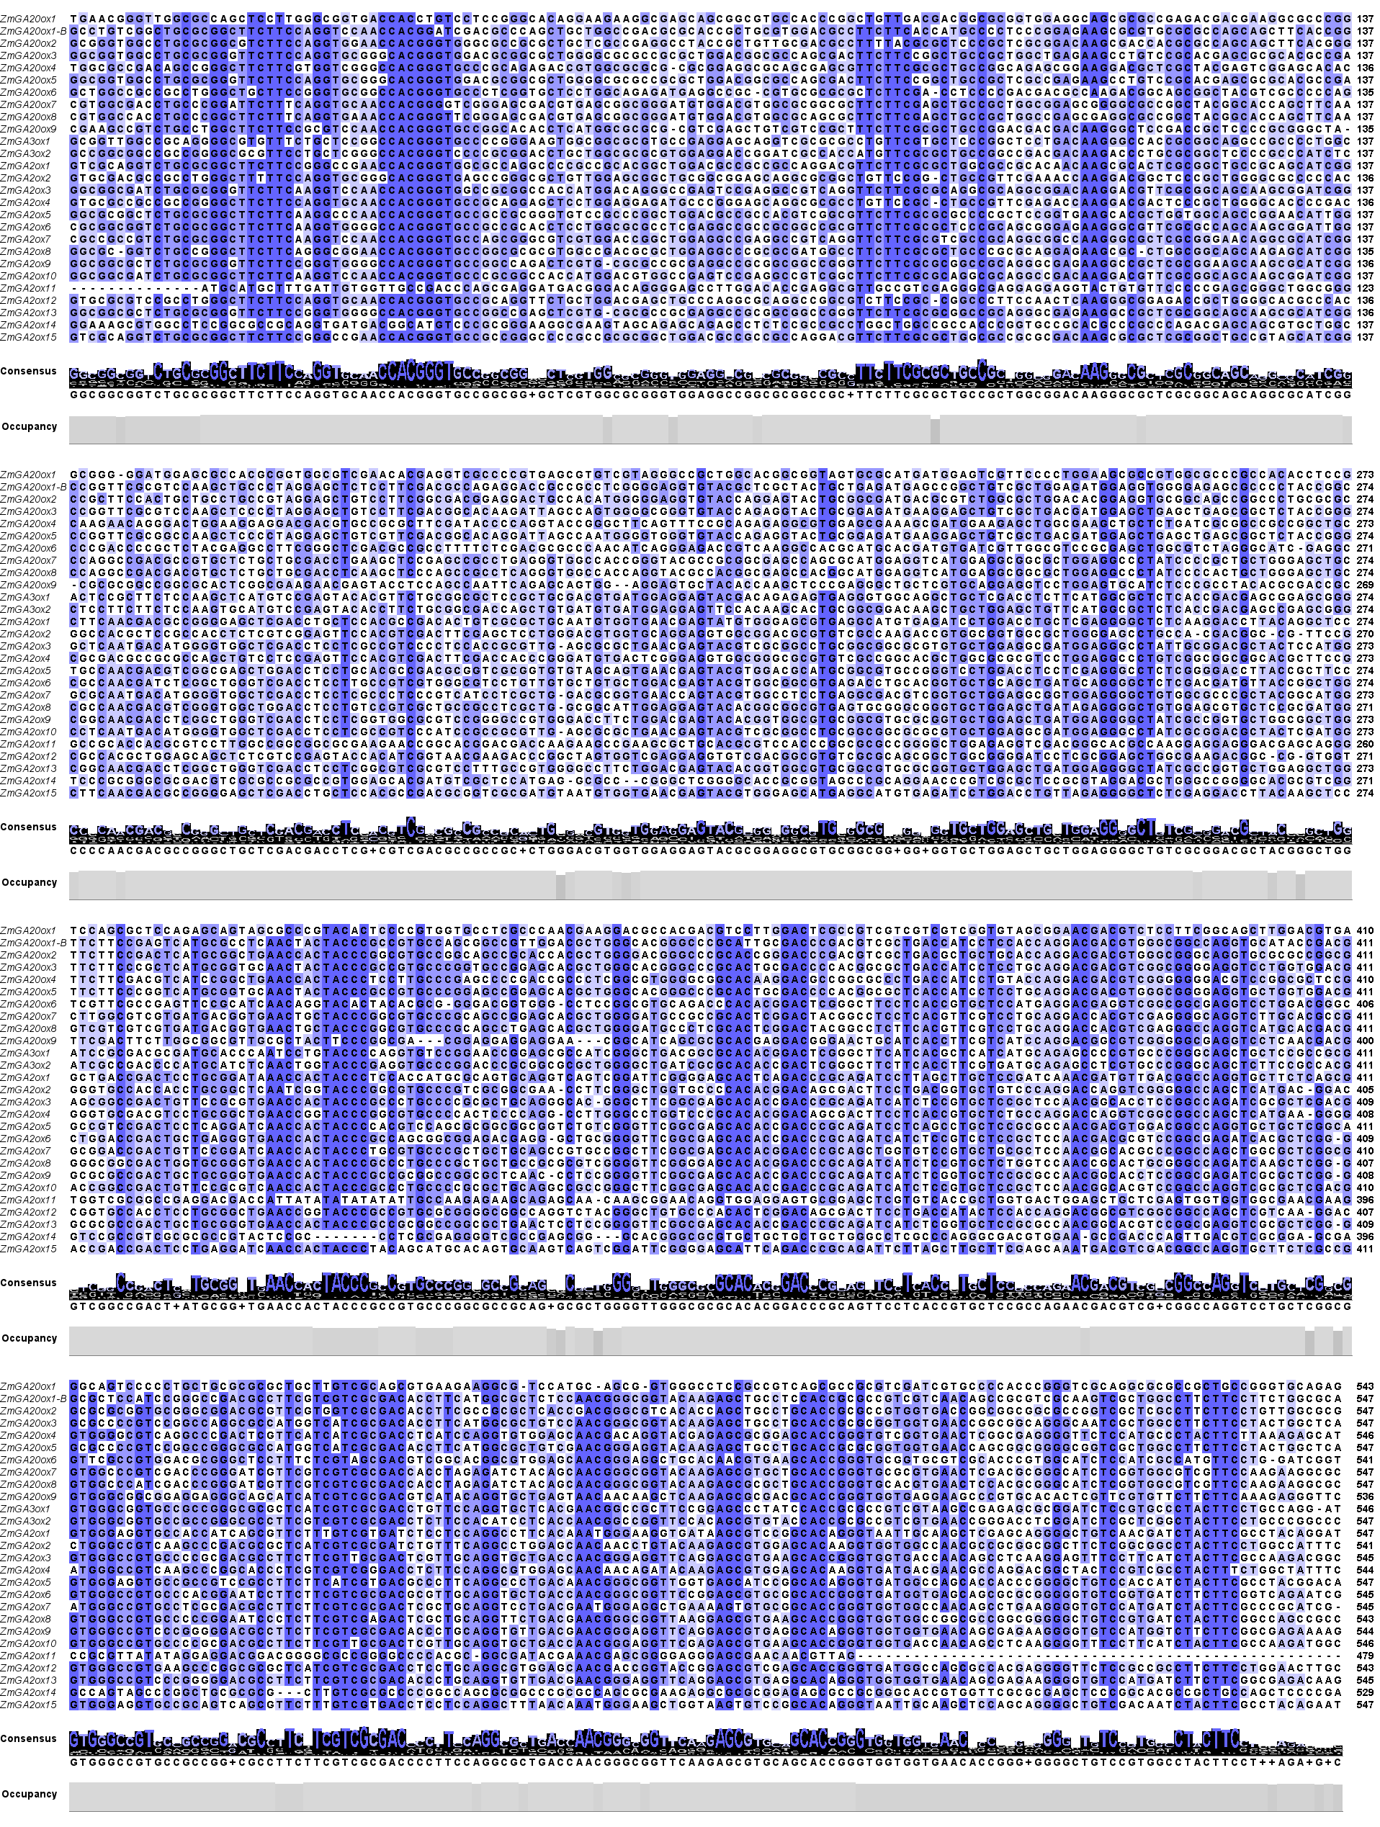

Fig.S1 DNA sequence (CDS) comparison of the maize ZmGAox gene family. Genomic DNA sequences were visualized using Jalview software, where darker blue areas indicate higher sequence similarity. “Consensus” shows the most common bases at each position in all aligned sequences. “Occupancy” indicates the frequency of occurrence of the most common base at each position.

