Supplementary Material

Physiological and environmental control of seed germination timing in Mediterranean mountain populations of Gundelia tournefortii

Efisio Mattana^{1,*}, Pablo Gómez-Barreiro², Nizar Youssef Hani³, Khaled Abulaila⁴,
Tiziana Ulian¹

1. Natural Capital and Plant Health Department, Royal Botanic Gardens, Kew, Wakehurst, RH17 6TN, Ardingly, West Sussex, UK.
2. Analytical Methods Department, Royal Botanic Gardens, Kew, Wakehurst, RH17 6TN, Ardingly, West Sussex, UK.
3. Shouf Biosphere Reserve (SBR), Park house, El Shouf, Maasser El Shouf, Lebanon. ORCID:
4. National Agricultural Research Center (NARC), Al-Baqa’, 1931, Jordan.

* corresponding author: e.mattana@kew.org

Table S1 – Seed lot details of the investigated populations. All seed collections were carried out inside the Shouf Biosphere Reserve.
Code | Site | Details | Date | N | E | Altitude  (m a.s.l.) | Germination  experiments | Puncture force  experiments
1058617 | Niha | Ain el halkoum | 11/07/19 | 33.57 | 35.61 | 1318 |  | x
1058628 | Maasser | Dalboun | 14/07/19 | 33.69 | 35.67 | 1255 | x | x
1058639 | Barouk | Ain lejjeh | 15/07/19 | 33.69 | 35.72 | 1672 | x | x
1058640 | Barouk | Dalboun Road | 16/07/19 | 33.69 | 35.66 | 1143 |  | x
1058651 | Ain Zhalta | Shouf Reserve | 16/07/19 | 33.72 | 35.72 | 1500 |  | x
1058662 | Maasser | Dalboun | 18/07/19 | 33.69 | 35.67 | 1291 |  | x
1058673 | Mrusti | Road to mountain | 25/07/19 | 33.62 | 35.66 | 1590 |  | x
1058684 | Jbaa | Near Ain shaashouaa | 01/08/19 | 33.60 | 35.64 | 1181 |  | x
1058695 | Mrusti | Road to mountain | 08/08/19 | 33.62 | 35.66 | 1590 | x
1058709 | Barouk | Dalboun Road | 08/08/19 | 33.69 | 35.67 | 1143 |  | x
1058721 | Niha | Ain el halkoum | 08/08/19 | 33.57 | 35.62 | 1318 |  | x
1058710 | Jbaa | Near Ain shaashouaa | 08/08/19 | 33.60 | 35.64 | 1181 | x

Figure S1 – Historic climatic data for the sampled localities downloaded at a resolution of 30 sec. from the WorldClim v2 website (Fick and Hijmans, 2017) and extracted using the “raster” package (Hijmans, 2020).

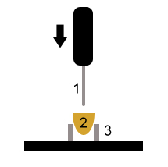
a
b
Figure S2 – a. Schematic representation of the puncture force experiment (1. probe, 2. sample, 3. sample support). b. Force vs. time visualization; the peak (maximum force) corresponds to the puncture event.

Figure S3 – Puncture force assessed for dry capitula and after 2 days, 1 month and 2 months cold-wet incubation at 5°C.

Table S2 – Linear mixed model fitted by RMEL on the status of imbibition (fixed factor: Dry and “48h imbibition) on the peak puncture force (N) applied to the basal area of the capitulum for each investigated seed lot (random factor). Confidence intervals that do not cross zero confirm the validity of the estimate. RMEL criterion at convergence; 328. Random effect variance: 0.007077 ± 0.08412. Random effect residual variance: 2.911096 ± 1.70619.
 | Estimate | Std. Error | t value | CI 2.5% | CI 97.5%
Intercept | 5.0329 | 0.2652 | 18.98 | 4.510718 | 5.5547514
48h imbibition | -4.3609 | 0.3726 | -11.70 | -5.094670 | -3.6320655

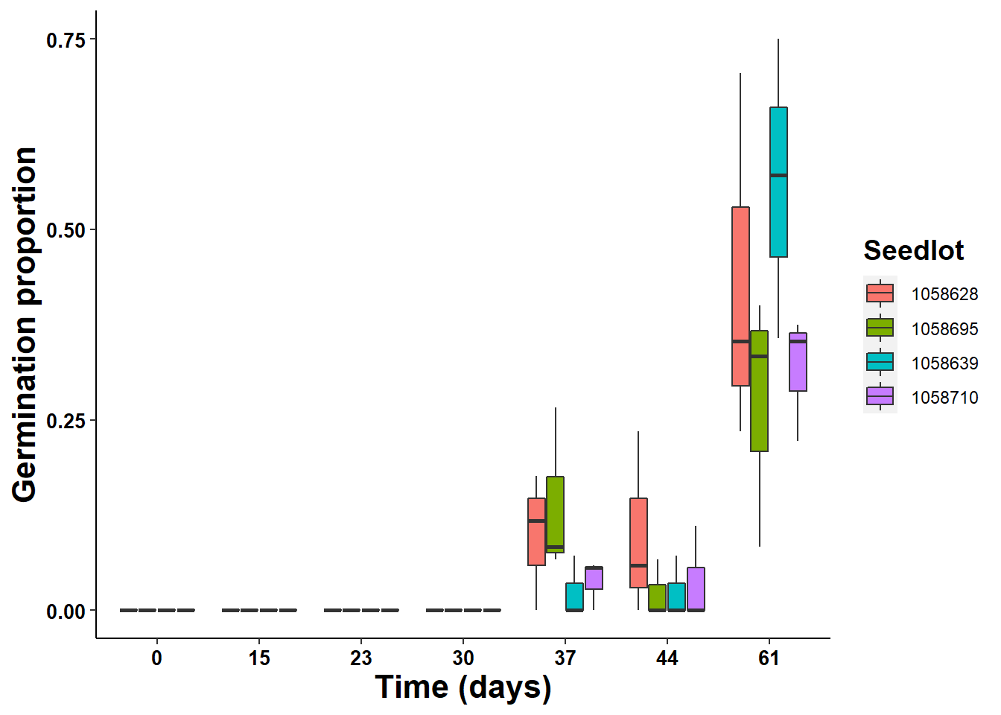
Figure S4 – Seed germination of capitula recorded weekly during cold-wet incubation at 5°C

Table S3 – Linear mixed model fitted by RMEL on the duration of cold-wet incubation at 5°C (fixed factor as continuous variable) on the peak puncture force (N) applied to the basal area of the capitulum (seed lot as random factor). Confidence intervals that do not cross zero confirm the validity of the estimate. RMEL criterion at convergence; -53.8. Random effect variance: 0.002021 ± 0.04496. Random effect residual variance: 0.032414 ± 0.18004.
 | Estimate | Std. Error | t value | CI 2.5% | CI 97.5%
Intercept | 0.6757017 | 0.0305020 | 22.15 | 0.61634551 | 0.736107070
Time | -0.0089030 | 0.0008674 | -10.26 | -0.01059701 | -0.007114228

