Supplementary Figures:
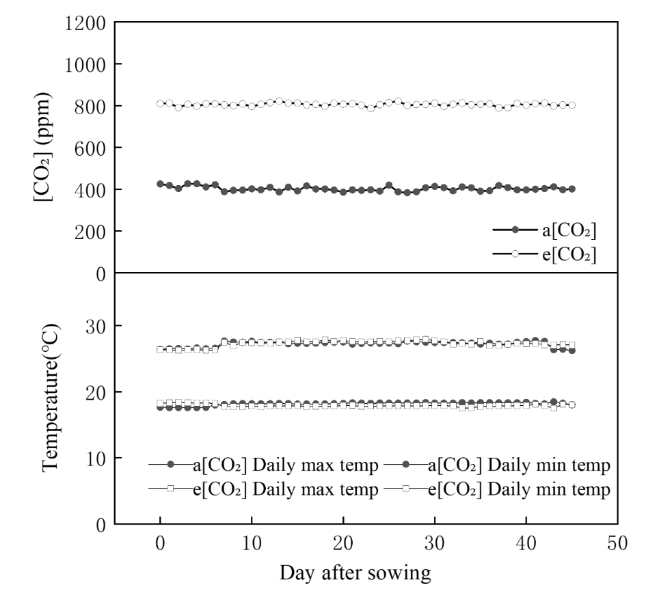
S1. The average of daily temperature (T) and CO₂ concentration ([CO₂]) in the chambers during the experiment.

S2. Changes of the fraction of transpirable soil water (FTSW) during the experimental period. “WW “and “DS” refer to well-watered and drought-stressed conditions, respectively.

