Supplementary Material
Regulation pathways of biochar and endophytic bacteria in Na⁺ translocation and salt stress alleviation in the soil-plant system
Xinyue Zhao ¹, Ping Sun ²*, Lei Wang⁵, Jiaxin Liu ¹, Pengzhan Lu ¹, Lecheng Liu^{1,3,4}, Youyuan Chen ^{1,3,4}*
(1. College of Environmental Science and Engineering, Ocean University of China, Qingdao 266100, China; 2. Key Laboratory of Geological Safety of Coastal Urban Underground Space, Ministry of Natural Resources (Qingdao Geo-Engineering Surveying Institute), Qingdao 266101, China; 3. Key Laboratory of Marine Environment and Ecology, Ministry of Education of China, Ocean University of China, Qingdao 266100, China; 4. Shandong Provincial Key Laboratory of Marine Environment and Geological Engineering, Ocean University of China, Qingdao 266100, China; 5. North China Municipal Engineering Design & Research Institute Co., Ltd.)
*Corresponding author.
- mail address: youyuan@ouc.edu.cn (Youyuan Chen); sunpingllj@163.com (Ping Sun)
ORCID: 0000-0001-9852-0335

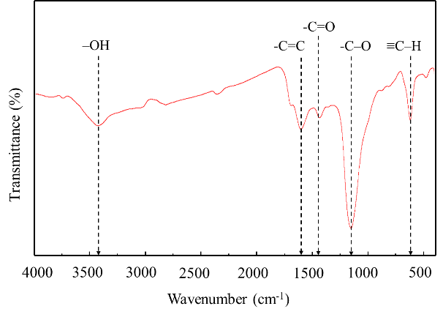
Figure S1. FTIR spectrum of Enteromorpha prolifera biochar

Table S1. Validity evaluation of the PLS-PM model which describes the pathways of Sphingomonas prati and Enteromorpha prolifera biochar effects on physiological response and Na⁺ transport in Suaeda salsa.
Item | SSO | SSE | Q²(=1-SSE/SSO)
SS | 12.000 | 2.809 | 0.766
PG | 36.000 | 5.372 | 0.851
PNU | 36.000 | 14.073 | 0.609
OM | 36.000 | 5.844 | 0.838
AS | 36.000 | 3.236 | 0.910
RS | 12.000 | 1.526 | 0.873
SS: Soil sodium; PG: Plant growth parameters; PNU: Photosynthesis and nutrient uptake; OM: Osmotic metabolism; AS: Antioxidation system; RS: Root sodium

