Appendix A. Supplementary data
Fig. S1 Light treatment conditions, relative portion of red (R), blue (B) in their combination: Treatment 1 — control (“white”, T_{color}=2500K); Treatment 2 — 50% R; Treatment 3 — 50% B; Treatment 4 — 50% R + 50% B.
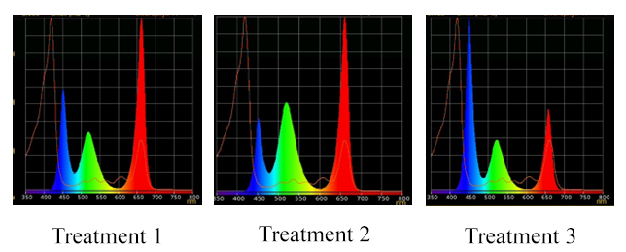

Fig. S2 Light treatment conditions, relative portion of red (R), “red” (∆λ_{0.5}= 645 ÷ 666 nm, λ_{max} = 656 nm), “blue” (∆λ_{0.5} = 435 ÷ 458 nm, λ_{max}= 447 nm), “green” (∆λ_{0.5}= 500 ÷ 540 nm, λ_{max} = 518 nm), and in their combination: Treatment 1— 50% R + 25% B + 25% G; Treatment 2— 24% R +28% B + 48% G; Treatment 3 — 46% R +30% B +23% G.

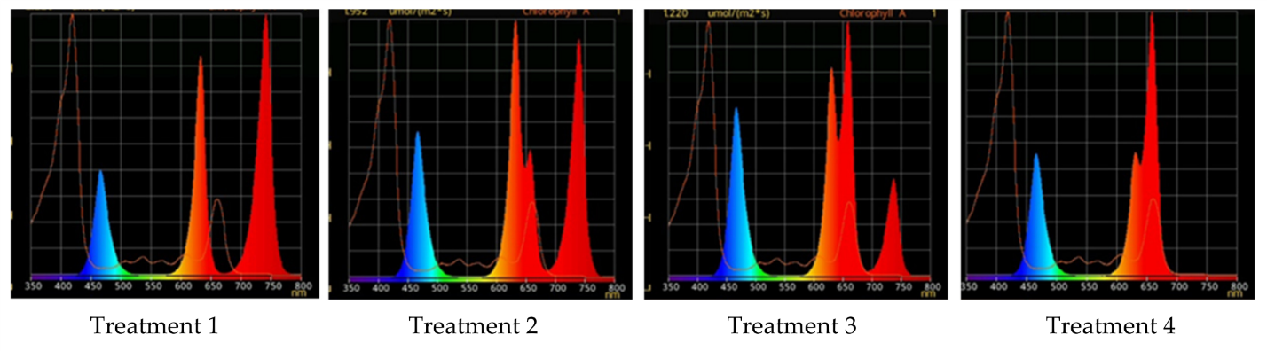
Fig. S3 Light treatment conditions, relative portion of red, λ_{max} = 660 nm (R₆₆₀), λ_{max} = 640 nm (R₆₄₀) and far-red, λ_{max} = 739 nm (FR), “blue”, λ_{max} = 447 nm in their combination: Treatment 1 — 0% R₆₆₀ + 100% FR; Treatment 2 — 30% R₆₆₀ + 70% FR; Treatment 3 — 70% R₆₆₀ + 30% FR; Treatment 4 — 100% R₆₆₀ + 0% FR.

Table 1.
Light treatment | Spectrum | PPFD  ($±$10)  $$\frac{μmol}{m^{2}∙s }$$
R | 100% red light | 75
RB | 50% blue light  50% red light | 150
B | 100% blue light | 75
Control | “white”  (COB, T_{color} = 2500K). | 150
G25 | 50% red  25% blue  25% green | 150
G48 | 24% red  28% blue  48% green | 150
G23 | 46% red  30% blue  23% green | 150
FR1 | 0% R₆₆₀ + 100% FR | 75
FR2 | 30% R₆₆₀ + 70% FR | 75
FR3 | 70% R₆₆₀ + 30% FR | 75
FR4 | 100% R₆₆₀ + 0% FR | 75

Table 2.
SaSLAH3_RT_F | TTGCATTGGTGGTTGCTGTT
SaSLAH3_RT_R | CACCTCTTCCGGACAACCAA
SaeELF1alfa_F1* | TGAGATGTGTGGCAATCC
SaeELF1alfa_R1* | GTTGCTTCTGACTCCAAGAAT
* MN076325.1
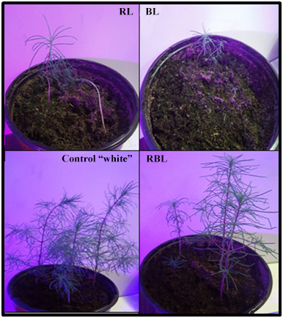
Fig. S4 Representative images showing Suaeda altissima plants that were grown for 55 days under quasi-monochromatic light spectra Control – “white” (COB, T_{color} = 2500K);
RL – 100% red light; BL – 100% blue light; RBL – 50% red light, 50% blue light.
Plants were grown inside a growth room with an average PPF of 75 or 150 ± 5 µmol·m^{‒2}·s^{‒1} (18-h photoperiod) provided by tunable LEDs (Cree, USA) lamps.
Fig. S5 Representative images showing Suaeda altissima plants that were grown for 55 days under RGB light spectra G25 – 50% red, 25% blue, 25% green, G48 – 24% red, 28% blue, 48% green, G23 – 46% red, 30% blue, 23% green.
Plants were grown inside a growth room with an average PPF of 150 ± 5 µmol·m^{‒2}·s^{‒1} (18-h photoperiod) provided by tunable LEDs (Cree, USA) lamps.

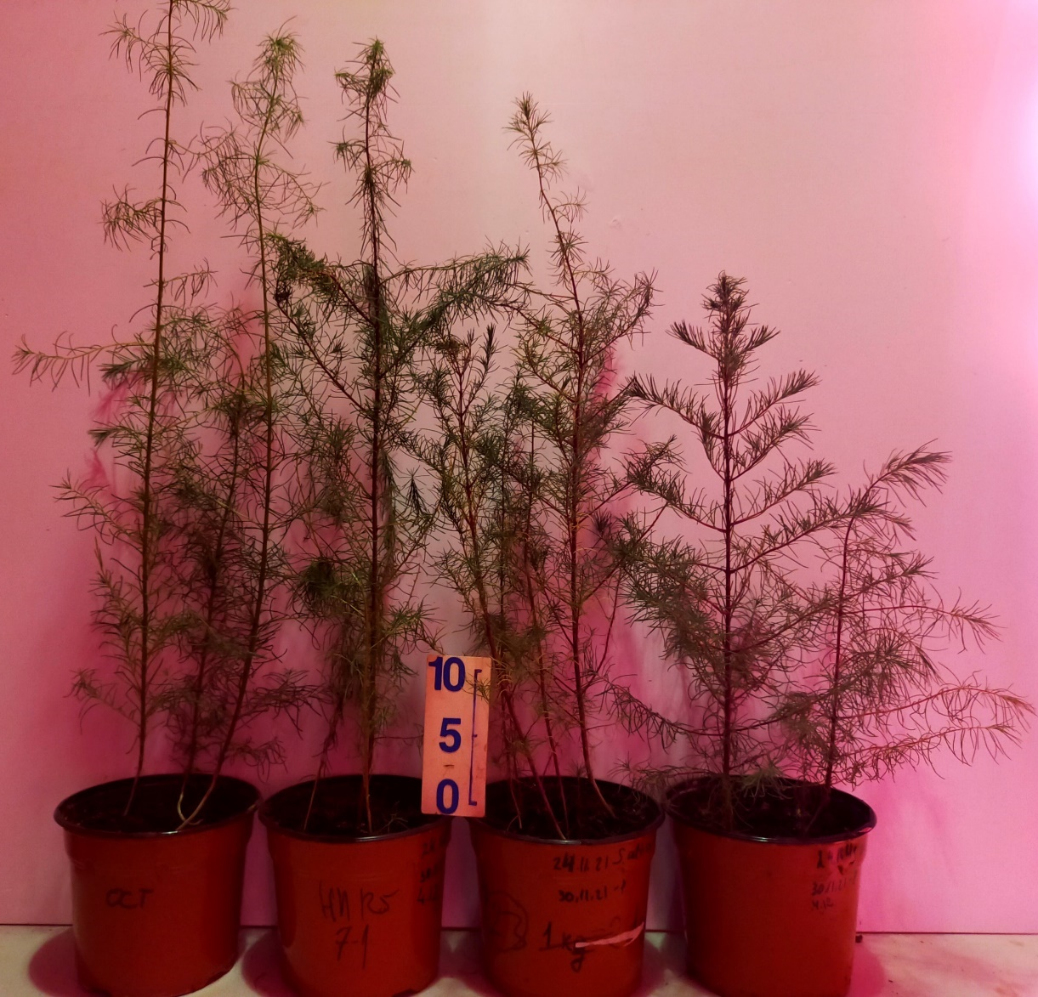
Fig. S6 Representative images showing Suaeda altissima plants that were grown for 55 days under R/FR light spectra FR1 – 0% R₆₆₀+100% FR, FR2 – 30% R₆₆₀+70% FR, FR3 – 70% R₆₆₀+30% FR, FR4 – 100% R₆₆₀+0% FR.
Plants were grown inside a growth room with an average PPF of 75 ± 5 µmol·m^{‒2}·s^{‒1} (18-h photoperiod) provided by tunable LEDs (Cree, USA) lamps.

.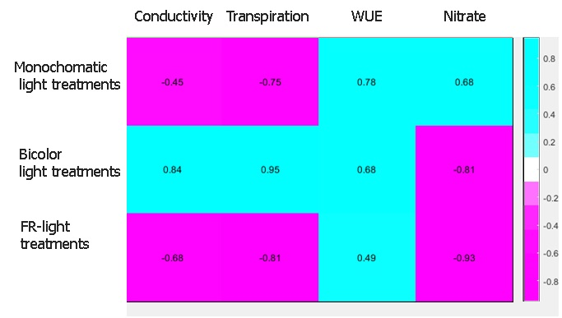
Fig. S7 Correlation heat map of SaSLAH3 gene expression and Conductivity, Transpiration, WUE_{i} and Leaf nitrate concentrations. Pearson’s correlation was calculated among SaSLAH3 expression and Conductivity, Transpiration, WUE_{i} and Leaf nitrate concentrations between three-four independent experiments. Colour key indicates the correlation higher than absolute value 0.3 between genes: purple, negative correlation; blue, positive correlation. The data displayed in MATLAB software.

