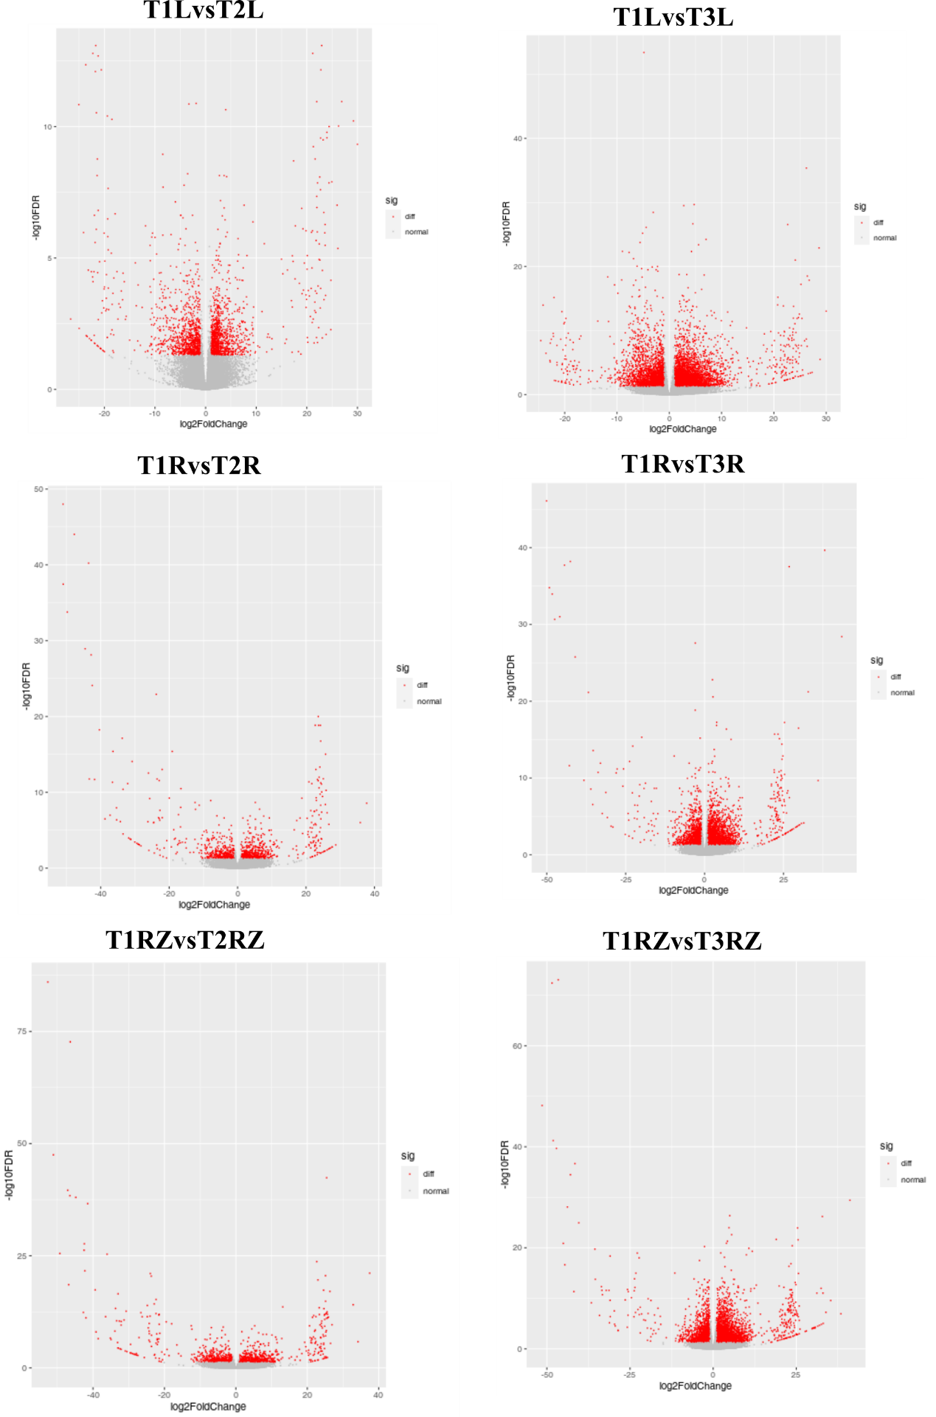
Figure S1. Volcano plots depict the differentially expressed genes identified under different temperatures. T1; 28ºC, T2; 34ºC, T3; 40ºC. 2d; 2 days after treatment, 4d; 4 days after treatment, 6d; 6 days after treatment.
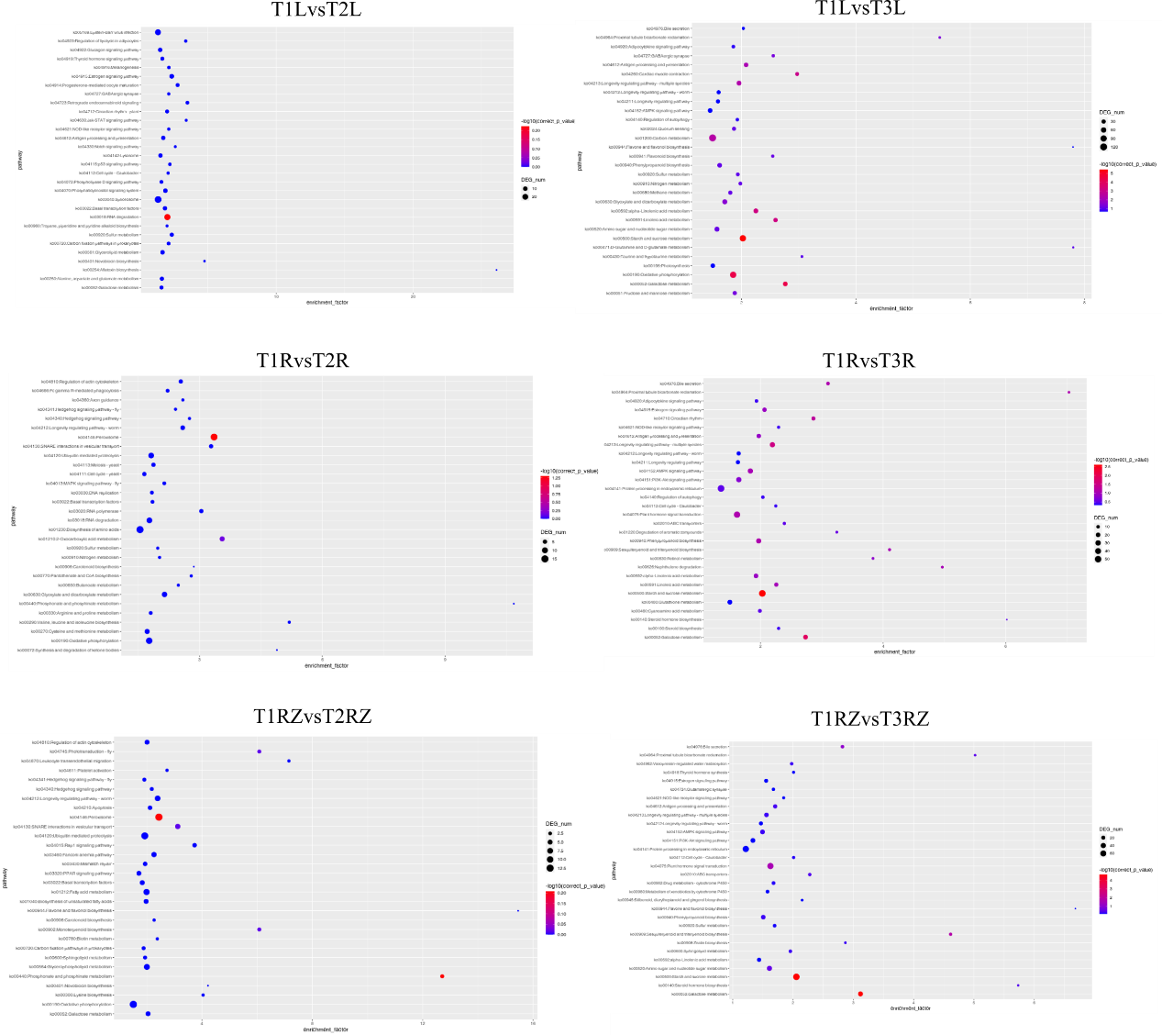
Figure S2. KEGG pathway enrichment analysis for differentially expressed genes in A. lancea under different temperatures. T1; 28ºC, T2; 34ºC, T3; 40ºC. 2d; 2 days after treatment, 4d; 4 days after treatment, 6d; 6 days after treatment.

