Supplementary file
S1. Materials and methods
S1.1. Morphological changes in seedling:
The seedlings were harvested and washed with deionized water. The root was cut into 1mm length from the tip region, transverse section as well as whole root tips, whole leaf specimen were fixed in 2% glutaraldehyde for 24h, followed by passage of the samples through alcohol gradation (10, 30, 50, 70, 80, 90, 100%). The dehydrated specimens were positioned on aluminium stubs, sputter coated with platinum and observed by SEM (ZEISS EVO-MA 10; Carl Zeiss Pvt.Ltd., Oberkochen).
S1.2. Osmolytes: Glycine betaine, Proline, trehalose, carbohydrate, reducing sugar, total amino acid
0.5 g dried tissue was extracted with 0.05% toluene, according to (Grieve and Grattan 1983), the final addition of Dichloromethane separated the glycine betaine in the organic phase which was read at 365nm using UV-Vis spectrophotometer (Shimadzu). Proline was estimated according to (Bates et al. 1973) with minor modifications, 0.5g tissue was homogenized with 0.1M sulphosalicylic acid, toluene was used in the final step for separating proline in the organic phase which was measured at 520nm using colorimeter (Abzyme).Trehalose content was estimated according to (Trevelyan and Harrison 1952) with minor changes. 0.1g dried tissue were grounded to fine powder and extracted with 80% ethanol, final reaction was initiated by addition of 0.5M Trichloroacetic acid and anthrone reagent, the product formed was measure at 620nm. Total carbohydrate content was estimated in accordance to (Hedge and Hofreiter 1962) ,0.1 g dried tissue was ground and extracted with 2.5N HCl for 2h at 85˚C, after neutralization with 20% Na₂CO₃, final reaction was initiated with anthrone reagent, product formed was measured at 630nm. Reducing sugar content was estimated following the method described by (Miller 1972). 0.1g dried tissue was extracted with 80% ethanol, final reaction mixture contained equal volume of supernatant and DNSA reagent, along with 40% sodium potassium tartarate, followed by heating at 60˚C for 10 min, the brown coloured product formed was measured at 510nm. The free amino acids were estimated according to (Lee and Takahashi 1966) by ninhydrin reagent method.
S1.3. Antioxidative enzyme activities: Superoxide dismutase (EC 1.15.1.1), catalase (EC 1.11.1.6), guaiacol peroxidase (EC 1.11.1.7), phenylalanine ammonia lyase (EC 4.3.1.24), polyphenol oxidase (EC 1.10. 3.1)
To estimate superoxide dismutase (SOD) activity, 0.1g fresh tissue was homogenized in 50mM phosphate, final enzyme extract was incubated with 80mM Tris-HCl buffer, 0.12mM EDTA, 10.8mM TEMED, 6mM NBT, 0.6mM riboflavin, exposed to fluorescent bulbs for 15 min, one unit SOD activity is expressed as 50% inhibition of NBT per gram fresh weight at 560nm (Giannopolitis and Ries 1977). Enzyme extract for catalase (CAT) activity was prepared in the same way, the rate of change in absorbance at 240nm due to 30mM H₂O₂ decomposition was measured using extinction coefficient of 39.4mM⁻¹cm⁻¹ (Aebi 1984). Guaiacol peroxidase activity (GPOD) was measured by change in absorbance at 470nm due to increase in tetraguaiacol formation, resulting from oxidation guaiacol, extinction coefficient 25.5mM⁻¹cm⁻¹ (Castillo et al. 1984). For analysis of Phenylalanine ammonia lyase (PAL) activity, 1g of tissue was homogenized in 50mM sodium borate buffer containing B-mercaptoethanol and PVP, to the enzyme extract borate buffer and L-phenylalanine was added, the rate of formation of trans cinnamate was measured at 290nm(Qin and Tian 2005). Polyphenol oxidase (PPO) activity was determined by addition of enzyme extract to the substrate, catechol, the rate of change in absorbance was measured at 398nm (Chen et al. 2000)
S1.4. Non enzymatic antioxidants: Carotenoids, anthocyanins, phenol, flavonoid, Ascorbate, free radical scavenging activity.
Carotenoid content was estimated from leaves of the seedlings according to (Kirk and Allen, 1965). To estimate the anthocyanin content, leaves were chopped and shaken with ethanol:HCl (85:15) for 72 h under dark conditions, extract was read at 535nm (Abdel- Aal and Hucl 1999). To analyze total phenolic content (TPC) and total flavonoid content (TFC), 0.1g tissue was homogenized in 80% ethanol, Folin Ciocalteu reagent method was used for estimation of TPC at 650nm (Malik and Singh 1980). TFC was determined using aluminium chloride method at 510nm (Ibrahim et al. 2011). Total ascorbate content was estimated according to (Cakmak and Marschner 1992), 0.1 g tissue was homogenized in 75mM sodium phosphate buffer, final product developed on addition of 10% TCA, 44% ortho-phosphoric acid 4%a'-dipyridyl in 70% ethyl alcohol and 3%FeCl₃ to the extract, coloured product was measured at 525nm. To estimate the free radical scavenging activity (FRSA), 0.1g of tissue was extracted in methanol:water (1:1), to study the scavenging activity 2,2 diphenyl-1- picrylhydrazil (DPPH) was used as stable free radical, the reaction mixture was incubated for 20 minutes in dark, the absorbance was measured at 517nm (Williams et al. 1995).
S1.5. Structural changes in functional groups
The shoot and root samples were shade dried for 10days to remove the moisture content. The dried tissue samples were ground to a fine powder. The FTIR spectrum was recorded in (3000 Hyperion Microscope with Vertex 80 FTIR System) in the region 450 to 4000 cm⁻¹, at SAIF, IIT Bombay.
S1.6. cDNA sequence analysis
The 5’UTR, 3’UTR and exons of OsNRAMP1 and OsNRAMP5 from both the cultivars were subjected to sequencing and the sequencing data was submitted to NCBI (GenBank Accessions: MW715875, MW715876, MW715877, MW715878, MW715879, MW715880, MW715881. MW715882, MW715883, MW715884, MW715885, MW715886, MW715887, MW715888). The PCR amplicons were checked for presence of single bands and were purified by HPLC, followed by Sanger sequencing (AgriGenome Labs, India). The sequences were trimmed out of overlapping sequences (Snapgene viewer). NRAMP domain-positive sequences were verified from the Pfam and the NCBI BLASTX program showing homology to known NRAMP genes with high E-value were evaluated. The presence of promoter and untranslated regions in the retrieved sequences were also checked using RAP-DB. The sequences of the two genotypes having the same amplifying primers were compared to analyse whether there are any sequential difference by using pairwise sequence alignment (AlignX, Vector NTI 11).
S1.7. Pot experiment
The pot experiments were carried out in Agricultural experimental Farm of University of Calcutta, Baruipur, South 24 Parganas (22.35˚N, 88.44˚E) situated in the Gangetic alluvial region under suitable conditions of 14/10 photoperiod, 30±2˚C and 70% relative humidity. Around 100 germinated seedlings were transferred to a pot having 2kg of soil and allowed to grow for 21 days following which 3-4 seedlings were transferred to a separate pot and allowed to grow till maturity. Both the cultivars were treated to 50µM Cd (5.6 mg kg⁻¹ Cd) by application of aqueous solution of CdCl₂ to 3Kg of soil per pot. Alongside a control set was taken which was not treated to Cd. The experiment was performed in triplicates.
S1.8. Estimation of Cd content in grains
100mg of oven dried grain samples were subjected to complete digestion in HClO₄:HCl:HNO₃ (4:2:1) following which the volume was made upto 25 ml with deionised distilled water (Majumdar et al. 2020). The Cd content in the samples were estimated by ICP-AES (SPECTRO Analytical instruments GmbH, Germany)
S2. Results
S2.1. Morphological parameter: Root morphology by SEM
Scanning micrographs of root tips, root transverse sections and root surface showed increased ultrastructural deformities with increasing Cd exposure concentration and time. The vascular tissue was highly distorted in IR64 in comparison to Dudheswar, specially, in seedlings exposed to Cd stress for more than 48h. The root tips and epidermis were structurally deformed in seedling exposed for longer periods.
S2.2. Osmolytes: Glycine betaine, Proline, trehalose, carbohydrate, reducing sugar, total amino acid
Regulation of osmolytes is an important factor contributing to stress tolerance. All osmo-regulants were found to accumulate significantly in CV. Dudheswar in comparison to CV. IR64. Glycine betaine and proline content increased significantly in CV. Dudheswar root and shoot in comparison to CV. IR64, both the proline and glycine betaine content showed similar trend by increasing gradually till T5 set followed by a decline in increase in T6 root by 12% for proline and glycine betaine content decreased by 78% in CV. IR64 of T6 root. Trehalose accumulation in root and shoot of CV. Dudheswar escalated in a dose dependent manner, whereas in CV. IR64, the trehalose content dropped significantly after T3 set and T2 set in shoot and root respectively. The carbohydrate content showed a dissimilar shift in CV. Dudheswar shoot, where it dropped in the T6 set, a highly varied response in terms of carbohydrate production was seen in CV. IR64, a gradual decrement was observed in both shoot and root after the T1 set. The reducing sugar and free amino acid accumulation was found to tremendously increase in both root and shoot of CV. Dudheswar in comparison to CV. IR64 (Fig.S3.2a-f).
S2.3. Differential regulation of protective metabolites and components
Superoxide dismutase (EC 1.15.1.1), catalase (EC 1.11.1.6), guaiacolperoxidase (EC 1.11.1.7), glutathione reductase (EC 1.8.1.7), glutathione peroxidase (EC 1.11.1.9), phenylalanine ammonia lyase (EC 4.3.1.24), polyphenol oxidase (EC 1.10. 3.1)
The antioxidant enzyme activity were much higher in CV. Dudheswar in comparison to CV. IR64, SOD, CAT and GPOD activity were tremendously hiked in CV. Dudheswar, the increase in CAT activity being the highest of 99.6% in CV. Dudheswar root, with respect to CV. IR64 root. The positive shift in SOD and GPOD activity were comparatively lower than that of shoot in CV. Dudheswar, which were 74% and 51% higher than that of CV. IR64 in T6 root. The PAL and PPO activity were highly elevated in CV. Dudheswar, which increased in dose dependent manner, in contradiction to the trend observed in CV. IR64, the PAL and PPO activity of which were retarded in T5 and subsequent treatment sets in both root and shoot, however the highest increase was observed in PAL activity which increased by 99.5% and 98.2% in CV. Dudheswar shoot and root respectively in comparison to CV. IR64 (Fig.S3.4a-e).
S2.4. Non enzymatic antioxidants: Carotenoids, anthocyanins, phenol, flavonoid, ascorbate, free radical scavenging activity.
A highly contradictory response was observed between the two cultivars w.r.t. pigment production, both the anthocyanin and carotenoid contents decreased significantly in CV. IR64, in contrast to CV. Dudheswar where both the pigments increased considerably. The phenol and flavonoid contents increased in shoot and root of both the CV.s, however the increase in phenol content was more prominent in shoot and root of CV. being 16% and 18% respectively in T6 set, in comparison to untreated set. The ascorbate content and free radical scavenging activity showed a similar trend, both of which increased significantly in root (7% for ascorbate content, 16% for radical scavenging activity) and shoot (20% for ascobate content, 29% for radical scavenging activity) of CV. Dudheswar whereas very mere increase upto 18% of CV. IR64 shoot, followed by decline in the subsequent sets was observed (Fig.S3.5a-f).
In our study, ascorbate and DPPH activity rocketed to high extents in CV. Dudheswar in comparison to CV. IR64, indicating the enhanced tolerance in CV. Dudheswar.
S2.5. Cd induced differential alteration in the functional groups
Variability in wave numbers corresponding to peaks and peak width were observed among the cultivars and among the treatment groups. Differences were seen around the wave number range 1800-1200 cm⁻¹, higher change was seen in FTIR spectrum of CV. IR64 in comparison to CV. Dudheswar (Table S4.2). Infrared spectrum of control root (CR) of CV. Dudheswar and CV. IR64 showed bands at 1735 cm⁻¹ and 1745 cm⁻¹ respectively, due to C=O stretching of ester carbonyl (Usman et al., 2019) they shifted to 1756 cm⁻¹ and 1725 cm⁻¹ respectively in treated root (TR) which might be indicative of the chelated carboxyl, in CV. IR64 the peak at 1620 cm⁻¹ was upshifted to multiple non-specific peaks in the region around 1635 cm⁻¹, indicative of the changed protein conformity in the amide I region under Cd stress. The band at 1506 cm⁻¹and 1519 cm⁻¹ of CR in CV. Dudheswar and CV. IR64 respectively showed an up-shift to 1519 cm⁻¹and downshift to 1506 cm⁻¹ respectively, corresponding to N-H bending vibrations (Usman et al., 2019). Analytical information can be obtained about phosphodiester functional groups that lies in the region between 1300 cm⁻¹and 1200 cm⁻¹which is attributed to >P=O asymmetric stretching frequencies (Usman et al. 2019), a higher change was observed in this region in CV. IR64 under cadmium stress which is due to P=O asymmetric stretching vibrations of phosphodiesters. The regions from 1200 cm⁻¹ to 900 cm⁻¹is attributed by a sequence of bands due to C-O, C-C, C-O-C and C-O-P stretching vibrations of polysaccharides (Usman et al. 2019) which mainly occur in carbohydrates and cellular polysaccharides.
S2.6. Sequence analysis across the two genotypes revealed no difference
Alignment of sequences across both the genotypes revealed no differences in the partial sequence assessments of OsNRAMP1 and OsNRAMP5 coding regions, 3⸍UTR regions of OsNRAMP1 and OsNRAMP5, and 1 Kb promoter region of OsNRAMP5. A partial nucleotide sequence of 1.4 Kb belonging to the protein coding region of OsNRAMP1 was compared between the two genotypes which exhibited absence of difference of sequence at the nucleotide level. A 0.72 Kb sequence belonging to the coding region of OsNRAMP5 were compared across CV. IR64 and CV. Dudheswar which also showed no difference. 3⸍ UTR sequences of 490 bp and 510 bp belonging to OsNRAMP1 and OsNRAMP5 respectively were also aligned and compared across the two genotypes, no difference of sequence was found at the nucleotide level across the two genotypes. Sequence alignment of OsNRAMP5 promoter sequence also showed no difference between the two genotypes (Fig.S3.8.a-e).
S2.7. A significant difference among the two genotypes was observed with respect to accumulation of Cd in grains
Among the two cultivars, IR 64 accumulated around 3mg Kg⁻¹ Cd in the grains and Dudheswar was reported to accumulate no Cd in the grains(Fig.3.9).
S3. Supplementary figures
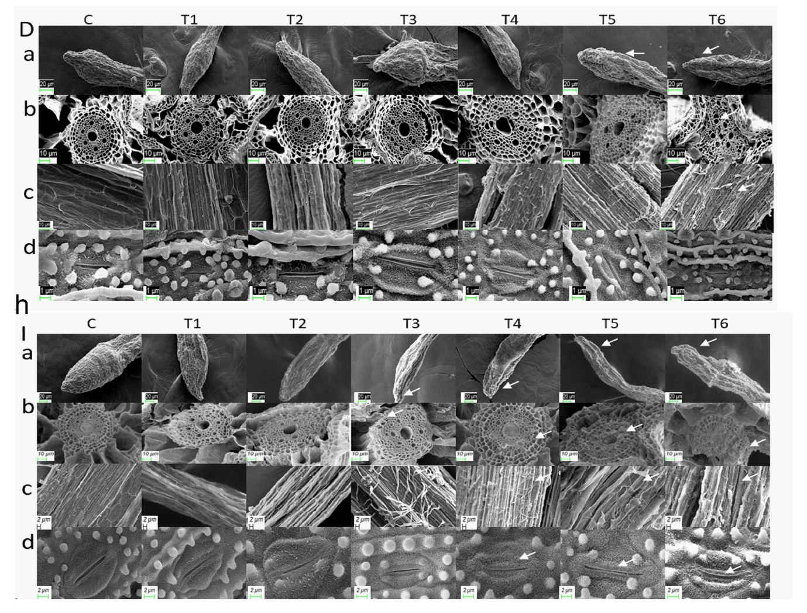
Fig.S3.1: Effect of Cd exposure on morphological parameters by Scanning Electron Micrograph images showing differential morphology of genotype D (Dudheswar) and I (IR64 under Cd stress a) whole root tip, b) root transverse section, c) Root surface, d) Stomata. (C-control set with 0µM Cd, T1-25µM Cd for 24h, T2-50µM Cd for 24h, T3-25µM Cd for 48h, T4- 50µM Cd for 48h, T5- 25µM Cd for 72h, T6- 50µM Cd for 72h).
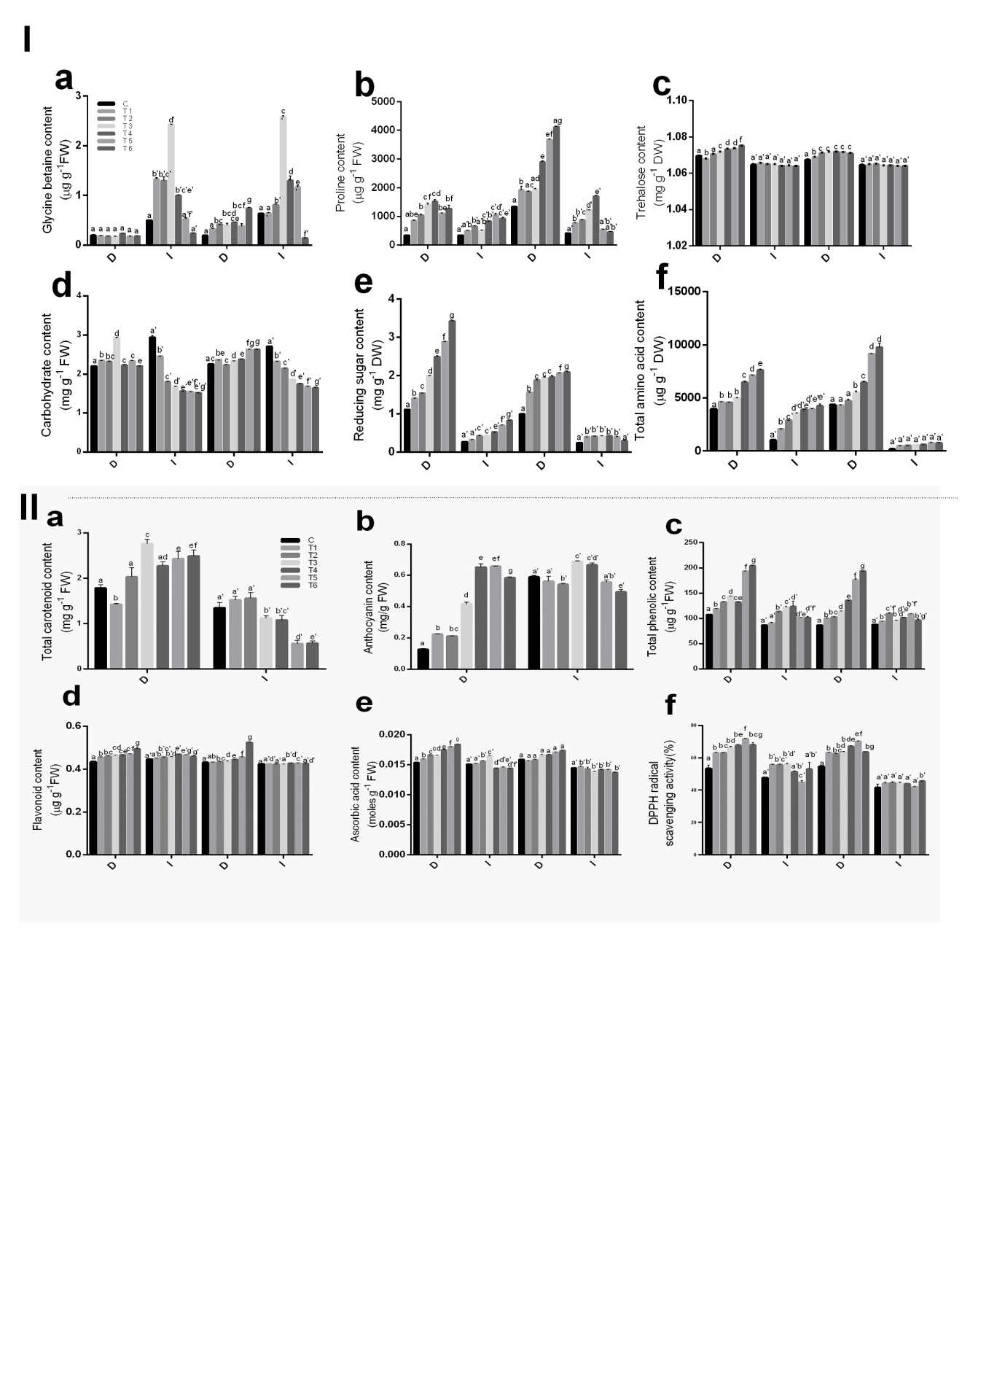
Fig.S3.2: Effect of Cd on Osmolytes a) Glycine betaine, b) Proline, c) Trehalose, d)Carbohydrate, e) Reducing sugar, f) Total amino acid. The values are represented as the mean of three independent replicates. The Mean values denoted by the same letters are not significantly different; different letters represent statistical significance at p<0.05. (D:Dudheswar, I:IR64, C-control set with 0µM Cd, T1-25µM Cd for 24h, T2-50µM Cd for 24h, T3-25µM Cd for 48h, T4- 50µM Cd for 48h, T5- 25µM Cd for 72h, T6- 50µM Cd for 72h).

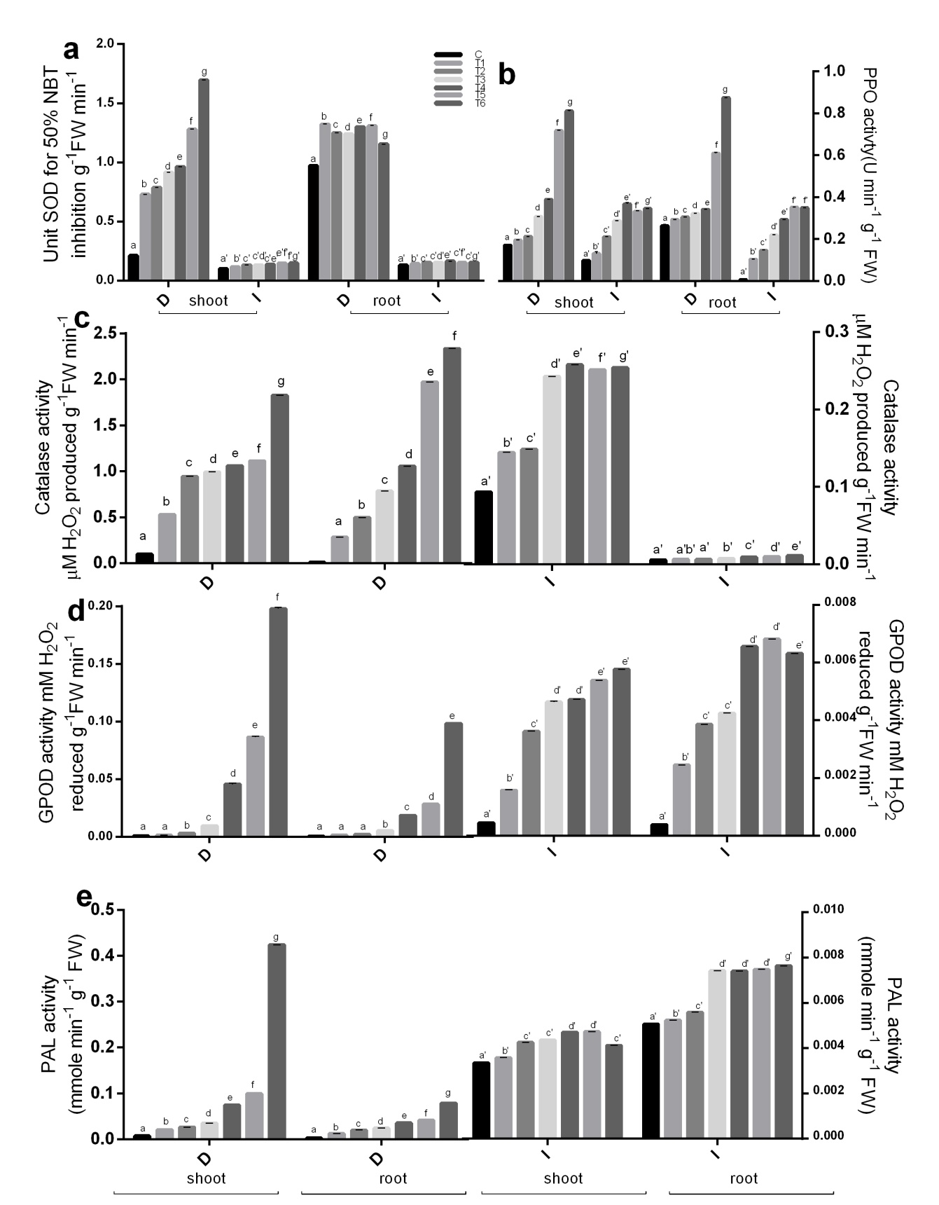
Fig.S3.3: Effect of Cd on enzymatic antioxidant activity a) SOD, b)PPO, c) CAT, d)GPOD, e) PAL. The values are represented as the mean of three independent replicates. The Mean values denoted by the same letters are not significantly different; different letters represent statistical significance at p<0.05. (D:Dudheswar, I:IR64, C-control set with 0µM Cd, T1-25µM Cd for 24h, T2-50µM Cd for 24h, T3-25µM Cd for 48h, T4- 50µM Cd for 48h, T5- 25µM Cd for 72h, T6- 50µM Cd for 72h).
Fig.S3.4: Effect of Cd on Non-enzymatic antioxidants a) Carotenoid, b) Anthocyanin, c) Phenol, d)Flavonoid, e)Ascorbic acid, f) DPPH radical scavenging activity percentage. The values are represented as the mean of three independent replicates. The Mean values denoted by the same letters are not significantly different; different letters represent statistical significance at p<0.05. (D:Dudheswar, I:IR64, C-control set with 0µM Cd, T1-25µM Cd for 24h, T2-50µM Cd for 24h, T3-25µM Cd for 48h, T4- 50µM Cd for 48h, T5- 25µM Cd for 72h, T6- 50µM Cd for 72h).

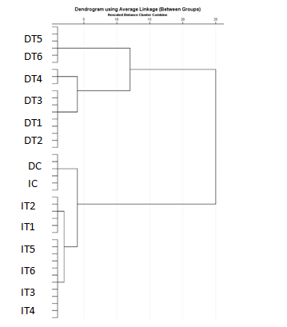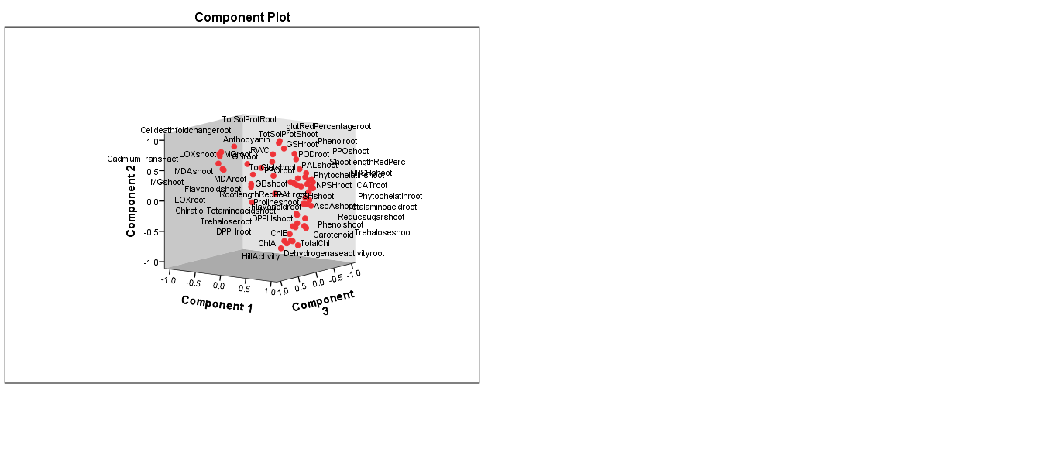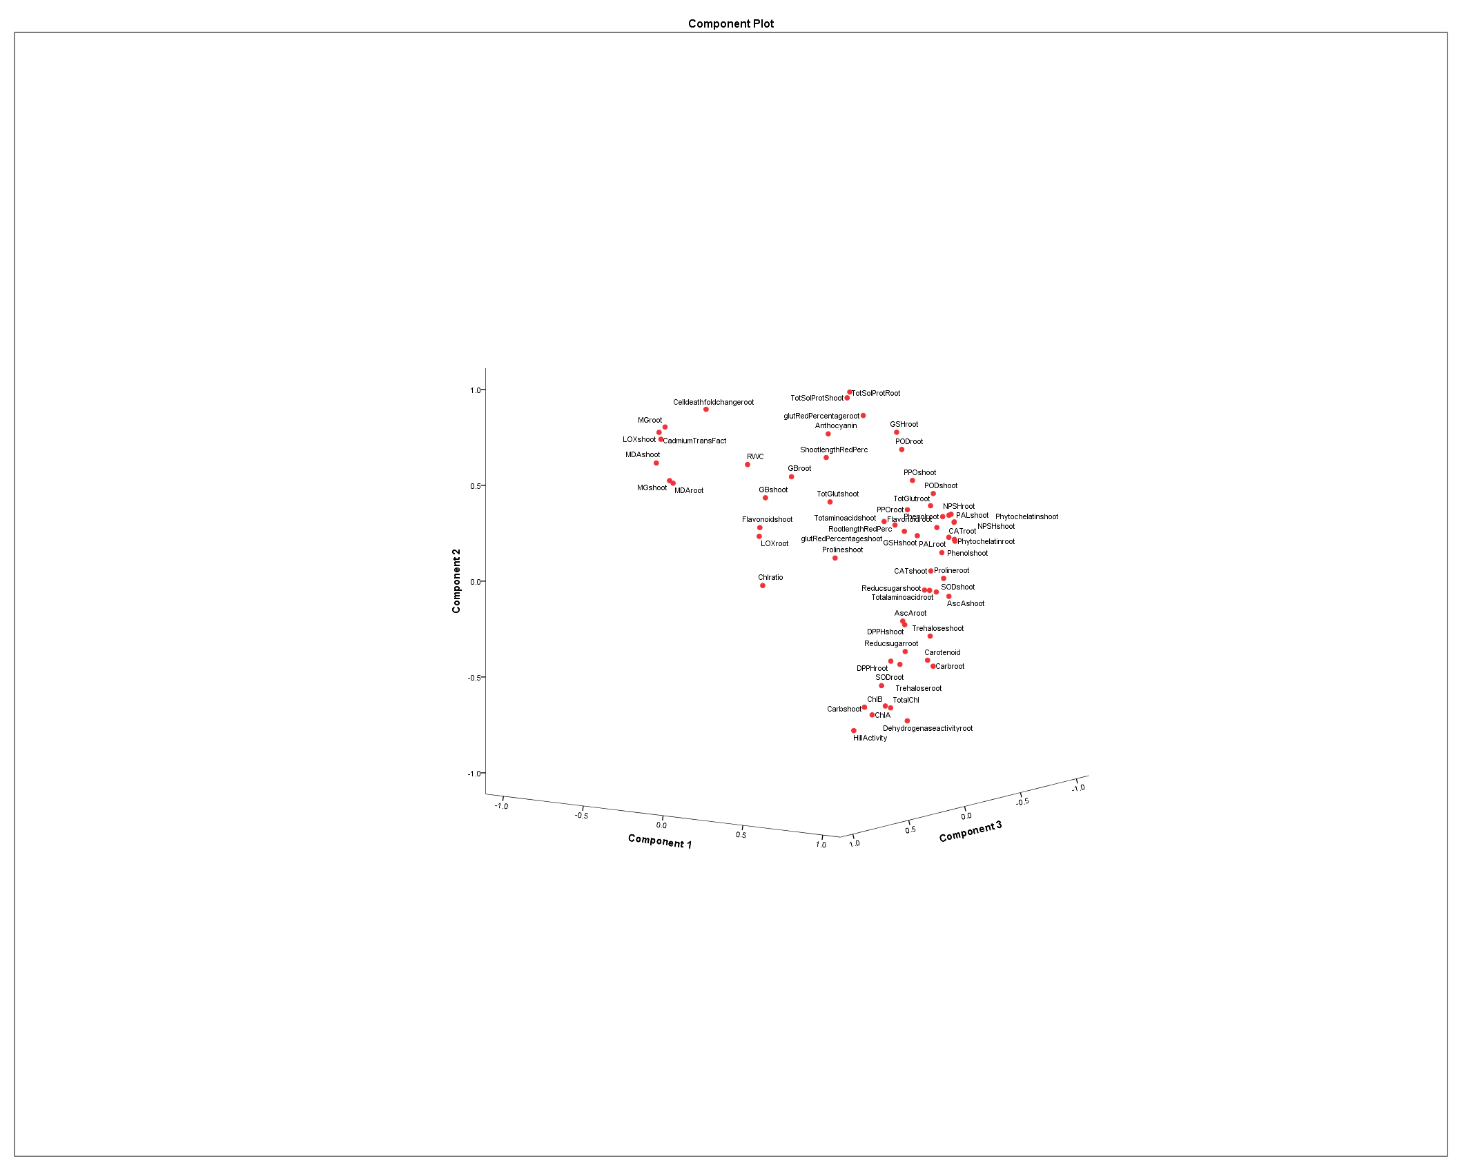
a
b
c
Fig.S3.5: Effect of Cd stress across the two genotypes and treatment sets a)Hierarchical clustering of treatment sets of both cultivars, b)PCA analysis with all the physiological and biochemical parameters, c)Inset of PCA components
Value of Spearman’s correlation coefficient
Lowest value
Highest value

Fig.S3.6: Analysis of Spearman’s correlation matrix for the physiological, biochemical parameters studied in both the genotypes under Cd stress. Colour gradient coding indicates correlation coefficient values.
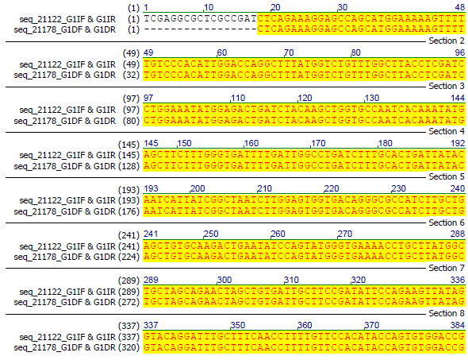
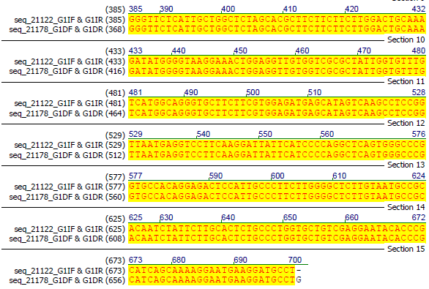

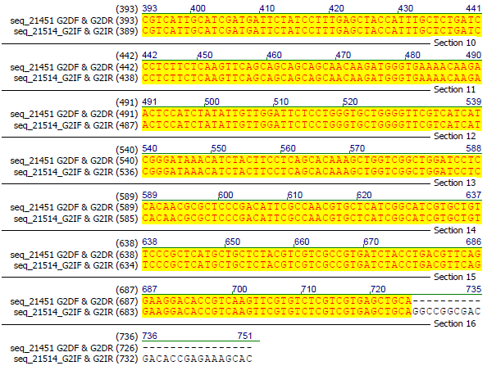
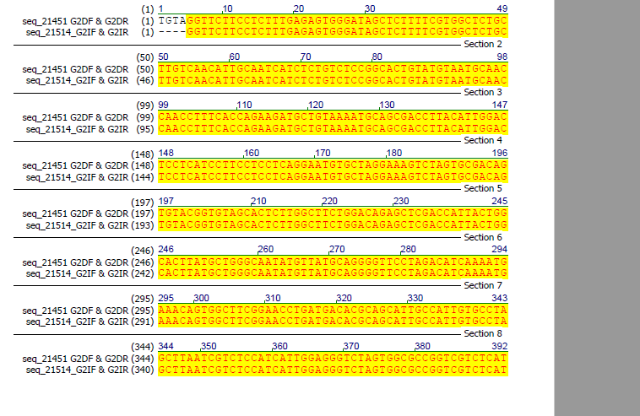
Fig.S3.7.a: OsNRAMP1 cDNA sequence alignment between CV. IR64 and CV. Dudheswar

Fig.S3.7.b: OsNRAMP5 cDNA sequence alignment between CV. IR64 and CV. Dudheswar
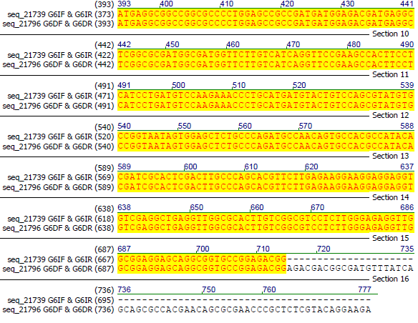
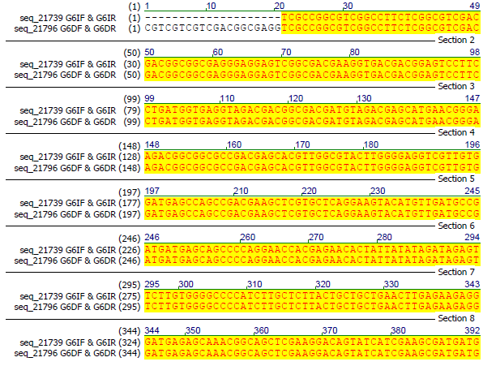
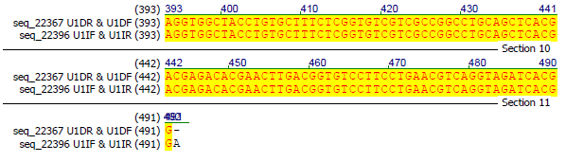
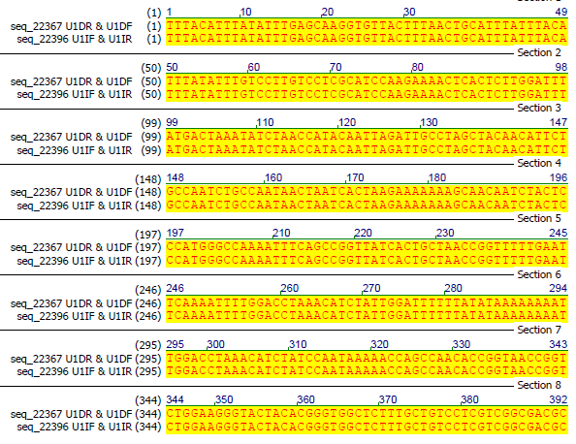
Fig.S3.7.c: Alignment of 3’ UTR sequences of OsNRAMP1 genes between the genotypes CV. IR64 and CV. Dudheswar

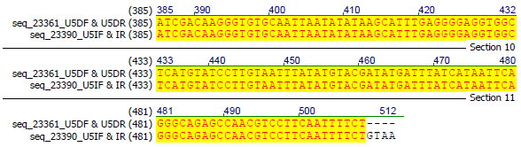
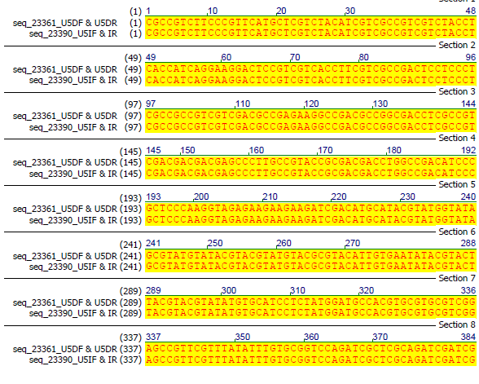
Fig.S3.7.d: Alignment of 3’ UTR sequences of OsNRAMP5 gene between the genotypes CV. IR64 and CV. Dudheswar

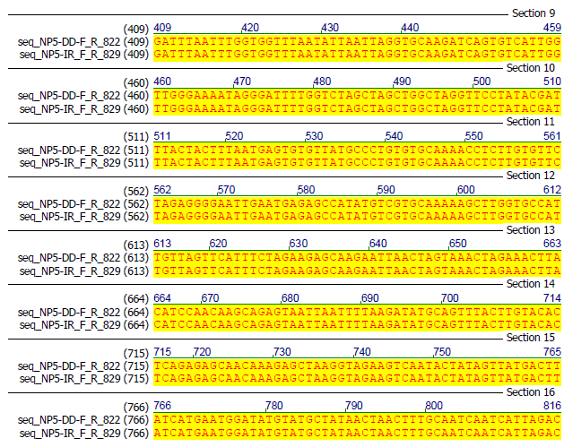
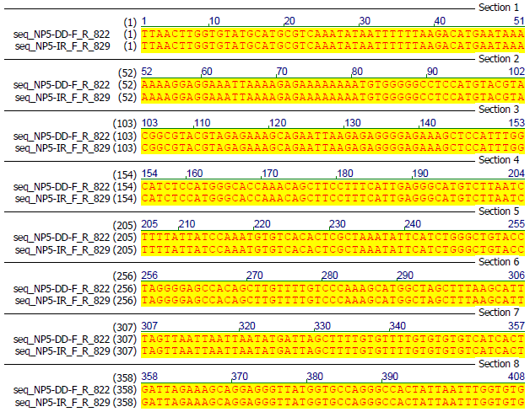
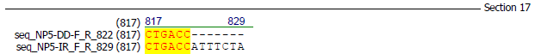

Fig.S3.7.e: Alignment of promoter sequences of OsNRAMP5 gene between the genotypes CV. IR64 and CV. Dudheswar
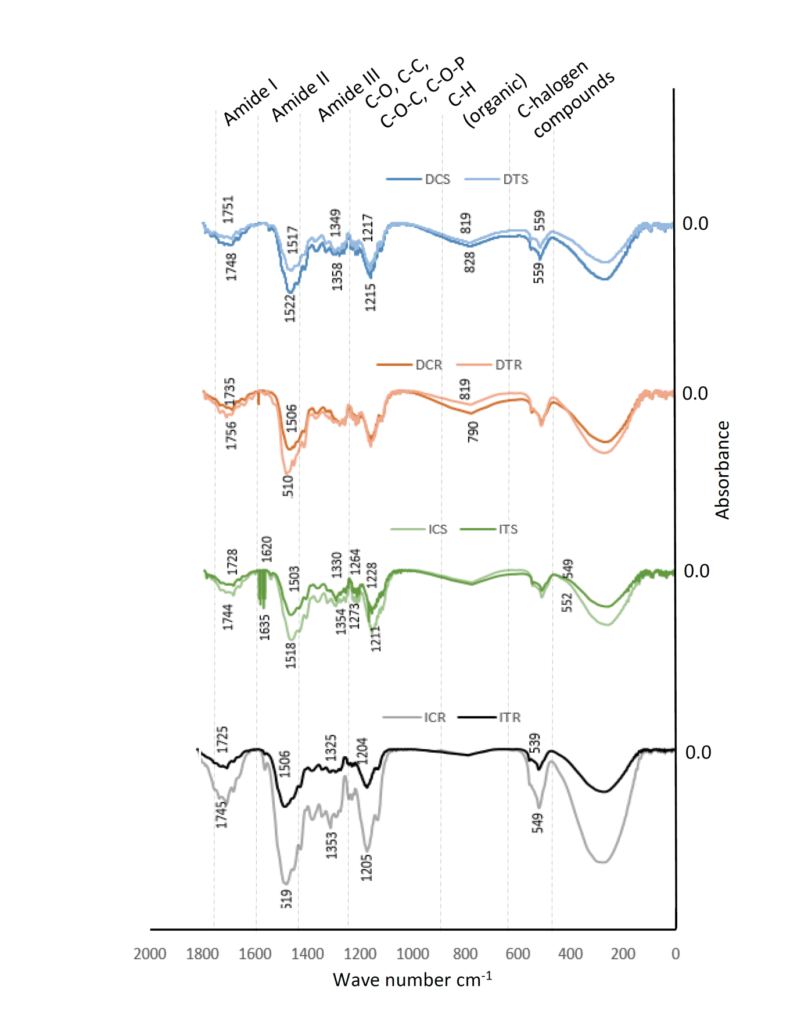
Fig.S3.8: Fourier Transform Infrared Spectra of root and shoot of CV. Dudheswar and CV. IR64 exposed to Cd stress (DCS:Dudheswar control shoot, DTS: Dudheswar T6 shoot, DCR:Dudheswar control root, DTR: Dudheswar T6 root,ICS:IR64 control shoot, ITS: IR64 T6 shoot, ICR:IR64 control root, ITR: IR64 T6 root, T6- 50µM Cd for 72h).

Fig.S.3.9: Cadmium accumulation in the grains of rice in Dudheswar(D) and I (IR64), ND- Not detected.
S4. Supplementary Tables
Table S4.1: Nucleotide sequences of the primers used for sequencing.
Sl No. | Primer name | Nucleotide sequence | Description
1 | G1F | ATGGGGGTGACGAAGGCG | OsNRAMP1,first primer set, forward direction sequence
2 | G1R | AATGTTGACAAGCAGAGCCACG | OsNRAMP1,first primer set, reverse direction sequence
3 | G2F | CTGGTGCTGTCGAGGAATACAC | OsNRAMP1,second primer set, forward direction sequence
4 | G2R | CTACACGGGTGGCTCTTTGCT | OsNRAMP1, second primer set, reverse direction sequence
5 | G5F | ATGGAGATTGAGAGAGAGAGCA | OsNRAMP5,first primer set, forward direction sequence
6 | G5R | CCCGCTCTCGTACAGGAAGA | OsNRAMP5,first primer set, reverse direction sequence
7 | G6F | GCCCCACAATCTGTTCTTGCAT | OsNRAMP5,second primer set, forward direction sequence
8 | G6R | CTACCTTGGGAGCGGGATGT | OsNRAMP5, second primer set, reverse direction sequence
9 | P1F | ATGTCACGTCAAACGACCAA | OsNRAMP1, promoter region, forward direction sequence
10 | P1R | CCGATCTCTGCAAGAAACCT | OsNRAMP1, promoter region, reverse direction sequence
11 | P5F | CTGGGTTCTTGTTGGCCTTA | OsNRAMP5, promoter region, forward direction sequence
12 | P5R | ACGAACTCTCAAGCCACACC | OsNRAMP5, promoter region, reverse direction sequence
13 | U1F | CCGTGATCTACCTGACGTTC | OsNRAMP1, 3’ UTR region, forward direction sequence
14 | U1R | TTACATTTATATTTGAGCAAGGTGT | OsNRAMP1, 3’ UTR region, reverse direction sequence
15 | U5F | CGCCGTCTTCCCGTTCAT | OsNRAMP5, 3’ UTR region, forward direction sequence
16 | U5R | ACAGAAAATTGAAGGACGTTGGC | OsNRAMP5, 3’ UTR region, reverse direction sequence

Table S4.2: Effect of Cd stress on FTIR spectra in root and shoot of rice genotypes (C: control, T: treated, D: Dudheswar, I: IR64)
 | Shoot |  | Root
D | C | T | C | T
 | 1748 | 1751 | 1735 | 1756 | C=C lipids, pectin,C=O triglycerides,C=O polysaccharides (Wu et al., 2001)
 | 1522 | 1517 | 1506 | 1510 | Amide II, C=N, C=C (guanine) (Paluszkiewicz and Kwiatek, 2001; Dovbeshko et al., 2000)
 | 1358 | 1349 |  |  | Symmetric bending C-H(methyl group),symmetric stretching C-O (carboxyl group)(Giordano et al., 2001)
 | 1215 | 1217 |  |  | Amide III, asymmetric phosphodiester stretching (nucelic acid, proteins) (Chiriboga et al., 1998; Eckel et al., 2001)
 | 828 | 819 | 790 | 790 | C-H out of plane bend (organic)(Chiang et al., 1999)
 | 559 | 559 |  |  | C-I stretch, aliphatic iodocompunds (Coates et al., 2006)
I | 1744 | 1728 | 1745 | 1725 | C=C lipids, pectin,C=O triglycerides,C=O polysaccharides (Wu et al., 2001)
 | 1635 | 1620 |  |  | C=O(amide I), C-C(phenyl), C-C(Uracyl) (Schulz and Baranska, 2007; Eckel et al., 2001)
 | 1518 | 1503 | 1519 | 1506 | Amide II, C=N, C=C (guanine) (Paluszkiewicz and Kwiatek, 2001; Dovbeshko et al., 2000)
 | 1354 | 1330 | 1353 | 1325 | Symmetric bending C-H(methyl group),symmetric stretching C-O (carboxyl group)(Giordano et al., 2001)
 | 1273 | 1264 |  |  | Amide III, asymmetric phosphodiester stretching (nucleic acid, proteins) (Chiriboga et al., 1998; Eckel et al., 2001)
 | 1211 | 1228 | 1205 | 1204 | Amide III, asymmetric phosphodiester stretching (nucleic acid, proteins) (Chiriboga et al., 1998; Eckel et al., 2001)
 | 552 | 649 | 549 | 539 | C-I stretch, aliphatic iodocompunds (Coates et al., 2000)
 | Shoot |  | Root
D | C | T | C | T
 | 1748 | 1751 | 1735 | 1756 | C=C lipids, pectin,C=O triglycerides,C=O polysaccharides (Wu et al., 2001)
 | 1522 | 1517 | 1506 | 1510 | Amide II, C=N, C=C (guanine) (Paluszkiewicz and Kwiatek, 2001; Dovbeshko et al., 2000)
 | 1358 | 1349 |  |  | Symmetric bending C-H(methyl group),symmetric stretching C-O (carboxyl group)(Giordano et al., 2001)
 | 1215 | 1217 |  |  | Amide III, asymmetric phosphodiester stretching (nucelic acid, proteins) (Chiriboga et al., 1998; Eckel et al., 2001)
 | 828 | 819 | 790 | 790 | C-H out of plane bend (organic)(Chiang et al., 1999)
 | 559 | 559 |  |  | C-I stretch, aliphatic iodocompunds (Coates et al., 2006)
I | 1744 | 1728 | 1745 | 1725 | C=C lipids, pectin,C=O triglycerides,C=O polysaccharides (Wu et al., 2001)
 | 1635 | 1620 |  |  | C=O(amide I), C-C(phenyl), C-C(Uracyl) (Schulz and Baranska, 2007; Eckel et al., 2001)
 | 1518 | 1503 | 1519 | 1506 | Amide II, C=N, C=C (guanine) (Paluszkiewicz and Kwiatek, 2001; Dovbeshko et al., 2000)
 | 1354 | 1330 | 1353 | 1325 | Symmetric bending C-H(methyl group),symmetric stretching C-O (carboxyl group)(Giordano et al., 2001)
 | 1273 | 1264 |  |  | Amide III, asymmetric phosphodiester stretching (nucleic acid, proteins) (Chiriboga et al., 1998; Eckel et al., 2001)
 | 1211 | 1228 | 1205 | 1204 | Amide III, asymmetric phosphodiester stretching (nucleic acid, proteins) (Chiriboga et al., 1998; Eckel et al., 2001)
 | 552 | 649 | 549 | 539 | C-I stretch, aliphatic iodocompunds (Coates et al., 2000)

S5.Supplementary references:
Aebi, H., 1984. 13 Catalase in vitro. In Methods in enzymology (Vol. 105, pp. 121-126). Academic press.
Abdel‐Aal, E. S., & Hucl, P. 1999. A rapid method for quantifying total anthocyanins in blue aleurone and purple pericarp wheats. Cereal chemistry, 76(3), 350-354.
Bates, L.S., Waldren, R.P. and Teare, I.D., 1973. Rapid determination of free proline for water-stress studies. Plant and soil, 39(1), pp.205-207.
Bregman, A.A., 1987. Laboratory investigations in cell biology.
Brand-Williams, W., Cuvelier, M.E. and Berset, C.L.W.T., 1995. Use of a free radical method to evaluate antioxidant activity. LWT-Food science and Technology, 28(1), pp.25-30.
Castillo, F. J., Penel, C., & Greppin, H. 1984. Peroxidase release induced by ozone in Sedum album leaves: involvement of Ca2+. Plant physiology, 74(4), 846-851.
Cakmak, I., & Marschner, H. 1992. Magnesium deficiency and high light intensity enhance activities of superoxide dismutase, ascorbate peroxidase, and glutathione reductase in bean leaves. Plant physiology, 98(4), 1222-1227.
Chiriboga, L., Xie, P., Yee, H., Vigorita, V., Zarou, D., Zakim, D., & Diem, M. 1998. Infrared spectroscopy of human tissue. I. Differentiation and maturation of epithelial cells in the human cervix. Biospectroscopy, 4(1), 47-53.
Chiang, H. P., Song, R., Mou, B., Li, K. P., Chiang, P., Wang, D., & Ho, L. T. 1999. Fourier transform Raman spectroscopy of carcinogenic polycyclic aromatic hydrocarbons in biological systems: Binding to heme proteins. Journal of Raman spectroscopy, 30(7), 551-555.
Chen, C., Belanger, R. R., Benhamou, N., & Paulitz, T. C. 2000. Defense enzymes induced in cucumber roots by treatment with plant growth-promoting rhizobacteria (PGPR) and Pythium aphanidermatum. Physiological and molecular plant pathology, 56(1), 13-23.
Coates, J. 2006. Interpretation of infrared spectra, a practical approach. Encyclopedia of analytical chemistry: applications, theory and instrumentation.
Dovbeshko, G. I., Gridina, N. Y., Kruglova, E. B., & Pashchuk, O. P. 2000. FTIR spectroscopy studies of nucleic acid damage. Talanta, 53(1), 233-246.
Eckel, R., Huo, H., Guan, H. W., Hu, X., Che, X., & Huang, W. D. 2001. Characteristic infrared spectroscopic patterns in the protein bands of human breast cancer tissue. Vibrational Spectroscopy, 27(2), 165-173.
Giannopolitis, C.N. and Ries, S.K., 1977. Superoxide dismutases: I. Occurrence in higher plants. Plant physiology, 59(2), pp.309-314.
Grieve, C.M. and Grattan, S.R., 1983. Rapid assay for determination of water soluble quaternary ammonium compounds. Plant and soil, 70(2), pp.303-307.
Giordano, M., Kansiz, M., Heraud, P., Beardall, J., Wood, B., & McNaughton, D. 2001. Fourier transform infrared spectroscopy as a novel tool to investigate changes in intracellular macromolecular pools in the marine microalga Chaetoceros muellerii (Bacillariophyceae). Journal of Phycology, 37(2), 271-279.
Hedge, J.E. and Hofreiter, B.T., 1962. Determination of reducing sugars and carbohydrates. I. Analysis and preparation of sugars. Methods in Carbohydrate Chemistry. Academic Press, New York, pp.1-18.
Ibrahim, M. H., Jaafar, H. Z., Rahmat, A., & Rahman, Z. A. 2011. The relationship between phenolics and flavonoids production with total non structural carbohydrate and photosynthetic rate in Labisia pumila Benth. under high CO2 and nitrogen fertilization. Molecules, 16(1), 162-174.
Kirk, J.T.O. and Allen, R.L., 1965. Dependence of chloroplast pigment synthesis on protein synthesis: effect of actidione. Biochemical and Biophysical Research Communications, 21(6), pp.523-530.
Lee, Y.P. and Takahashi, T., 1966. An improved colorimetric determination of amino acids with the use of ninhydrin. Analytical biochemistry, 14(1), pp.71-77.
Miller, G.L., 1972. Estimation of reducing sugar by dinitrosalicylic acid method. Analytical Chemistry, 31, pp.426-428.
Mallik, C. P., & Singh, M. B. 1980. Plant enzymology and histoenzymology. A text manual.
pp.1168-1175.
Majumdar, S., Sachdev, S. and Kundu, R., 2020. Salicylic acid mediated reduction in grain cadmium accumulation and amelioration of toxicity in Oryza sativa L. CV. Bandana. Ecotoxicology and Environmental Safety, 205, p.111167.
Paluszkiewicz, C., & Kwiatek, W. M. 2001. Analysis of human cancer prostate tissues using FTIR microspectroscopy and SRIXE techniques. Journal of Molecular Structure, 565, 329-334.
Qin, G. Z., & Tian, S. P. 2005. Enhancement of biocontrol activity of Cryptococcus laurentii by silicon and the possible mechanisms involved. Phytopathology, 95(1), 69-75.
Schulz, H., & Baranska, M. 2007. Identification and quantification of valuable plant substances by IR and Raman spectroscopy. Vibrational Spectroscopy, 43(1), 13-25.
Trevelyan, W.E. and Harrison, J., 1956. Studies on yeast metabolism. 5. The trehalose content of baker's yeast during anaerobic fermentation. Biochemical Journal, 62(2), p.177.
Usman, K., Al-Ghouti, M.A. and Abu-Dieyeh, M.H., 2019. The assessment of cadmium, chromium, copper, and nickel tolerance and bioaccumulation by shrub plant Tetraena qataranse. Scientific reports, 9(1), pp.1-11.

Wu, J. G., Xu, Y. Z., Sun, C. W., Soloway, R. D., Xu, D. F., Wu, Q. G., ... & Xu, G. X. 2001. Distinguishing malignant from normal oral tissues using FTIR fiber‐optic techniques. Biopolymers: Original Research on Biomolecules, 62(4), 185-19

