Table S1 Primers for mutant PCR identification.
Salk-number | BP+RP-PRODUCT_SIZE | Sequence5’-3’
SALK_033291C-RP | 541–841 | TGTGGAAGAGGTGTTTCTTGG
SALK_046040C-RP | 549–849 | CCATGCAAGCTTTAGCTTCTG
SALK_121189C-RP | 575–875 | TGAACTGTGAGACGCGTGTAC
SALK_088110C-RP | 520–820 | TATGAGGCAGTTACCGAAACG
SALK_008772C-RP | 461–761 | TATGGCTATTTGCAAGGGAAG
SALK_008776C-RP | 473–773 | CGCAATGAGAATCACTGTTTC
SALK_014621C-RP | 509–809 | TTGAATTAGCTGGAAACGCAG
SALK_100086C-RP | 524–824 | AAGAGCATCCAAAAATCCGAC
SALK_021737C-RP | 452–752 | CGATGATGTTGTTCACATTGC
SALK_077784C-RP | 520–820 | TGAGTAGAACTCTGAAGCGGC
SALK_047913C-RP | 439–739 | CATGAAGCTTCTCCTATCCCC
SALK_025820C-RP | 518–818 | TTTGCGGCATAAGAAGACATC
SALK_048970C-RP | 596–896 | CATGCTTTGGCTATTCTCGTC
SALK_203432C-RP | 595–895 | GGATTCAGAACCTCCTCCTTG
SALK_029738C-RP | 465–765 | TTGATTCTTTCTGCAACTTTGG
SALK_125517C-RP | 485–785 | TGTAAAGCCAGGGTTCACAAC
SALK_133805C-RP | 431–731 | ACGAATATCCCTGTCTTGCTG
SALK_065009C-RP | 529–829 | ACAAGAGTCACCAATGCAACC
SALK_046586C-RP | 572–872 | CACTGATACGGAACTCCCATG
SALK_075979C-RP | 487–787 | TGTGCACGACTTGCATTACTC
SALK_146618C-RP | 449–749 | CACATTTGGAATCCCAATCAG
SALK_089055C-RP | 592–892 | AAGTCCACGAGCGATTCCTAG
SALK_044069C-RP | 439–739 | GATTGCTGTGAAGAGGCTGTC
SALK_058300C-RP | 445–745 | GATCGGTACAATATTGGCAGG
SALK_009816C-RP | 569–869 | GAACTCAAACCTTCCAGAGCC
LBb1.3 | - | ATTTTGCCGATTTCGGAAC
wild-type-LP | 900–1100 (LP+RP) | CAACCACAAGAACACAAAACAC
wild-type-RP | 900–1100 (LP+RP) | GAGAAACAGAACAGAAAAATGGG

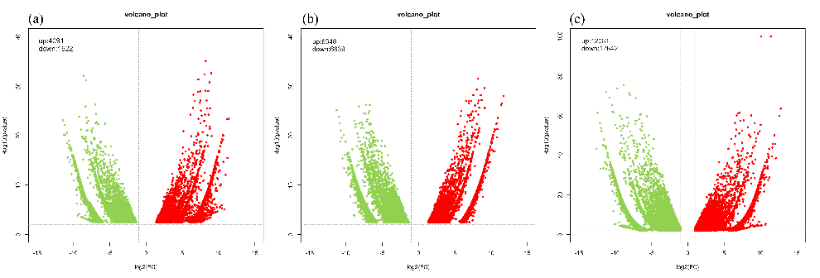

Fig S1. Volcano plots of differentially expressed genes under drought treatment
Note:The up- and down-regulated genes are represented by green and red dots, respectively. (a) DT-QY1-2d vs DT-QY3-2d; (b) DT-QY1-4d vs DT-QY3-4d; (c) DT-QY1-10d vs DT-QY3-10d.

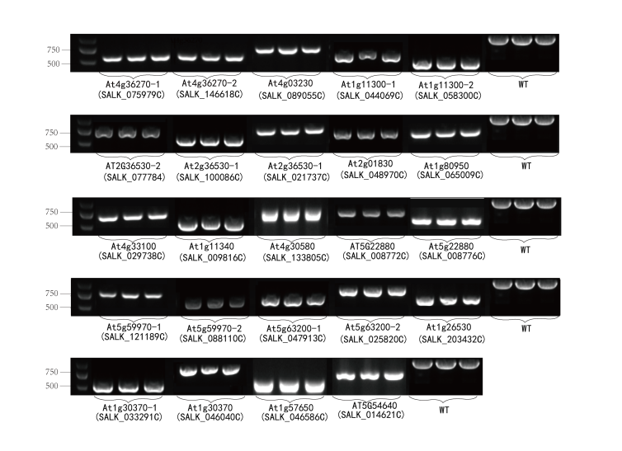

Fig S2. Identification of Arabidopsis thaliana-related gene mutants.

