Figure S1. The miR396 target site for GRF and miR396-resistant GRF (rGRF).
In the miR396-resistant rGRF-GIF version, silent mutations (highlighted in red) were introduced to reduce interactions with miR396 (Debernardi et al. 2020).
Figure S2. Phylogenetic tree of GRFs in Arabidopsis and tomato.
Neighbor-joining phylogenetic tree was constructed using the JTT model in MEGA11. The values in the tree are the branch length and three is a scale bar at the bottom.
Figure S3. The expression pattern of three GRF homologous genes in the meristem of tomato.
Images were downloaded from the tomato eGFP database (http://www.bar.utoronto.ca/efp2).
Figure S4. Phylogenetic relationship and conserved motifs of GIF genes.
Phylogenetic tree, five Multiple EM for Motif Elicitation (MEME) Motifs, and one conserved motif of Arabidopsis, wheat and tomato GIF proteins.
Figure S5. Co-immunoprecipitation (Co-IP) assay of the interaction between SlGRF4 and SlGIF1.
SlGRF4 and SlGIF1 were tagged with the HA and Flag tags, respectively. Proteins were immunoprecipitated (IP) with Anti-Flag Magnetic Beads and detected using Anti-Flag and Anti-HA antibodies. GFP-HA was used as the negative control protein and exposed for 5 s.
Figure S6. Segregation in the T1 heterozygous generation.
Germinating seeds of AC with and without RUBY phenotype can be easily distinguished. Scale bar: 1 cm.

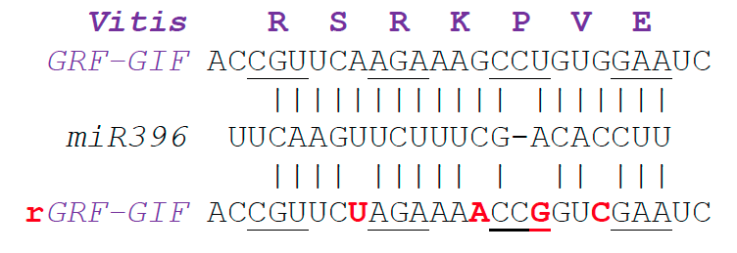
Figure S1. The miR396 target site for GRF and miR396-resistant GRF (rGRF).
In the miR396-resistant rGRF-GIF version, silent mutations (highlighted in red) were introduced to reduce interactions with miR396 (Debernardi et al. 2020).

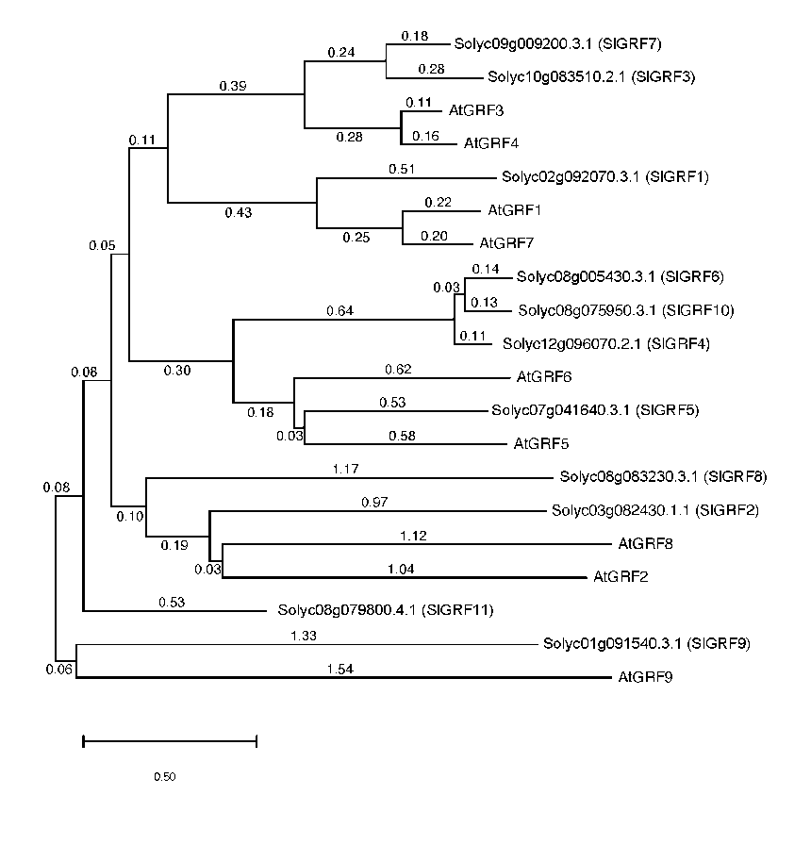
Figure S2. Phylogenetic tree of GRFs in Arabidopsis and tomato.
Neighbor-joining phylogenetic tree was constructed using the JTT model in MEGA11. The values in the tree are the branch length and three is a scale bar at the bottom.

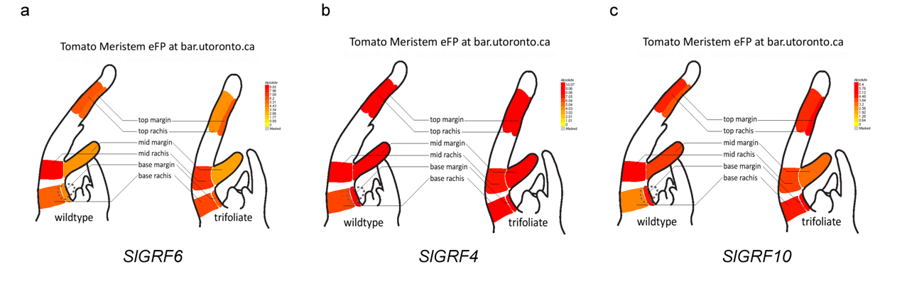
Figure S3. The expression pattern of three GRF homologous genes in the meristem of tomato.
Images were downloaded from the tomato eGFP database (http://www.bar.utoronto.ca/efp2).

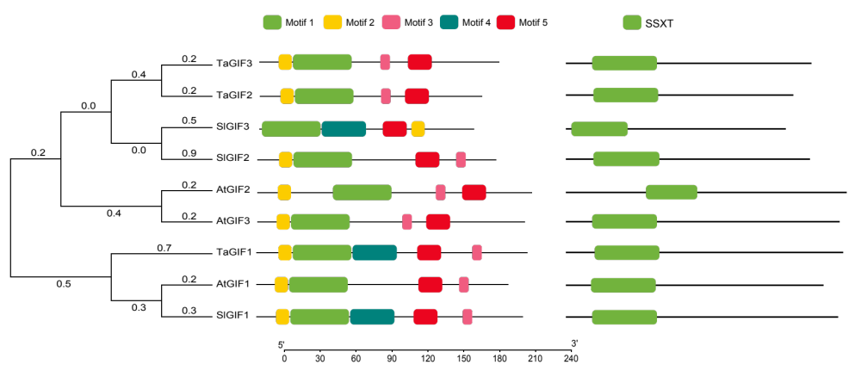
Figure S4. Phylogenetic relationship and conserved motifs of GIF genes.
Phylogenetic tree, five Multiple EM for Motif Elicitation (MEME) Motifs, and one conserved motif of Arabidopsis, wheat and tomato GIF proteins.

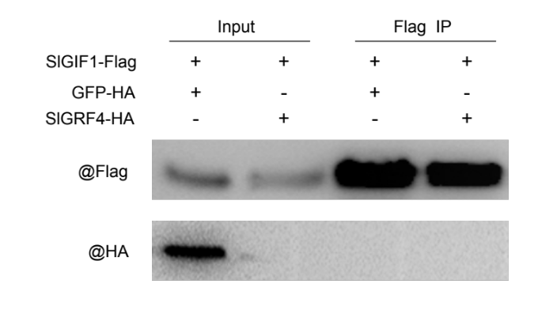
Figure S5. Co-immunoprecipitation (Co-IP) assay of the interaction between SlGRF4 and SlGIF1.
SlGRF4 and SlGIF1 were tagged with the HA and Flag tags, respectively. Proteins were immunoprecipitated (IP) with Anti-Flag Magnetic Beads and detected using Anti-Flag and Anti-HA antibodies. GFP-HA was used as the negative control protein and exposed for 5 s.

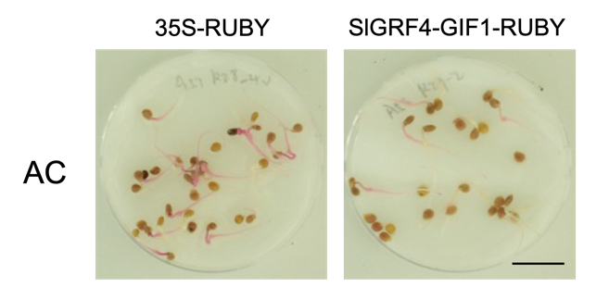
Figure S6. Segregation in the T1 heterozygous generation.
Germinating seeds of AC with and without RUBY phenotype can be easily distinguished. Scale bar: 1 cm.

