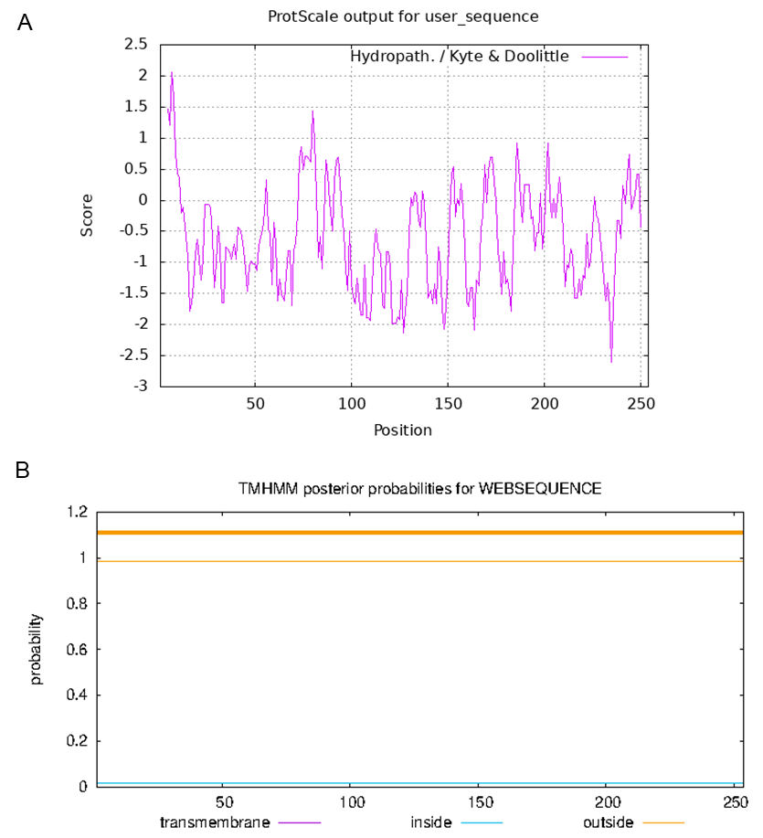
Figure S1
Prediction of hydrophilicity/hydrophobicity of CsMYB90 protein

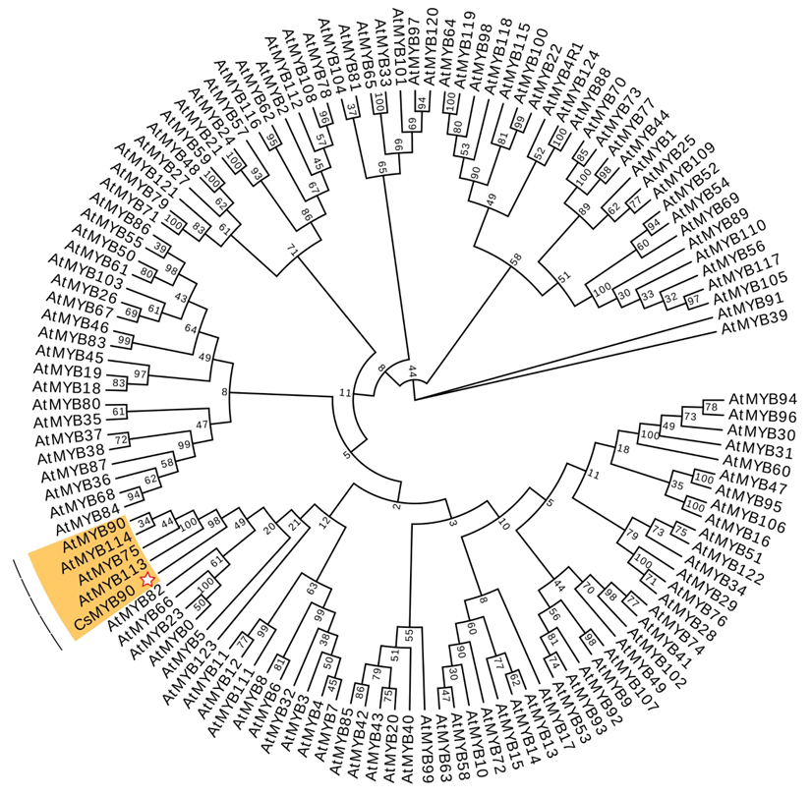
Figure S2
Phylogenetic tree of 126 R2R3-MYBs from Arabidopsis thaliana and CsMYB90 protein sequences

Figure S3
Total Ion Chromatogram

Figure S4
The Coefficient of Variation distribution in each group of samples
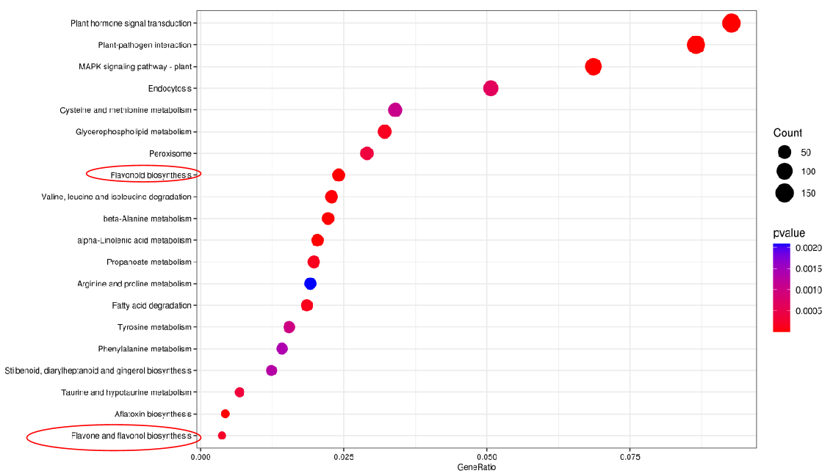
Figure S5
Enriched bubbles diagram

Figure S6
Electrophoresis of bacterial liquid PCR for CsMYB90 and NtDFR1

Figure S7
MYB and WRKYrelative expression level clustering heat map

Figure S8
Overexpression of CsMYB90 in tobacco improved cold tolerance
- Phenotypes of WT and CsMYB90-overexpressing lines under the control environment (26 °C), cold treatment (-2 °C), and after recovery. Bar = 1 cm; (B, C) Histochemical staining with 3,3’-diaminobenzidine (DAB) and nitroblue tetrazolium (NBT) for observing the accumulation situation of H₂O₂ and O₂⁻.

