Supplementary material

Silicon mitigates cadmium toxicity in grain amaranth (Amaranthus cruentus L.)

Monika Szabóová^{a,#}, Veronika Mistríková^{a,#}, Jana Kačírováª, Monika Lisinovičová^{a,b}, Marek Bujdoš^{b}, Andrea Hricová^{a,*}

ª Department of Genetics and Reproduction Biology, Institute of Plant Genetics and Biotechnology, Plant Science and Biodiversity Centre, Slovak Academy of Sciences, Nitra, Slovakia
^{b} Faculty of Natural Sciences, Comenius University, Bratislava, Slovakia
# These authors contributed equally.
*Corresponding author. Andrea Hricová, Institute of Plant Genetics and Biotechnology, Plant Science and Biodiversity Centre, Slovak Academy of Sciences, Nitra, Slovakia. E-mail address: andrea.hricova@savba.sk, phone number: +421/37 6943 328, ORCID: 0000-0001-5879-0912

Table S1
Sequences of specific primers for qRT-PCR amplification of abiotic stress-related genes in Amaranthus cruentus L.
Gene | Direction | Primer sequence (5′-3′) | Reference
Ah24 | Forward | GATTTAATTGAGATGGCTGAAA | Massange-Sanchez et al. (2015)
Ah24 | Reverse | GTTAGTGCAGCTTGTTCGC | Massange-Sanchez et al. (2015)
Chit5 | Forward | CGGTACCGTTTCAGTCCCAA | Lancíková et al. (2020)
Chit5 | Reverse | AGAGGATCCACCCGTACCAA | Lancíková et al. (2020)
AhDGR2 | Forward | CCCTTCCTGGTTGGATGGTC | Lancíková et al. (2020)
AhDGR2 | Reverse | CAACTTGAGCAATGGCGCTT | Lancíková et al. (2020)
AhERD | Forward | GCAACACATGAAGGGATGG | Reyes-Rosales et al. (2023)
AhERD | Reverse | TGGGACTTGTATTCAGCAGC | Reyes-Rosales et al. (2023)
GSH1 | Forward | CCGGTGTGAAGCTGTATGGA | Lancíková et al. (2020)
GSH1 | Reverse | CAGCAACCACTGGATCGTCT | Lancíková et al. (2020)

Reference
Lancíková, V., Tomka, M., Žiarovská, J., Gažo, J., Hricová, A., 2020. Morphological responses and gene expression of grain amaranth (Amaranthus spp.) growing under Cd. Plants. 9, 575. https://doi.org/10.3390/plants9050572.

Massange-Sanchez, J.A., Palmeros-Suarez, P.A., Martinez-Gallardo, N.A., Castrillon-Arbelaez, P.A., Avilés-Arnaut, H., Alatorre-Cobos, F., Tiessen, A., Délano-Friér, J.P., 2015. The novel and taxonomically restricted Ah24 gene from grain amaranth (Amaranthus hypochondriacus) has a dual role in development and defense. Front. Plant Sci. 6, 602. https://doi.org/10.3389/fpls.2015.00602.

Reyes-Rosales, A., Cabrales-Orona, G., Martínez-Gallardo, N.A., Sánchez-Segura, L., Padilla-Escamilla, J.P., Palmeros-Suaréz, P.A., Délano-Frier, J., 2023. Identification of genetic and biochemical mechanisms associated with heat shock and heat stress adaptation in grain amaranths. Front. Plant Sci. 14, 1101375. https://doi.org/10.3389/fpls.2023.1101375.

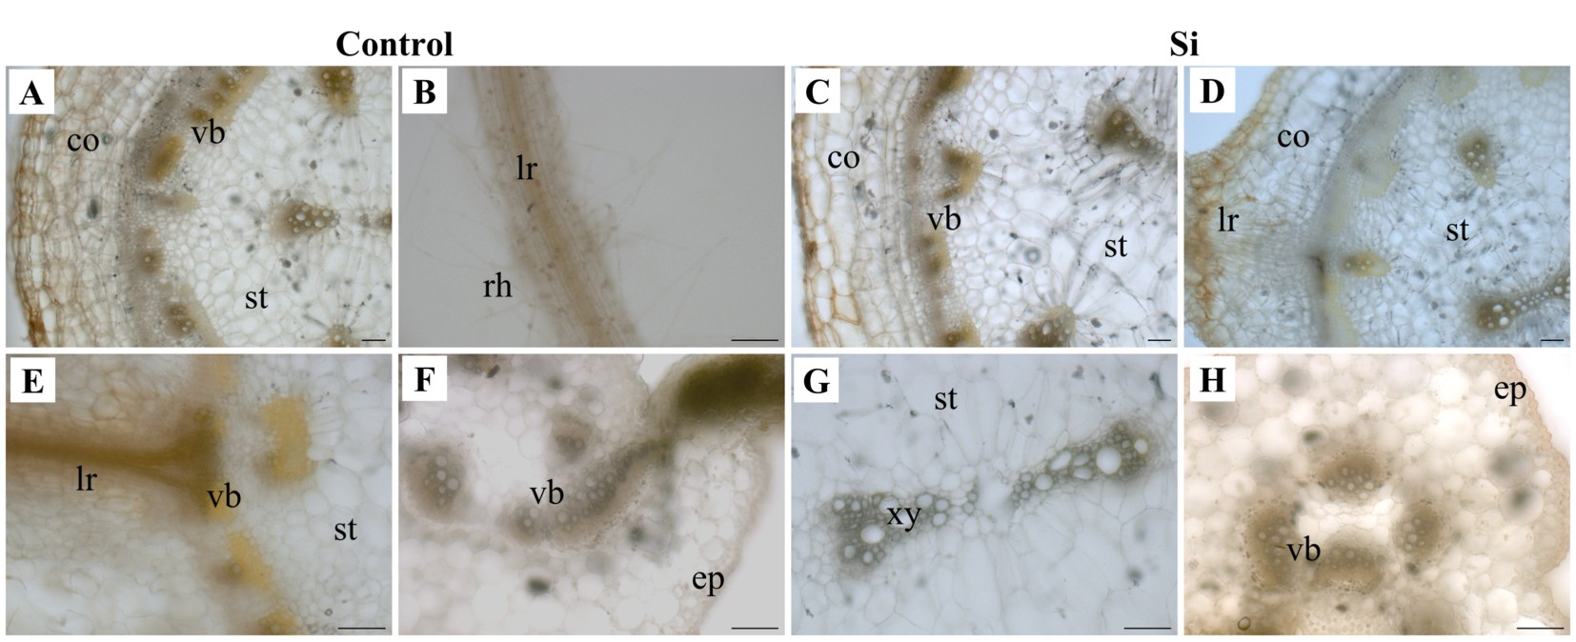
Fig. S1 Dithizone staining of control (A, B, E, F) and Si-treated (C, D, G, H) amaranth samples. No staining in the form of reddish precipitates was detected in cross sections of primary roots (A, C-E, G) and leaves (F, H), or lateral roots (B). Co – cortex; ep – epidermis; lr – lateral root; rh – root hair; st – stele; vb – vascular bundle; xy – xylem. Scale bar = 200 μm

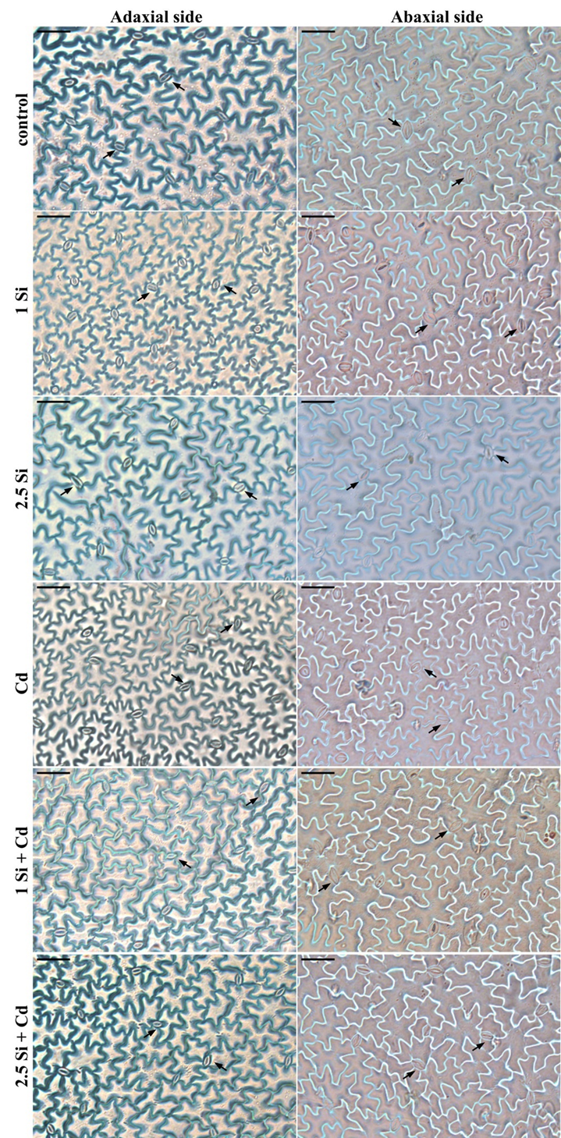
Fig. S2 Representative images of adaxial and abaxial leaf epidermal surfaces of amaranth plants after exposure to different treatments as observed under light microscope. Arrows indicate individual leaf stomata. Scale bar = 50 μm

