Electronic Supplementary Information
Transcriptomics and metabolomics analyses reveal the growth promoting effects of VOCs released by Clonostachys rosea f. catenulata on Arabidopsis thaliana
Boyu Wu¹, Wenhang Yin¹, Yueyun Zhang¹, Guolei Zhu¹, Ping Zhao¹,*, Xiaoqin Yang¹, Fanrui Zhou^{1,2}, Wei Chen², Lihua Zou^{1,*}, Imran Haider Shamsi^{3,*}
¹Key Laboratory of State Forestry and Grassland Administration on Highly-Efficient Utilization of Forestry Biomass Resources in Southwest China, Southwest Forestry University, Kunming Yunnan 650224, China.
²Department of Food Science and Nutrition, College of Biosystems Engineering and Food Science, Zhejiang University, Hangzhou 310058, China.
³Institute of Crop Science, Zhejiang Key Laboratory of Crop Germplasm Resource of Zhejiang Province, College of Agriculture and Biotechnology, Zhejiang University, Hangzhou 310058, China.
Correspondence:
hypzhao@swfu.edu.cn (P.Z.); lihuaz@swfu.edu.cn (L.Z.);drimran@zju.edu.cn (I.H.S.)
Fig S1. Expression and distribution of DEGs related to phenylpropanoid and lignin biosynthesis pathways.
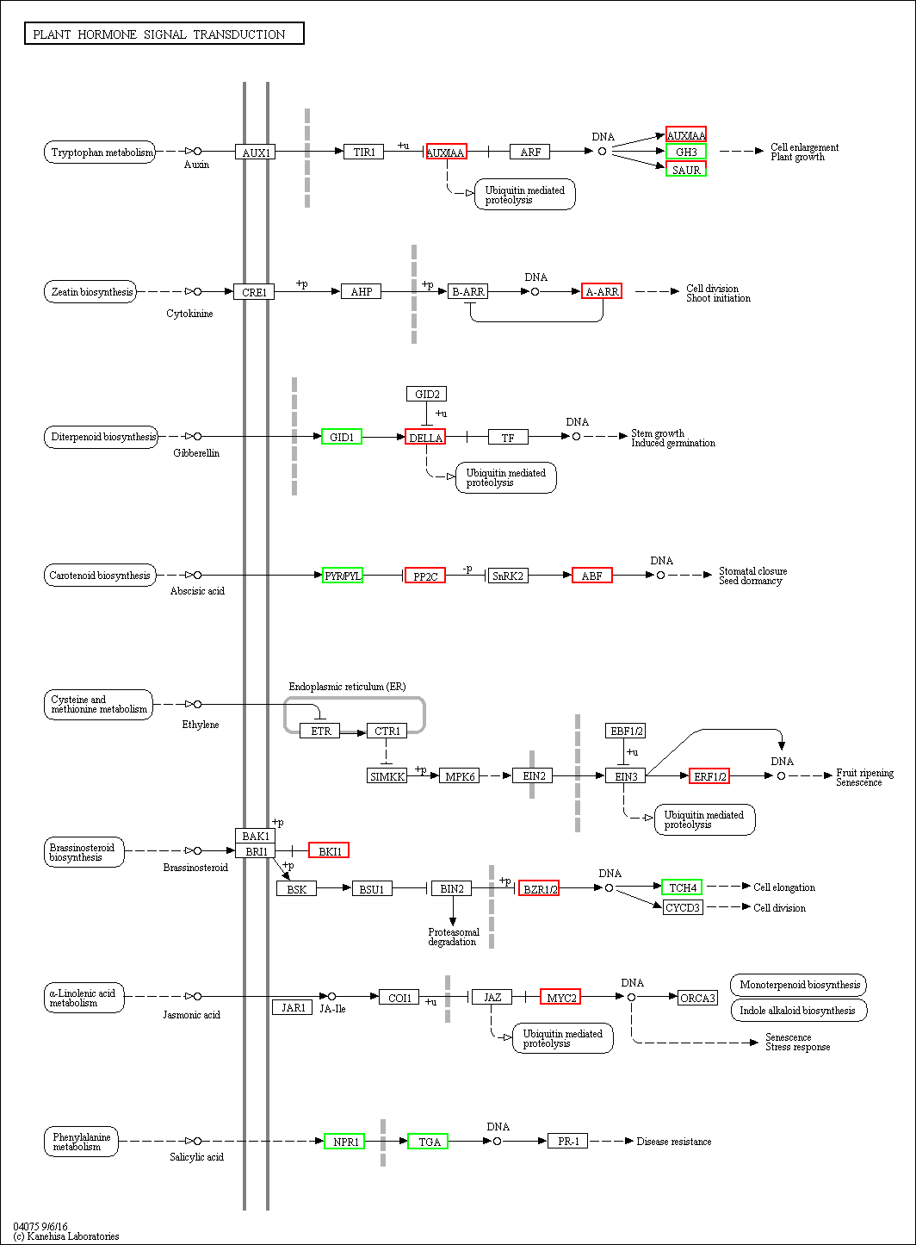
Fig S2. Expression and distribution of DEGs related to plant hormone signaling. Red represents up-regulation, green represents down-regulation.

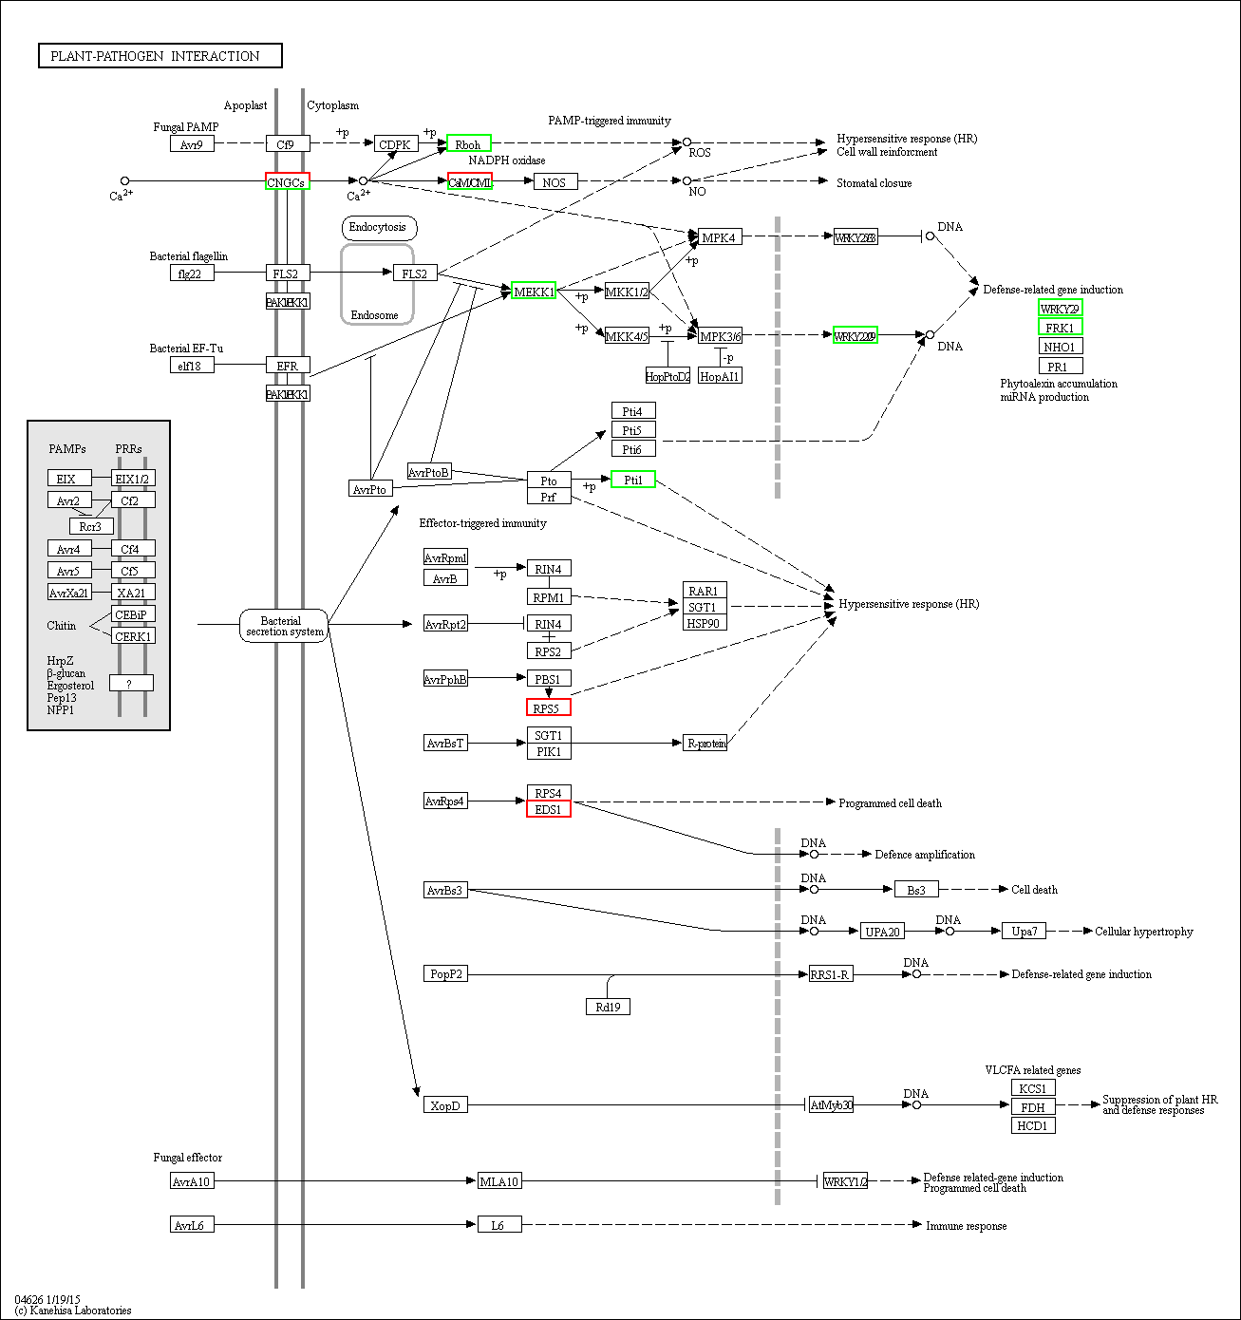
Fig S3. Expression and distribution of DEGs related to plant-pathogen interaction. Red represents up-regulation, green represents down-regulation.

