SUPPLEMENTARY MATERIALS
Figures
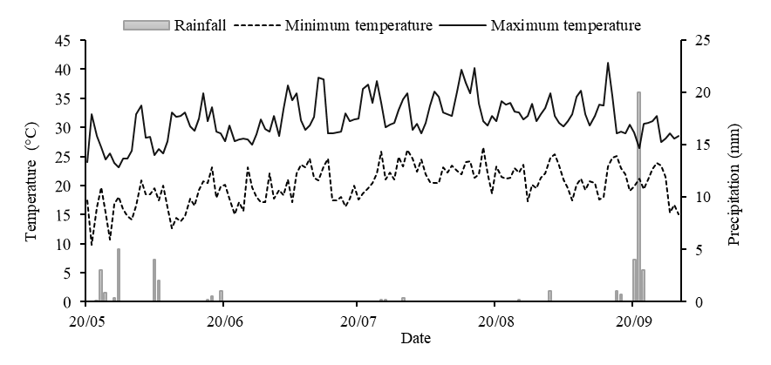
Supplementary Fig. S1 Daily precipitation and temperature during the maize growing season in 2021

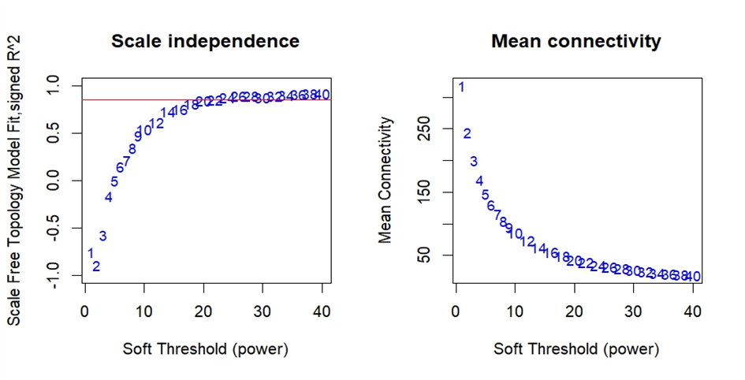
Supplementary Fig. S2 Weighted gene co-expression network analysis of the DEG dataset. (A) Scale-free topology model fit, and (B) gene mean connectivity under different soft threshold powers. The fit index curve indicates that soft threshold power above 20 meets scale−free topology above 0.85
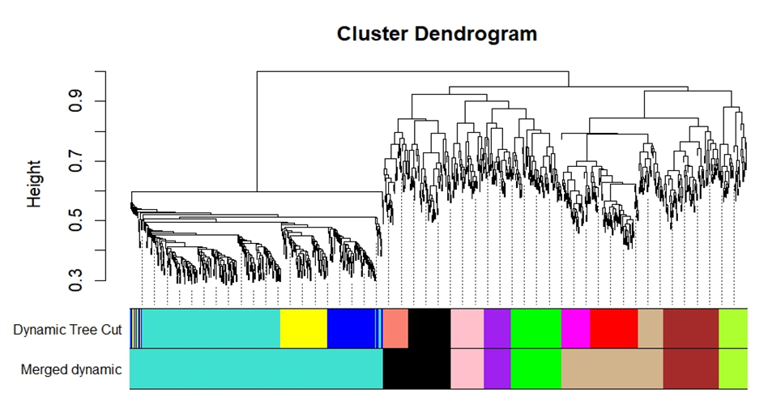
Supplementary Fig. S3 Clustering dendrogram of genes and module division by WGCNA. 8 modules repre-sented by colors in the horizontal bar (x-axis) were found using 0.15 threshold merging. Height on the y-axis represents the distance based on dissimilarity (lower values corresponding to the most connected genes in a given module

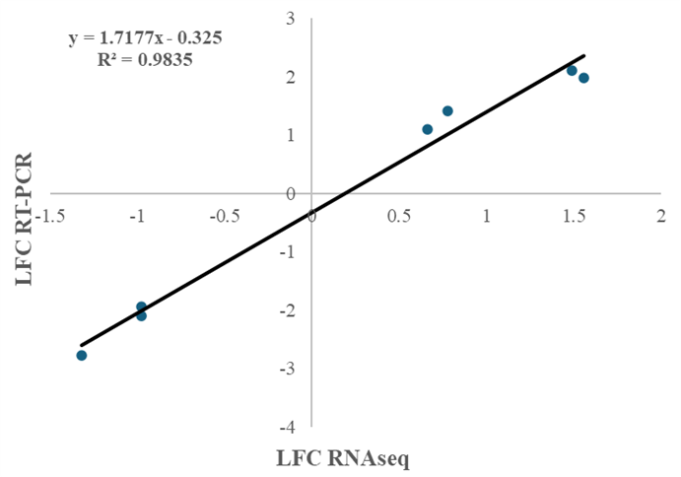
Supplementary Fig. S4 Validation of RNA-Seq data using quantitative real-time polymerase chain reaction (qPCR). All the data points are represented by the log2 fold change in the values
Tables
Code | Site | Region | Latitude | Longitude | Ear type | Kernel color
P1 | Adrar | Adrar | 28°01'18"N | 0°15'28"W | Flint | Yellow
P2 | OuledAhmed Tammi | Adrar | 27°50'25"N | 0°17'02"W | Flint | Orange
P3 | Tsabit | Adrar | 28°24'00"N | 0°14'08"W | Flint | Yellow
P4 | Aougrout | Timimoun | 28°42'00"N | 0°20'30" E | Flint | Orange
P5 | Timimoun | Timimoun | 29°15'32"N | 0°14'30"E | Flint | Yellow-orange
P7 | Zaouiet Kounta | Adrar | 27°13'27"N | 0°11'23"W | Flint | Yellow-violet
P9 | Zaouiet Kounta | Adrar | 27°04'30"N | 0°06'10"W | Flint/dent | Yellow
P11 | Fenoughil | Adrar | 27°39'27"N | 0°18'35"W | Flint | Yellow-violet
P12 | Charouine | Timimoun | 29°11'23"N | 0°16'10"W | Flint | Orange
P13 | Bouda | Adrar | 28°01'40"N | 0°27'30"W | Flint/dent | Yellow-orange
P14 | Sebaa | Adrar | 28°12'14"N | 0°10'26"W | Dent | Yellow
P16 | Tamantit | Adrar | 27°46'00"N | 0°15'59"W | Dent | Yellow
Supplementary Table S1 Origin and brief description of the twelve populations of maize from the Algerian Sahara

Supplementary Table S2 Chlorophyll fluorescence parameters measured in our study and their definition
Parameter | Formula | Definition | Reference
ETR |  | Electron transport rate | (de Sousa et al. 2017)
Fv/Fm | Fv/Fm | Maximum quantum efficiency of PSII photochemistry | (Baker 2008)
ΦPSII | (F'm–Fs)/F'm | Effective quantum yield of photochemical energy conversion in PSII | (Roháček 2002)
qP | (F’m − Fs)/(F’m − F’o) | Coefficient of photochemical quenching of variable fluorescence based on the puddle model of PSII | (Murchie and Lawson 2013)
NPQ | (Fm–Fm′)/Fm′ | Non-photochemical quenching | (Murchie and Lawson 2013)
qN | (Fm-F'm)/(Fm-F'o) | Coefficient of non-photochemical quenching of variable fluorescence | (Gorbe and Calatayud 2012)
qL | qL = qP × Fo′/Fs | Coefficient of photochemical quenching (lake model) | (Gorbe and Calatayud 2012)
ΦNO | 1/(NPQ + 1 + qL(Fm/Fo − 1)) | Quantum yield of non-regulated energy dissipation in PSII | (Kramer et al. 2004)
ΦNPQ | 1 - ΦPSII - ΦNO | Quantum yield of regulated energy dissipation in PSII | (Gorbe and Calatayud 2012)
Fm: Maximal fluorescence yield of dark-adapted sample with all PS II centers closed; F'm: Maximal fluorescence yield of illuminated sample with all PS II centers closed; Fo: Minimal fluorescence yield of dark-adapted sample with all PS II centers open; F'o: Minimal fluorescence yield of illuminated sample with all PS II centers open; F'=Fs: Chlorophyll fluorescence intensity measured at the steady-state after subjecting the sample to non-saturating actinic illumination. The terms Fm, F’m, Fo, F’o and Fs were determined as shown (Maxwell and Johnson 2000; Roháček 2002; Guidi and Degl’Innocenti 2011)
Gene name | Forward primer (5’-3’) | Reverse primer (5’-3’) | Tm °C
Zm00001eb351810 | ATCCAACACTGAACCCCACC | CGATGAAGCAGAGGCAGTCT | 59
Zm00001eb404560 | CCCTTGAGGTTGAGCACGAT | GTCACCAGACACTGCTCACA | 59
Zm00001eb161780 | CCAGCATCTCACCTGCATGA | AACGGAAGCGCGTTACAACT | 60
Zm00001eb127520 | TGGAGGCTGCGAGAAAGAAG | GCTCTCACGTACGGTCTCAC | 60
Zm00001eb352710 | AGTGCATAGCGGTTTTTGTCG | TCAATGGCAGCAAGGCTCTC | 60
Zm00001eb112180 | TGCATACTATCTTTCGCCTGT | CTGCTGGCGTGCACATAATC | 59
Zm00001eb162310 | CGAGATGGCCTCCTCAATGG | CTTACGGCTTGTGTTGGGTC | 60
Zm00001eb348450 (actin) | CTGGGGAAGACAGCTCTTGG | CCGACCAGGCTGCATAACTG | 61
Supplementary Table S3 List of primers for qRT-PCR analysis

Supplementary Table S4 ANOVA and Mean squares of measured traits at different levels of N application
Traits | Source of variation
Traits | N level (N) | Genotypes (G) | Interaction (G × N)
Grain yield (GY) | 115.88 * | 90.93 *** | 3.61 *
Dry matter accumulation (DMA) | 451.88 * | 434.35 *** | 15.73 ***
Total nitrogen uptake (TNC) | 65448.0 * | 20973.0 *** | 1795.0 *
Harvest index (HI) | 0.001 ns | 0.024 *** | 0.004 *
Agronomic nitrogen efficiency (AE) | 21.2 ns | 1229.7 *** | 226.1 ns
Nitrogen recovery efficiency (NRE) | 0.01 ns | 0.38 * | 0.16 ns
Nitrogen use efficiency (NUE) | 38612.0 * | 6748.0 *** | 603.0 **
Total production efficiency (TPE) | 146687.0 * | 30590.0 *** | 2196.0 ***
Physiological nitrogen efficiency (PEN) | 2190.8 ns | 1295.0 ns | 2184.3 ns
Nitrogen internal efficiency (NIE) | 221.88 ns | 481.87 *** | 56.00 *
Nitrogen harvest index (NHI) | 0.001 ns | 0.016 *** | 0.005 ns
ns: not significant at the 0.05 probability level. *, **, and ***: indicate significance at the 0.05, 0.01, and 0.001 levels, respectively
Supplementary Table S5 Meanª values of GY, DMA, TNU, and HI at different levels of N application
 | GY |  |  | DMA |  |  | TNU |  |  | HI
G | no-N | low-N | high-N | no-N | low-N | high-N | no-N | low-N | high-N | no-N | low-N | high-N
P1 | 4.09 gh | 4.49 cd | 5.12 de | 6.70 ef | 7.98 f | 9.83 fg | 87.52 ef | 112.00 gh | 126.84 g | 0.52 ab | 0.53 a | 0.45 bcde
P2 | 8.99 bc | 10.86 ab | 15.27 a | 21.17 a | 24.73 ab | 30.77 ab | 181.35 a | 231.34 ab | 303.03 ab | 0.38 def | 0.52 a | 0.43 de
P3 | 5.70 efg | 5.33 cd | 5.93 cde | 9.03 e | 8.59 ef | 10.39 fg | 123.24 cde | 113.94 fgh | 142.73 g | 0.54 a | 0.51 ab | 0.49 abcd
P4 | 4.73 fg | 5.97 cd | 7.31 cd | 9.38 e | 12.01 de | 12.33 f | 104.92 de | 140.15 efgh | 157.81 efg | 0.43 bcde | 0.49 abc | 0.51 ab
P5 | 7.75 cde | 10.62 b | 13.00 ab | 19.21 ab | 22.46 abc | 33.57 a | 158.61 abc | 196.61 abcd | 310.58 a | 0.34 ef | 0.49 abc | 0.34 f
P7 | 4.46 fgh | 6.24 c | 7.25 cd | 8.30 e | 12.48 de | 11.85 f | 89.45 ef | 149.71 defg | 146.01 fg | 0.47 abcd | 0.45 bcd | 0.53 a
P9 | 11.43 a | 13.12 a | 13.60 ab | 18.09 abc | 21.71 bc | 26.08 cd | 179.07 a | 212.13 abc | 276.07 abc | 0.54 a | 0.43 cde | 0.45 bcde
P11 | 2.60 h | 3.82 d | 4.50 e | 4.71 f | 6.87 f | 7.74 g | 56.45 f | 87.54 h | 108.37 g | 0.48 abcd | 0.43 cde | 0.50 abc
P12 | 6.46 def | 6.79 c | 8.45 c | 13.57 d | 15.54 d | 16.91 e | 151.54 abc | 166.26 cdef | 214.62 cde | 0.40 cdef | 0.43 cde | 0.43 cde
P13 | 7.81 cd | 13.02 a | 13.26 ab | 21.17 a | 25.78 a | 28.92 bc | 157.00 abc | 221.82 ab | 240.15 bcd | 0.32 f | 0.42 cde | 0.39 ef
P14 | 9.21 bc | 10.26 b | 13.72 ab | 17.45 bc | 19.54 c | 26.74 cd | 143.98 abcd | 178.75 bcde | 232.80 cd | 0.45 abcd | 0.41 de | 0.45 bcde
P16 | 9.91 ab | 12.01 ab | 12.28 b | 17.33 bc | 25.55 ab | 23.63 d | 168.70 ab | 246.35 a | 207.40 def | 0.50 abc | 0.40 de | 0.45 bcde
H1 | 8.47 bcd | 11.99 ab | 12.9 ab | 16.03 bcd | 24.08 ab | 26.27 cd | 123.74 cde | 214.85 abc | 239.00 cd | 0.45 abcd | 0.38 e | 0.42 de
H2 | 8.9 bc | 11.88 ab | 14.32 ab | 14.60 cd | 20.10 c | 23.39 d | 135.17 bcd | 202.40 abcd | 258.35 abcd | 0.53 ab | 0.38 e | 0.53 a
Means | 7.18 b | 9.03 ab | 10.49 a | 14.05 b | 17.67 ab | 20.60 a | 132.91 b | 176.70 ab | 211.70 a | 0.45 | 0.45 | 0.45
LSD_{0.05} | 2.06 | 2.36 | 2.64 | 3.58 | 3.95 | 3.81 | 39.09 | 53.57 | 63.00 | 0.1 | 0.06 | 0.07
CV % | 17.07 | 15.56 | 14.96 | 15.19 | 13.33 | 11.03 | 17.52 | 18.12 | 17.73 | 13.32 | 8.62 | 9.48
ª Means followed by different letters are significantly different at p-value of 0.05. G: Genotypes, GY: Grain yield (t ha⁻¹), DMA: Dry matter accumulation (t ha⁻¹), TNU: Total N uptake (kg N-uptake ha⁻¹), HI: Harvest index (kg grain kg⁻¹ biomass). LSD: Least significant difference and CV%: Coefficient of variation

 | AE |  | NRE |  | NUE |  | TPE
G | low-N | high-N | low-N | high-N | low-N | high-N | low-N | high-N
P1 | 4.94 | 6.87 e | 0.3 | 0.26 cd | 56.07 cd | 34.14 de | 99.79 f | 65.53 fg
P2 | 23.49 | 41.89 a | 0.62 | 0.81 ab | 135.79 ab | 101.78 a | 309.10 ab | 205.14 ab
P3 | –4.68 | 1.53 e | –0.12 | 0.13 d | 66.56 cd | 39.56 cde | 107.30 ef | 69.23 fg
P4 | 15.51 | 17.26 bcde | 0.44 | 0.35 bcd | 74.60 cd | 48.77 cd | 150.13 de | 82.19 f
P5 | 35.86 | 35.01 abc | 0.47 | 1.01 a | 132.74 b | 86.69 ab | 280.72 abc | 223.77 a
P7 | 22.23 | 18.61 bcde | 0.75 | 0.38 bcd | 77.96 c | 48.33 cd | 155.97 de | 79.02 f
P9 | 21.09 | 14.51 cde | 0.41 | 0.65 abc | 163.97 a | 90.71 ab | 271.44 bc | 173.88 cd
P11 | 15.24 | 12.70 de | 0.39 | 0.35 bcd | 47.72 d | 30.02 e | 85.83 f | 51.59 g
P12 | 4.02 | 13.21 de | 0.18 | 0.42 bcd | 84.82 c | 56.30 c | 194.28 d | 112.74 e
P13 | 65.22 | 36.35 ab | 0.81 | 0.56 abcd | 162.81 a | 88.40 ab | 322.27 a | 192.81 bc
P14 | 13.05 | 30.01 abcd | 0.44 | 0.59 abcd | 128.23 b | 91.44 ab | 244.25 c | 178.26 cd
P16 | 26.26 | 15.85 bcde | 0.97 | 0.26 cd | 150.06 ab | 81.87 b | 319.45 ab | 157.54 d
H1 | 44.03 | 29.53 abcd | 1.14 | 0.77 ab | 150.06 ab | 85.99 ab | 301.06 ab | 175.14 cd
H2 | 37.28 | 36.15 ab | 0.84 | 0.82 ab | 148.56 ab | 95.49 ab | 251.25 c | 155.92 d
Means | 23.11 | 22.1 | 0.55 | 0.53 | 112.84 a | 69.96 b | 220.92 a | 137.34 b
LSD_{0.05} | ns | 21.51 | ns | 0.48 | 29.47 | 17.57 | 49.42 | 25.43
CV % | 105.02 | 57.97 | 93.96 | 54.44 | 15.56 | 14.96 | 13.33 | 11.03
Supplementary Table S6 Meanª values of fertilizer-based NUE indices (AE, NRE, NUE and TPE) at different levels of N application
ª Means followed by different letters are significantly different at p-value of 0.05. G: Genotypes, AE: Agronomic N efficiency (kg grain kg⁻¹ N applied), NRE: N recovery efficiency (kg N uptake kg⁻¹ N applied), NUE: Nitrogen use efficiency (kg grain kg⁻¹ N applied) and TPE: Total production efficiency (kg biomass kg⁻¹ N applied). LSD: Least significant difference, CV%: Coefficient of variation
 | PEN |  | NIE |  |  | NHI
G | low-N | high-N | no-N | low-N | high-N | no-N | low-N | high-N
P1 | –1.11 | 24.65 | 46.58 c | 40.27 g | 40.54 f | 0.7 | 0.67 | 0.63 cd
P2 | –28.85 | 70.19 | 49.77 bc | 48.16 defg | 50.98 abcd | 0.63 | 0.61 | 0.68 abc
P3 | 45.6 | 3.47 | 46.17 c | 46.69 efg | 41.74 ef | 0.72 | 0.73 | 0.72 ab
P4 | 49.98 | 48.83 | 45.21 c | 42.63 fg | 46.29 cdef | 0.63 | 0.6 | 0.69 abc
P5 | 42.29 | 33.37 | 47.73 c | 54.54 bcde | 42.15 def | 0.58 | 0.65 | 0.53 e
P7 | 28.69 | 52.64 | 50.98 bc | 41.73 fg | 49.68 bcde | 0.69 | 0.57 | 0.74 a
P9 | 34.19 | 12.91 | 64.09 a | 63.68 a | 50.64 abcde | 0.72 | 0.66 | 0.65 bcd
P11 | 45.75 | 37.79 | 46.22 c | 44.05 fg | 41.67 ef | 0.66 | 0.67 | 0.65 bcd
P12 | 39.2 | 28.35 | 43.14 c | 41.02 fg | 39.57 f | 0.58 | 0.63 | 0.64 bcd
P13 | 41.8 | 91.84 | 50.67 bc | 59.74 ab | 54.98 abc | 0.53 | 0.65 | 0.58 de
P14 | 14.97 | 53.54 | 64.47 a | 57.17 abc | 59.24 a | 0.61 | 0.64 | 0.66 abcd
P16 | 28.23 | 61.99 | 60.52 ab | 49.20 cdef | 59.59 a | 0.66 | 0.6 | 0.63 bcd
H1 | 37.98 | 29.09 | 68.79 a | 56.23 abcd | 54.01 abc | 0.68 | 0.7 | 0.67 abc
H2 | 78.2 | 40.49 | 65.61 a | 61.14 ab | 56.09 ab | 0.72 | 0.7 | 0.74 a
Means | 32.64 | 43.02 | 53.6 | 50.5 | 49.08 | 0.65 | 0.65 | 0.66
LSD_{0.05} | ns | ns | 11.4 | 0.57 | 9.12 | ns | ns | 0.09
CV % | 120.15 | 65.51 | 12.6 | 10.1 | 11 | 13.27 | 8.94 | 8.01
Supplementary Table S7 Meanª values of plant-based NUE indices (PEN, NIE and NHI) at different levels of N application
ª Means followed by different letters are significantly different at p-value of 0.05. G: Genotypes, PEN: Physiological N efficiency (kg grain kg⁻¹ N uptake), NIE: N internal efficiency (kg grain kg⁻¹ N uptake), NHI: N harvest index (kg kg⁻¹). LSD: Least significant difference, CV%: Coefficient of variation
 | GY | DMA | TNC | HI | NHI | NIE | AE | NRpE | NUE | TPE | PEN
GY |  | 0.96*** | 0.94*** | – 0.18 | – 0.02 | 0.86*** | 0.72** | 0.63* | 1.00*** | 0.96*** | 0.03
DMA | 0.95*** |  | 0.98*** | – 0.45 | – 0.18 | 0.69** | 0.72** | 0.66* | 0.96*** | 1.00*** | – 0.11
TNC | 0.93*** | 0.95*** |  | – 0.44 | – 0.24 | 0.64* | 0.65* | 0.67** | 0.94*** | 0.98*** | – 0.12
HI | – 0.45 | – 0.70** | – 0.61* |  | 0.66** | 0.27 | – 0.24 | – 0.35 | – 0.18 | – 0.45 | 0.40
NHI | 0.21 | – 0.47 | – 0.35 | 0.88*** |  | 0.32 | – 0.06 | – 0.26 | – 0.02 | – 0.18 | 0.35
NIE | 0.72** | 0.55* | 0.41 | 0.03 | 0.13 |  | 0.63* | 0.39 | 0.86*** | 0.69** | 0.28
AE | 0.81*** | 0.81*** | 0.77** | – 0.41 | – 0.21 | 0.53* |  | 0.78*** | 0.72** | 0.72** | 0.22
NRpE | 0.78** | 0.82*** | 0.87*** | – 0.50 | – 0.29 | 0.27 | 0.84*** |  | 0.63* | 0.66* | 0.06
NUE | 1.00*** | 0.95*** | 0.93*** | – 0.45 | – 0.21 | 0.76** | 0.81*** | 0.78** |  | 0.96*** | 0.03
TPE | 0.95*** | 1.00*** | 0.95*** | – 0.70** | – 0.47 | 0.55* | 0.81*** | 0.82*** | 0.95*** |  | – 0.11
PEN | 0.4 | 0.38 | 0.22 | – 0.15 | – 0.19 | 0.56* | 0.63* | 0.16 | 0.40 | 0.38
Supplementary Table S8 Correlations between agronomic traits and NUE indices under high-N conditions (below the diagonal) and low-N conditions (above the diagonal)
GY: Grain yield, DMA: Dry matter accumulation, TNU: Total N uptake, HI: Harvest index, AE: Agronomic N efficiency, NRE: N recovery efficiency, NUE: Nitrogen use efficiency, TPE: Total production efficiency, PEN: Physiological N efficiency, NIE: N internal efficiency, NHI: N harvest index. *, **, and *** indicate significance at the 0.05, 0.01, and 0.001 levels, respectively

 | Input reads | Total mapped | Uniquely mapped | Multiple mapped
P11_1 | 27 255 071 | 24 784 250 (90.94%) | 22 795 205 (83.64%) | 1 989 045 (7.30%)
P11_2 | 30 140 847 | 27 497 002 (91.23%) | 25 406 192 (84.29%) | 2 090 810 (6.94%)
P11_3 | 24 044 887 | 22 380 902 (93.08%) | 20 849 069 (86.71%) | 1 531 833 (6.37%)
P13_1 | 28 900 132 | 26 911 843 (93.11%) | 24 819 944 (85.88%) | 2 091 899 (7.24%)
P13_2 | 26 357 985 | 24 445 566 (92.74%) | 22 579 009 (85.66%) | 1 866 557 (7.08%)
P13_3 | 26 027 118 | 24 194 183 (92.96%) | 22 413 464 (86.12%) | 1 780 719 (6.84%)
Supplementary Table S9 RNA sequencing reads and mapped to the maize genome
Input reads: total number of reads; Total mapped: total number of reads mapped on the maize genome; Uniquely mapped: total number of reads mapped to uniquely locations in the maize genome; Multiple mapped: total number of reads mapped to multiple locations in maize genome
Nbr | Module colors | Gene number |  | Nbr | Module colors | Gene number
1 | Black | 106 |  | 5 | Pink | 51
2 | Brown | 86 |  | 6 | Purple | 43
3 | Green | 78 |  | 7 | Tan | 160
4 | Greenyellow | 43 |  | 8 | Turquoise | 396
Supplementary Table S10 Number of DEGs genes for each co-expression module

Gene ID | Description
Zm00001eb355570 | Glutelin type-A 1
Zm00001eb146820 | arm27 - armadillo domain protein27
Zm00001eb330550 | px26 - peroxidase26
Zm00001eb376570 | znod1 - Zea nodulation homolog1
Zm00001eb057630 | pco110965
Zm00001eb030110 | cyp52 - cytochrome P450 52
Zm00001eb409220 | psan2 - photosystem I N subunit2
Zm00001eb223510 | MOB kinase activator-like 1A
Zm00001eb043900 | pmei48 - pectin methylesterase inhibitor48
Zm00001eb079860 | leucine-rich repeat (LRR) family protein
Zm00001eb105200 | Photosynthetic NDH subunit of subcomplex B 3
Zm00001eb423030 | ARM repeat superfamily protein
Zm00001eb263010 | Cysteine-rich receptor kinase
Zm00001eb381250 | Protein kinase domain-containing protein
Zm00001eb186310 | Taxadien-5-alpha-ol O-acetyltransferase
Zm00001eb413730 | hak12 - potassium high-affinity transporter12
Zm00001eb428590 | spx11 - SPX domain-containing membrane protein11
Zm00001eb155630 | sbt23 - subtilisin23
Zm00001eb018840 | Alpha-ketoglutarate-dependent dioxygenase alkB-like protein 2
Zm00001eb162310 | High affinity nitrate transport 2.4
Supplementary Table S11 Hub genes selected in turquoise module for NUE trait

References
Baker NR (2008) Chlorophyll fluorescence: a probe of photosynthesis in vivo. Annu Rev Plant Biol 59:89–113. https://doi.org/10.1146/annurev.arplant.59.032607.092759
de Sousa CAF, de Paiva DS, Casari RA das CN, et al (2017) A procedure for maize genotypes discrimination to drought by chlorophyll fluorescence imaging rapid light curves. Plant Methods 13:1–17. https://doi.org/10.1186/s13007-017-0209-z
Gorbe E, Calatayud A (2012) Applications of chlorophyll fluorescence imaging technique in horticultural research: A review. Sci Hortic (Amsterdam) 138:24–35. https://doi.org/10.1016/j.scienta.2012.02.002
Guidi L, Degl’Innocenti E (2011) Imaging of chlorophyll a fluorescence: a tool to study abiotic stress in plants. Abiotic Stress plants—mechanisms Adaptations, InTech, West Palm Beach. http://dx.doi.org/10.5772/22281
Kramer DM, Johnson G, Kiirats O, Edwards GE (2004) New fluorescence parameters for the determination of QA redox state and excitation energy fluxes. Photosynth Res 79:209–218. https://doi.org/10.1023/B:PRES.0000015391.99477.0d
Maxwell K, Johnson GN (2000) Chlorophyll fluorescence—a practical guide. J Exp Bot 51:659–668. https://doi.org/10.1093/jexbot/51.345.659
Murchie EH, Lawson T (2013) Chlorophyll fluorescence analysis: a guide to good practice and understanding some new applications. J Exp Bot 64:3983–3998. https://doi.org/10.1093/jxb/ert208
Roháček K (2002) Chlorophyll fluorescence parameters: the definitions, photosynthetic meaning, and mutual relationships. Photosynthetica 40:13–29. https://doi.org/10.1023/A:1020125719386

