Appendices to “Large Language Model-Empowered Debate Outcome Prediction via Argument Quality Assessment”
Appendix A. Customized Schema for Argument Strategy Annotation
To capture argumentation strategies in the CDWC dataset, we adapted Felton’s (2004) analytic framework for argumentative discourse to create a tailored coding schema. While retaining many of Felton’s original strategy categories, the customized schema integrates additional insights derived from an in-depth review of the CDWC data. Table A1 presents the revised strategy categories along with their definitions.
Table A1. Customized Schema for Argument Strategy Annotation
Category | Definition
Questions
Request for a stance | Asking the opponent to take a position on a specific case, scenario, or issue, including questions about whether they accept or agree with the speaker’s viewpoint.
Request for clarification | Asking the opponent to clarify their previous statement or provide more detailed information.
Request for response | Asking the opponent to directly address or respond to the speaker’s own argument or question.
Request for justification | Asking the opponent to offer evidence or further reasoning to support their previous claim or position.
Rhetorical question | Using an interrogative form to express a positive assertion. For example: “Isn’t it?”, “How could it not be?”, “Isn’t that exactly the case?”
Statements
Agreement | Explicitly expressing agreement, approval, or endorsement of the opponent’s statement.
Opposition | Rejecting, refuting, or challenging the opponent’s statements, arguments, or reasoning, or pointing out that their remarks deviate from the debate topic or are irrelevant.
Clarifying the opponent’s viewpoint | Interpreting, paraphrasing, or restating what the opponent has previously said.
Clarifying own viewpoint | Clarifying, interpreting, paraphrasing, or restating the speaker’s own prior statements.
Example-based reasoning | Providing one or more concrete examples and generalizing from cases to broader conclusions to support one’s own argument or counter the opponent’s argument.
Analogical reasoning | Drawing comparisons with similar phenomena or cases to support one’s own position or refute the opponent’s.
Causal reasoning | Explaining why A leads (or does not lead) to B by emphasizing the causal mechanism to support one’s own stance or challenge the opponent’s.
Comparative reasoning | Using quantitative data or observable trends to directly compare the advantages and disadvantages of two phenomena, or weighing them in terms of “benefits outweighing harms” or vice versa, to strengthen one’s position or weaken the opponent’s.
Definition-based reasoning | Challenging the opponent’s definition or interpretation of a concept, or offering one’s own definition and interpretation to support the argument.
Argument to absurdity | Testing whether the opponent’s viewpoint would lead to conclusions that are absurd or counter to common sense, thereby refuting the opponent or supporting one’s own claim.
Others | Off-topic remarks or comments unrelated to the main debate.
We used an LLM (GPT-4.5-Preview) to annotate argumentation strategies in the CDWC dataset. Each API call received an utterance, segmented into sentences, and the LLM assigned one strategy label from Table A1 to each sentence. After annotation, we computed speaker-level strategy features by counting the frequency of each strategy label in a speaker’s utterances, and then aggregated these counts across team members to construct team-level strategy feature vectors.

Appendix B. Confidence Intervals of Debate Outcome Prediction Accuracy
Table A2. Confidence Intervals from Bootstrapping Cross-Validation
Classifier | RF | SVC | LR | XGB
Hand-crafted Features | 0.581  (0.509, 0.647) | 0.583  (0.515, 0.64) | 0.579  (0.509, 0.664) | 0.578  (0.497, 0.646)
OpenAI Embeddings | 0.525  (0.47, 0.577) | 0.538  (0.503, 0.571) | 0.542  (0.5, 0.577) | 0.514  (0.443, 0.587)
Argument Strategy Features | 0.592  (0.538, 0.646) | 0.580  (0.524, 0.631) | 0.505  (0.443, 0.58) | 0.540  (0.47, 0.625)
Argument Quality (Our Work) | 0.659  (0.607, 0.723) | 0.649  (0.603, 0.69) | 0.659  (0.603, 0.702) | 0.625  (0.565, 0.681)
Notes: For each algorithm–feature set combination, we report the mean and 95% confidence interval of the cross-validation accuracy estimated from 100 bootstrapping resampling.
We report confidence intervals for prediction accuracy in Table 3, reflecting fluctuation due to data resampling. Consistent with the point estimates, confidence intervals based on argument quality features show both higher upper and lower bounds than those of other feature sets. Importantly, paired t-tests on bootstrapped accuracy scores indicate statistically significant improvements over all baselines, underscoring the effectiveness of argument quality evaluation for debate outcome prediction.
Appendix C. Results of the Full Ablation Study
Table A3. Results of the Full Ablation Study
 | RF | SVC | LR | XGB | Average
Support | 0.412 | 0.605 | 0.603 | 0.426 | 0.511
Response | 0.662 | 0.504 | 0.565 | 0.662 | 0.598
Language | 0.606 | 0.663 | 0.666 | 0.613 | 0.637
Response + Language | 0.654 | 0.674 | 0.676 | 0.635 | 0.660
Support + Language | 0.615 | 0.635 | 0.659 | 0.572 | 0.620
Response + Support | 0.561 | 0.569 | 0.588 | 0.526 | 0.561
Full set | 0.659 | 0.649 | 0.659 | 0.625 | 0.648
Notes: Same as Table 3, scores are aggregated means of cross-validation accuracy over 100 bootstrap resamplings.

Appendix D. Screenshot of the Customized Annotation Software
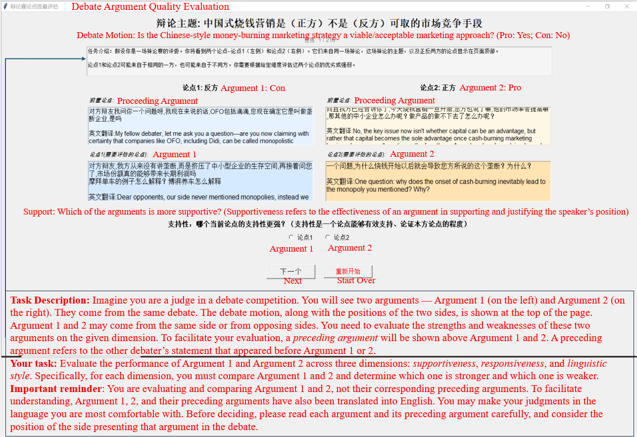
Figure A1. Screenshot of the Customized Annotation Software

References
Felton, M. K. (2004). The development of discourse strategies in adolescent argumentation. Cognitive Development, 19(1), 35–52.

