Supplementary Figures and Tables

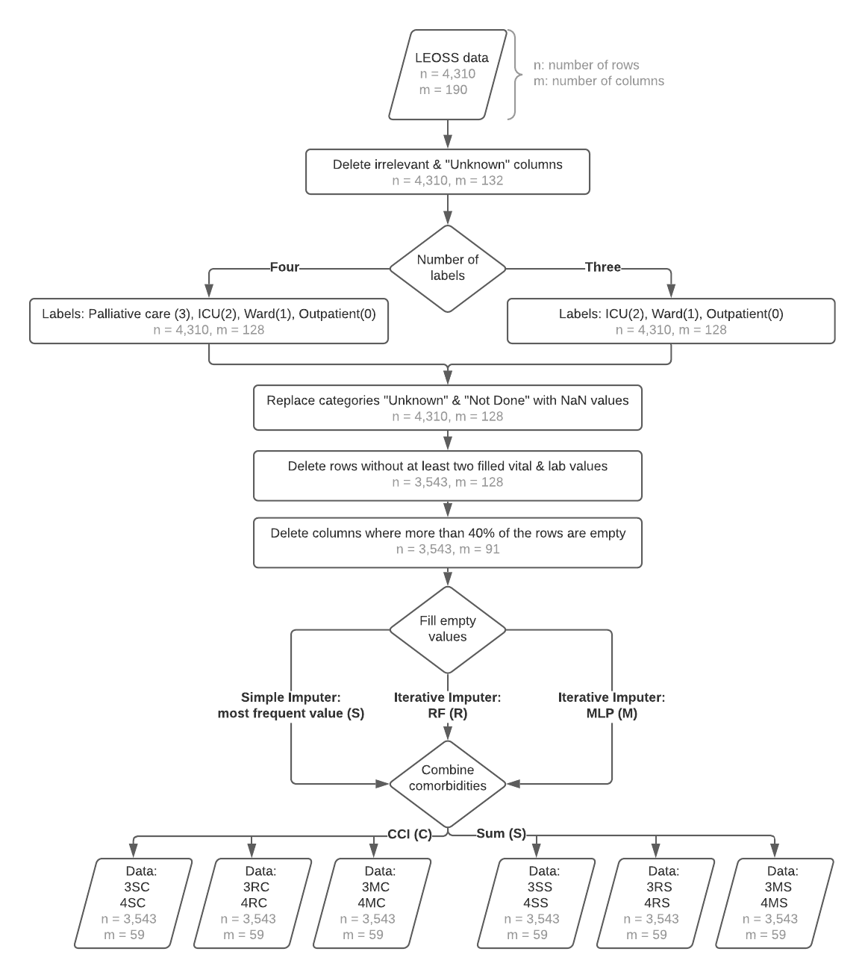
Figure 1: Data preparation (every row in the dataset corresponds with a single patient, the columns denote the features)

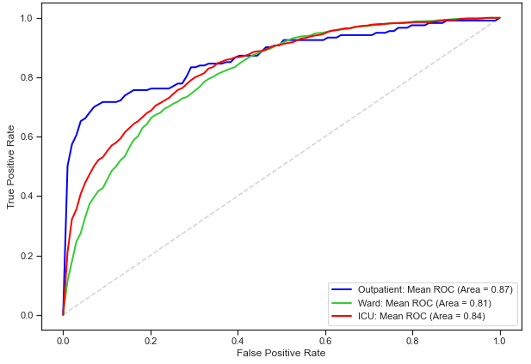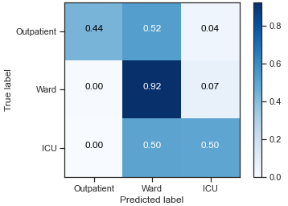
Figure 2: Receiver operating characteristic (left hand side) and confusion matrix (right hand side) for the XGB Classifier (3MC).

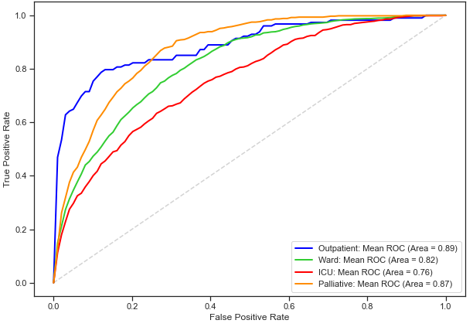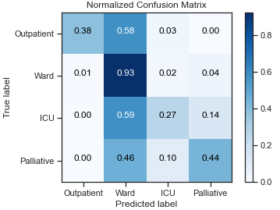
Figure 3: Receiver operating characteristic (left hand side) and confusion matrix (right hand side) for the XGB Classifier (4RC)
Table 1: Evaluation metrics for the different algorithms (3 labels)
Accuracy |  |  | Recall |  |  | Precision |  |  | Specificity
 |  | Total | Outpatient | Ward | ICU | Outpatient | Ward | ICU | Outpatient | Ward | ICU
TA | 3RC | 0.27 | 0.84 | 0.14 | 0.53 | 0.06 | 0.81 | 0.36 | 0.54 | 0.92 | 0.65
TA | 3RS | 0.28 | 0.84 | 0.15 | 0.53 | 0.06 | 0.82 | 0.37 | 0.54 | 0.92 | 0.66
TA | 3MC | 0.28 | 0.65 | 0.16 | 0.54 | 0.05 | 0.79 | 0.36 | 0.56 | 0.90 | 0.64
TA | 3MS | 0.29 | 0.65 | 0.17 | 0.54 | 0.05 | 0.81 | 0.37 | 0.56 | 0.91 | 0.65
TA | 3SC | 0.27 | 0.58 | 0.15 | 0.52 | 0.04 | 0.77 | 0.35 | 0.55 | 0.89 | 0.64
TA | 3SS | 0.28 | 0.58 | 0.16 | 0.52 | 0.04 | 0.78 | 0.36 | 0.55 | 0.89 | 0.65
TAE | 3RC | 0.50 | 0.73 | 0.53 | 0.40 | 0.10 | 0.71 | 0.50 | 0.75 | 0.52 | 0.85
TAE | 3RS | 0.50 | 0.73 | 0.54 | 0.38 | 0.10 | 0.71 | 0.50 | 0.75 | 0.50 | 0.86
TAE | 3MC | 0.51 | 0.69 | 0.53 | 0.43 | 0.10 | 0.72 | 0.49 | 0.77 | 0.53 | 0.83
TAE | 3MS | 0.51 | 0.69 | 0.53 | 0.42 | 0.10 | 0.71 | 0.49 | 0.77 | 0.52 | 0.83
TAE | 3SC | 0.48 | 0.68 | 0.53 | 0.32 | 0.08 | 0.70 | 0.47 | 0.72 | 0.49 | 0.87
TAE | 3SS | 0.48 | 0.68 | 0.54 | 0.31 | 0.08 | 0.70 | 0.47 | 0.72 | 0.48 | 0.87
DC | 3RC | 0.04 | 1.00 | 0.00 | 0.00 | 0.03 | 0.00 | 0.00 | 0.00 | 1.00 | 1.00
DC | 3RS | 0.04 | 1.00 | 0.00 | 0.00 | 0.03 | 0.00 | 0.00 | 0.00 | 1.00 | 1.00
DC | 3MC | 0.04 | 1.00 | 0.00 | 0.00 | 0.03 | 0.00 | 0.00 | 0.00 | 1.00 | 1.00
DC | 3MS | 0.04 | 1.00 | 0.00 | 0.00 | 0.03 | 0.00 | 0.00 | 0.00 | 1.00 | 1.00
DC | 3SC | 0.04 | 1.00 | 0.00 | 0.00 | 0.03 | 0.00 | 0.00 | 0.00 | 1.00 | 1.00
DC | 3SS | 0.04 | 1.00 | 0.00 | 0.00 | 0.03 | 0.00 | 0.00 | 0.00 | 1.00 | 1.00
RF | 3RC | 0.77 | 0.39 | 0.94 | 0.39 | 0.65 | 0.78 | 0.76 | 0.99 | 0.39 | 0.95
RF | 3RS | 0.77 | 0.40 | 0.94 | 0.39 | 0.64 | 0.78 | 0.76 | 0.99 | 0.40 | 0.95
RF | 3MC | 0.78 | 0.44 | 0.94 | 0.40 | 0.75 | 0.78 | 0.76 | 0.99 | 0.41 | 0.95
RF | 3MS | 0.78 | 0.38 | 0.94 | 0.41 | 0.70 | 0.78 | 0.76 | 0.99 | 0.41 | 0.95
RF | 3SC | 0.74 | 0.37 | 0.93 | 0.30 | 0.64 | 0.76 | 0.65 | 0.99 | 0.33 | 0.94
RF | 3SS | 0.74 | 0.36 | 0.93 | 0.31 | 0.65 | 0.76 | 0.65 | 0.99 | 0.33 | 0.94
XGB | 3RC | 0.78 | 0.44 | 0.93 | 0.47 | 0.68 | 0.80 | 0.73 | 0.99 | 0.47 | 0.94
XGB | 3RS | 0.78 | 0.43 | 0.92 | 0.47 | 0.69 | 0.80 | 0.73 | 0.99 | 0.48 | 0.93
XGB | 3MC | 0.79 | 0.44 | 0.92 | 0.50 | 0.82 | 0.80 | 0.73 | 1.00 | 0.49 | 0.93
XGB | 3MS | 0.78 | 0.40 | 0.92 | 0.49 | 0.77 | 0.80 | 0.72 | 1.00 | 0.48 | 0.93
XGB | 3SC | 0.74 | 0.40 | 0.91 | 0.38 | 0.58 | 0.77 | 0.62 | 0.99 | 0.40 | 0.91
XGB | 3SS | 0.74 | 0.40 | 0.90 | 0.38 | 0.60 | 0.77 | 0.61 | 0.99 | 0.41 | 0.91
MLP | 3RC | 0.76 | 0.45 | 0.88 | 0.50 | 0.54 | 0.80 | 0.65 | 0.99 | 0.51 | 0.90
MLP | 3RS | 0.77 | 0.42 | 0.89 | 0.50 | 0.58 | 0.80 | 0.66 | 0.99 | 0.50 | 0.91
MLP | 3MC | 0.78 | 0.42 | 0.90 | 0.52 | 0.70 | 0.81 | 0.68 | 0.99 | 0.51 | 0.91
MLP | 3MS | 0.78 | 0.40 | 0.89 | 0.52 | 0.68 | 0.81 | 0.67 | 0.99 | 0.51 | 0.90
MLP | 3SC | 0.75 | 0.48 | 0.88 | 0.44 | 0.50 | 0.79 | 0.61 | 0.98 | 0.47 | 0.89
MLP | 3SS | 0.75 | 0.44 | 0.88 | 0.45 | 0.47 | 0.79 | 0.62 | 0.98 | 0.47 | 0.90
ITA | 3RC | 0.73 | 0.60 | 0.72 | 0.69 | 0.37 | 0.84 | 0.53 | 0.96 | 0.70 | 0.77
ITA | 3RS | 0.72 | 0.63 | 0.76 | 0.63 | 0.36 | 0.83 | 0.56 | 0.96 | 0.65 | 0.82
ITA | 3MC | 0.72 | 0.62 | 0.72 | 0.72 | 0.50 | 0.85 | 0.53 | 0.98 | 0.72 | 0.76
ITA | 3MS | 0.73 | 0.63 | 0.76 | 0.67 | 0.43 | 0.84 | 0.56 | 0.97 | 0.68 | 0.81
ITA | 3SC | 0.68 | 0.53 | 0.72 | 0.62 | 0.36 | 0.82 | 0.49 | 0.97 | 0.65 | 0.76
ITA | 3SS | 0.70 | 0.59 | 0.76 | 0.57 | 0.31 | 0.82 | 0.53 | 0.95 | 0.63 | 0.81

 |  | ROC AUC |  |  |  | F1
 |  | Total | Outpatient | Ward | ICU | Outpatient | Ward | ICU
TA | 3RC | - | - | - | - | 0.11 | 0.24 | 0.43
TA | 3RS | - | - | - | - | 0.11 | 0.26 | 0.44
TA | 3MC | - | - | - | - | 0.09 | 0.27 | 0.43
TA | 3MS | - | - | - | - | 0.09 | 0.28 | 0.44
TA | 3SC | - | - | - | - | 0.08 | 0.26 | 0.42
TA | 3SS | - | - | - | - | 0.08 | 0.27 | 0.43
TAE | 3RC | - | - | - | - | 0.17 | 0.61 | 0.44
TAE | 3RS | - | - | - | - | 0.17 | 0.61 | 0.43
TAE | 3MC | - | - | - | - | 0.17 | 0.61 | 0.46
TAE | 3MS | - | - | - | - | 0.17 | 0.61 | 0.45
TAE | 3SC | - | - | - | - | 0.15 | 0.61 | 0.38
TAE | 3SS | - | - | - | - | 0.15 | 0.61 | 0.37
DC | 3RC | 0.50 | 0.50 | 0.50 | 0.50 | 0.07 | 0.00 | 0.00
DC | 3RS | 0.50 | 0.50 | 0.50 | 0.50 | 0.07 | 0.00 | 0.00
DC | 3MC | 0.50 | 0.50 | 0.50 | 0.50 | 0.07 | 0.00 | 0.00
DC | 3MS | 0.50 | 0.50 | 0.50 | 0.50 | 0.07 | 0.00 | 0.00
DC | 3SC | 0.50 | 0.50 | 0.50 | 0.50 | 0.07 | 0.00 | 0.00
DC | 3SS | 0.50 | 0.50 | 0.50 | 0.50 | 0.07 | 0.00 | 0.00
RF | 3RC | 0.83 | 0.87 | 0.80 | 0.82 | 0.48 | 0.85 | 0.51
RF | 3RS | 0.83 | 0.87 | 0.80 | 0.82 | 0.49 | 0.85 | 0.51
RF | 3MC | 0.83 | 0.86 | 0.80 | 0.83 | 0.55 | 0.86 | 0.53
RF | 3MS | 0.83 | 0.86 | 0.80 | 0.83 | 0.49 | 0.85 | 0.53
RF | 3SC | 0.80 | 0.86 | 0.76 | 0.76 | 0.47 | 0.84 | 0.41
RF | 3SS | 0.79 | 0.85 | 0.76 | 0.77 | 0.47 | 0.83 | 0.42
XGB | 3RC | 0.83 | 0.87 | 0.80 | 0.83 | 0.53 | 0.86 | 0.57
XGB | 3RS | 0.83 | 0.87 | 0.81 | 0.83 | 0.53 | 0.86 | 0.57
XGB | 3MC | 0.84 | 0.87 | 0.81 | 0.84 | 0.57 | 0.86 | 0.59
XGB | 3MS | 0.84 | 0.86 | 0.81 | 0.84 | 0.52 | 0.86 | 0.58
XGB | 3SC | 0.80 | 0.85 | 0.77 | 0.77 | 0.47 | 0.83 | 0.47
XGB | 3SS | 0.80 | 0.85 | 0.77 | 0.78 | 0.48 | 0.83 | 0.47
MLP | 3RC | 0.83 | 0.88 | 0.79 | 0.81 | 0.49 | 0.84 | 0.57
MLP | 3RS | 0.83 | 0.87 | 0.79 | 0.82 | 0.49 | 0.84 | 0.57
MLP | 3MC | 0.83 | 0.87 | 0.80 | 0.83 | 0.53 | 0.85 | 0.58
MLP | 3MS | 0.83 | 0.87 | 0.80 | 0.83 | 0.51 | 0.85 | 0.59
MLP | 3SC | 0.81 | 0.86 | 0.77 | 0.79 | 0.49 | 0.83 | 0.51
MLP | 3SS | 0.81 | 0.86 | 0.78 | 0.79 | 0.45 | 0.83 | 0.52
ITA | 3RC | - | - | - | - | 0.46 | 0.77 | 0.60
ITA | 3RS | - | - | - | - | 0.46 | 0.79 | 0.59
ITA | 3MC | - | - | - | - | 0.55 | 0.78 | 0.61
ITA | 3MS | - | - | - | - | 0.51 | 0.80 | 0.61
ITA | 3SC | - | - | - | - | 0.43 | 0.77 | 0.55
ITA | 3SS | - | - | - | - | 0.41 | 0.79 | 0.55

Table 2: Evaluation metrics for the different algorithms (4 labels)
 |  |  | Recall |  |  |  | Precision |  |  |  | Specificity
 |  | Total | Outpatient | Ward | ICU | Palliative | Outpatient | Ward | ICU | Palliative | Outpatient | Ward | ICU | Palliative
TAE | 4RC | 0.44 | 0.77 | 0.54 | 0.10 | 0.39 | 0.09 | 0.65 | 0.26 | 0.46 | 0.74 | 0.52 | 0.94 | 0.91
TAE | 4RS | 0.45 | 0.77 | 0.54 | 0.09 | 0.39 | 0.09 | 0.65 | 0.25 | 0.48 | 0.74 | 0.51 | 0.94 | 0.91
TAE | 4MC | 0.46 | 0.75 | 0.54 | 0.10 | 0.47 | 0.10 | 0.67 | 0.24 | 0.47 | 0.76 | 0.55 | 0.93 | 0.90
TAE | 4MS | 0.46 | 0.75 | 0.54 | 0.08 | 0.46 | 0.10 | 0.66 | 0.21 | 0.48 | 0.76 | 0.54 | 0.93 | 0.90
TAE | 4SC | 0.44 | 0.70 | 0.55 | 0.08 | 0.34 | 0.08 | 0.65 | 0.22 | 0.46 | 0.72 | 0.52 | 0.94 | 0.92
TAE | 4SS | 0.44 | 0.70 | 0.56 | 0.07 | 0.34 | 0.08 | 0.65 | 0.20 | 0.47 | 0.72 | 0.51 | 0.94 | 0.92
DC | 4RC | 0.03 | 1.00 | 0.00 | 0.00 | 0.00 | 0.03 | 0.00 | 0.00 | 0.00 | 0.00 | 1.00 | 1.00 | 1.00
DC | 4RS | 0.03 | 1.00 | 0.00 | 0.00 | 0.00 | 0.03 | 0.00 | 0.00 | 0.00 | 0.00 | 1.00 | 1.00 | 1.00
DC | 4MC | 0.03 | 1.00 | 0.00 | 0.00 | 0.00 | 0.03 | 0.00 | 0.00 | 0.00 | 0.00 | 1.00 | 1.00 | 1.00
DC | 4MS | 0.03 | 1.00 | 0.00 | 0.00 | 0.00 | 0.03 | 0.00 | 0.00 | 0.00 | 0.00 | 1.00 | 1.00 | 1.00
DC | 4SC | 0.03 | 1.00 | 0.00 | 0.00 | 0.00 | 0.03 | 0.00 | 0.00 | 0.00 | 0.00 | 1.00 | 1.00 | 1.00
DC | 4SS | 0.03 | 1.00 | 0.00 | 0.00 | 0.00 | 0.03 | 0.00 | 0.00 | 0.00 | 0.00 | 1.00 | 1.00 | 1.00
RF | 4RC | 0.71 | 0.39 | 0.94 | 0.23 | 0.41 | 0.63 | 0.73 | 0.61 | 0.62 | 0.99 | 0.42 | 0.97 | 0.95
RF | 4RS | 0.70 | 0.38 | 0.94 | 0.20 | 0.38 | 0.62 | 0.72 | 0.59 | 0.61 | 0.99 | 0.39 | 0.97 | 0.95
RF | 4MC | 0.69 | 0.37 | 0.93 | 0.18 | 0.42 | 0.57 | 0.72 | 0.50 | 0.64 | 0.99 | 0.40 | 0.96 | 0.95
RF | 4MS | 0.69 | 0.35 | 0.94 | 0.15 | 0.41 | 0.53 | 0.71 | 0.49 | 0.64 | 0.99 | 0.38 | 0.97 | 0.95
RF | 4SC | 0.67 | 0.41 | 0.92 | 0.14 | 0.34 | 0.65 | 0.69 | 0.48 | 0.57 | 0.99 | 0.33 | 0.97 | 0.95
RF | 4SS | 0.66 | 0.38 | 0.93 | 0.10 | 0.30 | 0.63 | 0.69 | 0.39 | 0.55 | 0.99 | 0.30 | 0.97 | 0.95
XGB | 4RC | 0.71 | 0.38 | 0.93 | 0.27 | 0.44 | 0.68 | 0.74 | 0.60 | 0.58 | 0.99 | 0.47 | 0.96 | 0.94
XGB | 4RS | 0.71 | 0.38 | 0.93 | 0.26 | 0.42 | 0.67 | 0.74 | 0.56 | 0.58 | 0.99 | 0.46 | 0.96 | 0.94
XGB | 4MC | 0.70 | 0.37 | 0.92 | 0.22 | 0.48 | 0.65 | 0.74 | 0.50 | 0.61 | 0.99 | 0.47 | 0.95 | 0.94
XGB | 4MS | 0.70 | 0.35 | 0.93 | 0.21 | 0.46 | 0.65 | 0.74 | 0.48 | 0.62 | 0.99 | 0.46 | 0.95 | 0.94
XGB | 4SC | 0.67 | 0.42 | 0.91 | 0.16 | 0.37 | 0.61 | 0.71 | 0.43 | 0.53 | 0.99 | 0.40 | 0.95 | 0.93
XGB | 4SS | 0.67 | 0.44 | 0.91 | 0.16 | 0.36 | 0.59 | 0.72 | 0.43 | 0.53 | 0.99 | 0.40 | 0.95 | 0.93
MLP | 4RC | 0.69 | 0.42 | 0.86 | 0.31 | 0.49 | 0.59 | 0.76 | 0.45 | 0.55 | 0.99 | 0.55 | 0.92 | 0.92
MLP | 4RS | 0.69 | 0.44 | 0.86 | 0.31 | 0.48 | 0.62 | 0.76 | 0.45 | 0.54 | 0.99 | 0.56 | 0.92 | 0.92
MLP | 4MC | 0.70 | 0.43 | 0.89 | 0.27 | 0.53 | 0.64 | 0.76 | 0.46 | 0.60 | 0.99 | 0.53 | 0.93 | 0.93
MLP | 4MS | 0.70 | 0.43 | 0.89 | 0.28 | 0.52 | 0.67 | 0.76 | 0.46 | 0.59 | 0.99 | 0.54 | 0.93 | 0.93
MLP | 4SC | 0.67 | 0.49 | 0.86 | 0.22 | 0.47 | 0.46 | 0.74 | 0.42 | 0.54 | 0.98 | 0.50 | 0.93 | 0.92
MLP | 4SS | 0.67 | 0.45 | 0.87 | 0.20 | 0.45 | 0.49 | 0.74 | 0.38 | 0.53 | 0.98 | 0.49 | 0.93 | 0.92

 |  | ROC AUC |  |  |  |  | F1
 |  | Total | Outpatient | Ward | ICU | Palliative | Outpatient | Ward | ICU | Palliative
TAE | 4RC | - | - | - | - | - | 0.17 | 0.59 | 0.14 | 0.42
TAE | 4RS | - | - | - | - | - | 0.17 | 0.59 | 0.13 | 0.43
TAE | 4MC | - | - | - | - | - | 0.17 | 0.60 | 0.14 | 0.47
TAE | 4MS | - | - | - | - | - | 0.17 | 0.60 | 0.12 | 0.47
TAE | 4SC | - | - | - | - | - | 0.14 | 0.60 | 0.11 | 0.39
TAE | 4SS | - | - | - | - | - | 0.14 | 0.60 | 0.10 | 0.39
DC | 4RC | 0.50 | 0.50 | 0.50 | 0.50 | 0.50 | 0.06 | 0.00 | 0.00 | 0.00
DC | 4RS | 0.50 | 0.50 | 0.50 | 0.50 | 0.50 | 0.06 | 0.00 | 0.00 | 0.00
DC | 4MC | 0.50 | 0.50 | 0.50 | 0.50 | 0.50 | 0.06 | 0.00 | 0.00 | 0.00
DC | 4MS | 0.50 | 0.50 | 0.50 | 0.50 | 0.50 | 0.06 | 0.00 | 0.00 | 0.00
DC | 4SC | 0.50 | 0.50 | 0.50 | 0.50 | 0.50 | 0.06 | 0.00 | 0.00 | 0.00
DC | 4SS | 0.50 | 0.50 | 0.50 | 0.50 | 0.50 | 0.06 | 0.00 | 0.00 | 0.00
RF | 4RC | 0.84 | 0.90 | 0.82 | 0.76 | 0.87 | 0.48 | 0.82 | 0.33 | 0.50
RF | 4RS | 0.84 | 0.90 | 0.82 | 0.76 | 0.87 | 0.47 | 0.82 | 0.29 | 0.46
RF | 4MC | 0.83 | 0.89 | 0.81 | 0.75 | 0.88 | 0.45 | 0.81 | 0.26 | 0.51
RF | 4MS | 0.83 | 0.89 | 0.81 | 0.74 | 0.88 | 0.42 | 0.81 | 0.23 | 0.50
RF | 4SC | 0.80 | 0.87 | 0.77 | 0.70 | 0.84 | 0.50 | 0.79 | 0.22 | 0.43
RF | 4SS | 0.80 | 0.88 | 0.77 | 0.70 | 0.84 | 0.47 | 0.79 | 0.16 | 0.39
XGB | 4RC | 0.84 | 0.89 | 0.82 | 0.76 | 0.87 | 0.49 | 0.83 | 0.37 | 0.50
XGB | 4RS | 0.83 | 0.89 | 0.82 | 0.76 | 0.87 | 0.49 | 0.82 | 0.25 | 0.49
XGB | 4MC | 0.83 | 0.88 | 0.81 | 0.75 | 0.88 | 0.47 | 0.82 | 0.30 | 0.54
XGB | 4MS | 0.83 | 0.87 | 0.81 | 0.74 | 0.88 | 0.46 | 0.82 | 0.29 | 0.53
XGB | 4SC | 0.80 | 0.86 | 0.78 | 0.70 | 0.85 | 0.50 | 0.80 | 0.23 | 0.44
XGB | 4SS | 0.80 | 0.86 | 0.78 | 0.70 | 0.84 | 0.50 | 0.80 | 0.23 | 0.43
MLP | 4RC | 0.82 | 0.89 | 0.80 | 0.73 | 0.86 | 0.49 | 0.81 | 0.36 | 0.52
MLP | 4RS | 0.82 | 0.89 | 0.80 | 0.73 | 0.86 | 0.52 | 0.81 | 0.37 | 0.51
MLP | 4MC | 0.83 | 0.89 | 0.81 | 0.74 | 0.88 | 0.51 | 0.82 | 0.34 | 0.56
MLP | 4MS | 0.83 | 0.89 | 0.81 | 0.74 | 0.87 | 0.52 | 0.82 | 0.34 | 0.55
MLP | 4SC | 0.81 | 0.88 | 0.79 | 0.71 | 0.85 | 0.47 | 0.80 | 0.29 | 0.50
MLP | 4SS | 0.81 | 0.88 | 0.79 | 0.71 | 0.85 | 0.47 | 0.80 | 0.27 | 0.49

